STUDENT NAME: NARESHKUMAR R. PATEL

STUDENT ID NUMBER: 1713063

MODULE NAME: HUMAN RESOURCE MANAGEMENT

MODULE CODE: LCMB 7000

ASSIGNMENT TITLE: HANOI HAT COMPANY

MODULE LECTURER’S NAME: MARY MARCH

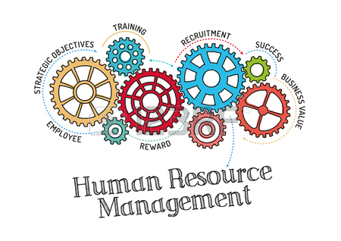
CONSIDER WHETHER THE HANOI HAT COMPANY CAN COMPETE IN A GLOBAL WORLD AND WHAT CHANGES THEY NEED TO MAKE TO IMPROVE EMPLOYEES ENGAGEMENT.
Reward management:
Reward management can be explained as the process, strategies and policies needed to ensure that employees feel that their contribution they make to attain organizational, departmental and team goal is remembered and rewarded. (Armstrong, 2010)
Reward practice should be more focused, not only about the financial pay, reward and worker benefits but also in concerned with other reward such as training, services, development opportunities and their job responsibility as well.
Reward practices has a lot of benefits it will help a company as Hanoi hat company to supports its staff to achieve the goals of the company in relation to high profit and performance. Reward practice can also motivate the employees to be more committed and engaged with the company. (Armstrong, 2010)
The responsibility and duties are augmenting when company become successful. Hence, the Hanoi hat company should make some changes in their practices, policies and strategy system if they want to compete at the global level.
At present the Hanoi hat company will not be able to compete in the global world unless they make some changes, outline below are some of the suggestions they can make to compete in the global world.
- Appoint the HR manager:
They will need to appoint an HR manager to handle the human resource in very effective way by developing policies and protocols that can be used in a global HR scale and sort out the staff problems and this can lead to increase in the production rate of the company. Also, the HR manager is only the person who have authorities make and emulate the protocol and policy regarding the reward for company’s employees. Furthermore, the management will then be able to make the effective bridge between the different firm policies, procedure and practices with the human resources. (Armstrong, 2006)

- Flexible working shift:
It has many positive aspects to both employee as well as employer. For employer it helps to augmenting the staff morale, commitment and engagement to the firm. Also meets the demand of customer by extended the working hours of operation. For the employee, help them to spend quality time with the family and allow the staff to work when they feel freshest, energetics and enjoy to working. Furthermore, the flexibility helps to women, one of the reasons behind this, they have more responsibility to take care of their children and other member of family. (Balancecareers, 2019)

- Non-financial reward:
If Hanoi hat company proffer reward other than involve any direct payment and it is made from part of work itself. For cite as an example training, develop skill, and recognise their milestone. It will definitely help them to stand equally with global market. (Armstrong, 2010)

- performance, contribution and competence-based reward system:
The Hanoi hat company will organize evaluation test for every employee and based on the performance, contribution and competence the management give them financial gift like increase basic pay or bonuses and non-financial gift such as shopping voucher, travel card, or movie tickets. (Armstrong, 2010)

- Retirement funds, pension and other benefits:
The company will give the benefits like sick pay, look their staff after the retire, insurance and free travelling service from company to home. (Armstrong, 2010)

References
- Armstrong, 2006. a handbook of human resources management practice. 10 ed. london: kogan page ltd..
- Armstrong, 2010. Armstrong's handbook of reward management practice. 3 ed. london: Kogan page ltd..
- Balancecareers, 2019. [Online]
Available at: https://www.thebalancecareers.com/advantages-and-disadvantages-of-flexible-work schedules-1917964

