Network Design
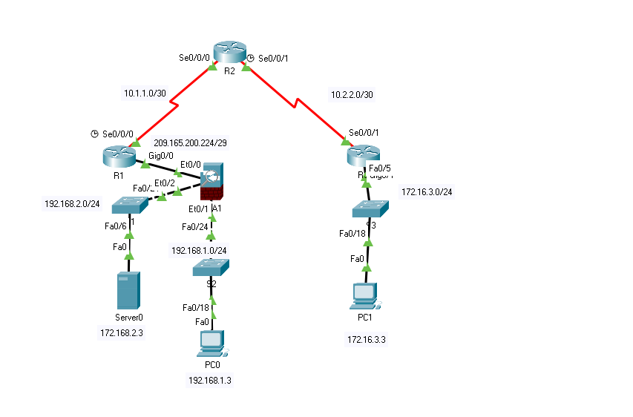

1.
If we want to secure a network it must be considered Security Domains like : Risk, Organization of information policy, Asset Management, Human Resources, Physical and environmental security, Access Control. Main purpose is to have security policies that consider all these points (domains) of security.
There are many attacks and threats that risk the network like :
Malware- that is a malware code that is destined for attacking but are different based on the purpose of the malware.
Viruses- are malware software which executes a specific unwanted function on end device that often is harmful.
Trojan Horse- is a type of malware that is designed to look as something else like legitimate application or file, but when the user is infected then trojan horse can attack end device.
Worms- are type of malware worms execute arbitrary code and installs copies of itself to replicate itself. So it replicates too fast and can spread across the network from system to system.
There are also some type of attacks like
Dos & DDOS attack – Denial of Service & Distributed denial of service, Dos attack can be performed by one user to bring down a service or server. DDOS hackers build network with infected machines that are called zombies and the it use them to attack a specific target.
Reconnaissance Attack – that is a method of gathering information about a host, by doing ping sweep, port scan, exploitation tools.
The way how we can protect from the kind of attacks is different for each attack but with main purpose of defending the network.
Mitigation of Malware attack can made by installing licensed antivirus on end devices.
Mitigation of DOS attack can be made by implementing IPS and firewalls, using Antispoofing technologies.
Mitigation of Reconnaissance Attack is made by many method like :
- Implementation of authentication for proper access
- Using anti-sniffer tools to detect packet sniffer attack
- Using encryption
- Use Firewall and IPS technologies.

NFP Framework is with 3 part
- Control Plane
- Management Plane
- Data Plane

Control Plane has features for secure like AutoSecure, it use routing protocol authentication and provides CoPP ( Control Plane Policing).
Management Plane is for securing the device with enabling password, presenting legal information, Ensuring the confidentiality of data using SSH and HTTPS, enabling role-based access control, Authorizing actions, Enabling management access reporting.
Data Plane Secure the traffic with ACL and antispoofing technique, it use layer two security and DAI.

3.
AAA is used for better security and with more details, can used for Authorization Authentication and Accounting.
Authorization- is used for Authorize the users what to do after the users is Authenticate.
Authentication- is used for prove the users who they are
Accounting – is used for document the activities of the user that is authenticated.

5.
Network security policy its very important to protect the network based on security policy that we use and develop we understand about the priorities and assets that our network has.
There are some objectives when develop security policy.
- What do you have that others wat?
- What processes, data, or information systems are critical to you, your company, or your organization.
- What would stop your company or organization from doing business or fulfilling its mission?

6.
There are different vulnerabilities on Layer 2
- Cam Table Attack, this is an attack that occurs on switches with their mac address table, the attackers try to generate many fake mac address in order to save on cam table of the switch as we know the switches has a limited number mac address that can learn if that number is reached it means that the switch will not operate anymore as layer 2 devices but will do only broadcast of the traffic.
- Vlan Hopping Attack, This is an attack where it is used Trunk and Native vlan. Attackers try to reach an target through double tagging a frame with native and with a specific vlan that can reach the network.
- DHCP Spoofing Attack, is an attack where the attacker try to offer DHCP services from itself in order to be in the middle of the communication from a user and a specific destination (doin man in the middle ).

Mitigation of Cam Table Attack, can be done by using Port security. This is a feature when we can limit the number of mac address learned for each switch port and if that violation occurs then the port can be shut down and send an notification to the administrator or security operator.

Mitigation of Vlan hoping can be done by using PVLAN edge feature, when we can isolate the communication in the vlans by placing ports on protected mode.
Mitigation of DHCP Spoofing, can be done by using DHCP Snooping, when we place switch ports on trusted or untrusted port. Trusted port will be only the ports that are connected switch to switch and port that is connected a Server, all other access ports are placed on untrusted port so will not accept any packet for offering a service of DHCP .
8.
The main functions of intrusion prevention systems are to protect the network from threats such as identify malicious or suspicious activities, log information about these activities, attempt to block or stop them, and report them.
Signature-based detection is an anti-malware approach that identifies the presence of a malware infection or instance by matching at least one byte code pattern of the software in question with the database of signatures of known malicious programs, also known as blacklists.

9.
A virtual private network (VPN) gives you online privacy and anonymity by creating a private network from a public internet connection. VPNs mask your internet protocol (IP) address so your online actions are virtually untraceable. IPsec is a group of protocols that are used together to set up encrypted connections between devices. It helps keep data sent over public networks secure. IPsec is often used to set up VPNs, and it works by encrypting IP packets, along with authenticating the source where the packets come from.
11.
The ASA uses a stateful approach to security. Every inbound packet is checked exhaustively against the ASA and against connection state information in memory.

Below are tests that I have done that everything works ok.
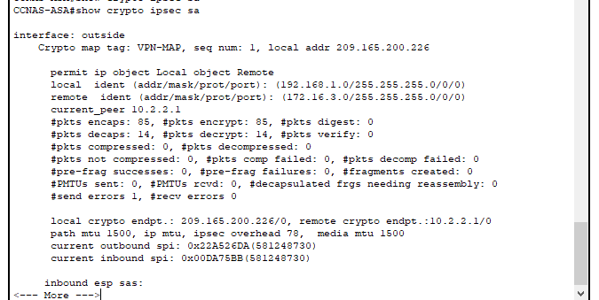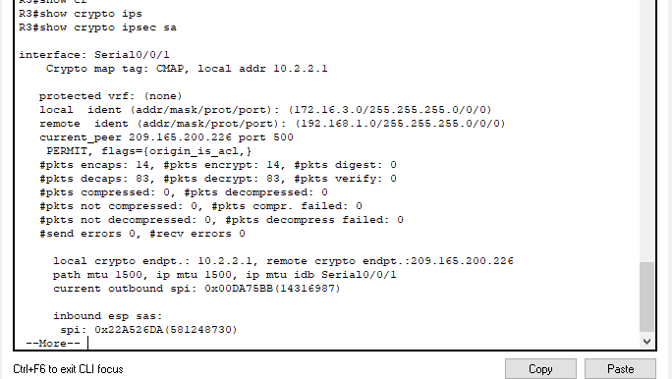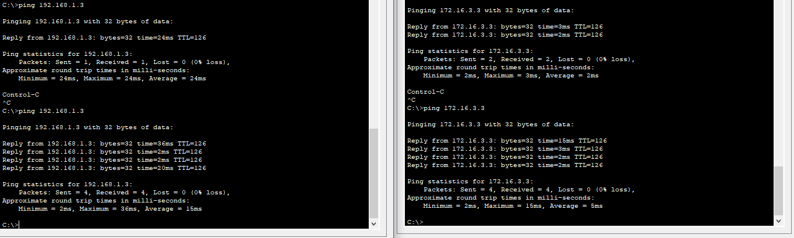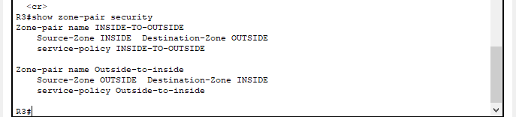
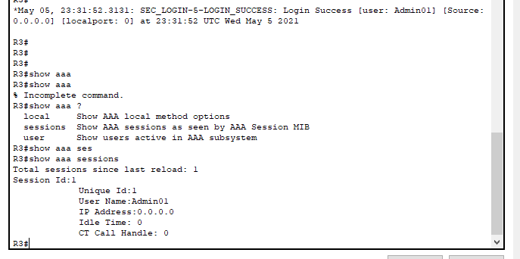
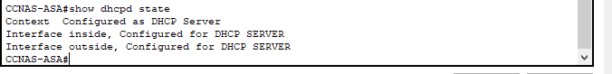

Part 2
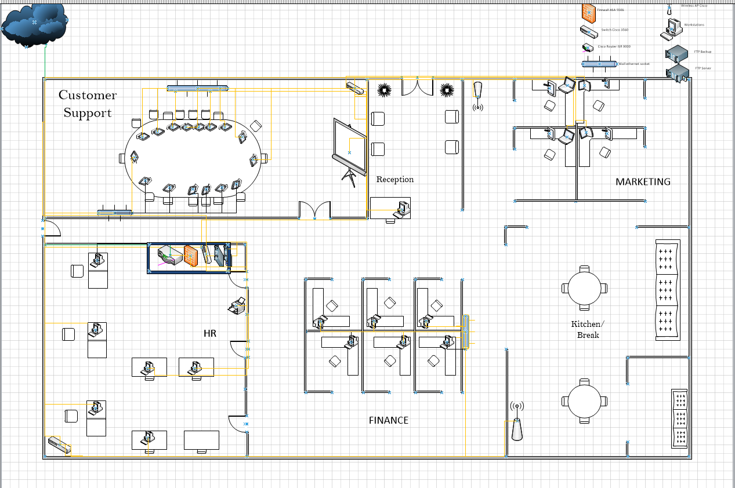

This Design is implemented on site working and also remote access workers, on each end device it is activated endpoint security and is installed antivirus licensed. There is one Cisco ASA firewall that is needed for traffic filtering and providing remote access VPN for remote workers.
Devices that are used on this design are:
SFP 10G link for ISP connection
3x 3560 Cisco series Switch
1 ASA 5506 Firewall
1 Cisco Router ISR 4000
2x Servers
2x Cisco Catalyst 9100 AP

ASA firewall is configured to work as stateful firewall to inspect packets that come from outside to inside, in order to protect our network. Also to inspect all the protocols that this company need to work with.
Router ISR is also a device that provides another security layer by implementing other packet filters with ACL and providing Routing.
Switches provide Layer 2 security for different attacks on layer 2 and providing access for end devices that are connected with ethernet.
AP provide access to wireless users, as employers use personal devices also this kind of AP can be configured to provide another network for guests and workers with personal devices due to security policy.

marking criteria and Student FEEDBACK

This section details the assessment criteria. The extent to which these are demonstrated by you determines your mark. The marks available for each criterion are shown. Lecturers will use the space provided to comment on the achievement of the task(s), including those areas in which you have performed well and areas that would benefit from development/improvement.

Common Assessment Criteria Applied (Assignment 1) | Marks available | Marks  awarded
1. Engagement with Literature Skills
Extent of research and/or own reading, selection of credible sources, application of appropriate referencing conventions.
No referencing apply to this report or a reference listing provided at the end. Your work lack appropriate of the content. The information given is more of defining terminologies, no depth and critical analysis. Demonstrated lack of engagement with literature skills. You need to engage with peer-reviewed articles, utilise the university library online resources and databases. (Grade mark: 30.00%) | 10 | 3
2. Knowledge and Understanding Skills
Extent of knowledge and understanding of concepts and underlying principles associated with the discipline.
See above to improve this section and to provide critical awareness of current problems and insight. (Grade mark: 30.00%) | 10 | 3
3. Cognitive and Intellectual Skills
Analysis, evaluation and synthesis; logic, argument and judgement; analytical reflection; organisation of ideas and evidence
Your report has no introduction and conclusion.  • You have wrote briefly on the proposal given case study. It is lacking critical analytic discussion.  • You have not done a proposed cost analysis for implementing the solution(s); which include software, hardware, etc.  • You have not done the timeline for the implementation, e.g. a Gantt chart  • You have not explained to A2Z at least three attacks that will plagues the organisations network infrastructure. You have written briefly with reference to VPN remote access.  • You have not explained three types of test to be conducted after the implementation to ensure the network infrastructure is secure.  • You have not provided an invoice for the professional/consultancy service as a Network Security Engineer. (Grade mark: 32.00%) | 25 | 8
4. Practical Application Skills
Deployment of methods, materials, tools and techniques; application of concepts; formulation of innovative and creative solutions to solve problems.
You have submitted a Cisco Packet Tracer file, not able to test the configuration as you have not supply the passwords for the design (figure and table) laboratory task given in part 1. However you given screenshots which would indicate a working design. You have not name and numbered your screenshots and refer to them in a discussion or explain them.  The practical knowledge and understanding gain from part 1 packet tracer implementation was used to:  • Construct a blueprint design, for the given case study, could do with more annotation. You could include link the remote office and annotate accordingly. A brief explanation given.  (Grade mark: 56.00%) | 50 | 28
5. Transferable Skills for Life and Professional Practice
Attributes in professional practice: individual and collaborative working; deployment of appropriate media; presentation and organisation.
Your work require formatting and organisation. There is no cover page. It need appropriate heading. Your report is written in first person writing; academic work should be done in third person tense. There are many typo and grammatical errors. Your writing need to be improved; utilised the university support team provided by student services. (Grade mark: 40.00%) | 5 | 2

Assignment Mark (Assessment marks are subject to ratification at the Exam Board. These comments and marks are to give feedback on module work and are for guidance only until they are confirmed. ) | Late Submission Penalties (tick if appropriate) |  | 44%
 | Up to four weeks late |  | 44%
 | First Attempt? |  | 44%

