Security Analysis Report
Vigilant Trust & Asset Management (VTAM)



Prepared by:
Student Name -Student ID

Word limit = 2000 words (Report)

Table of Contents

The word count is not included for this page. Abstract does not get included in the content list. For example:

Contents
Introduction 4
1. Identification of Modern Threats 4
2. Modern Security Policies 5
3. Technical Mitigation Measures 5
4. Proactive Monitoring and Incident Response 5
5. Continuous Training and Awareness 5
Conclusion 6
References 6

Introduction

Talk about computer security and its challenges in general. How it has affected the world in short. Add a picture (Figure 1) to glamourise the report. Pictures make documents look good. Word count is not included for this section.

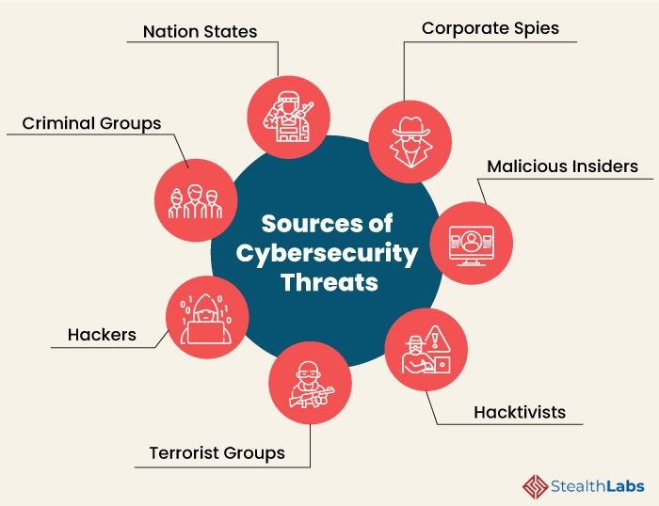

Figure 1. Security Challenges in Computers [1]

Ensure recommendations are grounded in specific standards like NIST CSF and the CISA Known Exploited Vulnerabilities catalogue.

- Task
Make sure you do not exceed 2000 words.

1. Identification of Modern Threats
Clearly identify current and emerging internal and external threats, including Ransomware-as-a-Service (RaaS), AI-powered social engineering (vishing), supply chain compromises, and risks associated with cloud adoption and hybrid work. (You can refer Lecture notes or use google to research on this task. Make sure you cite the text and add the reference in the list of references).
Have you identified a wide range of current internal and external threats, such as RaaS, supply chain attacks, and AI-powered social engineering?

2. Modern Security Policies
Develop a set of security policies that align with the Zero Trust model and best practices from frameworks like NIST CSF and ISO 27001. Try to discuss if your proposed security policies are clear, relevant, and practical?

- Utilize industry standards such as ISO 27001, NIST, or GDPR compliance guidelines when developing your security policies.
- Engage with frameworks like the CIA Triad (Confidentiality, Integrity, Availability) to assess the implications of your proposed measures.

Are the proposed security policies clear, practical, and explicitly aligned with Zero Trust principles and frameworks like NIST or ISO 27001?

3. Technical Mitigation Measures
Propose specific, feasible technical and administrative measures to mitigate identified threats, detailing how each measure will be implemented (e.g., MFA, SIEM, CSPM).

Are the mitigation measures realistic and achievable within the context of Vigilant Trust & Asset Management (VTAM)? Should be considered to meet the criteria of this section of the task.

Consider the latest trends in cyber threats, such as ransomware, insider threats, and social engineering tactics. Include references to relevant literature, case studies, or examples from other organizations to support your recommendations.

Are the mitigation measures (e.g., MFA, immutable backups, patch management based on CISA KEV) realistic, achievable, and reflective of current best practices?

4. Proactive Monitoring and Incident Response
Outline a plan for 24/7 monitoring, threat detection, and response, incorporating modern tools like SIEM and SOAR.

A flow chart or diagram is essential.

Is there a robust plan for ongoing monitoring and incident response? If yes, what and how?

Does the plan incorporate modern concepts like SIEM/SOAR and include specific procedures for current incident types like ransomware? A diagram is expected.

5. Continuous Training and Awareness
Describe an engaging, continuous training program focused on modern attack simulations (phishing/vishing) and promoting a culture of security awareness.

Include references to relevant literature, case studies, or examples from other organizations to support your recommendations. Does the training program effectively promote security awareness among staff? How?

Does the training program go beyond annual videos to include continuous, simulated attacks (phishing/vishing) and role-specific training to effectively promote a security-conscious culture?

Conclusion
Conclusion, recommendation and future work (From your findings what do you recommend, discuss or state these. What can be done in the future to improve on your findings will be the future work). (max 100 words). Word count is not included for this section.

References
The reference style should be IEEE kindly refer to the library website for details. Add all the references used in this report and make sure they are in-text citied. Word count not included.
Example:

- Stealth Labs, https://www.stealthlabs.com/blog/cyber-security-threats-all-you-need-to-know/ [Accessed on 02/07/2024]

- The Knowledge Academy, https://www.theknowledgeacademy.com/blog/types-of-cyber-security-breaches/ [Accessed on 12/07/2024]

