Information Engineering

Analysis of Systems Requirements
ACCB4013 - Assignment
Gareth Williams (1910285)
31st March 2020

The Abertawe Playhouse

The following diagrams describe the key processes and data flows following initial analysis of The Abertawe Playhouse day-to-day processes.

Context Diagram

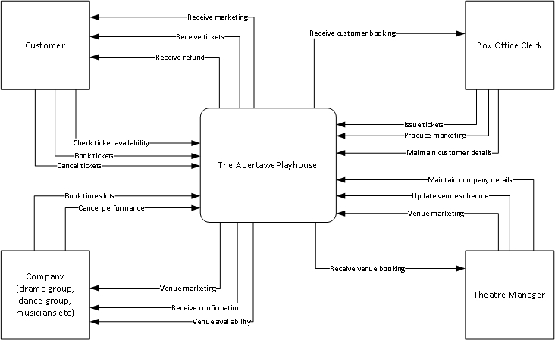

Level 0 DFD

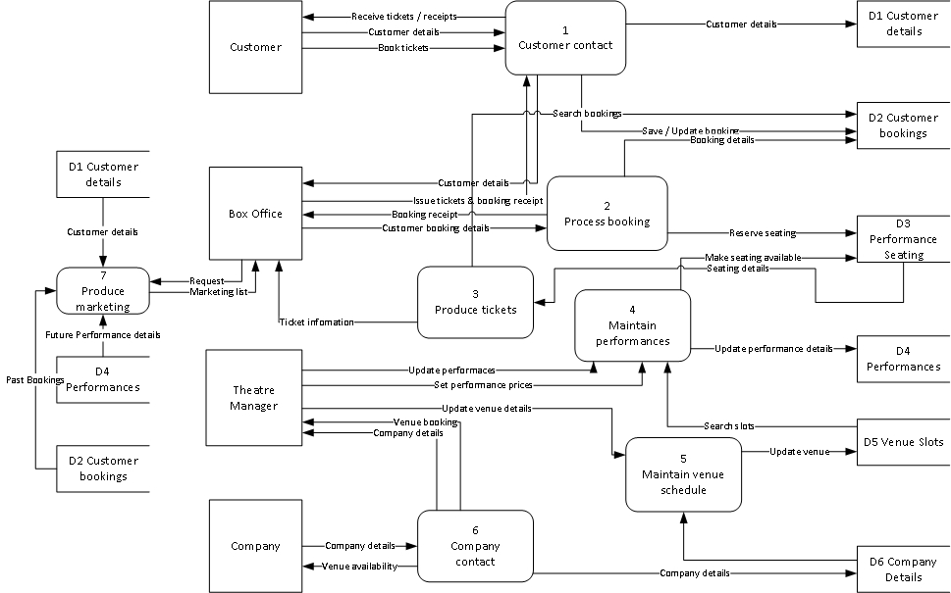

Level 1 DFD

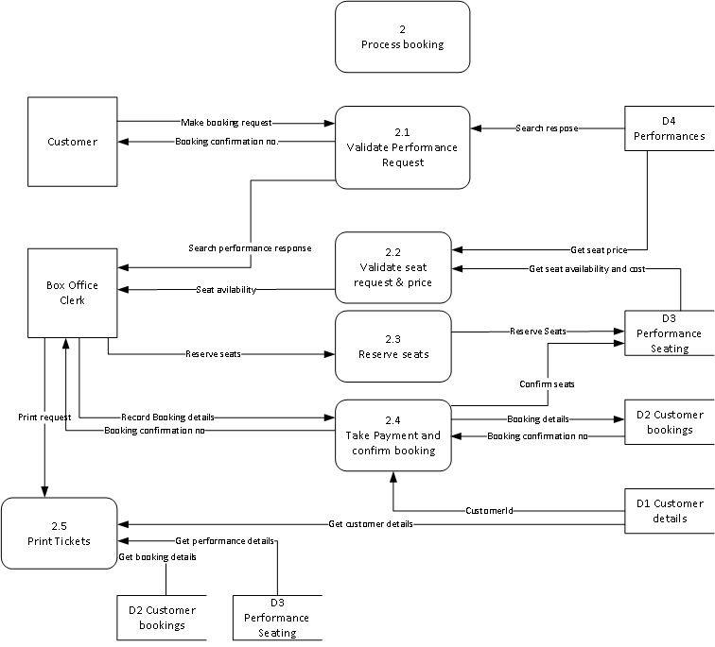

Entity Relationship Diagram

For clarity, only key field names are shown



