University of WALES TRINITY SAINT DAVID
School of Engineering
B.Eng Manufacturing systems

Group Project
M5X00400

Assignment B

David Adams 1908506
Table of Contents
Abstract 2
Introduction 3
Project Management 4
Gantt Charts 4
Team Formation 6
Belbins Theory 6
Team Management 11
SMART Objectives 11
Skills Gap Analysis 13
Conflict and Cohesion 14
Motivation 14
X and Y theory 14
Herzberg’s Two Factor Theory 15
Maslow’s hierarchy of needs 16

Table of Figures
Figure 1 - AM800 Facilities Gantt Chart 5
Figure 2 - Belbin's 9 Team Roles (Belbin, 2010) 7
Figure 3 - Maintenance Team Self Evaluation 8
Figure 4- Maintenance Org. Chart (Installation and Commissioning Phase) 8
Figure 5- Maintenance Org. Chart (Manufacturing Support Phase) 9
Figure 6 - Maintenance Team Roles and Responsibilities, Installation and Commissioning Phase 10
Figure 7 – SMART Objective for Maint Engineer A: Installation and Commissioning Phase 12

Abstract
This is a reflective report on the formation and management of a maintenance team for the new Aston Martin St. Athan Manufacturing Facility.
The primary purpose of the team was to observe, advise and assist in the Design, Installation and Commissioning Phases of the project with a directive to identify maintainability issues and glean as much in-depth relevant knowledge of the operation and interfacing of the equipment for the roles of maintaining and supporting this equipment during manufacturing.
The report will focus on particular challenges during the formation and management of the team and the challenges that I as a leader faced and how they were overcome. In particular, the lack of readily available engineers with required skillsets, dealing with conflict within the team, setting goals, and leading the team to achieve our goal through different leadership and motivational techniques.
The report documents team working theories and their relevance to myself and the challenges within the project.

Introduction
Aston Martin Lagonda Ltd. (AML) is the world’s only independent luxury car group which designs and manufactures luxury sports cars and SUVs.
“Founded by Lionel Martin and Robert Bamford in 1913 in a small London workshop, Aston Martin has since grown to become an internationally admired luxury brand.” (Aston Martin Lagonda, 2020)
With over 160 locations around the world, spanning 53 countries and 3 Manufacturing Facilities - Gaydon, Newport Pagnell and St. Athan.
“St Athan is the home of Aston Martin’s first SUV, the DBX. Upon the commencement of full production at St Athan in the second quarter of 2020, the company will have created up to 600 new highly skilled jobs, rising to 750 at peak production.” (Aston Martin Lagonda, 2020)
The Manufacturing Process is completed in 4 stages – Body Construction, Paint, Final Assembly and Off Tracks.
Body Construction is a highly automated process area where aluminium and composite parts have adhesive applied by robots and are then assembled by operators to create the Vehicle Body using specialist automated jigs. This body is then baked in an oven to cure the adhesive, creating joints that are 10 times stronger than spot welds.
Paint is the process by which the aluminium and composite body, and associated parts (fenders, hood, decklid, spoiler etc.) is transformed from a BiW (Body in White) to a PBS (Painted Body Shell). This is achieved over 7 different layers of paint, with each layer of paint being applied by specialist robot for maximum quality and repeatability. This is the most time-consuming process and takes over 70 hours to complete.
Final Assembly is the where the PBS is hand built to create an Aston Martin. The PBS automatically transfers along an assembly line where workers assemble everything (such as the engine, drivetrain, seats, windows and dashboard) on the vehicle. This area has various specialist machines used to move and carry the part-built vehicle and also various machines used to sub assemble parts before they are fitted to the vehicle.
Off Tracks is the inspection and verification stage of the process. This is where the assembled vehicle comes alive for the first time and is tested to ensure it meets all quality and safety standards. It includes test equipment such as water-tightness testing machines, rolling roads and vehicle geometry measurement equipment.

Project Management
To be able to support the creation and operation of this new manufacturing facility, a maintenance team had to be established to sit underneath current senior management within the organisation, with clear roles and responsibilities defined to be able to support the business during the two phases of the project. In 2017 I was recruited as Lead Maintenance Engineer, as a part of the project team and tasked to create and manage a maintenance team that would observe the installation and commissioning phase of the project using their previous experience to look for oversights and common pitfalls of the project in relation to equipment maintainability. They would also be tasked with understanding how the equipment operates and interacts with other processes, enabling them to provide maintenance support during the manufacturing phase. A particular challenge that I faced during the project was the technological development and utilisation of a robotic paint application system that incorporates a “bell applicator” and “PIG” technology. The combination of these three technical systems into one package was an industry first, AML St. Athan would be the first manufacturing facility worldwide to utilise the development. The unproven reliability and therefore maintainability of such a complex system was a concern and a risk to the project if not managed effectively. To overcome this, I recruited a robotics technician with previous technical experience of the robot system, to shadow the design installation and commissioning engineers to become a specialist.

Gantt Charts
A Gantt chart is a project planning and management tool used to show activities (tasks) against a timeline. On the left of the chart are the tasks and along the top is a suitable timescale. Each line of activity is represented by a bar which stretches along the timeline to indicate the start and end times, and duration of the tasks. They are a very useful tool in the management of a project and below is the one I used for the AM800 (DBX) Facilities Program.
Figure 1 - AM800 Facilities Gantt Chart

Team Formation
For me, the most significant challenge during the installation and commissioning phase was the formation of the team where the level and diversity of different specialist skills that was required of the Maintenance Engineers was very high and extremely varied. Initially, I did not think the required knowledge was readily available within the South Wales region for recruitment due to the lack of automotive manufacturing, and this was true. Equally, this was a benefit as it allowed me to recruit from other sectors without the relevant specialist knowledge but with a different and more broad range of abilities, whom I could train and develop on the job, to suit what I would identify as skills gaps recorded on a training matrix.

Belbins Theory
Belbin makes this observation in the following ways:
- “Over-speciﬁcation of the ‘‘ideal’’ candidate is unlikely to yield the ‘‘ideal’’ appointment.
- Dominant managers are prone to select candidates of indifferent ability who agree with them.
- Individuals with outstanding records of achievement often come from unexpected backgrounds. People with a broad range of abilities are well suited to operating in teams.”
(Belbin, 2010)
To be as effective as possible, Belbin theorised that a team needs to have a balance of nine team roles, these were identified as the following:
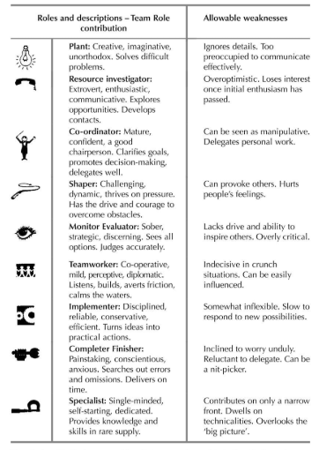
Figure 2 - Belbin's 9 Team Roles
(Belbin, 2010)
Usually, a larger team has more than one person belonging to a particular team role, however sometimes a small team may be lacking a particular team role, these scenarios can lead to an imbalanced team with either a surplus or void respectively of team roles. The below is the makeup of my chosen team. This can now be used to recruit new team members who can fill voids with their team roles.
Figure 3 - Maintenance Team Self Evaluation
Having applied this theory documented by Belbin, I feel I was able create a well-balanced team that works well together and has the required technical skills – learned through on the job training, whilst retaining their existing abilities and varied experiences which contribute to increased output and innovative problem solving. This knowledge is useful to me as a practitioner because if I am asked to create or manage a new team in the future, I can balance the team’s personality traits and technical skills to create effective working relationships with each other.

Figure 4- Maintenance Org. Chart (Installation and Commissioning Phase)
The installation and commissioning would be supported by a single day shift role, consisting of 1 lead engineer, 4 maintenance engineers and a robot technician, with an engineer assigned to each of the areas to become subject matter experts, and a robot technician assigned specifically to the paint application robotic system technology due to the complexities mentioned previously.

Figure 5- Maintenance Org. Chart (Manufacturing Support Phase)
Phase 2 Structure would be a double day shift role to support the double day manufacturing shift pattern. There would be a notable increase in the Leadership team to support this, with the addition of a Manager, 2 Shift Group Leader’s, another Lead Maintenance Engineer, 4 more Maintenance Engineers and a Robot Technician. The aim of this notable increase in additional leadership is to support the team and provide clear direction at all times.
“The team now needs to be balanced so that all the relevant Team Roles, together with any special skills, are well represented. If this can be achieved with only a small group of people, so much the better. Smaller teams have consistently shown greater balance, flexibility, and success than larger ones, provided they do not drop below the ideal number of four or the critical number of three.”
(Belbin, 2010)
Figure 6 - Maintenance Team Roles and Responsibilities, Installation and Commissioning Phase

Team Management
My role during the installation and commissioning phase of the project was to lead the maintenance engineers and provide day-to-day management of the team, documenting and collating all information pertaining to installation and commissioning, creating technical acceptance criteria for the project, liaising with the project teams in each area, contributing to the overall success or failure of the DBX Project. I also had to ensure the development of the team, looking to identify the requirements for the future and act accordingly.

SMART Objectives
SMART objectives are an acronym for “Specific, Measurable, Achievable, Relevant, Time-based Objectives.”
(Rubin, 2002)
- Specific - objectives need to be direct, detailed, and meaningful
- Measurable - objectives need to be trackable to monitor progress
- Achievable - objectives need to be able to be achieved within the constraints of the time and resource available
- Relevant - the goals are a tool to achieve a greater purpose and need to be relevant to contribute to the success or failure of the project
- Time-based goals have a definite time frame and a completion date
I identified the following key points which would define my objectives and what I would need to complete to contribute to the success of the project. To make the team as effective as possible in achieving our goals, I would have to consider and develop a solution whilst taking these key points into account.
- The installation and commissioning would be completed on a day shift pattern
- There were 4 main areas of process, clearly defined as Body Construction, Paint, Final Assembly, and Off Tracks
- The team would be responsible for looking after a wide range of specialist equipment (most of which is industry specific)
- Paint Application was to adopt a combination of emerging/complex technologies which were unproven in the automotive sector
- Financial constraints would mean the team would be small (3 to 5 people)
- The team would require an in-depth (specialist) knowledge of their own area of responsibility
- The team would be required to have a general understanding of other process areas to be able to carry out basic maintenance and fault finding
- The Manufacturing Process would be undertaken over a two-shift pattern
In order to achieve overall project success, I created objectives for myself and my team using the SMART model.
Figure 7 – SMART Objective for Maint Engineer A: Installation and Commissioning Phase

Conflict and Cohesion
For me, the most meaningful learning resulted from conflict that arose within the team between Robot Tech A (RTA) and Maintenance Engineer B (MEB), they were both assigned to paint due to their previous experiences, and both were defined as primary specialists in their team roles. MEB would often disagree with RTA with regard to the time spent studying each of the paint system technology, complaining that he should be listened to because he had the most paint experience previously. Initially I did not notice that this conflict was demotivating both team members. After speaking to MEB to understand what his objections were, I was able to set him a new objective to focus on developing the acceptance criteria for a part of the technology that he deemed less important. This drove him to look into the technology more he then realised he needed to gather more information to be able to fulfil a critical objective planned for later in the project, he then started to work more positively with, and closer to RTA, with both team members gaining a mutual recognition of each other’s value. Alternatively, this could be explained by MEB’s second strongest team role of shaper, where a characteristic is that they have a drive and courage to overcome obstacles. This theory is documented by Belbin below.
“Another example arises in the case of an individual who is seen as a vigorous objector and clearly a person to be avoided if peace is to be enjoyed. Objections and complaints commonly upset people unduly and lead to no favourable outcome. All this may sound very negative. The challenging nature of the objector may, however, suggest the makings of a Shaper. Shapers make courageous change agents, ready to overcome obstacles in pursuit of what is seen as a worthwhile objective. It is often a better tactic, rather than tackling such a person head on, to focus on some obstacle beyond the area of current dispute. In effect, the presumed Shaper’s energies will be redirected towards the external problem. If the plan works as hoped, the relationship will have produced one positive outcome. More important still will be the likely gain in mutual role recognition.”
(Belbin, 2010)
Having applied this method of resolution with favourable outcome, and after analysing the theory behind why it had worked, I now know how to resolve conflict between two specialist roles in the future. Furthermore, I have learned to look beyond the area of current dispute and seek to understand whether characteristics of Belbin’s team roles may play a part in why the team may be conflicting.

Motivation

X and Y theory
Once I had formed my team and provided objectives for them to complete, I had to motivate the team to achieve them, this was proving to be difficult when the team were learning to become subject matter experts.
The team were not responding well to the transactional type leadership I was providing in response to Douglas McGregor’s’ X Theory assumptions.
“With respect to people, this is a process of directing their efforts, motivating them, controlling their actions, modifying their behaviour to fit the needs of the organisation. Without this active intervention by management, people would be passive- even resistant – to organisational needs. They must therefore be persuaded, rewarded, punished, controlled – their activities must be directed. “
(McGregor, 1960)

Herzberg’s Two Factor Theory
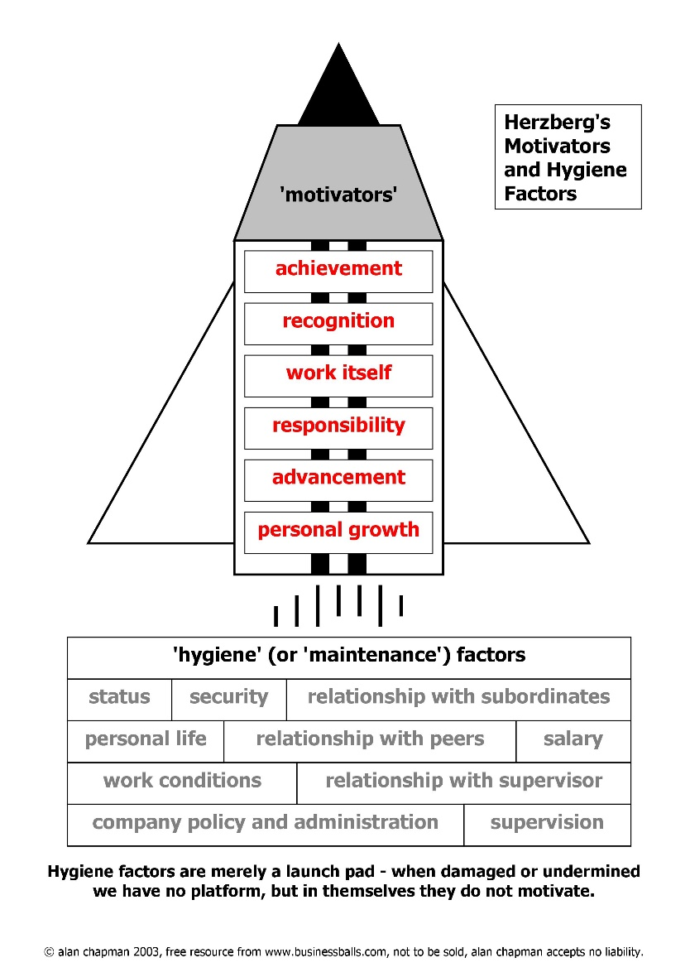
Subsequently, I questioned their needs and motivations. Herzberg suggests that there are two factors, Hygiene Factors and Motivational Factors.
(Chapman, 2003)
He continues to explain that Hygiene factors are essential for the existence of motivation, but they do not lead to satisfaction long-term and should not be regarded as motivators, they are more comparable to pacifiers. Examples of these are things like pay and benefits - physiological needs which the individuals want and expect to be fulfilled.
He also makes the point that motivational factors such as recognition, a sense of achievement and meaningfulness of the work all are satisfiers and individuals find these rewarding, fulfilling psychological needs that are perceived as an additional benefit – motivating individuals to increased performance.
(Herzberg, 1959)
Equally, his theory does not account for productivity, which is important within a project, to achieve milestones and goals on time and to avoid delays and costs incurred with such.

Maslow’s hierarchy of needs
Maslow developed a five-stage model in 1943 which compartmentalises people needs into five categories.
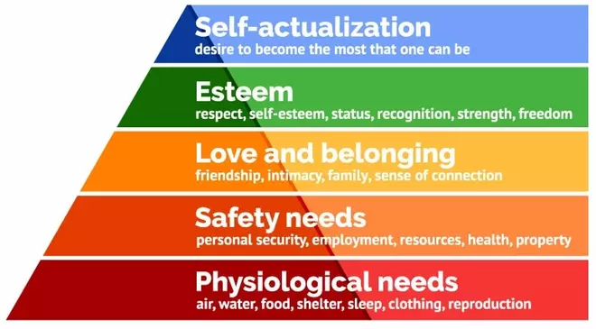
(McLeod, 2020)
He states that people are motivated to only attain a particular level of need and some needs take priority over others. As humans, our most basic need is for our survival (our physiological needs), this is the first stage of motivating our behaviour and includes things like air, water, food, shelter. Once this level is realised, we are then motivated by the next level, safety needs such as security, employment, health, property. Once these needs are met we seek the next level and so on until our needs are completely satisfied.
“It is quite true that man lives by bread alone — when there is no bread. But what happens to man’s desires when there is plenty of bread and when his belly is chronically filled? At once other (and “higher”) needs emerge and these, rather than physiological hungers, dominate the organism. And when these in turn are satisfied, again new (and still “higher”) needs emerge and so on. This is what we mean by saying that the basic human needs are organized into a hierarchy of relative prepotency”
(Maslow, 1943)
For me, the most relevant aspect of this theory was that my team had achieved the first three, most basic needs and were somewhere between realising the fourth and fifth level.
Having read about the different theories of motivation, I have developed my leadership style to move away from Herzberg’s X Theory and become more transformational, using a combination of Herzberg’s motivators to get my team to buy-in to and commit to objectives, and using an assumption made by McGregor’s Y Theory where;
“External control and the threat of punishment are not the only means for bringing about effort toward organisational objectives. People will exercise self-direction and self-control in the service of objectives to which they are committed.”
(McGregor, 1960)

Bibliography
Aston Martin Lagonda. (2020). About Us. Retrieved from Aston Martin Lagonda: https://www.astonmartinlagonda.com/about-us
Belbin, R. M. (2010). Team Roles at Work. Oxford: Butterworth-Heinemann.
Chapman, A. (2003). Improving Workplace Performance. Retrieved from Businessballs.com: https://www.businessballs.com/improving-workplace-performance/frederick-herzberg-motivation-theory/
Herzberg, F. (1959). The Motivation to Work. New Brunswick and London: Transaction Publishers.
Maslow, A. H. (1943). A Theory of Human Motivation. Psychological Review, pp. 50, 370-396.
McGregor, D. M. (1960). The Human Side of Enterprise. Chicago and London: The University of Chicago Press .
McLeod, S. A. (2020, March 20). Maslow's hierarchy of needs. Retrieved from Simply Psychology: https://www.simplypsychology.org/maslow.html
Rubin, R. S. (2002). Will the Real SMART Goals Please Stand Up? The Industrial-Organizational Psychologist.

