

University of Wales Trinity Saint David
Master of Business Administration (MBA)
Module: Strategic Management
Module Code: LCMB7003

Consumer Electronics industry in the UK: A Case of Apple

Title: Evaluation of current strategic position of Apple to enhance competitive advantage: Evaluation of management issues and recommendations

Lecturer: Balendran kandasamy
Student Name: Pooja Keshu Odedra
Student ID:2526717
Wordcount: 5286 words
Submission Date: 12th August, 2026

AI acknowledgement
I confirm that I used AI tools such as ChatGPT and Grammarly AI tools to review my work for grammatical errors and sentence formation issues while completing the entire assignment. I executed the ideas considered from the secondary research and whatever ideas, information I have taken from the secondary sources, I properly acknowledged those in my work.

Name: Pooja Keshu Odedra

Executive summary
The report has been prepared to highlight the consultation for Apple regarding defining and planning its business strategy for competitive advantage and growth. This report aims to shed light on internal and external business environmental analysis that impact business operation of Apple. It has been found that Apple needs to be aware about the regulatory policy and environmental considerations in terms of business operation in the UK. With respect of discussing business growth, Apple watch product has been selected considering the specific geographical market like UK. It is pivotal for Apple regarding determining strategic pricing options based on the multi-budget consumers as well as value-driven choices of the customers. It has been identified that in the UK, the wearable technology market has significant prospects and the strong competitors of Apple are Samsung and Google. Apple needs to be focused on continuously upgrade its Apple watch features and design to remain competitive in the UK market.
Table of Contents
Section 1 4
1.1 Introduction 4
1.2 Organisational context and overview 4
1.3 External and internal analysis 5
1.4 Comprehensive and holistic view of Apple 14
1.4.1 Current CSR strategy of Apple and alignment with the business objectives 14
1.4.2 Balance Score card analysis of Apple 16
1.5 Strategic choices and implementation 19
1.5.1 Strategic choices of Apple (Cost leadership and differentiation) 19
1.5.2 Most appropriate strategy for Apple 19
1.5.3 Recommended strategy for Apple 22
1.5.4 Challenges in Execution and solution 23
Section 2: Reflection: Kolb’s cycle of reflective practice 25
Reference list 28
Appendices 35
Appendix 1: Apple watch 35

Section 1

1.1 Introduction
Apple is a renowned multinational technological company headquartered in California. The concerned report is focused on the strategic management consultation for Apple defining long-term goals, growth profitability and competitive advantage. The report is designed with the steps like context of Apple, internal and external market environment, Comprehensive view of Apple, strategic choices and implementation along with reflection.

1.2 Organisational context and overview
About Apple
Apple is defining the technology industry all across the world including the UK through its leadership in global technology landscapes focused on phenomenal growth over the past two decades (Slotta, 2025a). The brand key performance indicators of Apple watch in the UK are that this product more resonates with Gen Z, Apple watch generally has appeal to women compared to men (Statista, 2025). In terms of Apple watch enthusiasts in the UK, 38% are in the high-income category. It is observed that 84% of the individuals who have Apple watch have loyalty towards the brand (Statista, 2025). The Apple Watch series 11 has the ultimate way to watch health such as detection of possible hypertension patterns, high blood pressure and detection of the sleep score (Apple, 2026b) [Figure 1].
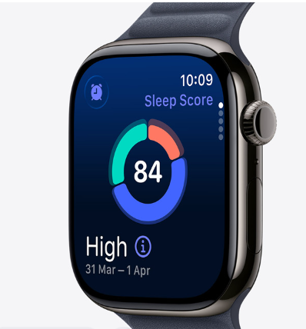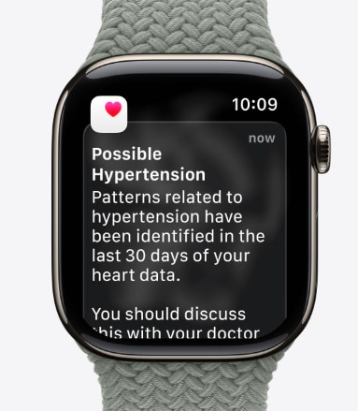
Figure 1: Apple watch series 11 (UK)
(Source: Apple, 2026b)
History: Apple was founded in 1976 and the founders are Steve Jobs and Steve Wozniak (Reed, 2024). Apple built its first product in 1977 and in that early time, it was focused on innovation that defined the computer industry (Reed, 2024).
Mission: The core focus of Apple's mission is driven by working to leave the world better along with creating powerful tools that can empower others (Apple, 2025a).
Vision: The vision of Apple is value oriented and it is immersed in commitment regarding considering the business as the force for good for accomplishing innovation, collaboration and serving others (Apple, 2025a).
Business model: In the UK, regarding business aspects, Apple uses tools for doing remarkable things such as devices optimised for AI, integrated services work together and powerful apps for bringing the ideas (Apple, 2026c).
Operational industry
Industry: Apple is operating in the industry of technology expanded with the sub industries like consumer electronics, software publishing. In the UK, it was forecasted that the consumer electronics market to reach approximately 25.4 billion British pounds in 2025 and estimated to increase even higher in future (Slotta, 2025c).
Key competitors: In the business marketing field of the UK, the key competitors of Apple are Samsung, Garmin, Google. The key competitive dynamics by the competitors for Apple are Samsung Galaxy Watch, Google Pixel Watch and Fitbit, and Garmin.
Market position: In the UK, with respect to smart watch market share, Apple and Samsung are holding the majority of the market share (Mintel, 2025). In regards of the smartwatch market in the UK, brand ecosystems are pivotal for the customers and the women aged between 25 to 44 are most likely to purchase smart watches (Mintel, 2025)

1.3 External and internal analysis
PESTEL
Elements | Factors | Opportunity/Threat
Political | - The UK has independent trade and regulatory policy imposed by Brexit and the economic aspects have become more complex (Chakraborty, 2026).  - In the UK long-term economic adjustment is needed by strategic policy interventions (Chakraborty, 2026).  - The UK faced issues due to Brexit regarding trade barriers, reduced market integration and labour market challenges (Chakraborty, 2026). | Threat
Economic | - In the UK, in 2025, the GDP will amount to about 2.8 trillion British pounds that was increased compared to the previous year 2024 such as 2.78 trillion British pounds (Clark, 2026) [Figure 2].  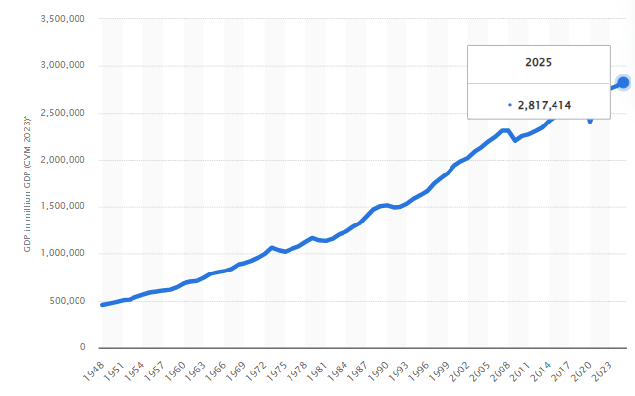  Figure 2: GDP of UK  (Source: Clark, 2026)  - In 2026, the global economic ranking of the UK is likely to fall in the future and it is projected that the global share of the UK's GDP may be 1.96% by 2030 (Clark, 2026). | Moderate threat
Social | - In the UK, wearable technology has been becoming an integral part of daily life and it is transforming futuristic ideas into reality (Slotta, 2025b).  - In the UK, the growing industrial norms have been observed regarding fitness trackers, smart watches, wireless earbuds and cutting-edge innovations (Slotta, 2025b). | Opportunity
Technological | - In the UK, preferences among the customers have been noticed regarding virtual reality headsets, augmented reality glasses and AI powered devices as well as the UK has the rising wave of wearable adoption (Slotta, 2025b).  - In the UK, the innovators need to understand the factors that the NHS is looking for while purchasing the digital and data-driven technologies for the use of health and care with the principles of good practices regarding design of the products (Department of Health and Social Care, 2021). | Opportunity
Environmental | - In the UK, climate change, infrastructure development and agricultural management are creating pressure on the natural environment (OECD, 2025).  - Based on the OECD data, the major environmental issues are such as climate change, air quality issues, challenges in freshwater resources, waste, circular economy and biodiversity (OECD, 2025).  - The UK is facing several environmental pressures over the past decade due to economic growth (OECD, 2025). | Threat
Legal | - Based on the guidance by the Medicines and Healthcare Products Regulatory Agency (MHRA) in the UK, the medical devices need to be certified and it is important to register the device with the MHRA (Medicines and Healthcare products Regulatory Agency, 2026).  - All the medical devices including Vitro Diagnostic medical devices, custom made devices along with systems or procedure packs, needed to be registered with the MHRA before placing them in the market of Great Britain (Medicines and Healthcare products Regulatory Agency, 2026). | Threat
Table 1: PESTLE analysis
In accordance with the PESTEL analysis, it can be said that in the UK, Apple may face issues due to complication in trade regulations, economic challenges and issues related to the labour market. Based on the PESTLE analysis, the areas of opportunities for the business of Apple are technological advancement and social aspects related to AI-powered wearable devices and rising preferences regarding wearable technologies. As per the report conducted by OECD (2025), in the UK, major environmental challenges have been noticed like issues regarding climate, air quality, freshwater resources and circular economy and air pollution is remaining the health concern. In the UK, MHRA performs market surveillance of the medical devices and makes decisions regarding the supply and marketing of the devices in the UK (Medicines and Healthcare products Regulatory Agency, 2026). So, Apple may face difficulties regarding Apple Watch (Apple Watch series 11) if the guidelines and provisions by MHRA are not properly maintained.
The difficulties may be raised regarding the areas of issue related to getting approval for marketing the smart Apple watch, especially such watches used as the medical wearable devices. Although there are some concerns in the UK market that Apple should be aware of, however, there are also opportunities for Apple in the UK related to social and technological trends. In the UK, wearable technologies are revolutionising the way by which people can be staying connected to the world and compared to the past, the wearable market is enhancing dynamically all around the world including the UK (Slotta, 2025b). According to the understanding of McCusker (2025) in the UK, the trends associated with the wearable technology are focused on,
- Wearable technology can revolutionise the healthcare system
- Emotional support wearables are connecting the people through technology
- Rising price may create temporary slowdown for smart watches in the UK
- Demand among the customers have been observed regarding advanced health metrics monitoring
- Apple dominates the smart watch market in the UK as Samsung narrowed the gap
McCusker (2025) further reported that the wearable technology market size was expected to reach by £1290 million in 2025, however, the cost-of-living crisis and economic pressures in the UK can slow the growth. So, despite having multiple opportunities regarding smart watches and wearable technologies in the UK, there is still concern in terms of economic aspects and cost-of-living crisis.
VRIO
Resources | Valuable | Rare | Inimitable | Organised | Competitive advantage
Technology | Yes | Yes | Yes | Yes | Sustainable advantage
HRM | Yes | No | No | Yes | Competitive parity
Economy | Yes | No | No | Yes | Competitive parity
Sustainability | Yes | No | No | Yes | Competitive parity
Innovation | Yes | Yes | Yes | Yes | Sustainable advantage
Research, development | Yes | Yes | No | Yes | Temporary advantage
Marketing | Yes | No | No | Yes | Competitive parity
Customer loyalty | Yes | No | No | Yes | Competitive parity
Distribution network | Yes | No | No | Yes | Competitive parity
Apple’s brand reputation | Yes | Yes | No | Yes | Temporary advantage
Watch OS and software capability | Yes | Yes | Yes | Yes | Sustainable advantage
Table 2: VRIO table
In accordance with the VRIO analysis, innovation and technology has significant implications for Apple regarding gaining sustainable competitive advantage. The ultimate benefits of Apple watch are even with healthy life such as meaningful health insights, connection to the people along with advanced safety features (Apple, 2026d). Apple (2026d) reported about the health benefits of Apple watches series 11 are notified for chronic high blood pressure, the individual can receive heart health notification, ECG on the wrist anytime and anywhere and detection of sleep score [Figure 3]. According to the report conducted by Apple (2026e), Apple has a commitment regarding internationally recognised human rights and respecting human rights in accordance with the United Nations Guiding Principles and human rights based on the global standards of business and human rights. The business conduct team of Apple is supporting the employees and answers the questions related to business conduct issues, regulations, policies as well as compliance with legal requirements.
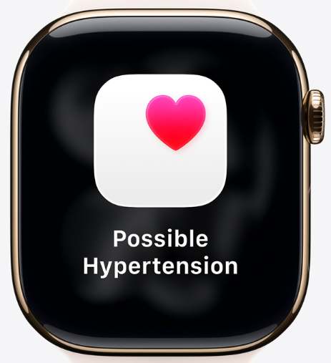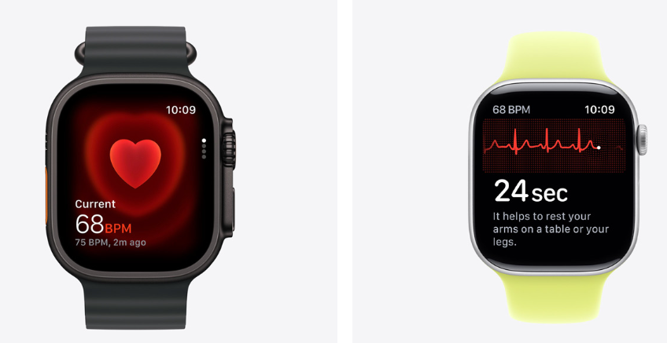
Figure 3: Health benefits of Apple watch series 11
(Source: Apple, 2026d)
As per the report conducted by Mintel News (2026), it has been observed that only 2% of the customers in the UK recently own a smartwatch. In the UK, consumers were waiting to see that watch that Apple would bring (Mintel News, 2026). Apple (2025b) reported that Apple has launched the Apple health study that aims to further understand the way by which technology including iPhone, Apple watch, and air pods can play a vital role regarding physical, mental and overall well-being for the people. So, it can be said that in terms of technology and innovation Apple watch has a significant impact on sustainable competitive advantage. In terms of Apple’s business, research and validation are significant and considered as the foundation of all of the work in health that supports innovative features across the devices to the users. Based on the business operational scenario of Apple, it has been noticed that innovation is up and emissions are down and Apple’s 2030 ambition is focused on science-based goals regarding becoming carbon neutral (Apple, 2026f). The operating system of Apple watch series 11 has the most advanced wearable operating system and its app and features are designed in such a way that keeps the people safe, active, healthy and connected (Apple, 2026h). In terms of Apple series 11 manufacturing, 100% of the electricity was sourced from renewable electricity and 100% of the expected consumer energy use has been matched with low carbon electricity (Apple, 2026h). Hence, it can be said that effective human resource management and research and development are supporting the innovation and technology advancement for Apple watch like Apple watch series 11.
SWOT
Strengths  - Apple has high standards of business operation and support people and communities (Apple, 2026g).  - More than 655k supplier employers are engaged about their workplace experience through the interviews as well as the anonymous surveys (Apple, 2026g).  - Apple reduced 60% of the global greenhouse gas emissions in the comparison with the 2015 baseline (Apple, 2026g). | Weakness  - Although the sales of the Apple watch have risen in the first quarter of 2026, due to competition, it is below compared to the heights in 2021 (Gallagher, 2026).  - In 2024, shipment of Apple watches fell by 19% due to lack of new features in Apple latest devices (Rahman-Jones, 2025).
Opportunities  - The supply chain management of Apple includes thousands of suppliers, facilities in more than 60 countries (Apple, 2026g).  - Apple watch is the top smart watch and Apple watch scored the highest in lab tests regarding durability, health functionality, readability, ease of use and ease of interaction (Linshi, 2024).  - Apple has set its high price positioning through cultivating strong brand awareness, brand with innovation, equality and exclusivity (Dwivedi and McDonald, 2025). | Threats  - For the first time, global sales of smart watches have decreased due to a sharp decline in the popularity of market leader Apple (Rahman-Jones, 2025).  - The massive rise of sales has been observed regarding Chinese made smartwatches from Huawei, Xiaomi and Imoo (Rahman-Jones, 2025).
Table 3: SWOT analysis
The cost-of-living crisis in the UK may make the customers aware of the expenses that may create obstacles to make purchase decisions regarding Apple watch products. According to the report conducted by Gallagher (2026), Apple watch sales are no longer close to the 35.9% that was in the 2021 first quarter and in the 2026 1st quarter, the highest shipment share of Apple watch was 23%. Apple retained 22% of the market share in the final 3 months of 2024 declined from 25% in the year of 2023 (Rahman-Jones, 2025). According to the report of Apple (2026g), Apple maintains high standards everywhere regarding its operating locations. Apple has established an ambitious target regarding carbon neutrality across its global supply chain by 2030 (Apple, 2022). One of the most urgent priorities of Apple is fighting climate change and continuing collaboration and partnership with the suppliers to make the supply chain of Apple carbon neutral by 2030 (Apple, 2022). It can be said that although Apple is nurturing its product’s exclusivity, innovation and brand awareness regarding determining pricing strategy, however, the high price may create strong competition for Apple.

1.4 Comprehensive and holistic view of Apple

1.4.1 Current CSR strategy of Apple and alignment with the business objectives
The strategic business management is focused on globalisation, innovation and sustainability and all the organisations need to build upon such a way that helps them to move forward (Wheelen et al., 2018). The achievement of Apple is focused on use of 99% recycled rare earth elements in all magnets, 99% recycled cobalt in all Apple designed batteries and prioritising to reduce 75% greenhouse gas emissions in the comparison with 2015 baseline (Apple UK, 2025a). In terms of discussing Apple's CSR strategy, the concepts stated in Triple Bottom Line can be applied.
People: Apple gives the employee power for choosing their own device in terms of simplifying IT management along with maintaining corporate standards (Apple UK, 2026a). Apple is closely working with the educators for engaging in and inspiring the learners and proceeding with investment for professional development by providing the resources, mentorship and tools (Apple UK, 2026b). Apple is focused on helping the learners for future opportunities, Apple is advancing equity through education and making such words where all the girls would be able to learn and choose their future (Apple UK, 2026b). The commitment and objective of Apple are driven by protecting the rights to privacy, more use of the recycled materials in the products and working to make a difference for the people along with serving the planet (Apple, 2025c). So, educational initiatives and people empowerment strategy of Apple will really be able to make a difference for the individual's life to proceed with aspiration and significant contribution to the society.
Planet: The objective oriented vision of Apple is immersed in essential impact on humanity through provisioning effort regarding protecting the planet considering the organisation is designing, building and recycling the products (Apple, 2025c). However, Greenpeace (2025) reported that organisations like Apple, Google, Amazon and Microsoft are focused on AI investment related commitments regarding building AI specific data centres as well as customised AI hardware on a large scale. AI and the growth of the data centres are resultant of the very shape enhancement of energy consumption (Greenpeace, 2025). Apple has started with nature-based solutions before balancing the remaining emissions (Apple, 2026f).
Based on the report of Apple UK (2025b), some of the recycled content practices in Apple’s watch series 11 are 100% recycled aluminium in the aluminium case, 100% recycled cobalt in battery, 100% recycled copper in the charging coils and Apple designed printed circuit boards (Apple UK, 2025b) [Figure 4]. Hence, although, CSR strategy of Apples has been aligned with the company's objectives, Apple needs to be focused on managing the application of AI considering environmental protection measures.
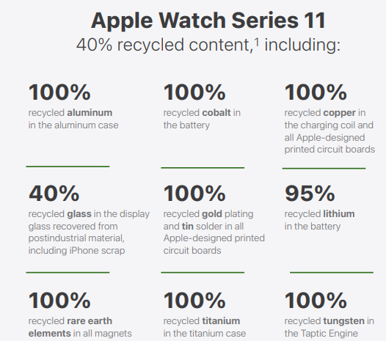
Figure 4: Recycled content of Apple watch series 11
(Source: Apple UK, 2025b)
Prosperity (Economic): Apple watch was launched in 2015, and most people agreed that it was a nice piece; however, the people did not know about the exact utility of this product (Fourreau, 2026). The Apple watch has found its purpose over the years and it is gradually improved regarding being a health and fitness device (Fourreau, 2026) [Figure 5]. It has been noticed that the objective of Apple is focused on protecting the planet through designing, building and recycling the products (Apple, 2025c). So, Apple is focused on the continuous search for the new big things such as the The wearables, home and accessories segment of Apple have been gaining significant revenue over the times [Figure 5].
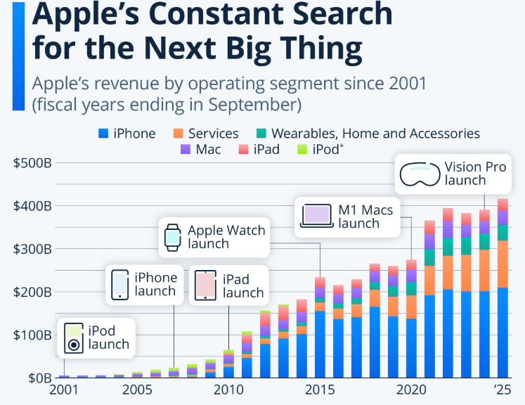
Figure 5: Constant search by Apple regarding new big things
(Source: Fourreau, 2026)

1.4.2 Balance Score card analysis of Apple
Balance score card is considered as the measures that drive performance and the measurement system of the organisations have significant impact on the behaviours of the employees and the managers (Kaplan and Norton, 1992).
Financial
Objectives | KPIs | Targets | Initiatives
Strong business performance regarding generating operating cash flow (Apple, 2026i).  Generating strong customer demand regarding products and services (Apple, 2026i). | - Growth in sales revenue  - Increased profit margin | Apple is focused on introducing the new products (Apple, 2026i).  Apple products are popular among Gen Y customers (Dwivedi and McDonald, 2025). | High price of Apple justified with brand awareness, innovation and exclusivity (Dwivedi and McDonald, 2025).  The price of the products of Apple is focused on shaping customers' perceptions of superior quality and craftsmanship (Dwivedi and McDonald, 2025).
Customer
Apple is focused on being a consistent brand (Apple UK, 2024).  Apple is enforcing connectivity regarding empowering business (Apple UK, 2024). | - Customer satisfaction  - Customer loyalty and retention  - Increased repeat purchases  - Brand awareness | The consumer can choose carbon neutral options of any of the Apple watches (Apple UK, 2025a).  Apple is focused on building trust and growth with the customers (Apple UK, 2024) | On April 22, the users of Apple watch could earn an Earth Day award through completing any workout of 30 minutes or more (Apple UK, 2025a) [Appendix 1].  Apple is creating easier connectivity with the consumers (Apple UK, 2024).
Internal business process
As per the report conducted by Apple UK (2025a), the goal (2030) of Apple is focused on becoming carbon neutral across all of its footprint considering the next 5 years.  Apple is working for supply chains regarding reducing direct climate impact related to industrial processes (Apple UK, 2025a). | - Recycled content  - Sustainable supply chain management  - Recycled content | The new milestones of Apple are focused on reduction of emissions, clean energy and recycled materials (Apple UK, 2025a).  The effort of Apple is driven by reducing carbon footprint and transition of its supply chain to renewable electricity and products with recycled materials (Apple UK, 2025a). | Apple provides special offers to the customers to recycle the devices in-store (Apple UK, 2025a).  Apple is meeting the issues related to collaboration, innovation and urgency (Apple UK, 2025a).
Learning and growth
The employee management related objective and its aspects of Apple is driven by Good for employees and great for business (Apple UK, 2026a).  Apple is focused on making differences regarding the lives of their employees (Apple UK, 2025c). | - Professional development opportunities for the employees  - Employee engagement  - Increased job satisfaction | Apple is concentrated on providing a deep level of care and respect with managing wellbeing confidence and satisfaction (Apple UK, 2025c).  Apple is developing people professionally and personally and Apple University creates classes and seminars that can help the employees to understand the culture, values of the organisation, and helps to sharpen business and software skills (Apple UK, 2025c). | Apple is focused on responsibility regarding supporting employees regarding the way to use and support the Apple devices (Apple UK, 2026a).  Apple’s initiatives are focused on feeling good for your whole family, feel good financially, feel good when the people grow and feel good when the people are recovering or renewing (Apple UK, 2025c).
Table 4: Balance score card of Apple

1.5 Strategic choices and implementation

1.5.1 Strategic choices of Apple (Cost leadership and differentiation)
The innovation of Apple watch series 11 is immersed in the most comprehensive set of health features, most lightweight regarding designing, having two new features related to sleep score and hypertension notifications (Apple Support, 2026). Another point of differentiating innovation of Apple watch series 11 are 5G cellular connectivity and the new antenna architecture for improved performance of the product (Apple Support, 2026). Apple (2026b) and Dwivedi and McDonald (2025) reported that in the UK, the cost of Apple watch series 11 is from £369 and price of the Apple’s products is based on the superior quality, craftsmanship, innovation and exclusivity. The UK is facing a cost-of-living crisis since late 2021 and the cost of essential goods has been increasing faster than household income (Kerr et al., 2025). So, the high price of Apple watches like the Apple Watch Series 11 may create competitive difficulties for Apple in the UK.

1.5.2 Most appropriate strategy for Apple
Porter’s five forces
Elements | Factors | Competitive Impact
Threat of new entrants | Although the smart watch market in the UK is growing, it is still slower than the previous year (Mintel, 2024). | Low
Bargaining power of buyers | 48% of the customers in the UK have revealed that monitoring health metrics makes them more stressed about the health condition (Mintel, 2024). | High
Bargaining power of suppliers | In terms of supply chain management in the UK, use of energy efficient technology has been noticed along with adapting circular business models (PwC UK, 2025). | Moderate
Threat of substitute | 44% of the interested customers are intended to try a smart watch for few days before deciding regarding purchases (Mintel News, 2026) | High
Competitive rivalry | In terms of the smart watches, there is a degree of uncertainty among the customers and customers are looking broadly regarding smartwatch functionality (Mintel News, 2026). 30% of the owners of Apple phones are relatively interested in smart watches (Mintel News, 2026). | Low
Table 5: Porter’s five forces
SAFs
Factors | Suitability | Acceptability | Feasibility | Justification | Scores
Latest features and innovations in Apple watches | 10 | 10 | 9 | The innovation in Apple watch series 11 is focused on comprehension, durability, and having scratch resistance more than previous generation (Apple Support, 2026). | 29
Price adjustment focused on cost-of-living crisis | 8 | 9 | 7 | In 2025, the cost-of-living crisis has increased and the households are mainly facing issues regarding increased food, electricity and fuel cost (Dyvik, 2025). | 24
Consistent focus on sustainability in supply chain management | 10 | 10 | 9 | Apple is closer to the Apple 2030 goal and focused on the science-based goals for becoming carbon neutral across the global footprint (Apple, 2026f).  100% recycled rare earth elements in all magnets have been used in Apple watch series 11 (Apple UK, 2025b). | 29
Continuous product upgradation to sustain competitive advantage | 10 | 10 | 10 | In the UK, the smart wearable market is influenced by advancement, connectivity and technology regarding health tracking, fitness monitoring and daily routine (IMARC, 2025) | 30
Table 6: SAFe (Apple)

1.5.3 Recommended strategy for Apple
Apple needs to be aware of the challenging areas in business related to environmental concerns and regulatory pressures regarding the business marketing field in the UK. Based on the SAFe analysis, the most appropriate strategy for Apple is managing consistency in product innovation regarding sustaining competitive advantage. Theories related to strategic management are focused on technology, innovation, strategic leadership, corporate governance, CSR and competitive advantage (Hill, Schilling and Jones, 2016). In terms of providing recommendations to Apple, it is pivotal to understand the industry life cycle such as the phases like development, growth, shake-out, maturity and decline.
Development: Advancement in the wearable technology industry in the UK is focused on more accurate health sensors, longer battery life and making it more appealing for everyday use (IMARC, 2026). It is recommended to Apple that,
- In terms of Apple watch, company needs to improve the features of health and fitness tracking smartwatch like expansion of recovery metrics and improvement of battery life for the continuous multi-day tracking.
- Apple needs to upgrade the smart watch features with more personalised AI-empowered health and fitness related insights.
Growth: Wearable technologies such as smart watches, fitness trackers are becoming popular in the UK, influenced by health and fitness conscious customers (IMARC, 2026). It is suggested for Apple that,
- The management team of Apple needs to proceed with the segmentation of the customers group such as consumers with multiple budgets and customers with value-driven choices.
- Apple needs to enhance and upgrade its smartwatch features that will have seamless interoperability and integration with iPhone, AirPods, smart home hardware to make the product inimitable.
Shakeout: Samsung announced the introduction of Galaxy Watch Ultra, Galaxy Watch7, which are the globally significant new products (IMARC, 2026).
- It can be recommended for Apple for expansion of offline mapping tools with respect for the free users.
- In terms of Apple Watch Series 11, on-device AI-powered smarter contextual coaching will be required to stay competitive in the market.
Maturity: In the consumer electronics market in the UK, online shopping is becoming a more convenient option for the customers along with competitive price options regarding market engagement (IMARC, 2026). It is recommended for Apple that,
- Apple should maintain flexibility regarding tier-based product subscription.
- Apple can proceed with significant discount when consumers will purchase iPhone and Smartwatch together.
Decline: Mintel (2024) reported that with respect to the smartwatch market share, Samsung and Apple are leading the market in the UK. Google launched Google Pixel Watch and it combined its own wearable operating system with the Fitbit health tracking, it is the premium product and faced strong competition from Apple and Samsung (Kleinman, 2022).
- It can be suggested for Apple that it can work with advanced gesture control regarding making the smartwatches innovative and differentiated like advanced hand movements in terms of touch-free use.
- Apple needs to proceed with more extended research regarding aesthetic appeal of the smartwatches considering pricing options for the customers.

1.5.4 Challenges in Execution and solution
Challenges | Probability | Impact | Severity | Challenge management
High expenses | 5 | 5 | 25 (High) | The high expenses can be reduced by workplace adjustment like hybrid or remote working or automating the workflows.
Lack of customer readiness regarding making purchasing decisions | 5 | 5 | 25 (High) | Apple needs to proceed with brand promotion of the Apple watches highlighting its value, advanced connectivity, exclusivity and new competitive updated features.
Delay in delivery | 3 | 3 | 9 (Moderate) | In terms of product upgradation, the schedule needs to be made based on 1 or 2 upgraded features consistently within a bounded time frame
Skill shortage | 3 | 3 | 9 (Moderate) | The training will be required regarding sustainable and integrated supply chain management, using upgraded features of Apple watches
Supply chain management issues | 3 | 3 | 9 (Moderate) | Apple needs to be focused on more efficiency regarding demand forecasting. It would be important to transition from rigid just-in-time model to just-in-case model
Table 7: Challenges to execute the strategy in Apple

Section 2: Reflection: Kolb’s cycle of reflective practice
Learning is called ‘experiential’ due to its tie up with intellectual origin of work and central role of experience in the learning procedure (Kolb, 1984).
Concrete experience
I have classified my research process during this assessment into three dimensions like cognitive learning, contextual learning and procedural learning. In terms of cognitive learning, I have felt a need for critical thinking skills as my curiosity influenced me to be engaged regarding realising the complicated topics related with this assessment. With respect to the contextual learning in this research process, I have learnt about the importance of sharing ideas and knowledge with my peers to make the research worthy. In regards to the procedural factors associated with the research, I have understood the wisdom regarding collecting the secondary qualitative information from authentic and credible secondary sources. In terms of the reflective practices in research, the significant factors are conceptualisation, contribution of the new knowledge and understanding the potential of the research (Harvey et al., 2025). I have found my limitations such as logical understanding regarding organising the information based on consequences and critical thinking skill was required for that. Sometimes, I felt, I need to be more focused on accepting the perspectives of others with mutual and comprehensive understanding. I have found my strengths regarding motivation, curiosity, and managing time.
Reflective observation
I have adopted the structured and organised way regarding utilisation of the information related to the assessment. At the initial stage, I have faced difficulties regarding selecting the most relevant information among the vast amount of information. Then gradually, I have understood the way to consider the most relevant and updated information to proceed with the research process. I have made significant learning and understanding while selecting the topic and organisation for this assessment. I followed the approach when choosing the topic such as alignment of the topic with balancing personal interests, academic relevance and its feasibility. Moreover, I thought that feasibility mostly required the potential of the research to be completed within the bounded timeframe with comprehensive understanding. I was focused on the missing factors or research gap in the previous studies that have accelerated the scope for further research and investigation.
Abstract conceptualisation
As per the study conducted by Singh, Aggarwal and Garg (2025) with respect to the research on consumer electronics industry, the research gap exists in these areas like execution of circular economy principles, role of technologies like industry 4.0, supply chain management and technological limitations. As perceived by Whittington et al. (2020) the significant subject topics in business are immersed in these areas such as business model, corporate governance, innovation, thinking differently regarding strategic understanding. I thought that Apple is a renowned organisation belonging to the consumer electronics goods industry and it was important for me to evaluate the business strategy of Apple that makes it more competitive globally. It was also important to evaluate the potential gaps in business operations in Apple that may reduce its potential regarding sustaining its competitive advantage.
Active experimentation
Based on my understanding, I need to improve my critical thinking and logical reasoning skills and ability for adaptability regarding cultural coordination. I think I need to proceed with the strategic initiatives that will make me able to improve my ability for a more comprehensive research approach.
Objective 1: To enhance critical thinking skills for logical reasoning
Specific | Measurable | Achievable | Realistic | Timebound
I will be focused on making evidence-based questions focused on ‘why’, ‘how’ and ‘what if’. | I will increase my active listening skill by 50% regarding listening and understanding the perspectives of others. | I will be focused on making inference and assumptions along with testing its validity through collecting the evidences | I will be working with the scenarios related with the decision making in business and will be focused on solving the real-time issues in business | 6 months
Objective 2: To enhance adaptability for cultural coordination
I will practise self-awareness and behavioural flexibility | I will be practicing my thought process and communication skills in a diverse way by 55% | I will be proceeding with scenario-based workplace communication practices based on the specific culture and situation of the workplace. | I will maintain a daily routine regarding emotional resilience progress charts. | 8 months
Table 8: Initiatives regarding improvement in future
(Source: Created by self)

Reference list
Apple (2022) Apple calls on the global supply chain to decarbonise by 2030, www.apple.com. Apple Newsroom (United Kingdom). Available at: https://www.apple.com/uk/newsroom/2022/10/apple-calls-on-global-supply-chain-to-decarbonize-by-2030/ (Accessed: July 28, 2026).
Apple (2025a) Our Values, https://investor.apple.com/. apple. Available at: https://investor.apple.com/our_values/default.aspx (Accessed: July 16, 2026).
Apple (2025b) New holistic Apple Health Study launches today in the Research app, www.apple.com. Apple Newsroom. Available at: https://www.apple.com/newsroom/2025/02/new-holistic-apple-health-study-launches-today-in-the-research-app/ (Accessed: July 23, 2026).
Apple (2025c) Our Commitmentto Human Rights, www.apple.com. apple. Available at: https://www.apple.com/compliance/pdfs/Apple-Human-Rights-Policy.pdf (Accessed: July 28, 2026).
Apple (2026b) Apple Watch, www.apple.com. Apple (United Kingdom). Available at: https://www.apple.com/uk/apple-watch-series-11/ (Accessed: July 16, 2026).
Apple (2026c) Apple at Work, https://www.apple.com/. Apple (United Kingdom). Available at: https://www.apple.com/uk/business/ (Accessed: July 16, 2026).
Apple (2026d) Why Apple Watch The ultimate device for a healthy life., www.apple.com. Apple (United Kingdom). Available at: https://www.apple.com/uk/apple-watch-series-11/why-apple-watch/ (Accessed: July 23, 2026).
Apple (2026e) Business conduct: The way we do business, /www.apple.com. Apple. Available at: https://www.apple.com/compliance/pdfs/Business-Conduct-Policy.pdf (Accessed: July 23, 2026).
Apple (2026f) Our planet deserves our best thinking., www.apple.com. Apple (United Kingdom). Available at: https://www.apple.com/uk/environment/ (Accessed: July 23, 2026).
Apple (2026g) Supply chain innovation, www.apple.com. Apple (United Kingdom). Available at: https://www.apple.com/uk/supply-chain/ (Accessed: July 23, 2026).
Apple (2026h) Apple watch series 11, www.apple.com. apple. Available at: https://www.apple.com/in/apple-watch-series-11/specs/ (Accessed: July 28, 2026).
Apple (2026i) Apple reports second quarter results, www.apple.com. Apple Newsroom. Available at: https://www.apple.com/newsroom/2026/04/apple-reports-second-quarter-results/ (Accessed: July 28, 2026).
Apple Support (2026) What’s new in Apple Watch and watchOS 26, https://support.apple.com/. Apple Support. Available at: https://support.apple.com/en-in/guide/watch/apdb93ea3872/watchos (Accessed: July 28, 2026).
Apple UK (2024) Apple expands tools to help businesses connect with customers, www.apple.com. Apple Newsroom (United Kingdom). Available at: https://www.apple.com/uk/newsroom/2024/10/apple-expands-tools-to-help-businesses-connect-with-customers/ (Accessed: July 28, 2026).
Apple UK (2025a) Apple unveils environmental progress, surpassing 60 percent reduction in global greenhouse gas emissions, www.apple.com. Apple Newsroom (United Kingdom). Available at: https://www.apple.com/uk/newsroom/2025/04/apple-surpasses-60-percent-reduction-in-global-greenhouse-gas-emissions/ (Accessed: July 28, 2026).
Apple UK (2025b) Apple Watch Series 11 Product Environmental Report, www.apple.com. apple. Available at: https://www.apple.com/ca/environment/pdf/products/watch/Apple_Watch_Series_11_PER_Sept2025.pdf (Accessed: July 28, 2026).
Apple UK (2025c) We count on you. And you can count on us, www.apple.com/. Apple. Available at: https://www.apple.com/careers/uk/life-at-apple/benefits.html (Accessed: July 28, 2026).
Apple UK (2026a) Give employees a choice. They’ll deliver their best work, www.apple.com. Apple (United Kingdom). Available at: https://www.apple.com/uk/business/enterprise/choice/ (Accessed: July 28, 2026).
Apple UK (2026b) Standing alongside educators to move learning forward., www.apple.com. Apple (United Kingdom). Available at: https://www.apple.com/uk/education-initiative/ (Accessed: July 28, 2026).
Chakraborty, D. (2026) “Brexit and the United Kingdom Economy: Challenges, Economic Implications, and Policy Recommendations,” Research Journal in Business and Economics, 4(2), pp. 251–255. Available at: https://doi.org/10.61424/rjbe.v4i2.936 (Accessed: July 16, 2026).
Clark, D. (2026) Gross domestic product of the United Kingdom from 1948 to 2025 (in million GBP), www.statista.com. statista. Available at: https://www.statista.com/statistics/281744/gdp-of-the-united-kingdom/?srsltid=afmboopn1s5gyintcwdhsohw1njln_ejhr7biiypwwgnbayqwkxid-gb (Accessed: July 16, 2026).
Department of Health and Social Care (2021) A guide to good practice for digital and data-driven health technologies, www.gov.uk. Government of UK. Available at: https://www.gov.uk/government/publications/code-of-conduct-for-data-driven-health-and-care-technology/initial-code-of-conduct-for-data-driven-health-and-care-technology (Accessed: July 16, 2026).
Dwivedi, A. and McDonald, B. (2025) “A model of brand price premiumness and its marketing outcomes,” Journal of Marketing theory and practice, pp. 1–22. Available at: https://doi.org/10.1080/10696679.2025.2544671 (Accessed: July 28, 2026).
Dyvik, E.H. (2025) Cost of living crisis in the UK - statistics & facts, www.statista.com. Statista. Available at: https://www.statista.com/topics/9121/cost-of-living-crisis-uk/?srsltid=AfmBOoqD99erg9gAcuK1f3zTbtEbMVA2YYogCBx878OCoJZ0VI3lyEy_#topicOverview (Accessed: July 28, 2026).
Fourreau, V. (2026) Apple’s constant search for the next big thing, www.statista.com. Statista. Available at: https://www.statista.com/chart/17862/apples-annual-revenue-by-operating-segment/?srsltid=AfmBOoqX8pfDzoslbjn81ShlQIwpkOQqTPvtI_lOzs6RVcIUjHlr2bPy (Accessed: July 28, 2026).
Gallagher, W. (2026) Apple Watch sales rise, but can’t get back to previous highs, https://appleinsider.com/. AppleInsider. Available at: https://appleinsider.com/articles/26/06/22/apple-watch-sales-rise-but-cant-get-back-to-previous-highs (Accessed: July 28, 2026).
Greenpeace (2025) ENVIRONMENTAL IMPACTS OF ARTIFICIAL INTELLIGENCE, www.greenpeace.de. greenpeace. Available at: https://www.greenpeace.de/publikationen/20250514-greenpeace-studie-umweltauswirkungen-ki-eng.pdf (Accessed: July 28, 2026).
Harvey, M., Walkerden, G., Semple, A., McLachlan, K., Lloyd, K. and Bosanquet, A. (2025) “Reflecting on reflective practice: Issues, possibilities and guidance principles,” Higher Education Research & Development, pp. 1–9. Available at: https://doi.org/10.1080/07294360.2025.2463517 (Accessed: August 3, 2026).
Hill, C.W.L., Schilling, M.A. and Jones, G.R. (2016) Strategic management: An integrated approach: Theory & cases. 12th ed. Boston: Cengage Learning (Accessed: August 3, 2026).
IMARC (2025) UK Smart Wearables Market Size, Share, Trends and Forecast by Device Type, Technology, Application, and Region, 2026-2034, /www.imarcgroup.com. imarcgroup. Available at: https://www.imarcgroup.com/uk-smart-wearables-market (Accessed: July 28, 2026).
IMARC (2026) UK Consumer Electronics Market Report by Product Type (Home Appliances, Entertainment and Communication, Personal Care and Grooming), Category (Smart, Conventional), End-Use (Residential, Commercial), Distribution Channel (B2B, B2C), and Region 2026-2034, www.imarcgroup.com. imarcgroup. Available at: https://www.imarcgroup.com/uk-consumer-electronics-market (Accessed: August 3, 2026).
Kaplan, R.S. and Norton, D.P. (1992) The balanced scorecard—measures that drive performance, https://hbr.org. Harvard Business Review. Available at: https://hbr.org/1992/01/the-balanced-scorecard-measures-that-drive-performance-2 (Accessed: July 28, 2026).
Kerr, R., Lightfoot, K., Moss, R.H., Sawsaa, A., Mc Eachan, R.R.C. and Dogra, S. (2025) “‘They’re Making the Rich Richer and the Poor Poorer’: The UK Cost of Living Crisis and Social Inequality,” Journal of Poverty, pp. 1–18. Available at: https://doi.org/10.1080/10875549.2025.2548774 (Accessed: July 28, 2026).
Kleinman, Z. (2022) “Google unveils new pixel watch,” BBC News, 12 May. Available at: https://www.bbc.com/news/technology-61409224 (Accessed: August 3, 2026).
Kolb, D.A. (1984) Experimental learning: Experience as the source of learning and development. London: Prentice-Hall (Accessed: August 3, 2026).
Linshi, J. (2024) Here’s what consumer reports says about the apple watch, https://time.com/. Time. Available at: https://time.com/3848892/apple-watch-consumer-reports/ (Accessed: July 23, 2026).
McCusker, B. (2025) UK Smartwatches and Wearable Technology Market Report 2025, https://store.mintel.com/. Mintel Store. Available at: https://store.mintel.com/report/uk-smartwatches-and-wearable-technology-market-report (Accessed: July 23, 2026).
Medicines and Healthcare products Regulatory Agency (2026) Regulating medical devices in the UK, www.gov.uk. Government of UK. Available at: https://www.gov.uk/guidance/regulating-medical-devices-in-the-uk (Accessed: July 16, 2026).
Mintel (2024) UK smartwatches and wearable technology market report 2024, https://store.mintel.com/. Mintel Store. Available at: https://store.mintel.com/report/uk-smartwatches-and-wearable-technology-market-report-2024 (Accessed: July 28, 2026).
Mintel (2025) UK Smartwatches and Wearable Technology Market Report 2024, https://store.mintel.com/. Mintel Store. Available at: https://store.mintel.com/report/uk-smartwatches-and-wearable-technology-market-report-2024 (Accessed: July 16, 2026).
Mintel News (2026) Apple Watch – The new must have or will consumer interest tick on by?, www.mintel.com. mintel. Available at: https://www.mintel.com/insights/technology/apple-watch-the-new-must-have-or-will-consumer-interest-tick-on-by/ (Accessed: July 23, 2026).
OECD (2025) Environment at a Glance: United Kingdom, www.oecd.org. oecd. Available at: https://www.oecd.org/en/publications/environment-at-a-glance-country-notes_59ce6fe6-en/united-kingdom_a8cf0616-en.html (Accessed: July 16, 2026).
PwC UK (2025) Five trends shaping the sustainability agenda in 2025, and the actions you can take now, www.pwc.co.uk. PwC. Available at: https://www.pwc.co.uk/services/esg/five-trends-shaping-sustainability-agenda-in-2025.html (Accessed: July 28, 2026).
Rahman-Jones, I. (2025) “Global smartwatch sales fall for first time,” BBC, 11 March. Available at: https://www.bbc.com/news/articles/cx20d3r7p5do (Accessed: July 28, 2026).
Reed, E. (2024) History of Apple: Company and Stock, https://finance.yahoo.com/. Yahoo Finance. Available at: https://finance.yahoo.com/news/history-apple-company-stock-142145068.html (Accessed: July 16, 2026).
Singh, H., Aggarwal, R. and Garg, P. (2025) “Circular economy implementation in the electronics sector: A systematic literature review and future research directions,” Cogent Business & Management, 12(1). Available at: https://doi.org/10.1080/23311975.2025.2509794 (Accessed: August 3, 2026).
Slotta, D. (2025a) Apple in the UK - statistics & facts, www.statista.com. Statista. Available at: https://www.statista.com/topics/8884/apple-in-the-uk/?srsltid=afmbooolom6rzinlrl5doe5m1i5w_7otor23z3rq2sqpcmtyhvz-28gh#topicoverview (Accessed: July 16, 2026).
Slotta, D. (2025b) Wearables in the UK- statistics & facts, www.statista.com. Statista. Available at: https://www.statista.com/topics/12225/wearables-in-the-uk/?srsltid=afmboopr8kwbopvw3uqkebdqdtw_ciwgstlerxxmnmpelua-pzatq247 (Accessed: July 16, 2026).
Slotta, D. (2025c) Consumer electronics in the UK - statistics & facts, www.statista.com. Statista. Available at: https://www.statista.com/topics/10712/consumer-electronics-in-the-united-kingdom/?srsltid=afmboorgw98mnq9vameju5pzblu5wn5lb3cvg9wnvuvz_jgdtkzqofsw (Accessed: July 16, 2026).
Statista (2025) Brand KPIs for watches: Apple Watch in the United Kingdom, https://www.statista.com/. Statista. Available at: https://www.statista.com/study/174907/brand-kpis-for-watches-apple-watch-in-the-united-kingdom/?srsltid=afmbooqsdcihrrbwgzy9kqzgbuixq_3dh-o1rslbixmkew0wozfq7_tt (Accessed: July 16, 2026).
Wheelen, T.L., Hunger, D.J., Hoffman, A.N. and Bamford, C.E. (2018) Strategic management and business policy: Globalization, innovation and sustainability. 15th edn. Harlow, England Pearson (Accessed: July 28, 2026).
Whittington, R., Regner, P., Angwin, D., Johnson, G. and Scholes, K. (2020) Exploring strategy. 12th ed. Hoboken: Pearson (Accessed: August 3, 2026).

Appendices

Appendix 1: Apple watch
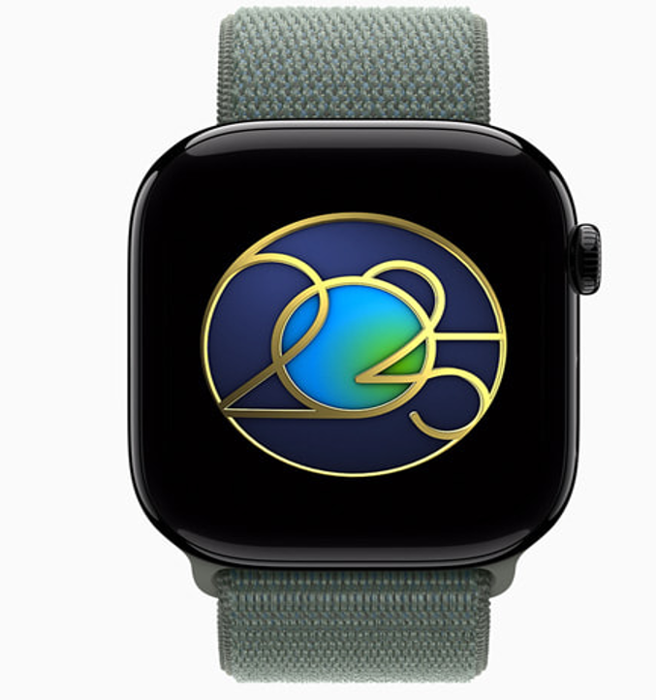
Figure 6: Earth day limited edition award (Apple watch)
(Source: Apple UK, 2025a)

