Name : Richard Yembi Nganga
ID : 1817242
Module Name : managing projects in the organization
Module code : BMSW5104
Group 2

Managing Projects in the Organisation

Executive Summary
A project is a planned set of processes that are undertaken by a group or an individual to achieve a specific goal. And managing a project is a complex art of planning, scheduling, and controlling the undertaking project. Usually, a project manager, along with specialized employees from different department of the organisation starts, manages and delivers the project within a predefined boundary of time. The role of a project manager is complexified by the unprecedented situations caused by the Covid 19 pandemic. The project manager now needs to apply different tools and techniques to fight back that not so forthcoming events and complexities. However, the pandemic has opened a new horizon for entrepreneurs. This report will focus on a new business project; “Good Health and Good Life”. And it will discuss and describe the planning, scheduling, and controlling of the project. Besides, the report will be discussing the stakeholder mapping, risk factors and change management plans in the light of the Covid 19 Pandemic. In other words, the report will include all the necessary steps to visualize and initiate the project. And by doing so, the author will also be able to evaluate his project management skills and develop a better personal development plan.

Table of Contents
Executive Summary ii
Introduction 1
Project Management Approaches, Tools and Techniques 2
Project Management Approaches 2
1. Waterfall 2
2. Agile 2
3. Hybrid 2
4. Scrum 2
5. Critical Path method 2
6. Integrated Project Management 2
Project management tools 3
Project Management Techniques 3
1. Work Break Down Structure 3
2. Gannt Chart 3
3. PERT 3
4. Stakeholder mapping 3
Quality of a Project Manager (needed for the project of “Good Health and Good Life”) 4
Responsibility of the project manager 4
Qualities needed 4
Project Scope Management 5
Company overview 5
Project Title 5
Background of the project 5
Scope of this project 5
Requirements 6
Affected Parties or businesses 6
Specific Exclusions 6
Timeline/Scheduling 7
Project Implementation Plan 9
PMI project implementation model 9
Project Communication Methods 12
Communicating with outside of the organisation 12
Communicating within the team 12
Stakeholder Mapping 13
1. Promoters 13
2. Defenders 13
3. Latent 13
4. Apathetic 14
Communication Method for different stakeholders 14
Project Risk Management 15
Change Management Process 16
1. Kotter’s change management model 16
2. McKinsey 7-s Change Management Model 16
3. ADKAR Model 17
Change management in this “Good Health and Good Life” Project 18
Reflection of the Project 19
SWOT analysis of my project management skills 19
Strength 19
Weaknesses 19
Opportunity 19
Threat 19
Reflection on my project management skills 19
My Personal Development Plan 21
Conclusion 22
References 23

Introduction
COVID-19 has brought about a disaster in the world of the economy. All the economic and non-economic indicators are representing a threat to the upcoming future. However, disaster may bring some opportunity to the entrepreneur. Due to COVID-19 people have less opportunity for going outdoor activities (Tereso et al., 2019). As a result, the threat to natural health has become a very common issue. So, the demand for an online-based gym has become a basic alternative to a physical gym that may help people to lead a healthy life.
So, the report aims to introduce a new business project namely, “good health and good life”. It is not only an online-based training program platform but also provides the support of necessary equipment through a direct distribution channel (Camarena Gil, 2019).
However, the success of this business idea will solely depend on the effectiveness of the project management plan and the project managers. In this regard, project management refers to the art of organising, leading, reporting, and completing a project through people (Umsl.edu, 2021).
In line with the basic project management approach, this project paper will focus on planning, scheduling, and controlling activities. The objective of this project is to establish a fully online-based gym platform. It will have a team of five members to explode the objectives. A clearly stated work breakdown structure will help to allocate and control tasks based on the expertise of the team members. It will use different project management techniques including the Gantt chart, critical path method, programme evaluation and review technique as the concern of project management technique related to the project planning (Rodríguez-Rivero et al., 2020).
This report will also outline the schedule, project implementation plan, communication method, stakeholder mapping, expected risks factors with the risk management plan, change management, etc. (Camarena Gil, 2019).
However, the success of this project will depend on the execution excellence of the project manager and the project management team. so, it is expected that effective teamwork along with this project management plan will help to explore the objectives (Dehao, 2020).

Project Management Approaches, Tools and Techniques

Project Management Approaches
Researchers and analysts have observed many project management approaches depending on the type of project and data available to decide for the project (Umsl.edu, 2021).

Waterfall
Outlined by Dr Winston Royce in 1970, The Waterfall methodology is the oldest project management methodology. According to this methodology, the project manager needs to have a clear idea about the project as no correction can be made after the project started. The project manager divides the work according to the requirements and sequentially place them on the to-do list (Tereso et al., 2019).

Agile
Developed in response to the failure of the Waterfall methodology in complex projects. It is software development focused. It is opposite to the Waterfall Method. The agile approach favours fast and flexible scheduling and budgeting (Adeani et al., 2020).

Hybrid
Combination of the waterfall and the agile approaches. This approach focuses on gathering and analyzing data initially like the waterfall method. From thereon, the project manager can take a more flexible approach to implement the project (Tereso et al., 2019).

Scrum
It is not a fully-featured project management approach. It takes the Agile approach and implements it on daily basis (Umsl.edu, 2021).

Critical Path method
Emerged to favour the non-software development-based project. The project manager breakdown all the activities and work within a pre-specified structure (Rew et al., 2020).

Integrated Project Management
Best for creative industries. This approach favours sharing and standardization of process across the organization (Tereso et al., 2019).
For the projects like “Good Health and Good Life”, following the Critical path method is more appropriate (Steinhauer, 2019).

Project management tools
Due to the Covid, 19 Pandemic more and more companies are developing a solution for managing the project from a remote location. Some renowned tools are mentioned below (Umsl.edu, 2021).
- Basecamp
- Microsoft project
- Google Workspace
- Asana
- Critics Podio
- Work-zone
- Notion
For this project, we will be using the Microsoft project for communicating and controlling (Tereso et al., 2019).

Project Management Techniques

Work Break Down Structure
This technique allows the project manager to break down the whole project into small manageable pieces. Breaking down the project allows the manager to delegate and assign task and time efficiently (Trojanowska, 2017).

Gannt Chart
Widely used technique to visualize the tasks and the time delegated to them. It complements the Work Breakdown Structure Technique (Kerzner, 2017).

PERT
It is a flow chart of the tasks. It shows us what is needed to be done sequentially, and the relationship between and among them (Tereso et al., 2019).

Stakeholder mapping
Not all stakeholder requires the same level of attention. Organizations can safely categorize them according to their power and interest over the project (Dehao, 2020).
For making the project of “Good Health and Good Life” more effective, we will be using all the techniques mentioned above. It will give us a comprehensive view of the sustainability of the whole project (Trojanowska, 2017).

Quality of a Project Manager (needed for the project of “Good Health and Good Life”)
A project manager is a person who deliberately handle a project and is responsible for the success and the failure of the project (Kerzner, 2017). All project managers should have some qualities as he is responsible for the whole project. The project we are working on; “Good Health and Good Life”, need some more skills than a traditional project manager by the nature of the project. Besides, the Covid 19 Pandemic is forcing all project managers to adapt and master some new tools and techniques (Dehao, 2020).

Responsibility of the project manager
To manage the project of “Good Health and Good Life” a manager will have to fulfil the following responsibilities (Rahman, 2021).
- Schedule everything for everyone
- Prepare a budget
- Ensure the quality
- Make sure all the assigned personals are extremely motivated to complete the tasks
- Ensure good communication between and among team members

Qualities needed
Before the Covid 19 Pandemic, all the responsibilities can be done in a physical office. But now, the project manager will have to adopt new technologies to make sure all her/his responsibilities are met (Tereso et al., 2019). The qualities a project manager must have to successfully implement the projects are mentioned below (Rahman, 2021).
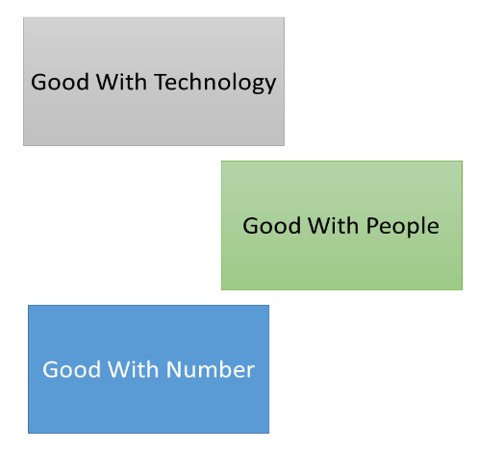
- Have a good grip on technologies required
Figure 1: Qualities Needed for a project manager
- Can communicate effectively and efficiently
- Can manage the data and make decisions using it
- Can motivate
- Is good with numbers
- Can take ownership for the whole project
- Can take the accountability for the whole project
- Know how to delegate work to the right person
- Can proactively manage the project

Project Scope Management
To determine and document the lists of the project goals, deliverables, deadlines, tasks and budget we must understand the project first (Kivilä et al., 2017).

Company overview
“Good Health and Good Life” is planned as an online-based gym platform and a distributor of gym equipment through a direct distribution channel. As it is an online-based business project, it can serve the audience or customer globally along with the United Kingdom. Initially, it will start with a team of five members (Camarena Gil, 2019).

Project Title
The title of this business project is “Good Health and Good Life.”

Background of the project
As the situation getting changed by the Covid 19 Pandemic, people need a better solution for their daily health care (Camarena Gil, 2019). People are trying to avoid direct face to face interaction with unknown people if not known one. Besides, they are avoiding public places and transportations like parks, metros, buses, gyms etcetera. Therefore, we can identify a need for a mass gym solution that can be accessed and utilized from the homes of the customers. The project is for developing a fully online based gym as an alternative to a physical gym that can be accessed from anywhere, globally (Rahman, 2021). Besides, it is predicted that the mentality of avoiding direct interaction with people is not going to be disappeared any time soon. So, there is a scope of success if the project is implemented correctly. Services the business is wanting to provide is
- Online gym facility (Providing instructions online)
- Distribute necessary gym equipment (Selling home-based gym equipment)
The project manager has a team of five members ready to execute the necessary tasks. Besides, the project is not investment heavy, unlike any physical gym (Adeani et al., 2020).

Scope of this project
This specific business project “Good Health and Good life” is intended to provide an online-based gym solution for a mass audience (Tereso et al., 2019). Besides, it will distribute necessary gym equipment through its distribution channel. Hence, it will cover the interest of specific health-conscious people (Rahman, 2021).
The project will need to be fulfilling the interest of a relevant group of stakeholders and can exclude the interest of others. Unlike a physical gym, the “Good Health and Good Life” must cover the online aspects of the business (Camarena Gil, 2019).

Requirements
The business will utilize the internet using both a native mobile app and a website. Hence, this will create a convenient method for the customers to interact with the instructors and navigate or buy the necessary pieces of stuff they might need (Umsl.edu, 2021).
The project manager must delegate someone the task of managing the internet infrastructure part of the business. And another one to manage the inventory of the products the business is selling. Besides, the instructor will need to learn how to give instructions to the people through video or other forms guidelines (Adeani et al., 2020).
This specific project will also need to collect data from relevant people to fulfil their requirements. Besides, as a new concept, the project will have to keep a handsome amount of money for their marketing and promotion part of the business (Steinhauer, 2019).

Affected Parties or businesses
To implement the project effectively and efficiently, the project team must find the relevant stakeholders. Relevant stakeholders are the people who are directly affected by the decisions made by the organisation (Steinhauer, 2019). For a business project like “Good Health and Good Life,” the stakeholder can be health-conscious people, celebrities including athletes, tech companies who may develop new technologies to complement the services provided by the business (Bellón et al., 2021).
Locating relevant stakeholder is not just important for selling the products or services, it is also needed to collect the data like the gym equipment they are willing to buy and estimate the number of customers of the services etcetera. Besides, by targeting the relevant stakeholders, the business will be able to market its products and services more efficiently (Kivilä et al., 2017).

Specific Exclusions
As the business will serve a wide variety of customers, it may find it difficult to locate any segment of customers to exclude. However, the people who are not afraid of direct interaction with others and the people who received the Covid 19 vaccine and willing to attend a physical gym instead of an online-based one can be excluded. Besides, a small portion of potential customers has their trainer. Those people can be and need to be excluded while counting the potential number of customers (Adeani et al., 2020).
It is also important to find the specific exclusion because by separating them we can separate their need. And maybe in future, the business will be able to launch new product or service for them (Heldman, 2018).

Timeline/Scheduling
Timeline sketching is the greatest way to visualize the process needed to implement the project. It helps the project manager to allocate the time to specific tasks and monitor the work activity effectively. Gantt chart is the most widely used technique to draw the timeline. It helps the manager to divide the work and time, list them accordingly and design an effective project timeline (Trojanowska, 2017).
To implement the business project “Good Health and Good Life”, the work can be divided into 12 parts. And the 44 weeks can be allocated to the project. It is visualized in Table 1.
Serial No. | Project Activities | Weeks
Serial No. | Project Activities | 4 | 8 | 12 | 16 | 20 | 24 | 28 | 32 | 36 | 40 | 44
1 | Making a Draft Budget | ✓
2 | Collecting data |  | ✓
3 | Locating relevant stakeholders |  |  | ✓
4 | Analysing overall market |  |  | ✓
5 | Conceptualizing the project and making a final Budget |  |  |  | ✓
6 | Documenting the findings |  |  |  | ✓
7 | Breaking down the project |  |  |  |  | ✓
8 | Preparing a well-written plan |  |  |  |  |  | ✓
9 | Developing the native mobile app |  |  |  |  |  |  | ✓ | ✓
10 | Developing the website |  |  |  |  |  |  | ✓ | ✓
11 | Launching the business |  |  |  |  |  |  |  |  | ✓
12 | Monitoring, controlling and making changes as needed |  |  |  |  |  |  |  |  |  | ✓ | ✓
Table 1: The Grant Chart

Besides, the PERT chart, which illustrates the relations between and among different parts of the project, help us visualize how one part is dependent on another. Besides, the flow which is needed to be followed to implement the project effectively can be seen from the cart (He et al., 2018).
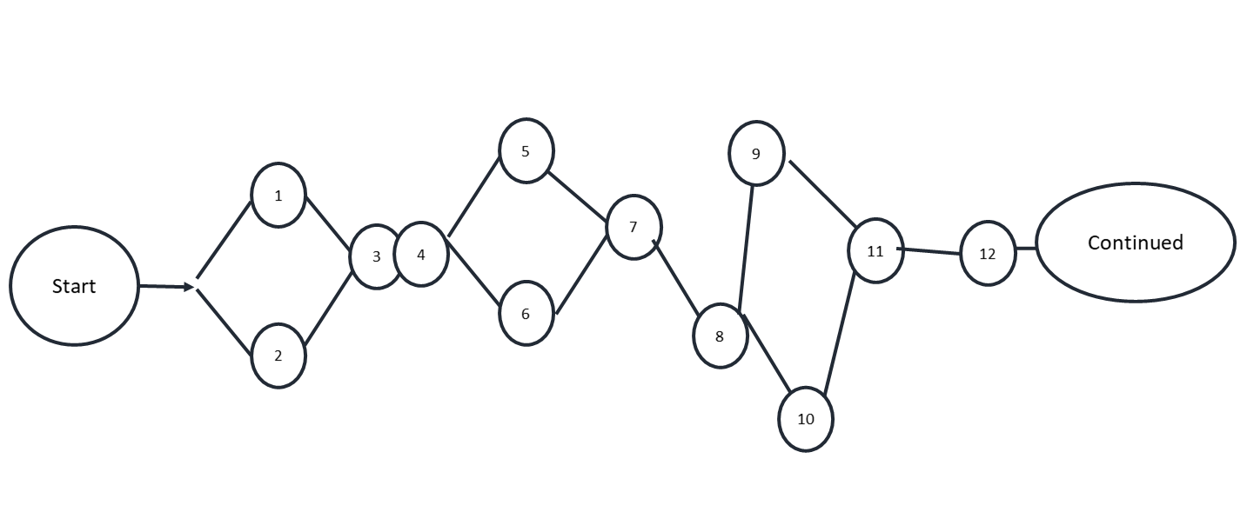
Figure 2: Pert Chart of the project

In the PERT chart, the number of tasks is taken from the Gantt chart. As the project is business launching related, it has no end. The business will need continuous control and changes (Kerzner, 2018).
As We have the timeline and flow ready, we can now opt-in for implementing the project (Rew et al., 2020).

Project Implementation Plan
The project implementation plan is the detailed descriptions of actions that are needed to implement the project. To implement the project of “Good Health and Good Life” we can follow the five steps implementation model developed by Project Management Institute (PMI) (Rahman, 2021).
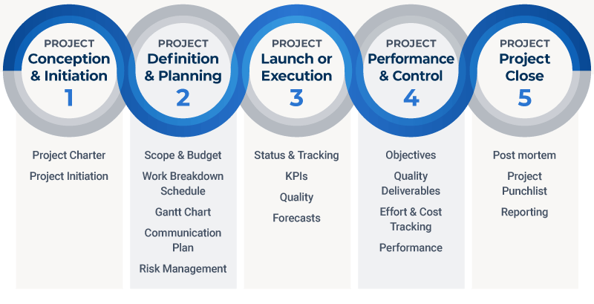
Figure 3: PMI Project Implementation Model

PMI project implementation model
- Conception and Initiation: To implement the project manager must start with conceptualizing the entire project. For our business project, we must make a draft budget, collect data from our stakeholders and conceptualize the business at this stage (Rahman, 2021).
- Definition and planning: At this stage, we need to make our budgetary decisions, break down our work activities and prepare the Gantt chart and communication plan. Besides, risk management related decisions are also should be conceptualized and sketched down to a paper properly (Steinhauer, 2019).
- Launch or execution: After taking the necessary preparation, the business should be launched at this stage. In the business project of “Good Health and Good Life”, after developing the app, the website and the contents, the project is ready to be launched (Kerzner, 2017).
- Monitoring performance and control: After starting the business, the project manager must monitor the performance of the business. If any deviation is found, the manager must work on fixing it. Besides, the project manager must monitor the timeline and performance of the team constantly to ensure the project is implemented effectively (Umsl.edu, 2021).
- Project close: As a business, the project will never end. However, the work will be turned into day-to-day activities after the business is launched and crossed its embargo period (Heldman, 2018).
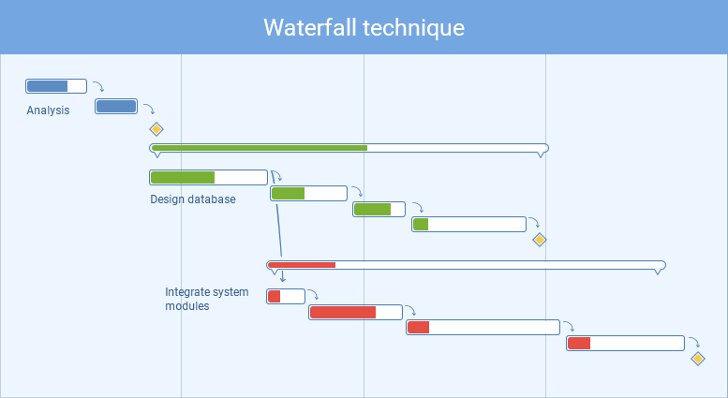
Figure 4: Project Implementation Plan
Along with the PMI model, different models can be used as complements. The examples are shown in Figure 5.
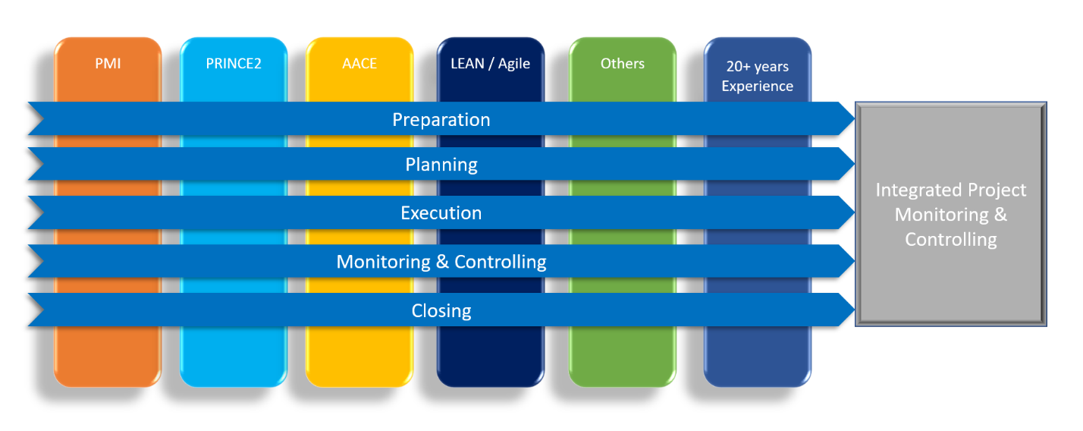
Figure 5: Project implementation plans & alternatives

Project Communication Methods
Communicating is one of the most important roles of a project manager. Before the Covid 19 Pandemic, communicating was different than now. Instead of the physical office, employees are doing their work from their places. This shift in the scenario will change the methods and tools of communication (Bellón et al., 2021).

Communicating with outside of the organisation
To conceptualize the project, the team will need to collect data from different stakeholders of the proposed business. As physical communication is not possible, the team will have to communicate through digital tools like emails, social media and phone calls (Rahman, 2021).

Communicating within the team
To execute the project most effectively and efficiently, the project manager needs to ensure both the one to one and one to many communication ways. As there is no physical office. They need to use technologically advanced tools like Google Workspace and Microsoft Teams for their day-to-day communication and for tracking the work done (Dehao, 2020).
Within the team, a proper timeline should be communicated with the help of digital tools. For example, Microsoft Project/Planner, HP project, Mind-view can be used to draw a proper timeline and it will be visible to the entire team. Besides, using digital tools like Microsoft teams and planners will help the project manager delegate and assign task more effectively (Kerzner, 2017).

Stakeholder Mapping
Stakeholder mapping is the process of visualising the categories of stakeholders who have a different level of influence and relation with the organisation. It is a common process to visualize the power and interest of individual stakeholder groups. For the project of “Good Health and Good Life” different individual with different power and interest can be founded and they can be categorized into four broad categories (Trojanowska, 2017).
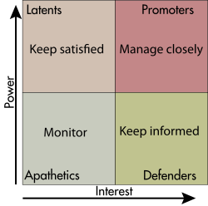
Figure 6: Stakeholder Matrix
- Promoters: These are the people with a high level of interest and power. For this business project, the team members can be identified as promoters as they have a huge interest and enormous amount of power over the project. Besides them, the investors are also the people who possess the power needed to control the business and the willingness to ensure the business is doing well. This category of stakeholders is needed to be informed about every decision and a close communication channel should be built for and around them (Trojanowska, 2017).
- Defenders: These are the people with a low level of power but a huge level of interest. Customers and competitors can be aligned with this category. They are required to be informed about the decisions. For this business project of “Good Health and Good Life”, this category of stakeholders is needed to be informed through different marketing channel (Bellón et al., 2021).
- Latent: This category of stakeholders possesses a huge amount of power over the organisation and the project but have little interest in it. For “Good Health Good Life”, government and regulatory bodies, media and influencing personals can be identified as the Latent category. If kept satisfied this category of stakeholders can bring in more traffic to the organization (Adeani et al., 2020).
- Apathetic: This category of people has little interest and power over the project. They are needed to be monitor closely. For this business project, the public with little interest in health care and exercises can be termed as apathetic. They should be monitored because they can be potential customers for the business (Umsl.edu, 2021).
Stakeholders play an important role in any project. For this business project, the project manager is needed to ensure proper communication with the stakeholder. By categorizing the stakeholders, it becomes convenient for the project manager to focus and prioritize the relevant stakeholders (Dehao, 2020)

Communication Method for different stakeholders
Based on the influence and the importance of stakeholders, different communication methods are needed to be implemented. The Covid 19 Pandemic made it harder to communicate effectively (Rahman, 2021). Communicating face to face is the most appropriate for sending and receiving any message or instruction. But it is not normal now (Adeani et al., 2020). The project manager needs to use digital tools like social media, Microsoft project, Google Workspace, Websites and Emails. Choosing the right platform to communicate is equally important as communicating itself. For internal communication, the project manager of “Good Health and Good Life” will use tools like Microsoft projects and planners and for external communication, platforms like social media and emails will be used (Kerzner, 2018).

Project Risk Management
No business and project are safe from uncertain circumstances. Risk management of a project includes identifying, assessing and controlling the uncertain situation. Managing the risk may decrease the threats on the capital and the earning of a business or project (Adeani et al., 2020).
- Identifying the risk: The risk management process starts with identifying the risks. For “Good Health and Good Life” there are some risks regarding customers’ acceptance of the product and services it is providing and the rise of new competitors (He et al., 2018).
- Collecting the data: After identifying the risks, the project manager should work on collecting appropriate data with the help of the team (Umsl.edu, 2021).
- Analysing the risks: If the project manager has related data on his hand, it is easy for him/her to make appropriate decisions (He et al., 2018). By analysing the data, the risk can be quantified (Steinhauer, 2019).
- Evaluating and ranking the risk: In this stage, the risks are needed to be evaluated again and ranked according to their probability and power of shading negative impact.
- Planning for risk response: After evaluating the risks, the project manager needs a plan for managing the risk (Rahman, 2021).
- Controlling the risk: This step requires the management of uncertainties. The project manager must monitor the project from beginning to end and make a proactive decision to tackle any deviation from the actual plan. Though a good portion of the risk is uncontrollable, the team and the manager should always be prepared for it (Heldman, 2018).

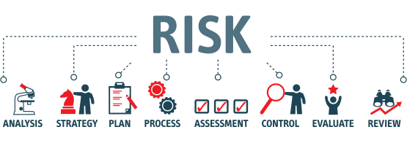
Figure 7: Risk Management Process

Change Management Process
Change management is one of the most important aspects of any modern-day projects. It is the process of accommodating regular processes with minimal afflictions due to uncertain or even planned change (Rahman, 2021). Managing the risk enables the project manager to implement positive changes regarding the changes in the environment and other factors. Some change management models provide a structured way of change management (Adeani et al., 2020). Some of these includes-

Kotter’s change management model
It Is one of the most popular models for managing changes. This model has divided the change management process into eight different stages and each of them focuses on employee’s response to the change (Heldman, 2018). The eight stages are illustrated in Figure 8.
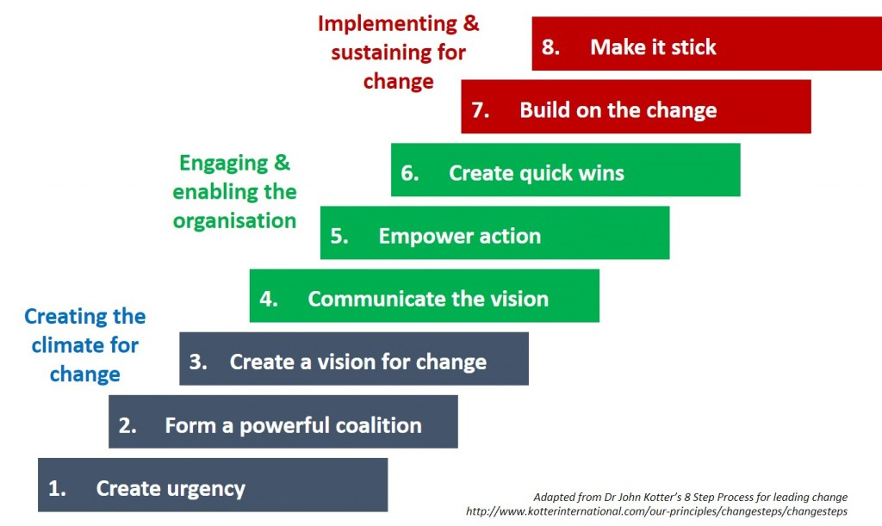
Figure 8: Kotter's Change Management Model

McKinsey 7-s Change Management Model
It is one of the oldest models out in the project management community. This model focuses on 7 crucial categories that should be taken as concerns for a company while implementing any change (Trojanowska, 2017). The categories are illustrated in figure 9 (Steinhauer, 2019).

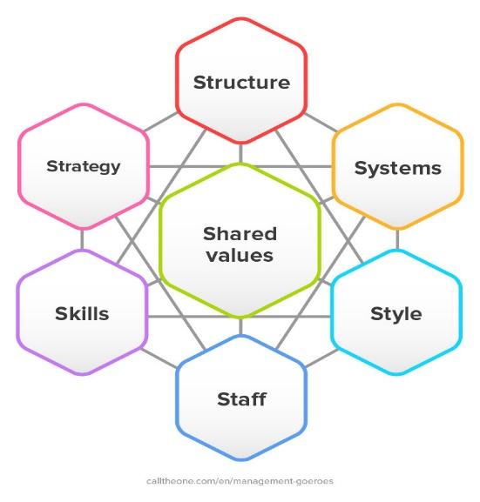
Figure 9: McKinsey 7-s Change Management Model

ADKAR Model
It can be used to find out various gaps in the process to assist in the designing of training programmes more effectively (Kerzner, 2018). ADKAR model stands for
- Awareness
- Desire
- Knowledge
- Ability
- Reinforcement
Using this model, the managers motivate and train the employees to tackle the ever-changing situations and provide the most output in every situation (Kerzner, 2017).
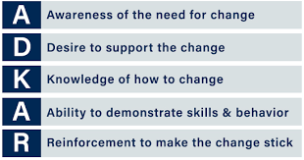
Figure 10: ADKAR Model

Change management in this “Good Health and Good Life” Project
The business project can be identified as an e-business. Thus, it is safe to say that this business project will be facing rapid and unprecedented changes (Tereso et al., 2019). The project manager of this project is needed to encourage proactive behaviour from the team and train them to think out of the box. She/he can follow the ADKAR model of change management as this model helps the managers to encourage employees to make positive changes (Kerzner, 2018).
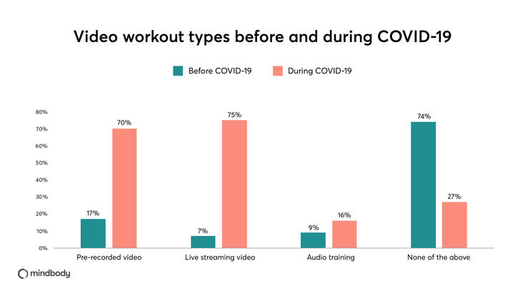
Figure 11: Online based Gym Trend

The online-based-gym-level-training concept is already facing a disrupting change for the Covid 19 Pandemic and it is illustrated in Figure 11. Hence, it is safe to assume that the post-Covid 19 era will impact this industry again (Dehao, 2020).

Reflection of the Project
After putting everything into a paper it is easier to visualize the impact this project had on my knowledge and experience. By asking questions to my team members, I have gathered data about my weaknesses and strengths (Rew et al., 2020). The data is summarised in Table 2.

SWOT analysis of my project management skills
Strength  - Good communication skills  - Good understanding of technologies  - Clear vision about what I want  - Energetic  - Can motivate my team easily  - Proactivity | Weaknesses  - Weak with change management  - Have less idea about app development  - Have some autocratic behaviour  - Weak with managing the time
Opportunity  - By working on the project, I will be able to gather the necessary knowledge and experience for managing a project (Tereso et al., 2019).  - I will be more effective and efficient while working with people (He et al., 2018). | Threat  - By working on the project, I may limit my time for personal development. It may cause mental stress, anxiety and other mental problems (Steinhauer, 2019).  - Failure of this project will cost me an unbearable amount of money. It can draw me with debts (Steinhauer, 2019).
Table 2: Swot Analysis

Reflection on my project management skills
Though I do not have enough experience as a project manager, I did not find any major issues while designing and crafting the project plan (Adeani et al., 2020). But, while implementing the project, I have identified some issues with myself. I have put those issues in my development plan bucket. However, by following Gibbs’ Reflective Cycle (GRC) model for my personal experience, I will be able to assess my learning and experience from this project (Bellón et al., 2021).
GRC covers 6 Stages. These stages linked with my personal experience and knowledge are mentioned below (Adeani et al., 2020).
- Description of my experience: While doing the project, I have gathered experience of working with people, breaking down work into manageable small pieces and many more. Though I knew about managing a project, the real-life implementation experience enriched my capabilities of managing a project (Heldman, 2018).
- Feelings and thoughts about the experience: When I started planning the project, I was a little nervous about whether I will be able to pull this off or not. I also thought I do not have enough knowledge to manage a project like this. But I learned a lot, read a lot of books, article and research papers. That learning part gave me the confidence needed for starting this project (Kerzner, 2018).
- Evaluation of the experience: The whole project was fun. However, I have felt stress and depression to some extent while I was putting everything together (Rahman, 2021).
- Analysis: This project enabled me to analyse my capabilities. Therefore, I am being able to make my self-development plan (Rew et al., 2020).
- Conclusion: I have gathered a lot of experience. If I could start working on it a little earlier, the project might be less stressful (Umsl.edu, 2021).

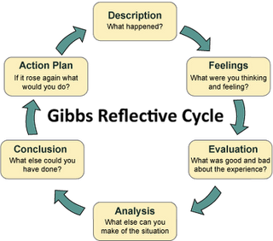
Figure 12: Gibbs Reflective Cycle

My Personal Development Plan
The experience I have gathered from the project of “Good Health and Good Life” enabled me to point out my lacking. Thus, I am now aware of what I need to do to become a successful project manager. My development plan is summarized in table 3 (Camarena Gil, 2019).
Goals | Action Steps | Resources | Measure of Success | Time Scale
Time management skill development | Need a proper calendar to draw my future work. I Have to be more punctual (Rew et al., 2020). | Time journal notebook, wristwatch and a calendar app on my mobile (Adeani et al., 2020). | Above-average rate of punctuality (Rahman, 2021). | 6 months
Learning How to code apps. | Prepare an app development environment on my pc and read some books on coding (Rew et al., 2020). | A personal computer, W3schools (Bellón et al., 2021). | Developing an actual app and publishing it to the marketplaces like the app store and play store (Heldman, 2018). | 1 year
Improving Leadership Skills | Learning how to encourage my team members and cherish democratic behaviour (Rahman, 2021). | Books on leadership (Kerzner, 2018). | Feedback from my subordinates (Steinhauer, 2019). | 1 year
Table 3: Personal Development Plan

Conclusion
This report provides insights into how the work environment has changed and how project managers are coping up with it (Steinhauer, 2019). The disrupted situation created by the Covid 19 Pandemic changed not only how consumer consumes services and products but also their daily lifestyle. This disruption created a scope for businesses like “Good Health and Good Life” (Bellón et al., 2021).
Throughout the report, planning, designing and controlling of the business project of “Good Health and Good Life is discussed. We have also analysed the sustainability of the project; risk related to the project and change management plan for the project (Heldman, 2018).
We have discussed the approaches, tools and techniques for project management, then analysed the quality needed from a project manager. To conclude, we have discussed the project reflections. The experience I have gathered and the personal development plan I have prepared will help me become a good project manager in the future (He et al., 2018).

References
Adeani, I.S., Febriani, R.B., Syafryadin, S., Mangana, A.V., Kurniawan, E., Ananda, J. and Maryam, S., 2020, Using GIBBS reflective cycle in making reflections of literary analysis. Indonesian EFL Journal (IEFLJ), 6(2), pp.139-148.
Bellón, B.L., Viñoles-Cebolla, R., Bastante-Ceca, M.J. and González-Cruz, M.C., 2021. The Utilization of Project Management Tools and Techniques and Their Relationship with the Success in Chemical Engineering. In Project Management and Engineering Research (pp. 103-115). Springer, Cham.
Camarena Gil, E., 2019. Project management GADE. Chapter 8.
Dehao, G., 2020, February. Analysis and Improvement of Construction Project Management System Based on Network Information. In 2020 12th International Conference on Measuring Technology and Mechatronics Automation (ICMTMA) (pp. 693-697). IEEE.
He, K.N., Parkinson, L. and Doyle, A.K., 2018. Gibbs’ Reflective Cycle.
Heldman, K., 2018. Project management jumpstart. John Wiley & Sons.
Kerzner, H., 2017. Project management: a systems approach to planning, scheduling, and controlling. John Wiley & Sons.
Kerzner, H., 2018. Project management best practices: Achieving global excellence. John Wiley & Sons.
Kivilä, J., Martinsuo, M. and Vuorinen, L., 2017. Sustainable project management through project control in infrastructure projects. International Journal of Project Management, 35(6), pp.1167-1183.
Picciotto, R., 2020. Towards a ‘New Project Management’movement? An international development perspective. International Journal of Project Management, 38(8), pp.474- 485.
Radujković, M. and Sjekavica, M., 2017. Project management success factors. Procedia engineering, 196, pp.607-615.
Rahman, M., 2021. Organizational alternatives for project management. [online] PMI. Available at: <https://www.pmi.org/learning/library/organizational-alternatives-project- management-techniques- strategies-5690> [Accessed 6 April 2021].
Rew, L., Cauvin, S., Cengiz, A., Pretorius, K. and Johnson, K., 2020. Application of project management t ools and techniques to support nursing intervention research. Nursing outlook, 68(4), pp.396-405.
Rodríguez-Rivero, R., Ortiz-Marcos, I., Díaz-Barcos, V. and Lozano, S.A., 2020. Applying the strategic prospective approach to project management in a development project in Colombia. International Journal of Project Management, 38(8), pp.534-547.
Steinhauer, H. and Towhidnejad, M., Project Management and Teamwork. Introduction to Engineering, 2019, p.79.
Tereso, A., Ribeiro, P., Fernandes, G., Loureiro, I. and Ferreira, M., 2019. Project management practices in private organizations. Project Management Journal, 50(1), pp.6-22.
Trojanowska, J. and Dostatni, E., 2017. Application of the theory of constraints for project management. Management and production engineering review, 8.
Umsl.edu. 2021. Project Management: Tools & Techniques. [online] Available at: <http://www.umsl.edu/~sauterv/analysis/488_f02_papers/ProjMgmt.html> [Accessed 6 April 2021].

