This paper aims to provide information to highlight issues that have arisen in relation to wellbeing and its impact on young people living in contemporary society. It will also introduce the meaning of wellbeing and why it has become a focal point of improving people’s lives in both physical and mental capacities. In addition, it will outline the issues associated with mental health and wellbeing and highlights the importance of youth work in assisting with improving overall mental health and wellbeing.

It is evident that there are multiple issues faced in contemporary society linked with health and wellbeing, especially among young people’s lives as society and expectations are changing as time evolves. Evidence linked to issues that have arisen and become more exposed via the use of social media and online sources have highlighted the issues that young people experience. Everyday life consists of people using social networks, young people are using it for several purposes including social networking sites in order to communicate and build social status. This has caused an incline in people feeling pressured to accept different lifestyles Akram and Kumar (2017).

In 2019, The Princes Trust published a statement following findings from a youth index report revealing more than half of 16-25 year olds think social media creates an overwhelming pressure on young people (The Princes Trust 2019). In addition to pressures faced via social media, substance misuse, a rise in homelessness, teenage pregnancy, self-harm and obesity are some of the issues presented and highlighted throughout the journey of young people’s lives.

What is wellbeing?

Michaelson, Mahony and Schifferes (2012, p.6) explain “wellbeing can be understood as how people feel and how they function, both on a personal and social level, and how they evaluate their lives as a whole”. For any individuals living in contemporary society, wellbeing is a word that is being mentioned more frequently across organisations and is a key focus on Government’s agenda throughout the United Kingdom. The Good Childhood report (2018, p.9) explains
“Well-being’ is a common topic of everyday conversations, yet differences in what people mean by this term abound. Happiness, relaxation, not being ill, having enough money or being successful are just some examples of what well-being can be taken to mean in different contexts”.
(The Children’s Society, 2018)
The importance of well being is explained by the Department of Health (2014) by stating
“Wellbeing adds years to life, improves recovery from illness, is associated with positive health behaviours in adults and children. It is also associated with broader outcomes and influences the wellbeing and mental health of those close to us”.
(Department of health, 2014).
Michaelson et al (2012) expand by highlighting that focusing on wellbeing can assist in reducing thoughts of what can go wrong in one’s life and concentrate on what makes people’s lives go well which assists people in focusing on the positives.
How can it be measured?

In order to be able to measure levels of well-being by focusing subjective aspects which describe how one may feel and the objective aspect (which includes the conditions that affect those feelings) must be monitored. Wellbeing is measured through the observation of factors that have been observed and how safe an individual feels (The Children’s Society, 2012).
Subjective aspects that affect one’s well-being are considered as an assessment of how an individual will assess the way they feel their life is going depending on life satisfaction and experience of positive and negative emotions during a particular time in their lives (The Children’s society, 2012). For example, if a young person is experiencing difficulties at home and struggling at school, failing exams, they will not feel that their life is going well and therefore, their mental health and wellbeing may suffer. “There is a two-way relationship between wellbeing and health: health and influences wellbeing and wellbeing itself influences health. Health is one of the top things people say matters for well-being” (Department of Health, 2014. P.1).

How to improve wellbeing

Wellbeing is a focus that the government put emphasis on where a promotion of physical activity is encouraged. “promoting physical activity has benefits for health but it also has benefit for wellbeing. In addition, strengthening social networks and time spent socialising benefit wellbeing as well as improving mental health in particular” (Department of Health, 2014, p.2).
The National Health service (NHS, 2019) explain that we can help improve our mental well-being using five steps, trying them could aid in young people feeling more positive and able to maximise the potential of life.
- CONNECT WITH OTHERS PEOPLE
Having good relationships with people can help provide a person with belonging and self-worth as well as providing opportunities that allows young people to share positive experiences. (NHS, 2019)

Recommended guidelines from the NHS suggest that individuals should take time to be with family, arrange days out with friends, less TV, volunteer in the local community in order to improve their general health and wellbeing.
2. BE PHYSICALLY ACTIVE
“Being active is not only good for your physical health and fitness. Evidence also shows it can improve your mental wellbeing by helping you set goals or challenges”. (NHS, 2019)

It is advised that young people could find free activities to get you fit, start running, join a sports team, join in with an exercise class, find out how to get started with exercise, go outside for a walk or bike ride.
3. LEARN NEW SKILLS
“Research shows that learning new skills can also improve your mental wellbeing by boosting self-confidence, helping you build a sense of purpose and helping you connect with others. There are lots of ways to bring learning into your life”. (NHS, 2019)

4. GIVE TO OTHERS
“Creating positive feelings and a sense of reward, giving you a feeling of purpose and self-worth and helping you connect with other people” help your mental health and wellbeing. (NHS, 2019)

5. PAY ATTENTION TO THE PRESENT MOMENT (MINDFULNESS)
“Paying more attention to the present moment can improve your mental wellbeing. This includes your thoughts and feelings, your body and the world around you. Mindfulness can help you enjoy life more and understand yourself better.” (NHS, 2019)

Despite advice and guidelines from various health professionals and agencies, it is evident that young people in contemporary society are experiencing issues that are affecting their mental health, a subject that is exposed on a daily basis throughout youth work practitioners.

Mental Health Issues

Best et al (2019) state “mental illness is a worldwide public health concern. In the UK, there is a high prevalence of mental illness and poor mental wellbeing among young people” (Best et al, 2019). Concerningly so, despite suggested methods to improve mental health and wellbeing, Schraer, (2019) suggests that since 2019 that the number of young people accessing Child and Adolescent Mental Health services has more than doubled in recent years. However, the rise in numbers are debatable as to the contributing factors of such findings due to the better awareness and diagnosis from professionals working collaboratively (Schraer, 2019). It has been highlighted within the Mind Over Matter Report (2018) “across the UK, it is estimated that one in four children will show some evidence of mental ill health.
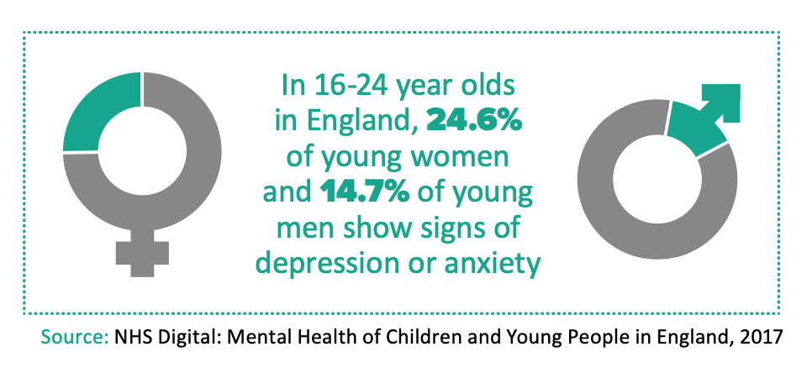
Half of all mental health problems begin by the age of 14 and three-quarters by an individuals mid 20’s” (Children, Young People and Education Committee, 2018, p.10). This is somewhat concerning for mental health organisations such as MIND and CHAMS who help support young people with mental health problems due the pressures that they will face and possibilities of there being insufficient funds to fund the support.
According to the Welsh Government (2017), more than 11,000 young people received counselling in 2017-2018, this is not surprising considering findings from the Royal Society for Public Health state as a key point that anxiety and depression in young people ages 16-25 has risen by 70% in the last twenty five years (RSPH, 2017, p.3). Statements as such are highlighted due to an average of three children in one classroom are estimated to have mental health problems. In highlighting such issues, in 2018, the number of young people accessing support from Barnardo’s had risen by 56% (BBC, 2019). They also stated that in 2018-19, Charity Barnado’s Cymru had seen an increase of young people receiving help had risen by a staggering 56% via school-based counselling, therapy sessions and trauma recovery support.
Mind Cymru (2019) state findings from a survey carried out that 48% of young people aged 11-19 wouldn’t know where to go to access support within school. As a result, the National Assembly’s Children and Young People Committee highlight they want more early interventions to take place. This would prove to be promising for young people that are at risk of being exposed to poor living conditions in order to prevent their mental health and wellbeing from deteriating.
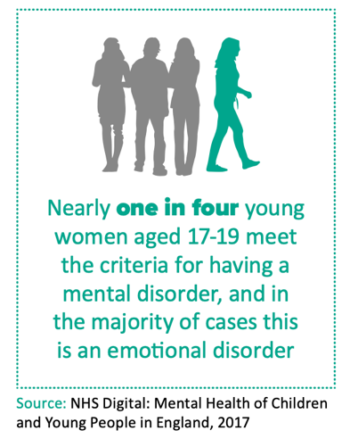
Data journalists Guibourg and Jeavans (2018) explain that findings form an NHS report conducted in 2018, nearly one in four young women experiences a form of mental illness and LGBT teens are at much more risk of developing mental health problems (see graph below). They also suggest that young women aged between 17-19 are more likely to struggle than young men of the same age, common struggles include anxiety and depression (Guibourg & Jeavans, 2018).

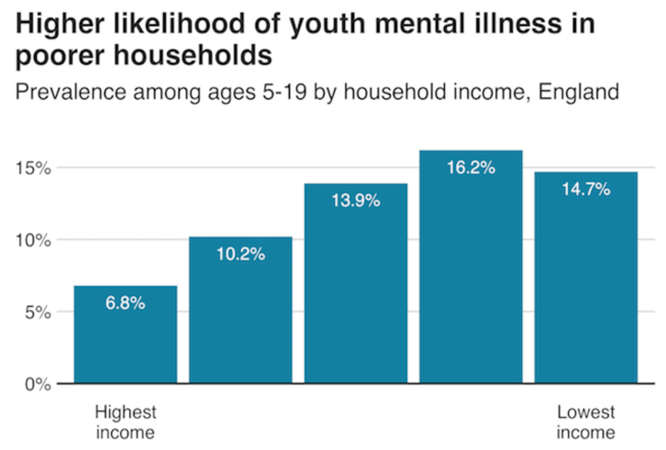
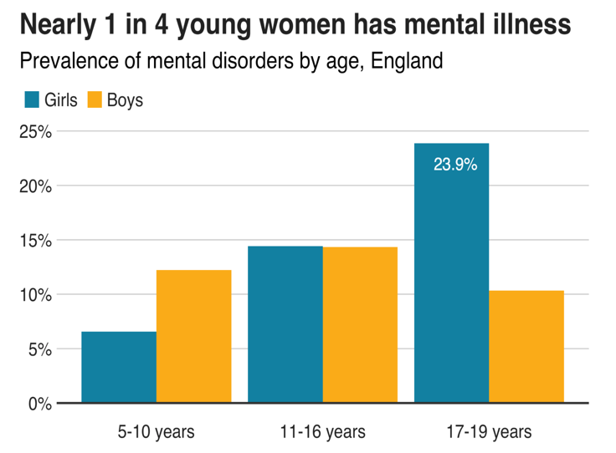

(Guibourg & Jeavans, 2018).

Other findings also published by the NHS displayed in the graph above suggest that factors contributing to mental health problems consist of those who live in poorer houses are more likely to develop mental health problems as life develops (Guibourg & Jeavans, 2018).
In 2012, the Welsh Government recognised that mental health issues were on the rise, understanding the need to introduce the ‘Together for Mental Health’ ten year strategy in order to improve young people’s mental health and wellbeing in Wales. They highlighted that mental health issues are now no longer an issue that the NHS are solely responsible for, it is everybody’s business using a whole system approach (WG, 2012).
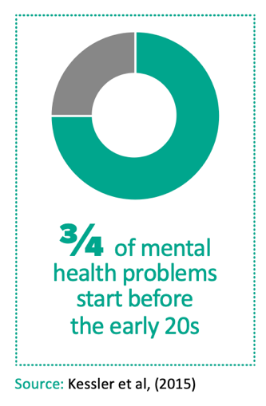
In addition, the Welsh Government also published ‘A Healthier Wales: Our Plan for Health and Social Care’ in 2018 which aims to make Wales a better place to live and to aim to ensure that all services are working together. With regards to young people living in Wales, this proves promising in providing a more supportive environment to live, one that aims to improve health and wellbeing and overall a better quality of life. It is evident that mental health issues across the globe are being recognised and the stigma that existed around the subject is reducing and both treatment and more importantly, the focus on prevention is ever developing.
The Mind Over Matter Report (2018) highlights that “across the UK, it is estimated that one in four children will show some evidence of mental ill health. Half of all mental health problems begin by the age of 14 and three-quarters by an individuals mid 20’s” (Children, Young People and Education Committee, 2018, p.10).
Common Themes Occurring

(The Guardian, 2019)
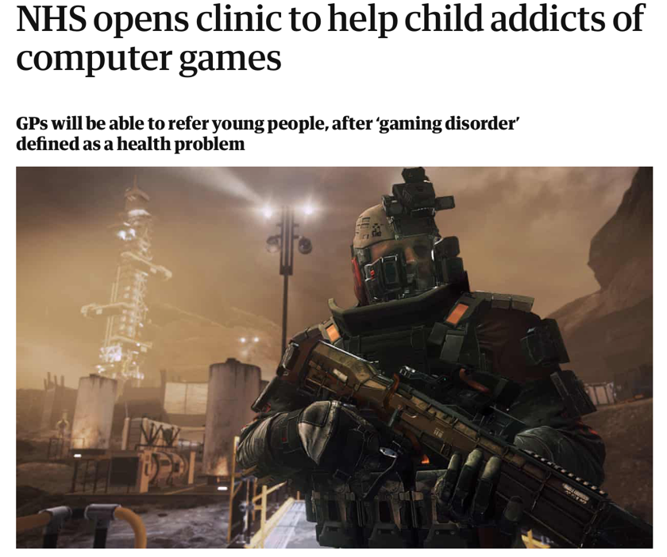
In contemporary society, young people have access to gaming devises, use of the internet and an abundance of opportunities to communicate and engage in online gaming. There is a large number of young people that are engaging in such activities and as a result, now a medical disorder “gaming disorder” has been recognised. People in England aged 13-25 are offered support from GP’s and the NHS as a result of its impact on a young person’s mental health.

This is having an impact on young people’s social development and as a result, countries such as South Korea have introduced a ban for young people under the age of 16 to play video games between midnight and 6am in order to reduce the risk of developing further mental health problems. (Campbell, 2019).


Common themes that occur throughout young people in contemporary society include increased levels of anxiety and insecurities around body image in addition to social status. The NHS (2017) released a statement suggesting that Instagram was ranked worst for mental health in a teen survey that was carried out, reported by the BBC. Findings suggested that young people felt that there was an increase in loneliness, anxiety and fear of missing out from using Instagram which perception of others’ lives were of better quality. This is a common factor to an increase in young people suffering with their mental health as well as body image issues (NHS, 2017).
In support, The Royal Society for Public Health (2017) state
“Research suggests that young people who are heavy users of social media – spending more than two hours per day on social networking sites such as Facebook, Twitter or Instagram – are more likely to report poor mental health, including psychological distress (symptoms of anxiety and depression)”.
(RSPH, 2017, pg.8)
Positively, there are methods that can assist in managing mental health problems, there are strong links between exercise and reducing experiences of mental health problems. A study carried out by scientists from Kings College London revealed that people who exercised reduced the risk of developing depression. Other studies undertaken by Best et al (2019) with regards to the positive relationship between exercise and mental health disorders discovered that throughout the study, their findings suggested that higher levels of physical activity were protective from future depression in children, adults and older adults (Best, 2019). The NHs (2018) support scientists from Kings College London by implying that those who exercise most are at less of a risk of having depression.
How can youthwork help with the issues?

In order to ensure that young people are being provided with the an opportunity to maximise their potential, to be able to become well-rounded individuals, it is essential that youth work practitioners understand the needs of young people and are open to working collaboratively with organisations and specialists within the required fields. Following guidelines from professionals, such as medical professionals and experts in health, well-being and fitness can promote positive lives for young people growing up in contemporary society.
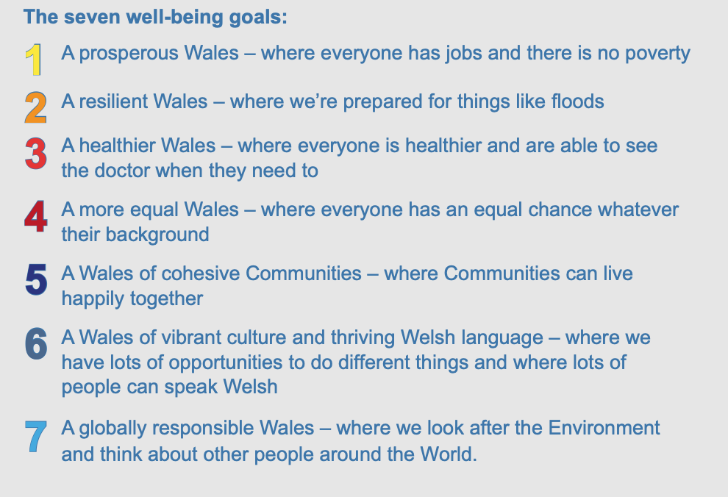
The Wellbeing of Future Generations Act (2015) aims to implement seven wellbeing goals that youth workers can adhere to in order to ensure that young people have opportunities of improving and maintaining good levels of wellbeing. The seven goals include a prosperous, healthier, resilient, more equal, cohesive of communities, globally responsible and vibrant culture and thriving Welsh language Wales. (Welsh Government, 2015)
In current climates, anxiety levels throughout the world have increased due to the coronavirus issues and uncertainties of the virus, especially among young people, this has proved to be somewhat concerning and its uncertainty has increased levels of anxiety among young people. As youth work practitioners, it is of use to the wellbeing of young people that activities and reassurances are on offer through the use of digital platforms in order to offer consistency in support throughout services working with young people.
In addition, mindfulness, considered a powerful tool to improve wellbeing is taught in schools across the UK as well as schools introducing walking a mile per day in schools to improve mental health and wellbeing of their students (The Guardian, 2019). Youth work practitioners across various methods of practice can also assist in delivering programmes to help improve wellbeing and tackle issues associated with mental health problems during adolescence.
In relation to exercise and its positive influence on mental health and overall wellbeing, guidelines from the Department of Health and Human Services suggest that young people aged six and over should have a recommended sixty minutes of exercise per day. Youth work practitioners could set up a running club, suggest joining local sports teams and setting up activities that young people wish to engage in. This would assist in promoting their identity, being inclusive, participate for all, empowering young people to make their own decisions, develop their knowledge and understanding of positive activities which in turn, would promote their wellbeing, reducing higher levels of mental health problems.
LSIS (2012, p.14) highlight the emphasis of working collaboratively and in partnership with other agencies, improving opportunities for young people, meeting the youth work national occupational standard of YW28. Working collaboratively with organisations has proved pivotal for the support offered for young people in order to maximise the potential of each young person engaging in youth work provisions.

Daily activities such as Joe Wicks PE sessions will provide opportunities for youth workers to promote healthier lifestyles via being active and improving physical health, linked to improvements in mental health. Due to the nature of exercise and releasing endorphins, this would aid in improving mood as well as creating a sense of happiness for the individual.
(www.thebodycoach.com, 2020)
Due to the voluntary participation element of youth work practice and principles and purposes of the profession, young people are more likely to engage and therefore benefit from activities introduced via informal educated activities that can assist in improving their mental health and wellbeing. Leading by example is key to ensure that young people have good, positive role models in order to replicate individuals with good morals and positive attitudes. In addition, confidentiality is key to the trusting working relationship that a young person develops with a youth worker and other professionals to ensure safeguarding the young person is at the forefront of the professionals mind.

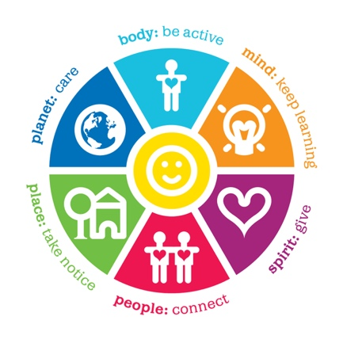
Youth workers, through practice and working collaboratively can devise person centred plans that tailor the needs of a young person by which enhances their wellbeing, educates them on how to be active, keep learning, give to others, connect with family and friends, take notice of their surroundings and care for the planet, considering future generations. By devising an individualised plan, having built a good relationship with the young person working in a non-formal and informal setting will increase the likelihood of maximising the potential of young people.
(Network of wellbeing.org, 2015)

Educating young people on activities that are available in their communities and the impact that staying healthy in both body and mind is key to ensuring that their mental heath and wellbeing is of a good level. Learning a new skill empowers young people to use their initiative and provides them with a sense of achievement which can help improve their wellbeing.
Many studies have proved the importance of wellbeing and its link with mental health, especially in young people. through a voluntary participation relationship via various activities and person-centred plans to ensure young people have access to support. Collaborative working is essential in order to ensure that professionals share their knowledge, understanding and expertise to ensure that young people can maximise their potential and live a long, happy life. The importance of both a trusting relationship and signposting young people on to organisations is key to ensure the support offered to a young person experiencing mental health problems is of its highest quality.
To conclude, the importance of wellbeing has seen a shift on the agenda of many professional organisations due to the impact that it has on an individual’s life. Overall, mental health problems experienced in young people in contemporary society is on the rise due to societal changes and expectations, yet education on how to reduce the risk, for example, positive links with exercise and mindfulness of developing such problems and education around improving wellbeing is ever evolving via collaborative working. This is essential in order to maximise a young person’s potential ensuring the importance of confidentiality, ethics and safe working practice.
If anything, it highlights the importance of youth work practice, the trusting relationships developed between practitioners and young people in improving the lives of young people within contemporary society by educating them in an informal and non-formal setting to ensure that they live happier, healthier lifestyles that will improve their wellbeing and reduce levels of mental health problems that they may experience otherwise.
References:

BBC (2019) Mental health: Counselling sought by 11,000 Welsh youngsters.
https://www.bbc.co.uk/news/uk-wales-50151883 (site visited 29/02/2020)

Bell, S., Audrey, S., Gunnell, D., Cooper, A., Campbell, R., (2019) The relationship between physical activity, mental wellbeing and symptoms of mental health disorder in adolescents: a cohort study. International Journal of Behavioural Nutrition and Physical Activity. Volume 16.
Best, S. (2018) Exercise Decreases Your Chance of Developing Depression, Regardless of Your Age. https://www.mirror.co.uk/science/exercising-decreases-your-chance-developing-12418713 (Site visied 22/03/2020)
Campbell, D (2018) NHS Opens Clinic to Help Child Addicts of Computer Games. The Guardian. United Kingdom. https://www.theguardian.com/society/2019/oct/08/nhs-opens-clinic-to-help-child-addicts-of-computer-games (site accessed 02/03/2020)
Department of Health (2014) The Relationship Between Wellbeing and Health. https://assets.publishing.service.gov.uk/government/uploads/system/uploads/attachment_data/file/295474/The_relationship_between_wellbeing_and_health.pdf (site visited 20/02/2020)

Guibourg & Jeavans, 2018. In charts: Report into children's mental health. BBC. United Kingdom

https://www.bbc.co.uk/news/health-46306241 (site visited 27/03/2020)
Kessler R, Berglund P, Demler O, Jin R, Merikangas K, and Walters E (2005) Lifetime prevalence and age-of-onset distributions of DSM-IV disorders in the National Comorbidity Survey Replication. Arch Gen Psychiatry, 62, 593-602
http://www.youngpeopleshealth.org.uk/wp-content/uploads/2019/09/AYPH_KDYP2019_FullVersion.pdf (site visited 03/03/2020)
Michaelson,J., Mahony, S., Schifferes, J., (2012) Measuring Wellbeing A Guide for Practitioners. New Economics Foundation. United Kingdom.
https://b.3cdn.net/nefoundation/7a378df45fafe612cc_a3m6i6g49.pdf (site visited 19/03/2020)
NHS (2017) Instagram ‘Ranked Worst For Mental Health’ In Teen Survey
https://www.nhs.uk/news/food-and-diet/instagram-ranked-worst-for-mental-health-in-teen-survey/ (site visited 21/02/2020)

NHS (2018) Regular Exercise May Helplower your risk of depression.
https://www.nhs.uk/news/mental-health/regular-exercise-may-help-lower-your-risk-depression/ (site visited 03/04/2020).
Pople, L., Rees, G., Main, G., Bradshaw, J. (2015) The Good Child Report. United Kingdom

Royal Society of Public Health (2017), Status of Mind: Social Media and Young People’s Mental Health and Wellbeing. United Kindgom

https://www.rsph.org.uk/uploads/assets/uploaded/d125b27c-0b62-41c5-a2c0155a8887cd01.pdf (site visited 29/03/2020)
Schraer, R (2019) Is Young People’s Mental Health Getting Worse?. BBC News. United Kingdom
https://www.bbc.co.uk/news/health-47133338 (site visited 20/03/2020)
The Children’s Society (2018) The Good Childhood Report. United Kingdom.
https://www.childrenssociety.org.uk/sites/default/files/the_good_childhood_report_full_2018.pdf (site visited 31/03/2020)

The National Assembly for Wales (2019) The Emotional and Mental Health of Children and Young People – Follow-up.

http://senedd.assembly.wales/mgIssueHistoryHome.aspx?IId=25377 (site visited 22/03/2020)
The Princes Trust (2019), The Princes Trust Youth Index 2019.
https://www.princes-trust.org.uk/about-the-trust/research-policies-reports/youth-index-2019 (site visited 23/02/2020)
Welsh Government (2019) Together for Mental Health Delivery Plan 2019- 2022. OGL, United Kingdom.
https://gov.wales/sites/default/files/consultations/2019-07/together-for-mental-health-delivery-plan-consultation-document.pdf (site visited 20/03/2020)

Welsh Government (2015) Wellbeing of Future Generations (Wales) Act 2015. https://futuregenerations.wales/about-us/future-generations-act/ (Site visited 20/02/2020)
https://www.nhs.uk/conditions/stress-anxiety-depression/improve-mental-wellbeing/ (site visited 11/03/2020)
https://futuregenerations.wales/wp-content/uploads/2017/01/160401-wfg-accessible-guide-for-young-people-en.pdf (site visited 20/02/2020)
https://networkofwellbeing.org/2015/07/29/sherry-clark-the-wheel-of-wellbeing/ (site visited 02/04/2020)
https://www.thebodycoach.com/blog/pe-with-joe-1254.html (site visited 08/04/2020)

