
Modernising the Mental Health Act could see more Autistic adults in our communities: Are the police prepared for this?

Steven J Williams (1910656)
BSc (Hons) Professional Policing
June 2022

Word Count: 10,731

Declaration
This work has not previously been accepted in substance for any degree and is not being concurrently submitted in candidature for any degree.

Signed:
Date: 02/06/2022
Statement 1:
This dissertation is being submitted in partial fulfilment of the requirements for the degree of BSc Professional Policing.
Signed:
Date: 02/06/2022
Statement 2:
This dissertation is the result of my own independent work/investigation, except where otherwise stated.
Other sources are acknowledged by footnotes giving explicit references. A bibliography is appended.
Signed:
Date: 02/06/2022
Statement 3:
I hereby give consent for my dissertation, if accepted, to be available for photocopying and for interlibrary loan, and for the title and summary to be made available to outside organisations.
Signed:
Date: 02/06/2022
Statement 4:
I hereby give consent for my dissertation, if accepted, to be available on the university’s IT system to those who have consent to use the system.
Signed:
Date: 02/06/2022
Acknowledgments
I would like to thank my supervisor for his support throughout the completion of this project. He has always replied quickly to my e-mails and prevented further stress. I would also like to thank my partner and children for being patient and understanding, most of the time! Thank you to my parents, who have not seen much of me, but fully understand and have been supportive throughout. Last but not least, thank you to my colleagues at South Wales Police.
Abstract
38 police respondents who have completed the Police Education Qualification Framework (PEQF) initial training, completed a survey regarding the Autism training they have received and experiences of dealing with Autistic suspects. Only 2.63% of these respondents were satisfied with the training they have received on Autism. Half of the respondents had dealt with a suspect with Autism and it was found that limited reasonable adjustments were made by officers, prior to arrival at custody. Some respondent replies suggest that some officers are confident but lack knowledge of Autism. Three custody Sargent’s from different custody suites within South Wales Police were interviewed. It was found that they have received a significant amount of Autism training compared to front-line police officers, and were more knowledgeable to offer reasonable adjustments in Custody. The custody suites evaluated in this research have little differences but these can affect the adjustments that can be offered. Tactile processing, such as fingerprinting, DNA swabs, and searches, is an area where there are limited adjustments that can be offered to minimise the negative effects they could have on an Autistic suspect. The PEQF training is insufficient in relation to Autism, and Autistic individuals are more at risk of being discriminated against between the point of first contact with police, and arrival at custody.

Table of Contents
________________________________________________________________________________
Chapter 1 – Introduction
1.0 Introduction…………………………………………………………………………………………………………… 8
1.1 Research background…………………………………………………………………………………………………………. 8
1.2 Research Rationale………………………………………………………………………………………………………….… 10
1.3 Aims and Objectives …………………………………………………………………………………………………….……. 11
1.4 Structure…………………………………………………………………………………………………………………….……… 12
1.5 Conclusion…………………………………………………………………………………………………………………….…… 12
________________________________________________________________________________
Chapter 2 - Literature Review
2.0 Introduction………………………………………………………………………………………………………………….…… 12
2.1 PEQF and police training on Autism…………………………………………………………………………………… 14
2.2 Reasonable adjustments in the custody environment……………………………………………………….. 16
2.3 Identification of Autism …………………………………………………………………………………………………….. 17
2.4 Appropriate adults……..……………………………………………………………………………………………………... 18
2.5 Custody environment……………..…………………………………………………………………………………………. 18
2.6 Caution………………………………………………………………………………………………………………………………. 19
2.7 Conclusion…………………………………………………………………………………………………………………………. 20
________________________________________________________________________________
Chapter 3 - Methodology
3.0 Introduction…..…………………………………………………………………………………………………………………. 21
3.1 Research strategy……………………………………………………………………………………………………………… 22
3.2 Ethics………………………………………………………………………………………………………………………………… 25
3.3 Limitations and problems…………………………………………………………………………………………………. 25
________________________________________________________________________________
Chapter 4 - Data Analysis and Findings
4.0 Introduction……………………………………………………………………………………………………………………… 26
4.1 Method of analysis……………………………………………………………………………………………………………. 27

4.2 Analysis of qualitative data gathered from a questionnaire……………………………………………… 27

Analysis of Qualitative Data Gathered from Interviews
4.3 Theme One: Training received…………………………………………………………………………………………. 32
4.4 Theme Two: Identifying Autism……………………………………………………………………………………….. 32
4.5 Theme Three: Appropriate adults…………………………………………………………………………………….. 32
4.6 Theme Four: Aiding communication and understanding the Caution and procedures……… 33
4.7 Theme five: Facilities and environment……………………………………………………………………………. 33
4.8 Theme six: Particular experiences…………………………………………………………………………………….. 33
4.9 Conclusion and recommendations……..…………………………………………………………………………….. 34
________________________________________________________________________________
Chapter 5 - Conclusion and Recommendations
5.0 Introduction……………………………………………………………………………………………………………………... 35
5.1 Completion and Achievement of Objectives…………………………………………………………………….. 35
5.2 Main Findings…………………………………………………………………………………………………………………… 36
5.3 Recommendations…………………………………………………………………………………………..………………. 39
5.4 Limitations……………………………………………………………………………………………………………………….. 40
5.5 Conclusion……………………………………………………………………………………………………………………….. 40
________________________________________________________________________________
Bibliography………………………………………………………………………………………………………………………… 42
________________________________________________________________________________
Appendices
Appendix A ……………………………………………………………………………………………………………………………. 46
Appendix B……………………………………………………………………………………………………………………………… 57
Appendix C……………………………………………………………………………………………………………………………… 70
Appendix D……………………………………………………………………………………………………………………………… 88
________________________________________________________________________________

List of Figures
Figure 1.1: Hourly mental health incident pattern. This graph shows the number of emergency calls made over a 24 hour period during weekdays and weekends (HMICFRS, 2018)……………………………………………………………………………………………………… 9
Figure 4.1: Bar chart. Graph showing question 6 responses “During your initial training, did you receive any training as a sub section of mental health training?”……............................................................................................... 28
Figure 4.2: Bar chart. This features the responses to “During your initial training, how long would you estimate the duration of autism training you received?”……………………………………………………………………………………………… 29
Figure 4.3 Table of Verbatim responses. These are responses from question 15 asking participants to discuss reasonable adjustments offered during arrest, or at any point during detention…………………………………………………………………………………….. 30
Figure 4.4: Table of reasonable adjustments. This shows number of responds to each adjustment and the percentages …………………………………………………… 30

List of Abbreviations
AA – Appropriate Adult
ASD – Autistic Spectrum Disorder
CJS – Criminal Justice Service
HCP – Health Care Practitioner
HM GOVERNMENT – Her Majesty’s Government
HMICFRS – Her Majesty’s Inspectorate of Constabulary and Fire and Rescue
LD – Learning Difficulty
MHA – Mental Health Act
NPCC – National Police Chiefs Council
NHS – National Health Service
PEQF – Police Education and Qualification Framework
PACE – Police and Criminal Evidence Act
PTSD – Post Traumatic Stress Disorder
SWP – South Wales Police
UK – United Kingdom
UNCRPD – United Nations Convention of the Rights of People with Disabilities

Chapter 1 – Introduction
The purpose of this dissertation is to investigate if the police are prepared for the potential modernisation of the Mental Health Act (MHA) 1983, and the potential for more incidences involving Autistic individuals, as a result of these changes. This Chapter will provide a background to this study, and highlight the rationale for this research. The aim and objectives of this dissertation will also be outlined.
1.1 Research Background
According to Debbaudt and Rothman (2001), Autistic individuals are more likely to have police contact, compared to the general population. Crane et al (2016) explain that the addition of sensory and communication difficulties associated with autism, can cause an increase in the likelihood of adverse outcomes.
UK Government (2018) conducted an independent review on the Mental Health Act (1983). It found that families of individuals with Learning difficulties (LD) and Autistic Spectrum Disorder (ASD), feel they should not be defined as a mental disorder, as they are lifelong disabilities and not treatable conditions. The Department of Health and Social Care (2021) propose changes to the MHA 1983, that neither LD nor ASD will be considered a mental disorder for which someone can be detained for treatment, unless there is a co-occurring mental health condition identified. Community alternatives are to be made available instead. These changes could come in to effect in 2023, however this is yet to be confirmed.
According to the National Health Service (NHS) (2021), in June 2021, there were 2075 individuals with LD in inpatient mental health hospitals, 1200 (58%) of these are individuals with ASD. UK government (2018) explain that some people, including patients and carers, believe that the current MHA is the only framework to keep individuals safe when they are at their most vulnerable. If this framework is removed, there is a risk that these individuals could be forced into the Criminal Justice System (CJS), which is not able or intended to cater for their needs.
As shown in fig 1.1, the peak time for mental health related incidents are between 3-6pm on weekdays, at the end of the working day for other organisations, and 5-10pm on weekends, meaning that there’s a shift in responsibility from professionals, who are specifically trained to deal with mental health, to the police, who only have limited training in mental health (Her Majesty’s Inspectorate of Constabulary and Fire & Rescue Service (HMICFRS) (2018).
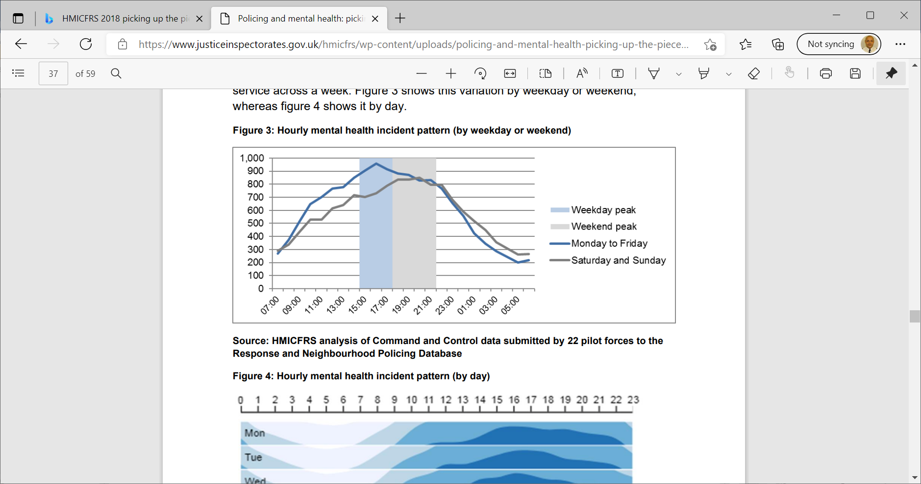

Figure 1.1: Hourly mental health incident pattern. This graph shows the number of emergency calls made over a 24 hour period during weekdays and weekends (HMICFRS, 2018).
Although police do their best to respond to mental health incidences, it means sufferers of mental-ill health are likely to receive a poorer service, as the police are not specifically trained to the standard of mental health professionals (HMICFRS, 2018). Ultimately, this could result in critical incidences which impact the public’s confidence on policing and its legitimacy. One example was an ASD individual known as ZH who had an aversion of being touched. He was restrained by police in 2008 whilst he became fixated with the water at a swimming pool. Officers perceived the need to take control of the situation, but none of them were aware of the features of autism, the problems it presented and how to best deal with the situation. ZH jumped in to the pool, and was lifted out by Officers, who then used handcuffs and leg restraints, and placed ZH alone in the back of a police van. The incident caused ZH to suffer from Post-Traumatic Stress Disorder (PTSD) and had a profound negative effect on his Epilepsy. The case highlighted the need for autism awareness within public services (ZH (A protected party by GH, his litigation friend) vs The commissioner of Police for the Metropolis, 2012). According to Angiolini (2017) the court of appeal held the findings by a trial judge that the officers were liable for a breach of the Disability Discrimination Act 1995, and had a duty to make reasonable adjustments to their control and restraint policy. The Equality Act (2010) states that anyone providing a service to the disabled, must make ‘reasonable adjustments’. This includes the police who have a duty, and therefore a legal obligation, to adapt their method and approach when dealing with ASD individuals. South Wales Police (2019) developed a joint equality plan 2019 – 2023. A key goal of this plan is to provide a person-centred service to those who are neurodivergent by training Officers and staff. Officers and staff interacting with autistic individuals need to be able to recognise their condition and know how to make reasonable adjustments (SWP 2019).
1.2 Research rationale
On a personal level, as a result of working 15 years in a forensic secure hospital with Autistic adults, and having experienced difficult incidences as a police officer dealing with Autistic suspects in the community and custody, it is felt that this is an area which requires further research and improvements by the police.
Similar research to which I intend to carry out was conducted by Crane et al (2016). Surveys were carried out with police officers of various ranks and the ASD community in England and Wales and found possible discrepancies between self-reported competence and professional conduct in practice. The Crane et al (2016) study was conducted before the proposed changes to the MHA 1983. With this in mind, the findings are of further relevance to inform police policies. According to Hepworth (2017), a systematic literature search finds little research on the initial stages of criminal investigation involving ASD individuals. Little attention has been paid to the rights of the individual during the criminal justice process. A key finding of Hepworth (2017) was that police training in relation to Autism is insufficient during the initial stages of the CJS process. Since this finding, the National Police Chiefs Council (NSPCC) (2018) explain that the Police Education Qualifications Framework (PEQF) programme has been introduced, and is a standardised national framework that provides qualification levels by rank or level of responsibility.
Due to the gap in academic research surrounding this topic, this dissertation research aims to investigate how prepared the police are for a potential influx of ASD individuals living in our communities, and the challenges this could present. The themes presented in this Chapter will be further analysed in Chapter two of this dissertation.
1.3 Aims and Objectives
The aim of this research is to establish how prepared the police are for a potential influx of police suspects with ASD. The main objectives of the research is to:
- Explore police officers’ awareness of reasonable adjustments, when dealing with autistic adults as suspects.
- Critically evaluate reasonable adjustments within the custody environment.
- Determine if current Police Education Qualification Framework (PEQF) is sufficient for police officers, in relation to Autism.
- Identify if Autism training differs by rank and level of responsibility.

This research will aim to answer the following questions:
- What reasonable adjustments are offered to ASD individuals upon arrest?
- What reasonable adjustments can be made within custody, to limit distress and aid communication?
- Do police officers receive specific Autism training on the PEQF programme, which provides the required knowledge to deal with ASD individuals fairly whilst upholding their rights?
- Does Autism training differ by rank, or level of responsibility?
1.4 Structure
To successfully complete the four objectives of this dissertation, all of the Chapters of this dissertation will aim contribute in their own way. Chapter Two will analyse previous and current academic literature relevant to this study. A deductive approach will be taken in Chapter Two to develop themes from theory, hypotheses, and research questions. Chapter Three will attempt to identify the most appropriate methods to collect research data, whilst taking in to consideration the size of this project, ethical requirements and time restraints. Chapter Four will analyse the results of the data collected, identify common themes, and briefly discuss the findings and implications of the results. Chapter Five will present these findings in relation to each objective, and conclude this dissertation by making recommendations based on the academic observations achieved throughout this dissertation.
1.5 Conclusion
This Chapter has presented the background and rationale for this research. The aims and objectives outlined are the core of this research, and the reasons why this issue requires further exploration have been explained. As mentioned previously, a more in-depth analysis of the current academic literature will be undertaken in the next chapter of this dissertation.

Chapter 2. Literature review
2.0 Introduction
According to the Department of Health and Social Care (2021), Autism is a lifelong disability that effects how people perceive, communicate and interact with other people. It is often referred to as Autistic Spectrum disorder (ASD), due to the range of ways that it can impact on people. Asperger syndrome may be defined as a condition which includes many of the features of ASD, but the person is of average or above average intelligence (Allen et al 2008).
The aim of this chapter is to analyse key and relevant literature which have academic value, around the subject of police training in Autism, the initial stages of criminal investigations involving ASD individuals, and the adjustments that are offered to uphold the rights of the individual. This aim will be achieved by critically analysing literature obtained from the University of Wales Trinity Saint David online library database, as well as academic and scholarly sources, found through Google Scholar internet search engine, which will include academic journals and government publications.
According to Hepworth (2017), much of the current literature focuses on interview techniques, and treatment during trials and imprisonment, for those with ASD. These areas are not going to be analysed during this chapter, as the focus will be on how prepared the police are for the potential influx of ASD individuals into the Criminal Justice System (CJS). Due to the scale of the research, interview techniques will not be analysed, although general communication, structuring of questions and the environment of interview rooms will be discussed.
The focus of this chapter will be police training and the Police Education Qualification Framework (PEQF) programme, and reasonable adjustments will focus on four key areas, identifying autism, Appropriate Adults (AA), the custody environment and the police Caution. These are critical stages of contact with ASD adults, where there’s potential to infringe on the rights of the individual, if correct procedures are not adhered to.
This chapter of this dissertation aims to address points two and three of the objectives:
- Critically evaluate reasonable adjustments within the custody environment.

- Determine if current PEQF programme is sufficient for police Officers, in relation to Autism.

2.1 PEQF and police training on Autism
Police training is crucial to ensure that individuals with ASD are treated fairly (Bradley 2009). According to Debbaudt and Rothman (2001), when responding to calls involving ASD individuals, education, perception and understanding can help officers avoid situations becoming unpleasant or dangerous. A key finding of Hepworth (2017) was that police training is insufficient during the initial stages of the CJS process. It was found that frontline officers in England and Wales receive a two hour, online ‘mental health’ training, which includes ASD as a sub-section, which could only result in confusion to front-line officers, about what ASD really is. Teagardin et al (2012) conducted a study where a 15-minute Autism video was shown to police officers. Although it was found the video improved knowledge, it was difficult for the officers to retain that knowledge over time, therefore, longer training would better support learning. The results indicated that video training alone was not sufficient, or as effective as in-person training. Granpeesheh et al (2010) compared e-learning (training on a computer as opposed to face-to-face) training to in-person training, for training new clinicians in academic knowledge of behavioural treatment of individuals with Autism. The in-person training consistently produced higher scores in tests after the training, compared to the group who received e-learning training. Granpeesheh et al (2010) suggested that e-learning training, with a smaller amount of in-person training, is a viable alternative to organisations who cannot provide in-person training for the length of time required. Wright (2008) conducted a similar study, although the content was teaching an introductory university course in environmental sciences, found that the group that received in-person training, scored an average of 6% higher than the group that received e-learning training. Although the content of the Wright study was different, is still reinforces that in-person training is considered best practise. Granpeesheh et al (2010) stated that one of the main disadvantages to e-learning is that an instructor is not present to answer questions. Debbaudt and Rothman (2001) state that the presence of police may cause ASD individuals to flee, fail to respond to orders or avert eye contact. These behaviours should not be interpreted as a lack of co-operation or a reason to use unlawful force. Police training and knowledge of ASD will prepare police officers for such situations.
One of the first large scale studies on the experiences of individuals with ASD and policing, was conducted by Crane et al (2016). A survey was conducted, which included almost 400 police respondents, and 80 adults from the ASD community (31 were adults with ASD). Rating their overall knowledge of ASD, 48% of police respondents felt they were knowledgeable and well equipped to deal with ASD. 37% of police respondents reported that they had received training on ASD. Of these, 49% were satisfied and 28% dissatisfied with the training they received. The top three training needs identified by police were enhancing communication (82%), minimising distress (78%); and training for working with someone with ASD that was specific to their role (71%).
Although these figures of knowledge and training are poor, they do not reflect the full dissatisfaction throughout the literature on police training. The police respondents in this survey were recruited via advertisements, essentially, they choose to participate, possibly meaning that they already have an interest, knowledge or personal experience of ASD. If the respondents were selected by the researchers, the results may differ as this potential bias is eliminated. However, the only study to examine if the frequency of interactions outside of work affects police officers’ ability to identify ASD during their work, was conducted by Josifko (2019). It was found that officers who do have frequent contact, did not score significantly higher, than those without frequent contact. Josifko (2019) theorised that this could be due to the large number of traits within the spectrum of ASD. Centres for Disease Control and Prevention (2012) explain the traits of ASD are the behaviours or characteristics commonly displayed by ASD individuals. Due to the spectrum, different individuals may display different traits. Examples would include rigidness with routines, obsessive interests, a fixation on parts of objects and patterns, repeating phrases or words, and unusual reactions to the way things sound, smell, taste, look or feel.
The majority of police respondents in the Crane et al study were the rank of constable (63%), but included all ranks up to Superintendent, meaning that that the training received could not be specified to a particular rank. For example, the number of constables who have received ASD training could be far below 37%, but this figure is higher, due to higher ranking officers receiving ASD training. Separate surveys for different ranking officers, or different roles would identify role specific training.
Crane et al (2016) found discrepancies between opinions of police and experiences of ASD individuals. The police sample were fairly satisfied how they worked with ASD individuals, whilst ASD individuals were generally dissatisfied. A key finding in a study conducted by Josifko (2019), was that ASD training did improve confidence levels of police officers, which may indicate that they are more prepared to interact with ASD individuals. However, increased confidence without increased knowledge may lead to more negative interactions. These findings could help explain the discrepancies between police and ASD individuals in the Crane et al study.
The National Police Chiefs Council (NSPCC) (2018) explain that the PEQF programme is a standardised national framework that provides qualification levels by rank or level of responsibility. It is intended to create new entry routes into policing, ensuring officers are equipped with the knowledge required to meet the challenges of modern policing. A literature search has found no research that identifies what training is provided in relation to Autism, under the PEQF programme. This framework has been developed since the study by Crane et al (2016). To build on this study, it would be beneficial to know exactly what Autism training is received under the new framework, and if this differs by rank or level of responsibility.
2.2 Reasonable adjustments in the custody environment
A critical review of current police training and policy for ASD was conducted by Hepworth (2017), which found that little research has been conducted on the initial stages of criminal investigation involving ASD individuals. Little attention has been paid to the rights of the ASD individual during the criminal justice process.
In England and Wales, the only disability-specific legislation that recognises the difficulties posed by ASD, is the Autism Act 2009 (HM Government, 2009). The mandatory requirements of this legislation are placed on public health and education services but are not applicable to the police. For this reason, along with a lack of knowledge and understanding, individuals with ASD are especially vulnerable in police settings, and the wider CJS. Holloway (2020) explains that many of the custody processes are the same throughout England and Wales, but it is important to be aware that facilities and environments may be different.
A systematic review by King, Murphy and Glynis (2014) found that most research on ASD within the CJS is of poor quality and lacked specific focus, only one study was found (Allen et al 2008) that researched the experiences of ASD individuals in the CJS. Josifko (2019) suggested using studies that include perceptions of individuals with ASD and police officers, results may create richer and more descriptive data. It is also thought that using studies that have worked in partnership with ASD individuals, creates a more valuable and meaningful study for the ASD community.
2.3 Identification of Autism
For reasonable adjustments to be offered so that communication can be enhanced, and to minimise distress, firstly, autism needs to be identified. Allen et al (2008) hypothesised that adults are less likely to have a diagnosis, compared to children, and due to the high functioning ability of individuals with Asperger’s syndrome, their difficulties are unlikely to be recognised by workers within the CJS. Approximately 11 out of 28 ASD adults stated they would never disclose a diagnosis, as they fear victimisation and negative stereotypes (Crane et al, 2016). Similarly, a key finding of Gibbs and Hass (2020) was that ASD individuals, and their parents/carers need to be confident the police have a solid knowledge and understanding of ASD to feel safe to disclose a diagnosis. Hepworth (2017) explains that a key responsibility of the custody officer is to identify the presence of ASD, which would require a considerable amount of training. Holloway et al (2020) explored the experiences of autistic individuals and officers, during a walkthrough of the custody process. It was found that a key barrier to communication was the structuring of questions. All detainee questions are pre-set with no flexibility to adjust questions according to the needs of the detainee. Pre-set questions include “do you suffer from any mental health problems or depression?” and “do you have any learning disabilities that we need to provide help or support for?” A custody Sargent, who participated in the study, stated that it would help if there was a set question about autism. It is not known if there’s flexibility for custody Sargent’s to make necessary adaptions to these questions, which appear to be vital to identify vulnerabilities and avoid injustices.
2.4 Appropriate adults (AA)
The Home Office (2019) state an AA is appointed to vulnerable detainees in custody to ensure that they understand their rights, in accordance with Code C of the Police and Criminal Evidence Act (PACE). Code C also states that an AA must be appointed if there are any doubts to the vulnerability of a detainee. Crane et al (2016) reported that 67% of the 192 police respondents, reported that an AA was always involved. Juvenile detainees are appointed trained, experienced AAs, but the same support is not afforded to adult detainees. They do not require any specific training and have no statutory responsibility, making responses to requests for an AA inconsistent or non-existent (Durcan et al, 2014). According to Hepworth (2017), only half of police forces in England and Wales have an established AA scheme, meaning that parents or carers are appointed AA, which poses problems of impartiality and qualifications. Contradictory to this, Crane et al (2016) found that 30% of police respondents reported AAs from an established scheme as unhelpful, and indicated that negative views were because the AA did not know the person and lacked understanding.
2.5 Custody environment
United Nations Convention on the rights of people with disabilities (UNCRPD) state that the existence of a disability can never justify a deprivation of liberty. Any process of deprivation of liberty requires that disabled people are entitled to protection by the human rights law, this includes the principle of reasonable accommodation. (UNCRPD, 2006, cited by Williams et al, 2020).
The additional sensitivity and sensory issues faced by ASD individuals are likely to make the custody environment particularly challenging (Holloway, 2020). Debbaudt and Rothman (2001) recognise that bright lights, smells, loud voices, and touch sensitivity may cause an ASD individual to react to a point where is it is impossible to regain their attention.
Crane et al (2016) found that 69% of autistic adults were dissatisfied with their experiences in custody and some reported discrimination. Reasons for this dissatisfaction included lack of information and explanations given by police officers. Many found an inappropriate environment, including custody suites and interview rooms, led to emotional stress and a breakdown in communication. One respondent (parent of an adult with ASD) referred to the custody environment as “totally inappropriate due to the noise, smell and lighting”.
Holloway (2020) found three key themes that impacted on the wellbeing of participants, in terms of environment. These were categorised as noise, visual and tactile. Participants suggested that they were detained in a quieter section of custody or provided with ear defendants. Other suggestions included dimming of the lights, duller colours on the walls, and soft flooring colours. The tactile demands were most evident during the processing stage. Participants referred to the forcefulness of fingerprinting, the uncomfortableness of DNA swabs and the intrusiveness of being searched. It was emphasised that it helped when officers provided a context for what was happening, what they were doing and why. This study offers good insight into the views of ASD individuals, but caution should be taken when interpreting results as only two ASD individuals participated in the study. As mentioned earlier, due to large number of traits to the spectrum of ASD, some of these suggestions may not be helpful to all ASD individuals.
2.6 Police Caution
During the arrest of a suspect, an officer will read the caution to a suspect. The Police and Criminal Evidence Act (PACE) 1984 – Code G Revised, 2012, states that sufficient information must be given to the arrested person, so that they understand why their liberty is being deprived (Bryant and Bryant (2020)). Hepworth (2017) believes that a failure to understand the caution puts those with ASD at risk of self-incrimination and proposed an ASD friendly version of the caution. Parsons and Sherwood (2015) conducted a pilot project using symbol-based information sheets in police custody, which had positive results, in terms of aiding communication and understanding with vulnerable individuals. It would be beneficial to identify if similar sheets are used, or accessible in relation to the caution, and whether police officers are aware of any such information, that would ensure ASD suspects understand the caution, ensuring compliance with PACE.
2.7 Conclusion
A literature search found that earlier research on ASD within the CJS is of poor quality and lacked specific focus. There is little research on the initial stages of criminal investigation involving ASD individuals, and little attention has been paid to the rights of the individual during the criminal justice process. This highlights the gap in knowledge, which has contributed to the reasons for this current research. The topic appears to be gaining more attention in recent times and some studies have been conducted involving the views of individuals with ASD. These studies are found to be more meaningful, and data is richer and more descriptive. However, the Crane et al (2016) study is one of the few studies to be conducted on a larger scale, involving the ASD community. This study collected data on police training, and knowledge, but did not identify training and knowledge to specific roles of policing. The NSPCC (2018) state the PEQF programme is a standardised national framework that provides qualification levels by rank or level of responsibility. As the new PEQF programme has been rolled out since this study, one objective of the current research is to identify what specific ASD training is being given to newly recruited police officers, and officers of different rank. Is this training is sufficient to identify and communicate with ASD individuals? Does it provide the knowledge to make adaptions, ensuring that the welfare, rights and entitlements of the individual are adhered to? Further research is required to answer these questions.
Holloway (2020) explains that many custody processes are the same throughout England and Wales, but facilities and environments may be different. The third objective of this research aims to explore these differences. Many of the issues identified had similar findings in the study conducted by Crane et al (2016). For example, custody environments lead to emotional stress and a breakdown in communication for ASD individuals. Reasonable adjustments in custody are not currently sufficient to cater for the needs of ASD individuals. Knowledge and understanding of ASD is required to make reasonable adjustments such as structuring of questions, and pre-explanation of procedures, as well as adaptions needed to facilities, such as AA schemes and accommodations. The results of this research will be critical in identifying whether the police are prepared for the modernisation of the MHA and will provide further thoughts and knowledge for future larger scale studies, which would benefit from including ASD individuals within the research.
Chapter 3. Research Methodology
3.0 Introduction
The proposed changes to the MHA (1983), mainly the removal of Autism from the Act, could see an influx of ASD individuals in our communities, as the proposed new legislation will not allow ASD individuals to be detained under the Act. The main purpose of this dissertation is to establish if the police are ready for this change. A failure to adhere to the rights of ASD individuals could result in miscarriages of justice, which would affect public confidence in policing and police legitimacy.
The previous chapter emphasised the lack of research on the initial stages of criminal investigation involving ASD individuals, and the lack of sufficient training for the police, in relation to ASD. No studies have been undertaken in relation to training for ASD within the relatively new PEQF curriculum. This chapter will detail the reasons and justifications for choosing the methods that are going to be used to achieve the four objectives of this dissertation, and why they are the most appropriate methods.
Crane et al (2016) surveyed police officers, which included questions on their knowledge, training and satisfaction of training received. However, this study did not identify training received by rank or role of the respondent. It is possible that higher ranking officers have received more training on Autism which would affect the overall results of the study and mask the lack of training received by particular ranks, more likely front-line police officers. Since this study, the PEQF framework was introduced nationally, and provides qualification levels by rank or level of responsibility. 50,000 new officers could be recruited by March 2023, which provides a once-in-a-generation opportunity to shape policing (The College of Policing, 2020). Has this opportunity been missed in relation to preparing and training police Officers’ on Autism, and to shape policing in terms of the service it can provide to ASD individuals.
This current study is intended to build on the study conducted by Crane et al (2016), and to establish if the PEQF framework has improved knowledge, developed awareness and better prepared police officers to deal to deal with ASD individuals more effectively.
The main objectives of this research is to:
- Explore police officers’ awareness of reasonable adjustments, when dealing with autistic adults as suspects.
- Critically evaluate reasonable adjustments within the custody environment.
- Determine if current Police Education Qualification Framework (PEQF) is sufficient for police officers, in relation to Autism.
- Identify if Autism training differs by rank and level of responsibility.
3.1 Research strategy
Greene (2006), cited by Greene (2008), created a framework for social science methodology which includes four domains of meaning. First is philosophical assumptions and stances, which refer to assumptions associated with the nature of the social world, known as Ontology, and the nature of social knowledge, known as epistemology. Second is Inquiry logistics, which includes the purpose and questions of the inquiry, broad designs and sampling logics. Third, is guidelines for practice, which includes practical guidelines on how to do a study. The last domain is socio-political commitment, which examines the mixed methods research in relation to the political and social policies of the research. Research paradigms are ways of explaining philosophical beliefs of the researcher and are important when deciding on which methods to choose. These four domains will be considered throughout this research. Reason (2008) discusses Egon Guba’s (1990) reluctance to define pragmatism, as you cannot clearly define the frame of your own thinking. Instead, Guba articulated basic questions about ontology, epistemology and methodology, to provide a framework in which pragmatic thinking could take place.
Evaluator’s skills can be seen in their choices, if you do not consider why and who you evaluate, technical questions can turn to false questions (Hadji,1989, cited by Tourmen, 2009). A mixed method strategy will be utilised during this study to cover all four objectives, as it is felt that objective 2 will require more in depth detail, in contrast to the other objectives. According to Greene (2008), practitioners seek to use different methods when the practical demands within the area worked, requires both generality and particularity. These are the reasons a mixed method approach is considered more appropriate for this research.
Baker and Edwards (2012) explain that quantitative methods differ from qualitative methods in many ways, especially by its emphasis on numbers. Quantitative research gathers a shallow band of information from a range of people, so the information can be used objectively, whereas qualitative research study fewer people, more in-depth, to generate a subjective understanding.
A questionnaire will be sent via e-mail, to two cohorts that have completed the PEQF training with South Wales Police. The one cohort would have completed the initial 6 months training in March 2020, and the second cohort who would have completed the initial training in September 2021. Questions will be mainly based around police training and knowledge. By sampling two different cohorts, this will enable any differences made to the curriculum to be identified during that time period, and it is expected that the cohort who completed training in September 2021, will have a clearer recollection of the training received. Smartsurvey will be used to design the questionnaire, and the link sent by e-mail from a verified police e-mail address to police officers work e-mail, ensuring authenticity as unsolicited e-mails are likely to be ignored.
Saunders et al (2019, p-448) explain that it is not always possible to collect data from all known groups, known as a census. Due to the scale of a study and time requirements, a subgroup can be selected to reduce the amount of data obtained. The sample in this study will amount to approximately 30% of all new constable recruits to have completed the initial training under the new PEQF within South Wales Police (SWP), allowing for an accurate generalisation of statistics. However, this percentage would be considerably lower compared to the new recruits who have completed the PEQF training nationwide. The e-mail addresses of samples will be provided by SWP Learning Development Services, and sent to 114 police officers, with an expected return of 30-40 samples. By specifying and choosing the sample, the aim is to reduce the likelihood of bias, as there is less chance of participants responding because they have a personal interest in the subject of ASD.
The qualitative method is an important part of the study and will be utilised by conducting three interviews with different custody sergeants in three different custody settings within SWP, so facilities and procedures can be compared. Part of these interviews will be based on police training and knowledge, similar to the questions asked in the questionnaire for police constables. This will allow for comparisons to be identified by rank, as to the training received. As Hepworth (2017) explained in the previous chapter, a key responsibility of the custody officer is to identify the presence of ASD, which would require a considerable amount of training.
Themes of the interview will aim to explore current police practices and critically evaluate reasonable adjustments within the custody environment. These will be conducted in a more semi-structured manner with the use of open questions. According to Saunders et al (2019, p-451), semi-structured interviews can achieve high level of validity and credibility because of the added benefit of being able to use clarifying and probing questions. Key measures to preparation include the researcher’s knowledge, interview themes, the interview location and supplying information to the interviewee prior to the interview, and the interview location.
To promote credibility, validity and reliability, the participants will be provided with information and the themes prior to interview, so that they are aware of the information relevant to this study. This will allow the participant’s time to prepare and bring any supporting documents or think in advance of any relevant experiences of ASD individuals in custody. According to Saunders et al (2019, p-454), it is possible for the location of the interview to influence the data collected, as it may help the participant to reflect more on the setting and trigger a response. All interviews will be conducted in a custody interview room, where ASD suspects would usually be interviewed. This will ensure convenience and privacy for the participant. This decision is also intended to have a positive impact on participant’s response to questions relating to the environment, as they may be positioned to better understand the environment from the perspective of an ASD individual. In the previous chapter, Crane et al (2016) found ASD individuals reported an inappropriate environment, including custody suites and interview rooms, which led to emotional stress and a breakdown in communication.
3.2 Ethics
An ethics form submitted to University of Wales Trinity Saint David, has obtained approval from the ethics committee, ensuring that all participants are protected in this study. Ensuring the research complies with all ethical requirements, all participants will be given the opportunity to consent or refuse to participate. A full explanation will be offered to explain expectations and detail the risks and benefits of participation. Nespor and Groenke (2009) explains this concept in terms of agency and participant. Participants are the people the researcher works with directly, the agency being the organisation that these participants represent. On this assumption, researchers run the risk of undermining the agency by not considering these ethical dangers. To negate this risk further, participation in this study has been authorised by a custody inspector, who has made suggestions as to the three custody Sergeants who will participate in the study.
3.3 Limitations and problems.
Lebaw, 1980, cited by Gendall (1988), emphasises the importance of past behaviours, to predict future behaviour. It is easier for people to tell you what they have done, as opposed to what they might do. This idea may present issues during this study due to the lack of experience of the sample targeted to complete the questionnaire. This means that half of the sample would be more likely to have had experiences of interacting with ASD suspects, and better able to answer questions relating to experiences, current police practices and reasonable adjustments. The first cohort would have about 2 years’ experience of working as a constable on response, compared to about 6 months of the second cohort sampled. It is expected that some of the sample may not have had any experiences of dealing with ASD suspects. This will be taken into consideration when designing the questionnaire, with the key focus being on knowledge, and training.
As noted in the previous chapter, using studies that include perceptions of individuals with ASD and police officers, results may create richer and more descriptive data and creates a more valuable and meaningful study for the ASD community. Due to time issues, the scale if this study, restrictions due to Covid, and ethical challenges, ASD individuals will not be included in this research. However, the intention of this study will be to provide information, insight and ideas for future, larger scale studies, which would benefit from involving ASD individuals within the study.

Chapter 4. Analysis of results

4.0 Introduction

This chapter of the dissertation will attempt to analyse the results of the research, following the collection of the data from primary quantitative and qualitative research. The quantitative results aim to address objectives one and three:
- Explore police officers’ awareness of reasonable adjustments, when dealing with autistic adults as suspects.
- Determine if current Police Education Qualification Framework (PEQF) is sufficient for police officers, in relation to autism.
A summary of the questionnaire replies can be found in APPENDIX A. A visual summary of each question has been provided in the form of a graph, which can be found in APPENDIX B.
The results of the qualitative research aim to address the second objective of this research:
- Critically evaluate reasonable adjustments within the custody environment.
- Identify if autism training differs by rank and level of responsibility.

The transcripts of these interviews can be found in APPENDIX C. The qualitative data aimed to identify what training is received by custody Sargent’s and compared to findings from the quantitative data on police training, to address objective four.

4.1 Method of Analysis
The results will be thematically analysed using deductive reasoning. According to Miles, Huberman, and Saldana (2013), a deductive approach develops codes or themes from theory, hypotheses, and research questions. A deductive approach is driven by the researcher's theoretical or analytical interest in the area, which tends to provide a less rich overall description of data but a more detailed analysis of some data (Braun and Clarke, 2006).
4.2 Analysis of qualitative data gathered from a questionnaire
Data obtained in relation to objective 3.
The survey was completed by 38 police officers, 35 were response
officers, and three were in the Hub's investigative department. The average
length of service was 21.84 months, ranging from 2 to 30 months. There were
no significant differences in the answers based on experience, indicating that no
changes were made to autism training during this period. Only 16 % of
respondents received autism training as part of their mental health education, as shown in fig 4.1.

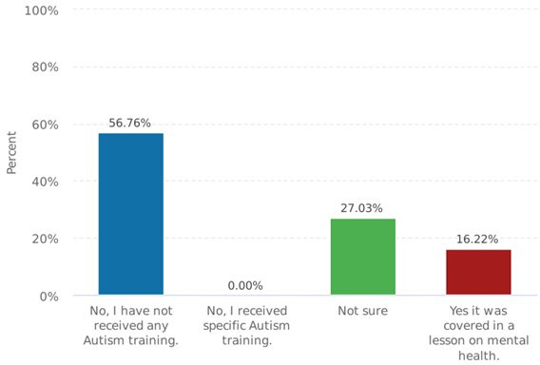
Figure 4.1 Bar chart. Graph showing question 6 responses “During your initial training, did you receive autism training as a sub section of mental health training?”

This dissertation research found only 2.63% were satisfied with the training they have received on autism, with 76.32% being unsatisfied. Only 13.16% rated themselves as ‘knowledgeable’ on autism, 44.74% rated their knowledge as ‘little or no knowledge’. In contrast, Crane et al (2016) found 48% of police respondents felt they were knowledgeable on autism. 49% were satisfied and 28% dissatisfied with the training received. Crane et al (2016), reported 37% of respondents had received training on autism, only 63% of these respondents were rank of constable. Different or enhanced training by rank or in regions, could explain the differences in these findings. As this dissertation research is based on SWP region only, it is unknown how training compares in other regions. Further research to assess these differences would be needed. Importantly Figure 4.1 shows no respondents received specific autism training. According to Hepworth (2017), non-specific autism training could result in confusion to front-line officers about what autism really is. This dissertation research found 39.47%, could not confidently explain the difference between mental health and autism and 18.42% were not sure.
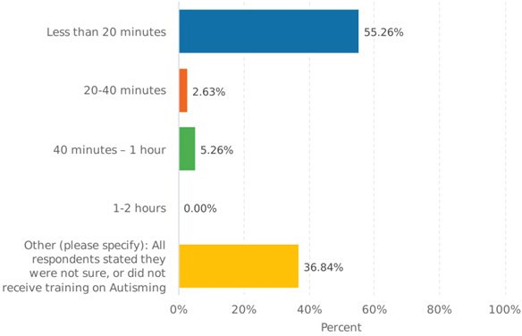
Figure 4.2 Bar chart. This features the responses to “During your initial training, how long would you estimate the duration of autism training you received?”

Figure 4.2 results appear ambiguous as 36.84% state they did not receive autism training or were unsure. In Figure 1.1, 84% of respondents said they had not received autism training or were unsure. The first option of answers was “less than 20 minutes” instead of “5-20 minutes”, therefore some responders who indicated they had not received training may have chosen this option. However, importantly only 8% of participants reported receiving over 20 minutes of training, any less is insufficient, as was found by Teagardin et al (2012) who discovered that a 15-minute film enhanced information, but officers couldn't retain it, therefore lengthier training would be more supportive and preferable.

Data obtained in relation to objective 1

ID: 187105753 | AA was arranged from Hafal by custody staff. The suspect didn't communicate with officers at all so it was difficult to know what adjustments were needed.
ID: 186291753 | During arrest there was not any reasonable adjustments that could be made in my opinion apart from the way I communicated with the suspect and my manner however this was dependable and circumstantial on the individual as I have dealt/arrested with numerous autistic suspects and witnesses. I find the only place or point in time that I can make reasonable adjustments is from the point of being booked in to custody after arrest. From being booked in I find is where the most support for a autistic suspect is made such as an AA or family member to help with the interviewing process.
ID: 186296705 | No reasonable adjustments were made, the other officers mis-understood the signs and symptoms and assumed he was trying to fight.
Figure 4.3 Table of Verbatim responses. These are responses from question 15 asking participants to discuss reasonable adjustments offered during arrest, or at any point during detention.

Reasonable adjustment used | Number of respondents | Percentage
Appropriate adult | 12 | 70.58
Adjusting language | 6 | 35.29
Minimising physical contact | 4 | 23.52
Limit disruption to routine | 2 | 11.76
Teddy allowed for comfort | 1 | 5.88
Engagement (1:1) in custody | 1 | 5.88
Limit effects of bright lights | 1 | 5.88
Adjustments to interview location | 1 | 5.88
Figure 4.4 Table of reasonable adjustments. This shows number of responds to each adjustment and the percentages.
Questions 12-15 of the survey were for those who had dealt with autistic suspects. Exactly half, 19 out of 38 respondents, said they had dealt with an autistic suspect. Question 15, as shown in fig 4.3, asked participants to discuss reasonable adjustments they made during arrest or detention. Some responses indicate a lack of knowledge, which supports Josifko's (2019) conclusion that increased confidence without increased knowledge may lead to more negative interactions.
Eight reasonable adjustments were identified from the answers to this question. An analysis tool was used on smart survey to code these answers and create a graph, which can be found in APPENDIX B. Each reasonable adjustment was taken from the total number of reasonable adjustments used (28), to create a percentage, which didn’t represent the figures accurately.
The number of respondents who reported an AA was used was 70%, similar to that found by Crane et al (2016), where 67% of the 192 police respondents, always involved an AA. However, it is important to note that AA’s are usually appointed after the individual’s detention has been authorised in custody.
Questions 12-14 of the questionnaire provided the following data:
- 79% reported explaining procedures were difficult or very difficult.
- 89% found it difficult or very difficult to help the autistic individual focus, engage or co-operate.
- 79% found it difficult or very difficult in ensuring the autistic individual understood the caution.

Despite these difficulties reported by respondents, the data in Figure 4.4 suggest that little adjustments were made to support these difficulties. For example, 79% found it difficult or very difficult ensuring the autistic individual understood the caution, but only 35% reported that adjustments to language were made. These comparisons suggest that police officers may have little awareness and lack knowledge of making reasonable adjustments to ease these difficulties, which could negatively impact the rights of the ASD individual.

Analysis of Qualitative data obtained from Interviews.

Data obtained in relation to objective 2. (Theme One data will be compared to data found in objective 3, to achieve objective 4 of this research).

4.3 Theme One: Training received
Participant one (P1) and Participation three (P3), reported that custody Sergeant’s receive two days refresher training every year. P1 stated that autism is always a topic, but training is more of a discussion. P3 reported a 2-day refresher 6 months ago that included an hour on autism. P1 and P3 both got autism training during their initial 2-week custodial training and from external charities. P2 had just completed the first custody training, which included autism training. All participants had completed the autism e-learning. P2 and P3 said the e-learning package included an informative autism video. All participants were satisfied with Autism training received, and felt they were ‘knowledgeable' on autism. There appears to be a clear difference in training received by custody Sergeants, compared to police Officers. According to Granpeesheh et al (2010), e-learning training with less in-person training can be a feasible alternative to in-person training.

4.4 Theme Two: Identifying autism
The participants confirmed they use pre-set questions to identify vulnerabilities, however there’s no specific questions regarding autism. This is consistent with Holloway et al (2020) study, which found a key barrier to communication was the structuring of custody questions. However, the participants stated they do structure their questions differently i.e. use basic language, avoiding jargon and asking shorter questions. A custody Sergeant in the Holloway et al (2020) study noted that a set question about autism might help. The three research participants agreed with this. All participants stated there should be a Health Care Practitioner (HCP) available 24/7 who could help identify autism and conduct a ‘fit for detention’ assessment. P1 mentioned there are Autism Champions on shift, which are Custody Detention Officers who have received more in-depth training on autism.

4.5 Theme Three: Appropriate adults
All participants confirmed that the same AA scheme Hafal is used. Hafal is a third-party charity organisation, which supports people with mental health (Hafal, 2022). Hepworth (2017) reported only half of police forces in England and Wales have an established AA scheme. Normally parents or carers are appointed AA, which can pose problems of impartiality and qualifications. Crane et al. (2016) reached a different conclusion, finding that 30% reported AA's from established schemes were unhelpful because the AA did not know the person and lacked an understanding. All participants in this dissertation research preferred using family or friends, as opposed to an AA from Hafal, as it would be beneficial to the autistic individual, as they could have more of an awareness of their needs. They would always ensure that the AA appointed is impartial. P2 provided an example to support his view, which can be found in APPENDIX C, Interview 2, and Question 18.
4.6 Theme four – Aiding communication and understanding the caution and procedures
P1 and P2 had brought the same easy read book and symbol flashcards to the interview, which are used in their custody settings. P3 confirmed the same materials are accessible. Photos of these can be found in APPENDIX D. Parsons and Sherwood (2015) conducted a pilot project using symbol-based information sheets in police custody, which had positive results, in terms of aiding communication and understanding with vulnerable individuals.
4.7 Theme five – Facilities and environment.
There were differences identified with facilities and the environment between the three custody settings. Participants were from three different custodies within SWP. P3 explained that their custody cells are located on two separate floors, the top floor offering a quieter alternative to the ground floor. In comparison, P1 and P2 custody have all wings on one floor, certain wings are kept free as a quieter alternative. Another difference is one custody has larger interview rooms available, which is not the same for the other two custody suites. Holloway (2020) stated it is important to be aware that facilities and environments may be different. Other characteristics of the facilities were consistent throughout all three locations. The Holloway et al (2020) study suggested sensory and tactical processing difficulties should be considered and adjusted, these were considered by all participants. The lights in the cells and corridors have three settings: normal, bright, and dim. Observation levels can be altered as needed, engagement observations can be applied, and wall colours can be duller, neutral, and not bright. Due to safety concerns, ear protection cannot be provided in any custodial setting. All three participants agreed that tactile processing, such as fingerprinting, DNA swabs, and searches, are non-adjustable and must be completed by any autistic detainee. The importance of explaining these procedures clearly beforehand were emphasised by P2. All participants however found reasons why the interview room could pose issues for Autistic individuals. P1 recalled an incident, where an Autistic detainee counted the soundproof tiles during interview and started re- counting every time he was interrupted. Although these rooms are not suitable, each participant suggested an alternative, such as conducting interviews from within the cell.
4.8 Theme Six – Particular experiences
P2 mentioned an autistic female detainee, who was sensitive to noise, and travelled to the station with sirens on, which could have been avoided. She then targeted the arresting officer and P2 asked them to leave, to calm the female. This officer however appeared to take the decision personally. P3 recalled a time where they refused to authorise the detention of an autistic male with diabetes. The suspect had been re-arranging chocolate bars in a shop, whilst out without support. He was located with chocolate bars in his pocket. Responding officers failed to identify that he had autism or was diabetic. The incident became clearer when P3 contacted the hospital where he resided. These incidences could have been avoided, or minimised, had response officers had better knowledge and understanding to identify signs of autism sooner.
4.9 Conclusion
The results of this research has found only 16% of respondents who have undertaken the PEQF police training, have received training on Autism, which was covered in a lesson on mental health. Only 8% of respondents claimed to have more than 20 minutes training on Autism, as Teagardin et al (2012) found, 15 minutes of training is not retainable, and could explain why 27% were unsure what training they received. These results suggest police training in relation to Autism, is not sufficient. In comparison, the three custody sergeants in this study have received specific autism training, and e-learning. Two have received training from external charities. These significant differences in training could explain the differences in results, compared to Crane et al (2016) study, where only 63% were rank of constable. Further studies would be required to establish training provided to different ranks, or level of responsibility. Police Officers awareness of reasonable adjustments when dealing with autistic suspects were poor. 70% of respondents used an AA, however, this is usually facilitated after the point of reaching custody. There were few adjustments made before arriving at custody, which suggests that ASD individuals are more at risk of being treated unfairly, or even discriminated against, between the point of first contact and arrival at custody. Examples in theme six of the qualitative data, further support this statement. There are many adjustments that can be offered or facilitated within the custody setting, and ASD individuals can be assessed by a HCP, to ensure they are fit for detention. Tactile processing are processes that must be undertaken, with limited options to minimise distress to the ASD individual. Explaining procedures fully appears to be the only means of minimising these negative effects.
Chapter 5. Findings and Conclusion
5.0 Introduction
This chapter aims to provide a conclusion surrounding the research question of; “Modernising the Mental Health Act could see more Autistic adults in our communities: Are the police prepared for this?”
The previous chapter presented the analysis and findings of primary data collected through a survey and qualitative interviews. This chapter will analyse these findings in more depth. The limitations of this dissertation will be discussed, as well as potential avenues for future research in this area, with suggested recommendations.
5.1 Completion and achievement of objectives.
- Explore police officers’ awareness of reasonable adjustments, when dealing with Autistic adults as suspects.
This objective has been achieved in Chapter 4 following analysis of survey results, mainly question 15.
- Critically evaluate reasonable adjustments within the custody environment.
An analysis of existing literature was carried out within Chapter 2, which developed theoretical and analytical interests. A deductive approach was used to conduct qualitative research, which identified 6 themes, through interviews.
- Determine if current Police Education Qualification Framework (PEQF) is sufficient for police officers, in relation to autism.
An analysis of existing literature was carried out within Chapter Two which highlighted a gap in knowledge. Chapter 4 achieved this objective through quantitative research, with a survey being the most appropriate method.
- Identify if autism training differs by rank and level of responsibility.
Data obtained in Chapter 4 from quantitative research and qualitative research, was compared to identify these differences.
5.2 Main findings
Explore police officers’ awareness of reasonable adjustments, when dealing with Autistic adults as suspects.
Police Officers awareness of reasonable adjustments when dealing with autistic suspects were poor. 79% of respondents in this dissertation research found it difficult or very difficult ensuring the autistic individual understood the caution, but only 35% reported that adjustments to language were made. 70% of respondents used an AA, however, this is usually facilitated after the point of reaching custody. No respondents mentioned any use of easy read or symbol-based material. There were few adjustments made before arriving at custody, which suggests that ASD individuals are more at risk of being treated unfairly, or even discriminated against, between the point of first contact and arrival at custody. Figure 4.3, table of verbatim responses to question 15 of the survey, found in chapter 4, identified examples of confident officers who lack knowledge. Josifko (2019) found increased confidence without increased knowledge may lead to more negative interactions. These examples can also provide reason to the findings of Crane et al (2016) which revealed discrepancies between officers’ opinions and the experiences of ASD individuals, which suggested it is possible that there are discrepancies between self-reported competence and professional conduct in practice. A Lack of knowledge could result in police Officers failing to make the required reasonable adjustments and making them unaware of how their actions or lack thereof, has affected the ASD individual.
Critically evaluate reasonable adjustments within the custody environment.
There are many adjustments that can be offered or facilitated within the custody setting, and custody Sargent’s have a clear awareness of what reasonable adjustments can be offered to uphold the rights and minimise stress for the ASD individual. Holloway et al (2020) found a key barrier to communication was the structuring of custody questions. The research for this dissertation found that the custody sergeants do make adjustments to pre-set questions. It was also found that participants for this dissertation preferred using family or friends as an AA, as opposed to an AA from a registered scheme, as it would be more beneficial to the autistic individual. This finding supported Crane et al (2016) finding that 30% of participants reported AA's from established schemes were unhelpful. All participants for this dissertation use symbol-based information sheets for ASD individuals in custody which Parsons and Sherwood (2015) found had positive results, in terms of aiding communication and understanding with vulnerable individuals. Holloway (2020) stated it is important to be aware that facilities and environments may be different. The main difference identified in this dissertation research was that one custody setting had cells on a separate floor, which offered a quieter alternative to ASD detainees. Holloway et al (2020) suggested sensory and tactical processing difficulties should be considered and adjusted. This dissertation research found tactile processing are processes that must be undertaken and are the only procedure where there’s limited options to minimise distress to the ASD individual. Explaining procedures fully appears to be the only means of minimising the negative effects of these intrusive procedures.
Determine if the current Police Education Qualification Framework (PEQF) is sufficient for police officers, in relation to Autism.
All 38 participants of the survey within this dissertation research have received initial training under the PEQF programme. Only 2.63% were satisfied with the training they have received on autism. It was found only 6 of the 38 respondents have received training on Autism and importantly, these 6 respondents stated that the Autism training was covered in a lesson on mental health. None of the respondents indicated that they have received e-learning training or any form of specific Autism training. According to Hepworth (2017), non-specific autism training could result in confusion to front-line officers about what autism really is. An absence of specific Autism training within the PEQF could explain why this dissertation research found that 39.47% could not confidently explain the difference between mental health and autism and 18.42% were not sure.
Only 8% of respondents claimed to have received more than 20 minutes training on Autism, which Teagardin et al (2012) found that 15 minutes of training is not retainable. This could explain why 27% of the 38 respondents of this dissertation research were unsure what training they have received. Granpeesheh et al (2010) suggested that e-learning training, with a smaller amount of in-person training, is a viable alternative to organisations who cannot provide in-person training for the length of time required. These results suggest police training in relation to Autism, is not sufficient, and this could provide reason to the findings of objective 1.
Identify if Autism training differs by rank and level of responsibility.
The three custody sergeants in this dissertation research have received specific autism training, and e-learning. Two have received training from external charities. There are clear, significant differences between training received by custody Sergeants, and training received by response police Officers.
Crane et al (2016) found 48% of police respondents felt they were knowledgeable on autism. 49% were satisfied with the training received and 37% of respondents had received training on autism. In contrast, this dissertation research found Only 13.16% rated themselves as ‘knowledgeable’ on autism, 2.63% were satisfied with the training they have received and 16% have received training on Autism, as a sub-heading of Mental Health. Only 63% of the respondents in the Crane et al (2016) study was rank of constable. Differences in training received by rank or level of responsibility could explain the differences in these findings. Hepworth (2017) explains that a key responsibility of the custody officer is to identify the presence of ASD, which would require a considerable amount of training. This dissertation has discussed the importance of front-line Officers identifying Autism so that reasonable adjustments can be offered. A key finding of Gibbs and Hass (2020) was that ASD individuals, and their parents/carers need to be confident the police have a solid knowledge and understanding of ASD to feel safe to disclose a diagnosis. Half of the respondents in this dissertation survey have dealt with ASD individuals as suspects, despite the average length of service only being 21.84 months, but it is unknown why front-line officers receive less training compared to other ranks. Are front-line Officers deemed less likely to have contact with ASD individuals? Or is the issues due to funding costs and time restraints to train front-line officers? Further research would be required to answer these questions.

5.3 Recommendations.
- Specific Autism training needs to be incorporated in to the PEQF programme and provided to all front-line police officers. The training provided should be in line with other ranks, and could include e-learning training, with a smaller amount of in-person training, if SWP cannot provide in-person training for the length of time required.
- Front line Officers should have materials available to aid communication and understanding upon arrest, before ASD detainees arrive in custody, and before they are appointed an AA. Easy-read books and symbol-based flashcards, which are available in custody, should be made accessible to front-line officers on patrol. This could aid in understanding of the caution, ensuring compliance with The Police and Criminal Evidence Act (PACE) 1984.
- Custody settings in SWP should seek input from Autism professionals to review tactical processing procedures to evaluate if any changes can be made. Changes to these procedures could ease the difficulties which they present to ASD individuals and their sensory sensitivities.
5.4 Limitations.
As a result of completing this dissertation at undergraduate level, this research was of a smaller scale and the word count was one of the biggest limitations of this research. Preferably, as mentioned in Chapter two and three, involving ASD individuals would create richer and more descriptive data, and the research would be more meaningful to the ASD community. The scale of this project, restrictions due to Covid and the ethical challenges meant that this was not possible. These factors, plus time restraints for travelling and analysing data, prevented this research from involving custody suites outside of SWP, and conducting a survey with a range of different ranking Officers in different forces to gain a wider scope of knowledge.
5.5 Conclusion.
This dissertation has successfully achieved the aims and objectives and answered the question “Modernising the Mental Health Act could see more Autistic adults in our communities: Are the police prepared for this?”
As evidenced throughout this dissertation, the police are not prepared for a potential influx of ASD individuals in our communities. The skills, training and knowledge provided to front-line officers are not sufficient to ensure that the rights of the individuals are upheld, and discrimination is avoided, which can increase the likelihood of injustice and negatively impact the legitimacy of policing. Knowledge of Autism and the awareness of the difficulties ASD individuals face is essential for officers, so that reasonable adjustments can be offered ensuring compliance of the Equality Act 2010. This could avoid the risk to ASD individuals being unfairly treated between the first point of contact and arrival at custody.
Custody environments generally are not fit for purpose for ASD individuals, however, Officers within the custody environment are better trained, and more knowledgeable to offer reasonable adjustments. Tactile processing is an area of difficulty. These are processes that must be undertaken by all detainees, but there are no adjustments that can be made to minimise the distress they could cause to ASD individuals.
Finally, this dissertation has shown how easy it would be for an Officer to unintentionally discriminate against an ASD individual, due to a lack of knowledge and lack of training provided to them by the organisation. It is inevitable that further ASD individuals will continue to be victimised in the future if changes are not made. It is important to note that further research in this area would be beneficial and recommended that research is carried out which includes ASD individuals. Further research outside of SWP, including separate surveys for a variety of different ranking officers would further benefit this research area. Research to establish the reasons why higher-ranking Officers may receive more Autism training compared to front-line Officers, who are likely to have frequent in-person contact with ASD individuals, would also be beneficial to academic literature.

Bibliography
Allen, D., Evans, C., Hider, A., Hawkins, S., Peckett, H. and Morgan, H. 2008. Offending Behaviour in Adults with Asperger Syndrome. Journal of Autism and Developmental Disorders, 38(), pp. 748–758
Angiolini,E. (2017). Report of the Independent Review of Deaths and Serious Incidents in Police Custody. [pdf] Available at: https://assets.publishing.service.gov.uk/government/uploads/system/uploads/attachment_data/file/655401/Report_of_Angiolini_Review_ISBN_Accessible.pdf. [Accessed on 29th April 2022].
Autism Act 2009, C.15. Available at: https://www.legislation.gov.uk/ukpga/2009/15/pdfs/ukpga_20090015_en.pdf. Accessed on 5 January 2022.
Baker, Sarah & Edwards, Rosalind. (2012). How many qualitative interviews is enough. Available at:
https://www.researchgate.net/publication/277858477_How_many_qualitative_interviews_is_enough (Accessed on 20th of February, 2022)
Bradley, K. 2009. The Bradley Report Lord Bradley’s review of people with mental health problems or learning disabilities in the criminal justice system. [PDF]. Available at: The Bradley Report (iriss.org.uk). Accessed on 5 January 2021.
Braun, V. and Clarke, V. (2006) ‘Using thematic analysis in psychology’, Qualitative research in psychology, 3(2), pp. 77–101.
Bryant, R., Bryant, S. 2020. Blackstone’s Handbook for Policing Students. Ed 14. New York:Oxford University Press.
College of Policing (CoP). 2020. College of Policing Limited Annual Report and Accounts for the year ended 31 March 2020. [PDF] Available at: College of Policing Limited Annual Report and Accounts for the year ended 31 March 2020 (publishing.service.gov.uk). [Accessed on 5 January 2021].
Crane, L., Maras, K. L., Hawken, T., Mulcahy, S., & Memon, A. (2016). Experiences of Autism Spectrum Disorder and Policing in England and Wales: Surveying Police and the Autism Community. Journal of autism and developmental disorders, 46(6), pp. 2028–2041.
Debbaut, D., Rothman, D. 2001. Contact With Individuals With Autism: Effective Resolutions. FBI Law Enforcement Bulletin. 70(4) pp 20-24.
Denscome, M. 2010. 4th ed. The Good Research Guide for Small Scale Social Research Projects. Berkshire: Open University Press.
Department of Health and Social Care. 2021. Reforming the Mental Health act. [website]. Available at: https://www.gov.uk/government/consultations/reforming-the-mental-health-act/reforming-the-mental-health-act. [Accessed on 25th October 2021].
Durcan, G., Saunders, A., Gadsby, B. & Hazard, A. 2014. The Bradley Report five years on An independent review of progress to date and priorities for further development. [PDF] Available at: MHC151-Bradley_report_five_years_on.pdf (mentalhealthchallenge.org.uk). Accessed on 5 January 2022
Equality Act 2010. Available at: Equality Act 2010 (legislation.gov.uk). [Accessed on: 10 January 2021].
Gendall. (1998). A framework for questionnaire design : Labaw revisited. Marketing Bulletin, 9, 28–39.
Gibbs, V., & Haas, K. 2020. Interactions between the Police and the Autistic Community in Australia: Experiences and Perspectives of Autistic Adults and Parents/Carers. Journal of autism and developmental disorders, 50(12), pp. 4513–4526.
Granpeesheh, D. et al. (2010) ‘Evaluation of an eLearning tool for training behavioural therapists in academic knowledge of applied behaviour analysis’, Research in autism spectrum disorders, 4(1), pp. 11–17.
Greene. (2008). Is Mixed Methods Social Inquiry a Distinctive Methodology? Journal of Mixed Methods Research, 2(1), 7–22. https://doi.org/10.1177/1558689807309969
Hafal. (2022). Welcome to Hafal. Available at: https://www.hafal.org/. Accessed on 21.04.2022
Hepworth, D. 2017. A Critical Review of Current Police Training and Policy for Autism Spectrum Disorder. USIR. Pp 1-18. Available at :http://usir.salford.ac.uk/id/eprint/44262/3/A%20Critical%20Review%20of%20Current%20Police%20Training%20and%20Policy%20for%20Autism%20Spectrum%20Disorder_Diana%20Hepworth_rev_2.pdf [Accessed on 25th October 2021].
HMICFRS (Her Majesty’s Inspectorate of Constabulary and Fire & Rescue Services). 2018. Policing and Mental Health Picking Up the Pieces. [PDF]. Available at: https://www.justiceinspectorates.gov.uk/hmicfrs/wp-content/uploads/policing-and-mental-health-picking-up-the-pieces.pdf. [Accessed on 25th October 2021].
Holloway, C. A., Munro, N., Jackson, J., Phillips, S., & Ropar, D. (2020). Exploring the autistic and police perspectives of the custody process through a participative walkthrough. Research in developmental disabilities, 97(), pp.103545.
Home Office. 2019. CODE C Revised Code of Practice for the detention, treatment and questioning of persons by Police Offcers. [PDF] Available at: Pace Code C (Revised) (publishing.service.gov.uk). Accessed on 5 January 2022.
King, C. and Murphy, Glynis H. 2014. A systematic review of people with autism spectrum disorder and the Criminal Justice System. Journal of Autism and Developmental Disorders, 44 (11). pp. 2717-2733.
Kumar, A., Singh, S. 2015. Use of Research Methodology in Research: An Overview. International Journal of Social Science, Journalism and Mass Communication. 2(2) pp 44-51.
Josifko, S. 2019. "Don't Taze Me, I Am Not Defiant, I Am Autistic: An Analysis of Police Officer Training and Knowledge of Autism Spectrum Disorder." PhD thesis. University of Nevada. Available at: https://www.proquest.com/docview/2376293478?accountid=130472&parentSessionId=VI900RvC7QzXRYiwGKzB%2B869qJPOt%2F%2FrS9baxoqq%2B5o%3D&pq-origsite=primo. Accessed on 5 January 2022.
Miles, M.B., Huberman, A.M. and Saldaña, J. (2013) Qualitative data analysis : a methods sourcebook. Third edition. Los Angeles, California: SAGE.
Nespor, & Groenke, S. L. (2009). Ethics, Problem Framing, and Training in Qualitative Inquiry. Qualitative Inquiry, 15(6), 996–1012. https://doi.org/10.1177/1077800409334188
NHS. 2021. Learning Disability Services Monthly Statistics AT: June. [PDF]. Available at: https://digital.nhs.uk/data-and-information/publications/statistical/learning-disability-services-statistics/at-june-2021-mhsds-april-2021-final. [Accessed on 27th October 2021].
NPCC. 2018. Workforce Transformation in the Police Service An introduction. [PDF] Available at: https://www.npcc.police.uk/Publication/Workforce%20Transformation%20Baseline.pdf Accessed on 27th December 2021
Parsons, S., Sherwood, G. 2015. The Widget Symbol Custody Sheet Pilot Project. British Journal of Learning Disabilities pp 1-21.
Reason. (2008). Egon Guba. Qualitative inquiry, 14(8), 1372 – 1373.
https://doi.org/10.1177/1077800408325262
Saunders, Mark, et al. Research Methods for Business Students Ebook, Pearson Education, Limited, 2019. ProQuest Ebook Central, http://ebookcentral.proquest.com/lib/trinity/detail.action?docID=5774742.
South Wales Police. (2019). Joint Equality Plan 2019 – 2023. [pdf] Available at: https://commissioner.south-wales.police.uk/media/1735/joint_equality_plan_2019-2023_v6.pdf#:~:text=The%20publication%20of%20our%20Joint%20Equality%20Plan%202019,priorities%20in%20the%20Commissioner%E2%80%99s%20Police%20%26%20Crime%20Plan. [Accessed on 5th of June 2022].
Teagardin, Dixon, D. R., Smith, M. N., & Granpeesheh, D. 2012. Randomized trial of law enforcement training on autism spectrum disorders. Research in Autism Spectrum Disorders, 6(3), pp. 1113–1118.
The Center for Disease Control and Prevention. 2012. Community Report From the
Autism and Developmental Disabilities Monitoring (ADDM) Network. [PDF] Available at:
https://www.cdc.gov/ncbddd/autism/documents/ADDM-2012-Community-Report.pdf#:~:text=The%20Centers%20for%20Disease%20Control%20and%20Prevention%20%28CDC%29,8-year-old%20children%20with%20ASDs%20living%20in%20diverse%20communities. [Accessed on 25th March 2022].
Tourmen. (2009). Evaluators’ Decision Making: The Relationship Between Theory, Practice, and Experience. The American Journal of Evaluation, 30(1), 7–30. https://doi.org/10.1177/1098214008327602
UK Government. 2018. Modernising the Mental Health Act Increasing Choice, Reducing Compulsion. [PDF] Available at: https://assets.publishing.service.gov.uk/government/uploads/system/uploads/attachment_data/file/778897/Modernising_the_Mental_Health_Act_-_increasing_choice__reducing_compulsion.pdf [Accessed on 25th October 2021].
Williams, F., Warwick, M., McKay, C., Macleod, C., & Connolly, M. 2020. Learning disability, autism and the criminal procedure (Scotland) act. Advances in Mental Health and Intellectual Disabilities, 14(5), pp.149-167.
Wright, J.M. (2008) ‘Web-Based Versus In-Class: An Exploration of How Instructional Methods Influence Postsecondary Students’ Environmental Literacy’, The Journal of environmental education, 39(2), pp. 33–46.
(ZH (A protected party by GH, his litigation friend) vs The commissioner of Police for the Metropolis, [2012])
ZH (A protected party by GH, his litigation friend) vs The commissioner of Police for the Metropolis [2012] 9CL02483 (Central London County Court). [PDF]. Available at: https://www.judiciary.uk/wp-content/uploads/JCO/Documents/Judgments/zh-v-commissioner-of-police.pdf. [Accessed on 25th October 2021].

Appendices.
APPENDIX A – Summary of questionnaire replies.

1. How do you identify:
Answer Choices |  |  | Response Percent | Response Total
1 | male |  | 57.89% | 22
2 | female |  | 39.47% | 15
3 | prefer not to say |  | 2.63% | 1
4 | Other (please specify): |  | 0.00% | 0
 |  |  | answered | 38
 |  |  | skipped | 1
Other (please specify): (0)
No answers found.

2. Please state your age:
Answer Choices |  |  | Response Percent | Response Total
1 | 18 - 25 |  | 26.32% | 10
2 | 26 - 33 |  | 52.63% | 20
3 | 34-40 |  | 13.16% | 5
4 | 41 and over |  | 7.89% | 3
 |  |  | answered | 38
 |  |  | skipped | 1

3. Please state the department you work in:
Answer Choices |  |  | Response Percent | Response Total
1 | CID |  | 0.00% | 0
2 | Custody |  | 0.00% | 0
3 | Hub |  | 7.89% | 3
4 | Response |  | 92.11% | 35
5 | Other (please specify): |  | 0.00% | 0
 |  |  | answered | 38
 |  |  | skipped | 1
Other (please specify): (0)
No answers found.

4. Please indicate when you completed your initial 6 month PEQF training:
Answer Choices |  |  | Response Percent | Response Total
1 | March 2020 |  | 60.53% | 23
2 | September 2021 |  | 5.26% | 2
3 | Other (please specify): |  | 34.21% | 13
 |  |  | answered | 38
 |  |  | skipped | 1
Other (please specify): (13)
1 | 01/03/2022 19:28 PM  ID: 185996449 | 2019
2 | 02/03/2022 10:02 AM  ID: 186027416 | September 2019
3 | 04/03/2022 16:58 PM  ID: 186234613 | September 2020
4 | 04/03/2022 18:32 PM  ID: 186242688 | September 2020
5 | 04/03/2022 18:32 PM  ID: 186242689 | September 2020
6 | 04/03/2022 21:51 PM  ID: 186256632 | September 2020
7 | 04/03/2022 22:40 PM  ID: 186258814 | September 2019
8 | 05/03/2022 01:54 AM  ID: 186263096 | Sept 2020
9 | 05/03/2022 07:33 AM  ID: 186266148 | September 2020
10 | 05/03/2022 22:34 PM  ID: 186296966 | September 2020 (DHEP)
11 | 07/03/2022 09:35 AM  ID: 186347502 | september 2020
12 | 07/03/2022 18:34 PM  ID: 186424819 | January 2022
13 | 27/03/2022 15:31 PM  ID: 188033097 | September 2019

5. Please list any personal experiences you have of Autism, prior to joining the police.
Answer Choices |  |  | Response Percent | Response Total
1 | Family with Autism |  | 13.16% | 5
2 | Friends with Autism |  | 10.53% | 4
3 | Previous work experience |  | 34.21% | 13
4 | I don’t have any previous personal experiences. |  | 42.11% | 16
5 | Other (please specify): |  | 0.00% | 0
 |  |  | answered | 38
 |  |  | skipped | 1
Other (please specify): (0)
No answers found.

6. During your initial training, did you receive Autism training as a sub section of mental health training?
Answer Choices |  |  | Response Percent | Response Total
1 | No, I have not received any Autism training. |  | 56.76% | 21
2 | No, I received specific Autism training. |  | 0.00% | 0
3 | Not sure |  | 27.03% | 10
4 | Yes it was covered in a lesson on mental health. |  | 16.22% | 6
 |  |  | answered | 37
 |  |  | skipped | 2

7. During your initial training, how long would you estimate the duration of Autism training you received?
Answer Choices |  |  | Response Percent | Response Total
1 | Less than 20 minutes |  | 55.26% | 21
2 | 20-40 minutes |  | 2.63% | 1
3 | 40 minutes – 1 hour |  | 5.26% | 2
4 | 1-2 hours |  | 0.00% | 0
5 | Other (please specify): |  | 36.84% | 14
 |  |  | answered | 38
 |  |  | skipped | 1
Other (please specify): (14)
1 | 01/03/2022 19:33 PM  ID: 185996809 | None
2 | 01/03/2022 20:31 PM  ID: 186000779 | Don’t believe we had any
3 | 03/03/2022 17:23 PM  ID: 186156105 | None
4 | 04/03/2022 05:10 AM  ID: 186175398 | 0 hours
5 | 04/03/2022 16:58 PM  ID: 186234613 | Don't remember having it
6 | 04/03/2022 18:32 PM  ID: 186242688 | Not Sure if had training
7 | 04/03/2022 18:32 PM  ID: 186242689 | Not Sure if had training
8 | 05/03/2022 03:57 AM  ID: 186264040 | Can't remember if any autism training was provided.
9 | 05/03/2022 22:20 PM  ID: 186296705 | none
10 | 05/03/2022 22:34 PM  ID: 186296966
11 | 07/03/2022 09:35 AM  ID: 186347502 | 0
12 | 08/03/2022 08:58 AM  ID: 186469760 | none
13 | 15/03/2022 13:22 PM  ID: 187105753 | no specific training received
14 | 20/03/2022 07:52 AM  ID: 187460154 | I DONT RECALL GETTING TRAINING

8. What aspects of Autism training did you receive during initial police training?
Answer Choices |  |  | Response Percent | Response Total
1 | Communicating with individuals with Autism |  | 25.71% | 9
2 | Explaining procedures to individuals with Autism |  | 5.71% | 2
3 | Guidance on where to find autism friendly leaflets, to help with understanding of procedures. |  | 2.86% | 1
4 | Identifying Autism |  | 8.57% | 3
5 | Managing distress of individuals with Autism |  | 17.14% | 6
6 | Managing sensory issues |  | 14.29% | 5
7 | Managing unexpected changes to procedures for individuals with Autism |  | 2.86% | 1
8 | Minimising distress for individuals with Autism |  | 14.29% | 5
9 | Modifying interview techniques |  | 14.29% | 5
10 | Opportunity to meet and interact with individuals with Autism. |  | 0.00% | 0
11 | Reasonable adjustments that can be offered to individuals with Autism |  | 8.57% | 3
12 | Other (please specify): |  | 51.43% | 18
 |  |  | answered | 35
 |  |  | skipped | 4
Other (please specify): (18)
1 | 01/03/2022 19:33 PM  ID: 185996809 | None
2 | 01/03/2022 21:01 PM  ID: 186002773 | I do not believe I had any training in autism
3 | 02/03/2022 07:40 AM  ID: 186014770 | None
4 | 04/03/2022 05:10 AM  ID: 186175398 | None
5 | 04/03/2022 16:31 PM  ID: 186232199 | None
6 | 04/03/2022 16:58 PM  ID: 186234613 | Don't know
7 | 04/03/2022 18:32 PM  ID: 186242688 | Cannot recall any awareness training -
8 | 04/03/2022 18:32 PM  ID: 186242689 | Cannot recall any awareness training -
9 | 04/03/2022 19:06 PM  ID: 186245190
10 | 04/03/2022 21:51 PM  ID: 186256632 | None
11 | 05/03/2022 03:57 AM  ID: 186264040 | Cannot remember any specfic autism training being provided.
12 | 05/03/2022 22:20 PM  ID: 186296705 | none
13 | 05/03/2022 22:34 PM  ID: 186296966
14 | 07/03/2022 09:35 AM  ID: 186347502 | none
15 | 07/03/2022 13:12 PM  ID: 186376079 | none
16 | 08/03/2022 08:58 AM  ID: 186469760 | did not receive any training
17 | 15/03/2022 13:22 PM  ID: 187105753 | none on the initial training, but very recently OST have introduced a scenario to the refresher training which includes dealing with a person with Autism. a brief 10 minutes is discussed which includes communicating, minimising distress and being aware of sensory issues of the person.
18 | 20/03/2022 07:52 AM  ID: 187460154 | getting an appropriate adult for interview

9. Can you confidently explain the difference between mental health and Autism?
Answer Choices |  |  | Response Percent | Response Total
1 | Yes |  | 42.11% | 16
2 | No |  | 39.47% | 15
3 | Not sure |  | 18.42% | 7
 |  |  | answered | 38
 |  |  | skipped | 1

10. How would you rate your knowledge on Autism?
Answer Choices |  |  | Response Percent | Response Total
1 | Knowledgeable |  | 13.16% | 5
2 | Neutral |  | 42.11% | 16
3 | Little or no knowledge |  | 44.74% | 17
 |  |  | answered | 38
 |  |  | skipped | 1

11. How satisfied are you with the training you have received on Autism?
Answer Choices |  |  | Response Percent | Response Total
1 | Satisfied |  | 2.63% | 1
2 | Neutral |  | 21.05% | 8
3 | Unsatisfied |  | 76.32% | 29
 |  |  | answered | 38
 |  |  | skipped | 1

12. Only complete questions 12-15 if you have dealt with an autistic individual as a suspect?Please rate ease/difficulty in explaining procedures?
Answer Choices |  |  | Response Percent | Response Total
1 | Very easy |  | 0.00% | 0
2 | Easy |  | 0.00% | 0
3 | Neutral |  | 21.05% | 4
4 | Difficult |  | 73.68% | 14
5 | Very difficult |  | 5.26% | 1
 |  |  | answered | 19
 |  |  | skipped | 20

13. Please rate ease/difficulty in helping to focus, engage and/or co-operate?
Answer Choices |  |  | Response Percent | Response Total
1 | Very easy |  | 0.00% | 0
2 | Easy |  | 5.26% | 1
3 | Neutral |  | 5.26% | 1
4 | Difficult |  | 68.42% | 13
5 | Very difficult |  | 21.05% | 4
 |  |  | answered | 19
 |  |  | skipped | 20

14. Please rate ease/difficulty in ensuring that the Autistic individual understood the caution
Answer Choices |  |  | Response Percent | Response Total
1 | Very easy |  | 0.00% | 0
2 | Easy |  | 21.05% | 4
3 | Neutral |  | 0.00% | 0
4 | Difficult |  | 57.89% | 11
5 | Very difficult |  | 21.05% | 4
 |  |  | answered | 19
 |  |  | skipped | 20

15. Please can you discuss any reasonable adjustments that were made or offered during arrest, or at any point during their detention?
Answer Choices |  | Response Percent | Response Total
1 | Open-Ended Question | 100.00% | 17
1 | 01/03/2022 14:22 PM  ID: 185962485 | Allowed the suspect more time to get ready as the disruption to her morning routine was causing her distress.  Also provided her with a specific meal in custody, as she refused to eat anything other than mash and egg, which she planned on having for lunch. The suspect had not disclosed that she was diabetic, and her refusal to eat had caused her blood sugar to drop to dangerous levels. Interviewed the suspect in her cell, as she was screaming hysterically in the interview room, but couldn’t explain why.
2 | 01/03/2022 16:15 PM  ID: 185977174 | No handcuffs used as the individual did not like physical contact. When in custody, they were on one to one watch rather than closing the cell door as this was particularly distressing for them
3 | 01/03/2022 17:24 PM  ID: 185985190 | Mum was present during the arrest and then a independent AA was arranged to meet with the male at custody and remained with him throughout the whole time he was detained in police custody.
4 | 01/03/2022 19:33 PM  ID: 185996809 | I allowed a family member to accompany the suspect to custody so that they could keep him calm and reassure him. They also knew how best to speak with him and explained things in a way he understood
5 | 01/03/2022 20:31 PM  ID: 186000779 | The use of appropriate adult (parent)
6 | 01/03/2022 21:01 PM  ID: 186002773 | Having an appropriate adult present to explain procedures, however in my incident the person with autism would only engage with his dad and no one else. Unfortunately his dad had initial disclosure of the incident and therefore couldn’t act as an AA
7 | 02/03/2022 07:29 AM  ID: 186014362 | Appropriate adult present.  Spoke slower and used simple language.  Allowed the suspect to keep a teddy bear for comfort which helped with engagement.
8 | 02/03/2022 07:31 AM  ID: 186014418 | Appropriate adult was arranged for interview and to understand rights whilst at custody.  Flashing lights turned off at arrival at property.
9 | 02/03/2022 07:40 AM  ID: 186014770 | Throughout the interview process with the individual whilst in custody. I ensured that the DP had access to an appropriate adult, who aided in communication between myself and the DP.  I ensured before the interview started, that the DP clearly understood the caution, clarified by asking the 3 questions to show understanding. This was quite difficult and took some time but I made sure I did not proceed with the interview until understanding was developed.  Throughout the interview I could see that the DP was struggling to focus on what was going on and was clearly uncomfortable in his surroundings during the interview. I ensured that regular breaks were taken to allow the DP to be able to fully explain his part in the allegation without getting too agitated.
10 | 02/03/2022 10:02 AM  ID: 186027416 | I made less physical contact with the subject once the arrest was completed compared to arrests with subjects that do not have autism. I made this adjustment due to knowing that physical contact made the subject anxious/agitated. I also was conscious to explain what was happening in a variety of ways to help with understanding and to put the subject at ease. I found slowing the arrest process and transferring the subject to the police vehicle down helped keep the subject calm. This was all dependent on the compliance of the subject but being aware of his autism helped to keep the situation as relaxed as possible.
11 | 03/03/2022 17:23 PM  ID: 186156105 | - Known person(s) such as family members present during arrest in order to aid officers in explaining and comfortability.  - Appropriate Adult present on person(s) attendance at custody to ensure ease of booking and prevent delays  - Prompt and effective investigation and file building to prevent unnecessary detention
12 | 04/03/2022 05:10 AM  ID: 186175398 | Suspect was supplied with an appropriate adult for interview
13 | 05/03/2022 18:49 PM  ID: 186291753 | During arrest there was not any reasonable adjustments that could be made in my opinion apart from the way I communicated with the suspect and my manner however this was dependable and circumstantial on the individual as I have dealt/arrested with numerous autistic suspects and witnesses. I find the only place or point in time that I can make reasonable adjustments is from the point of being booked in to custody after arrest. From being booked in I find is where the most support for a autistic suspect is made such as an AA or family member to help with the interviewing process.
14 | 05/03/2022 22:20 PM  ID: 186296705 | No reasonable adjustments were made, the other officers mis-understood the signs and symptoms and assumed he was trying to fight.
15 | 07/03/2022 13:12 PM  ID: 186376079 | Hand cuffing to the front, someone sitting in the back monitoring and speaking to the person. Talk them through everything, allow them to see everything, so take them to the cells and allow them to walk around - answer questions that a curious and intelligent mind would ask - what is the door made off ect. Even if it isn't indicated by custody sgt - get an AA (cover your back top ensure they understand and are dealt with correctly within pace)
16 | 15/03/2022 13:22 PM  ID: 187105753 | AA was arranged from Hafal by custody staff. The suspect didn't communicate with officers at all so it was difficult to know what adjustments were needed.
17 | 27/03/2022 15:31 PM  ID: 188033097 | lack of touching  speaking slower and more concise

 |  | answered | 17
 |  | skipped | 22

APPENDIX B- Summary of answers to questions 1-14 in the form of a graph.

QUESTION 1 - How do you identify

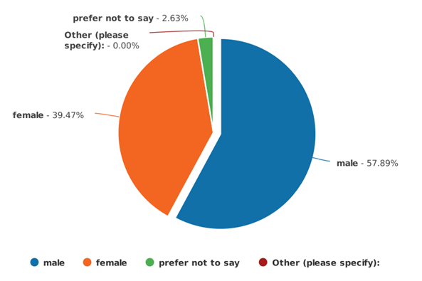

QUESTION 2 - Please state your age

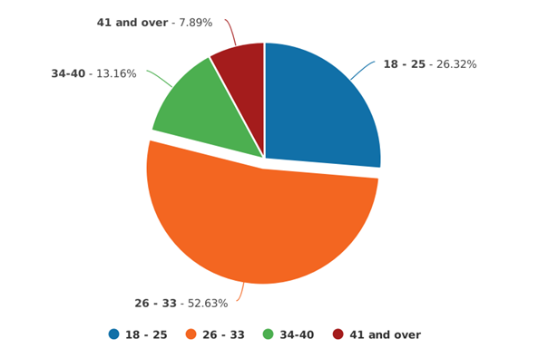

QUESTION 3 - Please state the department you work in:

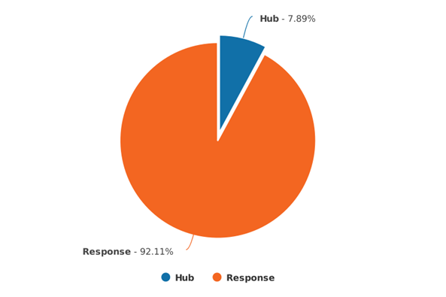

QUESTION 4 - Please indicate when you completed your initial 6 month PEQF training:

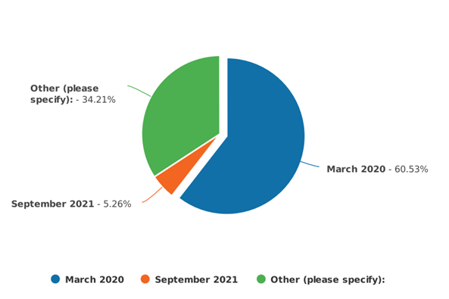

QUESTION 5 - Please list any personal experiences you have of Autism, prior to joining the police.

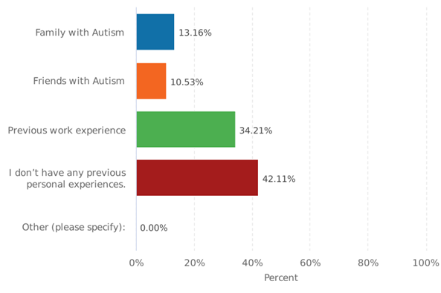

QUESTION 6 - During your initial training, did you receive Autism training as a sub section of mental health training?

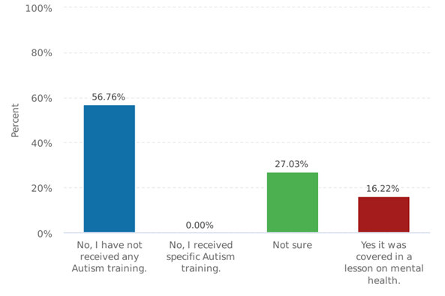

QUESTION 7 - During your initial training, how long would you estimate the duration of Autism training you received?

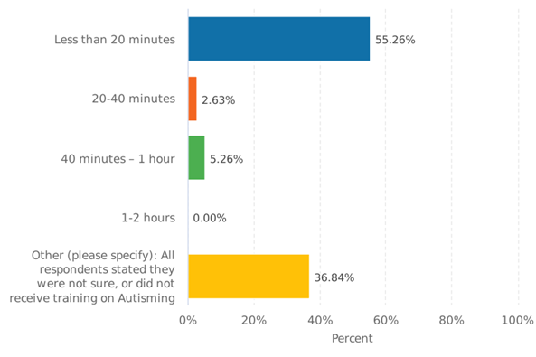

QUESTION 8 - What aspects of Autism training did you receive during initial police training?

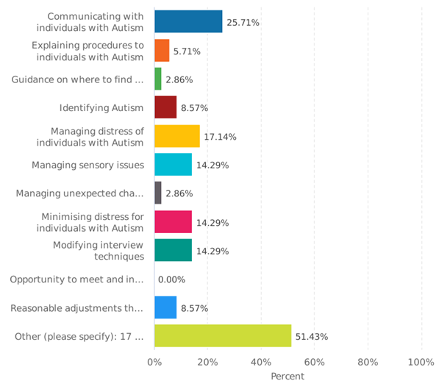

QUESTION 9 - Can you confidently explain the difference between mental health and Autism?

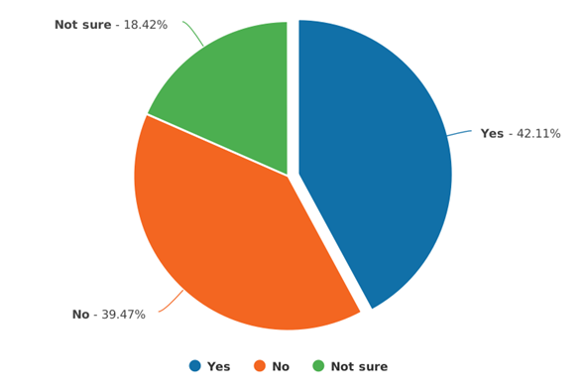

QUESTION 10 - How would you rate your knowledge on Autism?

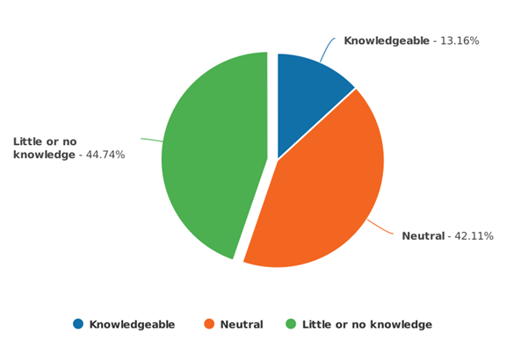

QUESTION 11 - How satisfied are you with the training you have received on Autism?

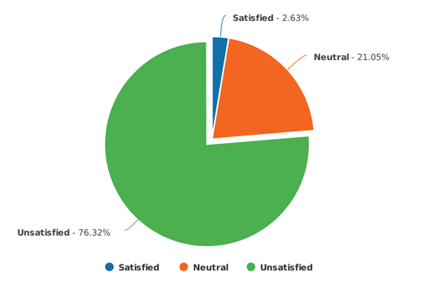

QUESTION 12 - Only complete questions 12-15 if you have dealt with an autistic individual as a suspect? Please rate ease/difficulty in explaining procedures?

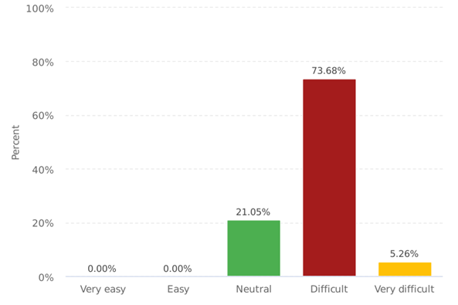

QUESTION 13 - Please rate ease/difficulty in helping to focus, engage and/or co-operate?

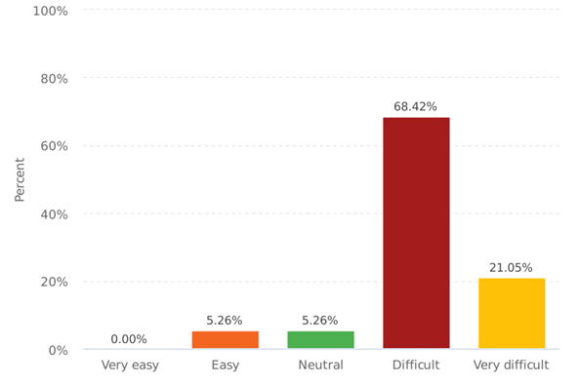

QUESTION 14 - Please rate ease/difficulty in ensuring that the Autistic individual understood the caution

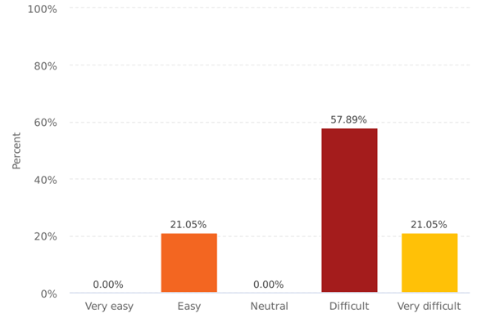

15) Please can you discuss any reasonable adjustments that were made or offered, at any time during arrest, or at any point during their detention.

15. Please can you discuss any reasonable adjustments that were made or offered during arrest, or at any point during their detention?
15. Please can you discuss any reasonable adjustments that were made or offered during arrest, or at any point during their dete
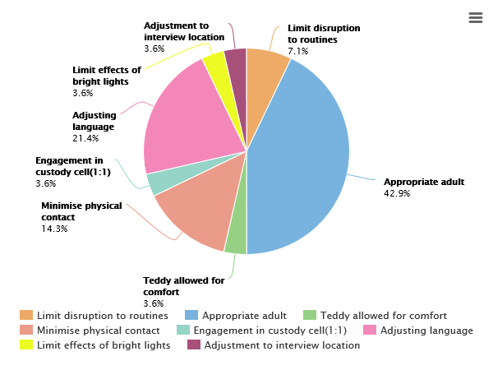

APPENDIX C – Transcript of interviews.

Interview 1 at Merthyr Tydfil custody suite.

Participation in this survey is voluntary and strictly confidential. All participants will remain anonymous. By completing this survey, you are consenting to participate in this study. Any questions or concerns you have regarding this survey, please contact me directly on steven.williams2@south-wales.police.uk. The duration of this interview is estimated to be 10-15 minutes.
As discussed prior to this interview, I will be discussing the following:
- The training you have received in relation to Autism.
- Current practices for dealing with autistic adults in custody.
- Reasonable adjustments that can be made in custody to identify autism, reduce stress, promote communication, and ensure the rights of the Autistic individual are upheld.

- How do you identify:
Male
Female
Prefer not to say
Other (please specify)
- Please state the amount of service you have, and the amount of time you have worked as a custody seargant?
Service: 15 years
Time as CS: 5 years

- Please list any personal experiences you have of Autism, prior to joining the police.
Family with Autism
Friends with Autism
Previous work experience
Other (please specify)
I don’t have any previous experiences.
- Have you received any specific training on Autism?
Yes
No, but we covered Autism under training on mental health.
No, I have not received any Autism training.
Not sure
- When did you last receive training on Autism, and what was the duration of this training?

- Every year we have 2 custody refresher days. During this training we get together and discuss experiences and challenges. Autism is always a topic that comes up. Colleagues discuss personal experiences as there are a few who have autistic children. Listening to other people’s experiences I find is a good way to learn, and you have the opportunity to ask questions and clarify certain issues you might not understand.
- About 2 years ago, I received training from a Autism charity that came in. This was fantastic. They made you wear headphones, they sprayed horrible smells, like a fart spray, around the room, and asked you to complete tasks. It helped understand the difficulties autism people face, and what we faced is probably further amplified for them.
- I received specific autism training during my initial custody training, 5 years ago. We had 2 weeks classroom based training and a week on IT training. We have to complete NCalts (e-learning) every year.

- What aspects of Autism training have you received?

Communicating with individuals with Autism
Identifying Autism
Managing sensory issues
Minimising distress for individuals with Autism
Modifying the structure of questions
Reasonable adjustments that can be offered to individuals with Autism
Managing distress of individuals with Autism
Managing unexpected changes to procedures for individuals with Autism
Explaining procedures to individuals with Autism
Guidance on where to find autism friendly leaflets, to help with understanding of procedures.
Opportunity to meet and interact with individuals with Autism.
Other (please specify)

- Can you confidently explain the difference between mental health and Autism?
Yes
No
Not sure
- How would you rate your knowledge on Autism?

Knowledgeable Seven out of ten.
Neutral
Little or no knowledge

- How satisfied are you with the training you have received on Autism?

Satisfied
Neutral
Unsatisfied

- Please rate ease/difficulty in explaining procedures?

Very easy
Easy
Neutral
Difficult
Very difficult

- Please rate ease/difficulty in helping to focus, engage and/or co-operate?

Very easy Depends what is going on in custody
Easy
Neutral
Difficult
Very difficult

- Please rate ease/difficulty in ensuring that the Autistic individual understands procedures?

Very easy Again, depends on the environment.
Easy
Neutral
Difficult
Very difficult
- How do you identify if a suspect who comes in to custody is Autistic? Are there a specific set of questions you ask?
- Always check their warning markers first.
- Ask a question similar to “do you need support with any mental health, depression or any other vulnerabilities” and “do you have any difficulties reading, writing or have learning difficulties?”.
- We also ask suspects if they “have a caring responsibility or depend on anyone”, this question can help trigger a disclosure of Autism. .
- There is no specific question to ask if they have Autism

- Do you request assistance of a healthcare professional to help identify Autism?
When they are presenting as vulnerable but not being specific about any disability or illness, then I would. There should be a HCP in custody 24/7, but it’s not always the case. We try to have an autism champion on every shift so I would contact these too. They are usually CDO’s (Custody Detention Officers) who have received more in depth training on Autism.

- Do you structure your questions differently, if you suspect or identify that a suspect is Autistic?
Yes. I will be more direct and use basic language and first names.

- Do you think it would help identify Autism is a specific question was asked- Are you Autistic?
Yes definitely.

- Do you have access to an established appropriate adult scheme?
Yes Hafal.

- What factors help you decide if an AA is a family member or requested from an established scheme?
- AA’s cannot be the aggrieved party or have any involvement in the case.
- I would listen to the individual and let them decide who they want, ensuring they are appropriate.
- Pre-cons would also need to be checked if it’s a family member to ensure that they don’t pose a risk.
- I feel that family or friends should be used when they can as they know the individual which I feel is more beneficial that knowing about Autism in general.

- How do you satisfy yourself that PACE has been adhered to, and an Autistic suspect fully understands the caution, and why they have been arrested?
How they present at the charge desk. If I have concerns I will request a HCP to carry out a fitness for interview test.

- Do you have access to any symbol based information sheets, which can help explain procedures and aid communication?

We have an easy read rights booklet from Hertfordshire Constabulary.
We also have flashcards which have been very useful with Autistic detainees who are less able to communicate verbally. They have symbols on such as drinks, food, telephone, which help to communicate. I’ve also downloaded easy read information sheets from GOV.UK previously.

- Are you aware of how you can access any such information sheets, to help explain procedures and aid communication?
Yes. As I said GOV.UK.

- What reasonable adjustments can be offered to help alleviate the impact of the sensory issues that the custody environment may have on an autistic suspect?

Please consider sensory difficulties such as bright lights, unpleasant smells, loud noises and touch sensitivity, and the impact they may have on distraction, emotional stress or a breakdown in communication. (ear defenders?)

-Lights in cells have 3 settings, bright, normal and dimmed.
- We have a confidential booking in room that we can use, as opposed to doing it at the charge desk.
- We have 3 wings on the same floor. We often keep one wing free so it can be used in the event of a detainee needing a quieter space. If we were full, then we would struggle to provide a further option, unless they were to transfer to another custody suite in extreme circumstances.
- No ear defenders available. Most probably due to a risk of causing injury, I’m not sure on that though.

- Are there any adjustments that can be made to tactile processes, such as searching, fingerprinting and DNA swabs?
Not something I have really considered. I do not think there’s any adjustments that could be made to a search.
I suppose they could carry out DNA swabs themselves, if you were confident they could do so without contaminating the swab.
Fingerprinting is quite a potchy process that needs guidance from the CDO’s. Again, I think they would have to hold and press their fingers and there’s no getting around it is there.

- Are there any difficulties within this interview room, in terms of the environment, that you feel could cause distraction or emotional distress to an Autistic individual?

I can recall two detainees (separate incidences) who have not been able to focus at all during interview because they were counting the tiles. The one would start counting again every time he was interrupted, in the end the interviewer allowed him to count the tiles before starting the interview. Eventually he was taken back to his cell and interviewed there because of the distraction.
The rooms are quite small but we do have bigger rooms available. The beeping at the start of the interview is quite loud too.

- Have you had any particular experiences that you have found difficult with autistic individuals in custody?

As mentioned just now with the tiles. It’s not really something you’d consider is it, but something so simple can cause a big difficulty. Interviewing in the cell is not ideal but I suppose there were less distractions there and making the individual comfortable, minimising distress, is the most important thing.

INTERVIEW 2 – At Bridgend Custody suite.

Participation in this survey is voluntary and strictly confidential. All participants will remain anonymous. By completing this survey, you are consenting to participate in this study. Any questions or concerns you have regarding this survey, please contact me directly on steven.williams2@south-wales.police.uk. The duration of this interview is estimated to be 10-15 minutes.
As discussed prior to this interview, I will be discussing the following:
- The training you have received in relation to Autism.
- Current practices for dealing with autistic adults in custody.
- Reasonable adjustments that can be made in custody to identify autism, reduce stress, promote communication, and ensure the rights of the Autistic individual are upheld.

- How do you identify:
Male
Female
Prefer not to say
Other (please specify)
- Please state the amount of service you have, and the amount of time you have worked as a custody seargant?
Service: 22.5 years
Time as CS: 3-4 weeks

- Please list any personal experiences you have of Autism, prior to joining the police.
Family with Autism
Friends with Autism
Previous work experience
Other (please specify)
I don’t have any personal experiences.
- Have you received any specific training on Autism?
Yes
No, but we covered Autism under training on mental health.
No, I have not received any Autism training.
Not sure
- When did you last receive training on Autism, and what was the duration of this training?
3-4 weeks ago, I completed the initial custody training. This included two weeks of PACE training, which includes specific Autism training. We also did a full day on vulnerability training which also included Autism training. Before I came to custody, I was a seargent on response and completed specific Autism training and NCALT packages online. NCALT is a form of e-learning where you complete training online. It included a video to watch about Autism.

- What aspects of Autism training have you received?

Communicating with individuals with Autism
Identifying Autism
Managing sensory issues
Minimising distress for individuals with Autism
Modifying the structure of questions
Reasonable adjustments that can be offered to individuals with Autism
Managing distress of individuals with Autism
Managing unexpected changes to procedures for individuals with Autism
Explaining procedures to individuals with Autism
Guidance on where to find autism friendly leaflets, to help with understanding of procedures.
Opportunity to meet and interact with individuals with Autism.
Other (please specify)

- Can you confidently explain the difference between mental health and Autism?
Yes
No
Not sure
- How would you rate your knowledge on Autism?

Knowledgeable
Neutral
Little or no knowledge

- How satisfied are you with the training you have received on Autism?

Satisfied
Neutral
Unsatisfied

- Please rate ease/difficulty in explaining procedures?

Very easy
Easy
Neutral
Difficult
Very difficult

- Please rate ease/difficulty in helping to focus, engage and/or co-operate?

Very easy
Easy
Neutral
Difficult
Very difficult

- Please rate ease/difficulty in ensuring that the Autistic individual understands procedures?

Very easy
Easy
Neutral
Difficult
Very difficult
- How do you identify if a suspect who comes in to custody is Autistic? Are there a specific set of questions you ask?

First thing to check would be their warning markers.
I would continuously asses their presentation when they are answering questions, ensuring I can see them. I would pay specific attention to their body language, eye contact, flapping of the hands and things like that.
We ask if they “suffer with any mental health, depression or anxiety disorders?” And “Do you class yourself as vulnerable?” and “Do you understand?”.

- Do you request assistance of a healthcare professional to help identify Autism?

Yes. A male earlier was booked in. I didn’t pick up on it when booking him in but the nurse (HCP) identified Autism when she spoke to him in his cell. Her husband is autistic so she knows exactly what to look out for. Lucky she was here. The nurses are always available but not always in custody. I think they cover other custody suites too but you can always get a hold of them.

- Do you structure your questions differently, if you suspect or identify that a suspect is Autistic?
Yes you try not to use official jargon and be direct. If I suspect Autism I have no problem asking them directly “Are you autistic?”

- Do you think it would help identify Autism is a specific question was asked- Are you Autistic?
Yes, it wouldn’t be too difficult to ask that question would it.

- Do you have access to an established appropriate adult scheme?
Yes. Hafal.

- What factors help you decide if an AA is a family member or requested from an established scheme?
We must ensure first that they have no involvement in the incident or investigation. Ultimately, I would choose family as the AA as they know the individual, and what triggers they may have. Any Tom, Dick or Harry from Hafal might be trained, but they’re going to get nowhere explaining things if they don’t know and understand the person. I had one from Hafal before and she wouldn’t go in the interview room because the suspect was screaming and aggressive. Two hours later his Auntie came. She went in to the room and he was screaming and pulling his hair. She pointed down by there (Participant points to the floor) and said that’s what’s wrong. There was a paper clip on the floor and the suspect was paranoid about small things because he thought he would swallow them. She (the auntie) put it in her bag and he calmed down straight away.

- How do you satisfy yourself that PACE has been adhered to, and an Autistic suspect fully understand the caution, and why they have been arrested?
Take them through basic steps and get them to clarify things and explain them back. If they cant then the nurse will be called to assess them to see if they’re fit to be detained and interviewed.

- Do you have access to any symbol based information sheets, which can help explain procedures and aid communication?
YES. We have a book and flash cards (Participant had brought these to interview with him).
EASY READ BOOK- Developed by Hertfordshire Constabulary.
FLASHCARDS by JAMES WYATT, 2010, Pocketcomms ltd.

- Are you aware of how you can access any such information sheets, to help explain procedures and aid communication?
Yes I think there’s stuff on GOV.UK but I have never had to check.

- What reasonable adjustments can be offered to help alleviate the impact of the sensory issues that the custody environment may have on an autistic suspect?

Please consider sensory difficulties such as bright lights, unpleasant smells, loud noises and touch sensitivity, and the impact they may have on distraction, emotional stress or a breakdown in communication. (ear defenders?)

- We have 3 wings here and always keep a wing free encase someone needs a quieter wing. We also keep that wing for juveniles and it’s rear the cells are full.
- We can adjust observation levels, checking on the individual. Cameras can be used instead if the noise of the spy hole opening is too loud or scares them.
- Engagement observations can also be used if it helps, whereby CDO’s will stay and talk to the individual every ten, twenty, thirty minutes, or whatever suits.
- Lights in cell can be adjusted. They have three settings, normal, bright and dimmed.
- We can put them in cells the opposite side of custody to the kitchen, to avoid smells coming from the kitchen.
- Corridor lights can be dimmed also.
- Paint on the walls are neutral, duller colours. There’s nothing bright that could cause issues.
- We don’t have access to or provide any ear protection due to the risk of self harm. There’s no knowing what are inside them, whether they contain sharps or any ligature risks.

- Are there any adjustments that can be made to tactile processes, such as searching, fingerprinting and DNA swabs?
I would say that is probably the most difficult part. They have to be searched and there’s not many adjustments that can be made. The fingerprinting machine is very sensitive and it would be a nighmare to get them to do it themselves because it wouldn’t work. There’s a certain pressure, and a knack to getting it right. CDO’s can just ensure that they fully explain what they are doing and why before doing it.

- Are there any difficulties within this interview room, in terms of the environment, that you feel could cause distraction or emotional distress to an Autistic individual?
I just mentioned neutral colours but the blue tiles are not neutral are they. The size of the room is very small and could be intimidating if there’s four of five people in here. The lights on the door could be a distraction and the furniture is wooden and hard. I just thought.... we do have larger rooms here for interview too. Not something I have thought about before but they might be more suitable to interview an autistic person.

- Have you had any particular experiences that you have found difficult with autistic individuals in custody?
YES. We had a female come I to custody who was very distressed and there was no reasoning with her. She was targeting the arresting officer, and I felt there was no calming her whilst he was present. I asked him to leave and he said “We let them call the shots now do we, I’m booking her in so she’ll have to deal with it”. He eventually left but took it very personally. I tried explaining to him why I made that decision but he could not comprehend it. She calmed as soon as he was out of the way. She had to wait in the cell with staff for 20 minutes before coming back to the desk to book in. She was extremely sensitive to noise and said that the sirens had been on, on the way to custody. I think she needed that time in the cell to come around before was able to process and understand what I was telling her.

Participation in this survey is voluntary and strictly confidential. All participants will remain anonymous. By completing this survey, you are consenting to participate in this study. Any questions or concerns you have regarding this survey, please contact me directly on steven.williams2@south-wales.police.uk. The duration of this interview is estimated to be 10-15 minutes.
As discussed prior to this interview, I will be discussing the following:
- The training you have received in relation to Autism.
- Current practices for dealing with autistic adults in custody.
- Reasonable adjustments that can be made in custody to identify autism, reduce stress, promote communication, and ensure the rights of the Autistic individual are upheld.

- How do you identify:
Male
Female
Prefer not to say
Other (please specify)
- Please state the amount of service you have, and the amount of time you have worked as a custody seargant?
Service: 28 years
Time as CS: 5 years

- Please list any personal experiences you have of Autism, prior to joining the police.
Family with Autism
Friends with Autism
Previous work experience
Other (please specify)
I don’t have any previous experiences.
- Have you received any specific training on Autism?
Yes
No, but we covered Autism under training on mental health.
No, I have not received any Autism training.
Not sure
- When did you last receive training on Autism, and what was the duration of this training?
- We have a two-day refresher training every year. We had this about 6 months ago and covered about an hour on Autism. Two years before, roughly September 2019, we had a charity come in and did a full days training on Autism. That was brilliant, I learnt a lot. They done a few different tasks, where they put a strain on your sensory abilities, and make you perform tasks.
- We also have an NCalt package to complete. It’s online learning or e-learning it’s called. There’s a video they show you with and I think you have an assessment at the end.

- What aspects of Autism training have you received?

Communicating with individuals with Autism
Identifying Autism
Managing sensory issues
Minimising distress for individuals with Autism
Modifying the structure of questions
Reasonable adjustments that can be offered to individuals with Autism
Managing distress of individuals with Autism
Managing unexpected changes to procedures for individuals with Autism
Explaining procedures to individuals with Autism
Guidance on where to find autism friendly leaflets, to help with understanding of procedures.
Opportunity to meet and interact with individuals with Autism.
Other (please specify)

- Can you confidently explain the difference between mental health and Autism?
Yes
No
Not sure
- How would you rate your knowledge on Autism?

Knowledgeable
Neutral
Little or no knowledge

- How satisfied are you with the training you have received on Autism?

Satisfied
Neutral
Unsatisfied

- Please rate ease/difficulty in explaining procedures?

Very easy
Easy
Neutral
Difficult
Very difficult

- Please rate ease/difficulty in helping to focus, engage and/or co-operate?

Very easy
Easy
Neutral
Difficult
Very difficult

- Please rate ease/difficulty in ensuring that the Autistic individual understands procedures?

Very easy
Easy
Neutral
Difficult
Very difficult
- How do you identify if a suspect who comes in to custody is Autistic? Are there a specific set of questions you ask?
I stick to the set questions that we ask every person who comes in to custody. There is no specific question about autism but we do ask if any support is needed for mental health, depression, or anxiety, or if they have any vulnerabilities we need to be aware of. We ask if they have any difficulties reading or writing or any learning difficulties. I know that a learning difficulty is different to Autism but I think it is common for a person with Autism to also have a learning disability. We would also check their markers on the system, but I find the best way is to interact with them and observe any social and behavioural difficulties they have.

- Do you request assistance of a healthcare professional to help identify Autism?
Yes, I would if it was not disclosed and I identified signs and symptoms. There is always a HCP available and they are better trained to identify different conditions.

- Do you structure your questions differently, if you suspect or identify that a suspect is Autistic?
Yeah, obviously you use basic language and shorter, single questions.

- Do you think it would help identify Autism is a specific question was asked- Are you Autistic?
Yes, thinking about it there is no specific question is there. Due to how literal they can be, there probably should be a question simply asking “DO you have Autism?”

- Do you have access to an established appropriate adult scheme?
Yes we use Hafal for adults, but it would be YOS for youths.

- What factors help you decide if an AA is a family member or requested from an established scheme?
Wether or not they have any part in the investigation, as victim or a witness. Also, if they are suitable, we always check pre-cons to make sure. If they are suitable, I would rather choose a familiar person, family usually, because they are more likely to keep the individual calm and have more knowledge on their needs. I doubt an AA will have any further knowledge of the individuals needs than you or I would. To be honest, I don’t know what training AA’s receive or what exactly they do. In my opinion they are not always beneficial.

- How do you satisfy yourself that PACE has been adhered to, and an Autistic suspect fully understand the caution, and why they have been arrested?
A fitness for interview test would be conducted by the HCP, if I had concerns.

- Do you have access to any symbol based information sheets, which can help explain procedures and aid communication?
Yes, we have an easy-read rights booklet and flashcards. I have only just come back from leave and they are not in the draw they’re normally kept in, otherwise I was going to bring them to show you. I will find them later. Proves they do get used though.

- Are you aware of how you can access any such information sheets, to help explain procedures and aid communication?
I have used some from BOB and I believe anyone can access them on the GOV.UK website.

- What reasonable adjustments can be offered to help alleviate the impact of the sensory issues that the custody environment may have on an autistic suspect?

Please consider sensory difficulties such as bright lights, unpleasant smells, loud noises and touch sensitivity, and the impact they may have on distraction, emotional stress or a breakdown in communication. (ear defenders?)

- We have two floors here. Only on a weekend does the second floor of cells get used. We usually keep the loud, difficult prisoners downstairs. Upstairs is a lot calmer and quieter. You don’t have people back and forth, like downstairs. I have always placed Autistic detainees on the top floor for this reason. There’s less likely to be unpleasant smells on the top floor too. The kitchen is on the ground floor, and it is generally cleaner up there with difficult prisoners being housed downstairs, you know the dirty protests and things would happen downstairs.
- Lights upstairs can be adjusted in corridors and by the charge desk. You wouldn’t do that downstairs for one person, due to how busy it is. It’s a bit different here because, as you know, it’s always manic. The lights can be adjusted in the cell too. I think there’s three different settings on them.
- No ear protection is available. No items can be taken in to cells unless they were on one-to-one observation I guess.

- Are there any adjustments that can be made to tactile processes, such as searching, fingerprinting and DNA swabs?
I guess they could do the swabs themselves but I don’t think there’s any other way of searching them or doing the fingerprinting. The CDO’s have to role their fingers for them. You could get the individual to remove all of their own clothes and wear issued clothing but that would be more intrusive, and they might prefer to wear their own clothing, due to textures and smells.

- Are there any difficulties within this interview room, in terms of the environment, that you feel could cause distraction or emotional distress to an Autistic individual?
The room is small isn’t it. The lights are quite bright, especially if you have just come out of a dark cell. The soundproof tiles (green) could be a distraction to some people I guess. Quite often, I know that Autistic detainees have been interviewed in their cells on Body Warn because they can’t cope with these rooms.

- Have you had any particular experiences that you have found difficult with autistic individuals in custody?
Not difficult, but I do remember refusing to detain an individual. He was arrested for theft of chocolate bars. The arresting officers were not aware that he was autistic, and this was identified at the charge desk, as he stated that he had gone out without his carer. There was no necessity for the arrest and no reason he couldn’t be VA’d. His carer attended custody to collect him and told officers that he always carries chocolate on him because he’s diabetic. He often goes in to shops and fixates on putting chocolate bars in order. He had OCD (obsessive compulsive disorder) and his local shops would allow him to reorganise chocolate bars as they knew him. Obviously, the shopkeeper on that day didn’t know and called the police.

APPENDIX D – Photos of communication aids used in custody.



