
Course: BSc (Hons) Health and Social Care
Module: Independent Project (BMHP6020_BIRM)
Component 1: Element 1 - Project Proposal
Student ID:
Student Name: Celine Bena
Title: Investigating the relationship between air pollution exposure and Asthma exacerbations among adults in the UK.

Table of Contents
Element 1 - Project Proposal 3
3) Background 3
4) Methods 4
5) Resources 4
6) Timescale 5
7) Self-reflection 5
References 6

Element 1 - Project Proposal

My project Title: Investigating the relationship between air pollution exposure and Asthma exacerbations among adults in the UK.
1) Aim
The main aim of the study is to figure out the interrelationship between air pollution and exacerbation of Asthma among adults in the UK.
2) Objectives
- To examine the issues of air pollution in the UK
- To evaluate the consequences of Asthma among UK adults
- To analyse the interrelationship between exposure to air pollution and exacerbation of Asthma among UK adults
- To recommend possible solutions to manage air pollution for the mitigation of long-term disease, Asthma

3) Background
The study focuses on the interrelationship between the increasing impact of air pollution and the exacerbation of Asthma among adults in the UK. The GP of the NHS in England highlighted that approximately 45% of the increase in Asthma attacks is attributed to the previous benchmark, and air pollution significantly worsens the overall condition (Orlovic et al., 2024). Along with the development of technology, air pollution is increasing rapidly due to the emission of greenhouse gases into the environment.

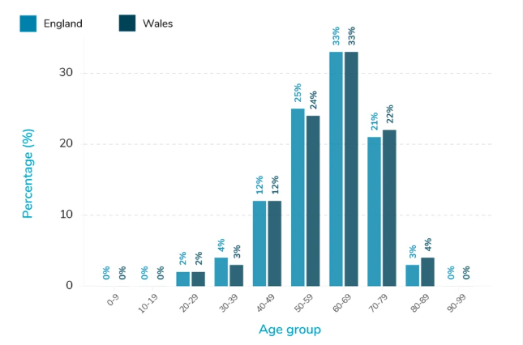
Source : (Han et al., 2023)
Approximately two-thirds of people with Asthma have been suffering due to poor air quality, and the overall condition is being exacerbated. Around 7.2 million people in the UK are living with long-term respiratory conditions like asthma (Gao et al., 2023). The air quality index varies by location, with Crowland in England being the most polluted city with 65 AQI. On the contrary, Dunblane in Scotland is the cleanest city with 12 AQI. The study will figure out the reason behind air pollution in the UK and its impact on adults, covering recommendations for the management of the condition (Macintyre et al., 2023).

4) Methods
The secondary method of research is going to be applied for further evaluation of the study. Different types of journal articles, authentic government websites, proper policy documents, and different open academic resources will be utilised to accommodate necessary data.
The criteria for the selection of the resources and accumulation of data will be associated with the proper utilisation of Google Scholar to identify current, authentic, accurate journals aligned with the aim and objectives of the study (Furidha, 2023).
After the accumulation of secondary resources, the further process of analysis will be followed by the execution of thematic analysis, identifying initial codes, interpretation and final themes from the findings.
The resources will be properly cited in the overall findings, and proper citations will be added in the reference list to avoid the possibility of academic misconduct. The overall process will be done in the researcher's own words to avoid the possibility of plagiarism.

5) Resources
Online database - data from NHS and UK Government website
Google scholar
MS Word / Excel

6) Timescale
Activities | Week 1 | Week 2 | Week 3 | Week 4 | Week 5 | Week 6
Topic, aim and objectives selection
Identification of the resources literature review
Planning and execution for secondary research and estimation
Findings and analysis
Closure
Source: Author

7) Self-reflection
As a researcher, I have found that my strength area is the estimation and evaluation of the topic to proceed with the literature review. I faced challenges in the overall process of time management and consideration of the subsequent stages, where I need to be more proficient to proceed with the research successfully in future.

References
Furidha, B.W. (2023) ‘Comprehension of the descriptive qualitative research method: A critical assessment of the literature.’ Acitya Wisesa: Journal Of Multidisciplinary Research, pp.1-8. Available at: https://doi.org/10.56943/jmr.v2i4.443
Gao, X., Jiang, M., Huang, N., Guo, X. and Huang, T. (2023) ‘Long-term air pollution, genetic susceptibility, and the risk of depression and anxiety: a prospective study in the UK Biobank cohort.’ Environmental Health Perspectives, 131(1), p.017002. Available at: 10.1289/EHP10391
Han, Y.Y., Chen, W., Forno, E. and Celedón, J.C. (2023) ‘Adverse events during adulthood, child maltreatment, and asthma among British adults in the UK Biobank.’ Annals of the American Thoracic Society, 20(11), pp.1614-1623. Available at: https://doi.org/10.1513/AnnalsATS.202305-481OC
Macintyre, H.L., Mitsakou, C., Vieno, M., Heal, M.R., Heaviside, C. and Exley, K.S. (2023) Impacts of emissions policies on future UK mortality burdens associated with air pollution. Environment International, 174, p.107862. Available at: 10.1016/j.envint.2023.107862
Orlovic, M., Tzelis, D., Guerra, I., Bar-Katz, V., Woolley, N., Bray, H., Hanslot, M., Usmani, O. and Madoni, A. (2024) ‘Environmental, healthcare and societal impacts of asthma: a UK model-based assessment.’ ERJ Open Research, 10(4), pp.00577-2023. Available at: https://doi.org/10.1183/23120541.00577-2023

