‘Our world’ Exhibition

Introduction
‘Our world’ exhibition represents the reality of our landscapes today. It brings together a mixture of artworks ranging from paintings to human sculptures to reveal the truth about the harm we are creating to our surrounding landscapes today and how they might exist in the years to come if no change is made.
The artwork featured will educate viewers about how environmental issues such as pollution has affected our surrounding environment.
The purpose of the exhibition is to raise awareness to the public about the world in which we live in today and persuade viewers to make a change to their lifestyle to minimise the harm.
The artists i've chosen to include in the exhibition are Alexis Rockman, Edward Burtynsky, Keith Arnatt, Andreas Gursky and Ha-schult. I choose these artists because each of their artwork highlights environmental issues caused by neglect and industry.

Context
The environment is the air we breathe, the land we live on and the water we drink. The environment has vastly changed over the past few years and is still rapidly changing today, getting worse day by day. It is easy to overlook and ignore the damage that is being done to our environment.

It's vital to look after the environment because:
- It gives us food- it helps grow fruit and vegetables from trees and the ground
- It gives us medicine
- Creates the air we breathe through the process of photosynthesis
Our landscapes are hugely affected by:
- Wildfires
- Deforestation
- Pollution
- Littering
- Acid rain
Wildfires are usually caused by humans. They have a negative impact on soils, the environment and the economy.

Deforestation is caused by trees being cut down which increases the amount of carbon dioxide in our atmosphere causing global warming.

Littering is caused by leaving waste on the floor rather than putting it in a bin. This creates a major effect on our environment because of the large amount of money used to clean the rubbish from the roads which then pollutes the clean air.

Pollution
The three major type of pollution air, water and soil. Each one of these harm our surrounding environment.
Air pollution - This is caused by the vehicles we use, the carbon dioxide released increases the planet temperature creating global warming.
Water pollution- This is created by rubbish being thrown in waters which producing dirty polluted water.
Land pollution- Land pollution is land that has been damaged by waste and human activities.
Soil pollution- soil pollution is produced from a mixture of things e.g. waste disposal. It affects the growth of plants and our health.

Acid rain is rain that has a high PH levels and large amounts of acids. It created by burning gases into the atmosphere. It affects both animals and landscapes.

Artworks and Artists

Alexis Rockman
Alexis rockman is an american artist. His paintings show future landscapes that have been affected by environmental issues. His paintings bring to attention about our actions and attitudes towards the natural world.
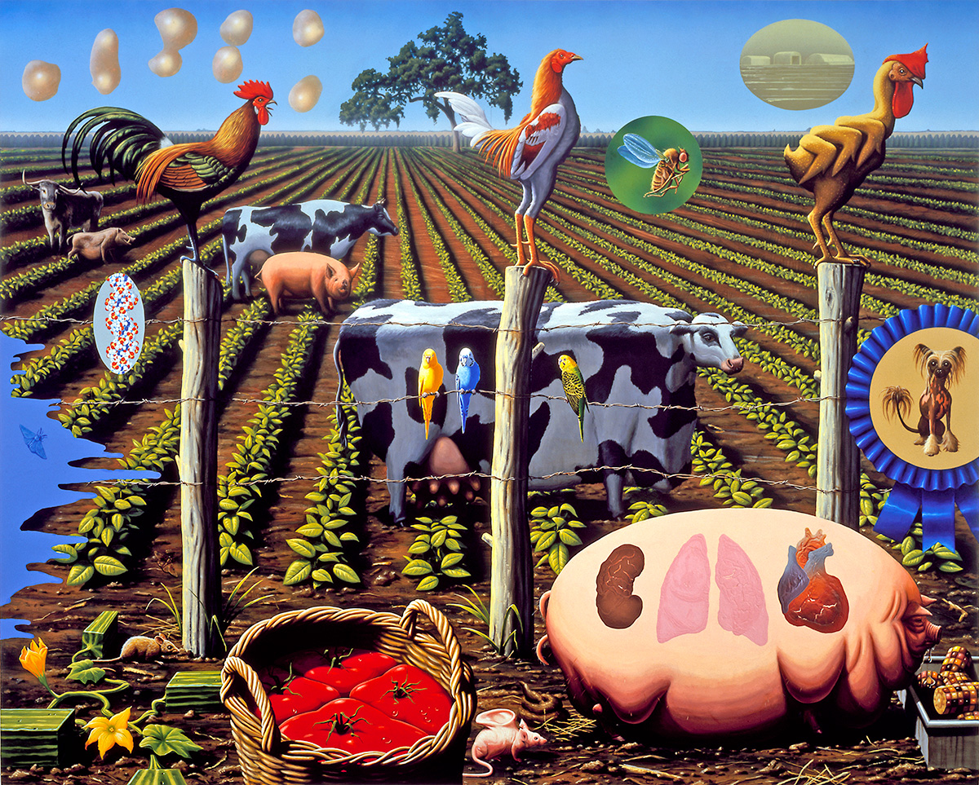
This agricultural style painting is called ‘the farm’ by the artist Alexis Rockman. The painting shows animals that have been genetically modified. The pig for instance, is very obese and has human organs growing inside of him, because they specifically hearts similar to human hearts.The background of the painting show three chickens. The first chicken appears normal although the other two look very different. The other two chickens show the process through genetic modification, one chicken appears with different colours and the other one has three wings. I choose this painting for the exhibition because it shows the danger of genetic engineering to animals and the environment.

Edward Burtynsky
Edward Burtynsky is a canadian photographer and artist. His artwork shows landscapes such as quarries that have been affected by industry. The meaning of his work is to reveal the harsh reality of what people never really see or choose to ignore about the results of our consumption.
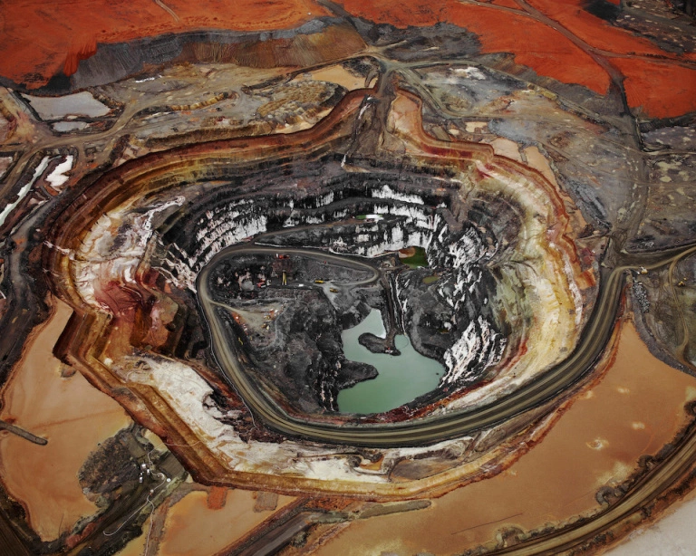
This photograph was taken at a mine in Australia. The image shows a natural landscape that has been affected by human industrialization. The first elements that immediately caught my eye within this work are the textures and patterns, it makes the landscape really interesting to look at. The road leads the viewer eye into the circular pit in the middle for viewers to have a closer look. The work is visually pleasing because of its contrasting colours, the warm colours give a sense of calmness and strongly gets the message across to viewers.
Even though his work shows the negative impact of indutrustrliazion on nature, it also shows beauty within the vastness of the landscape. I choose this piece of work because it draws attention to the environment hazards in the world today. I think the purpose of his work is to encourage viewers to change the way we do things. His work makes viewers think of what they could do for the environment to avoid anything like this happening again.

Keith arnatt Keith Arnatt is a British artist. His series of work called ‘miss grace's lane’ shows photographs of rubbish that has been abandoned. The photographs were produced in the late 80s to early 90s when industrialism and pollution was starting to become an concern politically. The series of work show the wastage and excess humans create and makes viewers aware about how we value things. The objects displayed in his work emphasis both their beauty and deacy.
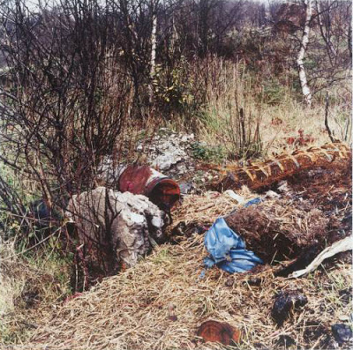 This is one of the images from his series of work. It shows discarded rubbish that's been left behind. I find the image captivating because it is a representation on how we live today and shows the negative impact we have as humans on our environment.
Ha-schult Ha schult German artist. He creates sculptural humans called ‘Trash people’ which are made out of crushed cans, computer parts, bottles and more to raise awareness to recycle and reduce waste. The ‘trash people’ draw to attention about how litter causes landfill and what our world is experiencing today.
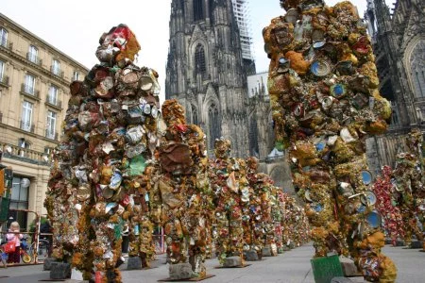
I find these sculptures very interesting and powerful because they make viewers think about the litter we produce and how it has harmed our planet. It also reveals the fact that the world is becoming less natural. Exhibiting these sculptures made out of litter will allow viewers to relate to the piece of artwork

Andreas Gursky
Andreas Gursky is a German artist. His work shows large landscape photographs taken from high vantage points of industrial and urban areas such as factories. The sharp details captured in his photographs makes his images seem unreal and yet true at the same.
I choose this artist for the exhibition because his work shows the man made world we have created and highlights the effects of globalism.
This photograph shows an inside of supermarket. It portrays all the items stored within the shop. The colours captured and composition technique used makes the the photograph visual appealing. I like this image in particular because of the amount of detail that has been captured, the work makes viewers think about social landscapes around the world today.

Diagram of artworks
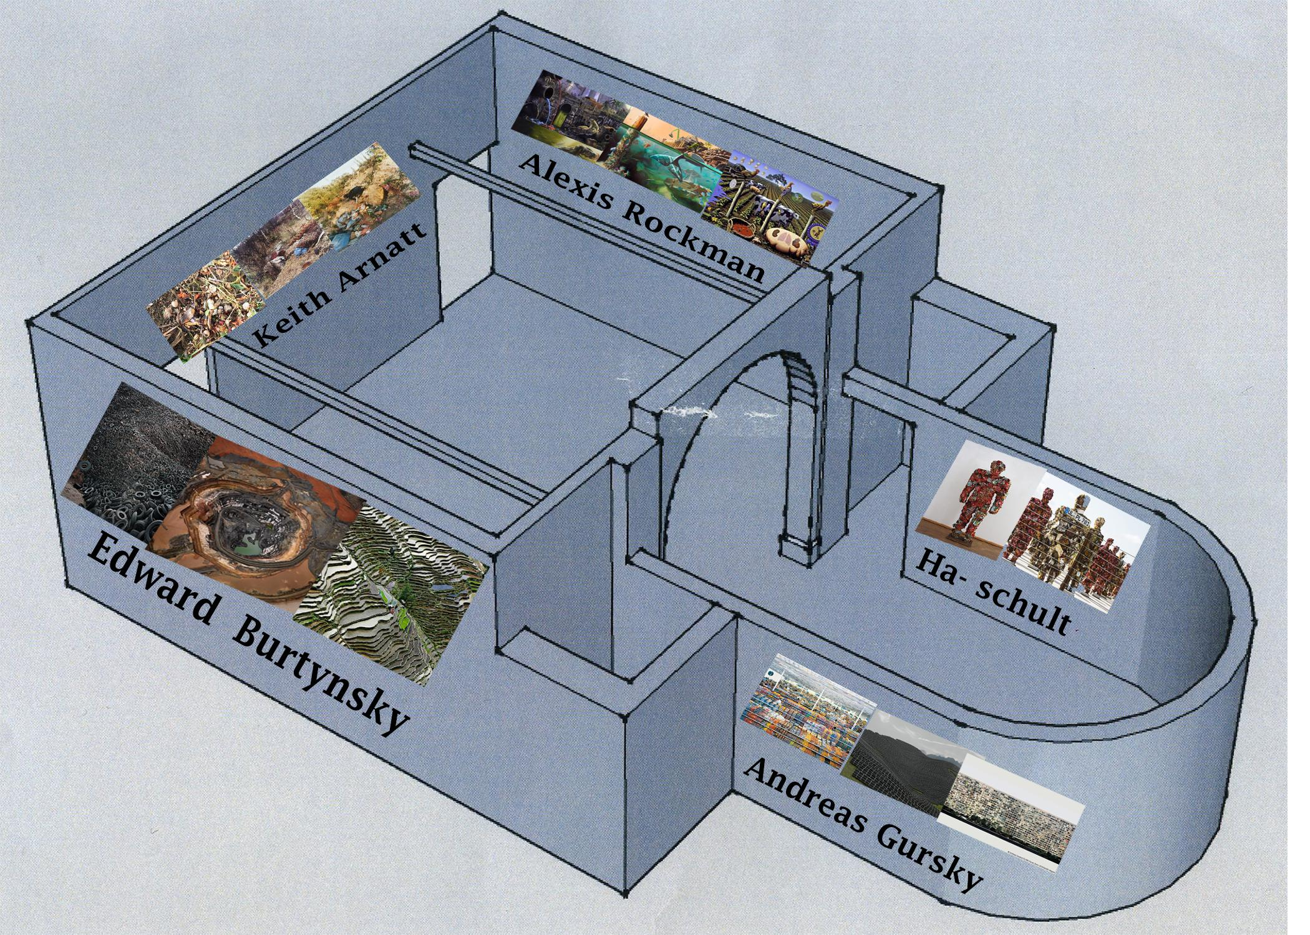
The artworks featured in the exhibition will be displayed within one room to give an emotional connection and atmosphere to the viewers.

Bibliography
Alexisrockman.net. (2018). Wonderful World | Alexis Rockman. [online] Available at: http://alexisrockman.net/wonderful-world/ [Accessed 3 May 2018].
Edward Burtynsky. (2018). Mines. [online] Available at: https://www.edwardburtynsky.com/projects/photographs/mines/ [Accessed 3 May 2018].
Tate. (2018). ‘Miss Grace’s Lane’, Keith Arnatt, 1986-7 | Tate. [online] Available at: http://www.tate.org.uk/art/artworks/arnatt-miss-graces-lane-t13165 [Accessed 3 May 2018].
Pinterest. (2018). whatever. [online] Available at: https://www.pinterest.co.uk/pin/513691901218790873/?lp=true [Accessed 3 May 2018].
En.wikipedia.org. (2018). Environmental issue. [online] Available at: https://en.wikipedia.org/wiki/Environmental_issue [Accessed 3 May 2018].
Globalissues.org. (2018). Environmental Issues — Global Issues. [online] Available at: http://www.globalissues.org/issue/168/environmental-issues [Accessed 7 May 2018].
Alexisrockman.net. (2018). Wonderful World | Alexis Rockman. [online] Available at: http://alexisrockman.net/wonderful-world/ [Accessed 3 May 2018].
Edward Burtynsky. (2018). Home Page. [online] Available at: https://www.edwardburtynsky.com/ [Accessed 7 May 2018].
En.wikipedia.org. (2018). HA Schult. [online] Available at: https://en.wikipedia.org/wiki/HA_Schult [Accessed 7 May 2018].

