University Trinity Saint Davies, Marketing Information System.
Student Name: Andreia Dumintrascu
Student ID: 1905740
Module Code: M4X01916
Lecturer:



Table of Content

Page 3……………………………………………………………Introduction
Page 3-4 ……………………………………………Marketing within MIS
Page 4………………………………………………Gathering Information
Page 4-5………………………………………………………………Communication
Page 6…………………………………………………………………Effectiveness
Page7…………………………………………………………………...Conclusion
Page 8……………………………………………………………………References

Introduction Within the following lines and paragraphs, The importance of Marketing Information System will be analysed focusing on the Hotel and Tourism Industry. Also, its effectiveness will be analysed as well especially when it comes to it being used as a tool for the gather of information to maintain a good reputation of the hotel.
Marketing Information System according to Kotler (2006) is a system that gathers, stores, analyses and share important information and data to managers. Therefore, it is important that all the hotels have got this system to be able to share every data needed through all the departments. MIS next to the theoretic definition can be described as being built by networks and software equipment that is working to put all the decisions and important analysations that need to be made considering the data collected by the entire hotel. The specific topics that will be mentioned in this assignment are the following, gathering, importance of MIS in Marketing, Communication and MIS’s effectiveness over the hotel industry, also, all of the mentioned topics will be linked with the chosen hotel which is The Amathus Beach Hotel, Cyprus which is one of the luxury hotel located just a few meters of the beach offering to the guests loads of facilities and services.
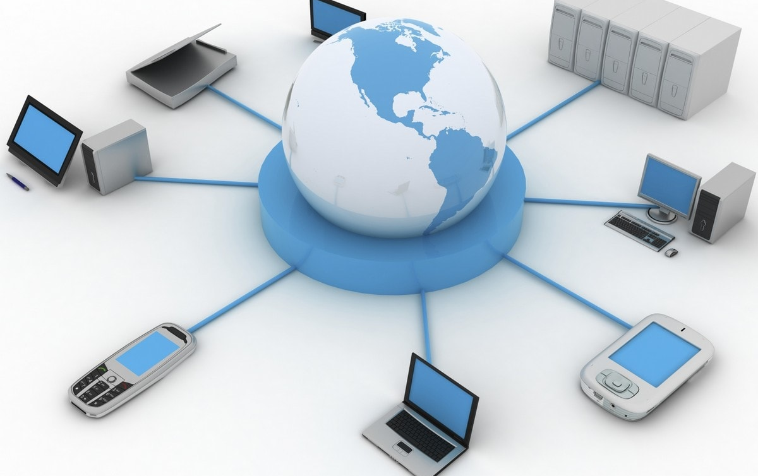 Marketing within MIS
Speaking from the side people think that marketing is all based on good products, great impact on guests and profit that accords to the hotel’s economy. Theoretically then describing the marketing considering the MIS is developed through the information and decisions that are took after the needed processes. According to Harmon (2003) The marketing Information System is the system that is influencing the way the marketing works in a hotel and this because it transfers information’s about guests, suppliers and any other associates. Therefore, it has information about everyone, and it should collect only the necessary ones to make sure that the hotel is working in making profit continuously. It is very important that the managers are using the decisions in a very productive way, because there could be services that they could include or take out, services that may have an vey unexpected impact on customers.
Thinking about the chosen hotel as a model it can be seen that the staff is always doing such a good job in using the system in the best way possible and this because those people in charge are trying to make sure that the hotel touches as much as possible the luxury standard. Therefore, it did initiate loads of facilities such as outdoor and indoor pools, access to restaurant and specific food, gym, jacuzzi bath, sauna, tennis table, meeting rooms, hairdressers. There are many services as well, services just as, free parking, WI-FI, room service, fitness classes, live music and many other, that were introduced to increase the level of satisfaction of the customer, to increase the economy of the hotel and its reputation as well. To make sure that the hotel is keeping its high standard they are continuously checking on the feedbacks and on the number of new coming to them every year to make sure that the right decisions are taken with the support of the MIS which is showing through data either if the guest is happy or not with the given services.
Gathering Information
There are so many ways to collect information and to keep updating it day to day. James A. (1998) define marketing information system as “A structured, interacting complex of persons, machines and procedures designed to generate an orderly flow of pertinent information collected from both intra and extra-firm sources for use as the bases for decision making. All the businesses in the Hotel and Tourism especially should have specific systems for each department to be able to keep all the needed information for each guest coming at the hotel. Next to the software systems, there are practical methods to collect feedbacks and opinions. Some of the methods are described as questionnaires, interviews, telephonic basic questions. Also there is a good option if the hotel is using social media to share information to the guests and people that aspire to come at the hotel and then to wait until there will be shown relevant result of the impact of the products over the people and to compare by balancing the different reactions on different products.
In the chosen hotel, which is Amathus, it can be showed that everyone is trying their best to organize and to plan as many strategies as possible to be able to collect information that will then help in taking decision to rise up the hotel itself. For example, they are creating electronic questionnaires after each ended call to make sure that the people are giving a rate for the services. Next to the basic information that are linked with the feedback that is helping with decisions about the products, facilities and services, they are collecting information about competitors that are trying to successfully rise their hotels above the other ones in the same area. Therefore to make sure that the staff from the Amathus Hotel is doing the best job, they are continuously checking what other hotels provide, this using the MIS to collect all the information needed and then to take decisions referring to what can be done to keep the “competition” be frequently won by the Amathus Hotel . 
Integrated Marketing Information and Communication System
Communication is one of the most important aspects of the hotel and this because it allows all the people in charge of the hotel to share information through the departments and also it allows them to discuss clearly and detailed what needs to be done, what is going well, what is going worse and how they should either maintain or improve this. Also, the communication within customers is very important as well and therefore staff must keep creating relationships within professional boundaries to make sure that people are being honest and comfortable when speaking about their experiences and about their expectations/ aspirations. Communication is also very important when the decisions are about to be taken, decisions about prices, products, services, facilities etc…
Thinking about the Amathus hotel following the theory, communication within the guests is very well structured because there will be always people to speak to no matter what the customer has to say. On its website it has live chats set up, and usage of social media to make sure that the guests have enough sources to get in touch with everything is available for the hotel as well. Another important thing that includes the communication within the Amathus hotel is that the principal system of communication is b internal system, email-based to make sure that all the staff is able to communicate one to another any needed aspect.

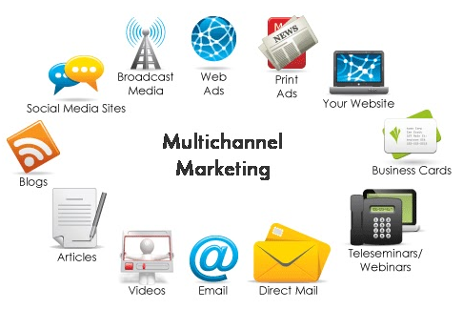

Effectiveness of MIS
About the MIS effectiveness I can say that MIS is one of the most effective tolls in the hotel industry and this because it is in charge of all the systematic “life” of the hotel especially when it comes to decisions, updates or downgrades. As Richard and Stafford said in 10968; the marketing information system has been the first tool that appeared after the computers were initiated for commercial and scientific purposes. Also, its purpose has always been the same, to be able to use the specific systems such as marketing intelligence system or marketing research system, marketing decision support system… to be able to provide the hotel with everything that is needed to touch expectations and to be able to create an atmosphere between staff, atmosphere which will help in the communication and the analyse of the data collected.

Considering the hotel from Cyprus, considering MIS from all the aspects and this because it is increasing the amount of people coming to it each year, thing that really demonstrated that the decisions that are made over the hotel in terms of changes, products and services are well taken and that the right people are taking part at the meeting and at the processes. Also, MIS is used for the data collection from everyone coming and not only. The information is then used to make different decisions considering the hotel and its departments

Conclusion
As a conclusion after analysing the MIS purpose and some other aspects that have at the base the marketing informational system, the final result is that that MIS has such an important role in any of the hotels. This because it is developing the hotel itself and it pushes it to the best way of going possible. About the Amathus Hotel can be said absolutely that the staff is using MIS in a very effective way and that they are trying to maintain and collect all the information up to date and to make sure that all the data and all the decisions are correctly taken in the hotel’s advantage.

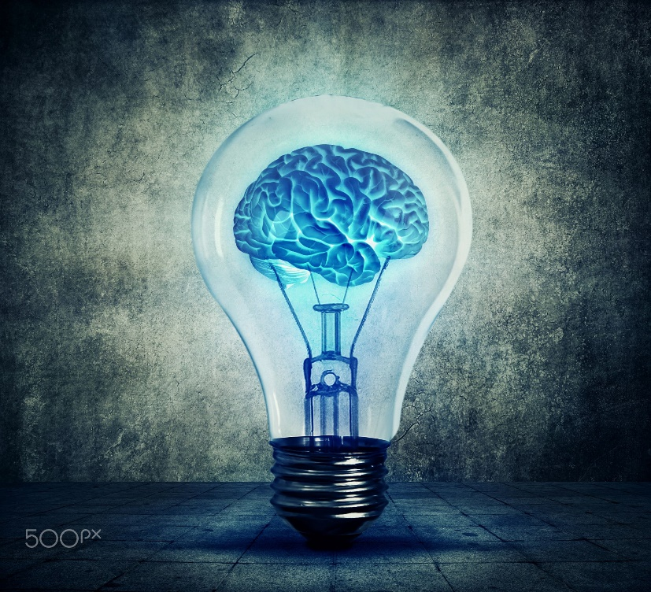

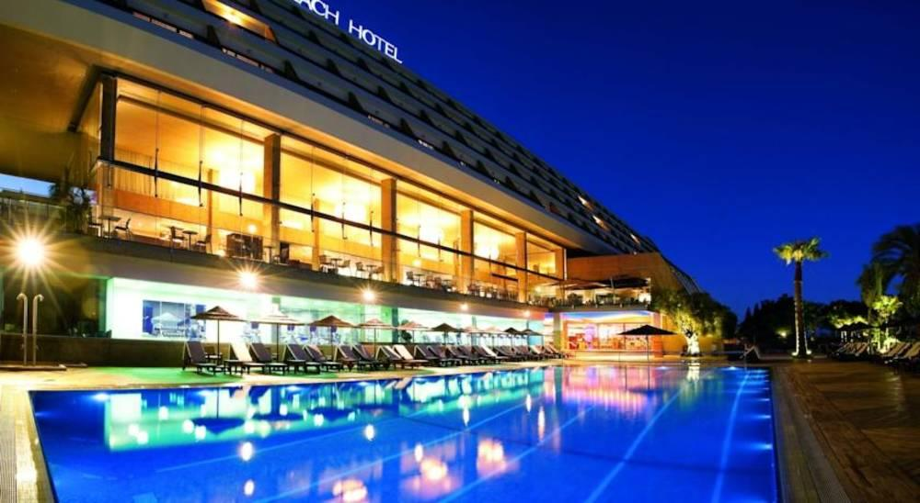

References

Harmon Robert R. (2003). Marketing information system, Encyclopaedia of information systems, Volume 3. Elsevier Science (USA), 137-151
Richard H. Brien &James E. Stafford. (1968), Marketing information systems, a new dimension for marketing
Kotler F Keller K (2006). Marketing Management. Northwester University: Dartmouth College
researchhttps://www.researchgate.net/publication/272492393_MARKETING_INFORMATION_SYSTEM/link/54e645490cf2cd2e028e6998/download
https://www.amathuslimassol.com/privacy-policy
https://www.researchgate.net/publication/322746420_Marketing_Information_Syste ms_An_integrative_view

