This assignment is an example how assessment for learning can aid progression within three areas of learning within the primary school sector. Both students and teachers often use assessment for learning to decide what stage the learners are at, where they need to go and the best way to get them there.
Assessment for learning is fundamental within all educational establishments across the world. There have been considerable changes within assessment for learning in Welsh schools in recent years. It has previously been observed that The Successful Futures report has been a key influence for change by addressing the current weaknesses within assessment for learning in order for it to be improved within Welsh Education (Donaldson, G. 2015). Throughout this essay assessment for learning in Wales, its weaknesses and improvements will be discussed and explored further. Examples of learning opportunities which will demonstrate progression within three areas of learning experience will also be discussed and evaluated. These learning opportunities are designed for a year five class consisting of twenty-eight learners aged between nine and ten years old. This is a mixed ability group of students in a lower-class area of the city. The class includes an autistic learner, two learners with speech and communication impairments and a student with severe behavioural issues which can impact the learners he is working with. Twelve out of the twenty-eight students have English as an additional language from stage A-D and there are 8 languages between the students. Despite the learning and language difficulties this group of students face, the year group has three additional adults who provide language, learning and emotional support. There are strategies in place for students who struggle concentrating throughout lessons such as a quiet area and headphones to combat noise disturbance for those who are sensitive to sound. These additional adults and strategies are used throughout all lessons when they are needed to ensure all children feel comfortable and confident to learn and experience new things. There are five more able and talented students in this group making the gap between the lowest ability learner and the highest very large, from working with this group it has been found that mixed ability working groups help support all learners and create the best outcome results. For example, the higher-level students take on the role of mentor through these activities to support their lower ability classmates whilst securing their own knowledge on the area of learning taking place.
The learning opportunities presented in this essay will take place during the early stages of the schemes of work, the assessment for learning strategies in place are to gauge the pupils’ knowledge and understanding before progressing further. The first learning opportunity is centred around the Mathematics and Numeracy area of learning, focusing on establishing the priciples of logical reasoning within square numbers. The students will learn the meaning of sqaure numbers by using concrete appartus to estabilsh how they are formed. In time, this scheme of work will progress onto square roots, partitioning and fractions. The second learning opportunity is a humanities lesson which focuses on Tudor crime and punishment. The aim of this lesson is to develope the pupils enquiry skills by gathering, analysing, and evaluating a range of evidence and to communicate and present their findings using De Bono’s thinking hats. This will encourage puils to extend their thinking and questioning of stimuli further than they have previously. Whilst this class have looked at other aspects of Tudor life, this will be the first lesson within the crime and punishment sector. Finally the third learning opportuinity is based around the Language, Literacy and Communication area of learning. The class had previously been looking at the aspects of persuasive writing whilst drafting a leafet for their Tudor themed theme park, this lesson looks at the last aspect of persuasive writing which is alliteration. The learners will be given opportunities to speak and write in order to be effective, express viewpoints, knowledge and understanding. This lesson will progess into the stages of drafting and re-drafting a piece of work through self evaluation.
There are two main strategies within the assessment for learning category which are formative and summative; summative resulting in an evaluation of achievement such as a test or exam and formative being an on-going process which is used by both student and teachers to establish what stage learners are at, what goals need to be set and what needs to be done to achieve them (Assessment for Learning, 2019). The Northern Ireland Curriculum recognises the difference between these strategies in practice, unlike summative assessment where pupils’ tests are marked after a topic or term, formative assessment actively involves pupils in their assessment process. The use of formative assessment day to day can remove the stigma, faced by many pupils, around assessments and final tests or exams (Northern Ireland Curriculum, 2007, p 1-2). Whilst this document refers to formative and summative as “not opposing or contradictory practices” (Northern Ireland Curriculum, 2007, p 1-2) its forefront focus on the formative strategy would suggest that a wider use of formative assessment for learning is recommended over the stigmatised summative assessment.
Studies such as that conducted by Black and Wiliam (1998, p.140-141) have shown broader advances in learning due to formative assessment for learning strategies. Their studies examined 250 research articles from 160 journals published over a nine-year period, they also conducted over 20 studies on students ranging from primary school to university students in over seven countries. The importance and originality of this study is that it explores a vast range of data within a long time span and due to the specificity of the data included in this review it can be concluded that it is a very reliable source for the benefits of assessment for learning in schools. These studies concluded increases in achievement ranging from 15-30 percent for students whose own assessments were shared with them, particularly with lower achieving students, validating the relationship between assessment for learning and learning gains. It is noted that John Hattie has similarly recognised that positive feedback, an integral practice within formative assessment, has a positive impact on learner achievement. Feedback is ranked 10th out of 150 factors that can take affect on learning gains, particularly if it involves feedback from teacher to student (Hattie, J. 2012). Many other of Hattie’s highest-ranking factors which create positive learning gains are identified as assessment for leaning strategies such as self-assessment, peer-assessment, sharing learning objectives and questioning. Similarly, Professor Graham Donaldson states “Assessment arrangements should give priority to their formative role in teaching and learning” (Donaldson, G. 2015), directly addressing that formative assessment takes precedence within the assessment for learning sector. The literature reviewed here seems to suggest a pertinent relationship for assessment for learning and pupil achievement.
Assessment for leaning is one of the three pillars of education according to Kime, S (2017), an effective use of assessment for learning whether it be summative or formative, will inform future pedagogy and curriculum. This has ideas that report coincide with the Cambridge Community (n.d.) report on assessment for learning. For example, they both highlight that the use of assessment for learning can determine common misconceptions and mistakes within learning. Once common misconceptions within learning are identified, clear pathways to meeting success criteria can be established as these problems can be prepared for in advance. Therefore, students facing these misconceptions can be catered to and their understanding can be restored promptly. It is written in Kime’s report, “You can’t clearly work out how well pupils are learning unless you have an equally clear map of what you want them to learn.” (Kime, S., et al, 2017). Once it is identified what the students need to learn and how they will learn it, assessment for learning is the tool that determines where the students are on the map. Although, this report also identifies some challenges with regard to assessment for learning, one being misconceptions reasserting themselves over time. In this report, learning is described as going backwards instead of forwards, if a student is assessed on Monday that particular assessment will not indicate where the student will be the next day, week, month or year (Kime, S., et al, 2017). This informs teachers to facilitate for assessment for learning consistently and strategically in order to recognise that students have fallen behind in their learning which had seemingly been on track, to revisit learning that has already been assessed to recall information which will also strengthen the students’ memory.
As previously stated, the successful futures document has been a key influence for change within assessment for learning in Wales. Donaldson (2015) states that the Welsh Government recognised the weaknesses with assessment for leaning in Wales due to lack of understanding and approaches not being embedded. Donaldson (2015) and The Welsh Government (2017) outline the use of high-quality formative assessment, including personalised and adaptive assessments to support all learners whether they be lower or higher achieving. Assessment for learning is changing along with the primary school curriculum, the successful futures report centres around the 2022 curriculum and assessment for learning working alongside the curriculum to ensure its success.
The first learning opportunity within this assignment is designed around the Mathematics and Numeracy area of learning experience, this lesson will encourage learners to establish the principles of logical reasoning within square numbers (see appx 1). This is an introductory lesson to sqaure numbers and follows lessons which have been looking at multiples. This lesson provides a good example of assessment for learning as it is a transitioning lesson from one topic to another, as this lesson is the first of square numbers the student’s progession can be gauged and I can use this to plan further lessons. For example, if students take to the work well, the topic can be taught at a faster pace. If not I can assess where they are struggling and slow the lessons down to plan more thoroughly so that the students’ understanding is secure. The progression steps that are intended to be engaged with during this lesson are; “demonstrate an understanding of, and can recall, multiplication tables including 2, 3, 4, 5 and 10, and use the term ‘multiples’, explore multiplicative relationships, using a range of representations by sharing/grouping and the array, learn about relationships in numbers” (Welsh Government, 2019a). The first section of this lesson is a small group activity in which the children will recall multiplication tables, this activity is intended to activate students’ prior knowledge of the subject since this has been the topic of previous Mathematics and Numeracy lessons. Activating prior knowledge is a concept of Jerome Bruner’s, it is included in his theory of ‘Discovery Learning’. It is written that within this concept Bruner believed that the most effective way for students to learn something was to discover it rather than it be told to them (McLeod, S. 2018). Here, students will be discovering how much they can recall of the topic they have studied in recent lessons. It will be observed by both myself and students if any misconceptions emerge, strategies are pre-planned if this is the case (see appx.1). Group work is an overriding aspect to develop assessment for learning. These groups are selected randomly using lollipop sticks, this helps learners accept that it is a fair system and encourages students to socialise with and learn from members of the class they usually would not (Welsh Assembly Government, 2010). Some issues that could arise within this activity include some students not being fully engaged or challenged, this is noted so that myself and the teaching assistants are aware and vigilant. The main body of this lesson includes a direct teaching approach to explain the new topic followed by questioning to gauge students’ understanding, lollipop sticks will be used to select a random student to answer. Studies show that using a random selection method produces effective results because it ensures all learners are motivated to understand the question and be able to articulate their answer as they are aware that they could be selected. (Welsh Assembly Government, 2010). Due to this class containing learners with communication impairments and English as a second language there are many writing and speaking frames around the classroom for them to utilise during an activity of this sort, ensuring all students feel comfortable to answer a question at random. The students will use counters to arrange their arrays in order to complete the next activity, the teacher will model how to use these counters effectively and sensibly. Modelling is an instructional activity in which the students learn by observing the teacher demonstrating a new concept or approach (Eggen and Kauchak, 2012). Along with the teacher modelling, students will be selected at random to model the method. Studies have shown that this strategy is more likely to keep students engaged and has positive effects on students understanding and behaviour (Eunice T., et al. 2002), it will also identify any students not creating their arrays accurately which can be rectified once observed. The students will be working towards completing ‘chilli challenges’ as an activity, these have been designed by ability and each student is aware of which challenge they are required to complete. The plenary of this lesson is an individual exercise to test the students understanding unaided by their peers. This activity is presented in the form of game to remove the stigma of ‘being tested’ which could make some students feel unnecessary pressure, this can be seen as an informal summative assessment to check the students final understanding before moving on to the next lesson.
The second learning opportunity is centred around the learning area of humanities and focuses on historical enquiry. The objective of this lesson is for learners to use appropriate disciplinary approaches, including digital humanities, to gather, analyse, and evaluate a range of evidence and to communicate and present their findings (Welsh Government, 2019b). Similarly to lesson one, this is an introductory lesson to a topic, although the students have been learning about the Tudors this is the first lesson looking at Tudor Crime and Punishment. The opening phase of this lesson (see appx.2) includes a think, pair, share activity in which the students discuss crime and punishment in the modern day. A strategy such as think, pair, share can be well managed by both teachers and students and helps ease the learners into collaborative work with a larger number of students (Welsh Assembly Government, 2010). During the core teaching and learning students will be using De Bono’s hats to enquire stimuli and later share their discussion with the class. These larger groups consist of two groups of five students and three groups of six students, the Welsh Assembly Government (2010) recommends a maximum group size of six to ensure all students are involved and engaged with the task. Professor Graham Donaldson (2015) recommends collaborative learning as it reinforces the ability to function as a member of a team which is key valuable skill to be taken into the modern workplace, these skills help encourage enterprising, creative individuals. The five groups consist of mixed ability students, this is designed to give lower achieving students a more knowledgeable other within close proximity. The more knowledgeable other is a term used by Lev Vygotsky to describe a person with a higher understand or ability than the learner (McLeod, S. 2018). This also keeps the higher achieving students engaged with the task as they take responsibility as the mentor. By allowing group work to take place along with the scaffolding provided to each group I am given time to listen and interact with groups as a means of assessment. The literature ‘Teaching Backwords’ highlights an effective way to find proof of learning is to engage with the learners when they are not stereotypically teaching them. By moving around the classroom, the teacher can talk and listen to students to gauge what they have learnt and what still needs to be done to secure their knowledge (Griffith, G., Burns, M. 2014). A mini plenary is used in the middle of the core teaching and learning of this lesson, this is where I will use specific questioning to determine a judgement of the pupils’ progress. The Assessment for Learning Strategy (2008) highlights the importance of teachers having the ability to make accurate judgements of learners’ progress. This report also highlights that teachers need a repertoire of assessment skills which they can use to make fair assessments in the classroom. If teachers are not fully comfortable, each school should have someone who can develop support assessment, run in-school moderation and induct new staff to ensure continuity throughout the school’s assessments. The plenary of this lesson focuses on peer assessment as an assessment for learning strategy, the Welsh Assembly Government (2010) identifies peer assessment as uniquely valuable due to the familiar language used by peers, the assessment will also be taken more seriously if it comes from a person with a closer bond with the student than a teacher would have. By using the students to assess each other’s work the teacher is, again, free to observe the discussions taking place and to make assessments of their own.
Finally, the third learning opportunity is designed to develop the students Language, Literacy and Communication skills (seep appx.3). The objectives of this lesson are to plan and write for different purposes and audiences, use a range of words, phrases and idiomatic language for effect, in simple and compound sentences and read over work and use a range of familiar strategies and tools to improve writing (Welsh Government, 2019a). Unlike the previous learning opportunities. This lesson takes place towards the end of the scheme of work. This will allow students the opportunity to self-assess what they have produced and make changes to ensure they are hitting their success criteria. The opening phase of this lesson involves a ‘Kahoot’ quiz to activate the students’ prior knowledge of persuasive writing techniques, I have also observed that this class finds the activity very engaging and fun. Griffith, A., et al (2014) reiterates the Northern Ireland Curriculum’s (2007) view of tests being old fashioned and stigmatised, however this literature states that contemporary quiz formats can be very productive and engaging. This ‘Kahoot’ quiz will provide a sense of healthy, fun competition whilst also providing me with an informal summative assessment of where the students are in this topic. If the students particularly struggle, I will know to plan the next lessons revisiting what the students have forgotten or do not understand. An extension of this activity will be to allow the children to create their own quizzes for each other, an engaging way to assess the students’ knowledge towards the end of a topic. I will be using a direct teaching approach to lead the students through the core learning of this lesson, this consists of elements of social constructivism. I decided to explain alliteration to the children to use specific questioning and provide scaffolding, so the students find the answer themselves. I allowed the students a wait time of eight to nine seconds, or sometimes more, Hodgson, C (2010) recommends that a longer wait time can have a more thoughtful response to questioning and students to think beyond recalling information. Similarly to lesson two, the students will be selected to answer these questions will lollipop sticks to keep them engaged in the learning and to assess whether they are following the teaching. The use of whiteboards within this lesson is also a strategy for assessment for learning as I will be able to read each students answer to gauge their understanding of the task and also give corrections if needed. I have used this method previously with this class and found that it is a quick and efficient way to assess the students. The plenary of this lesson involves the students completing a self-assessment form, this form will be used in future lessons to redraft and improve their persuasive leaflets. Throughout all three learning opportunities it is stated that the learning objective and success criteria will be shared with the pupils (see appx 1,2,3), by doing this the learners are able to assess themselves accurately. The Welsh Assembly Government (2010) states that learners who know the criteria by which they are assessed will take more responsibility for their work; research shows this particularly benefits the lower achieving learners within the class. By using self-assessment accurately and consistently in class, students will start to self-assess themselves throughout their learning rather than just within an assigned task.
Throughout the three learning opportunities the use of specific questioning is evident through core teaching and learning (see appx 1,2,3). This questioning provides the learners with scaffolding, a concept closely related to the zone of proximal development which was developed by Lev Vygotsky. The zone of proximal development is the guidance given to leaners about knowledge or skills they cannot do alone, and the scaffolding is the activity provided by myself to guide the learners through this zone (McLeod, S. 2018). For example, the zone of proximal development is the new learning introduced to the students within these lessons, the scaffolding is the questioning I have used to guide the students towards the answer. Questioning is a very useful assessment for learning strategy used day-to-day by teachers. The Welsh Assembly Government writes “For effective responses, both learners and teachers must understand the cognitive demands of the questions asked.” (Welsh Assembly Government, 2010). Meaning, it is not effective to ask the learners to analyse something if their understanding of the term analysis is not there. Therefore, I have chosen to use open-ended questions leaving room for discussion to gauge students’ understanding. Encouragement to ask questions is promoted within this group of learners, allowing the students to develop their own questions can aide assessment for learning and understanding. Teaching backwards notes some effective ways of assessing understanding and learning after questioning such as; looking for positive facial expressions, giving a thumbs up or thumbs down sign or a green traffic light and finally, expressing understanding convincingly using their own words (Griffith, G., Burns, M. 2014). Although these strategies do not provide concrete proof of learning and may be misleading at times, they are effective tools to use throughout day-to-day teaching.
Providing feedback to learners is also used throughout all three of these learning opportunities. Within these lessons there are no marks or grades given to the students, this is because research has shown that feedback given as grades or marks has a negative impact on learning (Welsh Assembly Government, 2010). Grades can be compared to classmates and make children feel as if they are failing, which in turn can create negative feelings towards school and learning. Professor Graham Donaldson mentions several times in his Successful Futures report that feedback should be meaningful and of a high quality in order to support students and focus on improving their learning (Donaldson, G. 2015). Effective feedback is given as immediately as possible and focuses on quality of dialogue rather than quantity (Welsh Assembly Government, 2010), hence why in each lesson plan there is allocated time for questioning and feedback. This is so I can understand how well the students are understanding the topic so far. If they are not following, I can help them get back on track before moving on.
To conclude this essay has discussed and explored the use of assessment for learning within three learning opportunities. Planning these learning opportunities using assessment for learning as an explicit feature was more challenging than expected. A lot of my teaching, past and present, has used assessment for learning but without my own knowledge. At first thought assessment for learning made me think of the exams and tests that I had experienced during my time at school. After deeper exploration I have found that assessment for learning is ever-changing and progressing, the role of assessment for learning has become integral in helping achieve the purposes of Wales’ 2022 curriculum and determining how these purposes are being met (Donaldson, G. 2015). Assessment for learning holds an important role within the planning of lessons, schemes of work and further a field. Great teachers, as I aspire to be, will use assessment for learning to ensure maximum potential from their learners without anyone feeling like they have been left behind. Despite the assessment for learning strategies I have experienced often being very effective, I still hold concerns of the accuracy of these assessments and wonder if enough is being done to establish equal opportunities to be assessed for all pupils. Whilst there are many sources which promote assessment for learning there are people who remain sceptical about the strategy. David Didau presents many objections, such as learning cannot be seen, only performance can, and performance is highly dependent on the cues and stimuli provided by the teacher (Didau, D. u.d). Despite its limitations due to its opinionated blog format, David Didau’s objections certainly add to the deep discussion of assessment for learning. Although some remain sceptical, assessment for learning remains within the Welsh educational system and is ever evolving and I believe, ever improving.
References
- Assessmentforlearning.edu.au. (2019). Assessment for Learning: Home | Assessment for Learning. [online] Available at: https://www.assessmentforlearning.edu.au/default.asp?id=912 [Accessed 28 Oct. 2019].
- Kime, S., et al. (2017). What Makes Great Assessment? Durham, Evidence Based Education.
- Cambridge-community.org.uk. (n.d.). Getting started with Assessment for Learning. [online] Available at: https://cambridge-community.org.uk/professional-development/gswafl/index.html [Accessed 28 Oct. 2019].
- Black, P & Wiliam, D 1998, Inside the Black Box: Raising standards through classroom assessment, School of Education, King’s College, London, United Kingdom.
- Donaldson, G. (2015) Successful Futures; Independent Review of Curriculum and Assessment Arrangements in Wales. OGL: Crown Copyright 2015
- Northern Ireland Curriculum (2007). Assessment for Learning for Key Stages 1&2. Belfast: PMB.
- Hattie, J. (2012). Visible learning for teachers: maximizing impact on learning. London, Routledge.
- Welsh Government (2017). Education in Wales: Our national mission. Action plan 2017–21. Cardiff: Crown Copyright.
- Welsh Government (2019a). Mathematics and Numeracy; Draft Statutory Guidance Area of Learning Experience. Cardiff: Crown Copyright.
- Welsh Government (2019a). Language, Literacy and Communication; Draft Statutory Guidance Area of Learning Experience. Cardiff: Crown Copyright.

- Mcleod, S. (2018). Bruner - Learning Theory in Education | Simply Psychology. [online] Simplypsychology.org. Available at: https://www.simplypsychology.org/bruner.html [Accessed 28 Oct. 2019].
- Welsh Assembly Government (2010). How to develop thinking and assessment for learning in the classroom. Cardiff: Crown Copyright.
- Eggen, P. and Kauchak, D. (2012). Strategies and models for teachers. Boston: Pearson.
- Eunice T. Hartley, Thomas J. Kehle & Melissa A. Bray (2002) Increasing Student Classroom Participation Through Self-Modeling, Journal of Applied School Psychology
- Welsh Government (2019b). Humanities; Draft Statutory Guidance Area of Learning Experience. Cardiff: Crown Copyright.
- Chartered Institute of Educational Assessors, DCSF, National Strategies, QCA (2008). The Assessment for Learning Strategy. Nottingham: Crown Copyright.
- Griffith, G., Burns, M. (2014) Outstanding Teaching; Foreword by Professor John Hattie, Teaching Backwards. Carmarthen: Crown House Publishing.
- Mcleod, S. (2018). Vygotsky | Simply Psychology. [online] Simplypsychology.org. Available at: https://www.simplypsychology.org/vygotsky.html [Accessed 20 Oct. 2019].
- Hodgson, C. (2010) NFER review: Assessment for learning in primary science: Practices and benefits. Slough: NFER
- Didau, D. (n.d.). Why AfL might be wrong, and what to do about it. [online] David Didau. Available at: https://learningspy.co.uk/myths/afl-might-wrong/ [Accessed 30 Oct. 2019].

Appendix 1
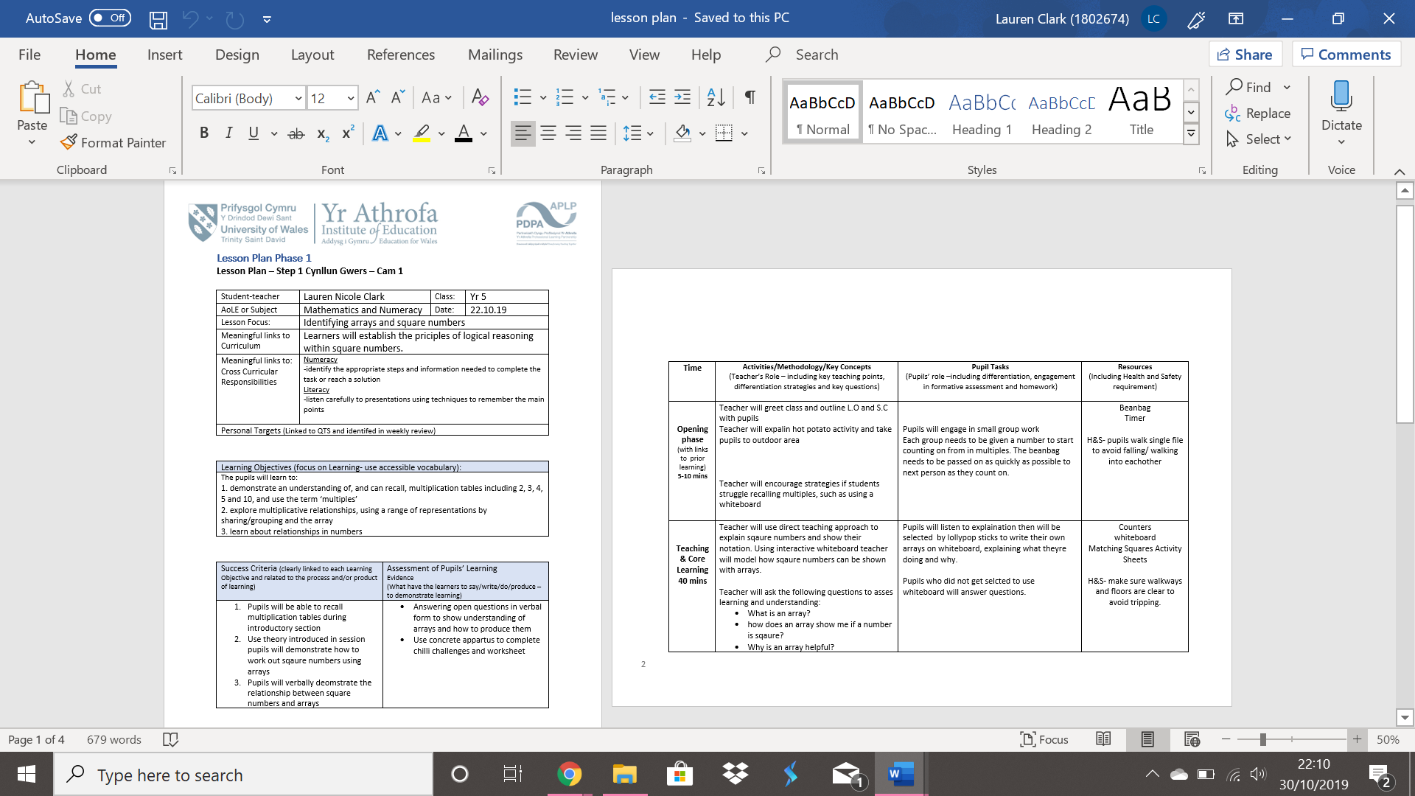

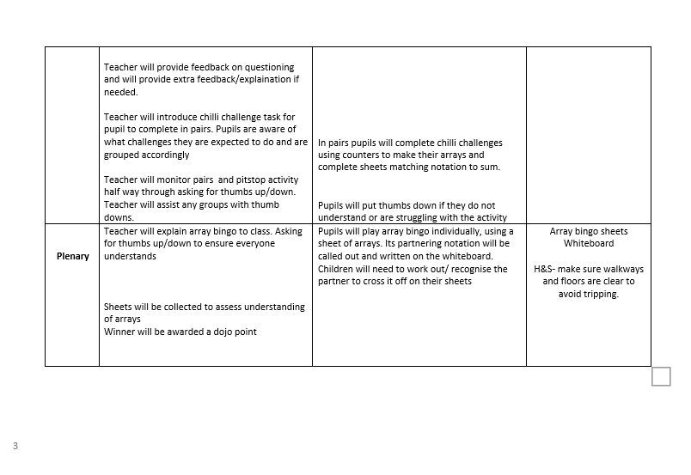Appendix 2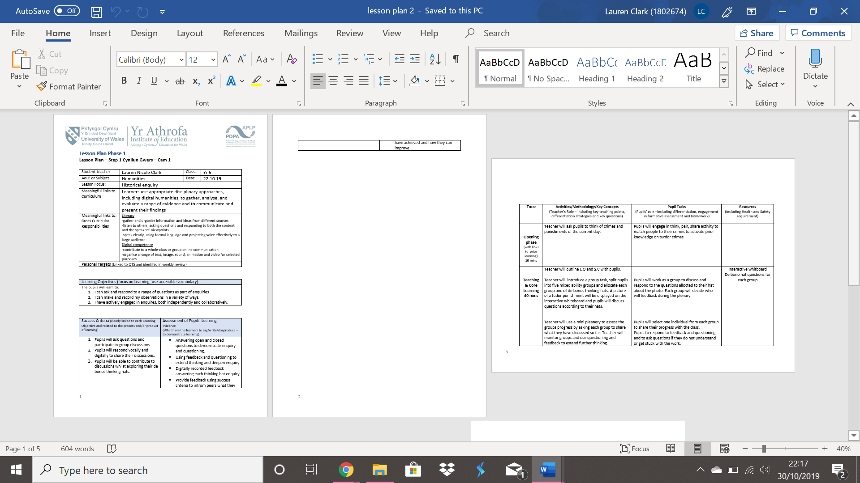

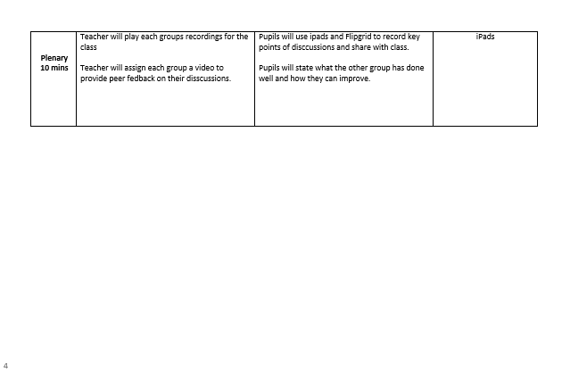
Appendix 3


