CONTEMPORARY THEMES IN THE HOTEL AND HOSPITALITY SECTOR

Conference Presentation

Florin Snopu 2026401
Giulia Chifari
Slide 1


Slide 2
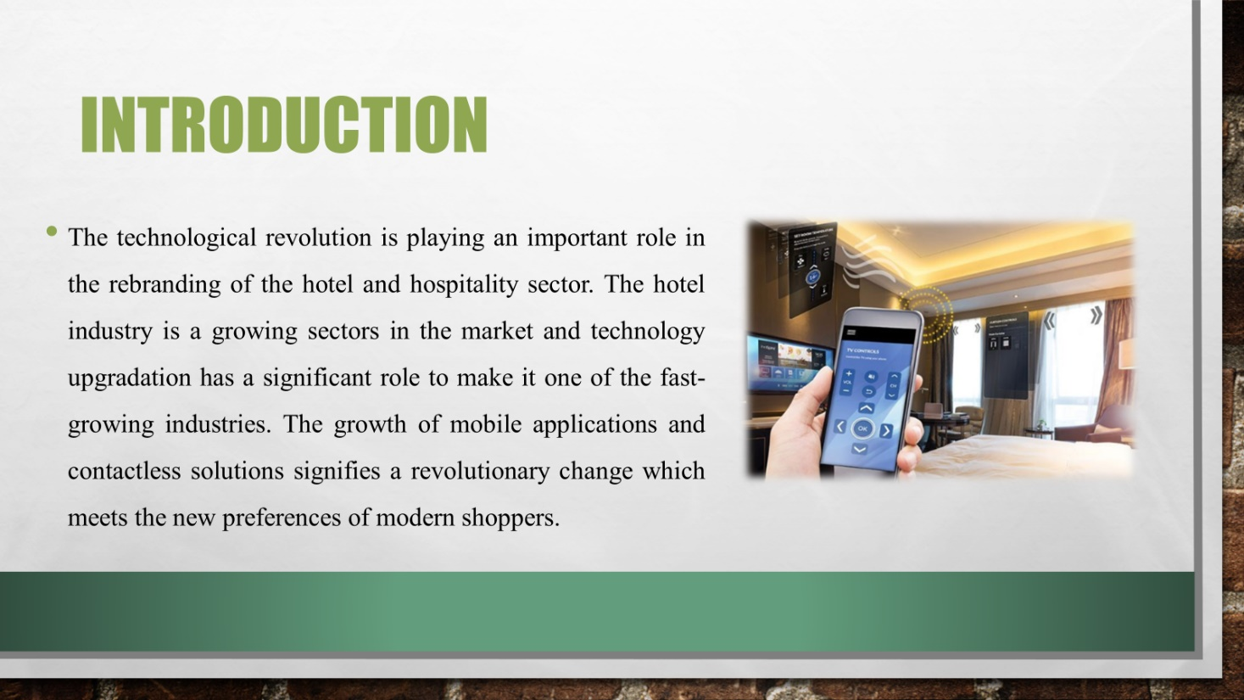
This presentation will include the research findings of Contemporary Theme-Technology with the analysis of the multi-dimensional impact of technology by focusing on its strengths, weaknesses, and opportunities for making future recommendations. Technology integration is not only a trend but a basic need for the continuous growth and customer satisfaction in the dynamic world of hospitality.

Slide 3
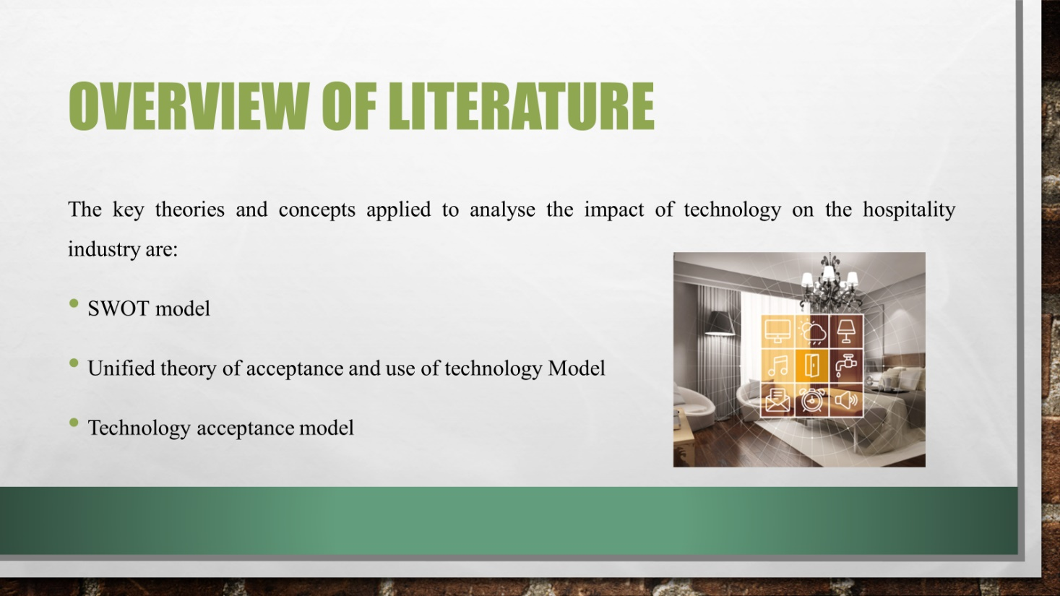
With the help of applying these key theories and concepts, the paper aims to provide a comprehensive analysis of how the contemporary 'Technology' theme impacts and shapes various aspects of the hospitality industry.

Slide 4
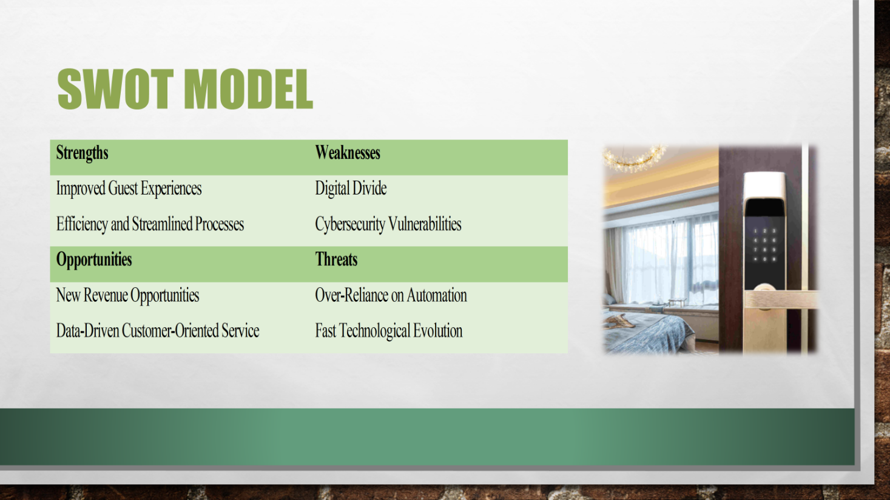
Strengths:
1. Improved Guest Experiences: The integration of contactless solutions and mobile apps enhances guest experiences by offering convenient and seamless functionalities including online check-ins, room customisations, and direct communication channels (Mohanty and Munir, 2024).
2. Efficiency and Streamlined Processes: Contactless options advance processes from check-in to checkout for reducing wait times and mitigating health risks in the contemporary public health concerns (Johnson et al., 2020).
Weaknesses:
1. Digital Divide: The possibility of a digital divide may lead to a fragmented guest experience as older or technically illiterate guests may find it challenging to cope with and access the technology (Chen et al., 2021).
2. Cybersecurity Vulnerabilities: Hotels are mainly relying heavily on technology which become vulnerable to cyber threats. Minimal measures are reported to be in place to safeguard guest privacy for raising concerns about trust in technological integration (Fragniere and Yagci, 2021).
Opportunities:
1. New Revenue Opportunities: Mobile apps can serve as powerful marketing tools by offering loyalty schemes and personalised promotions for attracting and retaining guests.
2. Data-Driven Customer-Oriented Service: The data generated by technological interfaces provides opportunities for detailed insights into guest behaviours and preferences for enabling personalised services and informed decision-making (Hayes et al., 2021).
Threats:
1. Over-Reliance on Automation: A potential threat is over-addiction to automation which has been bringing risking the loss of personalised guest experiences. Balancing technological capability with human touches becomes crucial to avoid decreasing hospitality's ethics (Osei and Cheng, 2023).
2. Fast Technological Evolution: The fast evolution of technology poses challenges for hotels to keep pace in the market. Frequent and costly upgrades are necessary for threatening competitiveness without proactive re-evaluation (Ashton, 2021).

Slide 5
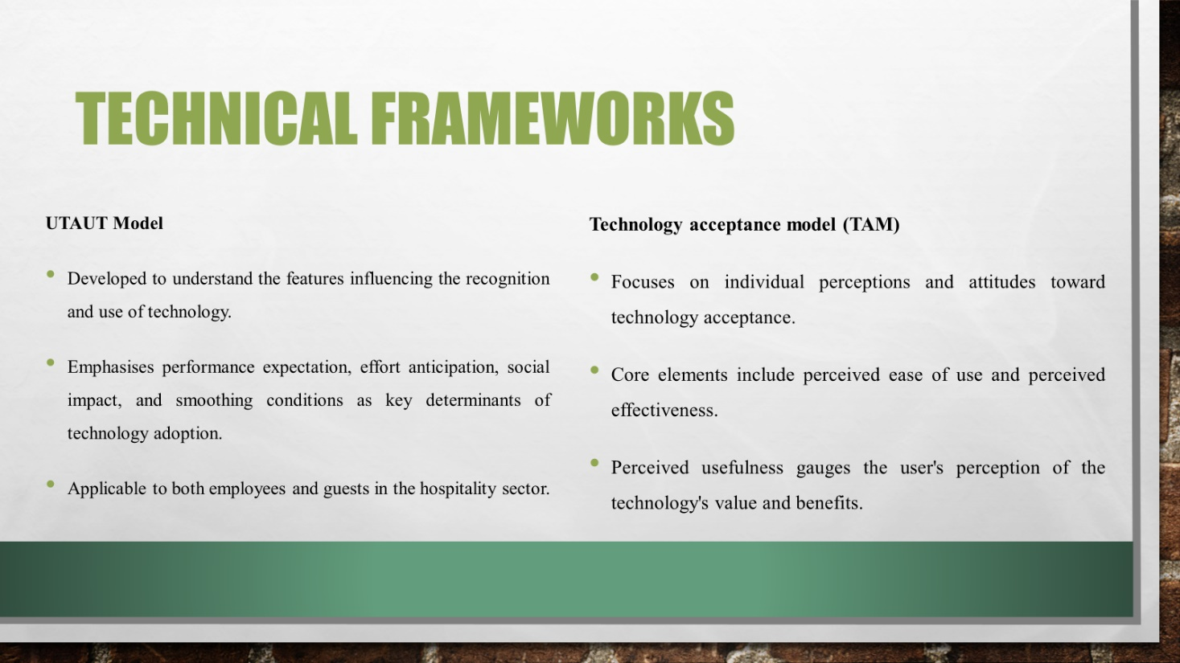
UTAUT and TAM frameworks serve as a solid theoretical base to analyse technology acceptance in hotel contexts. UTAUT combines the impactful components like performance expectancy, effort expectancy, social influence, and facilitating conditions. These all factors cumulatively influence the attitudes and behaviours of both guests and the staff concerning technology adoption (Hao, 2021). On the other hand, TAM concentrates on individual perceptions by addressing the key components of perceived ease of use and perceived usefulness. In the hospitality sector, these frameworks guide for in-depth analysis by highlighting the importance of user experience, social influence and the perceived value of technology within hotel operations and guest interactions (Lew et al., 2020).

Slide 6
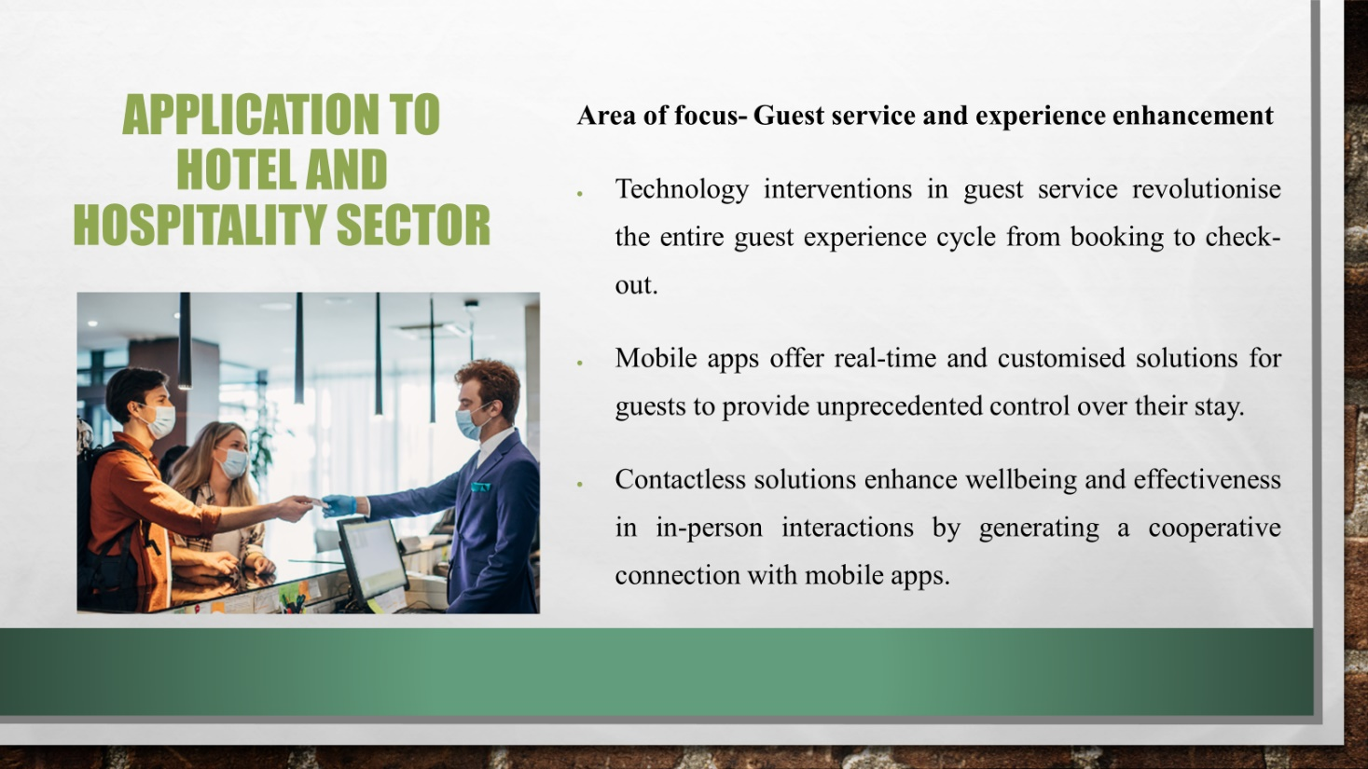
The study focuses on the guest service and experience enhancement within the hotel industry. It will help to examine how the contemporary theme of technology including mobile apps and contactless solutions impacts this crucial area. The real-world implications of technological advancements on guest interactions, convenience, and overall satisfaction will be explored as technology has effective role in guest satisfaction by improving overall efficiency of the hotels (Deri et al., 2023). This targeted focus aims to provide insights into the tangible effects of technology in delivering enhanced services and experiences for hotel guests.

Slide 7
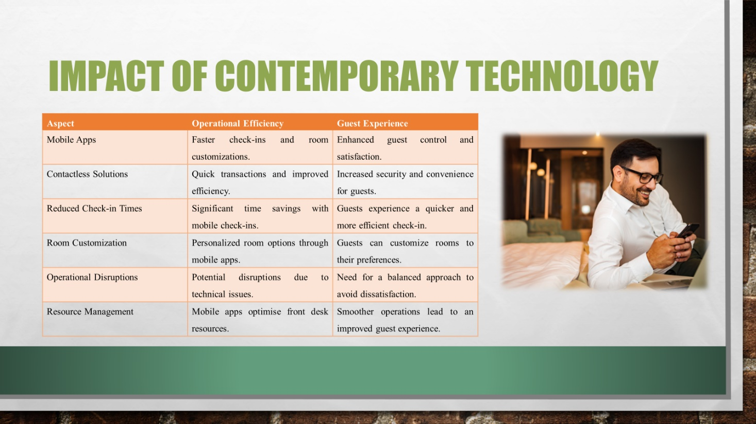
In the specialised domain of Guest Service and Experience Enhancement, technological interventions have brought a transformative era throughout the guest experience with the help of redefining every stage from booking to check-out. Mobile apps emerge as powerful tools as it has not been just facilitating real-time solutions but also tailoring experiences to the specific preferences of each guest (Chen and Chen, 2022). The introduction of technology also help in improving operational efficiency by getting strong skills to employees in the hotel industry (Mercan et al., 2021). This empowerment grants guests an unparalleled level of control over their stay by fostering a sense of personalisation and satisfaction (Kim and Kim, 2022). The integration of contactless solutions further increases this impact by not only arranging safety in face-to-face interactions but also effortlessly complementing the functionalities of mobile apps.

Slide 8
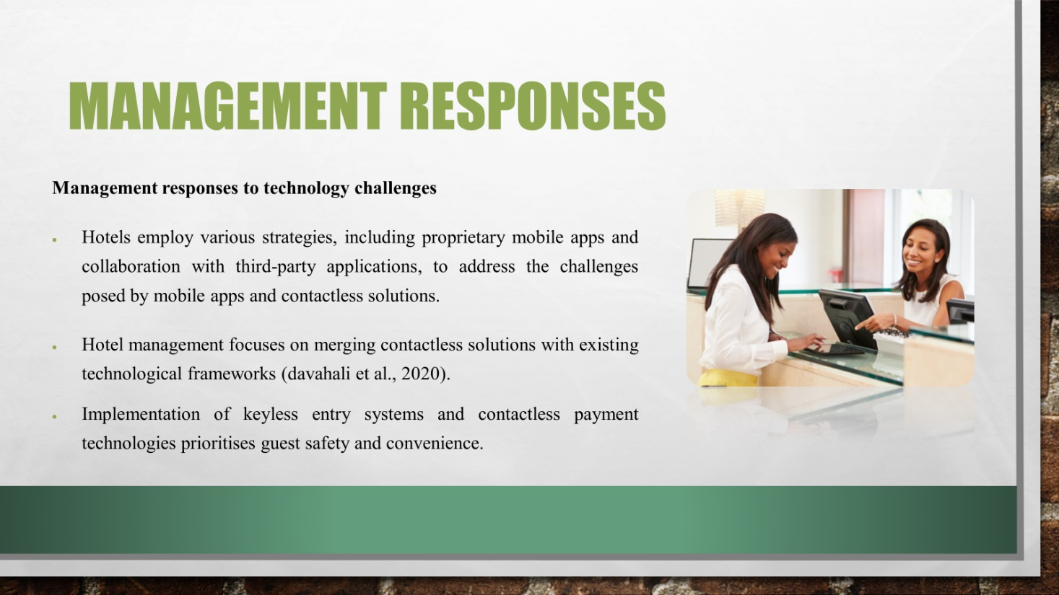

Slide 9
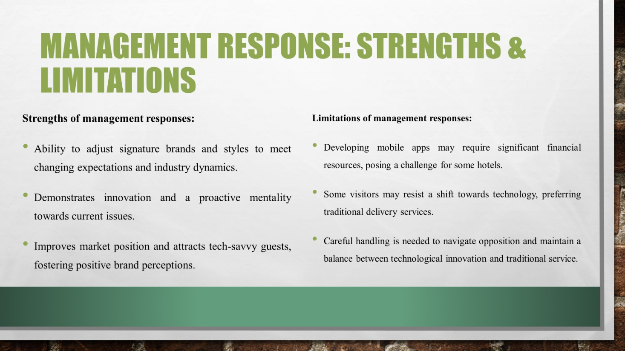
The hotel management responses to the challenges presented by modern technologies reflect both their assets and shortcomings. The proactive adoption of solutions like proprietary mobile apps and contactless systems is an indication of a desire to improve the guest experience and to address the industry demands (Darvishmotevali et al., 2020). This adaptability can help increase the market positioning as well as appeal to customers who are technically sophisticated. However, programmes that require the utmost of human and material resources can be expensive leading to difficulties in meeting the management and running costs. Resistance from visitor who has not knowledge of advance tech system is one of the severe challenge to the hotel management system (Notounis, 2022).

Slide 10
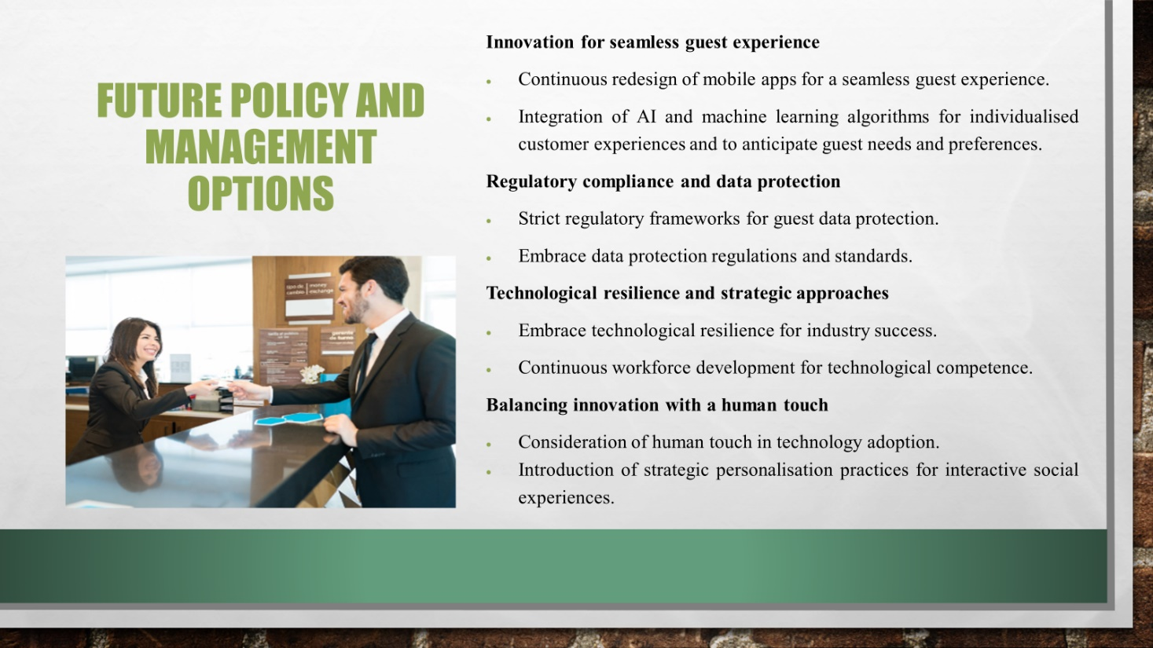
The policy and management suggestions in the hotel and hospitality sector highlight an integrated approach towards technology adoption to provide a smooth and personalized guest experience. Constant redesigning of mobile apps will help to show a dedication to staying relevant and addressing the ever-changing demands of guests (Da et al., 2023). The need for tight regulatory frameworks and the adoption of data protection rules will show the sector's aim of protecting guest data by ensuring privacy and building trust. The adoption of technological resilience through a culture of continuous workforce development is a move towards a proactive stance while traversing the dynamic tech terrain (Melian-Alzola et al., 2020). A balance between innovation with a human touch can be achieved by emphasising the significance of personal interactions together with technological advancements while the introduction of strategic personalization practices attempts to create interactive social experiences that are warm and personalised.

Slide 11
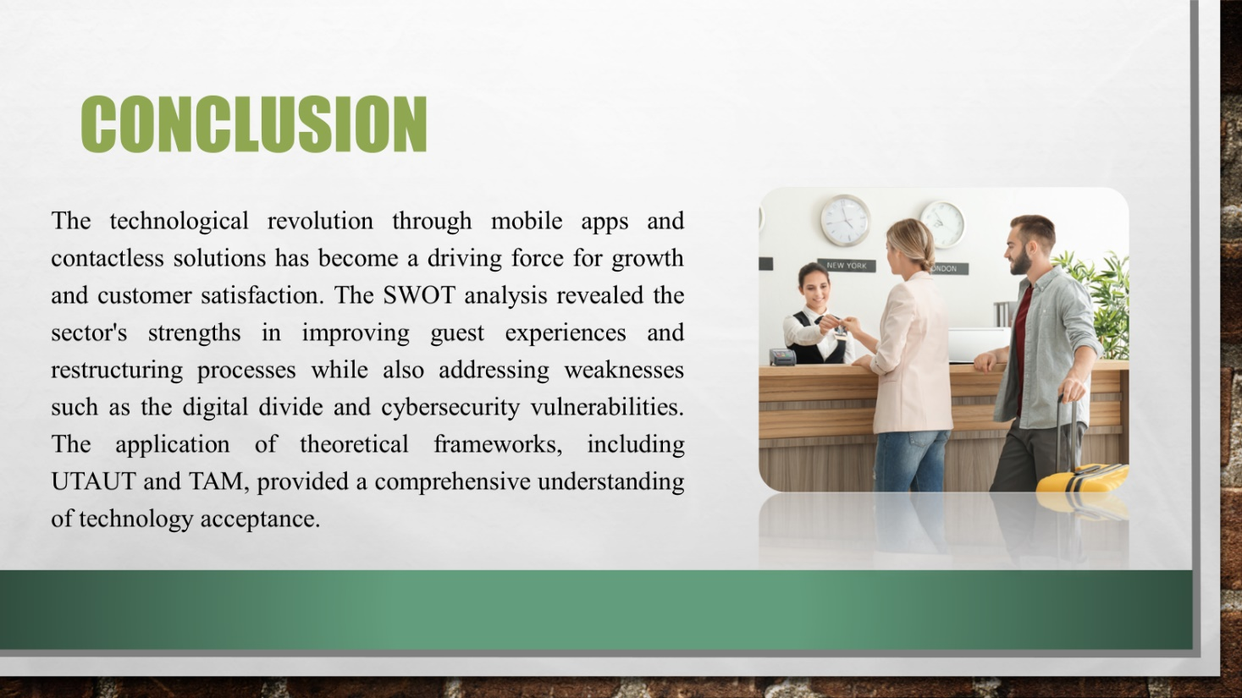
The focus on guest service and experience enhancement demonstrated the transformative impact of technology by emphasising the need for a balance between innovation and human touch.

Slide 12
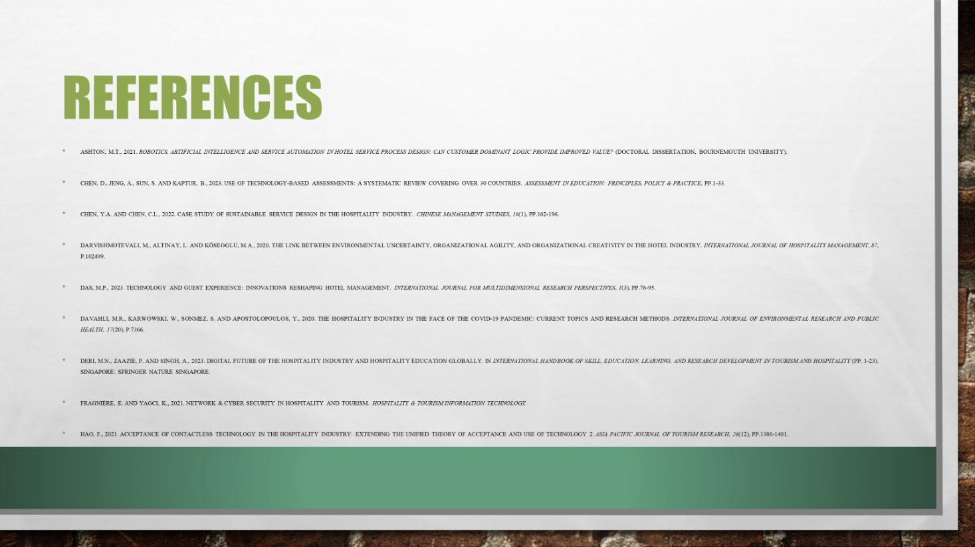
Slide 13


