Operating Systems
Module Name: Computer Architecture and Operating Systems
Module Code: ACCA4022
Student Name: Akaur Rahman
Student ID: 2505136
Lecturer Name: Md Shantanu Islam

Submission date:

Contents
Introduction 4
Key functions of general Operating Systems 4
Task Management: 4
Application/Program Management: 4
File/Directory Management: 5
Device Management: 5
Security Management: 6
Use of Windows OS CLI commands 7
Example 1: 7
Example 2: 7
Example 3: 8
Example 4: 8
Example 5: 8
Example 6: 9
Example 7: 9
Example 8: 10
Example 9: 10
Example 10: 11
Use of Linux OS CLI commands 11
Example 1: 11
Example 2: 12
Example 3: 12
Example 4: 13
Example 5: 13
Example 6: 14
Example 7: 14
Example 8: 15
Example 9: 15
Example 10: 16
Use of Windows OS scripts 16
Example 1: 16
Example 2: 17
Use of Linux OS scripts 18
Example 1: 18
Example 2: 19
Conclusion 20
References 20
Appendices 21

Introduction
Operating systems are critical software systems that manage the hardware of computers and provide support for running application software. They provide a link between users and hardware, enabling software to run efficiently. Operating systems manage processes, memory, and hardware devices. Operating systems like Windows and Linux provide support for graphical user interfaces as well as command line interfaces (CLI). CLI provide users with the ability to run applications directly and automate applications through scripts. This report will provide information about the main functions of operating systems and demonstrate the usage of CLI in Windows and Linux operating systems.

Key functions of general Operating Systems
An operating system (OS) manages computer hardware and provides services for software applications. It acts as an intermediary between users and hardware [1]. Operating systems manage resources such as processors, memory, storage and input/output devices. Additionally, it provide interfaces that allow users to interact with the computer through graphical environments or command line tools [2].

Task Management:
Task management is the operating system’s way of handling multiple programs running at the same time. Each running program is a process. The OS divides CPU time among processes so resources aren't wasted. That lets several applications run at once. It's called multitasking. The OS also watches processes and can terminate ones that stop responding or that hog resources. Tools like Windows Task Manager let users see running processes and system performance. When task management works well, the system runs better and stays stable [1].
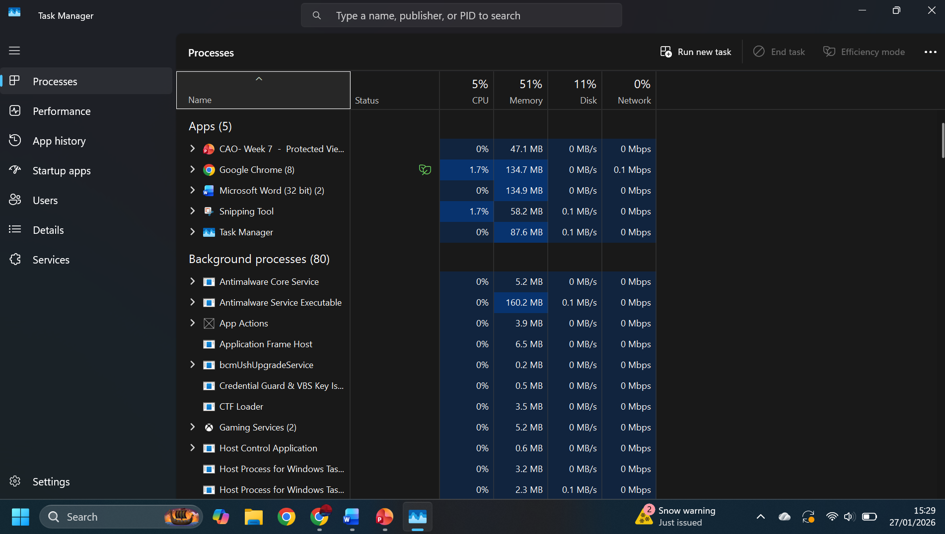
Figure 1: Windows Task Manager displaying running processes.
Application/Program Management:
Management of applications includes managing the installation, running, and deinstalling programs in the system. Memory and processing are allocated by the operating system for running applications. Applications are also isolated by the operating system, meaning that the failure of one application does not affect the running of other applications in the system. Operating systems offer system services, enabling applications to access files, networks, and graphics. Program management also includes updating and deinstalling programs in the system [3].
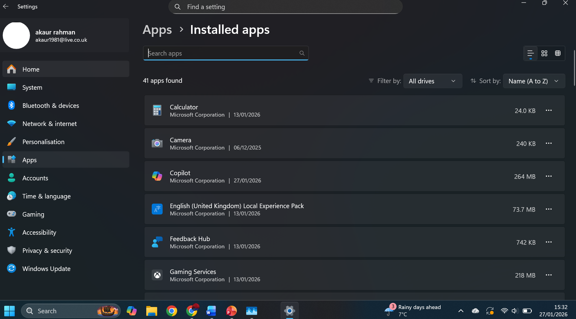
Figure 2: Windows application management interface.

File/Directory Management:
An operating system organises data through its file management system, which means that the data is stored in the form of files and these files are stored in directories or folders to enable proper organisation. The operating system offers various facilities that enable the creation, deletion, copying, moving, and renaming of files. The file management system can keep track of the location of the data on the storage devices to enable proper access to the data [1].
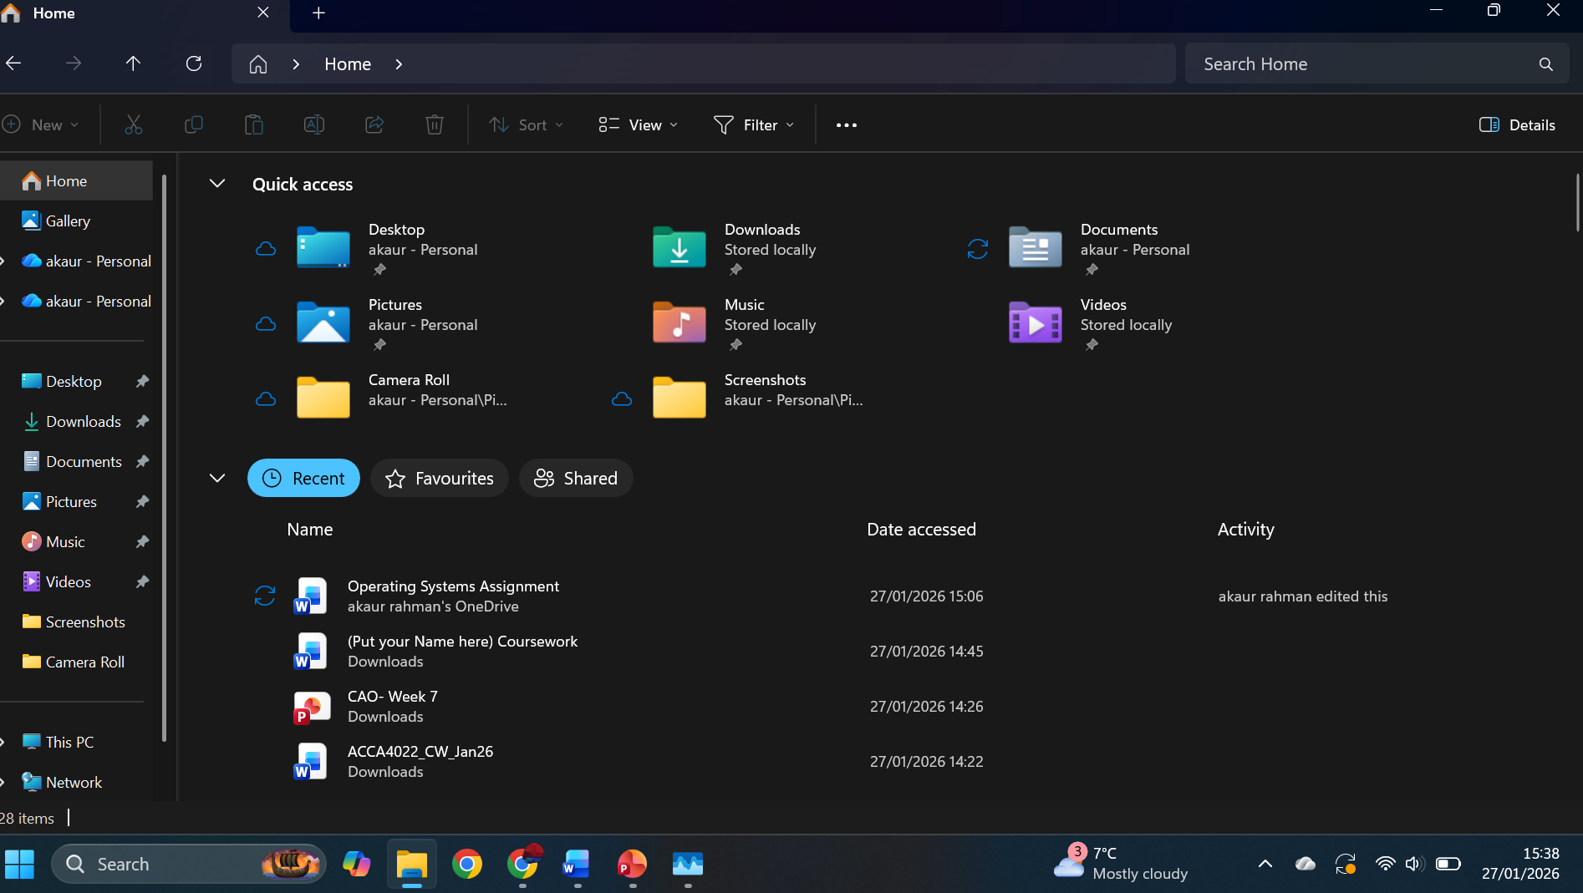
Figure 3 Windows File Explorer showing file directories.

Device Management:
The device management controls hardware devices connected to the computer, for example, the printer, keyboard, camera and disk drives. The operating system talks to the hardware through device drivers. These are small pieces of software that translate what the operating system says into what the hardware can understand. It also manages the allocation of resources to hardware devices and how they are utilised without conflicts. It is worth noting that device management is for monitoring hardware performance and detecting errors for efficient communication between hardware and software [1].
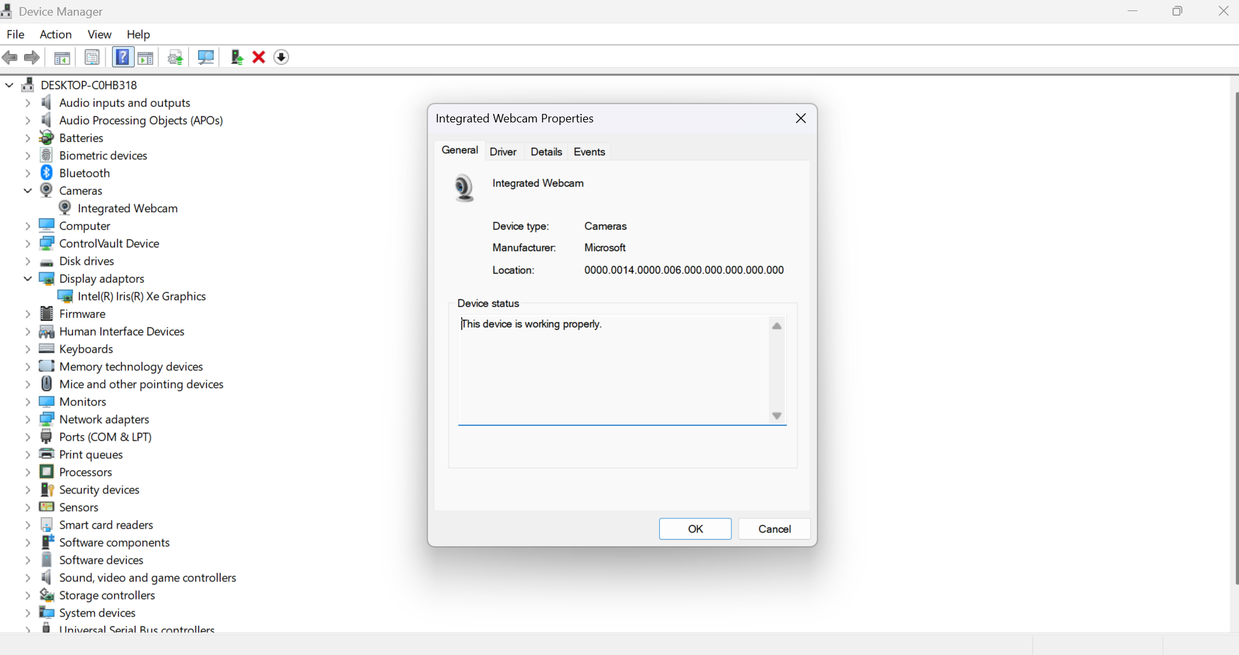
Figure 4: Windows Device Manager displaying hardware devices.

Security Management:
The management of security ensures the computer system is safe from unauthorized access and cyber attacks. The operating system utilises different authentication methods such as usernames and passwords to validate users. Access control systems are designed to restrict user permissions for the purpose of protecting system files and data. The operating system has different security tools like firewalls and antivirus for protecting the system and user data. These tools keep the system secure and protect user data [2].
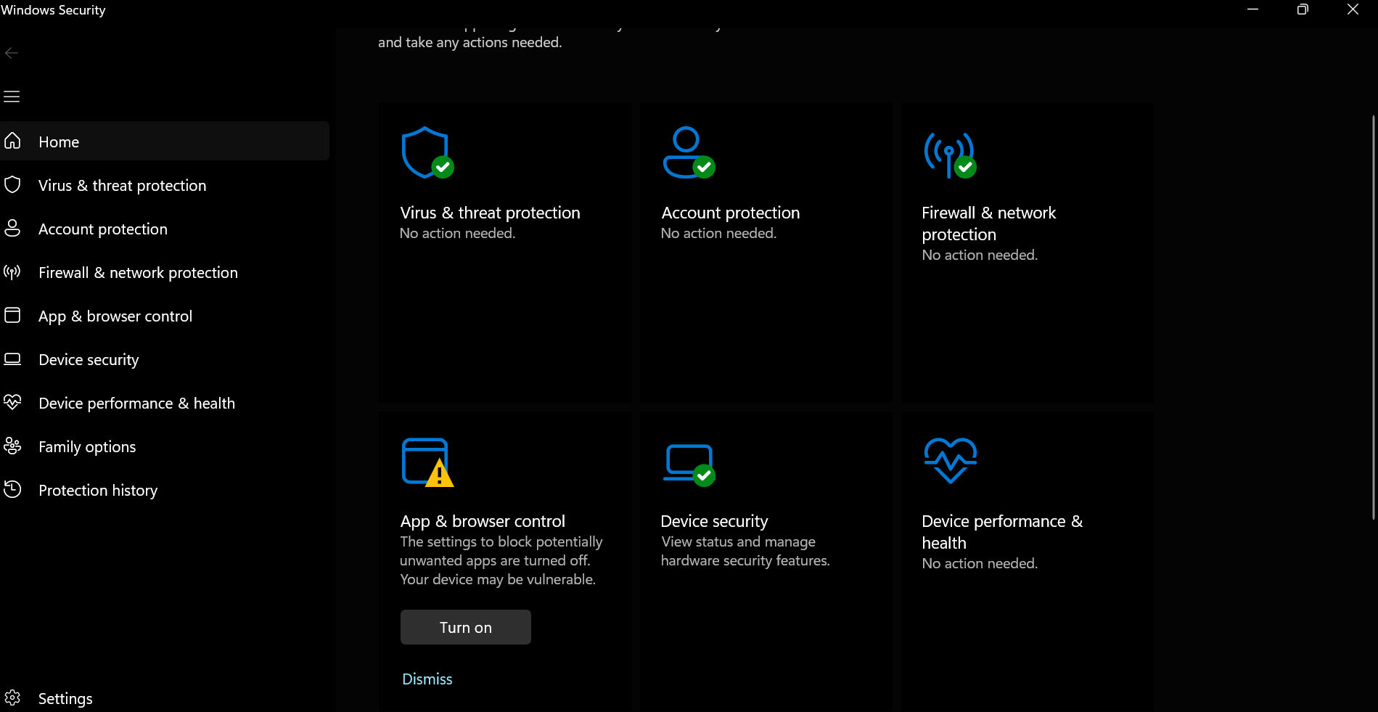
Figure 5 Windows security settings interface.

Use of Windows OS CLI commands
The Windows Command Line Interface (CLI) allows users to interact with the operating system using text commands. CLI commands enable efficient system management tasks such as file operations, network diagnostics and process monitoring. Command line tools are widely used in system administration and automation because they provide direct control over operating system functions [1].

Example 1: dir (Directory)
The dir command lists files and folders in the current directory. The output shows the file name, size, date modified and directory structure, helping users quickly view and manage stored files.
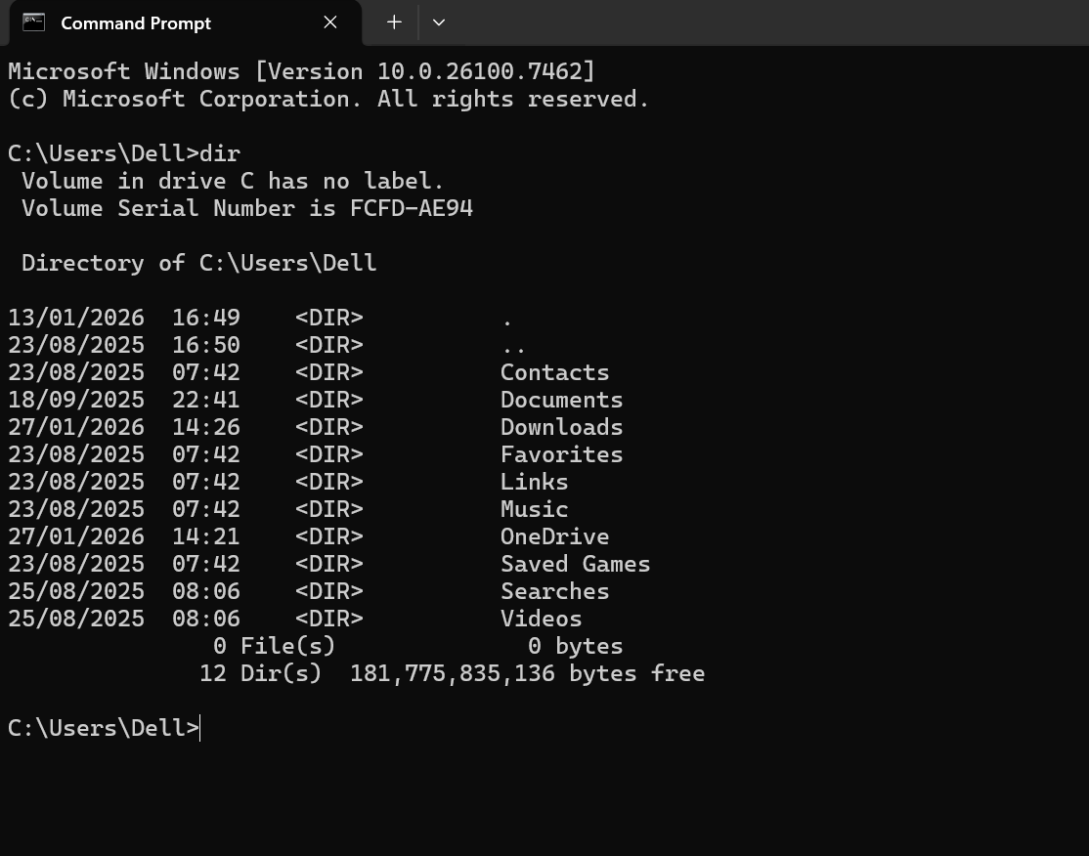
Figure 6 Output of dir command.

Example 2: cd (Change Directory)
The cd command changes the current directory. After executing the command, the shell prompt updates to indicate the new location in the Linux file system.
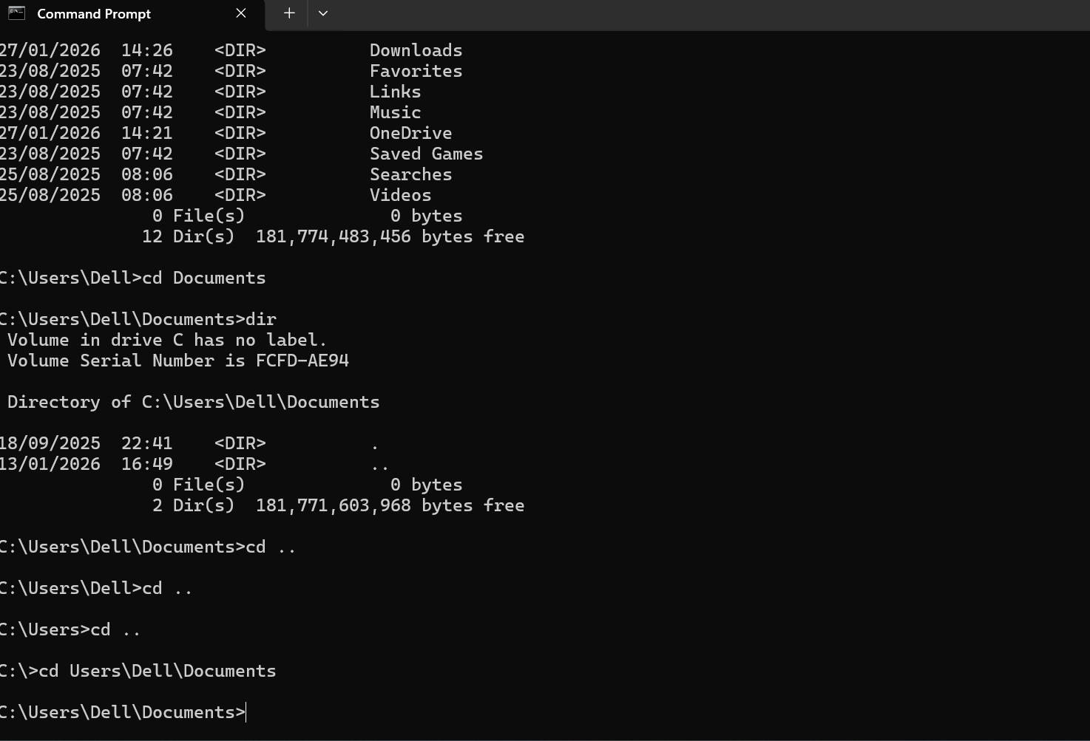
Figure 7: Output cd command
Example 3: mkdir (Creates New Directory)
The mkdir command creates a new directory in the current location. The output normally shows no message, but the new folder appears when listing the directory contents using the dir command.
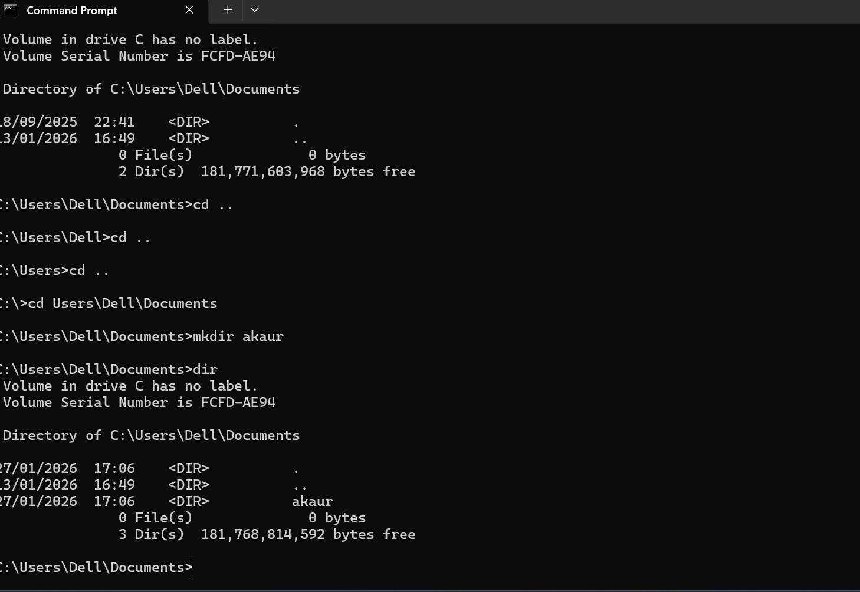
Figure 8: Output of mkdir command

Example 4: rmdir (Removes an empty directory)
The rmdir command removes an empty directory from the system. If the directory is successfully deleted, no output is displayed, but it will no longer appear in the directory list.
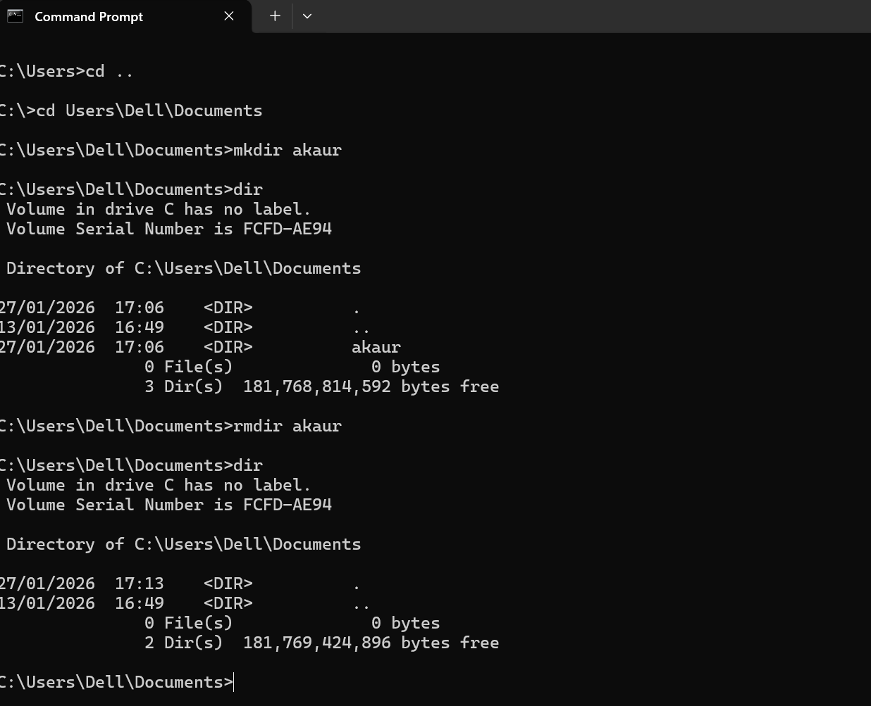
Figure 9: Output of rmdir command
Example 5: echo (Displays text messages in the command prompt)
The echo command prints text directly to the command prompt. The output displays the entered message exactly as written, making it useful for displaying information or debugging scripts.
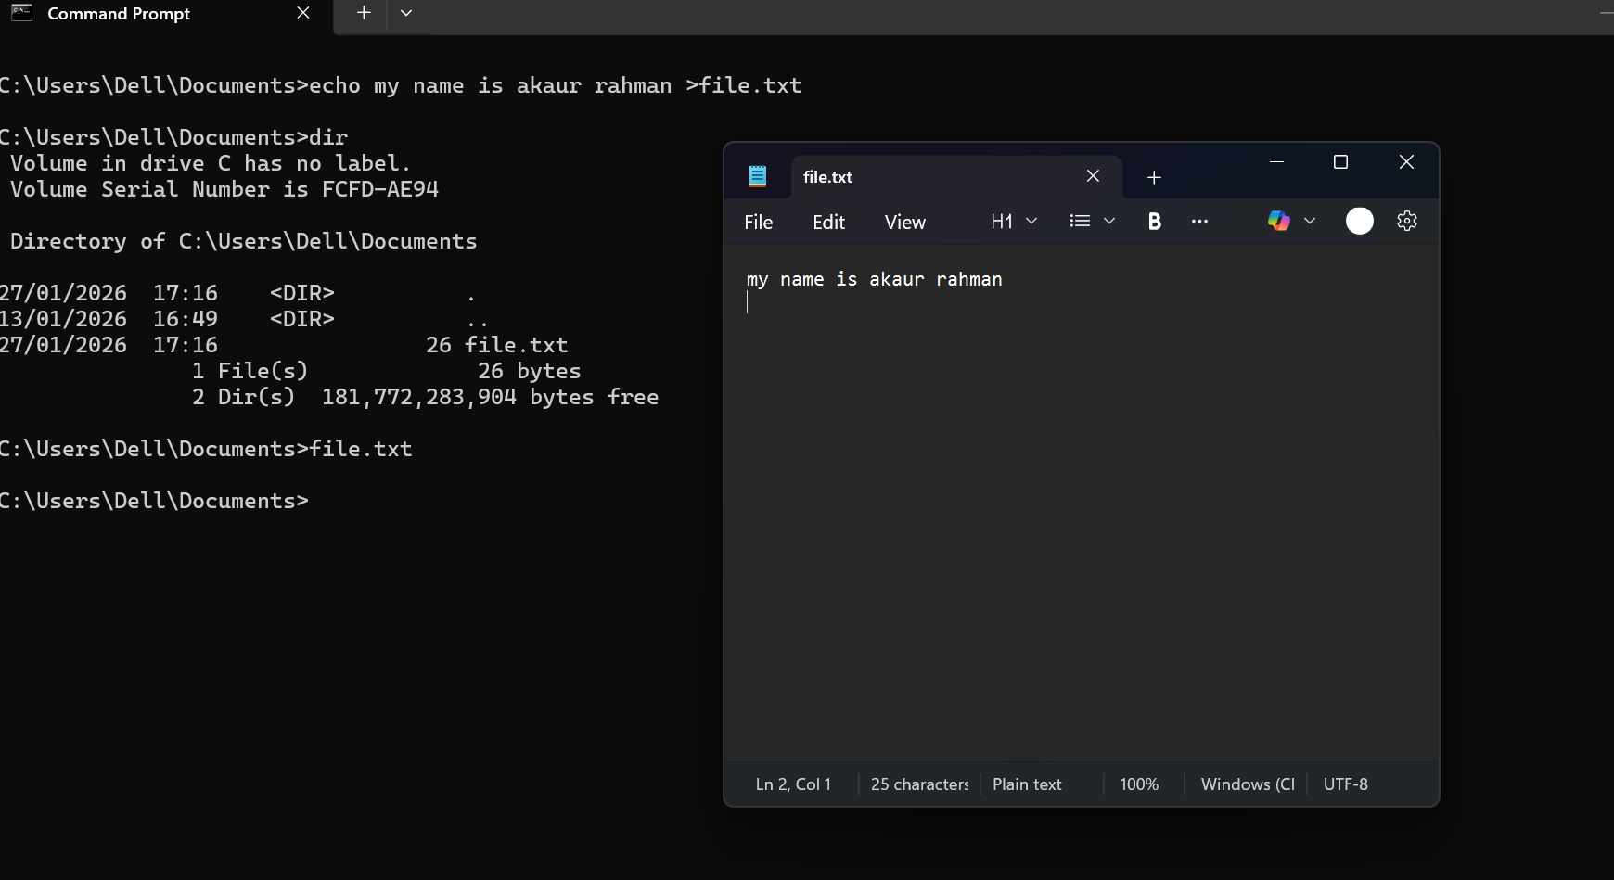
Figure 10: Output of echo command

Example 6: tasklist (Shows all currently running processes)
The tasklist command displays all currently running processes on the system. The output lists process names, process IDs and memory usage, helping users monitor active programs and system performance.

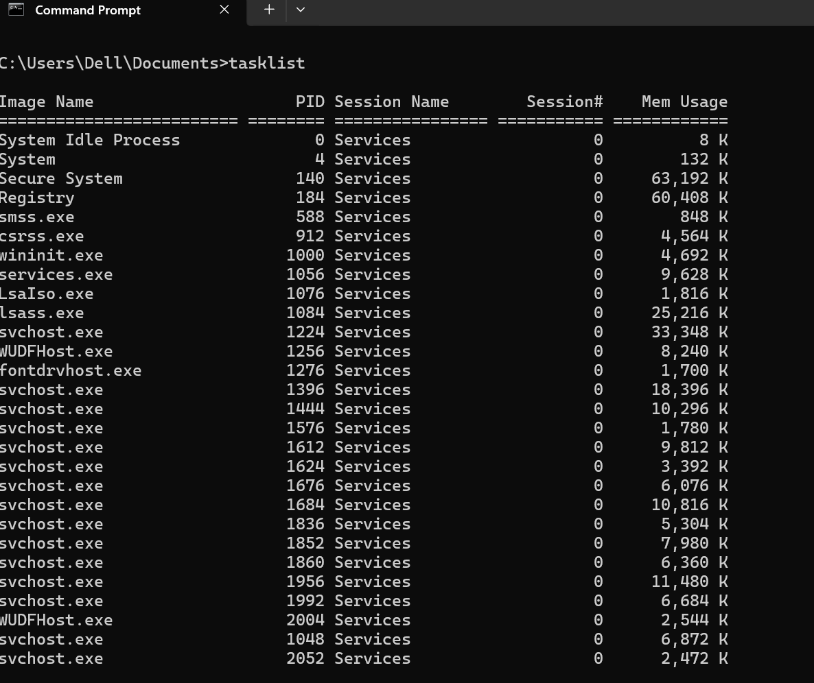
Figure 11: Output of tasklist command
Example 7: systeminfo (Displays detailed information about the computer system)
The systeminfo command displays detailed system configuration information. The output includes operating system version, processor type, installed memory and system boot time, helping users understand system specifications.
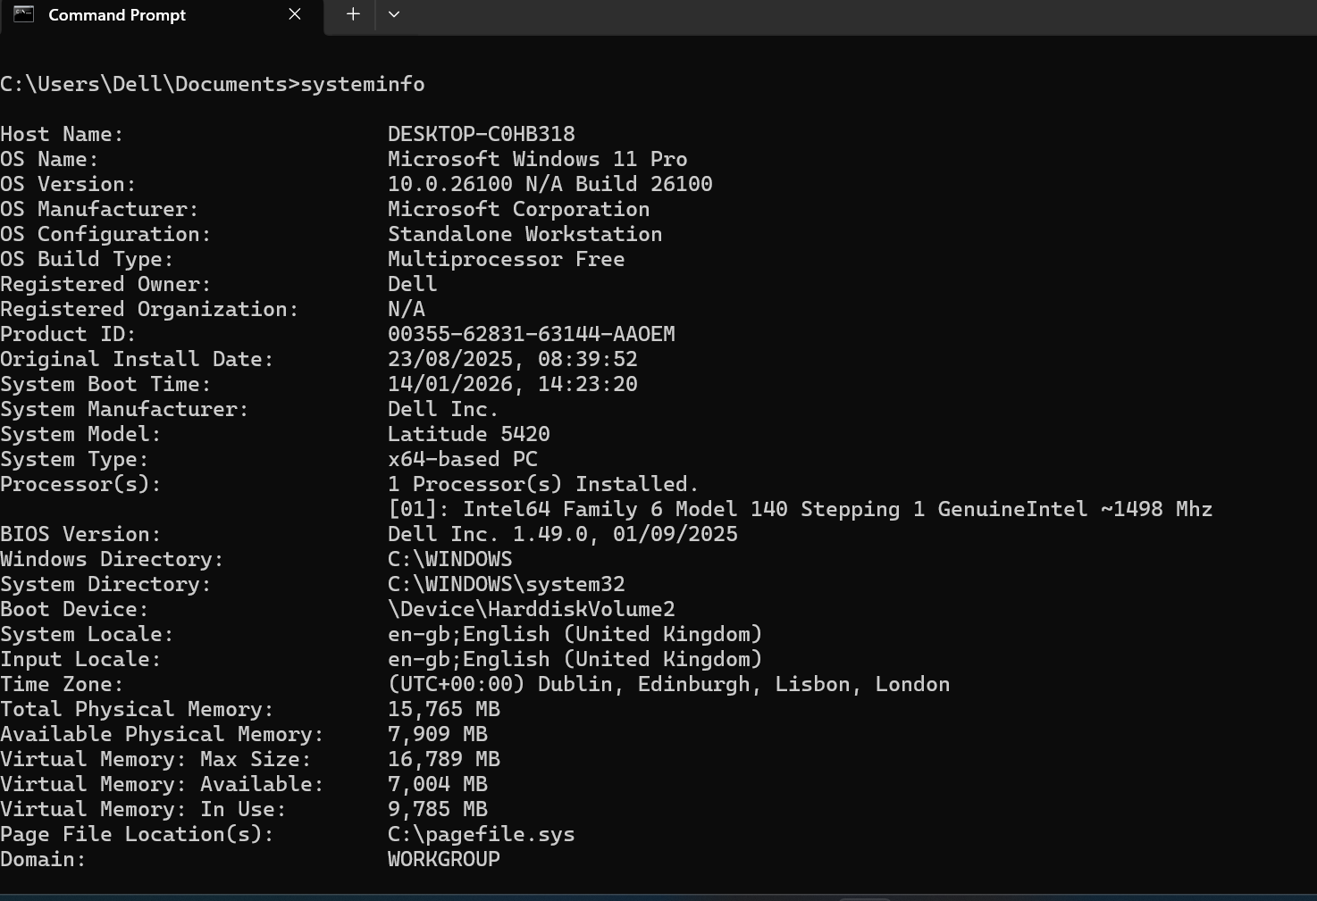
Figure 12: Output of systeminfo command
Example 8: ipconfig (Displays network configuration information)
The ipconfig command displays network configuration information. The output includes the IP address, subnet mask and default gateway, which helps users diagnose network connectivity problems.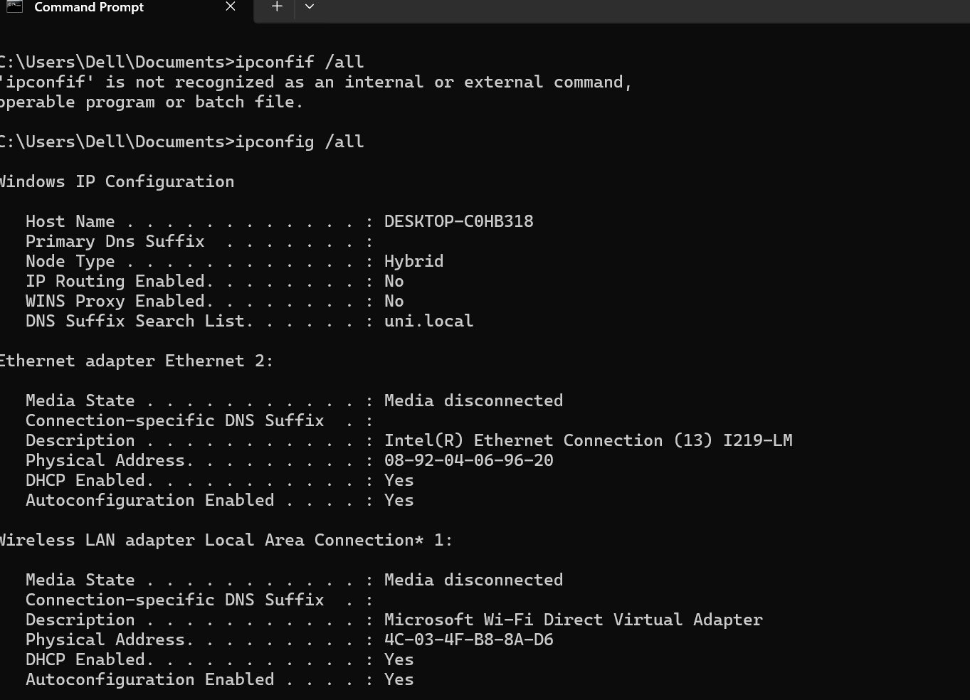
Figure 13: Output of ipconfig command
Example 9: ping (Tests connectivity between network devices)
The ping command tests connectivity between the computer and another device on a network. The output shows response times and packet statistics, confirming whether the connection is successful.
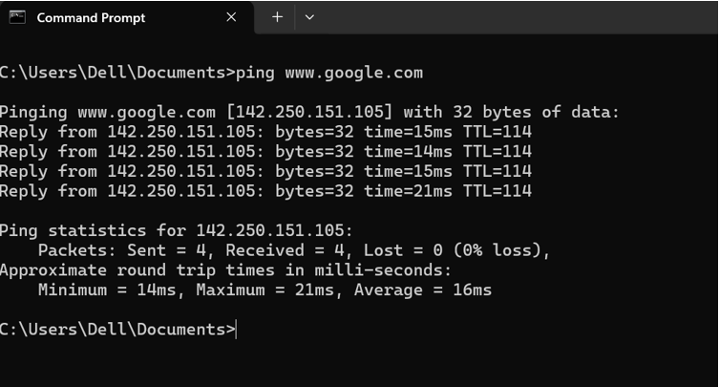
Figure 14: Output of ping command
Example 10: tracert
The tracert command traces the path that network packets take to reach a destination. The output lists each router hop along the route, helping users identify network delays or connectivity issues.
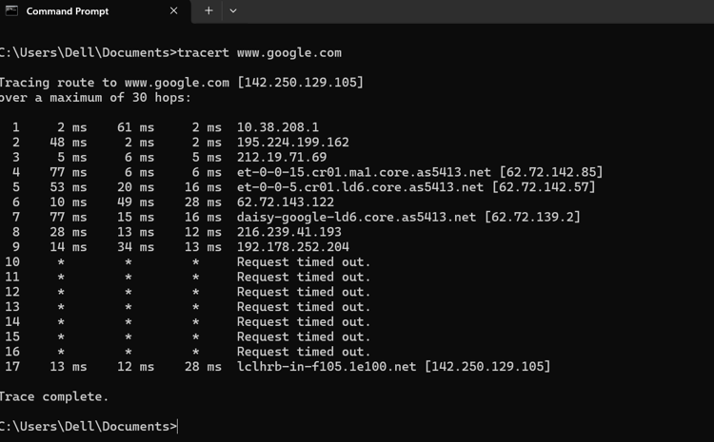
Figure 15: Output of tracert command
Use of Linux OS CLI commands
Linux systems offers a powerful command-line interface for users to handle files, processes, and network resources. The Linux shell interprets the commands entered by the user and executes them in the operating system. CLI commands are widely used for system administration and automation tasks [4].
Example 1: su (Switch to another user account)
The su command allows a user to switch to another user account, usually the root user. The output prompts for a password and changes the command prompt to show the new user.
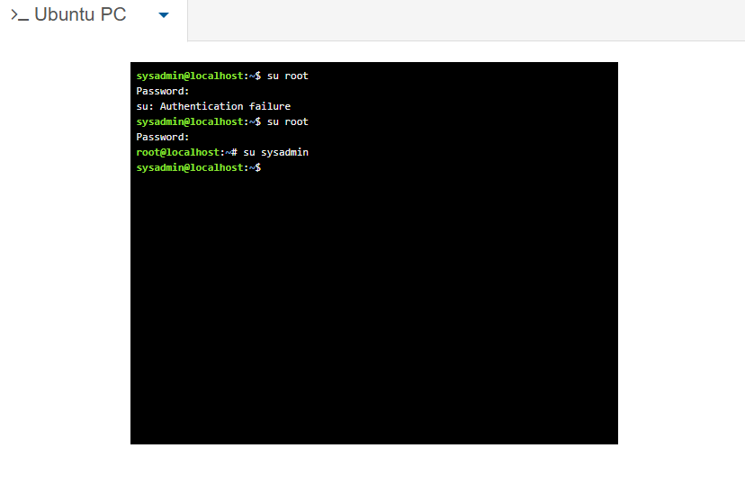
Figure 16: Output of su command
Example 2: pwd (Display the current working directory)
The pwd command prints the current working directory. The output shows the full path of the directory where the user is currently located in the file system.
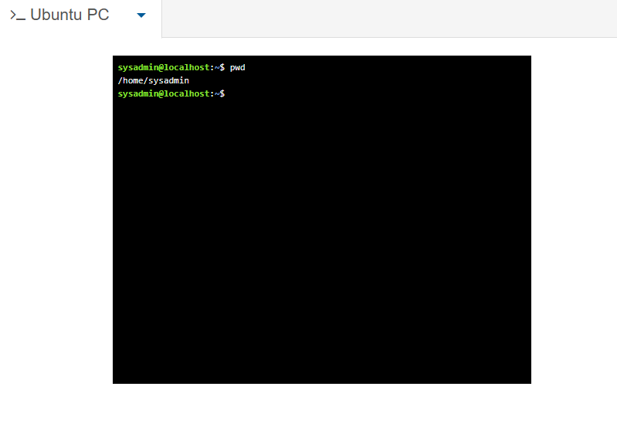
Figure 17: Output of pwd command.

Example 3: cd (Change the current directory)

The cd command changes the current directory. After executing the command, the shell prompt updates to indicate the new location in the Linux file system.
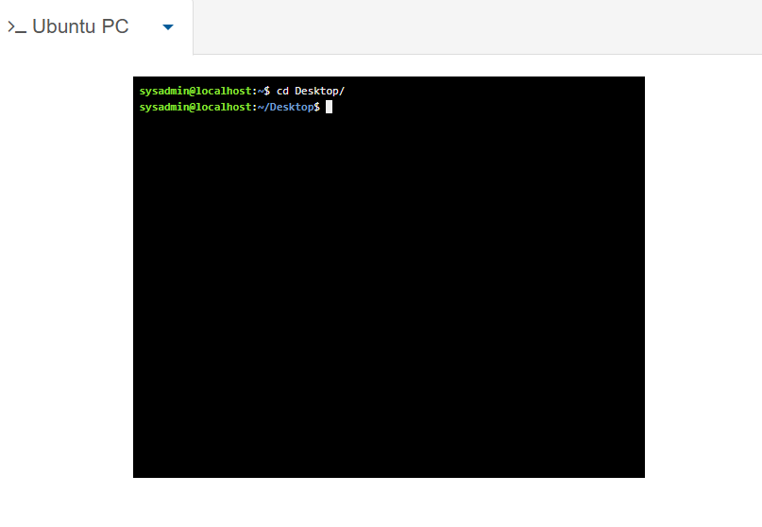
Figure 18: Output of cd command

Example 4: mkdir (Create a new directory)
The mkdir command creates a new directory. The output normally shows no message, but the new folder becomes visible when listing the directory contents using the ls command.
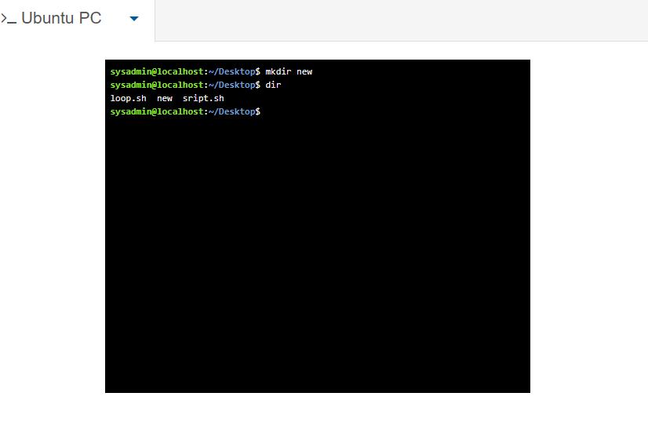
Figure 19: Output of mkdir command

Example 5: ls (List files and directories)

The ls command lists files and directories within the current folder. The output displays file names and, with additional options, may include permissions, file size and modification dates.
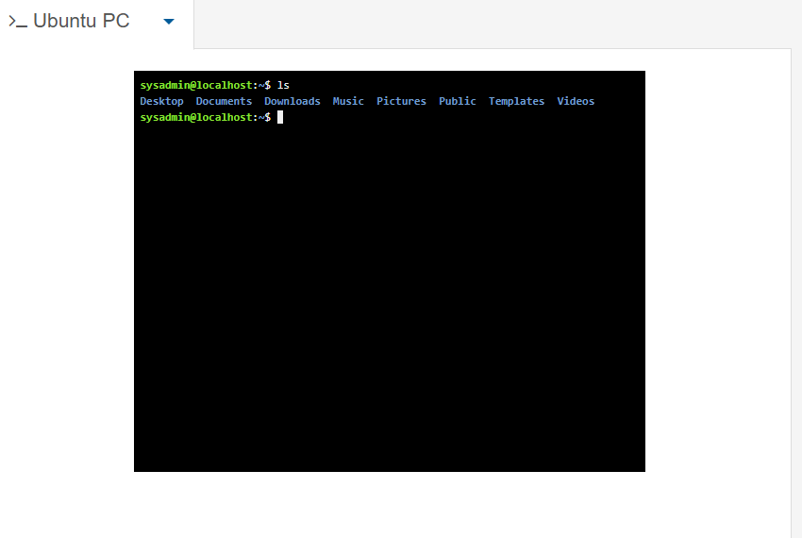
Figure 20: Output of ls command
Example 6: rmdir (Remove an empty directory)
The rmdir command removes an empty directory. If successful, the directory disappears from the directory list when the ls command is executed.
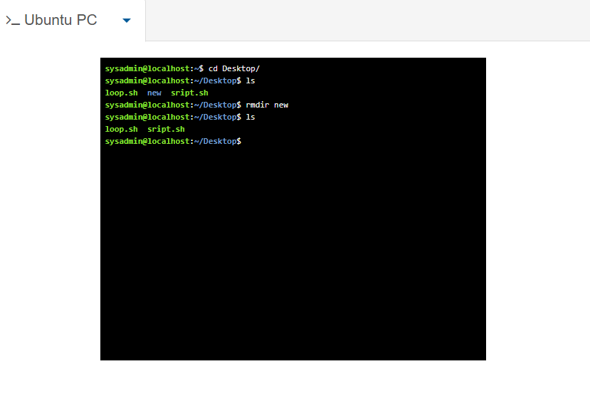
Figure 21: Output of rmdir command

Example 7: touch (Create a new file)
The touch command creates a new empty file or updates the timestamp of an existing file. The output normally shows nothing, but the file appears when listing files using ls.
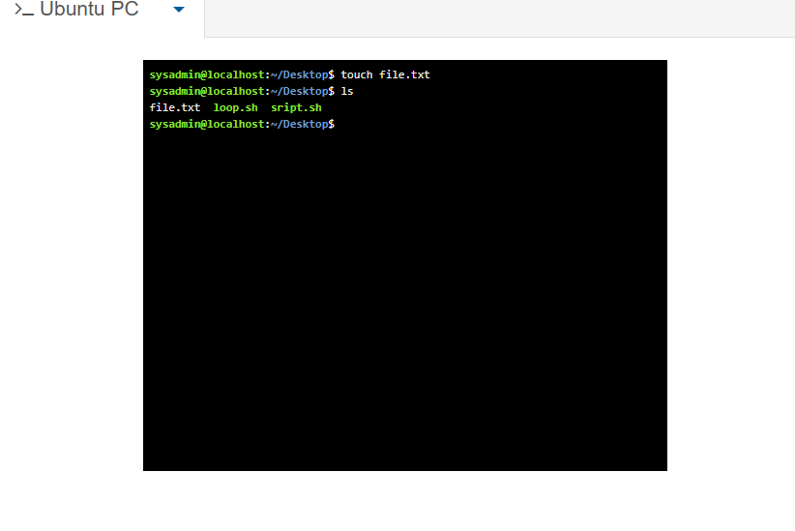
Figure 22: Output of touch command

Example 8: echo and cat (Write and display file contents)
The echo command writes text into a file, while the cat command displays the file contents. The output shows the text stored in the file directly in the terminal.
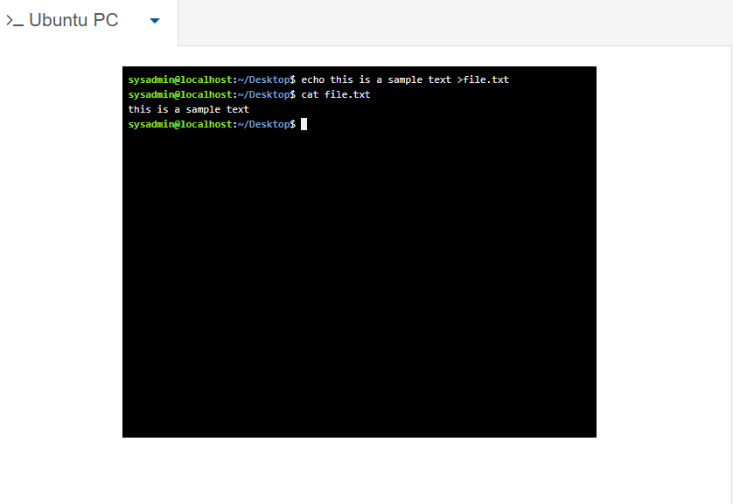
Figure 23: Output of echo and cat command

Example 9: ifconfig (Display network interface configuration)
The ifconfig command displays network interface configuration. The output includes IP addresses, network interfaces and status information used for network troubleshooting.
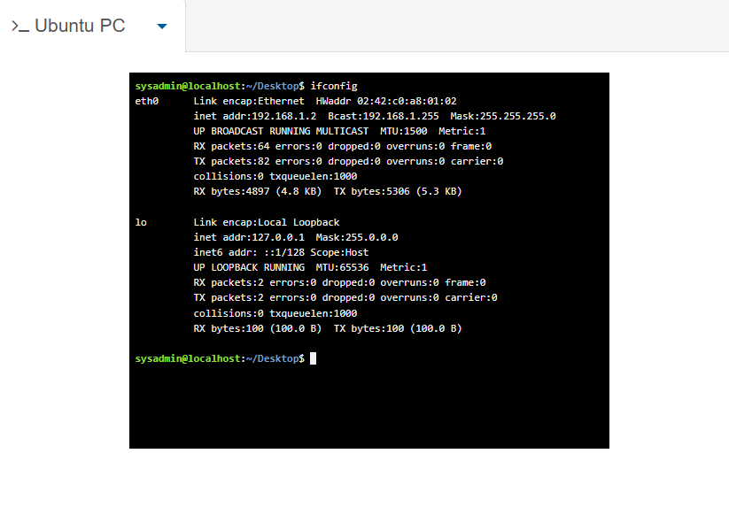
Figure 24: Output of ifconfig command

Example 10: whoami (Display the current user)
The whoami command displays the username of the currently logged-in user. The output prints the active user account name in the terminal.
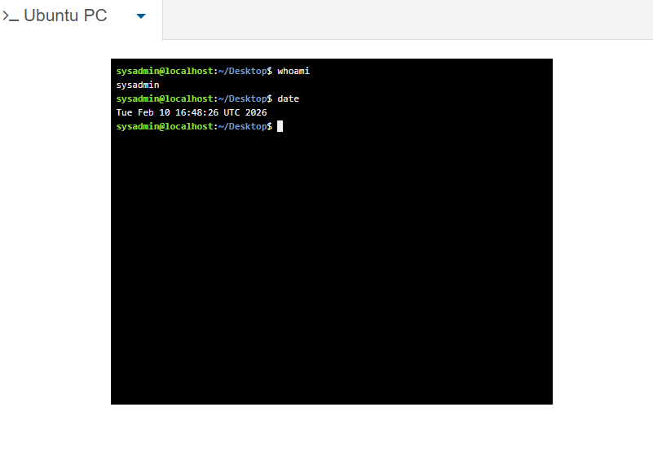
Figure 25: Output of whoami command

Use of Windows OS scripts
Batch scripting allows automation of tasks in Windows using command sequences stored in .bat files. These scripts help automate repetitive operations such as running programs or managing files. Batch scripting is commonly used by system administrators to improve efficiency and automate system tasks [1].
Example 1: Add Two Numbers
This batch script shows a simple example of how Windows command line scripts can perform a calculation using user input. The script begins with @echo off, which stops the commands from being displayed on the screen and makes the output easier to read. The command set /p num1= asks the user to enter the first number and stores it in the variable num1. The next command set /p num2= asks the user to enter the second number and stores it in num2. The command set /a sum=num1+num2 performs the addition and stores the result in the variable sum. The echo command then displays the result to the user in the command window. Finally, the pause command keeps the window open so the user can see the result before the program ends. The output shows the numbers entered and the final calculated sum.
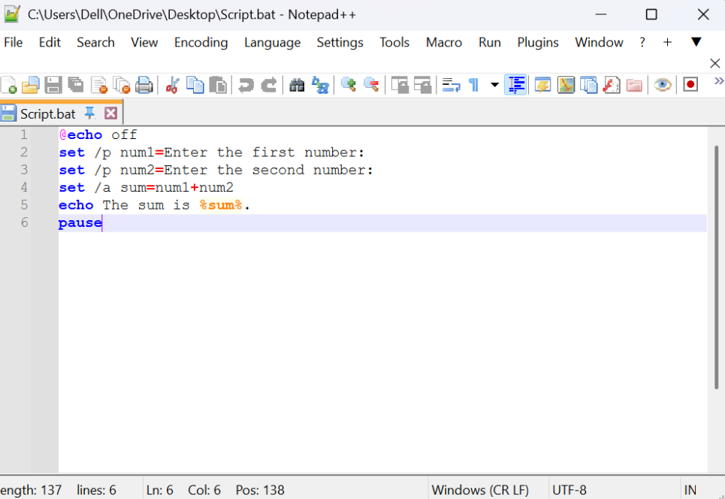
Figure 26: Input of script
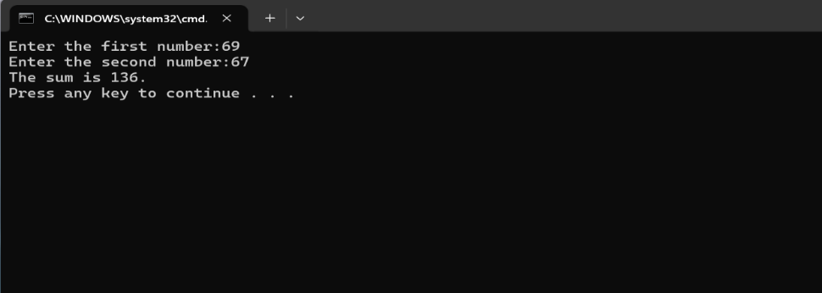
Figure 27: Output of figure 26

Example 2: Voting Age Script
This batch script checks whether a user is old enough to vote based on the age they enter. The script begins with @echo off, which hides the command lines and keeps the output clean. The command set /p age= asks the user to enter their age and stores the value in the variable called age. The script then uses an if condition to compare the age entered with the voting age requirement. The statement if %age% geq 18 checks whether the age is greater than or equal to 18. If this condition is true, the script displays the message “You are eligible to vote.” If the age is less than 18, the else part runs and shows the message “You are not eligible to vote yet.” In the screenshot, when the user enters 11, the script shows that the user cannot vote. When 56 is entered, the script confirms that the user is eligible to vote.

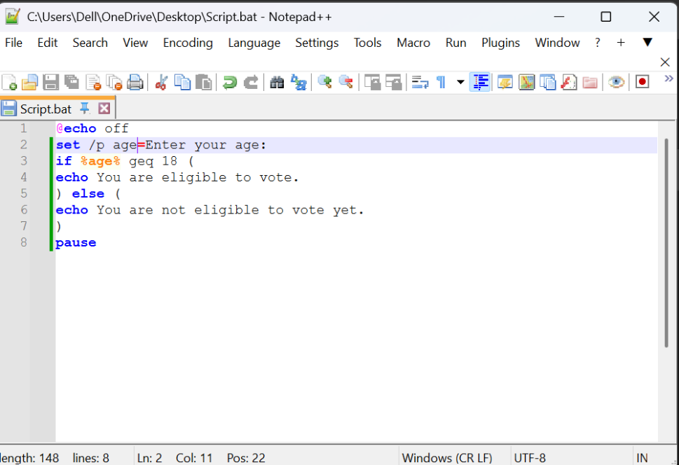
Figure 28: Input of script
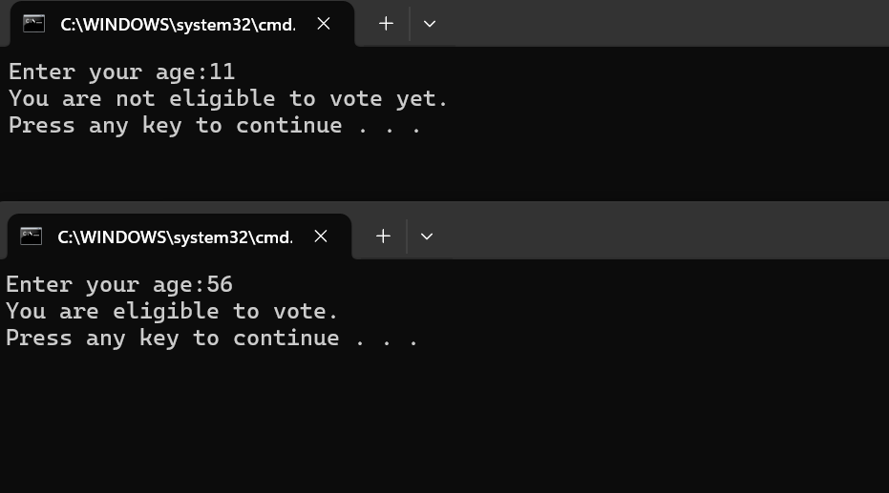
Figure 29: Output of figure 28

Use of Linux OS scripts
Linux operating systems use Bash scripting to automate command line tasks. Bash scripts are files that contain a sequence of commands executed by the Linux shell. They allow users to perform repetitive tasks automatically, such as processing files, running commands, or performing calculations. Bash scripting is widely used in system administration and automation tasks [5].
Example 1: bash script to add 2 numbers
This Bash script adds two numbers entered by the user. The script begins with the echo command, which prints the message “enter the first number” on the screen. The command read num1 then waits for the user to type a number and stores it in the variable num1. The script repeats the same process for the second number using echo "enter the second number" and read num2. After the numbers are entered, the script performs a calculation using total=$((num1 + num2)). This line adds the two values and stores the result in the variable total. The final command echo "the sum is $total" displays the result in the terminal. In the screenshot output, the user enters 67 and 69, and the script calculates the result correctly as 136. This script demonstrates how Bash scripts can accept user input, perform calculations, and display results.
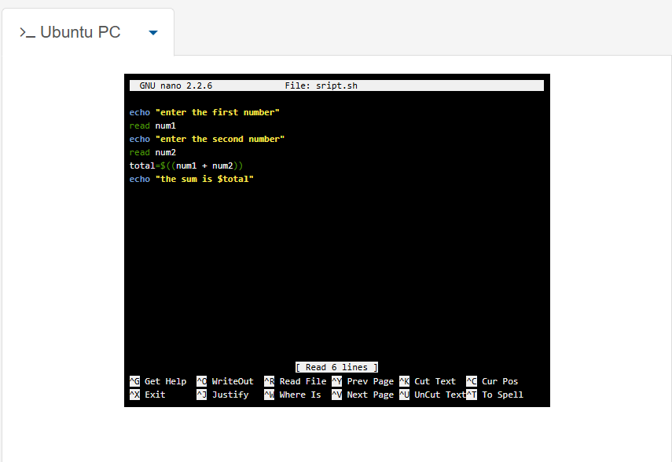
Figure 30: Input of script
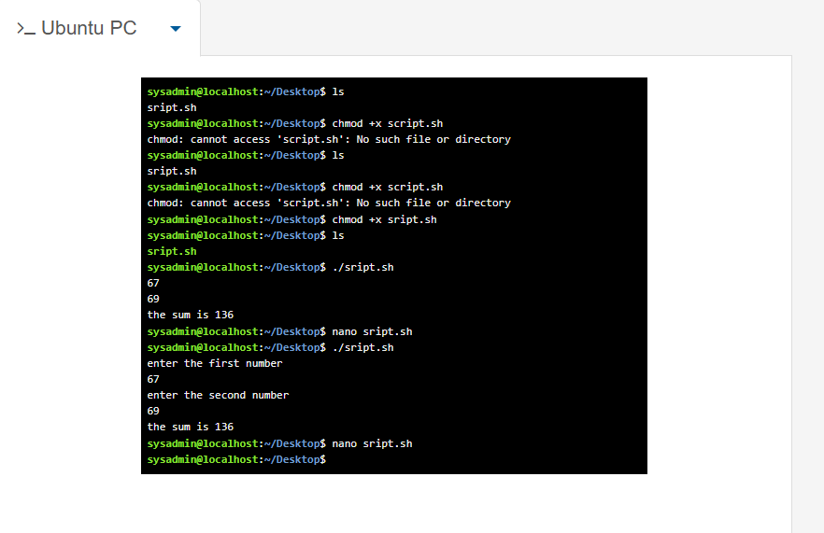
Figure 31: Output of script in figure 30
Example 2: loop
This Bash script demonstrates how a loop can be used to repeat commands automatically in Linux. The script uses a for loop written as for ((i=1; i<=10; i++)). This loop starts with the value 1, increases the value by 1 each time, and stops when it reaches 10. Inside the loop, the command echo "$i" prints the current value of the variable i. The do and done keywords define the start and end of the loop block. When the script is executed using the command ./loop.sh, the loop runs ten times and prints the numbers 1 to 10 in the terminal. The output in the screenshot shows each number on a separate line. This example demonstrates how loops can repeat tasks automatically in Bash scripting. Loops are useful in scripting because they allow commands to run multiple times without repeating the same code manually.
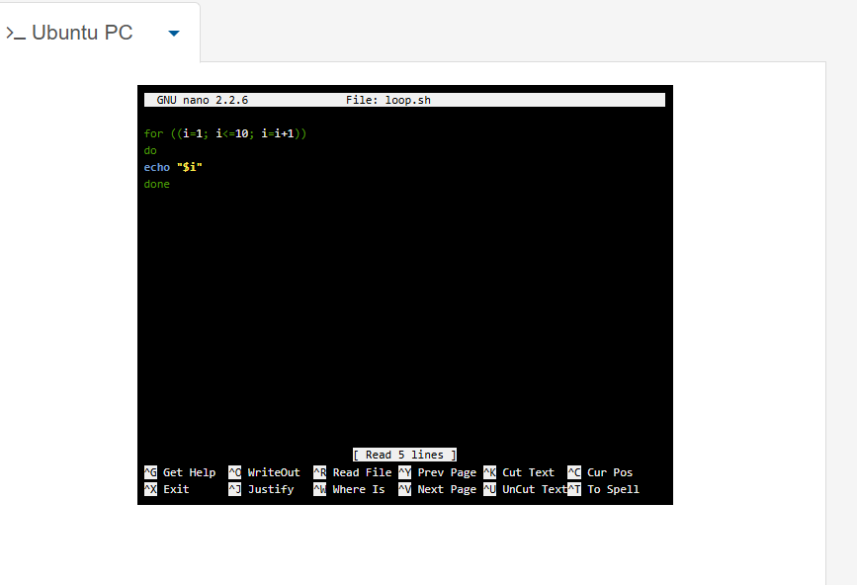
Figure 32: Input of script
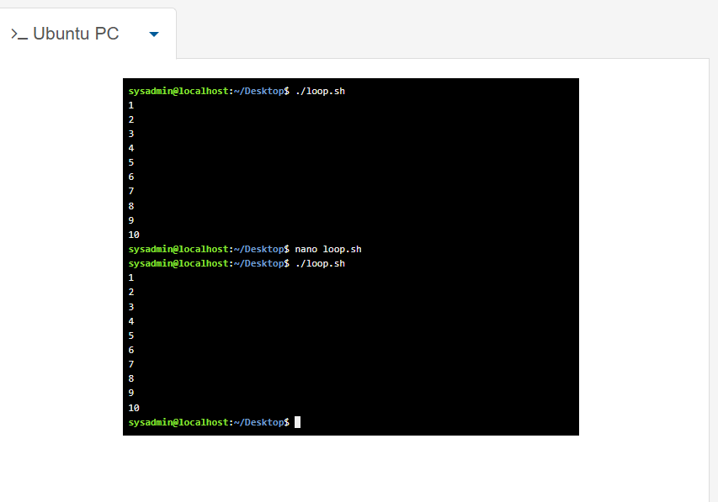
Figure 33: Output of figure 32

Conclusion
Operating systems manage computer hardware resources and provide services for application programs. This report discussed key operating system functions including task management, file management, device control and security. It also demonstrated Windows and Linux command line commands and basic scripting examples used for automation.

References

[1] W. Stallings, Computer Organization and Architecture: Designing for Performance, 10th ed. Pearson, 2016.

[2] K. C. Laudon and J. P. Laudon, Management Information Systems, Pearson, 2013.

[3] Y. Bai, SQL Server Database Programming with Visual Basic.NET, Wiley, 2020.

[4] E. Siever, Linux in a Nutshell, O’Reilly Media, 2009.

[5] C. Negus, Linux Bible, Wiley, 2015.

Appendices
Linux Unhatched
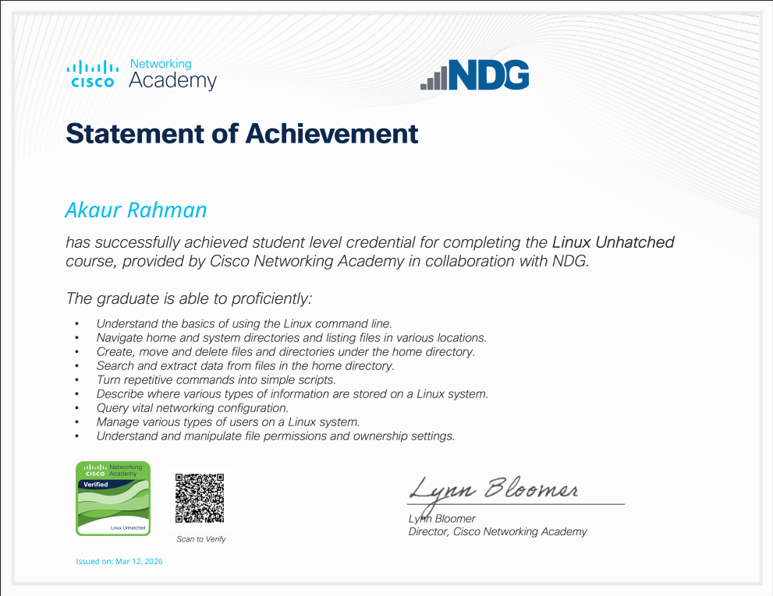

Figure 34: Certificate of completion

