Decoding Tesla's Social Media Marketing Strategy:
A Comprehensive Analysis
Keyun chen
2229979
8 July 2023

3221 words

Executive Summary
This report provides an analysis of Tesla's current social media marketing status and the challenges it faces using various frameworks, including Porter's Five Forces, Ansoff's Matrix, PESTEL, Porter's Generic Strategies, and SWOT. The analysis reveals several key findings and recommendations for Tesla's social media marketing strategy.
The findings indicate that while Tesla benefits from strong brand recognition and a competitive advantage over potential new entrants, it faces high bargaining power from buyers, intense competition, and challenges in maintaining brand uniqueness. Additionally, the report highlights the importance of engaging with the target audience, penetrating the mass market, showcasing product innovation, and leveraging social media algorithm changes to maximize the effectiveness of Tesla's social media marketing efforts (Musonera,2012).
To address these challenges and capitalize on opportunities, the report offers several recommendations. These include fostering innovation and differentiation, enhancing brand protection, proactively engaging with customers, developing region-specific strategies for market penetration and development, improving product communication and showcasing innovation, adapting to social media algorithm changes, highlighting environmental awareness and sustainability, and balancing the quantity and quality of content.
Implementing these recommendations will enable Tesla to refine its social media marketing strategy, maintain a competitive edge, engage with its target audience effectively, expand its market reach, and promote its innovative and sustainable products.
By addressing the identified challenges and leveraging their strengths, Tesla can navigate the dynamic social media marketing landscape and achieve success in engaging with its audience, expanding its market share, and promoting its brand as a leader in the electric vehicle industry.

Contents
1、Introduction 4
2、 Main Findings： 5
2.1 Porter's Five Forces Analysis 5
2.2 Ansoff’s Matrix 7
2.3 PESTEL 9
2.4 Porter's Generic Strategies Analysis 11
2.5 SWOT 12
3、Conclusion 14
4、Recommendation 16
References 18

1、Introduction
In the dynamic and highly competitive business landscape, the marketing department plays a pivotal role in shaping the success of organizations. This report critically evaluates the marketing strategies employed by Tesla, a renowned electric vehicle manufacturer, to establish its brand and drive customer engagement. By examining the marketing activities of Tesla and identifying its future developments, this report aims to address the challenges faced by the company and provide recommendations for enhancing its marketing effectiveness(Johnson,2020).
Founded by Elon Musk in 2003, Tesla has emerged as a trailblazer in the automotive industry, revolutionizing sustainable transportation through innovative electric vehicle technology. The company's visionary mission is to accelerate the global transition to sustainable energy by offering high-performance electric vehicles that not only combat climate change but also deliver an unparalleled driving experience.Tesla's marketing strategies revolve around positioning its vehicles as more than just eco-friendly transportation options(Tesla.Inc,2023). The company emphasizes their superior performance, cutting-edge technology, and exquisite design, targeting environmentally conscious consumers who seek a thrilling driving experience. Through various marketing channels, including social media platforms, Tesla effectively engages with its audience, shares product updates, and fosters a community of passionate Tesla enthusiasts(Grant,2020).
One notable aspect of Tesla's marketing approach is its direct-to-consumer sales model, bypassing traditional dealership networks. This approach enables Tesla to maintain control over the customer experience, build closer relationships with buyers, and offer a seamless purchasing process. By embracing this disruptive sales model, Tesla sets itself apart from conventional automakers and enhances its appeal to tech-savvy consumers(Ivanchenko,2017).
This report critically evaluates the marketing activities of Tesla by employing analytical frameworks such as the PESTEL analysis and Porter's Five Forces analysis，and aims to critically evaluate Tesla's marketing strategies, identify the challenges faced by the company, and provide recommendations for enhancing its marketing effectiveness. By leveraging the power of strategic marketing, Tesla can continue to redefine the automotive industry, capture a broader customer base, and achieve its mission of sustainable energy transition.
- Main Findings：

2.1 Porter's Five Forces Analysis
When applying Porter's Five Forces analysis to Tesla's social media marketing activities, the following observations can be made regarding the competitive forces within the industry:
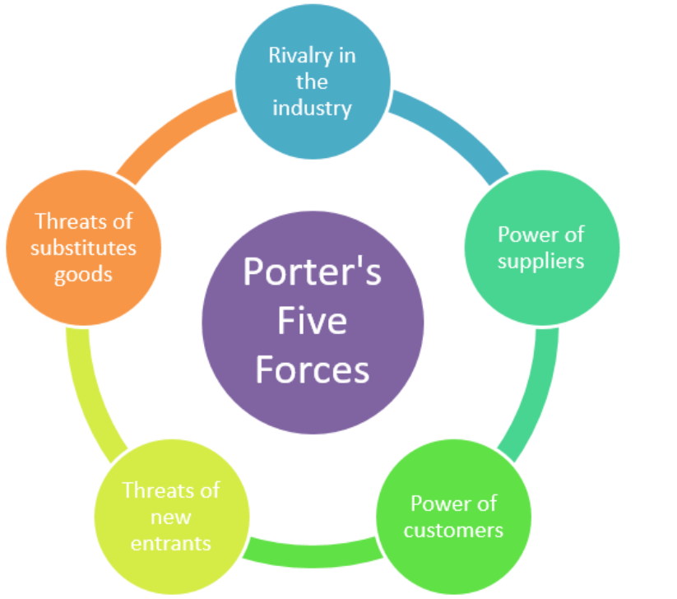
（Musonera，2019）
Threat of New Entrants:The threat of new entrants in the social media marketing platform is relatively low for Tesla. Established social media platforms, such as Facebook, Twitter, Instagram, and YouTube, require significant investments, a large user base, and network effects to effectively compete. Tesla benefits from its strong brand recognition and existing presence on these platforms, giving it a competitive advantage over potential new entrants(Cagle,2019).
Bargaining Power of Suppliers:In the context of social media marketing, suppliers refer to content creators and influencers. The bargaining power of suppliers is moderate for Tesla. While influencers can impact Tesla's brand perception and

reach, Tesla has the leverage to select the most suitable influencers for their target audience and negotiate terms of collaboration（Musonera，2019）. The company's strong brand recognition and market position provide it with bargaining power in establishing partnerships with influential individuals and content creators.
Bargaining Power of Buyers:The bargaining power of buyers in the social media marketing platform is high. Social media users have access to abundant information, can compare different brands, and openly share their opinions. To maintain customer loyalty and reduce the influence of negative opinions, Tesla needs to actively engage with its customers, address their concerns, and provide a positive user experience(Cagle,2019). Prompt and transparent communication with customers is essential for building trust and maintaining a favorable brand image.
Threat of Substitute Products or Services:The threat of substitute products or services in social media marketing for Tesla is relatively low. Social media platforms offer unique opportunities for engagement and direct interaction with customers, which traditional marketing channels may not provide. However, Tesla should remain vigilant about emerging platforms or alternative marketing channels that may disrupt the effectiveness of social media marketing (Kompalla,2017). Continual monitoring of trends and adapting to changing consumer preferences is necessary to ensure the sustainability of Tesla's social media marketing efforts.
Intensity of Competitive Rivalry:The intensity of competitive rivalry in social media marketing is high. Tesla faces competition from other automotive companies, as well as emerging electric vehicle startups, that leverage social media platforms to promote their products, build brand awareness, and engage with customers. To differentiate itself, Tesla needs to consistently deliver unique and compelling content, create a strong community of followers, and stay ahead in terms of innovation and sustainability(Kotler,2021). Continuous innovation and differentiation are vital for Tesla to maintain a competitive edge in the social media marketing landscape.

2.2 Ansoff’s Matrix
Ansoff's Matrix analysis is a strategic framework that helps businesses determine

growth strategies by evaluating four options for market and product expansion(Tsatsoula,2018).Ansoff's Matrix Analysis of Tesla's Current Social Media
Status and Challenges:
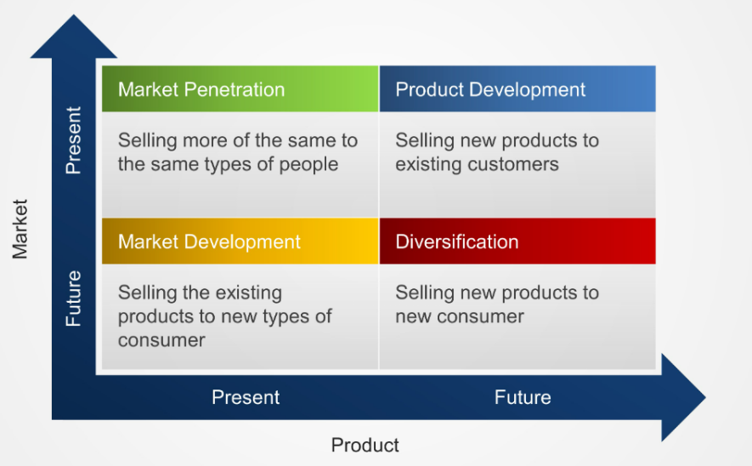
(Tsatsoula,2018)
1. Market Penetration:
Tesla has been successful in leveraging social media platforms to penetrate and engage with its target audience. The company has built a strong online presence, with a significant number of followers and active engagement on platforms like Twitter, Instagram, and YouTube(Tesla.Inc,2023). Tesla's social media marketing has helped it establish a loyal customer base and generate brand advocacy. However, there are some challenges that Tesla faces in terms of market penetration:
Saturation: With the increasing popularity of electric vehicles and the competitive landscape, the electric vehicle market is becoming saturated. Tesla needs to find innovative ways to differentiate itself from competitors and continue capturing a larger share of the market(Johnson,2020).
Targeting the Mass Market: While Tesla has successfully targeted early adopters and tech-savvy consumers, there is an opportunity for the company to penetrate the mass market (Kotler,2021). To achieve this, Tesla needs to develop social media strategies that resonate with a broader audience, addressing concerns such as affordability, range anxiety, and charging infrastructure.
2. Market Development:

Tesla has the potential to expand its social media presence and tap into new markets. Currently, the company primarily targets the North American and European markets. However, there are opportunities for market development through social media in regions such as Asia, Latin America, and Africa. Challenges in market development for Tesla's social media marketing include:
Cultural and Language Barriers: Expanding into new markets requires Tesla to overcome cultural and language barriers. Localization of content, engagement with local influencers, and understanding the unique preferences and needs of different markets are crucial for successful market development（Andrew，2022）.
Regional Regulations and Policies: Each region has its own regulations and policies related to electric vehicles and social media marketing(Tsatsoula,2018). Tesla needs to navigate these regulatory challenges and adapt its social media strategies accordingly to comply with local laws and regulations.
3. Product Development:
Tesla has been at the forefront of electric vehicle innovation, and its social media marketing plays a vital role in promoting new products and features. However, there are areas for improvement and challenges in product development through social media marketing:
Product Communication: Tesla's product updates and announcements are eagerly anticipated by enthusiasts and potential customers. However, there have been instances where communication has been delayed or lacking, leading to speculation and confusion(Martin,2017). Tesla needs to enhance its social media communication strategy, ensuring timely and accurate information sharing to maintain customer satisfaction and avoid potential misinformation.
Showcasing Innovation: Tesla's social media marketing should focus on effectively showcasing the company's continuous innovation and technological advancements. By highlighting features such as autonomous driving capabilities, battery technology advancements, and over-the-air updates, Tesla can maintain its reputation as an innovative leader in the electric vehicle industry (Ferrell,2021).

4. Diversification:
Diversification through social media marketing can present opportunities and challenges for Tesla:
Collaborations and Partnerships: Tesla has the potential to collaborate with complementary brands and influencers to expand its reach and tap into new customer segments. Strategic partnerships with renewable energy companies, technology firms, or sustainability advocates can help promote Tesla's brand values and differentiate its social media marketing efforts(Martin,2017).
Maintaining Brand Authenticity: As Tesla explores diversification through collaborations, it must ensure that partnerships align with its brand values and maintain authenticity. It is essential to choose partners that share Tesla's commitment to sustainability, innovation, and customer-centricity.

2.3 PESTEL
PESTEL analysis is a framework used to analyze and assess the external factors that can impact a business or industry, including political, economic, sociocultural, technological, environmental, and legal factors (de Sousa,2022）.

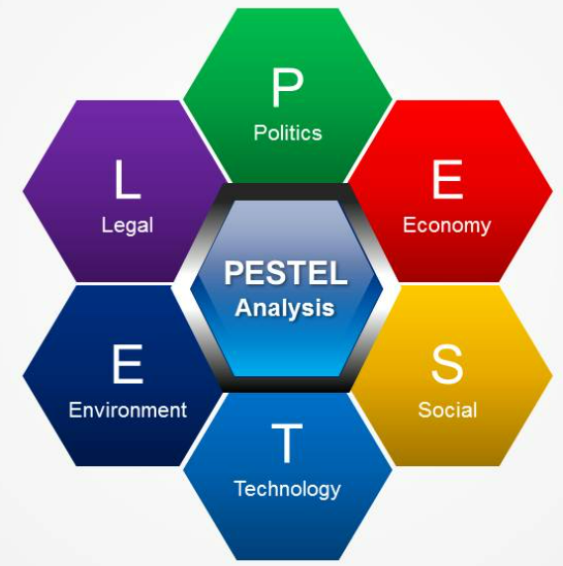
（Debnath，2021）
Political Factors:Political factors can influence Tesla's social media marketing

through regulations related to data privacy, advertising, and content moderation. Compliance with these regulations is crucial to ensure that Tesla's social media activities align with legal requirements（Zhou，2023）.
Economic Factors:Economic conditions, such as income levels and disposable income, can impact the effectiveness of Tesla's social media marketing. Economic downturns or fluctuations may affect consumer purchasing power and influence their decision to engage with or purchase Tesla's products (de Sousa,2022）.
Sociocultural Factors: Sociocultural factors play a significant role in shaping Tesla's social media marketing strategies. Changes in consumer attitudes towards sustainability, environmental consciousness, and technological innovation can create opportunities and challenges for Tesla's messaging and content development（Debnath，2021）.
Technological Factors:Technological advancements in social media platforms provide Tesla with opportunities to enhance its social media marketing efforts. Tesla needs to stay updated with emerging platforms and features to effectively engage with its target audience and leverage new trends and functionalities.
Environmental Factors:Tesla's emphasis on sustainability and environmental consciousness aligns with growing consumer demand for eco-friendly products. Tesla can leverage this trend in its social media marketing to highlight its commitment to reducing carbon emissions and promoting renewable energy.
Legal Factors:Legal factors, such as intellectual property laws, are crucial for Tesla's social media marketing. Protecting Tesla's brand assets, trademarks, and copyrighted content is essential to maintain the integrity and authenticity of its social media presence.

2.4 Porter's Generic Strategies Analysis
Porter's Generic Strategies Analysis of Tesla's Current Social Media Status and Challenges:

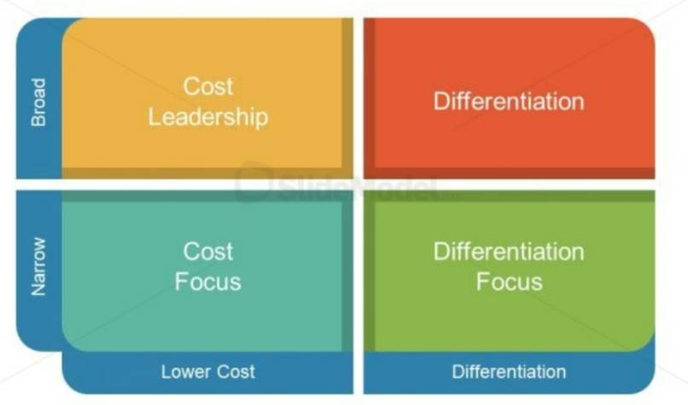
（Saxena，2021）
Tesla has successfully differentiated itself in the social media landscape by emphasizing its technologically advanced electric vehicles, sustainable practices, and commitment to innovation. This differentiation has allowed Tesla to stand out among its competitors and attract a dedicated following on social media platforms.
Intense Competitive Rivalry:One challenge Tesla faces is the intense competition in the social media marketing space. As other automotive companies and emerging electric vehicle startups also leverage social media platforms, the market becomes
crowded, making it challenging for Tesla to maintain a unique and distinctive presence（Zhou，2023）.
Threat of Imitation and Copycat Content:As a pioneer in the electric vehicle industry, Tesla's innovative social media content and campaigns have been imitated by competitors and other industry players. This poses a challenge as it dilutes Tesla's uniqueness and makes it difficult to differentiate its messaging and offerings.
Balancing Content Quantity and Quality:Tesla's active presence on social media platforms necessitates a consistent flow of content to engage with its audience effectively. However, maintaining a balance between content quantity and quality can be challenging, especially with the high demand for timely and engaging updates(Kotler,2021).
Social Media Algorithm Changes:Social media platforms frequently update their algorithms, affecting the visibility and reach of organic content. This presents a challenge for Tesla in terms of maximizing its social media presence and ensuring its
content reaches the intended audience.

2.5 SWOT
SWOT analysis is a strategic framework that assesses an organization's internal strengths and weaknesses, as well as external opportunities and threats, to develop insights for decision-making and strategy formulation.
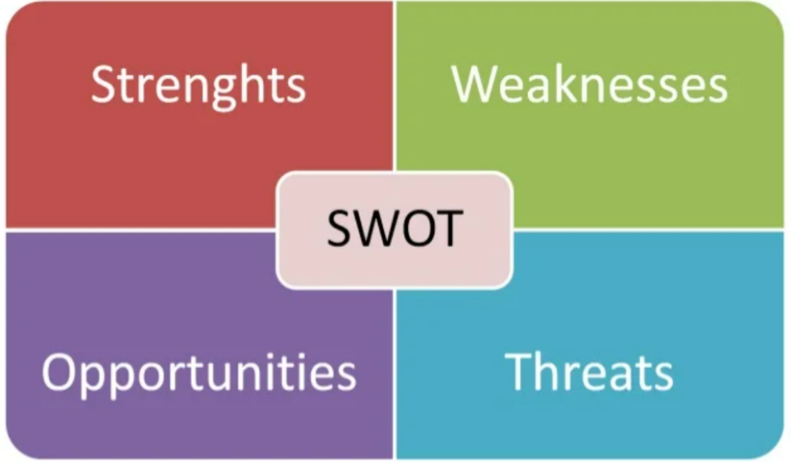
（Gurl，2017）
Strengths:
1. Strong Brand Recognition: Tesla enjoys a strong brand recognition and reputation in the electric vehicle industry, which provides an advantage for building influence on social media.
2. Innovative and Technologically Advanced Products: Tesla's innovative and technologically advanced products attract attention and provide content creation advantages on social media(Kotler,2021).
3. Engaged Community: Tesla has an engaged community, including owners and enthusiasts, who actively participate in discussions and share content on social media, establishing a loyal user base(Dwivedi,2021).
Weaknesses:
1. Limited Traditional Advertising Presence: Tesla has a limited presence in traditional advertising channels and relies primarily on social media and word-of-mouth marketing. This may restrict its reach to certain customer segments.
2. Managing Online Reputation: Tesla faces challenges in managing online reputation, as negative feedback and complaints can have a detrimental impact on its brand image（Zhou，2023）.
3. Vulnerability to Competitive Advancements: As a leading electric vehicle manufacturer, Tesla faces pressure from competitors constantly introducing new products and technologies, requiring continuous innovation to maintain a competitive edge.
Opportunities:
1. Growing Demand for Electric Vehicles: The increasing demand for electric vehicles presents an opportunity for Tesla to promote its electric vehicle products on social media.
2. Influencer Collaborations: Collaborating with social media influencers can increase Tesla's exposure and influence, attracting more potential customers.
3. Expansion into New Markets: Tesla can leverage social media platforms to expand into new markets and regions, attracting more potential customers and expanding its market share(Dwivedi,2021).
Threats:
1. Intense Competition: Tesla faces competition from other automotive companies and emerging electric vehicle startups on social media, requiring differentiation and continuous innovation to stand out.
2. Changing Social Media Algorithms: Changes in social media algorithms can impact the organic reach and effectiveness of Tesla's social media campaigns, requiring adaptability and adjustment of strategies（Zhou，2023）.
3. Negative Publicity and Controversies: Tesla is susceptible to negative publicity and controversies on social media, which can harm its brand reputation and customer perception(Mocker,2017).

3、Conclusion
Based on the analysis conducted using above model the following main findings and conclusions can be drawn regarding Tesla's current social media marketing status and the existing challenges:
1. Competitive Landscape: Tesla operates in a highly competitive social media marketing landscape, facing competition from other automotive companies and emerging electric vehicle startups. The intensity of competition requires Tesla to differentiate itself and continually innovate to maintain a competitive edge（Dai，2022）.
2. Brand Recognition and Differentiation: Tesla enjoys strong brand recognition and reputation, particularly in the electric vehicle industry. However, the threat of imitation and copycat content poses challenges to maintaining brand uniqueness and differentiation(Johnson,2020).
3. Engaging with Target Audience: Tesla's social media marketing efforts have been successful in engaging its target audience, including owners, enthusiasts, and potential customers. However, managing online reputation and addressing customer concerns promptly are essential to maintain a positive brand image.
4. Market Penetration and Development: While Tesla has penetrated the market successfully and established a loyal customer base, there is room for further market penetration, especially in the mass market segment. Expanding into new markets, particularly in regions such as Asia, Latin America, and Africa, presents opportunities for growth(Kotler,2021).
- Product Innovation and Communication: Tesla's innovative and technologically advanced products are well-received on social media. However,
effective communication of product updates and announcements, as well as showcasing ongoing innovation, is crucial to maintain customer interest and enthusiasm（Dai，2022）.
- Social Media Algorithm Changes: Frequent algorithm changes on social media platforms can impact the visibility and reach of Tesla's content(Johnson,2020).
Adapting to these changes and optimizing strategies accordingly is necessary to maximize the effectiveness of social media marketing campaigns.
7. Environmental Awareness and Sustainability: Tesla's emphasis on sustainability aligns with growing consumer demand for eco-friendly products.
Leveraging this trend in social media marketing can further enhance Tesla's brand image and attract environmentally conscious customers(Ahmed,2021).
8. Balancing Quantity and Quality of Content: Maintaining a balance between the quantity and quality of social media content is essential(Kotler,2021). Tesla needs to ensure a consistent flow of engaging and informative content to keep followers interested while maintaining high standards of content quality.
These findings highlight the complex and dynamic nature of Tesla's social media marketing landscape. By addressing the identified challenges and leveraging their strengths, Tesla can refine its social media marketing strategy and maintain a competitive edge in engaging with its target audience, expanding its market reach, and promoting its innovative and sustainable products.

4、Recommendation
1. Competitive Landscape:
Foster innovation and differentiation: Continuously invest in research and development to stay ahead in terms of technological advancements and sustainability initiatives. Differentiate Tesla's social media content by showcasing unique features, performance, and customer benefits（Dai，2022）.
Develop a comprehensive competitive analysis: Regularly monitor competitors' social media strategies, content, and engagement levels to identify areas of improvement and stay updated on emerging trends.
2. Brand Recognition and Differentiation:
Enhance brand protection: Strengthen intellectual property rights and actively enforce copyright measures to prevent copycat content and maintain Tesla's brand authenticity.
Leverage brand advocates: Cultivate relationships with brand advocates, influencers, and loyal customers who can amplify Tesla's brand message and advocate for its products on social media.
3. Engaging with Target Audience:
Proactive customer engagement: Actively monitor social media channels for customer feedback and address concerns promptly.(Kotler,2021) Respond transparently, provide personalized support, and seek opportunities to convert negative experiences into positive ones.
User-generated content campaigns: Encourage customers to share their Tesla experiences through contests, hashtags, or interactive campaigns. Feature user-generated content on Tesla's social media platforms to foster a sense of community and strengthen brand loyalty(Kotler,2021).
4. Market Penetration and Development:
Localization and regional targeting: Develop region-specific social media strategies that consider cultural nuances, language preferences, and local market conditions. Collaborate with local influencers to increase brand visibility and establish a strong presence in new markets(Aleksi,2021).
Address mass market barriers: Tailor content to highlight the affordability, convenience, and environmental benefits of Tesla's products. Educate potential customers about charging infrastructure, range capabilities, and cost savings to alleviate concerns and expand the customer base (Daylan,2023).
5. Product Innovation and Communication:
Timely and transparent communication: Establish clear communication channels to share updates on new products, features, and enhancements. Utilize social media platforms to inform and educate followers about Tesla's technology advancements, safety features, and industry-leading performance(Aleksi,2021).
Interactive content formats: Experiment with interactive content such as virtual tours, live Q&A sessions, and augmented reality experiences to engage followers and provide an immersive brand experience.
6. Social Media Algorithm Changes:
Continuous monitoring and adaptation: Stay informed about algorithm updates on social media platforms and adjust content strategies accordingly (Daylan,2023). Test and optimize different content formats, posting times, and engagement
techniques to ensure maximum visibility and reach.
7. Environmental Awareness and Sustainability:
Highlight sustainability initiatives: Showcase Tesla's commitment to environmental responsibility through engaging content that educates and inspires followers(Kotler,2021). Share stories about renewable energy integration, carbon footprint reduction, and community impact to resonate with environmentally conscious audiences(Ahmed,2021).
8. Balancing Quantity and Quality of Content:
Develop a content strategy: Plan a content calendar that balances promotional content, informative posts, and engaging visuals. Consistency is key, so ensure a regular posting schedule and align content with Tesla's brand values and messaging.
Quality control and feedback loops: Implement rigorous quality control processes to maintain the highest standards in content creation. Encourage feedback from followers and monitor engagement metrics to continuously improve content quality and relevance(Ahmed,2021).
These recommendations aim to address the challenges identified in the analysis and provide actionable measures for Tesla to enhance its social media marketing strategy. It's important for Tesla to customize these recommendations based on its specific goals, target audience, available resources, and industry dynamics. Regular evaluation and adaptation will be key to ensuring the effectiveness of the implemented measures.

References
Musonera, E., & Cagle, C. (2019). Electric Car Brand Positioning in the Automotive Industry: Recommendations for Sustainable and Innovative Marketing Strategies. Journal of Strategic Innovation & Sustainability, 14(1).

Kim, H. (2020). Analysis of how Tesla creates core innovation capability. International Journal of Business and Management, 15(6), 42-61.

How ethical is Tesla, Inc? | Ethical Consumer， from：https://www.ethicalconsumer.org/company-profile/tesla-inc,(2023)

Fan Mo&Yingying Wang（2021）.Risk and Opportunity Analysis of Tesla Motors Inc. Marketing Strategy and Business Ethics Study: -- A Mini Review

How Tesla Sets Itself Apart - Harvard Business Review， from：https://hbr.org/2020/02/how-tesla-sets-itself-apart,(2023)

Johnson, G., Whittington, R., Regnér, P., Angwin, D., & Scholes, K. (2020). Exploring strategy. Pearson UK.

Martin, D. M., & Väistö, T. (2016). Reducing the attitude-behavior gap in sustainable consumption: A theoretical proposition and the American electric vehicle market. In Marketing in and for a Sustainable Society. Emerald Group Publishing Limited.

Sandalow, D. B. (Ed.). (2009). Plug-in electric vehicles: what role for Washington?. Brookings Institution Press.

Paunov, C., & Planes-Satorra, S. (2019). How are digital technologies changing innovation?: Evidence from agriculture, the automotive industry and retail.

Mandip, G. (2012). Green HRM: People management commitment to environmental sustainability. Research Journal of Recent Sciences, ISSN, 2277, 2502.

Martin, K. D., & Murphy, P. E. (2017). The role of data privacy in marketing. Journal of the Academy of Marketing Science, 45, 135-155.

Grant, J. (2020). Greener marketing. John Wiley & Sons.

Ferrell, O. C., & Fraedrich, J. (2021). Business ethics: Ethical decision making and cases. Cengage learning.

Ivanchenko, N. (2017). Tesla, Inc.: The Automotive Business Analysis (Doctoral dissertation, Brandeis University, College of Arts and Sciences).

Cagle, C. (2019). Electric Car Brand Positioning in the Automotive Industry: Recommendations for Sustainable and Innovative Marketing Strategies. Journal of Strategic Innovation and Sustainability Vol, 14(1), 121.

Kompalla, A., Geldmacher, W., Just, V., & Lange, S. (2017). Tailored automotive business strategies in the context of digitalization and service-oriented models. Calitatea, 18(156), 77.

Kotler, P., Kartajaya, H., & Setiawan, I. (2021). Marketing 5.0: Technology for humanity. John Wiley & Sons.

Tsatsoula, E. (2018). Application of Ansoff's Matrix-Methodology: Marketing Growth Strategies For Products.

Harvard Business Review - Full text available at: EBSCOhost Business Source Complete

de Sousa, G. C., & Castañeda-Ayarza, J. A. (2022). PESTEL analysis and the macro-environmental factors that influence the development of the electric and hybrid vehicles industry in Brazil. Case Studies on Transport Policy, 10(1), 686-699.

Debnath, R., Bardhan, R., Reiner, D. M., & Miller, J. R. (2021). Political, economic, social, technological, legal and environmental dimensions of electric vehicle adoption in the United States: A social-media interaction analysis. Renewable and Sustainable Energy Reviews, 152, 111707.

Zhou, Z. (2023). Tesla Marketing Analysis. Academic Journal of Business & Management, 5(2), 171-177.

Dai, Y., Jiao, N., & Wu, Y. (2022, December). Improving GM and Tesla’s Declining Sales in China Based on SWOT Analysis. In 2022 2nd International Conference on Financial Management and Economic Transition (FMET 2022) (pp. 219-227). Atlantis Press.

Gurl, E. (2017). SWOT analysis: A theoretical review.

Mocker, M., & Fonstad, N. O. (2017). How AUDI AG is Driving Toward the Sharing Economy. MIS Quarterly Executive, 16(4).

Johnson, G., Whittington, R., Regnér, P., Angwin, D., & Scholes, K. (2020). Exploring strategy. Pearson UK.

Ahmed, M., Zheng, Y., Amine, A., Fathiannasab, H., & Chen, Z. (2021). The role of artificial intelligence in the mass adoption of electric vehicles. Joule, 5(9), 2296-2322.

Aleksi, H. (2021). Social Media as a Tool for Internationalization: Case Virkkukoukkunen.

Fahy, J., and Jobber, D., (2015), Foundations of Marketing, 5th edition, London: McGraw-Hill

Kotler P and Chernev, A. (2014), Strategic Marketing Management, 8th edition, Cerebellum Press

ride, W.M., and Ferrell, O.C. (2016), Marketing: Concepts and Strategies, 7th ed, Houghton Mifflin

