

Postgraduate/Distance Learning
Assignment coversheet & feedback form

THIS SHEET MUST BE THE FIRST PAGE OF THE ASSIGNMENT YOU ARE SUBMITTING (DO NOT SEND AS A SEPARATE FILE)

For completion by the student:
Student Name: Charlotte Florentine

Module code: AHHI7016  Module title: Studying the Medieval | Student ID number:  1706627 |  |  | Educational support needs:  No
Module tutor:
Janet Burton

Assignment due date: 30/08/2019
If your module has multiple submissions please indicate which piece of work this is.

3rd 
I confirm that this is my original work and that I have adhered to the University policy on plagiarism.
Signed ………………Charlotte Florentine……………………………………………
Email submission: if you are submitting this form via email, please tick this box
(as a substitute for your signature) to confirm that you agree to the above declaration.
Assignment Mark
1st Marker’s Provisional mark
2nd Marker’s/Moderator’s provisional mark
External Examiner’s mark (if relevant)
Final Mark

NB. All marks are provisional until confirmed by the Final Examination Board.

For completion by Marker 1 :
Comments:

Marker’s signature: |  |  | Date:
For completion by Marker 2/Moderator:

Comments:

Marker’s Signature: |  | Date:
External Examiner’s comments (if relevant)

External Examiner’s Signature: |  | Date:

Comment on the nature and function of the illustrations in the Luttrell Psalter

The Luttrell Psalter was commissioned by Geoffrey Luttrell, a Lincolnshire landowner, between about 1330 and 1345. Psalters were books of psalms which would have been used by monks, and which de Hamel suggests were frequently used by parish priests. The Luttrell Psalter demonstrates how the laity appropriated psalters and had them decorated, though certainly not universally, with secular themes. Therefore, the Luttrell Psalter features many illustrations depicting the medieval countryside, particularly its peasant farmers at work. This doesn’t seem quite so remarkable when we consider there were proportionately more serfs than freemen and landowners in medieval England. Hone believes about two thirds of the population in England in 1300 would have been serfs, engaging in the agricultural activities depicted in the psalter. Bovey estimates 85% of the total medieval population were peasants. The remaining 15% relied on the 85% for carrying out agricultural work on their lands; work which supplied their principal source of food. Agriculture dominated the visual landscape, actually and psychologically. Nor do these illustrations seem so remarkable if we interpret them as part of the response to the agrarian difficulties which beset the medieval population in the early fourteenth century.
According to Camille, the manor held ‘symbolic power’. It was the metaphorical base for manorial governance. The meal served in the hall (see fig 1), and the discipline with which this food is cultivated, gathered, cooked and served in the earlier psalter illustrations, conveys the efficiency of the manorial economy. The function of the psalter’s rural themed illustrations was, in part, to show how well-organised the labour on Geoffrey’s manor was.
According to Emmerson and Goldberg, recreation implied high status. The quiet dignity which Geoffrey is afforded in the depiction at the dining table contrasts directly with the rough, bustling labour which preceded it. Thus, the lord is associated with leisure, while the peasant is associated with labour. The medieval Church separated society into three estates: oratores (i.e. the clergy), bellatores (i.e. knights or nobles who supplied knights) and laboratores (e.g. peasant labourers). This justified the feudal system, with each behaving according to his estate because it was the will of God. fig. 6 emphasises Geoffrey’ identity as a knight. Geoffrey’s robe is embroidered with the Luttrell heraldic arms, as is the caparison of his war horse, his helmet and pennon. These visual signifiers convey Geoffrey’s social status, the value of his lands and estates, and his obligation to provide knight service to the king.
Labour was a concept that underpinned the Christian faith. Manorial labour agreed with the design God originally had for man: ‘God took the man [Adam] and placed him in the Garden of Eden to work it and watch it.’

fig. 1

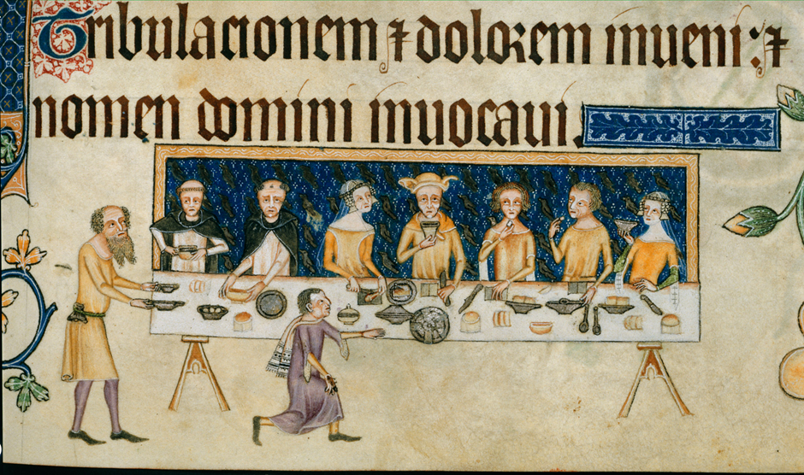

Image from The British Library, Digitised Manuscripts, <http://www.bl.uk/manuscripts/Viewer.aspx?ref=add_ms_42130_fs001ar> [accessed 30/08/2019].

Camille comments on the invisibility of agricultural labourers in eighteenth century depictions of the rural economy. In comparison, the Luttrell Psalter gives the ‘‘hands’’ of agriculture extraordinary visibility. The eighteenth-century painting Mr and Mrs Andrews (fig. 2), by Gainsborough, only suggests a rural economy, with sheep dotting a distant field, and prettily arranged sheaves of corn on the margins indicating the recent harvest. The labourer is decentralised. Gainsborough emphasised the figures of the landowners, their elaborate costumes, and the extent of their lands, as though it were a finished product. Conversely, fig 3 emphasises the manual labour which allowed the landlord to live in such a manner. Camille argues this was because the medieval landowner placed greater value on labour not land. Of course, in rural medieval society, land was useless without the labour force to farm it and supply a profit. It is also important to remember that, unlike paintings, psalters illustrations accompanied the text of the psalms. Psalters differed in that they were used by the laity to exert some control over their religious lives and emotions, which will be discussed later in this paper.
fig. 3 depicts peasants gathering and sheathing the lord’s corn from the harvest. The position of the rural labourer is centralised, revealing the lord’s reliance on him for the preservation of the manorial system and feudalism. The illustration is arguably from the peasant’s perspective. The weariness on their faces perhaps is perhaps a consequence of the extra two days plus ‘boon’ work which the serf worked over the harvest period. The figure in the middle appears to be inspecting the quality of the corn, or perhaps isolating the best sheaves of corn as part of the Church’s ‘tithe’. He is a conspicuous figure, having removed the gloves of labour, which hang visibly from his waist. No doubt this allowed him to get a better ‘‘feel’’ of the corn. His coiffed hairstyle singles him out from the other figures, and he might in fact be one of the lord’s officers, such as the bailiff, reeve or hayward. He might have even been checking for signs of theft, as he appears to view the peasant on his left with suspicion. He was possibly a salaried professional, in a better financial and social position than the other peasants, and on whom the lord trusted and depended to manage the manor in his absence. It demonstrates how within the manorial system there were attractive routes to advancement for the medieval peasant. What is significant about fig. 3 is that it alludes to the authority of the manorial lord, suggesting that the peasantry was never really autonomous, but continually subjugated by him.
Alexander explains that illustrations express the attitudes of those creating them. The peasants in fig. 3 might have reinforced a stereotype amongst the gentry and nobility classes that peasants, due to their idleness, were reluctant to work. Another theory is that fig 3 simply illustrates medieval Christian attitudes to labour. Heavy labour was thought a more worthy atonement for man’s biblical Fall: ‘By the sweat of your brow you will eat bread.’ The figures here suggest labour on the manor was physically arduous. The landlord could justify working his peasants so hard, since it agreed with Christian ethics concerning labour.
If Emmerson and Goldberg are correct in their conclusion that the Luttrell Psalter was to be used in Geoffrey’s chantry chapel in the parish church of Irnham, the illustrations were meant to accompany masses performed for his soul. The parish priest allocated this task would have an easier job if reminded, through such illustrations, of what a fine and just manorial lord Geoffrey was. Roffey explains how chantries were part of a ‘personal strategy for intercession’. The psalter illustrations thus supported Geoffrey’s preparations for death. Illustrations specifically of agricultural labour were an attempt to give the manorial system a religious foundation which would justify its existence and its morality. Thus, Geoffrey could go to his grave with his conscience clear.

fig. 2
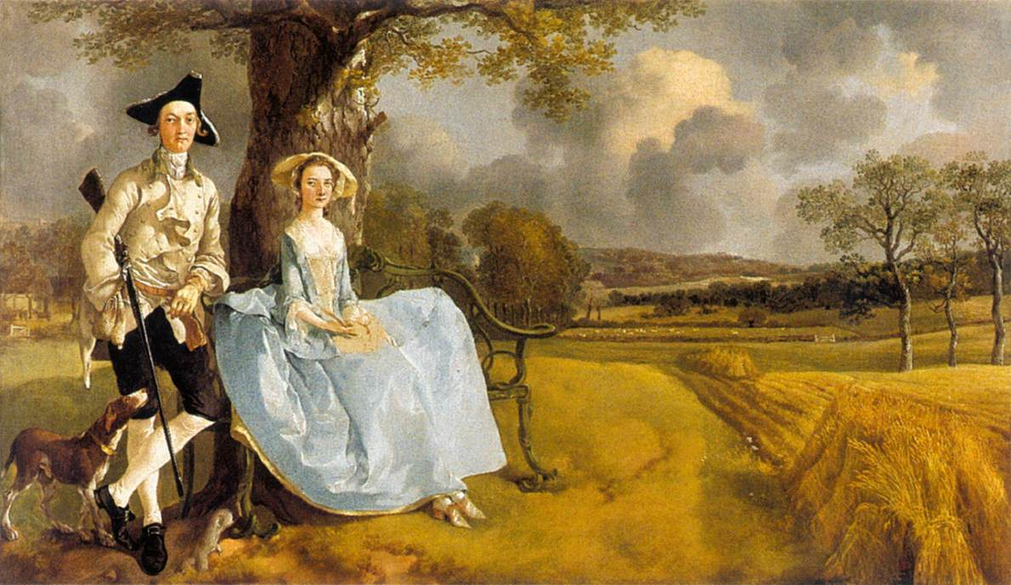https://commons.wikimedia.org/wiki/File:Mr_and_Mrs_Andrews_1748-49.jpg
Note the prettily arranged sheaves of corn and the conspicuous absence of labourers, posing no distraction to the harmony of the picture. It is very much the landowner’s landscape.

fig. 3
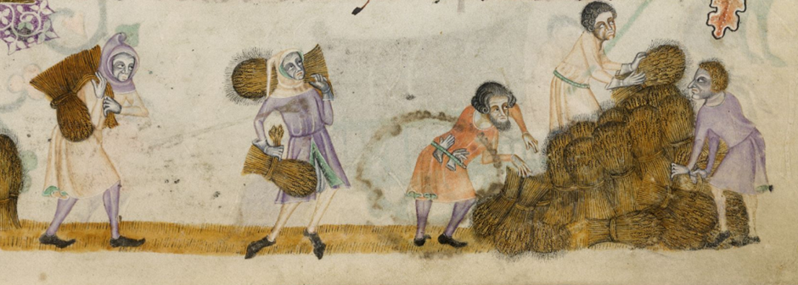
Image from The British Library, Digitised Manuscripts, <http://www.bl.uk/manuscripts/Viewer.aspx?ref=add_ms_42130_fs001ar> [accessed 30/08/2019].
Here, the landowner is decentred, thus we see the countryside in all its chaos and, significantly, we see it from the labourers’ perspective. The misery etched on their faces suggests the illuminator felt sympathy for the rural peasant.

fig. 4

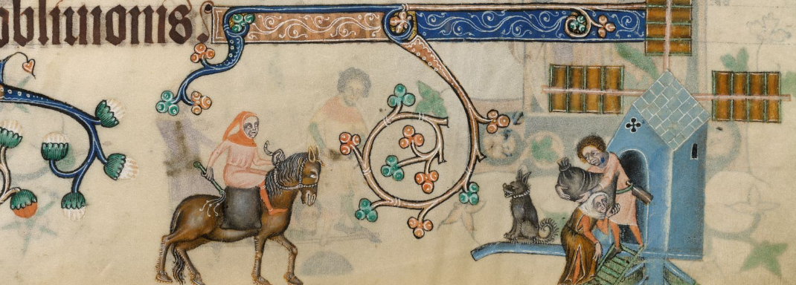
Image from The British Library, Digitised Manuscripts, <http://www.bl.uk/manuscripts/Viewer.aspx?ref=add_ms_42130_fs001ar> [accessed 30/08/2019].

Camille argues that ‘self-surveillance’ is a pervasive motif in the Luttrell Psalter. The manorial system depended on the whole community following the same set of rules. One of these was that corn could was to be milled at the lord’s mill, or a fine was incurred. In fig. 4 The miller conveys his tyranny over the peasantry as, whip in hand, he looks down from his horse, surveying two crumpled figures, leaving the mill with a bag of ground corn. In this way, the overworked peasant is equated with the horse, another servile beast under the master’s whip. Camille argues that we should not ‘equate realistic art with socially conscious… thought.’ However, the illustrations, particularly fig. 3 and fig. 4, reveal a dissatisfaction which suggests the illuminators drew from the perspective of the peasant, which conflicts with the lord’s desire to construct an idyll of the manorial system. Camille argues that the Luttrell Psalter depicts a ‘golden age of feudal order’ that had since passed. The illustrations were the landlord’s effort to conceal the fact that this order, the basis of his livelihood, was crumbling.
fig. 4 also shows how the lord deputised his supervisory duties. The miller assumed the lord’s role over the peasants, thus symbolising the lord’s dominance over the peasantry. The size of the mill has not been drawn to scale, since it functions merely as a symbol of the lord’s seignorial authority. The look of despair on the peasants’ faces appears to have been drawn with sympathy by the artist, while supporting Bennet’s argument that the mill was a ‘form of oppression’. This was based on the practice of ‘multure’, a form of taxation whereby the lord deducted a percentage of a peasant’s grain from that which was deposited at the mill.
Like the miller, fig. 5 suggests the ploughman was so important to the manorial economy that he had a level of autonomy. Camille argued that the ploughman was ‘dominator of his machine’. The illustration captures the way in which the ploughman used the autonomy which his plough had bestowed on him to subjugate the land. This, echoed his lord’s subjugation of him. However, the law did in fact cater for the rural peasant. The lord could sue his tenants for ‘public injury’ in the manor courts, while his tenants had a similar liberty in that they could sue for ‘private damage’ or breach of their common customary rights. Of course, manorialism had to be accepted as a perfectly moral system, and customary rights accepted as the illogical rights of an oppressive regime. fig. 5 indicates the peasant labourer’s lack of acceptance of the system in which he was a part. Therefore, Camille’s assessment that the labourers’ ‘psychological state’ is unimportant seems grossly misjudged. The aggressive, hostile countenances of the ploughmen in fig. 5 surely anticipated the peasant unrest which was gathering momentum.

fig. 5

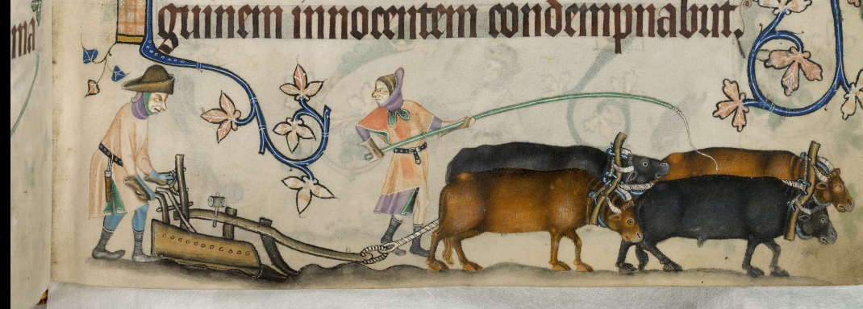
Image from The British Library, Digitised Manuscripts, <http://www.bl.uk/manuscripts/Viewer.aspx?ref=add_ms_42130_fs001ar> [accessed 30/08/2019].

Brown dated the Luttrell Psalter to 1330-45, but in many ways it anticipated the Peasant’s Revolt of 1381, when there was a demand for wages, and release from oppression, servile labour and treatment like beasts. Two other significant historical events impinged on agriculture around this time. One was the Black Death of 1348, which is believed to postdate the psalter slightly and, if this was occurring at the time the psalter was made, there are no visual cues to indicate it. The other was the agrarian crisis of 1315-1322, which Kershaw refers to as a ‘succession of arable and livestock disasters.’ Flooding caused subsequent crop failure, famine and disease. The beasts of agriculture, the sheep and cattle, were also struck down with disease, leaving inadequate for important farming work. Poverty was rife and the wool industry was in difficulties. Geoffrey, who we may assume was an older man when the psalter was produced, must have had a good recollection of these times, which may have been only ten or fifteen years previously. Despite the unlikelihood that agriculture recovered completely after this crisis, the Luttrell Psalter gives the impression of a healthy manorial system, with robust, well-nourished animals (see fig. 10), and a healthy yield of crops at harvest time. The illustrations of rural labour in the Luttrell Psalter are a conscious disavowal that the manorial system was approaching collapse.
Emmerson and Goldberg suggest they form part of a specific ‘agenda that emphasizes an idealized order of society and the rewards that follow.’ If by ‘rewards’ the authors are referring to the lord’s harvest meal, then the principal beneficiary of this order was the lord. The manorial system implied a mutual dependence between peasant and lord, such as the law acknowledged. The peasant depended on the lord’s single greatest asset: land. Despite the immorality implicit in the manorial system, it enabled the peasant to live a self-sufficient life, to cultivate the crops necessary for his survival, and the survival of the cattle which supported his labours. In return for this land, the peasant had also to cultivate the lord’s demesne land, which met his basic needs. The controversy lay in the way in which the remaining produce of the rural economy was assumed by the lord, who sold or traded it at market. Whereas the peasant labourer could only ever, at best, have his most basic needs met, the lord could construct a noble, masculine identity with the ‘surplus’ of which Hilton refers. This is demonstrated best by the luxury of the manorial hall, and the nobility’s family meal in fig. 1. Meanwhile, the extravagant costume of the knight and his war horse in fig. 6, suggests another way this surplus was disposed of.
The way in which the noblewomen serve their lord from below in fig. 6 has the effect of naturalising the notion of servility to the manorial lord. In fact, all the illustrations were intended to naturalise the servility on which manorialism depended. Geoffrey was conscious that his claims to a noble identity, and to lordship, needed to be strengthened. This was no doubt prompted by the Luttrell family’s recent humiliation, when a papal dispensation had been sought in 1331 for his marriage to Agnes, after it was suggested they were blood relatives and their alliance might be discredited. The psalter illustrations which make sometimes exaggerated use of his heraldic arms, as in fig. 6, were designed to corroborate this official dispensation.
In fig. 1 the focus of attention is the lord, who is central to the lives of his family, his household staff and his agricultural labourers. The friars seem to provide a comedic element. The object of the friars’ attention appears to be filling their food bowls and capturing the attention of the server passing by. This seems to be a comment on the greed of the friar orders. But implicit in this illustration is also the idea that as a travelling order, the friars were equally dependent on the manorial lord for their sustenance. The illustration attests to Geoffrey’s piety and generosity as a lord, which was deliberately employed to justify the fairness of the manorial system. The Luttrell arms which frame the illustration of the Luttrell family meal is Geoffrey’s proclamation of his genteel status.

fig. 6

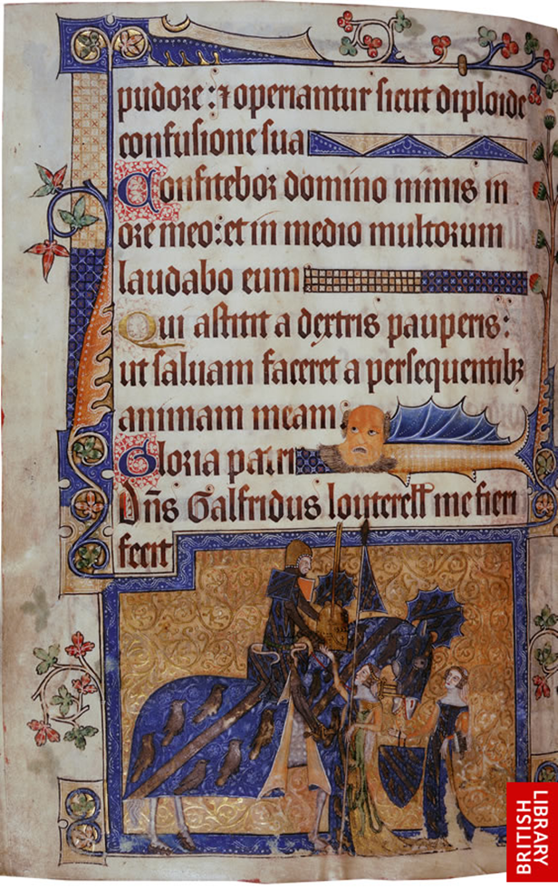
Image from The British Library, Digitised Manuscripts, <http://www.bl.uk/manuscripts/Viewer.aspx?ref=add_ms_42130_fs001ar> [accessed 30/08/2019].

Emmerson and Goldberg stated that, in the Luttrell Psalter, ‘labour is… conceived… as that which contributes to the welfare not of individuals or their families, but of the community and, specifically, the lord as head of that community. The psalter portrays the manor as a co-operative unit (see fig.8). The manorial economy depended on peasants working together, rather than against one another. This meant observing one another’s common customary rights, making sure all produce was accounted for and possessively protecting one’s ‘‘strip’’. The figure thieving cherries in fig. 7 was a threat to this balance. However, the illustration might just as easily be alluding to peasant struggle. It reflects the fact that many peasants would have had to survive on heavily regulated, inadequate portions of the manor acreage.

fig. 7
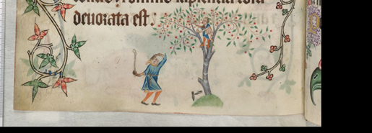 Image from The British Library, Digitised Manuscripts, <http://www.bl.uk/manuscripts/Viewer.aspx?ref=add_ms_42130_fs001ar> [accessed 30/08/2019].

Since religion dictated so much of fourteenth century experienced, many historians have examined the Luttrell Psalter’s more secular illustrations for religious meaning. The link between medieval Christianity and labour has already been alluded to. Rentz interpreted the Luttrell Psalter illustrations not only as an actual manorial economy, but a ‘devotional economy…in which manual labour is figured as spiritual – in the context of a sacramental meal’. Geoffrey was able to rationalise his involvement in manorial oppression, using the illustrations in the Luttrell Psalter to imply manorialism was a positive expression of Christian faith. At the centre of the dinner table he is portrayed as the saviour, on whom the agricultural economy hinged.
This essay has hopefully shown how the illustrations in the Luttrell Psalter served a variety of different functions. Firstly, they functioned as a guide to manorial efficiency, emphasising that a strong community which observed common rights would easily sustain itself. This would have also lent support to Geoffrey’s reputation as a manorial lord, providing a lasting memorial to him in his death. In aligning the manorialism with Christian ideology, Geoffrey could also justify the system’s morality. He could convince priests of this, too, as they turned the pages of his psalter.

fig. 8.

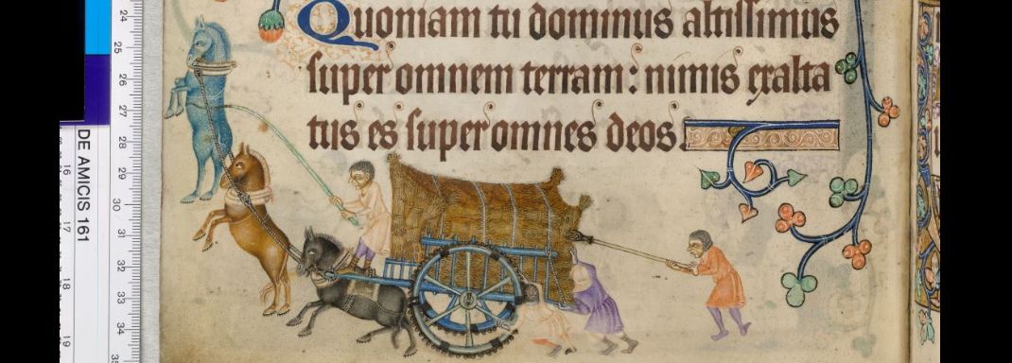
Image from The British Library, Digitised Manuscripts, <http://www.bl.uk/manuscripts/Viewer.aspx?ref=add_ms_42130_fs001ar> [accessed 30/08/2019].
On the manor, the whole community, animals included, pull together in order to support the manorial economy. The cart is stacked highly and densely with harvest produce, the weight of which is implied by the three peasants pushing it from behind. This was an effective way for Geoffrey to suggest that life on his manor, rightly or wrongly, was marked by its abundance.

fig. 9
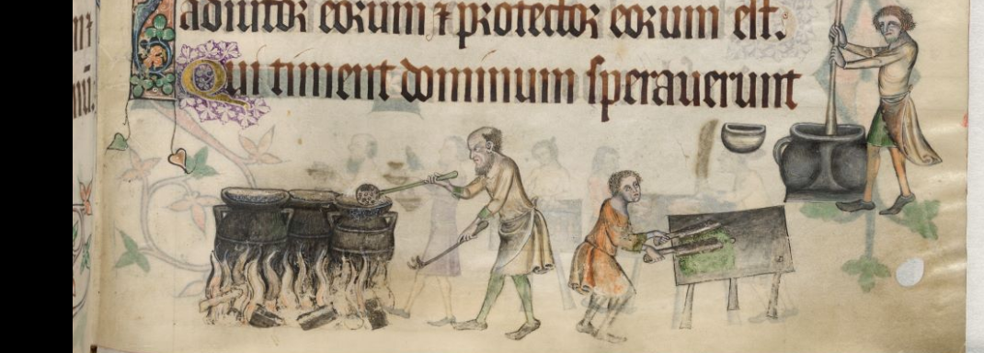
Image from The British Library, Digitised Manuscripts, <http://www.bl.uk/manuscripts/Viewer.aspx?ref=add_ms_42130_fs001ar> [accessed 30/08/2019].
A roaring fire and four big cauldrons imply Geoffrey ate well, which was a signifier of his social status. It was also testament to the successful management of his manor. This was something he wished to publicise, in order to give confirmation to his claims to nobility.

fig. 10
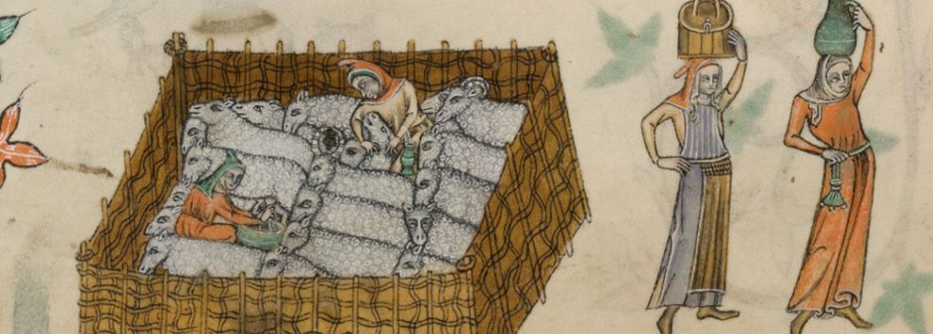
Image from The British Library, Digitised Manuscripts, <http://www.bl.uk/manuscripts/Viewer.aspx?ref=add_ms_42130_fs001ar> [accessed 30/08/2019].
This illustration of fat, woolly sheep, packed tightly into their fold for milking, suggests manorial animals were in good supply and free from disease. We may presume the dairymaid on the far right is balancing a generous jug of quality milk on her head. The purse hanging conspicuously from her waist indicates a fruitful participation in the wool and dairy industries. The illustration was intended to be a positive, as well as a lasting, testament to Geoffrey’s manor.

Bibliography
Alexander, J.J.G., Medieval Illuminators and their Methods of Work, (New Haven and London: Yale University Press, 1992).
Bailey, The English Manor, (UK: Manchester University Press, 2002).
Bennett, H.S., Life on the English Manor: A Study of Peasant Conditions, 1150-1400, (UK: Cambridge University Press, 1937 ).
Bothwell, J., Goldberg, P.J.P. and Ormrod, W., The Problem of Labour in Fourteenth Century England, (UK: York Medieval Press, 2000).
Bovey, A., ‘Peasants and their Role in Rural Life’, (30/04/2015) https://www.bl.uk/the-middle-ages/articles/peasants-and-their-role-in-rural-life [Accessed 20/08/2019].
Camille, M., ‘Labouring for the Lord: The Ploughman and the Social Order in the Luttrell Psalter’, Art History, 10(4), (1987), pp. 423-463.
Camille, M., Mirror in Parchment: The Luttrell Psalter and the Making of Medieval England, (London: Reaktion Books Ltd., 1998).
de Hamel, A History of Illuminated Manuscripts, (Book Club Associates by arrangement with Phaidon Press, 1986).
Hone, N. J., The Manor and Manorial Records, (London: Methuen and Co., 1906).
Kershaw, I., ‘The Great Famine and Agrarian Crisis in England, 1315-22’, Past and Present, 59 (May 1973), (pp. 3-50).
Lis, C. and Soly, H. Worthy Efforts: Attitudes to Work and Workers in Pre-Industrial Europe, (Leiden and Boston: Brill, 2012).
Rentz, E.K., ‘Representing Devotional Economy: Agricultural and Liturgical Labor in the Luttrell Psalter’, Studies in Iconography, 31 (2010), (pp. 69-97).
Roffey, S., The Medieval Chantry Chapel: An Archaeology, (Woodbridge: The Boydell Press, 2007).
http://www.bl.uk/manuscripts/Viewer.aspx?ref=add_ms_42130_fs001ar

M.P. Brown; in E.K. Rentz, ‘Representing Devotional Economy: Agricultural and Liturgical Labor in the Luttrell Psalter’, Studies in Iconography, 31 (2010), (pp. 69-97), p. 70.
C. de Hamel, A History of Illuminated Manuscripts, (Book Club Associates by arrangement with Phaidon Press, 1986), p. 197.
N.J. Hone, The Manor and Manorial Records, (London: Methuen and Co., 1906), p. 58.
Camille, Mirror in Parchment: The Luttrell Psalter and the Making of Medieval England, p. 120.
R.K. Emmerson and P.J.P. Goldberg,‘ ‘The Lord Geoffrey had me made’: Lordship and Labour in the Luttrell Psalter’; in Bothwell et al., The Problem of Labour in Fourteenth Century England, (UK: York Medieval Press, 2000), pp. 43-63 (p. 61).
C. Lis and H. Soly, Worthy Efforts: Attitudes to Work and Workers in Pre-Industrial Europe, (Leiden and Boston: Brill, 2012), p. 120.
ibid, p. 164.
ibid, p. 101.
M. Camille, Mirror in Parchment: The Luttrell Psalter and the Making of Medieval England, (London: Reaktion Books Ltd., 1998), p. 180.
M. Camille, ‘Labouring for the Lord: The Ploughman and the Social Order in the Luttrell Psalter’, Art History, 10(4), (1987), pp. 423-463, p 427.
H.S. Bennett, Life on the English Manor : A Study of Peasant Conditions, 1150-1400, (UK : Cambridge University Press, 1937 ), p. 83.
H.S. Bennett, Life on the English Manor : A Study of Peasant Conditions, 1150-1400, p. 84.
M. Bailey, The English Manor, (UK: Manchester University Press, 2002), pp. 98-99.
ibid, p. 99.
J.J.G. Alexander, Medieval Illuminators and their Methods of Work, (New Haven and London: Yale University Press, 1992).p. 143
C. Lis, and H. Soly, Worthy Efforts: Attitudes to Work and Workers in Pre-Industrial Europe, (Leiden and Boston: Brill, 2012), p. 101-2.
Emmerson and Goldberg,‘ ‘The Lord Geoffrey had me made’: Lordship and Labour in the Luttrell Psalter’, p.51.
S. Roffey, S., The Medieval Chantry Chapel: An Archaeology, (Woodbridge: The Boydell Press, 2007), p. 17.
M. Camille, Mirror in Parchment: The Luttrell Psalter and the Making of Medieval England, pp. 199 and 215.
H.S. Bennett, Life on the English Manor : A Study of Peasant Conditions, 1150-1400, (UK : Cambridge University Press, 1937 ), p. 130.
Camille, Mirror in Parchment: The Luttrell Psalter and the Making of Medieval England, p. 209.
ibid, p. 192.
Bennet, Life on the English Manor : A Study of Peasant Conditions, 1150-1400, p.137.
ibid, p. 133.
Camille, Mirror in Parchment: The Luttrell Psalter and the Making of Medieval England, p. 180.
Hone, The Manor and Manorial Records , pp. 109-112.
Camille, Mirror in Parchment: The Luttrell Psalter and the Making of Medieval England, p. 209.
Brown; in E.K. Rentz, ‘Representing Devotional Economy: Agricultural and Liturgical Labor in the Luttrell Psalter’, p. 70.
Froissart; in A. Bovey, ‘Peasants and their Role in Rural Life’, (30/04/2015), https://www.bl.uk/the-middle-ages/articles/peasants-and-their-role-in-rural-life [Accessed 20/08/2019].
I. Kershaw, ‘The Great Famine and Agrarian Crisis in England, 1315-22’, Past and Present, 59 (May 1973), pp. 3-50, (p. 16).
ibid, p. 7, p. 11, p. 13, pp. 24- 25, and pp. 48-49.
Emmerson and Goldberg, ‘ ‘The Lord Geoffrey had me made’: Lordship and Labour in the Luttrell Psalter’, pp. 59-60.
Hone, The Manor and Manorial Records, p. 112.
Camille, Mirror in Parchment: The Luttrell Psalter and the Making of Medieval England, p. 180.
ibid
Camille, Mirror in Parchment: The Luttrell Psalter and the Making of Medieval England, p. 200.
ibid, p. 96 and p. 105.
Emmerson and Goldberg, ‘ ‘The Lord Geoffrey had me made’: Lordship and Labour in the Luttrell Psalter’, p. 61.
Hone, The Manor and Manorial Records, p. 109.
Rentz, ‘Representing Devotional Economy: Agricultural and Liturgical Labor in the Luttrell Psalter’, p. 71.

