

Critical Evaluation of Braun’s & Wallace Tree Multiplier using VHDL
ELECTRONICS II……ACDA 6001

By
Christian Howells 2215654

BEng Electrical & Electronic Engineering | January 2023
Contents
Introduction 3
Background Research 3
Combinational Circuits 4
Number Systems 4
Half Adder 5
Full Adder 6
Binary Multiplier 9
Brauns Multiplier 9
Wallace Tree 10
Booth’s Multiplier 11
VHDL/ FPGA 11
TASK 1 13
Braun’s Multiplier 13
Logic Circuit Design 13
Simulation 14
Synthesis & Schematic 16
TASK 2 22
Wallace Tree Multiplier 22
Dot Diagram 22
Logic Circuit Design 23
Simulation 24
Synthesis & Schematic 26
TASK 3 32
Calculated longest Delay in Brauns Multiplier 32
Calculated longest Delay in Wallace Tree Multiplier 33
Delay Comparison Table 34
References 41
Appendices 42
Brauns multiplier 8x8 code 42
Wallace Tree 8x8 Multiplier Code 50

Introduction
The goal for this assignment is to use VHSIC Hardware Description Language (VHDL) to compare, synthesize and evaluate the behaviour and performance of both a Braun’s 8-bit multiplier, and an 8x8 bit Wallace Tree multiplier.

Background Research
Digital circuits within electronic circuits have two states, ‘ON’ and ‘OFF’ or ‘1’ or ‘0’ or ‘True’ or ‘False’. Logic gates are used, with each gate having a different function (behave differently). A Truth Table will quickly show how logic gates respond to different input levels. Some examples of relevant logic gates are shown below, but these are in their simplest form, a combination of logic gates can help achieve more complex functions. When dealing with a complex function, Karnaugh maps and Boolean algebra can be used to simplify the function.
A | B | Q
0 | 0 | 0
0 | 1 | 0
1 | 0 | 0
1 | 1 | 1
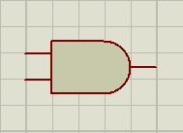
AND Gate: For an AND gate to provide a logic ‘1’ output, both inputs A and B have to be at logic level ‘1’. Any other logic level ‘0’ on either input results in a logic level ‘0’ at output ‘Q’. The symbol, Truth Table and Boolean expression are shown below.

Boolean expression; Q = A.B

A | B | Q
0 | 0 | 0
0 | 1 | 1
1 | 0 | 1
1 | 1 | 1
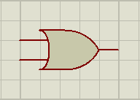
OR Gate: For an OR gate to provide a logic ‘1’ at output ‘Q’, either of inputs A or B have to be at logic level ‘1’ or when both are at logic level’1’. The symbol, Truth Table and Boolean expression are shown below.

Boolean expression; Q = A + B

A | B | Q
0 | 0 | 0
0 | 1 | 1
1 | 0 | 1
1 | 1 | 0
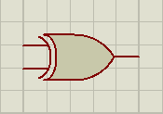
XOR Gate: For an XOR gate to provide a logic ‘1’ at output ‘Q’, one of either A or B inputs must be ‘1’. If both inputs are ‘0’ or ‘1’ the output ‘Q’ will be ‘0’. XOR can only have 2 inputs. XOR is not a simple gate but a collection of gates. The symbol, Truth Table and Boolean expression are shown below. The XOR function has its own Boolean symbol, Ꚛ.

Boolean expression; Q = $\overline{A+B}$ = $\overline{A.}B+A.\overline{B}$ = A Ꚛ B

Combinational Circuits
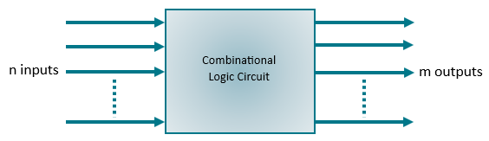
A combinational logic circuit is a type of digital circuit that can be made up from several kinds of logic gate. The output is dependent on the state of its current inputs. The combinational circuit has no memory, so previous input combinations are irrelevant. Types of combinational circuit include, Half Adder, Full Adder, Half Subtractors, Full Subtractors and Parallel Adders.

Number Systems
Decimal | 0 | 1 | 2 | 3 | 4 | 5 | 6 | 7 | 8 | 9 | 10 | 11 | 12 | 13 | 14 | 15
Binary | 0000 | 0001 | 0010 | 0011 | 0100 | 0101 | 0110 | 0111 | 1000 | 1001 | 1010 | 1011 | 1100 | 1101 | 1110 | 1111
Hex | 0 | 1 | 2 | 3 | 4 | 5 | 6 | 7 | 8 | 9 | A | B | C | D | E | F
The Binary number system is used due to the arithmetic being much simpler than other numbering systems, it is the base for all computer systems and operations. Binary numbers have a base of 2 and have 2 symbols, ‘0’ and ‘1’. Hexadecimal is often used by developers and designers to provide a user-friendly alternative to Binary. Hex has a base of 16 and require 16 symbols, 0 to F (see table below).
[1]
The conversion between hexadecimal and Binary involves the substitution of each Hex digit by four Binary bits of the same value: (1111001100101010)₂ = (F32A)₁₆
$\underset{F}{\underbrace{1111}}$ $\underset{3}{\underbrace{0011}}$ $\underset{2}{\underbrace{0010}}$ $\underset{A}{\underbrace{1010}}$
Numbers that are only positive are known as ‘Unsigned Numbers’. Numbers that can be negative are known as ‘Signed Numbers’. Binary arithmetic is simpler to perform compared to decimal/hexadecimal as there are only ‘0s’ and ‘1s’.
0 + 0 = 0; 0 + 1 = 1; 1 + 0 = 1; 1 + 1 = 10
The addition of two ‘1s’ results in a 2-digit number outcome. To perform this function a Half Adder is required. [2] [1]

Half Adder
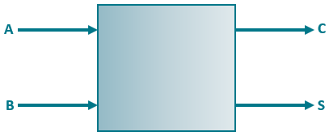
The most basic combinational circuit is the Half Adder. It conducts the binary addition of two single bit binary inputs. The block diagram below shows the two inputs, A and B, and two outputs, S (Sum) and C (Carry). The S output provides the LSB (least significant bit), the C output provides the MSB (most significant bit) of the addition. The Truth Table shows the outcomes for differing inputs.
Half Adder
A | B | C | S
0 | 0 | 0 | 0
0 | 1 | 0 | 1
1 | 0 | 0 | 1
1 | 1 | 1 | 0

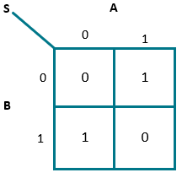
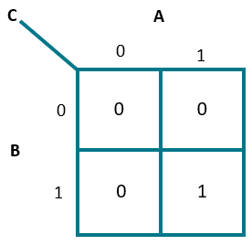
The data found in the Truth Table can be represented by Karnaugh maps

Boolean expression; C = A.B and S = A Ꚛ B
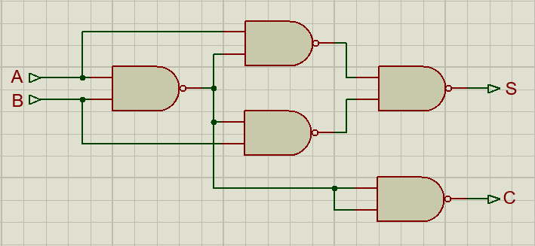
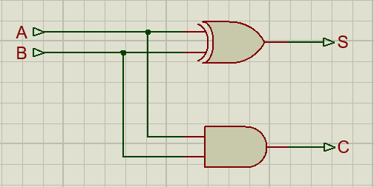
The simplest way to draw a Half Adder circuit is by using an XOR gate and an AND gate. In practice, the XOR is not a simple gate, it’s a collection of gates, and has more than one way of implementation. Another way of building a Half Adder is by utilizing NAND gates. During design, consideration should be given to the time taken for the output to change, as a result of a change in input state; This is known as the propagation delay time. Different gates have different delay times, but in general, the more gates a signal passes through the longer the delay. Logical depth is the term used for the number of gates a signal has to pass through. At first glance, the left hand circuit below looks to have the least logical depth, but this is not the case as the XOR function may have a gate depth of three; ∴ ‘S’ and ‘C’ would have logical depths of 3 & 1 respectively. The circuit using only NAND gates has a logical depth of 3 (S) & 2 (C). If the Sum output ‘S’ has a much larger logical depth than the Carry out ‘C’, ‘C’ will respond before ‘S’, potentially causing problems. [2] [3]

Full Adder
A | B | Cin | Cout | S
0 | 0 | 0 | 0 | 0
0 | 0 | 1 | 0 | 1
0 | 1 | 0 | 0 | 1
0 | 1 | 1 | 1 | 0
1 | 0 | 0 | 0 | 1
1 | 0 | 1 | 1 | 0
1 | 1 | 0 | 1 | 0
1 | 1 | 1 | 1 | 1
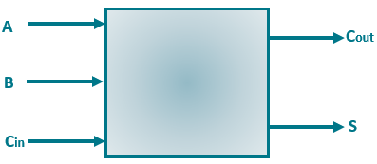
A Full Adder is capable of adding three single bit Binary numbers, which in practice would be two Binary inputs and a Carry out from a previous stage (half adder). If multiple bit Binary numbers needed to be added together a form of network can be formed. The initial stage is carried out by a Half Adder which has 2 inputs, A & B, and 2 outputs S & C_{out}.
Full Adder

The following stage will be a Full Adder with 3 inputs, A, B, & C_{in} (C_{in} is C_{out} from previous stage) and 2 outputs, S & C_{out}. It is possible to add together numbers of any length, by increasing the number of Full Adders. The Truth Table describes the function of the Full Adder.
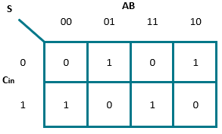
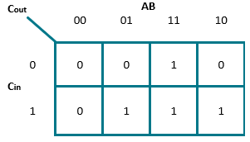
The data found in the Truth Table can be represented by Karnaugh maps

Boolean expression; C_{out} = A.B + B.C_{in} + A.C_{in}
and
$$S=\overline{A}.B.\overline{C}+ \overline{A}.\overline{B}.C+A.B.C+A.\overline{B.}\overline{C}$$
$S= \overline{A}\left(B.\overline{C}+ \overline{B}.C\right)+A(B.C+ \overline{B}.\overline{C})$
$S= \overline{A}(B$ꚚC) +A($\overline{B}$Ꚛ$\overline{C})$
S = A Ꚛ B Ꚛ C_{in}

The simplest approach to a Full Adder is by combining 2 Half Adders, it also uses less circuitry than the alternative shown (image below right). However, the logical depth of the 2x HA option equates to 6 for ‘S’ and 5 for 'C_{out}’. The option with the larger number of gates provides the smallest logical depth: 3 for ‘S’ and 3 for 'C_{out}’.
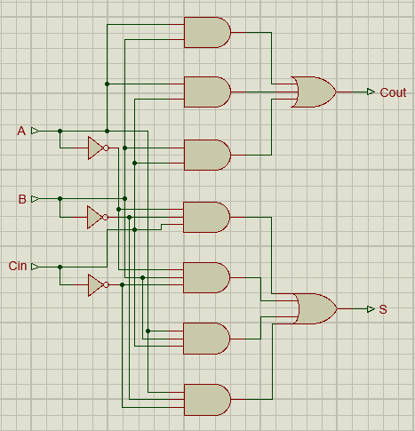
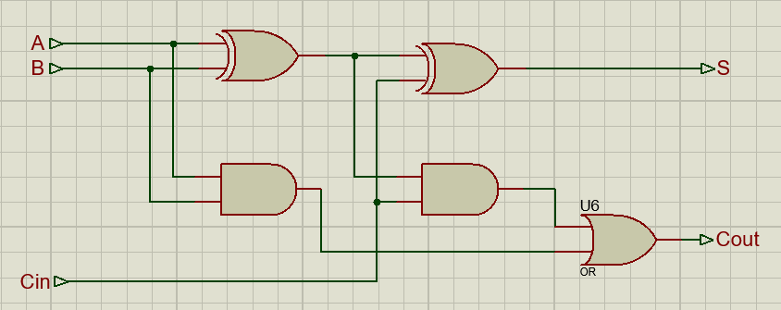

Below is the structure of a parallel binary adder for the addition of two 4-bit unsigned integers using one HA and three FAs connected in a chain. The Carry out from the adder becomes the Carry in for the next higher order adder in the chain.
If A_{n} is to be added to B_{n}, then the parallel binary adder will required n adders.
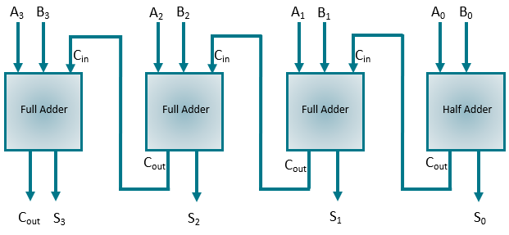

[2]
acstv10n5_54.pdf (ripublication.com)
https://www.allaboutcircuits.com/technical-articles/std-logic-vector-data-type-in-vhdl-code/

Binary Multiplier
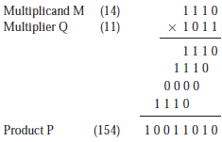
Binary multiplication is the process of multiplying two binary numbers. It follows similar principles to decimal multiplication but only involves the digits ‘1’ and ‘0’. The basic steps include multiplying each bit of one binary number with all bits of the other number and then adding up the results. The resultant is represented in binary form.
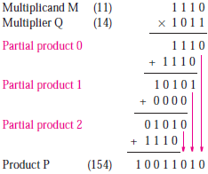
Each multiplier bit is looked at from right to left. If the bit is 1, a shifted version of the multiplicand is added to form a partial product, otherwise nothing is added. The sum of these partial products results in the desired product. This approach is common in binary multiplication. This is an example of manually performing the multiplication.
A
B
The image to the right will use several adders to produce the multiplication. A four-bit adder is utilised in each step to calculate the new partial product. The least significant bits can be moved straight to the final product, as they are unaffected by later additions as the computation continues.
Combinational circuits are used for binary multiplication using array multipliers. If two 4-bit binary numbers represented by A (A₃,A₂,A₁,A₀) and B (B₃,B₂,B₁,B₀) were multiplied together, the result would be the product, P (P₇,P₆,P₅,P₄,P₃,P₂,P₁,P₀) [3] [4]

Brauns Multiplier
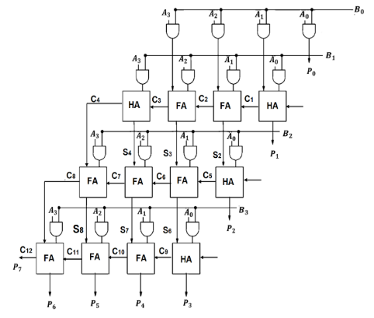
Brauns Multiplier is a specific algorithm for binary multiplication designed to optimize the multiplication process. When implemented, it uses AND gates and adders, with a parallel processing technique, to achieve efficient unsigned number multiplication. Within the structure. Each product is created in parallel with the AND gates. Each partial product is added to the sum of partial product that was already produced by the previous row of adders. The carry out is shifted one bit to the left, it is then added to the sum generated by the first adder and newly generated partial product.
An n x n bit Braun Multiplier will require; n x (n-1) number of adders,
n² number of AND gates.
e.g., An 8x8 Braun Multiplier will require: 8 x 7 = 56 adders,
8² = 64 AND gates. [5]
Advantages | Disadvantages
Simple | Inefficient - No of components increases quadratically with the number of bits
Dynamic power can be reduced using bypassing techniques | Possibility of glitching problems due to ripple carry adder in final stage
Faster than conventional | Consumes more power compared to Wallace
[5] [6] [7]

Wallace Tree
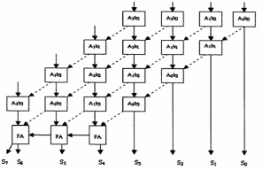
The Wallace Tree Multiplier is a hardware based binary multiplier architecture designed to efficiently perform binary multiplication. It was invented by computer scientist C.S.Wallace in 1964. Implementing a Wallace tree multiplier using half & full adders involves constructing a binary tree structure for efficient reduction of partial products. A matrix of the partial products is generated by multiplying each bit of one operand by each bit of the other operand. Each level of the tree structure represents a stage of reduction. The carry bits from each stage are passed on through the tree to ensure correct summation. The arrangement of the adders within the tree structure can impact the performance, area efficiency and power consumption of the multiplier.
Advantages | Disadvantages
High speed | Complex to lay out with irregular wires
Least No of partial products when compared to other multipliers | Large chip area
Less power
[8] [7]

Booth’s Multiplier
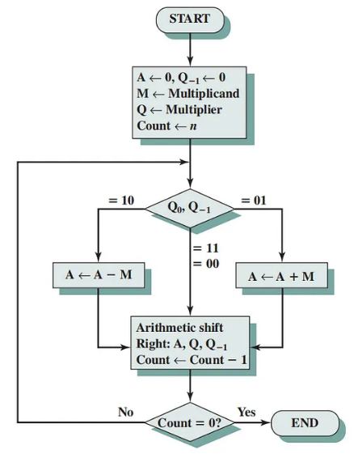
The Boothe multiplier was invented by W.Boothe in 1970. It’s a type of hardware multiplier architecture designed for efficient signed binary multiplication. Booth’s algorithm utilises bit shifting to quickly perform the multiplication of two signed binary numbers. The algorithm takes into account the +ve or -ve sign of the numbers to be multiplied. It adjusts the partial products by adding/subtracting the shifted multiplicand based on the bit values of the multiplier. The multiplication process is repeated by shifting the multiplicand and tailoring the partial product until all bits of the multiplier have been processed. The algorithm is known for its efficiency compared to traditional multiplication methods, it uses fewer additions, leading to faster calculation . [7] [9]
Advantages | Disadvantages
Reduces number of partial products generated, more efficient process | Complex control logic
Lower power consumption | Increased hardware complexity
Improved speed | Not efficient for short or random patterns

VHDL/ FPGA
VHSIC Hardware Description Language is a hardware description language used for modelling and constructing digital systems. It allows engineers to describe the behaviour and structure of electronic systems. VHDL is commonly used in the design and simulation of digital circuits, particularly in the development of ASICs (Application-Specific Integrated Circuits) and programmable logic devices. VHDL is used to describe the functionality of circuits implemented in FPGAs (Field Programmable Gate Array). It enables the design, simulation, synthesis, and implementation FPGA based systems.
An FPGA is a hardware device containing an array of programmable logic blocks and configurable interconnections. FPGAs are used in digital signal processing, communication systems, and image processing. VHDL is the language used to describe a design, FPGA offer a platform for the implementation of these designs. There are several levels of abstraction that allow designers to describe the functionality and structure of digital systems. [10]
Behavioural Level: This is the highest level of abstraction where functionality of the design is described without specifying the structural details.
Register Transfer Level (RTL): The design is described in terms of dataflow and how data moves between registers. Its more structural than behavioural level.
Dataflow Level: The attention is on the flow of data through the logic. Its more structural than the RTL level.
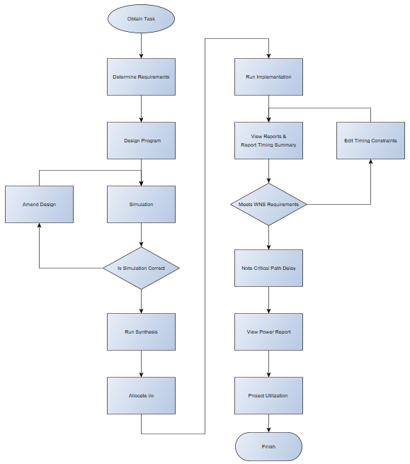
Structural Level: This provides the lowest level of abstraction, detailing the physical components and connections diagram.
Flowchart

TASK 1

Braun’s Multiplier
An 8 bit Brauns Multiplier using two unsigned numbers. The multiplier generates partial products, it multiplies each bit of A with each bit of B. It adds these partial products together to obtain a 16 bit result. The structure and logic diagram are shown below, all inputs, output ports, carry overs and signals have been identified.

Logic Circuit Design
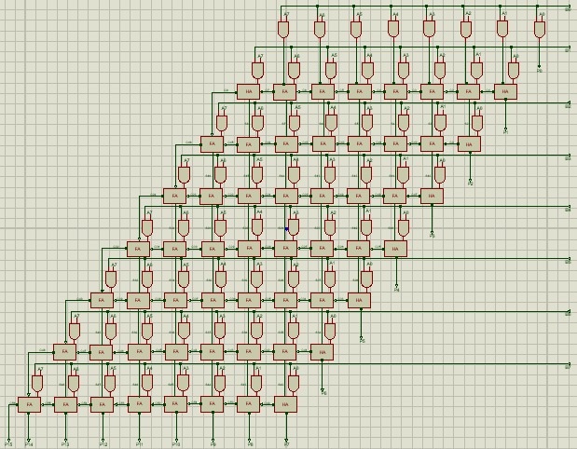
48 Full Adders, 8 Half Adders and 64 AND gates are used to construct the Logic Diagram.

Simulation
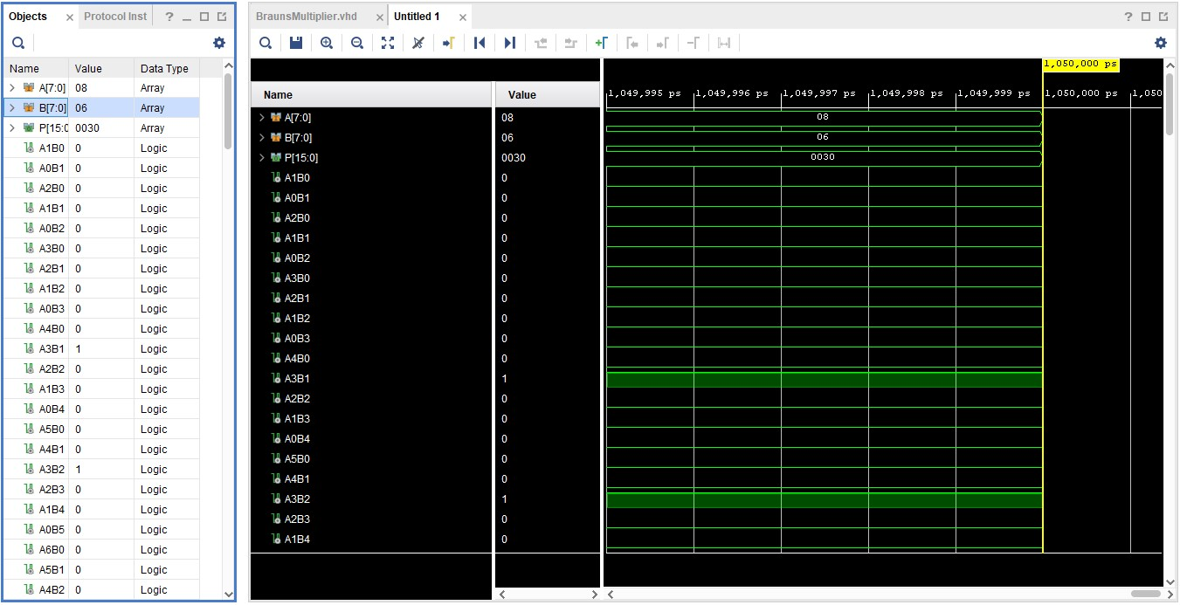
The Run Behavioural Simulation function was carried out. Simulation allows the code to be analysed and its behaviour verified. The clock on each input needs to be set, in this instance the Leading Edge ‘1’ and the Trailing Edge ‘0’. The input values were forced, with the following results. Hexadecimal system is used, the results were verified using a hexadecimal calculator.
08 x 06 = 0030
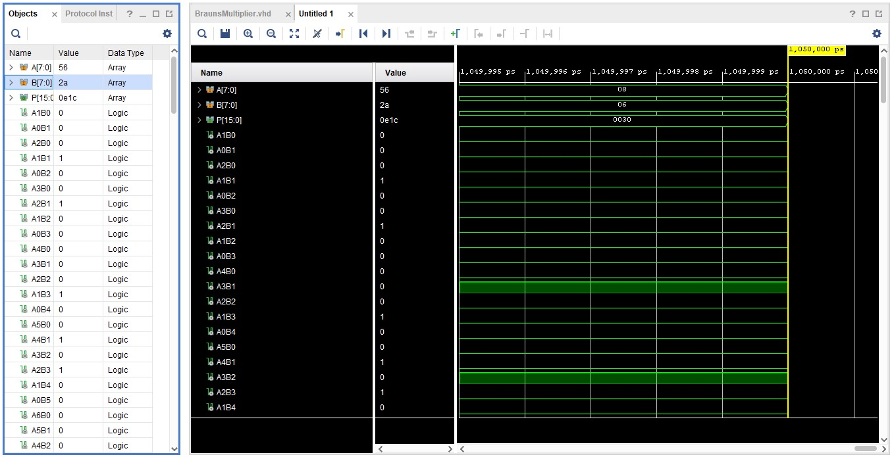
56 x 2A = 0E1C

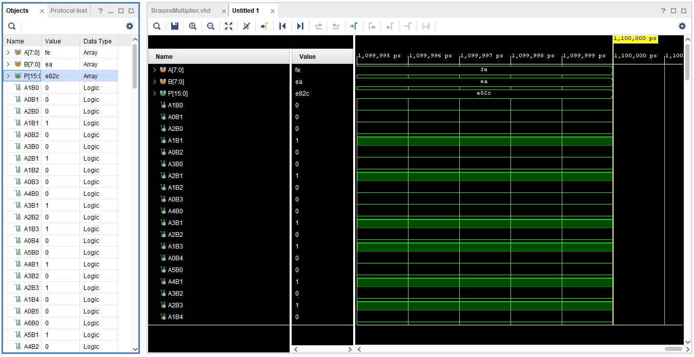
FE x EA = E82C
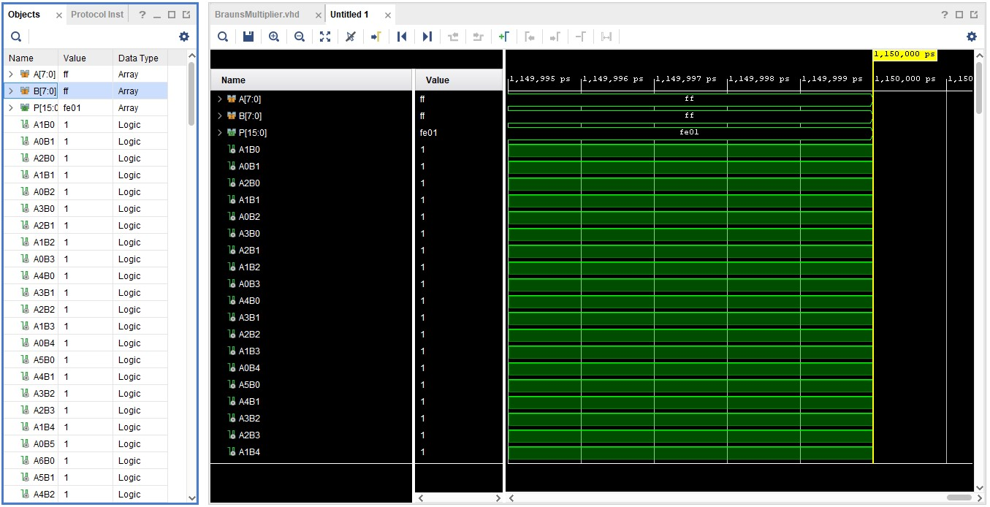
FF x FF = FE01
The verification process helps detect errors and refine the design before proceeding to actual hardware implementation, this increases efficiency by saving time and resources during the development phase.

Synthesis & Schematic
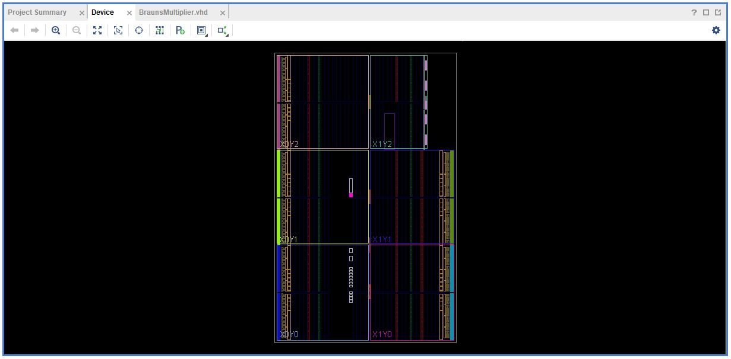
After running the simulation, the process of synthesis is conducted to convert the VHDL source files into a netlist. A netlist is a representation of the logical elements e.g., logic gates & flip flops, and the connections within the design. This proves converts the abstract VHDL design into a form suitable for actual hardware, enabling the synthesis tool to optimize and map the design onto Vivado. [10]

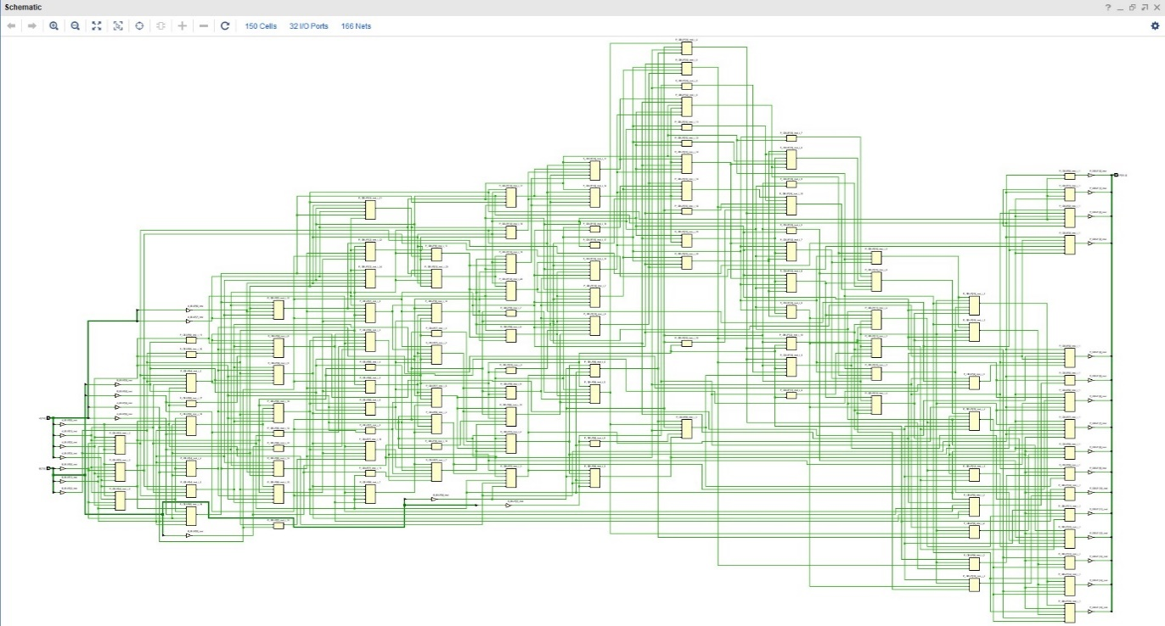
Schematic

Pin Designation:
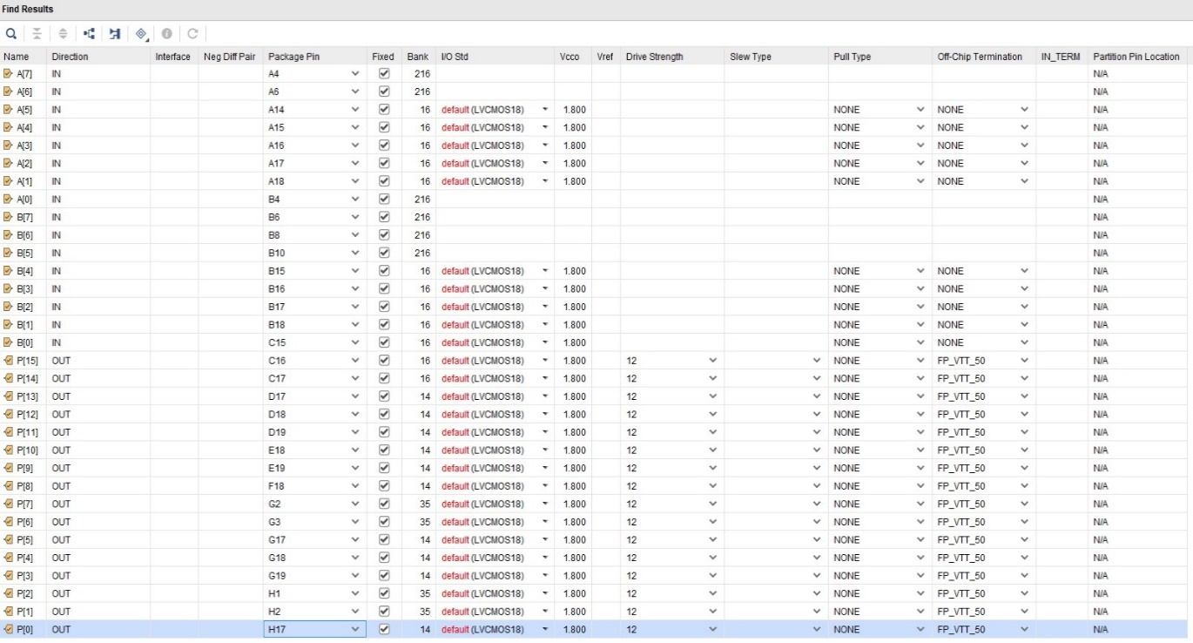
Pin allocation refers to the assignment of physical pins on an integrated circuit or programmable device to specific signal or functionalities defined in the VHDL code. The logical design is mapped to physical pins on the target device

Implementation
The timing summary provides information about the critical paths in the design and the associated timing characteristics. The summary is crucial for ensuring that the design meets the required performance constraints. Critical paths are the longest paths in the design that determine the maximum time it takes for a signal to travel form its source, to its destination. Optimizing these paths is essential.
WNS (Worst Negative Slack) refers to the most critical timing deficit within all paths in the design. Slack denotes the time available for a signal to be delayed without breaking timing constraints. A positive slack signifies that the path meets the timing requirements, while a negative slack indicates the path is failing to meet those requirements. The WNS pinpoints the critical path with the least timing margin, highlighting the path closest to breaking timing constraints. If the WNS is substantial, it indicates the design falls short of the required clock frequency, meaning adjustments should be made to improve timing performance. The following screenshots highlight the path with the max delay and value for WNS. The timing constraints were edited to improve max delay and lower WNS value to 0ns.
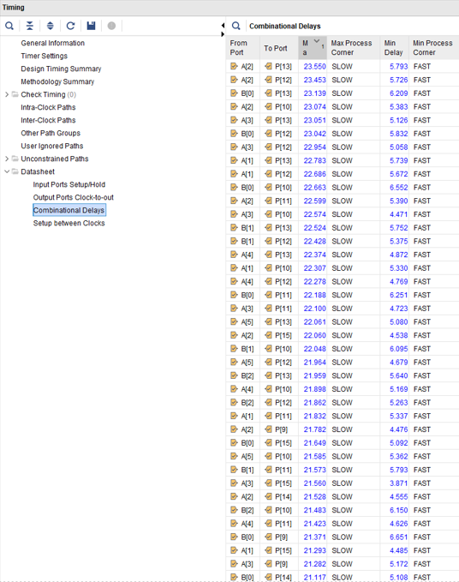
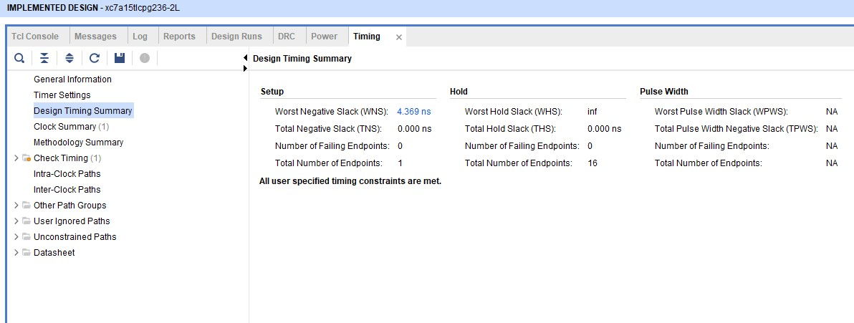

- Maximum delay of 23.550ns on A(2)P(13)
- WNS of 4.369ns
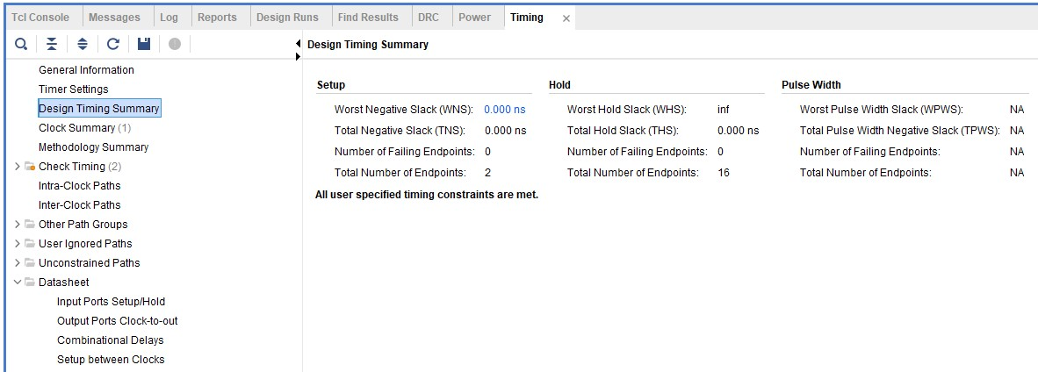
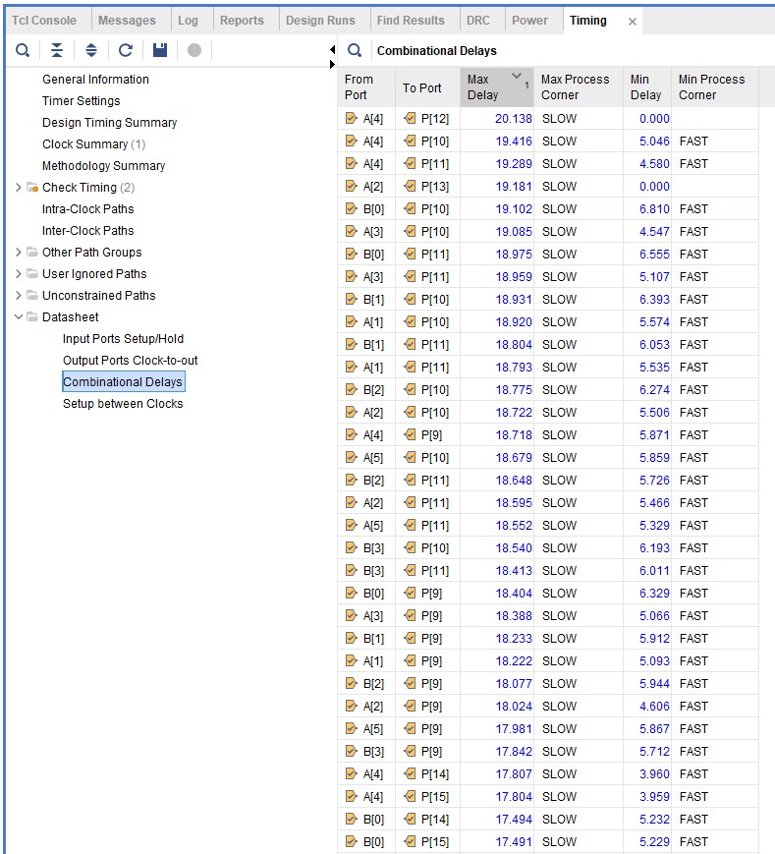

- Max delay of 20.138ns on A(4) P(12)
- WNS of 0ns
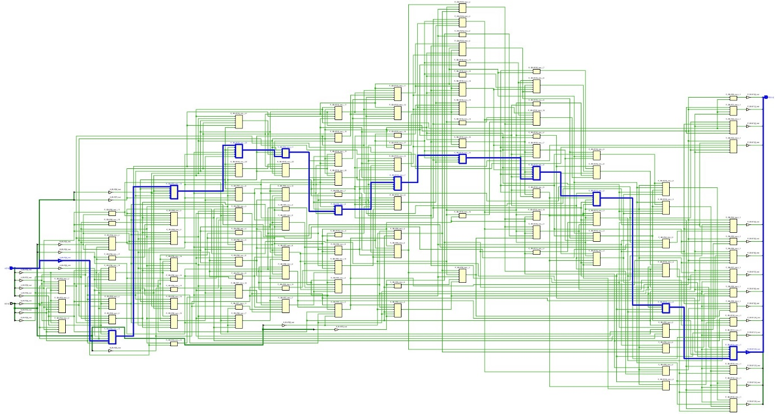
Max Delay A(4) P(12). The below diagram shows the maximum delay for the Braun multiplier.

RTL Analysis
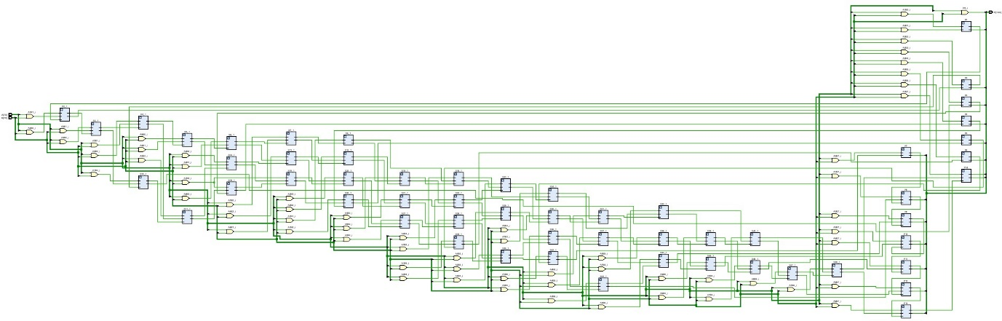
In RTL (Register Transfer Level) analysis is how data moves between the hardware registers and the logical operations that take place between these registers. It’s a level of abstraction, that allows designers to specify the functionality of a digital circuit without explicitly detailing the individual logic gates. Logic operations are defined using equations and the synthesis tools can infer the necessary hardware components during implementation process. Below is the logic diagram taken from Vivado. [10]

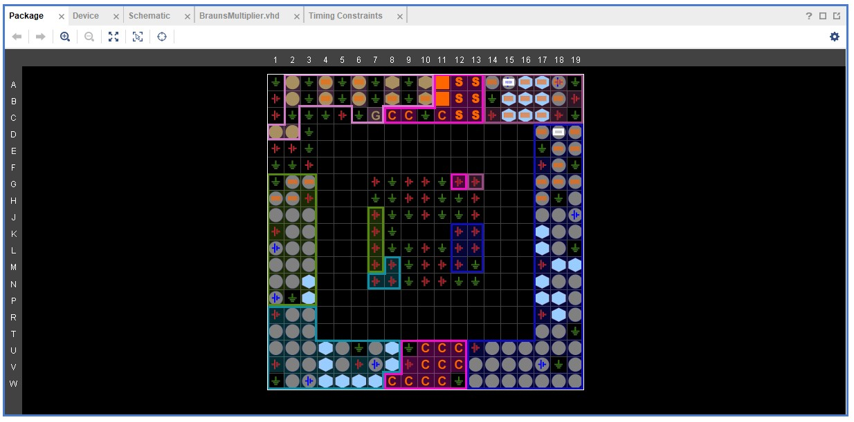
Package

TASK 2

Wallace Tree Multiplier
The following diagrams were drawn during the design of a Wallace tree multiplier.

Dot Diagram
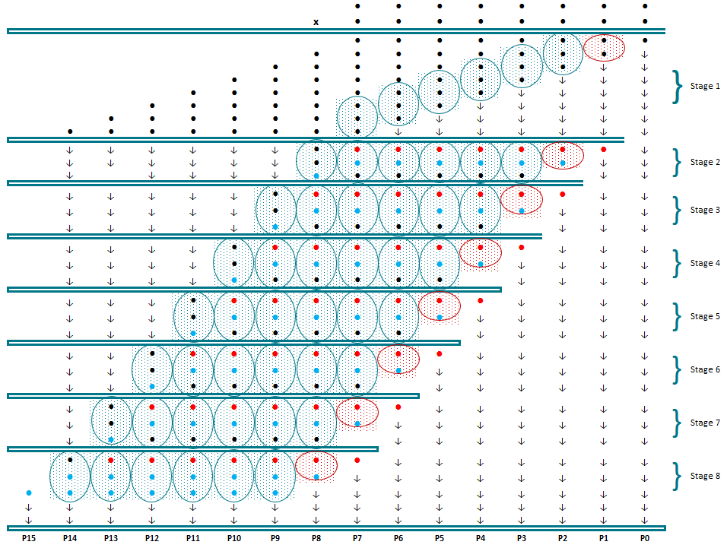
The dot diagram illustrates the need for 48 Full Adders & 8 Half Adders to construct the multiplier.

Logic Circuit Design
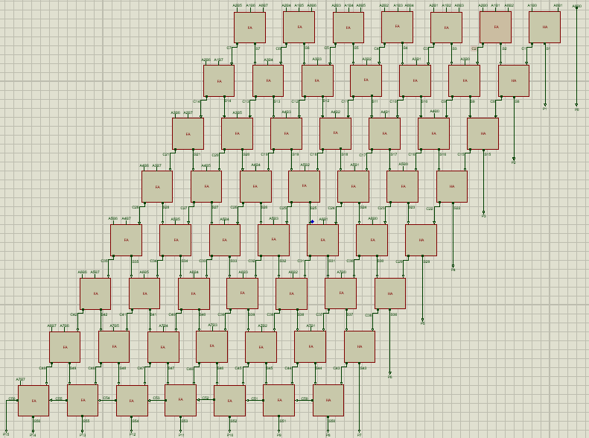
Below is the logic diagram for the 8x8 Wallace Tree Multiplier, drawn using the design suite Proteus.

Simulation
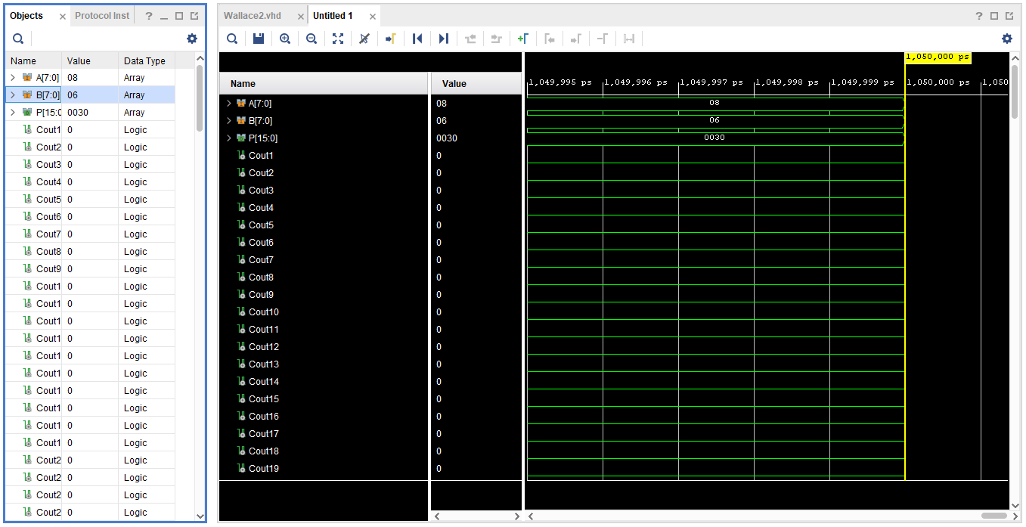
The same steps were followed when running behavioural simulation for the Wallace Tree multiplier, as for the Brauns multiplier. The results verified, by comparing them to those from a hexadecimal calculator.
08 x 06 = 0030

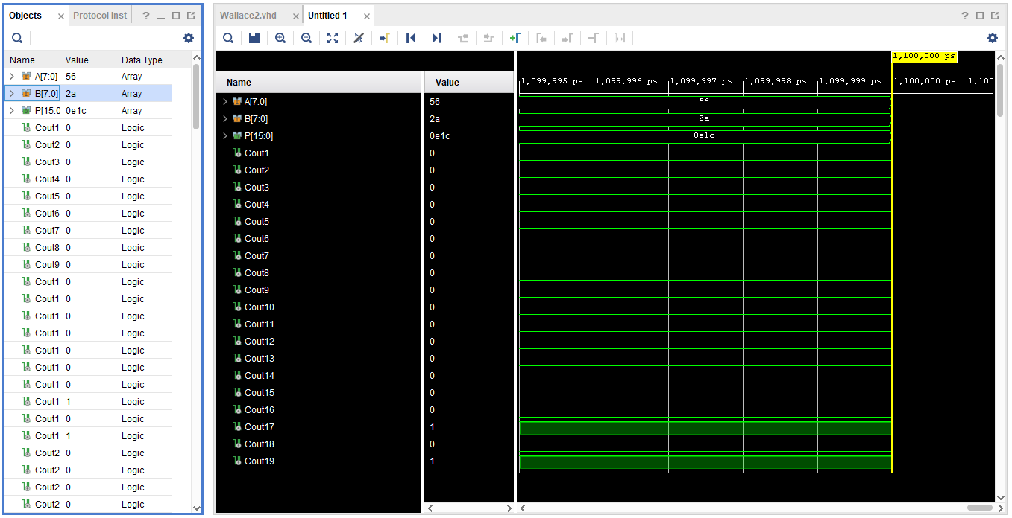
56 x 2A = 0E1C

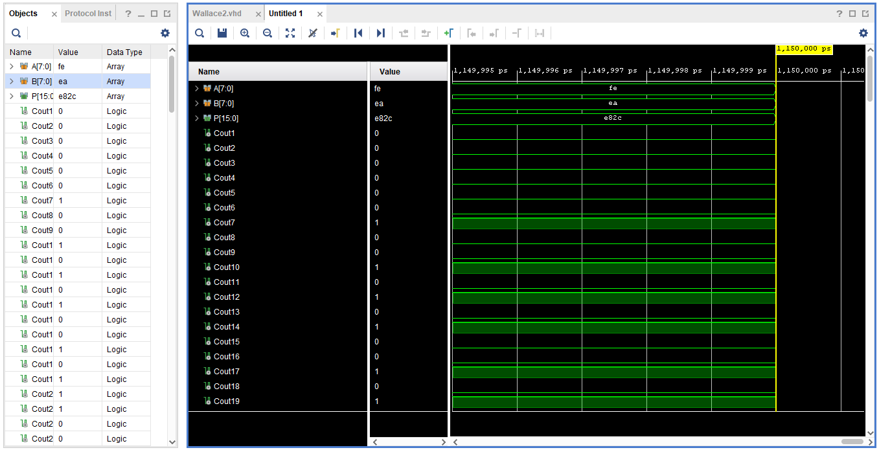
FE x EA = E82C

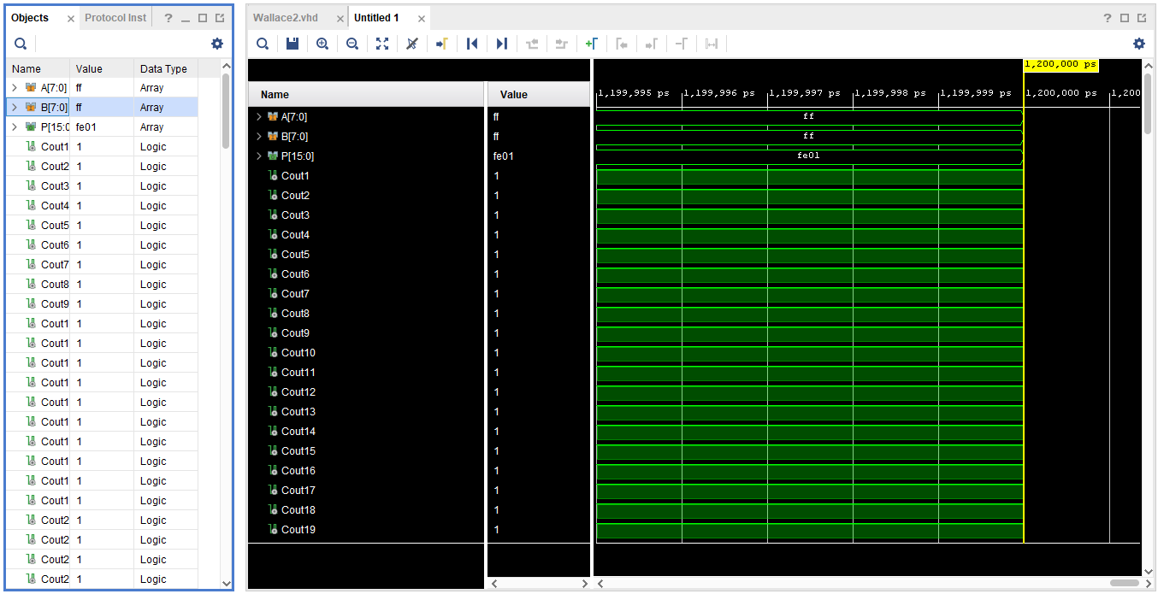
FF x FF = FE01
All results were correct.

Synthesis & Schematic
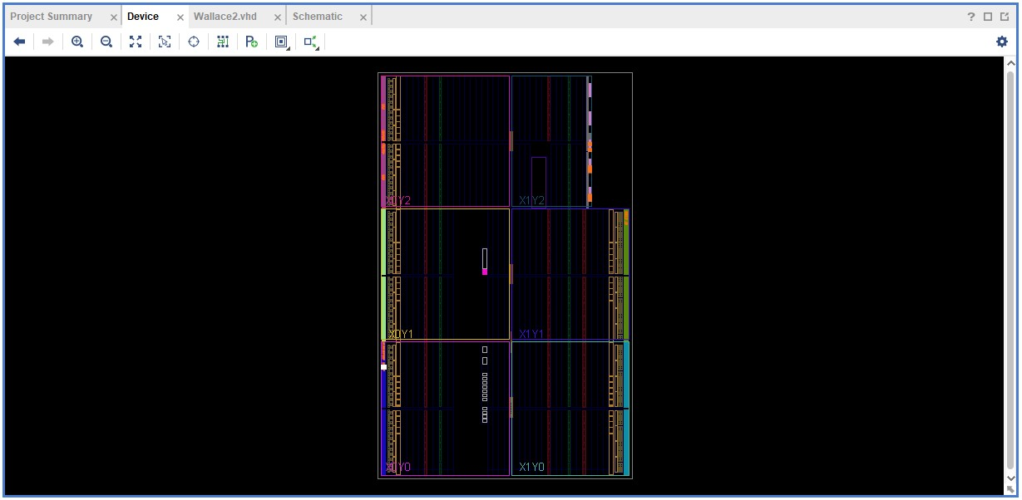
The synthesis process involves transforming the VHDL code of Wallace tree multiplier into a netlist that can be implemented on Vivado, using the synthesis toll. This tool analyses the VHDL code and generates a netlist that represents the logical structure of the design

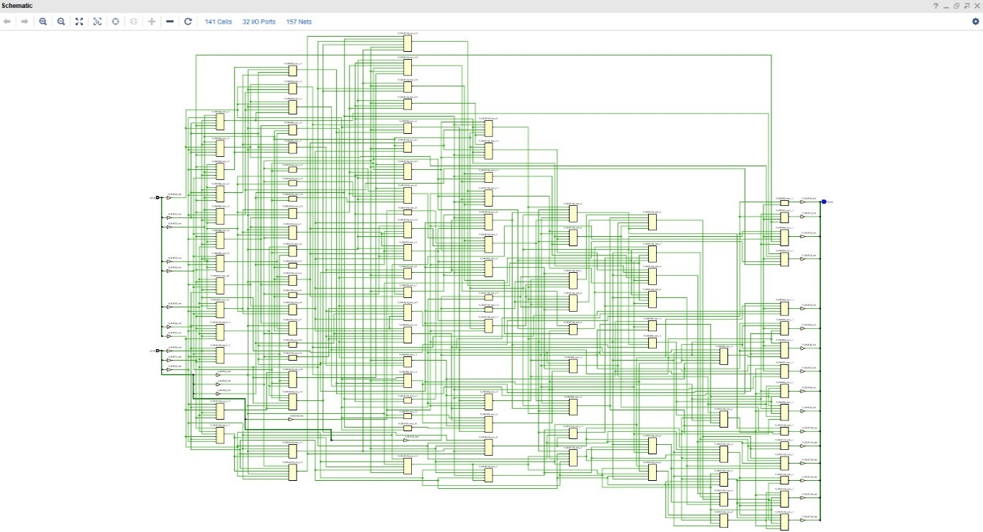
Schematic

Pin Designation
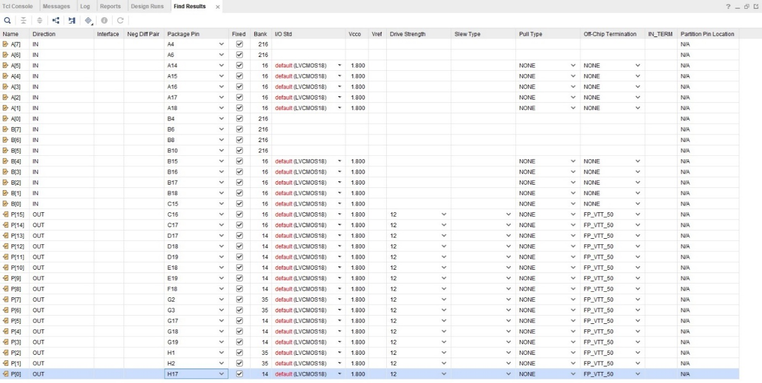
The pin allocation for the design involves specifying the physical pins or locations on Vivado, to which the designs signals will be mapped during the implementation process. This is an essential step to ensure the code interfaces correctly with the external world i.e. LED’s, switches etc.

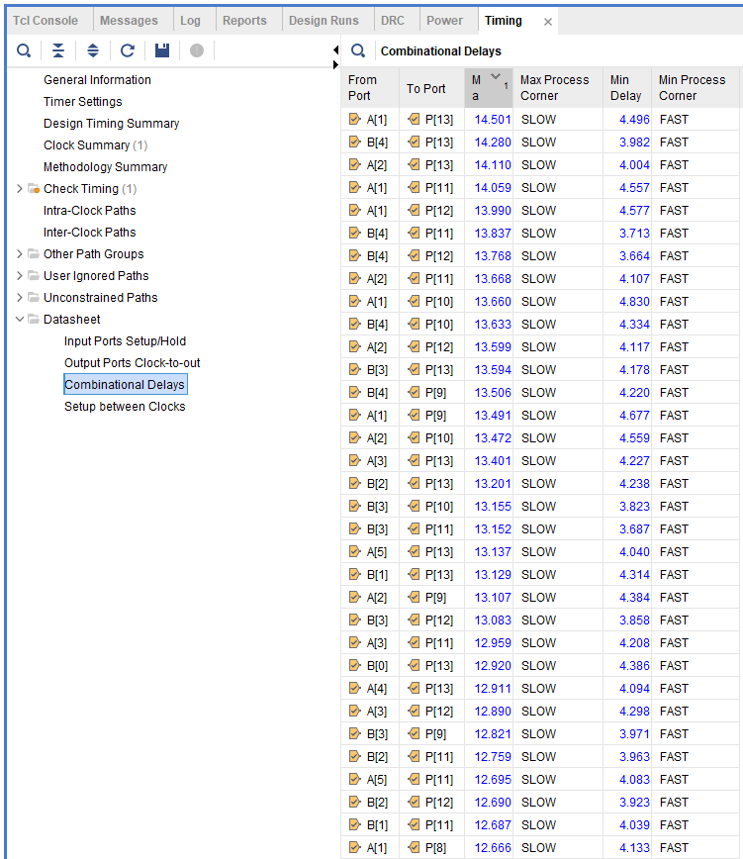
Implementation

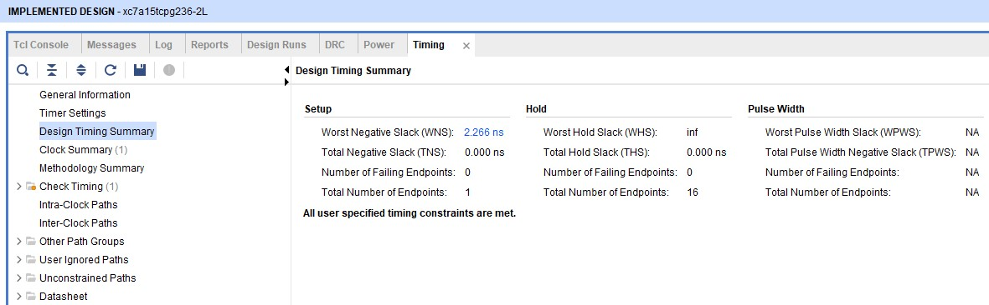
- Max delay of 16.76ns on A(0)P(14)
- WNS of 2.266ns

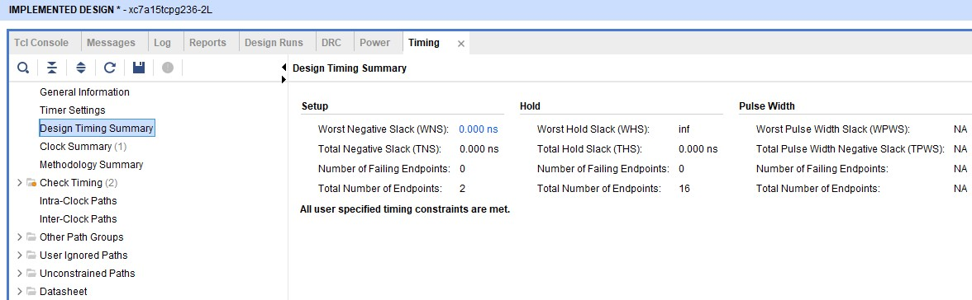
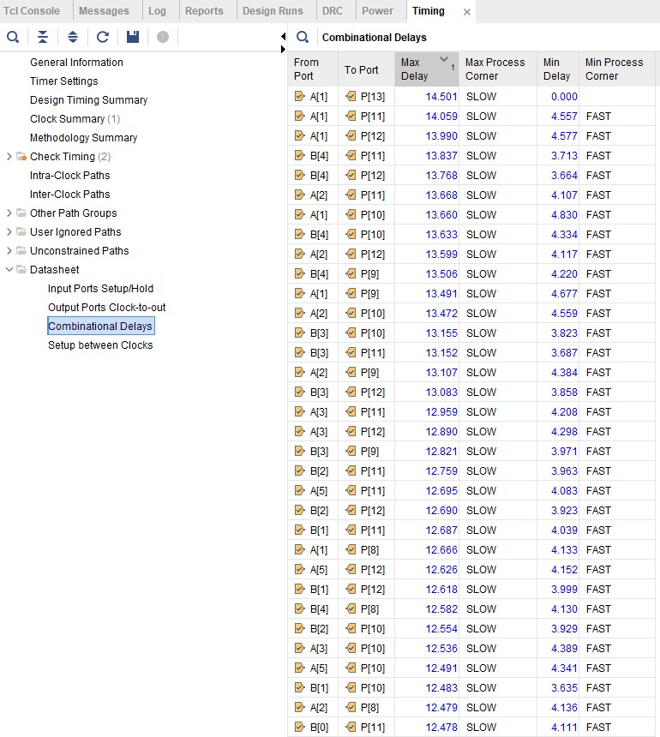
- Max delay of 14.501ns on A(1)P(13)
- WNS of 0ns

Max Delay A(1) P(13). The below diagram shows the maximum delay for the Wallace Tree multiplier.
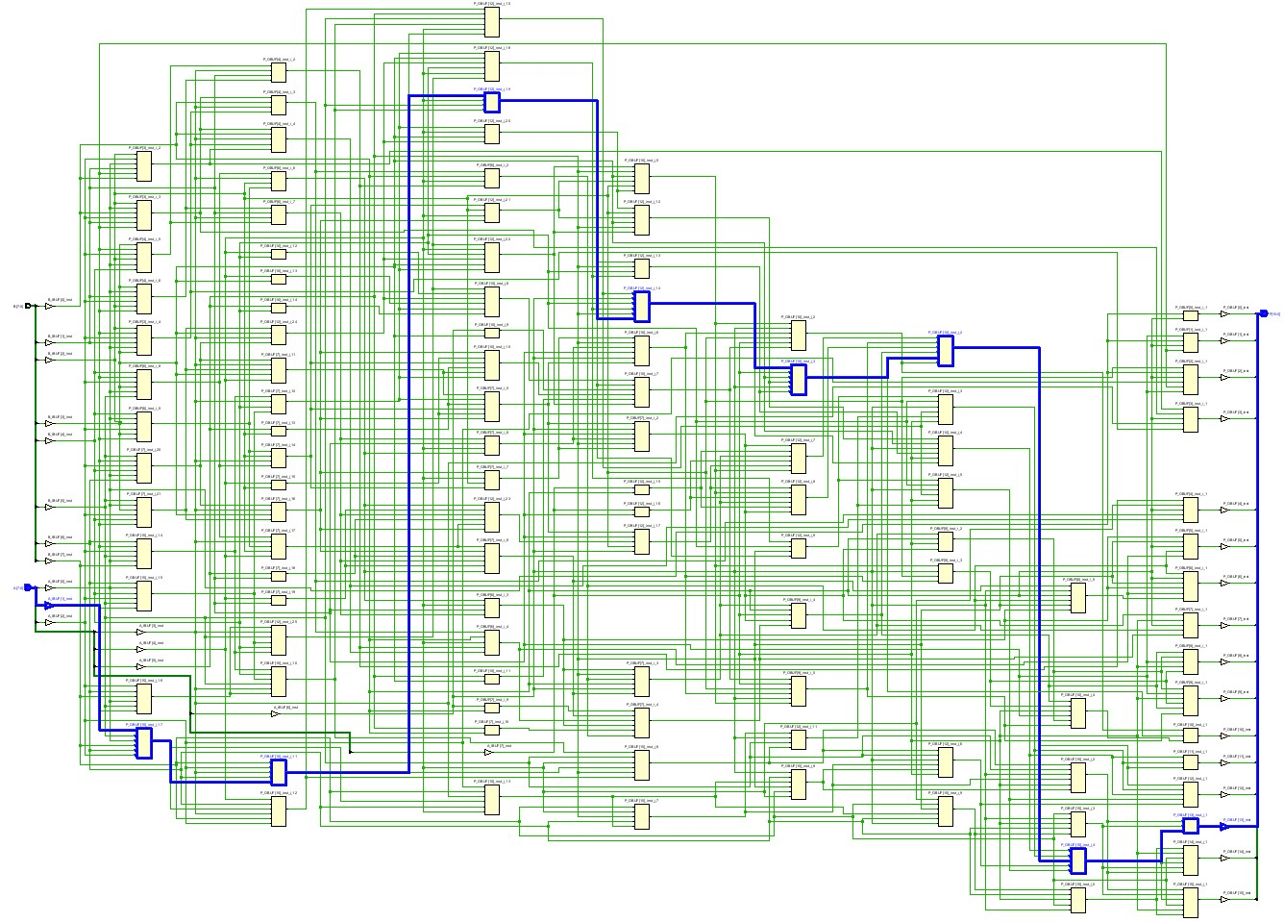
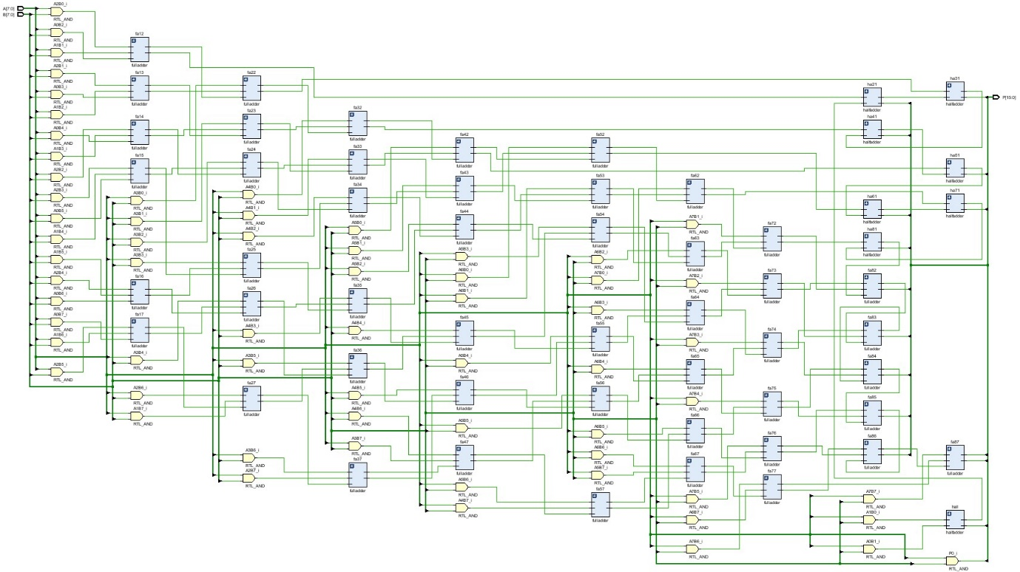
RTL Analysis
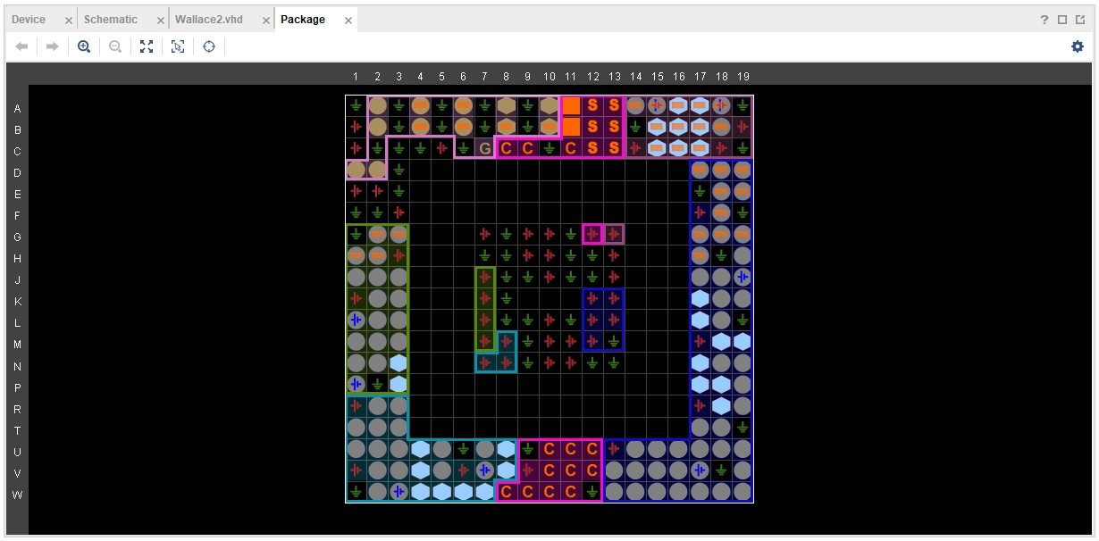
Package

TASK 3

Calculated longest Delay in Brauns Multiplier
The maximum delay was between input A(4) and output P(12). If an:
- AND Gate delay, t_{g} = 1ns
- Adder delay, t_{ad} = 2ns
The signal passes through 1x AND gate (1 x 1ns) and 15x Adders (15 x 2ns),
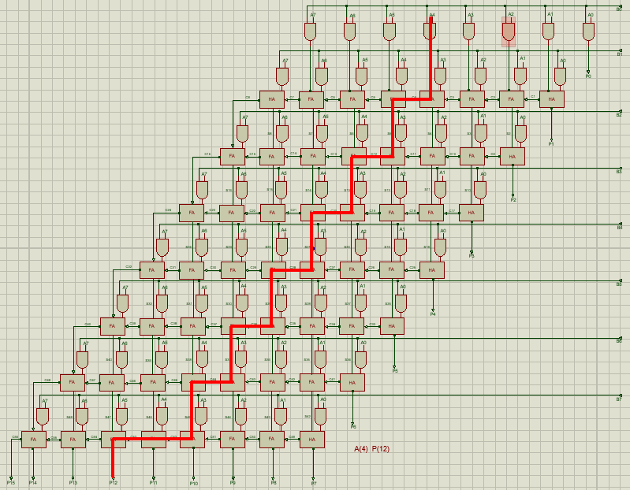
Therefore; the max delay of this 8 bit Brauns Multiplier is 31ns
The image above shows the critical path through the circuit that has the longest propogation delay. Analyzing the critical path is important for optimizing the performance of the multiplier.

Calculated longest Delay in Wallace Tree Multiplier
The maximum delay was between input A(1) and output P(13). If an:
- AND Gate delay, t_{g} = 1ns
- Adder delay, t_{ad} = 2ns
The signal passes through 1x AND gate (1 x 1ns) and 13x Adders (13 x 2ns),
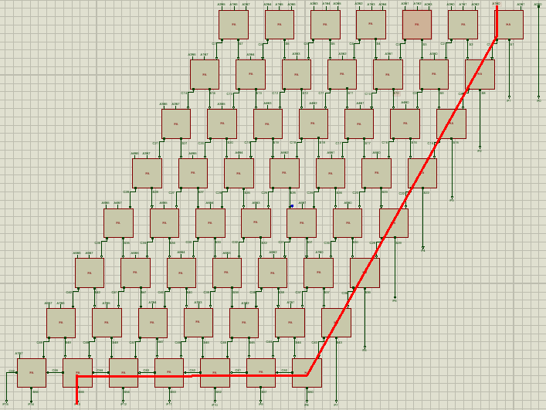
Therefore; the max delay of this 8 bit Brauns Multiplier is 27ns
The image above shows the critical path in the Wallace Tree Mulripler, its the path that determines the maximum delay from input to output, Factors ifluencing the critical path include, the Carry propogation, partial product generation amd output formation.

Delay Comparison Table
The table below show the Calculated verses Simulated maximum delay values
Delay Time | Brauns Multiplier | Delay Time | Wallace Tree Multiplier
Calculated  31ns | 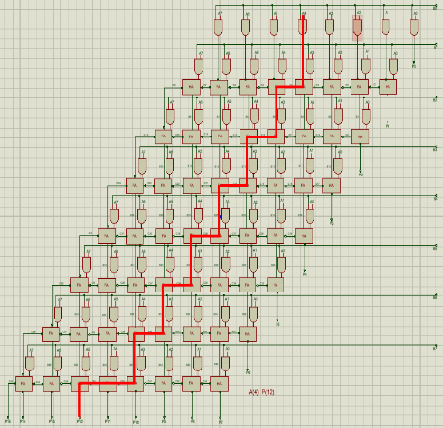 | Calculated  27ns
Simulated  20.138ns | 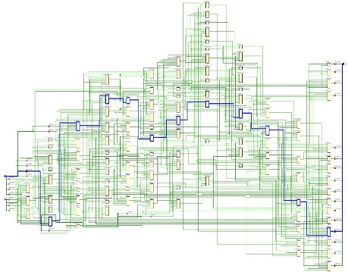 | Simulated  14.501ns | 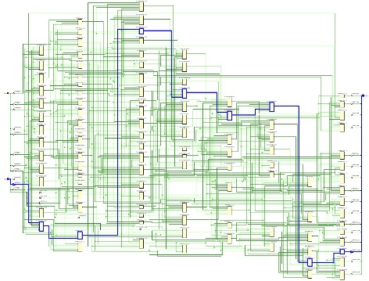

The calculated delay values may be higher than the vaules obtained from simulation in Vivado due to possible inaccuracies in the delay values of the components. The AND gate and Adder delay values may be generic. Further resarch into accurate figures could be carried out. A Full adder and Half adder may have differing delays, but a single value was used in this example.
- The Braun Multiplier had a difference of approx 11ns between calculated and simulated.
- The Wallace Tree Multiplier had a difference of approx 12.5ns between calulated and simulated.

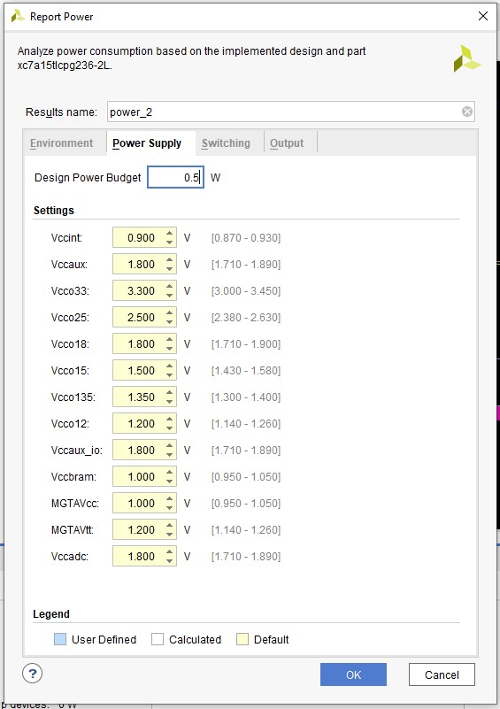
Brauns

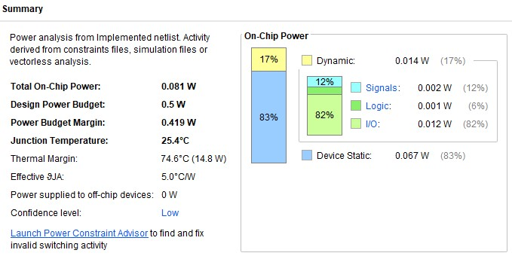
Brauns

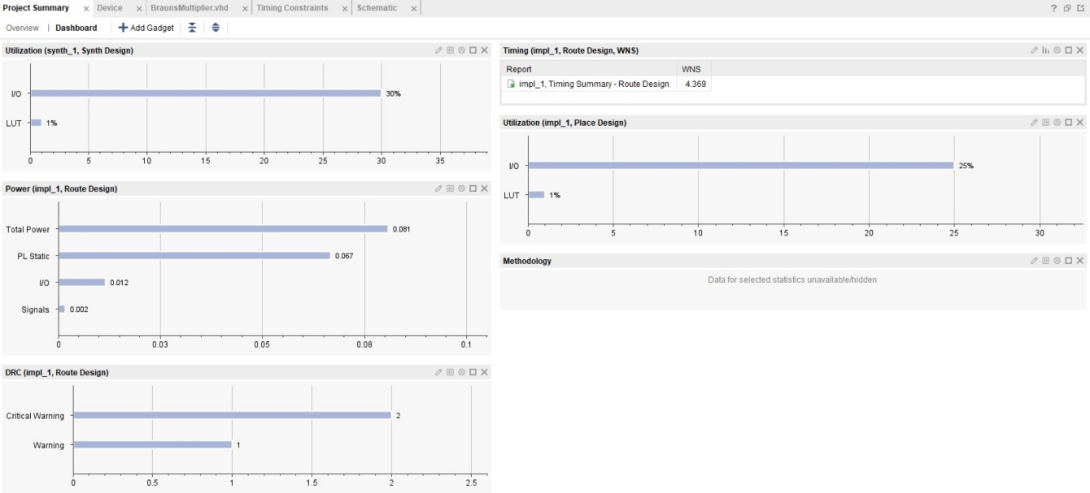
Brauns
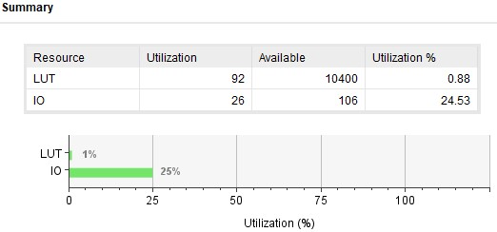
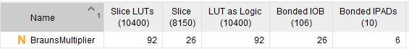

Brauns

Wallace
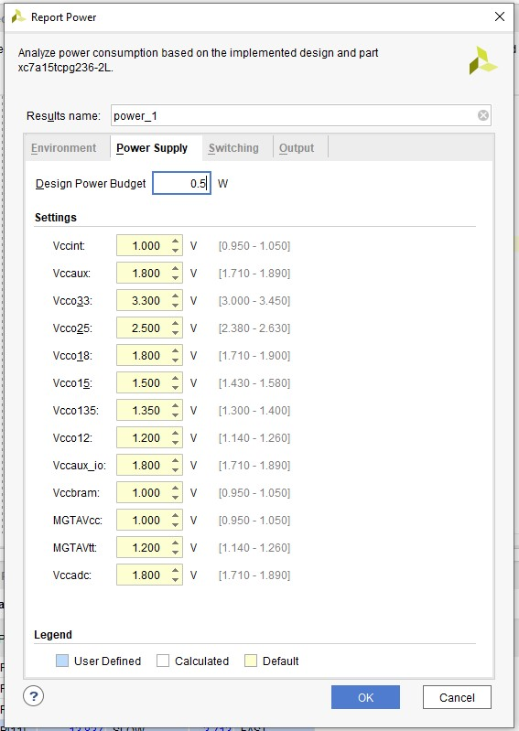

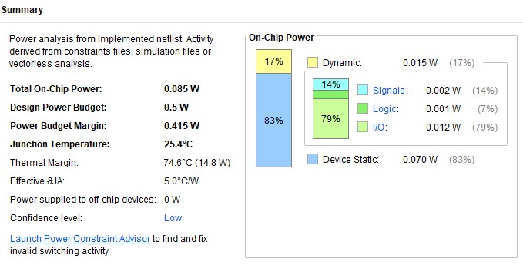

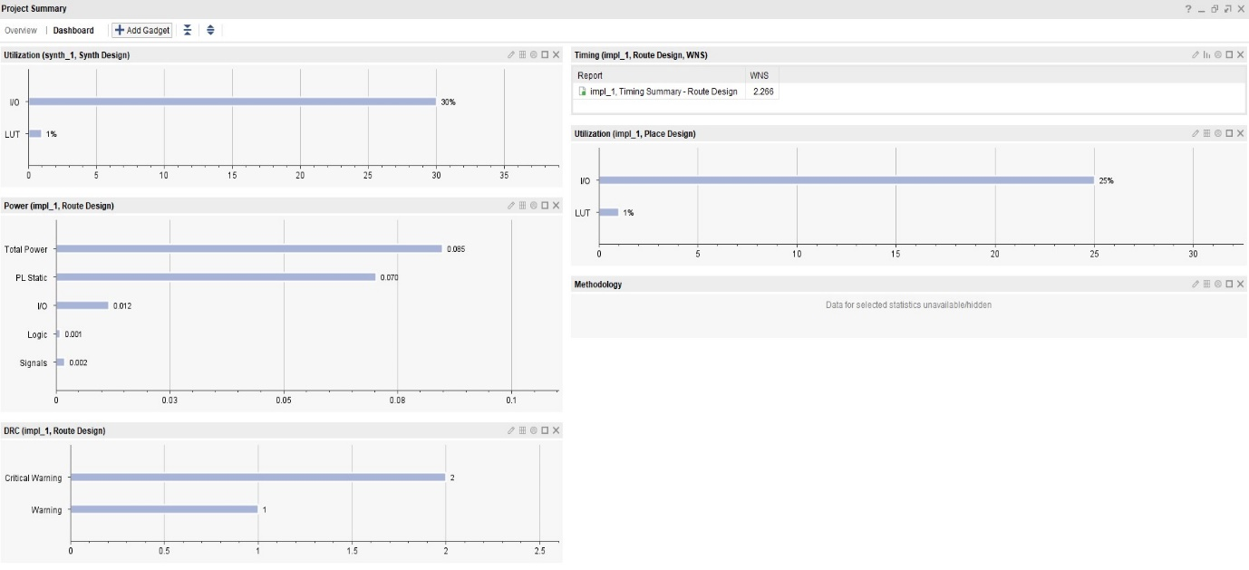
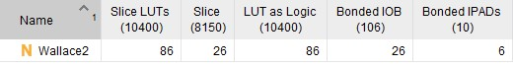

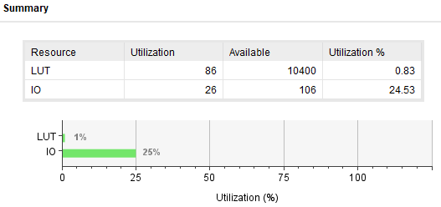

Wallace

Conclusion Recommendations

References

[1] | P. J. Ashenden, Digital Design An Embedded Systems Approach Using VHDL, Burlington: Elsevier, 2008.
[2] | N. Storey, Electronics: A Systems Approach, Edinburgh: Pearson Education Limited, 2006.
[3] | Z. V. Stephen Brown, Fundamentals of Digital Logic with VHDL design, New York: Mcgraw Hill, 2009.
[4] | O.N.Pandey, Electronics Engineerin, Cham: Springer Nature, 222.
[5] | V. B. R. Anitha, “Brauns multiplier implementation using FPGA with bypassing techniques,” VIT University Vellore, Sept 2011. [Online]. Available: https://aircconline.com/vlsics/V2N3/2311vlsics17.pdf. [Accessed 10 Jan 2024].
[6] | A. Lahoti, “Comparison between Braun Multiplier and Wallace Multiplier technique,” 3 March 2021. [Online]. Available: https://medium.com/multiplier-techniques-in-vlsi/comparison-between-braun-multiplier-and-wallace-multiplier-technique-c26c38a17c69. [Accessed 10 Jan 2024].
[7] | H. S. Vikas Kaushik, “A review on comparative performance analysis of different digital multipliers,” 2017. [Online]. Available: https://www.ripublication.com/acst17/acstv10n5_54.pdf. [Accessed 10 Jan 2024].
[8] | Academic Accelerator, “Wallace Tree,” Academic Accelerator, [Online]. Available: https://academic-accelerator.com/encyclopedia/wallace-tree. [Accessed 11 Jan 2024].
[9] | J. Kulrativid, “Booth Algorithm,” Medium, 11 Jul 2022. [Online]. Available: https://medium.com/@jetnipit54/booth-algorithm-e6b8a6c5b8d. [Accessed 11 Jan 2024].
[10] | W. Kafic, VHDL 101, Oxford: Newnes, 2011.

