Anisah Khan (1808794) Lecturer: Mumtaz Goolam
University of Wales Trinity Saint David

Introduction To Physiology BMHP_BIRM
SKELETAL SYSTEM
CASE STUDY
Contents Page

- Introduction 1

- Case Study 1

  - Ethical and Legal Considerations 1
  - Assessment Report 2

- Discussion 3

  - The Skeletal System 4

- Recommendations 5

- Conclusion 6

- References 7

- Appendix A: Health and Lifestyle Questionnaire 9
for Mrs S

- Appendix B: Informed Consent Form (copy) 11

- Appendix C: Mrs S, BMI Score 12

- Introduction

The purpose of this work is to develop a health assessment report detailing the health of an individual as a case study. It will include all aspects of the physiology of the individual, normal and abnormal, in order to conduct a health and fitness assessment.

Health and lifestyle assessments are an excellent way of capturing crucial information pertaining to a persons medical status (Mathioudakis et al, 2016). They help health professionals to provide the best standard of care, measure risk factors and health behaviours (Madans,2017), as well as signposting patients who may need extra support (NPMC, 2021).

By asking questions about tobacco, alcohol use or physical exercise, these assessments help to highlight issues that can be prevented or improved with intervention from a health professional. They also help screen for abnormalities such as non communicable disorders (NCDs) which are non-infectious and non-transmissible diseases that can occur as a result of genetic, physiological, environmental or behavioural factors (Cirino, 2018). These include cardiovascular disease, diabetes, hypertension and obesity. According to the World Health Organisation (2021), 41 million deaths a year are attributed to NCD’s which corresponds to 71% of all deaths globally. The collection and analysis of data in a health and lifestyle assessment can help to avoid, improve or treat such disorders.

This report will be based on a health questionnaire and a collection of information from the individual. It will present findings along with discussion and it will also present recommendations to remedy the abnormal components of the findings.

- Case Study

  - Ethical and Legal Considerations

The case study is regarding a 61 year old female, who completed a health’s and lifestyle questionnaire which can be found in appendix A. For the purpose of this report and to protect her identity, she will be referred to as Mrs S. Keeping her name anonymous helps to respect her rights to confidentiality (Majumder, 2015) and is in accordance with the NHS Confidentiality Policy (2019).

Applying and implementing standards relating to legal and ethical issues, is vital within the
1
healthcare scope of practice. All efforts have been made to adhere to the requirements outlined in the Data Protection Act 2018 and the General Data protection Regulation (GDPR). This includes, the lawful, fair and transparent process of data, accuracy, confidentiality and informed consent (GOV.UK, 2018).

As a significant ethical requirement (Josephson and Smale, 2020) informed consent to conduct the case study was taken from Mrs S in the form of a signed document, a copy of which can be found in appendix B.

2.2 Assessment Report

Mrs S completed the questionnaire and elaborated on her health history during the assessment consultation. The health and lifestyle questionnaire asked a range of questions revealing that Mrs S is a non smoker, she does she consume alcohol and consumed a balanced diet.

She does not currently suffer from high blood pressure but has in past when she used to undergo renal dialysis. She has since had a kidney transplant in 2011 and has not suffered from hypertension in the last 8 years. On examination her blood pressure was 138/89.

Mrs S indicated ‘yes’ to having weakness down one side of her body due to the fact that she also suffers from Multiple Sclerosis (MS). MS is a lifelong condition that affects the nerves, brain and spinal cord. It causes a broad range of symptoms including problems with vision, limb movement, sensation, speech and balance (NHS, 2018).

Mrs S indicated in the questionnaire that she is not able to exercise. This was due to a fall last year in which she suffered a distal femur break which left her severely immobile. She underwent extensive surgery in which the bones were realigned with plates and screws. She feels that this has contributed to considerable weight gain over the last 12 months.

Mrs S was unable to bear weight for the first few weeks and needed a hospital bed at home whilst recovering. Having no downstairs bathroom and unable to climb stairs, she had to use a commode and bed bath which she felt knocked her confidence and self esteem significantly.

Although she commented that she is heavily supported by her family, she felt that perhaps their concern that she may injure herself again has led to a lack of movement around the
2
house. Although they insist on doing everything for her out out of kindness, she feels that it is impacting her recovery, independence, confidence and definitely her weight gain. Despite having MS, Mrs S felt that she was healthier and more mobile prior to her injury.

She was supported by the Early Intervention Team briefly on discharge, but due to Covid 19 pressures, she was only seen in the first few weeks and discharged from then. She had two physio follow ups since the accident during trauma outpatient clinic appointments from which she has also been discharged.

- Discussion

The health questionnaire identified an elevated blood pressure of 138/89 indicating prehypertension. Prehypertension, is the intermediate stage between normal blood pressure and hypertension which needs to be monitored in order to avoid further complications (Srivastava, Mirza and Sharan, 2020). Mrs S regularly monitors her blood pressure at home and commented that it is not usually that high and that she attributes to white coat syndrome. This is the effect in which a persons blood pressure elevates when they are around medical professionals (Pioli el al, 2018).

Secondly Mrs S indicated that she has experienced weakness in one side of her body, in the early stages of her MS diagnosis, however she has not suffered from this in a while and at present it is not causing any issues in her lifestyle or ability to function.

Thirdly, due to an inability to exercise, Mrs S’ weight has increased with her current weight being 82.6 kg. Using the measurements taken in the questionnaire, Mrs S’ BMI was calculated. BMI or Body Mass Index is a statistical index and screening method of weight category, defining a person as being underweight, healthy weight, overweight and obese (NHS, 2019). An individuals BMI number is considered as a respected indicator of the development or existence of health issues (Nuttall, 2015). Using the NHS calculator tool (2018), Mrs S’ BMI score was 33, indicating that she is in the obese category. The result can be found in appendix C.

According to the the World Health Organisation (2021), obesity is defined as “abnormal or excessive fat accumulation that may impair health.” It is a leading health concern globally and it is a pathophysiological disorder that if left untreated could result in complications including diabetes, hypertension and cardiovascular disease (Gadde et al, 2018).
3

This abnormality in her physiology is causing the most discomfort and poses the most risk to her overall health, as she feels her weight gain is causing her physical and emotional pain.

Her renal team are happy with her progress currently and all of her blood tests and urine tests indicate that her kidney function is stable and doing well. There has been no change in the medication for her kidney over the last six years and prior to her femur break, they have not caused her to gain weight.

Similarly, Mrs S has lived with having MS for over 25 years and in that time it did not hinder her her ability to maintain her weight or do light exercise (short walks).

Therefore, analysis of her questionnaire answers and consultation discussion, indicate that the abnormality in her physiology that needs addressing is her weight gain. The issue within her skeletal system is the root cause of the rapid change in her weight.

3.1 The Skeletal System

The human skeletal system is considered as being the foundation and framework of the body, comprising of bones, cartilage, tendons and ligaments. It constitutes 20% of a persons body weight and an adult skeleton contains 206 bones. (Seladi-Schulman, 2018).

It’s functions include support and movement, protection (acting as boundaries for soft organs), mineral homeostasis (storing 99% of the body’s calcium, 85% of its phosphate and 50% of its magnesium), haemopoiesis (production of white and red blood cells in the bone marrow and platelets) and triglyceride storage, where yellow bone marrow acts as a reservoir of energy for the body (Walker, 2020).

Each bone is made up of many cells, protein fibres, and minerals (Taylor, 2020). Bone or osseous tissue, are categorised into two principal sub groups; The axial skeleton and the appendicular skeleton. The axial skeleton (made up of 80 bones) includes all the bones along the axis of the body including the skull, cerebral column and the rib cage. The appendicular skeleton (126 bones) includes the upper and lower limbs, the pectoral girdle and the pelvic girdle (Waugh and Grant, 2018).

There are 5 different types of bones within the human body each having different shapes and different
4
functions. Flat bones, such as those in the skull, thoracic cage and pelvis, protect internal organs such as the brain, heart and pelvis organs. As these bones are flat they provide protection similar to a shield as well as providing large areas for attachment to muscle. Long bones such as the femur, which happens to be the longest bone in the body, support weight and aid movement. Short bones are cube shaped and they provide stability and some movement such as those in the wrist and ankle joints. Irregular bones have complex shapes and structure such as the vertebrae and sesamoid bones are embedded within tendons and their function is to protect the tendons from stress and wear such as the patella (Visible Body, 2021).

As with all physiological systems, disorders within the skeletal system can occur. They can include issues such as, cancer of the bone, rheumatoid arthritis, osteoporosis, carpal tunnel syndrome, dislocation or fracture (Britannica, 2021).

Bone fracture is a very common skeletal injury and healing can comprise of both biological and mechanical aspects (Ghiasi et al, 2017). Fractures can be categorised into 10 different types including, stress’s compression, spiral or oblique fractures. Mrs S suffered quite a serious segmented fracture to the femur. A segmented fracture occurs when the bone fractures in 2 places leaving segmented bone between 2 breaks. This type of fracture occurs commonly in long bones and healing can be long and complicated.

- Recommendations

Mrs S suffered a segmented distal femur fracture that required extensive surgery. It caused extreme pain, difficulty bearing weight, an inability to walk, swelling, painful muscle spasms and numbness. Added to this Mrs S renal complications restricted her long term pain relief options. Mrs S complained of pain and weakness in her injured leg and apprehension to fully weight bear. She reported that her consultant was happy for full weight bearing and return to normal as possible function.

In order to help remedy the the abnormality in her physiology, a person centred care plan needs to be put into place to help Mrs S lose weight and regain confident leg function. The purpose of a person centred care plan is to produce outcomes that help an individual gain improvement in; health and emotional wellbeing, quality of life, making a positive contribution, increased choice and control, freedom from discrimination and harassment, economic wellbeing and maintaining personal dignity and respect (Skills For Care, 2009).

Part of the plan should include pathological tests and investigations to determine Mrs S’ bone health,
5
including blood tests to check for vitamin D and calcium and a Dexa scan to measure her bone density.

Most importantly, Mrs S needs regular physiotherapy with a community therapist who can help her regain and monitor muscle strength. According to Keller et al (2013), following a femoral fracture, muscles are considerably weaker then before, so physiotherapy is critical for regaining strength. Physio will also help Mrs S to resume regular walking and light exercise which will help her begin to lose weight and gain independence. Crucially it will help her to be less dependent on family and more mobile, rather then being stagnant. Additionally, gentle, regular exercise such as chair based tai chi sessions, at her local well being hub, will help Mrs S develop strength, balance and coordination as well with giving her the opportunity to socialise with others. This in turn will help her improve self esteem and emotional well being.

To help with the weight loss and to aid healing, Mrs S should also be referred to a dietician for advice about appropriate and beneficial foods to promote a balanced diet that is both nutritional and conducive to weight loss (low calorie).

Counselling sessions to help Mrs S discuss the trauma and impact that her injury has had on her health and well-being over the last 12 months will help her to process her experience and move forward to regain better health.

- Conclusion

A health and lifestyle questionnaire was used to determine both the normal and abnormal aspects of Mrs S’ physiology. Obesity was identified as the main cause of her health complaints, caused by a pathological abnormality with her skeletal system. Recommendations to improve her health were made and guidance regarding confidentiality, consent and GDPR were adhered to.

6
- References

Britannica Encyclopaedia (2021) Bone Diseases (online) Available at: https://www.britannica.com/browse/Bone-Diseases
(Accessed: 4 August 2021)

Cirino, E. (2018) Most Common Non Communicable Diseases (online)
Available at: https://www.healthline.com/health/non-communicable-diseases-list
(Accessed: 30 July 2021)

Gadde, K.M., Martin, C.K., Berthoud, H. and Heymsfield, S.B. (2018) Pathophysiology and management of obesity. J Am Coll Cardiol, 71(1), pp.69-84.
DOI: 10.1016/j.jacc.2017.11.011

Ghiasi, M.S., Chen, J., Vaziri, A., Rodriguez, E.K. and Nazarian, A. (2017) Bone fracture healing in mechanobiological modeling: A review of principles and methods. Bone reports, 6, pp.87-100.
https://doi.org/10.1016/j.bonr.2017.03.002

GOV.UK (2018) Data Protection (online) Available at: https://www.gov.uk/data-protection
(Accessed: 31 July 2021)

Josephson, A. and Smale, M. (2020) What do you mean by “informed consent”? Ethics in economic development research. Applied Economic Perspectives and Policy.
https://doi.org/10.1002/aepp.13112

Keller, K. and Engelhardt, M. (2013) Muscle atrophy caused by limited mobilisation. Sportverletzung Sportschaden: Organ der Gesellschaft fur Orthopadisch-Traumatologische Sportmedizin, 27(2), pp.91-95.
DOI:org/10.1055/s-0033-1335159

Madans, J. H. (2017) Health Surveys. International Encyclopaedia of Public Health. 2nd Edition (online)
DOI:10.1016/B978-0-12-803678-5.00193-4

Majumder, K. (2015) A young researchers guide to writing a clinical case report (online) Available at: https://www.editage.com/insights/a-young-researchers-guide-to-writing-a-clinical-case-report
(Accessed: 31 July 2021)

Mathioudakis, A., Rousalova, I., Gagnat, A.A., Saad, N. and Hardavella, G. (2016) How to keep good clinical records. Breathe, 12(4), pp.369-373.
DOI:10.1183%2F20734735.018016

National Health Service (2019) Confidentiality Policy (online) Available at:
https://www.england.nhs.uk/wp-content/uploads/2019/10/confidentiality-policy-v5.1.pdf
(Accessed: 1 August 2021)

National Health Service (2019) Overview: Multiple Sclerosis (online) Available at:
https://www.nhs.uk/conditions/multiple-sclerosis/
(Accessed: 1 August 2021)

National Health Service (2019) What is the Body Mass Index (BMI)? (online) Available at:
https://www.nhs.uk/common-health-questions/lifestyle/what-is-the-body-mass-index-bmi/
(Accessed: 1 August 2021) 7

National Health Service (2018) BMI healthy weight calculator (online) Available at: https://www.nhs.uk/live-well/healthy-weight/bmi-calculator/
(Accessed: 2 August 2021)

Newport Pagnell Medical Centre (2021) New Patient Questionnaire (online) Available at:
https://www.npmc.nhs.uk/_common/getdocument/94724
(Accessed: 31 August 2021)

Nuttall, F.Q. ( 2015) Body mass index: obesity, BMI, and health: a critical review. Nutrition today, 50(3), p.117.
DOI: 10.1097%2FNT.0000000000000092

Pioli, M.R., Ritter, A.M., de Faria, A.P. and Modolo, R. (2018) White coat syndrome and its variations: differences and clinical impact. Integrated blood pressure control, 11, p.73.
DOI: 10.2147%2FIBPC.S152761

Saladin-Schulman, J. (2018) Skeletal System Overview (online) Available at: https://www.healthline.com/human-body-maps/skeletal-system
(Accessed: 4 August 2021)

Srivastava, A., Mirza, T.M. and Sharan, S. (2020) Prehypertension (Online) Available at:
https://pubmed.ncbi.nlm.nih.gov/30855897/
(Accessed: 2 August 2021)

Skills for Care (2009) Towards an outcome focused care service - a training toolkit (Online) Available at: https://moodle.uwtsd.ac.uk/pluginfile.php/434062/mod_resource/content/1/Week%208-%20RESOURCE%20FOR%20PERSONCENTRED%20CARE.pdf
(Accessed: 3 August 2021)

Taylor, T. (2020) Skeletal System. Innerbody Research (online) Available at:
https://www.innerbody.com/image/skelfov.html
(Accessed: 2 August 2021)

Visible Body (2021). The Long and Short of It: The Five Types of Bones (online) Available at:
https://www.visiblebody.com/learn/skeleton/types-of-bones
(Accessed: 4 August 2021)

Walker, J. (2020) Skeletal system 1: the anatomy and physiology of bones. Nursing Times, 116(2), pp.38-42. (Online) Available at:
https://www.nursingtimes.net/clinical-archive/orthopaedics/skeletal-system-1-the-anatomy-and-physiology-of-bones-27-01-2020/
(Accessed: 3 August 2021)

Waugh, A. And Grant, A. (2018) Ross and Wilson Anatomy and Physiology in Health and Illness: 13th Edition. London: Elsevier Ltd

World Health Organisation (2021) Non Communicable Diseases (online) Available at:
https://www.who.int/news-room/fact-sheets/detail/noncommunicable-diseases
(Accessed: 30 July 2021)

World Health Organisation (2021) Obesity and Overweight (online) Available at:
https://www.who.int/news-room/fact-sheets/detail/obesity-and-overweight
(Accessed: 3 August 2021)
8
- Appendix A: Health and Lifestyle Questionnaire for Mrs S
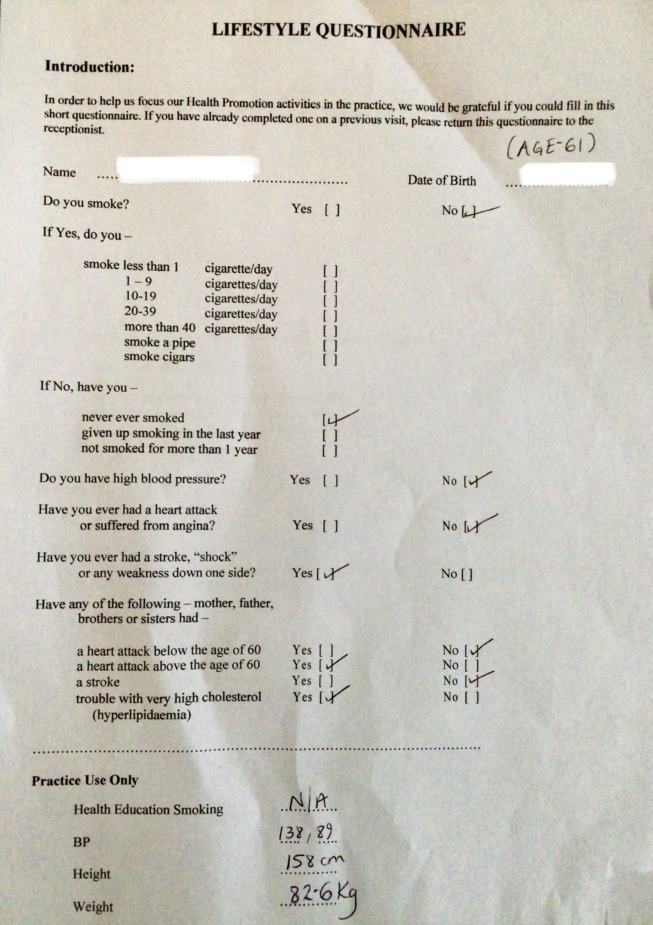
9
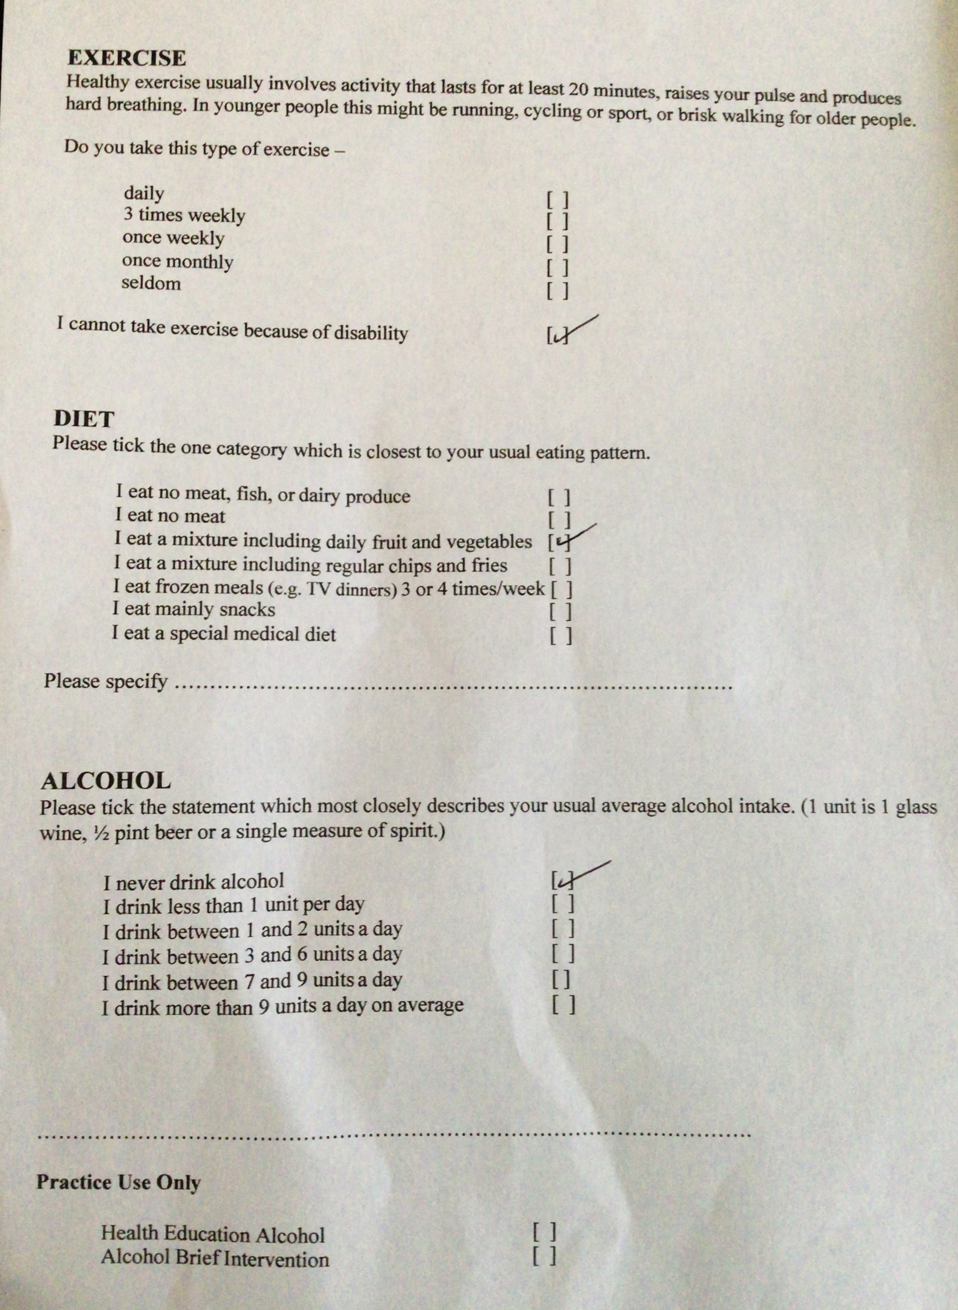
10

- Appendix B: Informed Consent Form (copy)

University of Wales
Trinity Saint David

Client Name ____________________________________________

Student Name ____________________________________________

This UWTSD case study is being undertaken as part of a Health and Social Care degree program.

By signing this consent form you are agreeing to allow your details and the content of your consultation to be written up as part of a case study assignment, which will also be reviewed by a committee of examiners and academics.

If you consent to being written about in this study it will be the students responsibility to ensure that any information that could identify you will be carefully altered to protect your identity.

If you consent to being written about in this study you have the right to ask for all copies to be destroyed within a month after the consultation concluded.

The student may describe to you verbally the contents of the assignment and case study but no paper copies will be assigned to you.

Please indicate that you agree to have this study keep by UWTSD for future educational purposes.

Yes I agree

No I do not agree

Clients signature ______________________

Date ______________________

11

- Appendix C: Mrs S, BMI Score
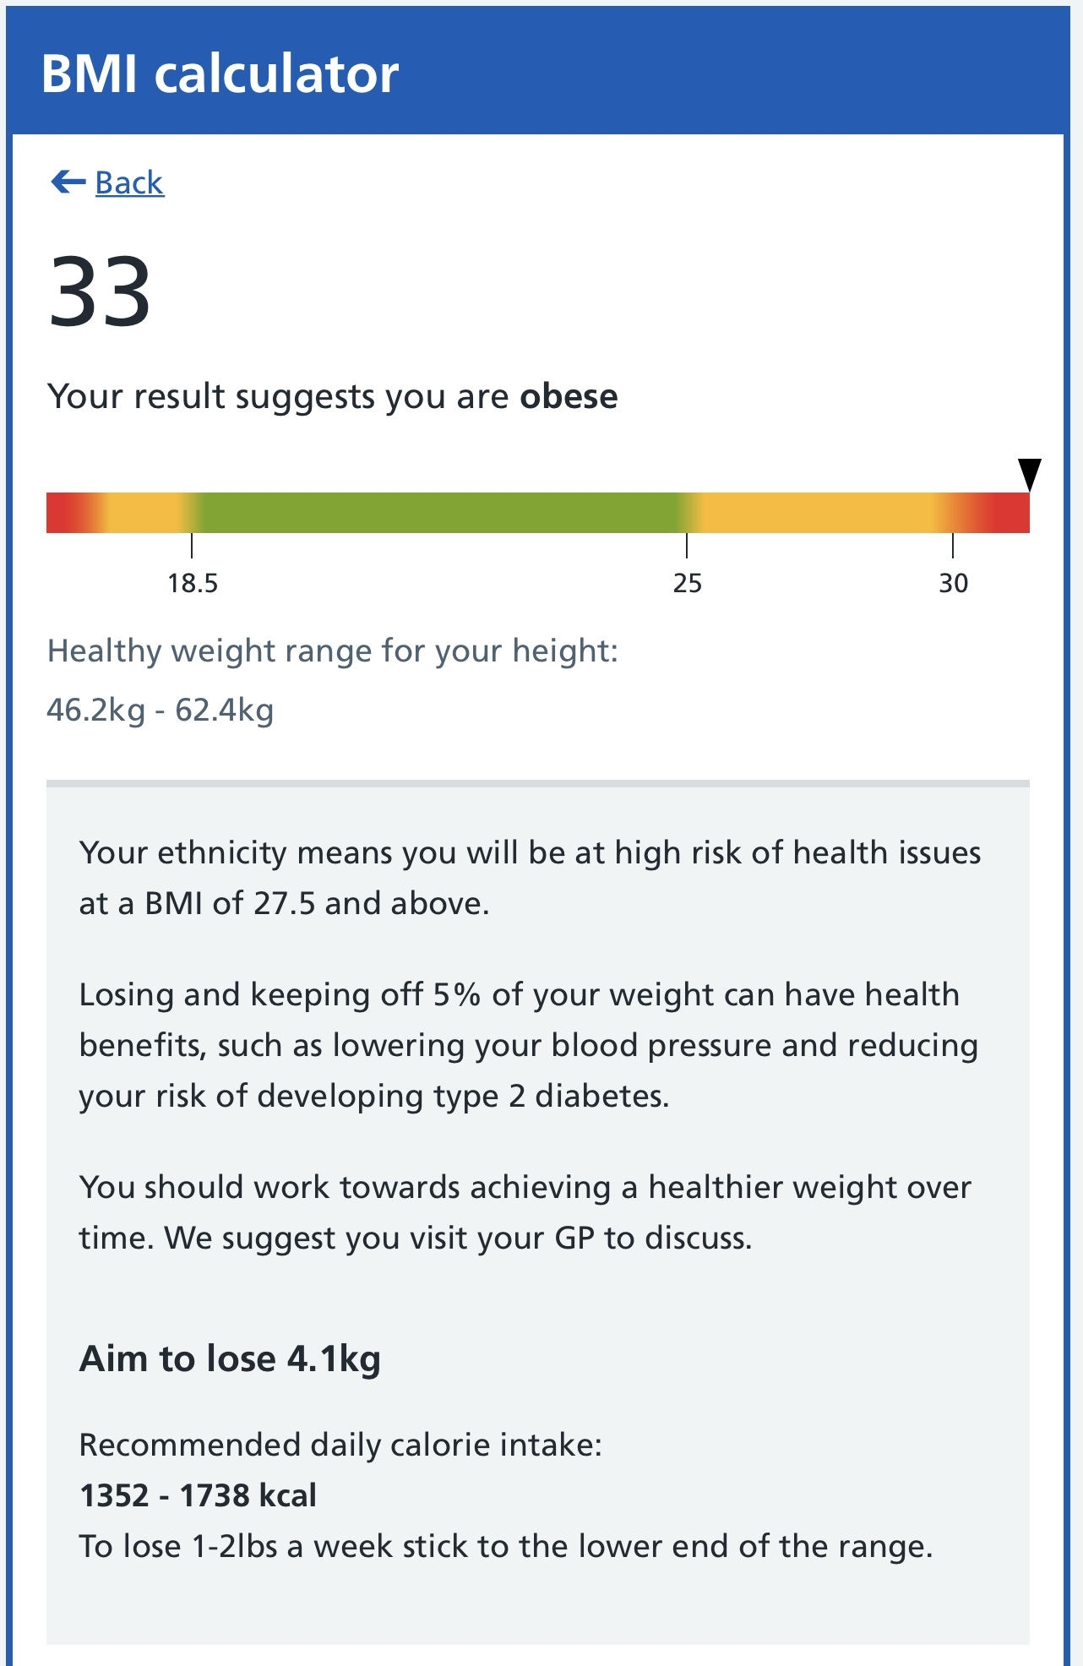

12

