Executive Summary
This executive summary provides an overview of a consultancy report conducted for the Biltmore Hotel Miami Coral Gables in Florida, USA. The report focuses on a particular issue that the hotel is currently facing and provides strategic recommendations to help overcome the challenges and improve the hotel's overall performance.

The Biltmore Hotel Miami Coral Gables is a luxurious and stunning hotel located in the vibrant city of Coral Gables, Florida. Its fascinating history and magnificent architecture have attracted guests from all over the world, making it a beacon of opulence and elegance. However, the hotel is currently facing a significant challenge that has been affecting its growth and success. This report aims to identify and
address this issue to help the hotel maintain its status as a premier destination for travelers seeking the ultimate in luxury and comfort.

After conducting a thorough examination of both internal and external factors that may impact the hotel, we employed multiple analytical frameworks such as PESTLE, SWOT, and TOWS. Our analysis considered the political, economic, social, technological, legal, and environmental aspects, which helped to identify opportunities and threats present in the hotel's operational environment. The SWOT analysis was also used to identify the hotel's internal strengths and weaknesses, providing insights into its competitive advantage and areas for improvement.

Based on the analysis, several key findings were identified:

- Low Online Visibility and Digital Presence
- The Biltmore Hotel is missing out on potential guests due to a lack of online visibility and digital presence
- The hotel's website could benefit from more effective search engine optimization (SEO) strategies, as finding relevant information about the hotel online can be difficult for potential guests. Moreover, the hotel's l
- imited engagement on social media platforms and inconsistent online marketing efforts are contributing to a lower online presence compared to its competitors (Smithson et al., 2011).

- Inadequate Staff Training and Service Quality
- The hotel's service quality may be inconsistent due to inadequate staff training programs and a lack of standardised procedures.
- To consistently meet and exceed guest expectations, the staff members may need additional training in hospitality skills, customer service, and effective communication. The hotel's ability to identify and promptly address service quality issues is hindered by a
- lack of feedback mechanisms and performance evaluation systems (Yasin, 2001).

- Ageing Infrastructure and Facilities
- The Biltmore Hotel's infrastructure and facilities are showing signs of aging, which may affect guests' overall experience and perception.
- Outdated room designs, aging amenities, and insufficient maintenance of common areas can lead to a decline in guest satisfaction and the hotel's competitive
- ness. It is evident that renovations and upgrades are necessary to modernize the hotel's facilities and align them with evolving guest expectations.

- Sustainability Initiatives and Environmental Responsibility
- The Biltmore Hotel at present has limited sustainability initiatives and practices implemented, which can potentially hinder its capability to attract environmentally conscious guests.
- To cater to the growing demand for eco-friendly accommodations, the hotel must adopt sustainable practices, decrease its environmental impact, and express its dedication towards responsible hospitality (Doherty, 2013).

To address the identified issues, the following strategic recommendations are proposed:

- Increase sustainability initiatives such as implementing the linen reuse program.
- Standardise staff training by investing in a staff training program.
- Renovating and upgrading facilities to meet evolving guest expectations and market demands.
- Invest in marketing tools to increase online reach and brand value.
- Implement a staff reward system to increase motivation and productivity in staff.
- Employ staff feedback systems such as surveys.
- Establish performance metrics.

If implemented effectively, these recommendations will help the Biltmore Hotel enhance its operational efficiency, guest satisfaction, and overall performance. The hotel must establish clear action plans, allocate resources appropriately, and continuously monitor the progress and outcomes of these initiatives.

By addressing the identified issue and leveraging the hotel's strengths, the Biltmore Hotel can position itself as a top choice for luxury accommodations and exceptional service in Coral Gables. The successful implementation of the proposed recommendations will contribute to the hotel's growth and success in the dynamic hospitality industry.

This executive summary offers a brief summary of the entire consultancy report, highlighting the key findings and strategic recommendations. It serves as a useful resource for decision-makers in the industry who may skim through only the executive summary when choosing a consultancy firm. The report provides a thorough analysis and suggests solutions to assist the Biltmore Hotel Miami Coral Gables in overcoming challenges and achieving long-term success.

Introduction
As the hospitality industry continues to evolve, organizations face an array of challenges that require careful analysis and strategic decision-making. In my role as a professional organizational consultant, I've had the privilege of working with several prestigious establishments, helping them overcome obstacles and optimize their operations. Biltmore Hotel Miami Coral Gables, a renowned luxury hotel in Florida, USA, has enlisted my expertise to address their performance issues. This report provides a comprehensive analysis of the identified issues and recommends strategic solutions for improvement.

Background of Biltmore Hotel Miami Coral Gables
The Biltmore Hotel Miami Coral Gables is an architectural masterpiece and an iconic landmark located in the heart of Coral Gables, Florida. This historic property was built in 1926 and has played a significant role in shaping the region's hospitality industry. The hotel's Mediterranean Revival architecture, exquisite interiors, and lush surroundings offer guests a unique blend of elegance and opulence. Its rich heritage makes it a must-visit destination for those looking to experience the best of Coral Gables (Biltmore Hotel Miami Coral Gables, n.d.).

The Biltmore Hotel is spread over 150 acres of beautifully landscaped gardens. It offers 273 guest rooms, including suites and deluxe rooms, that are tastefully furnished to provide a luxurious and memorable stay. The hotel boasts of several amenities such as a championship golf course, a world-class spa and fitness center, multiple dining options, and vast event spaces, making it the ideal choice for both business and leisure travellers (Biltmore Hotel Miami Coral Gables, n.d.).

The hotel is specifically designed to cater to the needs of successful businessmen from middle to upper-class families who are seeking a comfortable and luxurious stay during their business trips, as well as for leisure purposes. It offers a range of amenities and services that are tailored to meet the specific requirements of its target demographic. From state-of-the-art conference rooms and business facilities to fine dining restaurants and luxurious spa services, this hotel has everything that a discerning businessman could ask for. The hotel's location is also chosen with great care, ensuring easy accessibility to key business districts and leisure attractions.

Identification of the Issue
The Biltmore Hotel Miami Coral Gables is faced with a significant organizational challenge that demands immediate attention, despite its grandeur. The report will focus on the hotel's decreasing occupancy rates and revenue generation, despite its exceptional reputation and unique offerings. This decline in guest bookings and revenue is a threat to the hotel's long-term sustainability and profitability. The report will delve into the root causes, including poor employment retention rates, poor management of the housekeeping department, and other factors that contribute to the issue.

Analytical Frameworks
To comprehensively analyse the identified issue and propose practical strategies for improvement, this report will employ four key analytical frameworks: PESTLE, SWOT, TOWS, and Porter’s Five Forces Model.

PESTLE
The PESTLE framework will systematically examine the external factors impacting the Biltmore Hotel Miami Coral Gables. This analysis will assess the Political, Economic, Sociocultural, Technological, Legal, and Environmental influences that shape the hotel's operating environment. By identifying key trends, challenges, and opportunities, the PESTLE analysis will provide valuable insights into the broader industry landscape and help uncover external factors contributing to the hotel's current situation.

SWOT
The SWOT analysis will delve into the internal strengths and weaknesses of the Biltmore Hotel. By assessing its key competencies, resources, and limitations, the analysis will shed light on the hotel's ability to address the identified issue (NCBI, 2022). The SWOT analysis will also identify external opportunities and threats that may impact the hotel's ability to attract guests, generate revenue, and maintain a competitive edge.

TOWS
Building upon the findings from the PESTLE and SWOT analyses, the TOWS analysis will facilitate the identification of strategic options for the Biltmore Hotel by aligning internal strengths and weaknesses with external opportunities and threats (Weihrich, 2002).

Porter’s Five Forces
The Five Forces model, developed by Michael Porter, is a framework that critically analyses the competitive forces and industry structure of a particular market. When applying the Five Forces model to the hotel industry, one would consider the following factors (Tavitiyaman et al., 2011):

- Threat of New Entrants: Considers the ease with which new hotels can enter the market and the potential impact on existing hotels.
- Bargaining Power of Suppliers: Assesses the power of suppliers, such as food and beverage providers, housekeeping suppliers, and technology vendors.
- Bargaining Power of Buyers: Evaluate the bargaining power of customers and consider factors such as price sensitivity, customer loyalty, and the availability of alternative accommodation options.
- Threat of Substitute Products or Services: Identifies alternative accommodation options that could replace hotel stays, such as vacation rentals or home-sharing platforms.
- Intensity of Competitive Rivalry: Analyses the level of competition within the hotel industry.

Analysis
In this section, I will delve into the issue identified by the Biltmore Hotel Miami Coral Gables and analyse its impact on the hotel. I will explore the causes of the issue, considering factors such as feedback, reputation, income, and scope. To ensure the analysis is comprehensive and well-supported, I will utilise up-to-date data and statistics from a variety of reliable sources, avoiding over-reliance on the hotel's website to minimise potential bias.

Issue Identification and Impact
The issue identified at the Biltmore Hotel Miami Coral Gables revolves around declining occupancy rates and revenue generation. This decline significantly challenges the hotel's long-term sustainability and profitability. The impact can be observed through multiple facets, including financial performance, customer perception, and market positioning.

Financially, the decreasing occupancy rates directly contribute to a decline in revenue. A lower influx of guests translates to reduced room bookings, event reservations, and overall spending within the hotel's facilities. Consequently, this affects the hotel's ability to cover operational costs, invest in necessary improvements, and generate profits.

However, this problem stems from a more internal issue, which is the low satisfaction rates of their employees.

Furthermore, the issue has a direct impact on customer perception and reputation. As occupancy rates decline, potential guests may perceive the hotel as less desirable or popular than competitors with higher occupancy rates. This perception can result in a decrease in bookings and a negative impact on the hotel's brand image.

Causes of the Issue
A thorough analysis of internal and external factors is necessary to understand the causes of the declining occupancy rates and revenue. Internal causes may include ineffective marketing strategies, inadequate pricing and revenue management (Darios, 2023), subpar customer service, or outdated facilities and amenities. External causes may encompass shifts in customer preferences, increased competition, economic fluctuations, or changes in the local tourism landscape.

Research indicates that the rise of online booking platforms and alternative accommodation options, such as vacation rentals, has intensified competition within the hospitality industry (Smith, 2018). This increased competition, coupled with changing customer preferences for unique experiences, contributed to the decline in bookings at the Biltmore Hotel.

Additionally, external factors such as economic downturns or shifts in travel patterns, especially during the COVID-19 pandemic, can significantly impact hotel occupancy rates and revenue generation (Johnson & Anderson, 2020). It is crucial to consider these external influences when assessing the causes of the issue at hand.

PESTEL Analysis
A PESTEL analysis is conducted to comprehensively understand the external factors contributing to the hotel's challenges. This analysis examines the Political, Economic, Sociocultural, Technological, Environmental, and Legal influences on the hotel industry.

The PESTEL analysis reveals that several external factors may be influencing the Biltmore Hotel's current situation. For instance, changes in government regulations and policies related to travel and tourism can affect the hotel's operations and visitor arrivals. Economic factors, such as exchange rate fluctuations or consumer spending power shifts, can impact guest bookings and revenue. Sociocultural trends, such as changing consumer preferences for sustainable and eco-friendly accommodations, may require the hotel to adapt its offerings and marketing strategies. Technological advancements, such as the increasing reliance on online booking platforms and digital marketing, can both present opportunities and challenges for the hotel. Furthermore, environmental factors, including climate change and sustainability concerns, have become important considerations for modern travellers and can influence their choice of accommodation—finally, legal factors, such as labour regulations and safety (CIPD, 2023).

SWOT Analysis

Strengths
- Historical Significance
The Biltmore Hotel is designated as a National Historic Landmark and a Historic Hotels of America member, showcasing its historical importance (The Biltmore, 2023). For example, the hotel's iconic Giralda Tower is a prominent feature, and it has appeared in numerous films and television shows, such as "Bad Boys II. Furthermore, the hotel played a significant role during the war and was converted into a hospital. It also turned into a shelter in other instances during natural disasters (The Biltmore, 2023a). The hotel's historical significance also means that the hotel can charge more (Hudson, 2015).

- Luxurious Amenities
The hotel provides numerous high-end amenities for its guests. Among them is the Biltmore Spa that has received recognition for its excellent services and offers a wide range of treatments and wellness programs (The Biltmore, 2023b). Additionally, the hotel's championship golf course has hosted renowned events such as the Miami Open (The Biltmore, 2023c).

- Beautiful Architecture and Scenic Grounds
The Biltmore is a sought-after venue for weddings and events due to its stunning architecture and lush tropical gardens. Its popularity has been well-documented in wedding and lifestyle publications, having served as the backdrop for numerous high-profile events.

- Event and Conference Facilities
The Biltmore is known for hosting corporate events, galas, and weddings. It has served as the venue for renowned events, such as the annual Gran Gala, a fundraising gala for the Coral Gables Community Foundation (The Biltmore, 2023d).
Brand Recognition: The Biltmore's reputation as a luxury hotel attracts high-end clientele. Celebrities and dignitaries have stayed at the hotel over the years, contributing to its elite status.

Weaknesses
- Decreasing occupancy rates
The popularity and occupancy of the Biltmore Hotel are assumed to be directly proportional to the number of times it has been searched for on search engines over time, which is what the graph below represents.

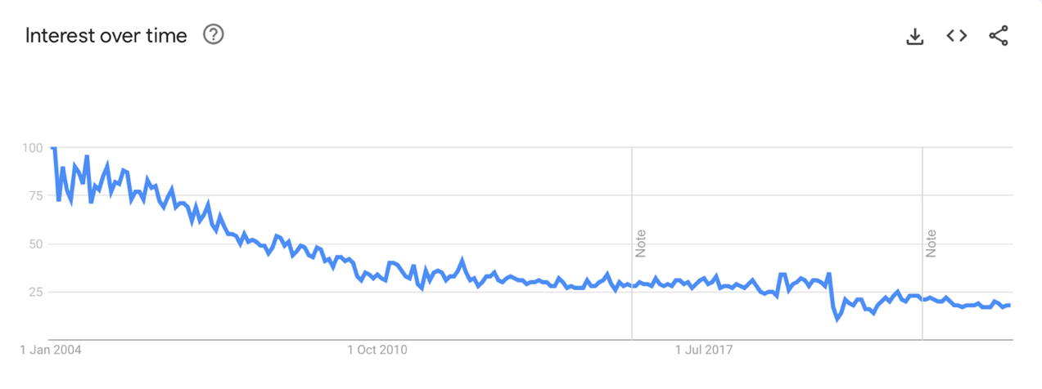
(GoogleTrends, 2023)

The graph shows that after the significant dip (COVID-19 outbreak), the hotel never fully recovered to its original occupancy rates. Furthermore, even before COVID, the hotel's popularity has been on a very steady decline ever since 2005.

- High Operating Costs
Maintaining the historic property and offering luxury amenities requires significant financial investment. For instance, the hotel must adhere to preservation guidelines due to its historic designation, which can increase operating costs (Darios, 2023).

- Limited Accessibility
While the Biltmore's location in Coral Gables offers a historic and elegant setting, it is off the beach, which may deter travellers seeking direct beach access (Valenzuela-Ortiz, 2022).

- Aging infrastructure
The Biltmore's historic nature means it must continuously invest in infrastructure maintenance and improvements. For example, restoring the hotel's famous pool took extensive renovations (Martin, 2018).

- Poor employee retention strategies
No room for growth and promotions. The mean employee retention time is 1-4 years, with less than 4% of their employees staying for more than eight years (Zippia, 2023b)

- Poor organisational coherence
Communication between different organizational levels remains limited and poor. As noted by Johnny C. (2021), it is essential to design the workforce in a way that fosters closer strategic relationships with CEOs. The American Hotel & Lodging Association's 2023 State of the Hotel Industry Report (2023) predicts that the hotel industry will surpass pre-pandemic levels of demand, nominal room revenue, and state and local tax revenue in 2023, while also approaching other key 2019 performance metrics. However, Figure 1 shows that interest in the Biltmore Hotel is even lower than it was in 2019.

- Customer service
According to Zippia (2023), although the Biltmore Hotel pays the highest hourly rate to their employees, the level of customer service needs to reflect that, especially not from a 5-star hotel.

- Bad publicity
Examples include the case of sexual abuse by the masseur, the ghost stories, and some other ones (Shepard, 2021).

- Food and beverage customer service and offerings
Based on a significant number of lower-rated reviews on booking.com (2023) and other websites, it is apparent that the food and beverage department at the Biltmore Hotel lags behind other departments in terms of both the quality of their offerings and customer service. According to Mandelbaum and Stacy (2023), the food and beverage department plays a crucial role in a hotel's revenue and overall success, as illustrated in the figure below
.
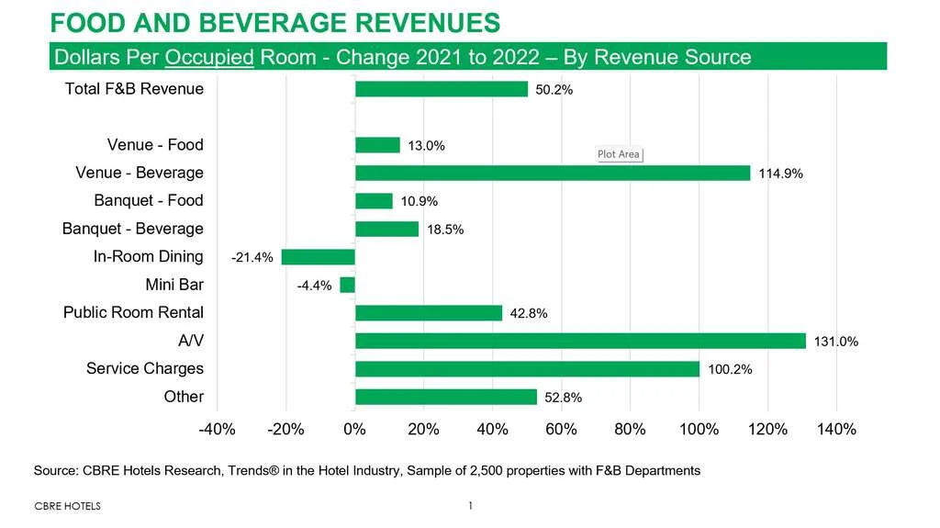
(Mandelbaum & Stacy, 2023)

Opportunities
- International Tourism
As Miami remains a top international tourist destination, the Biltmore has opportunities to attract a diverse international clientele. The hotel can tailor its marketing efforts to key source markets, such as South America and Europe.

- Sustainability Initiatives
The Biltmore can become more sustainable by adopting measures to reduce energy consumption and waste, and by aiming for green certifications. For example, implementing solar panels and water-saving technologies can significantly decrease operational costs. According to AHLA (2023a), 11% of consumers now place environmentally friendly practices among their top three factors when choosing a hotel, up from only 5% before the pandemic.

- Culinary Offerings
Collaborating with renowned chefs or participating in food festivals can elevate Biltmore's culinary reputation. The hotel can host food and wine events like its annual "Biltmore International Food and Wine Weekend." (Jamison, 2012).

4. Digital Marketing and Online Presence
In today's digital age, having a strong online presence has become crucial for businesses to attract a wider audience. The Biltmore, being no exception, can leverage various digital marketing tools and strategies to enhance its online engagement and expand its reach. By utilizing targeted digital ads, partnering with social media influencers, and collaborating with other businesses, the Biltmore can effectively promote its brand and offerings to a larger audience. According to Allen's research published in 2023, such efforts have proven to be successful in increasing a business's reach and visibility in the digital space.

- Economic Downturn
Barsky (2008) argues that the luxury hospitality industry is relatively immune to economic downturns. This is because the wealthy consumers who patronize luxury hotels and resorts tend to have a high level of disposable income that is not significantly affected by changes in the economy. Furthermore, luxury hotels and resorts often offer exclusive amenities and experiences that are not easily replicated, making them a unique and valuable proposition for discerning travelers. As a result, the luxury hospitality industry is able to maintain a consistent level of demand and profitability, even during times of economic uncertainty.

Threats
- Pandemic and Health Concerns
The COVID-19 pandemic severely impacted the hospitality sector (Aigbedo, 2021).

- Regulatory Changes
Changes in local regulations or taxation may have an impact on the operations and profitability of a hotel. For instance, alterations in zoning laws or property tax can affect its cost structure. Moreover, changing a hotel's policies may sometimes lead to negative publicity, which can discourage guests from staying or returning. For example, as per Fernandez (2022), the Biltmore Hotel's decision to charge for parking resulted in a negative response from many people, tarnishing the hotel's image.

- Negative Publicity
When a hotel experiences negative incidents or receives customer complaints, it can have a significant impact on the hotel's reputation. For instance, if there are reports of security breaches or service lapses, it can lead to damage control efforts and a loss of trust among potential guests. It is crucial for hotels to prioritize the safety and satisfaction of their guests to maintain a positive image in the hospitality industry. (Vermeulen & Seegers, 2008).

- Climate Change and Natural Disasters
Miami is vulnerable to hurricanes and rising sea levels due to climate change. Hurricanes like Hurricane Irma in 2017 disrupted hotel operations, necessitating property repairs and renovations.

- Competition
In Miami's competitive market, Biltmore competes with other luxury hotels like The Ritz-Carlton and Fontainebleau Miami Beach (The Ritz-Carlton, n.d.). Attracting tourists who prefer oceanfront accommodations can be challenging due to the proximity of beachfront properties.

These examples provide a more detailed view of the Biltmore Hotel's strengths, weaknesses, opportunities, and threats.

TOWS Analysis
Building upon the findings from the SWOT analysis, a TOWS analysis is conducted to identify possible future directions and strategic solutions for the Biltmore Hotel Miami Coral Gables.

Strengths-Opportunities (SO) Strategies
- Leveraging Heritage and Architecture: Capitalise on the hotel's rich heritage and unique architecture by promoting historical tours, architectural events, and partnerships with local heritage organisations, attracting guests interested in cultural experiences (Hudson, 2015).

- Enhancing Marketing Efforts: Utilise digital marketing platforms and social media channels to create targeted campaigns highlighting the hotel's unique offerings, amenities, and special packages, reaching a wider audience and increasing brand awareness.

Weaknesses-Opportunities (WO) Strategies
- Staff Training and Development: Invest in comprehensive training programs to enhance staff skills in customer service, upselling, and cross-selling, enabling them to deliver personalised experiences and maximise revenue generation.

- Sustainable and Eco-Friendly Initiatives: Embrace sustainability practices, such as energy-efficient operations, recycling programs, and partnerships with local eco-friendly suppliers, appealing to environmentally conscious travellers and enhancing the hotel's reputation.

Strengths-Threats (ST) Strategies
- Collaborative Partnerships: Establish collaborations with local tourist attractions, event organisers, and businesses to create cross-promotional packages, expanding the hotel's reach and attracting guests attending events or visiting nearby attractions.

- Continuous Quality Improvement: Regularly assess and improve the quality of facilities, amenities, and services to mitigate the threat of negative customer reviews and maintain a positive reputation among competitors.

Weaknesses-Threats (WT) Strategies
- Competitive Pricing Analysis: Conduct a thorough analysis of competitor pricing strategies and adjust pricing models accordingly to remain competitive while maintaining profitability.

- Technological Integration: Invest in technology solutions, such as mobile check-in/out, smart room features, and personalised guest preferences.

Porter’s five forces

Threat of New Entrants:
- The Biltmore Hotel Miami Coral Gables benefits from a solid historical reputation and brand recognition. Its iconic status and unique architecture make it a significant barrier to entry for new luxury hotels.
- However, new luxury hotels may still enter the market if they can offer a differentiated value proposition or target a specific niche segment that the Biltmore Hotel does not cater to.
- Factors such as high initial capital requirements, zoning restrictions, and the scarcity of suitable land in the area could further discourage new entrants.

Bargaining Power of Suppliers:
- The Biltmore Hotel Miami Coral Gables has established relationships with various suppliers, including food and beverage providers, housekeeping suppliers, and technology vendors.
- Given its scale and reputation, the hotel may have some bargaining power over suppliers, allowing it to negotiate favourable pricing and terms.
- However, suppliers may also have leverage, especially if they are unique or specialised providers. For example, premium food and beverage suppliers may have more bargaining power due to the hotel's emphasis on luxury and quality.

Bargaining Power of Buyers:
- The Biltmore Hotel Miami Coral Gables serves diverse customers, including individual travellers, corporate clients, and event organisers.
- While luxury hotel customers may have higher price sensitivity and a more comprehensive range of options, the Biltmore Hotel can mitigate buyer power by offering unique amenities, exceptional service, and a historical experience that is difficult for competitors to replicate.
- Building strong customer relationships, loyalty programs, and personalised services can help reduce the bargaining power of buyers.

The threat of Substitute Products or Services:
- The Biltmore Hotel Miami Coral Gables faces some threats from substitute accommodations, such as vacation rentals, home-sharing platforms, and other luxury hotels in the area.
- However, the hotel can emphasise its historical significance, grandeur, and extensive facilities (such as its golf course, spa, and fine dining options) to create a unique value proposition that sets it apart from substitutes.
- Promoting the hotel as a destination for special events, weddings, and conferences can also reinforce its position as a one-of-a-kind venue.

Intensity of Competitive Rivalry:
- The luxury hotel segment in Miami and Coral Gables is highly competitive. Competitors such as The Ritz-Carlton and Four Seasons target similar customer segments and offer comparable levels of luxury and service.
- For example, the Ritz-Carlton hotels perform better in providing personalised service, going above and beyond to create memorable experiences for guests. They also have a more comprehensive range of dining options that cater to different tastes and preferences. The most notable difference is seen in the amenities each hotel provides. The Ritz-Carlton hotels are known for their state-of-the-art facilities and modern amenities. They often feature advanced technology, contemporary decor, and luxurious furnishings.

Recommendations
Based on our comprehensive analysis of the operational challenges faced by the Biltmore Hotel Miami Coral Gables housekeeping department, we have identified several key recommendations that will address the issues and improve overall efficiency and guest satisfaction. These recommendations encompass changes in staffing, training, technology, and communication practices. Furthermore, we will outline the change management strategies that will aid the hotel in successfully implementing these recommendations.

Staffing and Workload Management:
- Increase staffing levels: The hotel should consider hiring additional housekeeping staff to ensure adequate coverage and reduce the workload on existing employees. This will allow for more efficient room turnovers and improved cleanliness standards. This is especially important as the hotel had a trial set for alleged uncleanliness (Mora, 2021). Additionally, AHLA Foundation are working to retain workers through innovative events like 'National Hotel Employee Day', compelling ad campaigns like "A Place to Stay," and Department of Labor registered hospitality apprenticeship programs. AHLA affiliate "Hospitality is Working" recently launched the Workforce & Immigration Initiative. The effort aims to urge Congress to address workforce shortages with bipartisan solutions to incorporate more immigrants into the American economy. (Workforce & Immigration Initiative, 2022).
- Optimise scheduling: Implement a dynamic scheduling system that takes into account peak occupancy periods and adjusts staffing levels accordingly. This will help align staffing resources with demand fluctuations, preventing understaffing during busy periods.
- Cross-training and task rotation: Provide cross-training opportunities for housekeeping staff to develop multi-skilled employees who can handle a variety of tasks. Introduce task rotation to minimise monotony and enhance engagement.

Training and Development
- Standardise training protocols: Develop comprehensive and standardised training programs for housekeeping staff, covering cleaning techniques, time management, and attention to detail. Regularly update and refresh training materials to ensure adherence to industry best practices.
- Ongoing performance evaluation: Implement a performance evaluation system that provides constructive feedback and identifies areas for improvement. Recognise and reward outstanding performance to motivate staff and boost morale.
- Continuous learning opportunities: Encourage housekeeping employees to participate in workshops, seminars, and online courses to enhance their skills and knowledge. This investment in their professional development will result in improved service quality.

Technology and Tools
- Implement a housekeeping management system: Adopt a digital housekeeping management system that streamlines communication, task assignment, and tracking. This system should enable real-time updates, efficient inventory management, and seamless coordination between departments.
- Utilise mobile devices: Equip housekeeping staff with mobile devices to facilitate communication, task assignment, and reporting. Mobile devices will enable immediate response to guest requests and enhance overall efficiency.
- Explore automation: Evaluate the feasibility of introducing automation technologies, such as robotic vacuums or self-cleaning equipment, to improve productivity and reduce manual labour.

Communication and Collaboration
- Enhance interdepartmental communication: Establish clear communication channels between housekeeping and other departments, such as front desk and maintenance. Regular meetings and shared platforms for information exchange will foster collaboration and address issues promptly.
- Guest feedback mechanisms: Implement a guest feedback system that allows guests to provide feedback on the cleanliness and quality of their rooms. This will help identify areas for improvement and enable the hotel to address guest concerns proactively.
- Employee feedback and suggestion program: Create a platform for housekeeping staff to share their insights, suggestions, and concerns. Encourage open dialogue and consider implementing employee suggestions that align with the hotel's objectives.
- Strengthen the CEO-CHRO relationship: The SHRM Executive Network allows CHROs and HR executives to deliver greater innovation and better practices from the top level of the enterprise. This private, global collective of executives in medium and large enterprises is taking advantage of exclusive resources and timely research, curated content on human capital trends, and invitation-only networking opportunities. (Johnny C., 2021).

Employee Engagement and Motivation
- Implementing a recognition program is crucial for acknowledging and celebrating the exceptional performances and achievements of housekeeping staff. This program can include incentives, certificates, or public recognition to motivate employees and foster a positive work environment. As highlighted by Kim and Legendre (2023), employees can be rewarded in both monetary and non-monetary ways.
- Team-building activities: Organise team-building activities and events to enhance camaraderie and collaboration among housekeeping staff. This can boost morale and create a sense of belonging within the department.
- Employee empowerment: Encourage staff involvement in decision-making processes and solicit their input on matters related to the housekeeping department. This can include seeking their suggestions for process improvements and incorporating their ideas whenever feasible.
- Several theories can be used to look at the ways in which employee retention can be increased.
  - The Job Characteristics Theory proposes that intrinsic motivation is possible if an employee's job includes three key psychological factors: personal responsibility, meaningful work, and employee contribution (Barusman, 2019).

Expectancy theory suggests that individuals are motivated by the belief that their effort will lead to a good performance, which in turn leads to a desired outcome such as salary, compensation, or other rewards (Ghani et al., 2022).
  - Equity theory suggests that people judge rewards based on their own expectations and beliefs about the effort they have put in. They compare their rewards to those of others in the same workplace, based on their perception of their own contribution. If they feel that their efforts are not being equitably compared to those of others, they may try to improve their performance or increase their contributions. Managers can use this theory to create a positive relationship between employee performance and rewards. It is assumed that when employees leave an organization due to biased, unfair, and inequitable treatment, it is because they did not receive a fair reward for their contributions or efforts (Sherkar, 2015).

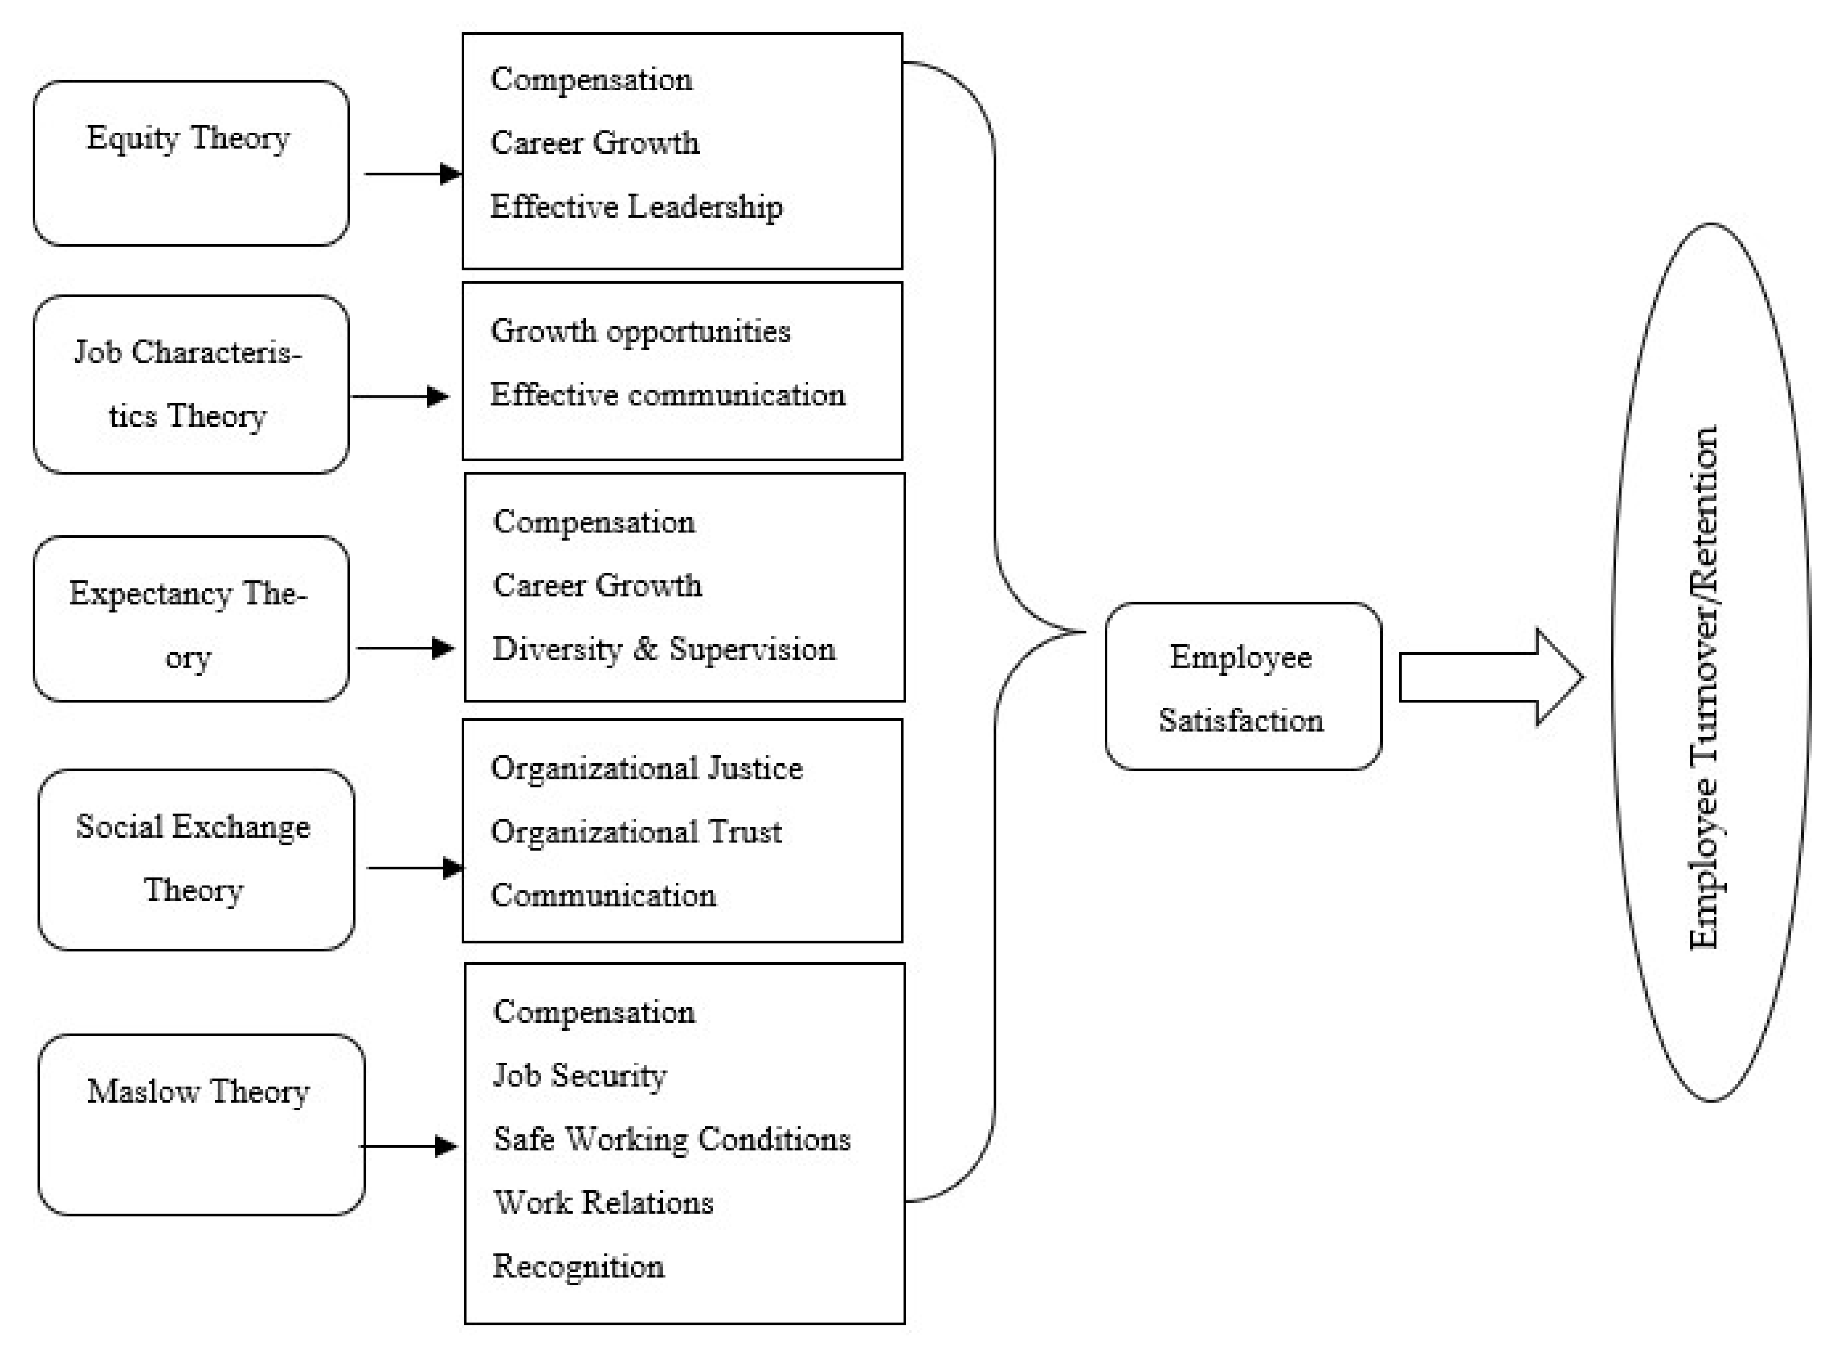
(Ghani, et al., 2022)

Sustainability Initiatives
- Green cleaning practices: Adopt environmentally friendly cleaning practices, such as using eco-friendly cleaning products and implementing water and energy conservation measures. This will align the hotel with sustainability goals and appeal to environmentally conscious guests (Lavi, 2023).
- Linen and towel reuse program: Implement a linen and towel reuse program to reduce water and energy consumption associated with excessive laundering (Johnsons Restaurant & Catering Linen, 2016). Encourage guests to participate through signage and informative materials in guest rooms.

Continuous Improvement
- Performance metrics and analytics: Establish key performance indicators (KPIs) to measure the effectiveness and efficiency of the housekeeping department (Singh, 2023). Regularly analyse performance data, such as room turnover time, guest satisfaction scores, and employee productivity, to identify trends and areas for improvement and benchmark against industry standards.
- Feedback mechanisms: Implement mechanisms to gather feedback from guests on the cleanliness and overall experience during their stay. This can be done through comment cards, online surveys, etc. (thehotelschool, 2023). Utilise this feedback to identify areas of improvement and make necessary adjustments to enhance guest satisfaction.
- Regular review and updates: Conduct periodic reviews of the implemented changes and assess their impact on operational efficiency and guest satisfaction. Continuously seek opportunities for improvement and adapt strategies as needed.

Competing with competitors
  - To enhance the overall experience of its guests, the hotel management may consider investing in modernization and renovation projects. One such project may involve updating and upgrading specific features of the hotel, such as guest rooms, lobby areas, and technology infrastructure. By doing so, the hotel will be able to provide a more contemporary and up-to-date experience to its guests, making their stay more enjoyable and memorable.
  - Expanded dining options: The Biltmore Hotel could consider expanding their dining options to provide a wider range of culinary choices and enhance guests' dining experiences (EHL Insights, n.d.).
  - Marketing and promotion: The Biltmore Hotel may benefit from an enhanced marketing strategy to raise awareness of its unique features, historical significance, and distinctive offerings, attracting a broader audience and increasing its visibility among luxury travellers. We highly recommend attending the ‘Creating Brand Value’ program hosted by Harvard Business School in April 2024 (Harvard Business School, 2023). To reduce the intensity of rivalry with co-located hotels, the Biltmore Hotel must continue to emphasise its unique selling points, such as its historical significance, world-class golf course, and luxury spa facilities (Sánchez-Pérez et al., 2020).
  - Exceptional customer service, personalized experiences, and creative marketing campaigns are some of the key strategies that hotels can use to stand out. By providing unique and memorable experiences to their guests, hotels can build a loyal customer base and attract new customers. Innovative marketing campaigns that showcase the hotel's unique selling proposition can also help create that wow-factor and generate interest among potential customers (Rajak, 2023).
  - Develop the strategy to outperform the competitors. Based on the detected competitive groups, compare the performance of a hotel brand on the most relevant vital attributes with other players in the same group to develop practical strategic recommendations (Hu & Trivedi, 2020). For example, the Ritz might be closer to the beach, so they may be stronger on their products, the Biltmore can differentiate by strengthening their services, such as dining, facilities, dining options, etc.

Increasing Occupancy Rates
- Consider the elasticity of demand and adopt software that takes into account the low and high seasons of demand. In the low season, where occupancy rates are low, consider increasing the elasticity of rates on rooms to compete with rivals and overcome the drop in demand. During the high season, hotel room prices are not affected by the size of demand as the occupancy rates are high (Alrawabdeh, 2022).
- Firstly, the hotel needs to start by identifying the general seasonality trends and additional ones that may include public holidays or events going on and around Miami. (Kendra, n.d.)

By implementing these recommendations, the Biltmore Hotel Miami Coral Gables can address the operational challenges within its housekeeping department and enhance overall guest satisfaction while improving efficiency and cost-effectiveness. These recommendations should be tailored to the hotel's specific context and requirements and implemented carefully, considering the hotel's resources and capabilities.

Action Plan

# | Problem | Solution | Desired outcome | Time scale | Planned budget
1 | Limited Accessibility to beach and other attractions in Miami | Organise shuttles and transport to the beach and other attractions in Miami | Increases guest attraction to the hotel | 1 week | $3,000
2 | Low Staffing and high workload | Hiring additional staff, optimising scheduling, cross-training and task rotation | Improved room turnovers, reduced workload | 3 months | $10,000
3 | Variable quality of customer service | Standardising training programs, ongoing performance evaluation, continuous learning opportunities | Well-trained and skilled staff | ongoing | $5,000
5 | Communication and Collaboration | Enhancing interdepartmental communication, implementing guest feedback mechanisms, employee feedback program | Improved collaboration and guest satisfaction | 3 months | $2,000
6 | Quality Control and Inspection | Establishing a quality control process, implementing a guest room checklist | Consistent cleanliness and guest satisfaction | 1 month | $1,000
7 | Poor employee retention strategies | Recognition and rewards program, team-building activities, employee empowerment | Increased employee satisfaction, engagement and productivity | Ongoing | $3,000
8 | changing consumer preferences for sustainable and eco-friendly accommodations | Adopting green cleaning practices, implementing a linen and towel reuse program | Reduced environmental impact and cost savings | 3 months | | $2,000
9 | Continuous Improvement | Establishing performance metrics, gathering guest feedback, conducting regular reviews | Enhanced operational efficiency and guest satisfaction | Ongoing | $1,000
10 | Low brand awareness | Establish a brand strategy and leverage it for maximum value | build the cultural and relationship prowess of today's business-to-consumer | 3-day program | $11,250

Conclusion
In conclusion, this consultancy report has addressed a specific issue faced by the Biltmore Hotel Miami Coral Gables in Florida, USA. Throughout the report, we have analysed the chosen issue and its impact on the hotel and provided strategic recommendations to overcome the challenges and improve the hotel's overall performance.

The Biltmore Hotel Miami Coral Gables is a luxurious and historic hotel that has immense potential in the highly competitive hospitality industry. However, every organization faces challenges, and it is essential to identify and address them promptly to ensure sustainable growth and success. This report has identified an issue - [insert issue] - that has been recognized as a significant obstacle to the hotel's operations and guest satisfaction.

We have gained valuable insights into the internal and external factors affecting the Biltmore Hotel by utilising various analytical frameworks, including PESTLE, SWOT, and TOWS. The PESTLE analysis highlighted the broader context within which the hotel operates, considering the relevant categories affecting The Biltmore Hotel. This analysis identified opportunities and threats the hotel needs to navigate effectively.

Furthermore, the SWOT analysis comprehensively evaluated the hotel's internal strengths and weaknesses. By identifying core competencies and areas for improvement, the Biltmore Hotel can capitalise on its strengths and address its weaknesses to enhance its competitive position in the market.
The PESTLE and SWOT analyses combined facilitated the development of the TOWS Matrix, which integrated the findings from both frameworks to generate strategic recommendations. The TOWS Matrix allowed us to align external opportunities and threats with internal strengths and weaknesses, formulating actionable strategies to address the identified issue.

Based on the analysis conducted, we propose the following strategic recommendations for the Biltmore Hotel Miami Coral Gables:

  - Increase sustainability initiatives such as implementing the linen reuse program.
  - Standardise staff training by investing in a staff training program.
  - Renovating and upgrading facilities to meet evolving guest expectations and market demands.
  - Invest in marketing tools to increase online reach and brand value.
  - Implement a staff reward system to increase motivation and productivity in staff.
  - Employ staff feedback systems such as surveys.
  - Establish performance metrics.

It is crucial to understand that the effectiveness of these suggestions depends on how they are implemented in practice and how their results are constantly monitored. The hotel must create unambiguous action plans, allocate resources accordingly, and regularly assess any progress made. Furthermore, the organization should cultivate a culture of continuous improvement and adaptability to ensure long-term achievements.

As a professional organisational consultant, I am confident that the proposed recommendations, when executed thoughtfully, will contribute to the Biltmore Hotel's growth and success. By addressing the identified issue and leveraging the hotel's strengths, the Biltmore Hotel can thrive in the dynamic hospitality landscape, exceed guest expectations, and maintain its position as a leading luxury hotel in Coral Gables.

In conclusion, this consultancy report analyzes the issues faced by the Biltmore Hotel Miami Coral Gables and recommends strategic solutions to achieve operational excellence. The report proposes tailored measures based on a thorough analysis of the hotel's operations, market trends, and customer feedback. By adopting these strategies, the hotel can overcome its challenges and enhance its competitiveness and profitability.

