LCLM4001 Academic Skills
Digital Skills (LCLM4002_LON)
Write a report about the role that social media tools such as LinkedIn and Facebook can have in the recruitment of staff.
AMJAD KHAN
Student ID: 24122362
Lecturer: Mohammad Shaijee

Table of Contents
Introduction 3
The Role of LinkedIn in Recruitment 3
The Role of Facebook in Recruitment 5
Advantages of Using Social Media for Recruitment 6
Disadvantages of Using Social Media for Recruitment 7
Conclusion 8
References 9

Introduction
Social media platforms like LinkedIn and Facebook have notably changed the way many things have been done in the past, from the recruiting of corporate companies. According to Sabir Rajpoot, (2023), LinkedIn and Facebook are the most utilised in social recruitment, with much of 87% and 55% respectively. These virtual platforms have entirely revolutionised recruitment strategies by giving employers access to a dynamic space to connect directly and efficiently with potential candidates. The professional environment of LinkedIn allows to target specific job profiles and Facebook's social reach cannot be compared with it and allows companies to connect with a bigger audience. What sets these platforms apart, is the ability to access a wide range of talent, which highlights their principal importance in the current trends in recruitment.
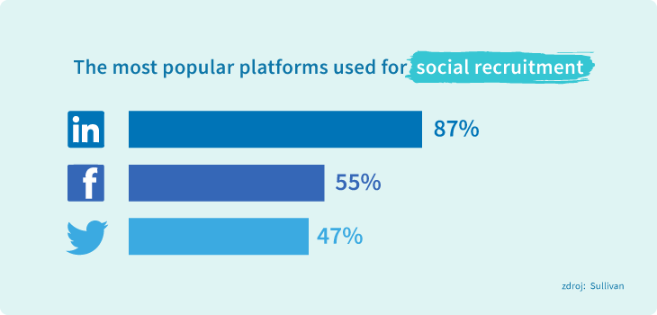
Figure 1: This depicts the population that depends on social media for recruitment. Source (Sabir Rajpoot, 2023)

The Role of LinkedIn in Recruitment
LinkedIn has become a major tool in the recruitment industry. On this platform professional profiles are showcased, and candidates can showcase their skills, work experience and another educational backgrounds as a matter of choice. These detailed profiles allow a recruiter to quickly discover and reach out to the right candidates matching specified job requirements.
Targeted Advertising: Using LinkedIn's advanced advertising, recruiters can target specific types of demographics. For example: ads for people who have specific skills or in specific industries (Md. Sajjad Hosain and Ahshanul, 2023). It is about this precision that job ads get to the most relevant audience for increasing the efficiency of the recruitment process.
Recruiter Tools: LinkedIn has a specialised service called LinkedIn Recruiter, that gives recruiters access to advanced search options that let them explore a large candidate pool. These tools make the recruitment process effectively efficient (Md. Sajjad Hosain and Ahshanul, 2023). Philtres help recruiters narrow down the candidates to those that match the job requirements, so they can find the perfect person for the job.
Professional Groups and Networking: The platform also supports the formation of industry-specific groups, which are instrumental for recruiters looking to interact with potential candidates. These groups offer insights into current industry trends and allow recruiters to engage with passive candidates, those not actively seeking a job but open to new opportunities (Md. Sajjad Hosain and Ahshanul, 2023). Networking within these groups can uncover hidden talent and foster connections that may convert into future recruitment opportunities.
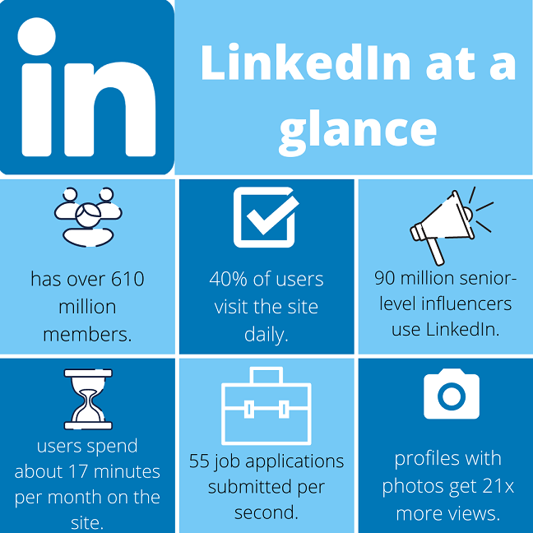
Figure 2: This depicts the How do Employers use LinkedIn? Source (UOS, 2024)

The Role of Facebook in Recruitment
Facebook, with its extensive user base, serves as a versatile platform for recruitment, particularly effective for targeting younger demographics and specific community groups. The informal nature of Facebook makes it a less intimidating space for job seekers, potentially increasing the accessibility and appeal of job postings.
Job Posting Features: Organizations can leverage their business pages to post job openings. Integration with Facebook Marketplace further amplifies the visibility of these postings, allowing them to reach a broader audience (Team, 2024). This feature is especially useful in tapping into local job markets and attracting a diverse applicant pool.
Social Engagement: Engaging potential candidates through the sharing of content, discussions, and showcasing company culture plays a crucial role in attracting employees. By aligning the company’s values with the personal and professional interests of candidates, organizations can foster a more engaged and committed workforce. This strategy not only attracts applicants but also helps in building a strong employer brand.
Employee Referrals: Facebook enhances the scope of employee referral programs by simplifying the process of sharing job openings. Employees can easily share job advertisements within their network, increasing the reach and credibility of the recruitment process (Vincere, 2022). Referrals are often perceived as more trustworthy and can lead to higher-quality candidate applications. This method not only expedites the hiring process but contributes to higher retention rates, as employees tend to perform better in environments recommended by their peers.
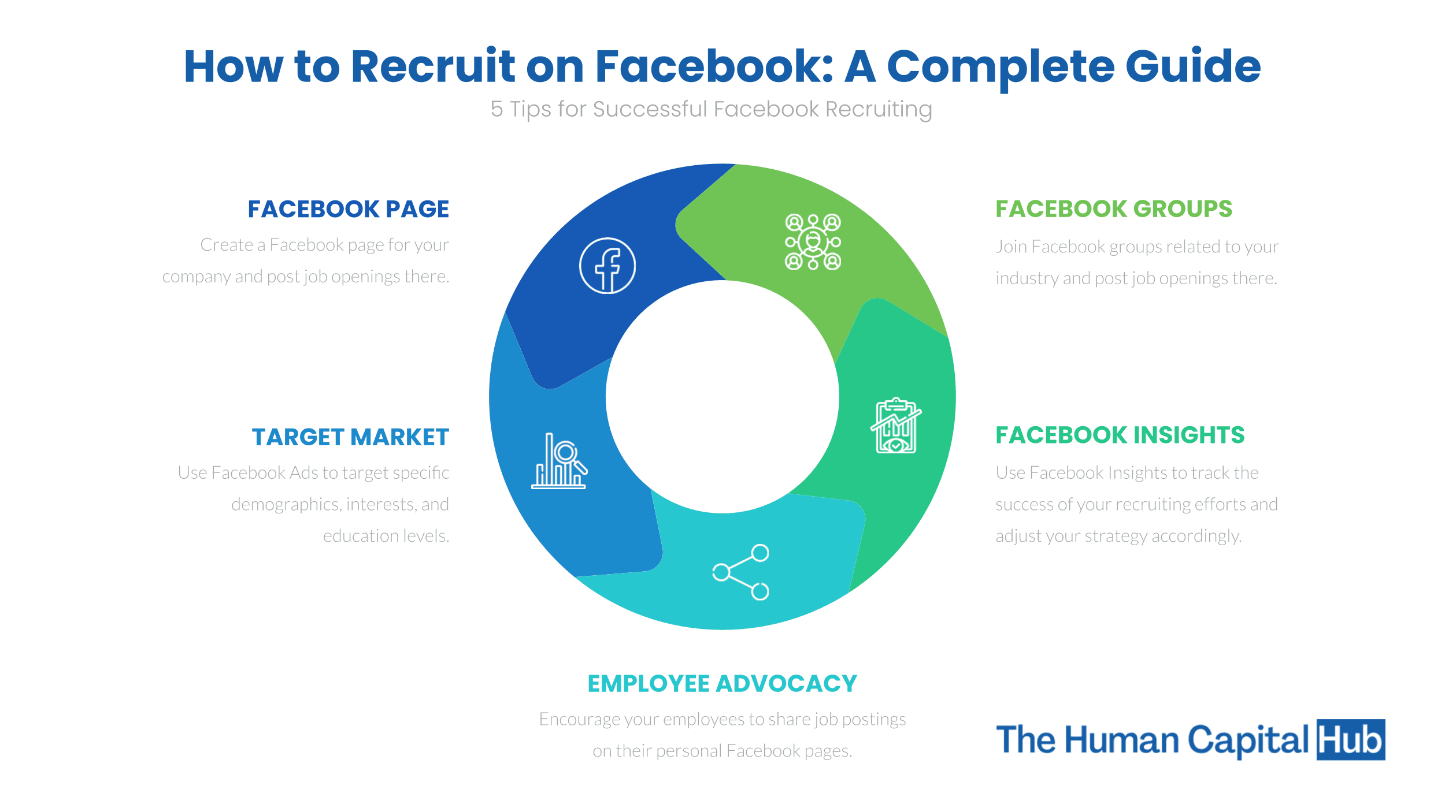
Figure 3: This depicts the How to Recruit on Facebook. Source (THCU, 2024)
These aspects highlight how LinkedIn and Facebook have adapted to the needs of modern recruiters, offering tools that cater to both broad and targeted recruitment strategies. By utilizing these platforms, organizations can significantly enhance their recruitment efforts, tapping into a rich pool of candidates from diverse backgrounds and industries.

Advantages of Using Social Media for Recruitment
The integration of social media into recruitment processes offers several benefits:
Broader Reach: Social media platforms expand geographical and demographic reach, accessing a more diverse candidate pool.
Cost-Effectiveness: Social media recruitment can be more cost-effective compared to traditional methods, especially with options to post job openings for free or at a minimal cost on various platforms (Bajaj, 2023).
Speed: The rapid nature of communication on social media platforms allows for quicker dissemination of job postings and faster responses from candidates, significantly speeding up the recruitment process.
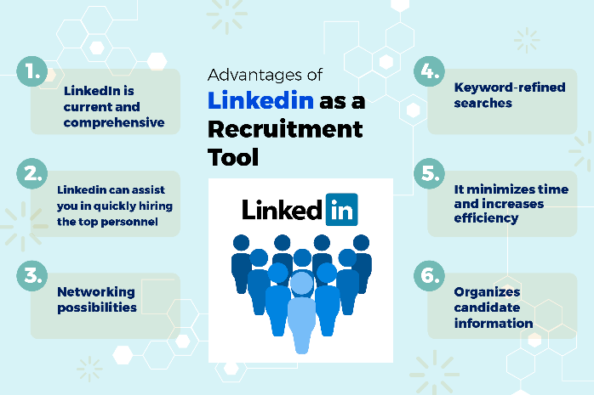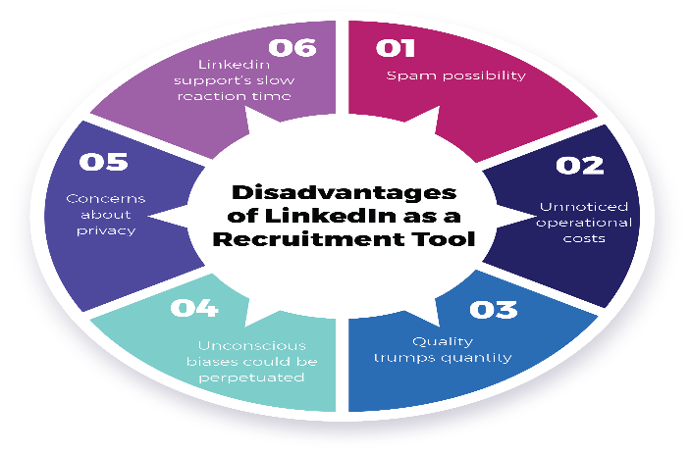
Figure 4: This depicts the advantages and disadvantages of LinkedIn. Source (Shrofile, 2024)

Disadvantages of Using Social Media for Recruitment
Despite its benefits, using social media for recruitment also presents several challenges:
Quality of Applicants: The ease of applying through social media can result in a high volume of applicants, many of whom may not meet the required qualifications (Gibson, 2022).
Privacy Concerns: There is a potential risk of privacy invasion, as recruiters might access personal information that candidates may prefer to keep private (Gibson, 2022).
Brand Reputation: Negative interactions or feedback on social media platforms can adversely affect a company's reputation if not managed properly.
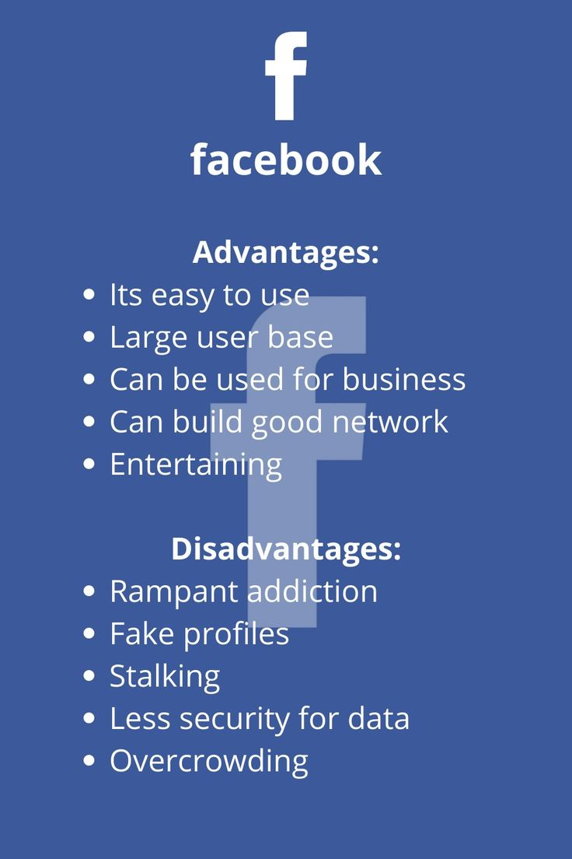
Figure 5: This depicts the advantages and disadvantages of Facebook. Source (Vinay Kumar, 2024)

Conclusion
LinkedIn and Facebook have revolutionised the recruitment landscape with tools that give them enormous reach and targeted search. Although these tools present a variety of efficacy benefits including lower costs and wider availability of talent, their application also faces downsides such as privacy concerns and the requirement for controlling online interactions and activities for the benefit of the company's image. Organisations should strategically integrate these tools into their recruitment processes so that the benefits derived from them are maximised while the risks are minimised, and these tools should complement the broader HR strategies and business goals of the organisation. By its nature, social media recruitment is a powerful platform for engaging candidates, encouraging collaboration and fostering communication between existing depts within the organisation.

References
Bajaj, A. (2023). 6 Advantages of Social Media Recruitment. [online] Gohire. Available at: https://gohire.io/blog/advantages-of-social-media-recruitment.
Gibson, E. (2022). Disadvantages of using social media for recruitment. [online] Reworking. Available at: https://reworking.com/disadvantages-of-using-social-media-for-recruitment/.
Md. Sajjad Hosain and Ahshanul, M. (2023). The roles of LinkedIn-based skill endorsements and LinkedIn-based hiring recommendations on hiring preferences: evidence from Bangladeshi employers. Management matters, 20(2), pp.169–184. doi:https://doi.org/10.1108/manm-05-2023-0021.
Sabir Rajpoot (2023). 7 Tips for Successful Recruitment on LinkedIn Recruitment strategies have changed a great deal over the past few years. One of many practices which have been growing rapidly from day to day is recruitment on social media. [online] Linkedin.com. Available at: https://www.linkedin.com/pulse/7-tips-successful-recruitment-linkedin-sabir-rajpoot [Accessed 24 Nov. 2024].
Team, C. (2024). What is Facebook Recruiting | Talentlyft. [online] Blog. Available at: https://www.talentlyft.com/hr-glossary/facebook-recruiting [Accessed 24 Nov. 2024].
Vincere (2022). A Comprehensive Guide to Recruiting on Facebook in 2023. [online] www.vincere.io. Available at: https://www.vincere.io/blog/a-comprehensive-guide-to-recruiting-on-facebook-in-2023/.

