Student Name: Rhys Alexander Davies

Student Number: 1803152

Module Code: ACCA5012

Lecturer: Kemi Ademoye

Module Name: Application Development

Contents
Introduction 3
Application Development Trends 3
Blockchain Technology 4
What is blockchain technology? 4
How does blockchain technology work? 4
Where is the trend, blockchain technology, used now? 4
Where can blockchain technology be used in web development? 4
Discussion 5
Requirements 6
Mobile First Strategy 7
Web API Used 8
Design & Implementation 8
Design 8
Implementation 8
load-page.js 9
DogApi.js 11
Particle.js 12
Lightbox.js library 13
Website Screenshots 14
Index.html 14
About.html 15
Projects.html 16
Dogapi.html 17
Photography.html 18
Evaluation 20
Testing 20
20
Reflection 23
References 24

Introduction
The following document will contain research towards upcoming application development trends in my field of work which is web development. A list will be compiled of the most popular trends and one of interest will be chosen to research in further detail.
The document will then move onto a report which documents the implementation of the website created. This will include research conducted into the coding, consumption of an API, using external libraries and bootstrap. There will be a testing plan also including to ensure all functionalities of the website work and have multiple browser support.

Application Development Trends
- Progressive Web Applications [1]
- Single Page Websites [1]
- Static Web Pages [1]
- Push Notifications [1]
- Motion UI [1]
- Blockchain Technology [2]
- JavaScript [2]
- Internet of Things [2]
- Voice Search Optimization [2]
- Accelerated Mobile Pages [2]
- Artificial Intelligence and Bots [2]
- Machine learning [3]

Blockchain Technology
The application development trend that will be looked into in more detail is blockchain technology.

What is blockchain technology?
A blockchain can be seen as a distributed ledger, which holds the to and from for each transaction [4]. Blockchain technology utilises a peer-to-peer network architecture which aims to eliminate traditional trust-based models used by banks and commercial entities who process payments over the internet. It removes the need for third parties within transactions as it allows for two parties to directly transact with each other [5]. Blockchain uses a tamper-resistant database across a large number of nodes which provides security against manipulation to ensure all data is valid. Blockchain uses cryptographic hashes where data being hashes provides a fingerprint value which verifies the authenticity of the data [6].

How does blockchain technology work?
Blockchain works with a host node creating a transaction which is digitally signed and then a private key is given to the transaction via cryptography. The transaction is then verified by other nodes by flooding the transaction to peers based on pre-set criteria. Once validated it creates a block. Each block within a Blockchain contains data. That data has a previous hash, its own hash value and the data itself. When on the network the block then becomes part of the ledger links itself between blocks using its own hash value and the previous one [7].

Where is the trend, blockchain technology, used now?
The bitcoin network was the first application to be built on Blockchain technology and is used by all cryptocurrencies after bitcoin and also used by decentralized apps [4]. Another example is Spotify. Spotify is using blockchain technology to help better connect the artists that use their platform and licensing with the tracks on Spotify [8].

Where can blockchain technology be used in web development?
Blockchain technology is a popular upcoming trend for a reason. As mentioned above it provides safety in transactions in many ways. This technology is a rapidly growing trend within the web development community with many multination banks looking to develop Blockchain technology into their web banking applications [2]. Blockchain technology can be used to work in many government sectors such as healthcare, voting and travel and transport [5]. This shows how far the newly developing trend can go, although being around for some time, with new development and innovation this technology could shape our future on the web.

Discussion
Blockchain technology has already had a big impact on the way in which web development is going and has opened up many possibilities and potential features of which blockchains could be used to create. As explained above with the financial sector is looking to develop their systems to use blockchain technology for their web banking applications and when implemented will allow for many more services and sectors to follow, like voting and health records. Security is the main priority and with blockchains it gives that security as it is next to impossible to tamper with the blocks within a chain as if data is tampered with the hash of the tampered block changes and therefore will not have a matching hash which breaks the chain and therefore the data isn’t valid. In terms of effectiveness based on Bitcoin using blockchain to completely support its whole infrastructure it makes sense that with changes it could be developed effectively into banks. Using Blockchain wouldn’t change the usability of web applications for users and at the same time gives users better and more secure protection of their data. Overall blockchain within web development is a new trend and will be researched and developed highly for its respected uses.

Requirements
The website created is a portfolio website for myself based around web development and photography. The purpose of the website is to be able to show off skills, projects and other aspects of work and life. There will be 6 main pages Home, About, Projects, Gallery, Contact. The project page will incorporate the API which will lead off to another separate page where the API can be used.
Main Requirements:
- Responsive
- Use JavaScript/ jQuery content switching for the pages
- Include a responsive gallery
- Have a motion UI background for user engagement
- Keep a very minimalist design.
- Utilise bootstrap

Mobile First Strategy
The mobile first strategy in short terms is building a website based off of requirements for a mobile platform then building it for desktop. This is due to the influx of users that access websites on their phones as opposed to desktop computers these days
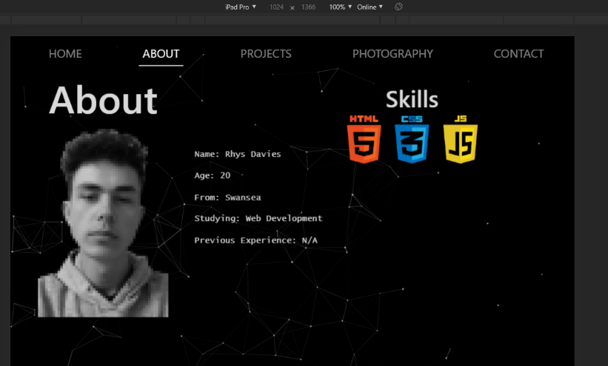
Three query methods are used within the CSS. 426px which targets the largest display for a mobile phone screens therefore anything below that screen size will result in the changes to the classes below it. The next media query is 767px query which targets medium to small devices like tablets. The final media query used is 992px this is used because it is where the nav bar shrinks down into a burger menu therefore simplicity and slick design some of the elements have been repositioned in better positions. Below is the iPad Pro and iPad viewport, it shows how the content has been repositioned with the change in the Nav bar to a burger icon.
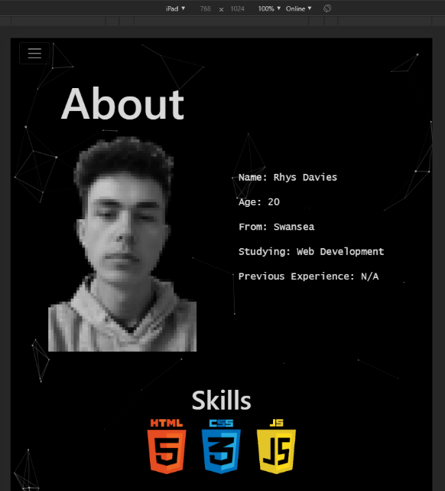

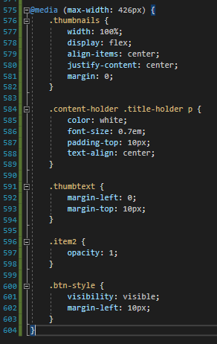
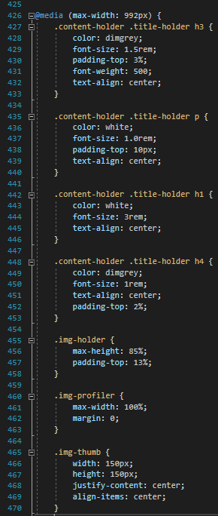
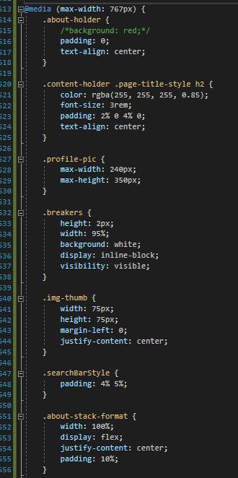

Web API Used
The web API I used was called the Dog API. This API was chosen because I knew the gallery was going to contain photos of dogs and it seemed like a good crossover to have. The main functionality of the API is to get text entered into search box, query the API then fetch the data from the API which will be a URL image of the dog typed in. The image URL received will then replace the SRC tag of the existing image placeholder and display the photo that was fetched from the API.

Design & Implementation

Design
The design of the website created is simplistic and attractive. By using a motion UI background to keep user engagement with the website. The main colour scheme for the website is black and white this is because there will be no issues with colour contrast and all text and titles will be easily viewable due to the colour scheme. The design of the navigation bar is simple bootstrap navigation that collapsing into a burger bar, as discussed above, at a certain size. The website’s pages use a seamless content swapping JavaScript function which swaps content from an identifiable DIV tag and replaces it on the index page. This reduces load time slightly and looks very slick when swapping between the pages. The website is 100% responsive to all media devices and maintains a slick look while doing so. The idea for the design came from some YouTube tutorials that were searched to get an idea of what they looked like and the progress to get to the final version. The Motion UI idea was found on YouTube as was the layout for the first page including the Nav bar which was recreated in bootstrap [9] [10].

Implementation
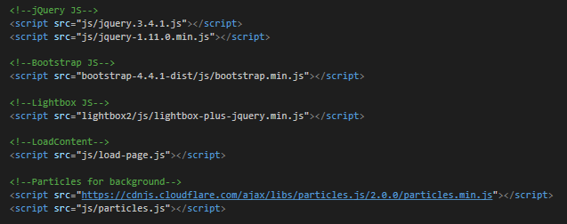
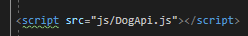
Here is the script list. This is all the scripts used on the index. jQuery is needed for the content switching page and for the particle.js. The DogApi.js file is on the dogapi.html page. This is because for design purposes the page was to open separately not using the load-page script.

load-page.js
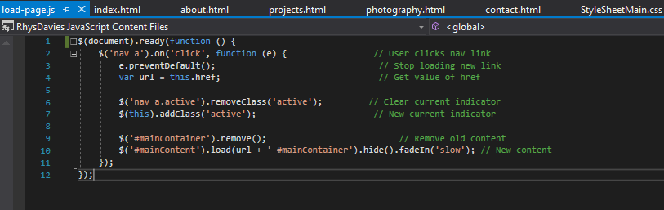
This is the load-page.js is the script that deals with the content switching. The script is loaded upon the webpage being opened. When a “<nav><a>” link is clicked the default response which is to go to that “.html” is prevented and the URL of that clicked page is held within the variable URL. The active class is then removed from and added to the current active page. It then removes the DIV containing the ID specified and replaces it with the DIV from the new URL. The content then fades in using the class slow.
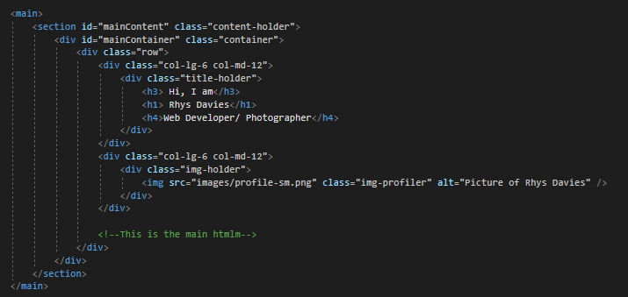
This is the HTML code from the index page, each page follows this format for the content switching to work. Within the main tag there is a section tag that has the ID ‘mainContent’ and this is how the content load script knows where to get the data from on the new page.
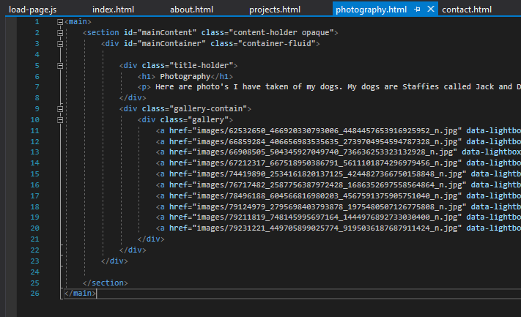
As shown above the page doesn’t follow standard html layout as it doesn’t include the HTML tag or any of the relevant tags. There is no CSS links or navigation tags it’s just the main tag and the content. This is what then gets put into the index.html page and replaces what is already there.

DogApi.js
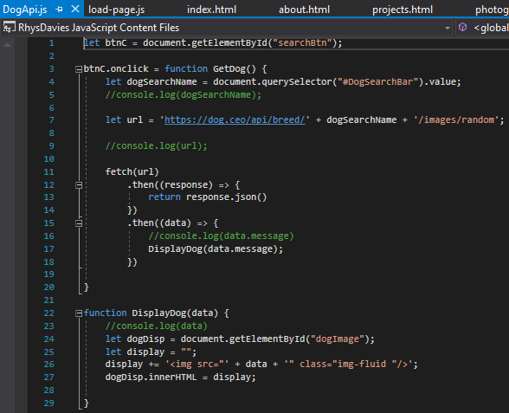
This is the code for the dog API used in the website. Firstly, the button that is clicked to confirm the search is captured by getting the ID attached to that button. An onclick function is then created from the button. The function then gets the value from the search bar by querying the ID, the value is then stored in the variable. The URL variable is then equal to the API call plus the value of the search bar plus the end of the API call. The fetch function is called and the URL is passed into it. The response is returned in JSON format. The JSON data is then passed through the display function with the “. message“ notation which is what the image URL is stored under in the JSON data. Onto the display function, the ID of where I want the image to be displayed is fetched and stored under a variable name. A new variable display is created with empty parenthesise. The display variable just created will now have an image tag and source with one open parenthesise then a closing comma to allow for the data to added in. This allows the source to be equal to the data we just fetched and passed into the function from above it is then closed off like a normal img tag. The image tag we called earlier is then equal to the display variable we just created which allows for the image to be displayed.

Particle.js
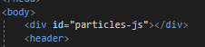
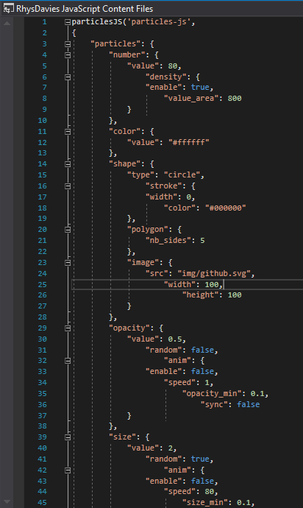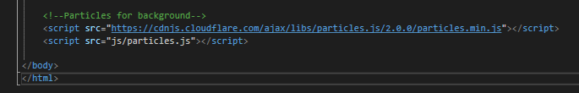
The particle system for the motion UI background is code taken from online [11] and utilising an ajax particle system. The code was modified for to suit the website type and style. The ajax particle system script is linked to the document through the website rather than through a file. In the HTML the particle.js function is called through the ID particle-js as shown above within a div tag.

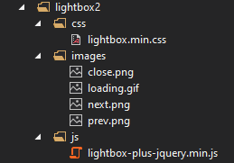
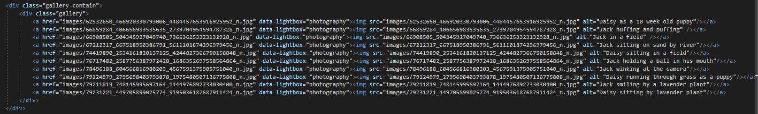
Lightbox.js library
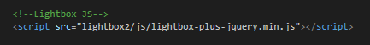

For the gallery/ photography page the lightbox library was used. Lightbox is a really useful slick gallery plugin for HTML. The lightbox gallery works by calling the
data-lightbox call and naming the gallery. This then shows the image link to the left in a large pop-up window, it also adds scrolling functionality through the photos when in the gallery mode.

Website Screenshots

Index.html
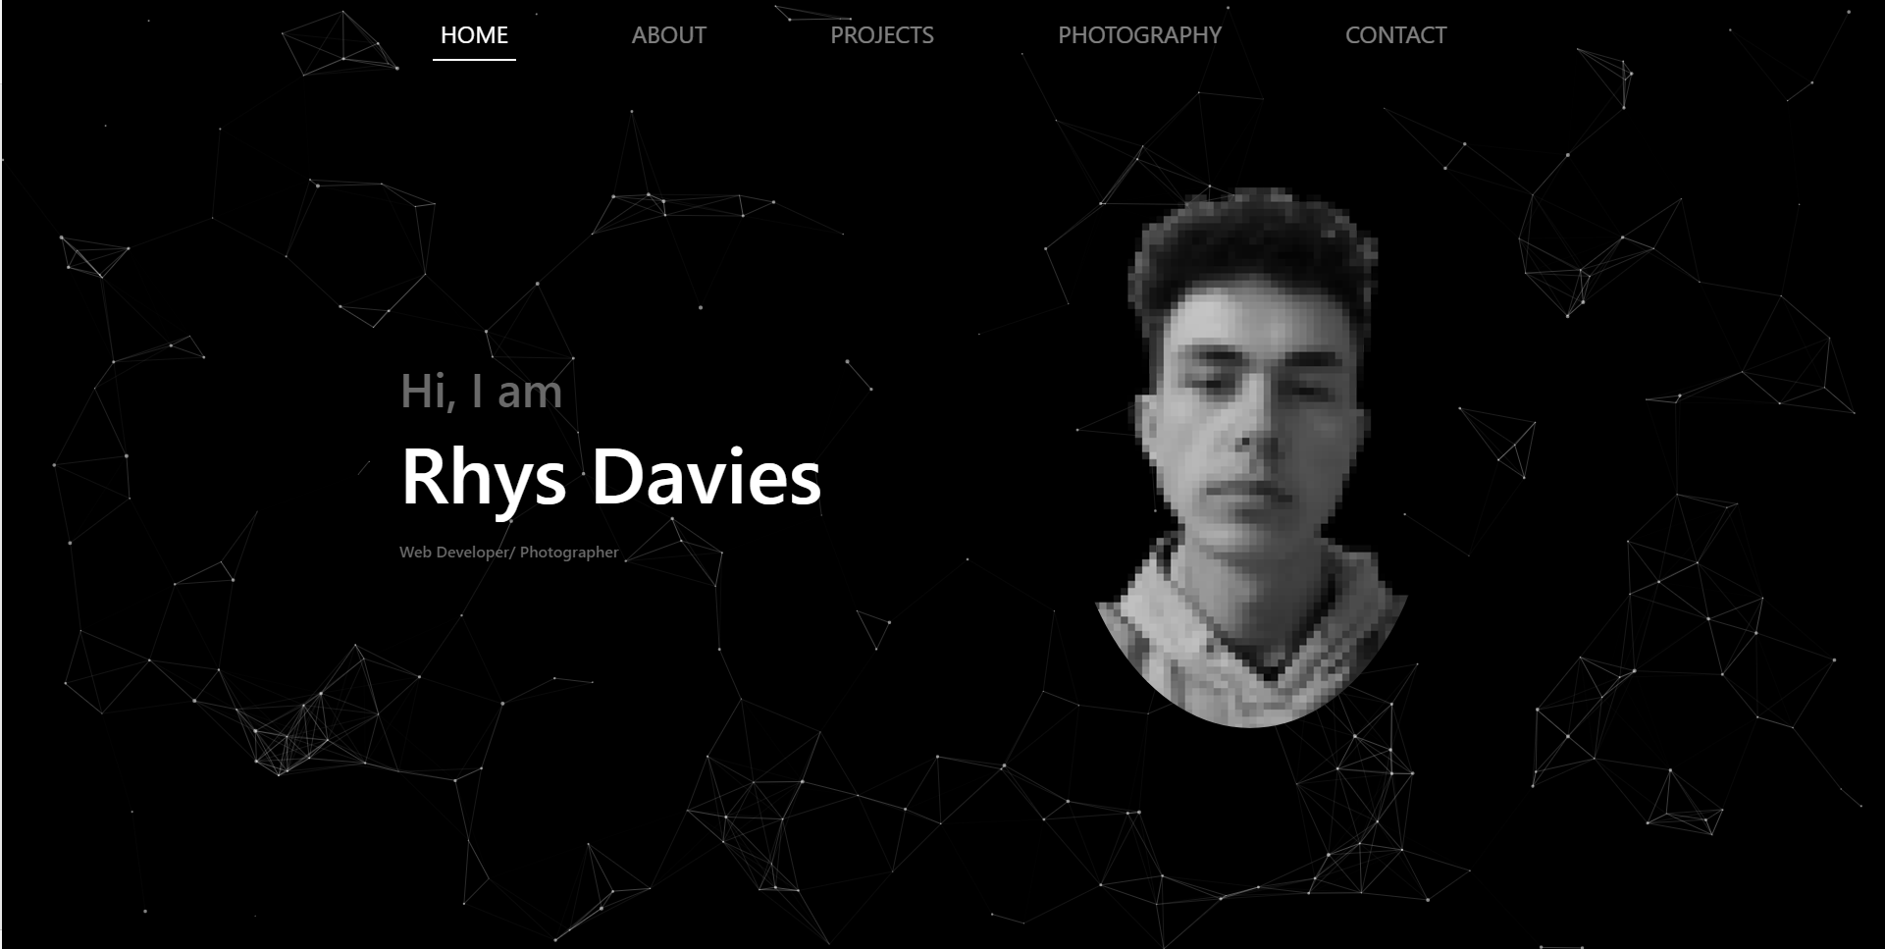
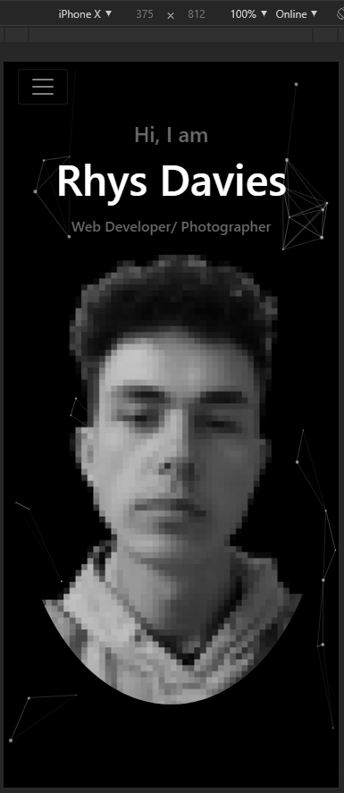
Phone View: Tablet View:
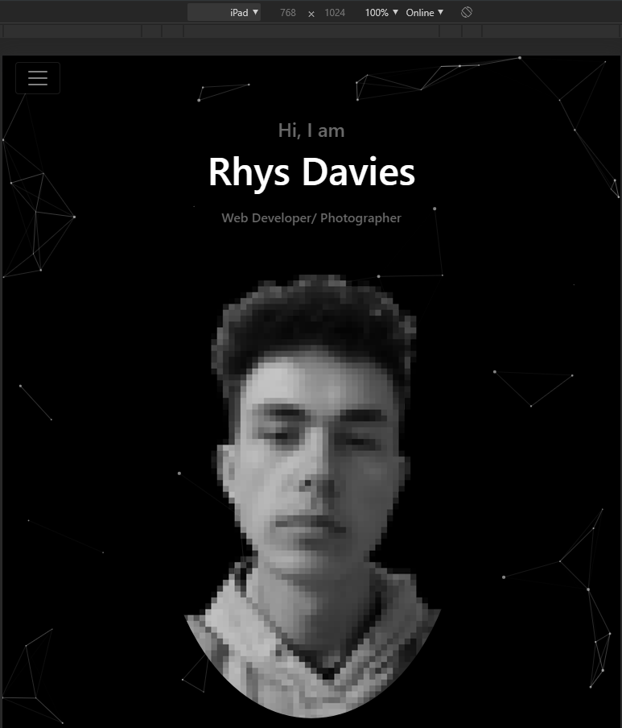

About.html
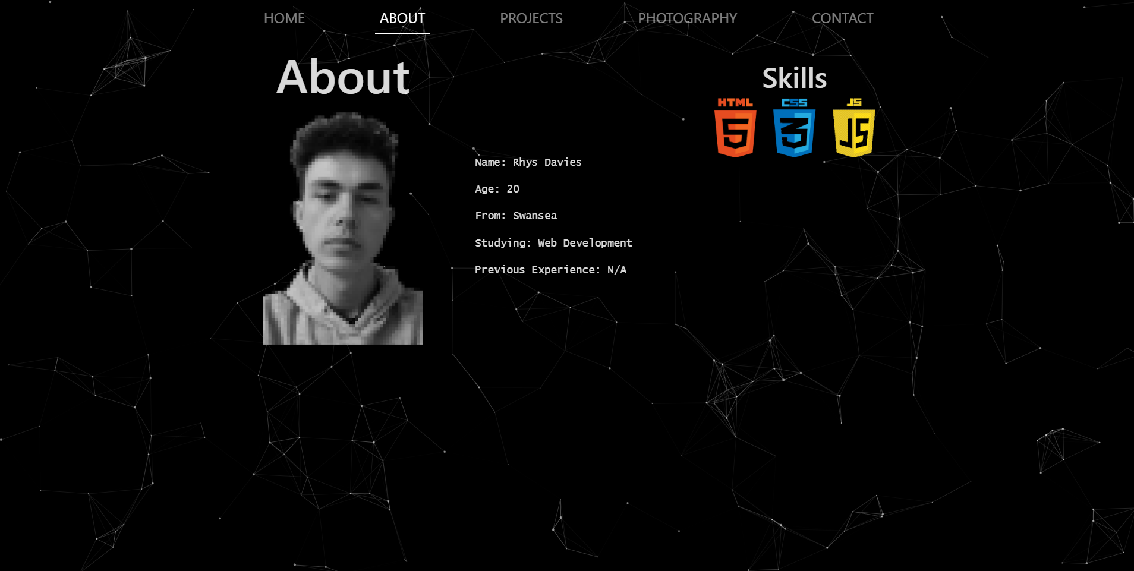
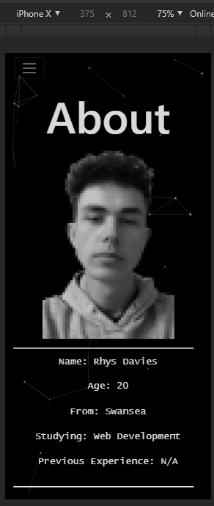
Phone View: Tablet View:

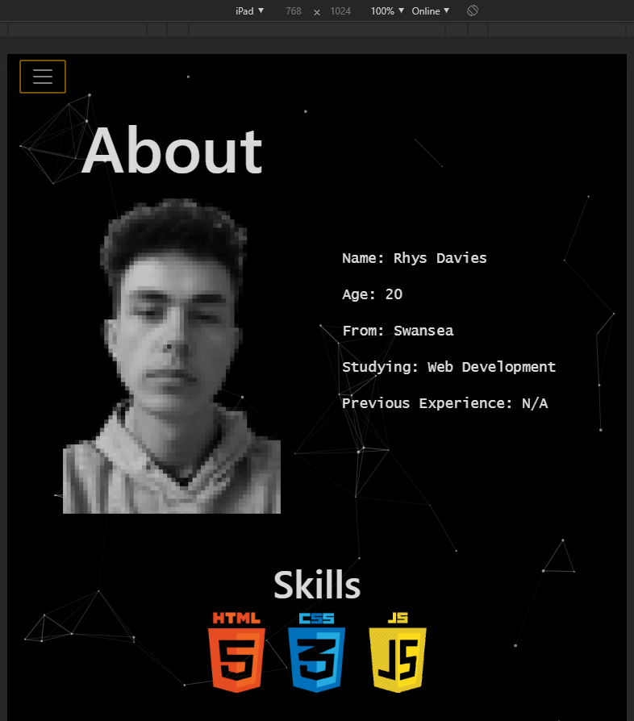

Projects.html
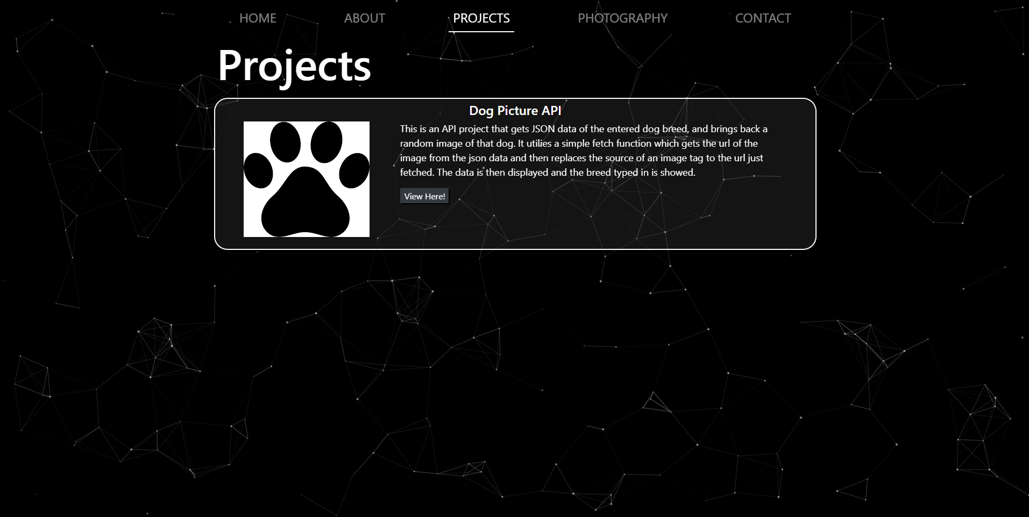
Phone View: Tablet View:
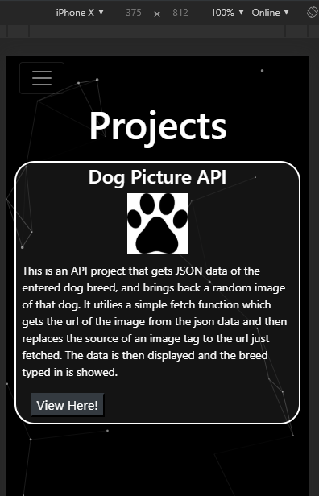
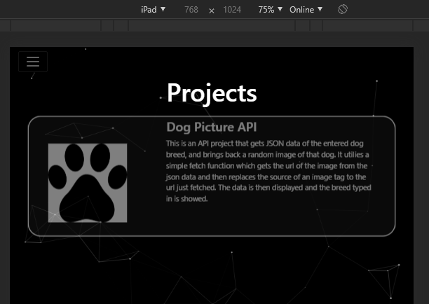

Dogapi.html
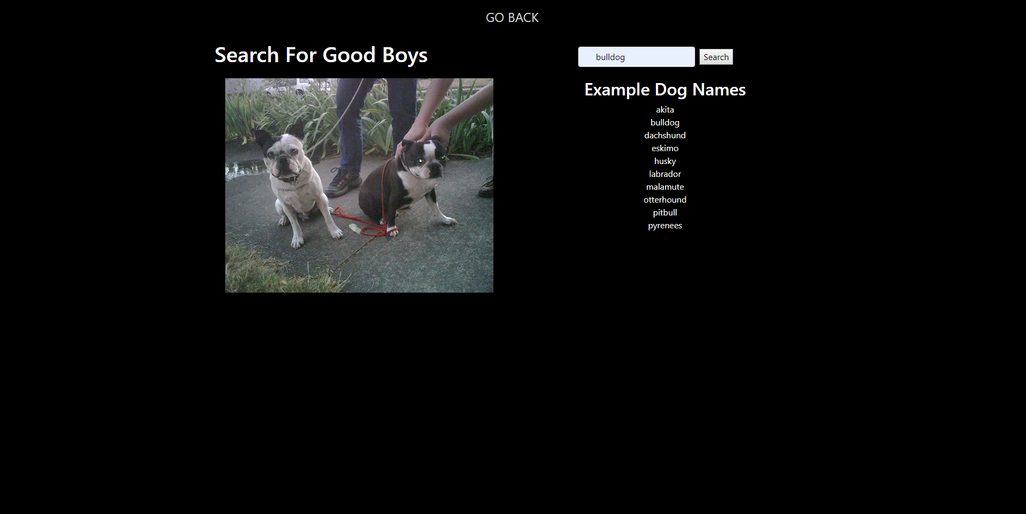
Phone View: Tablet View:
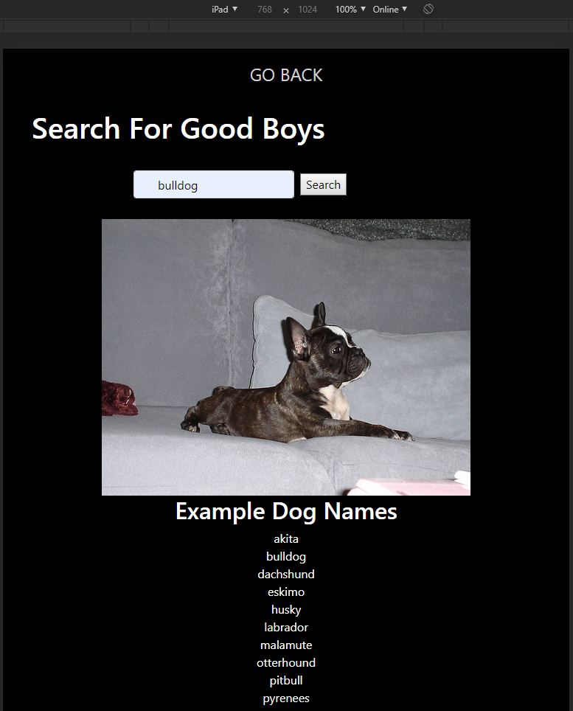
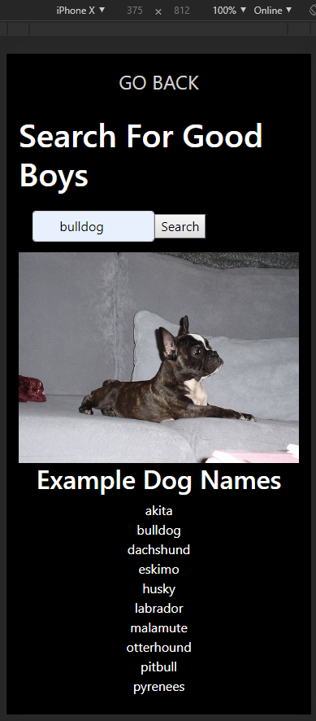

Photography.html
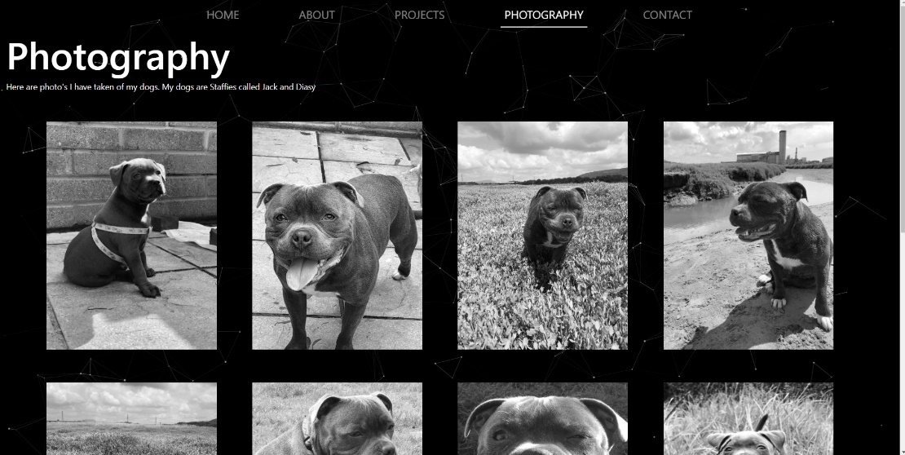

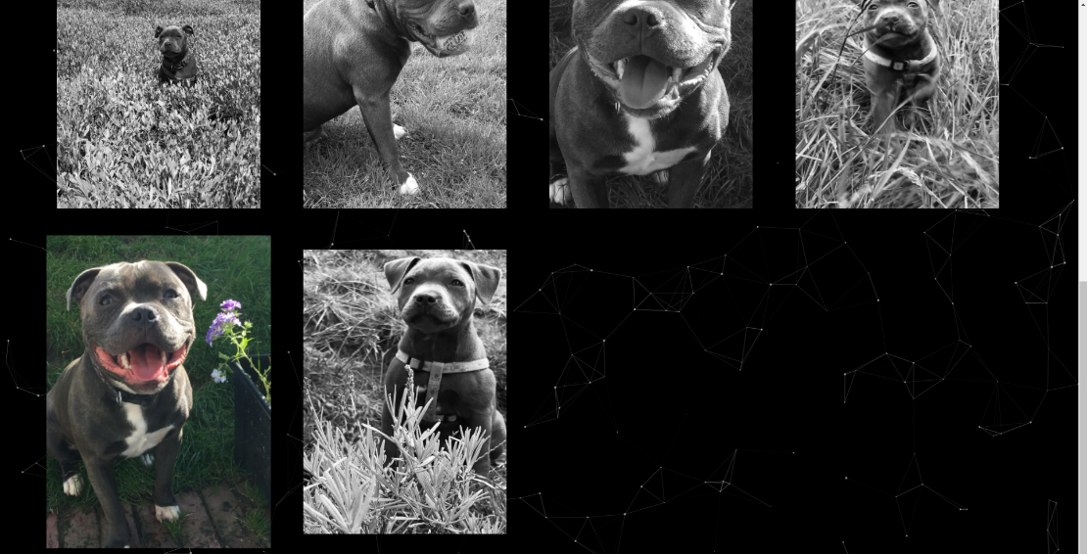

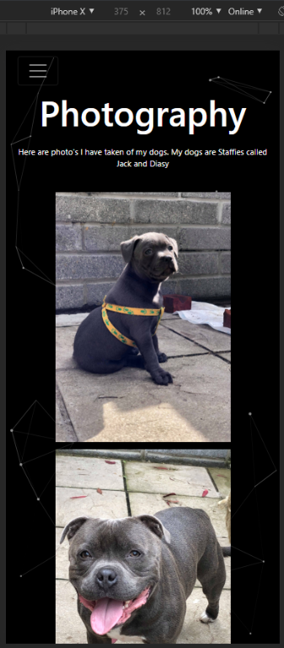
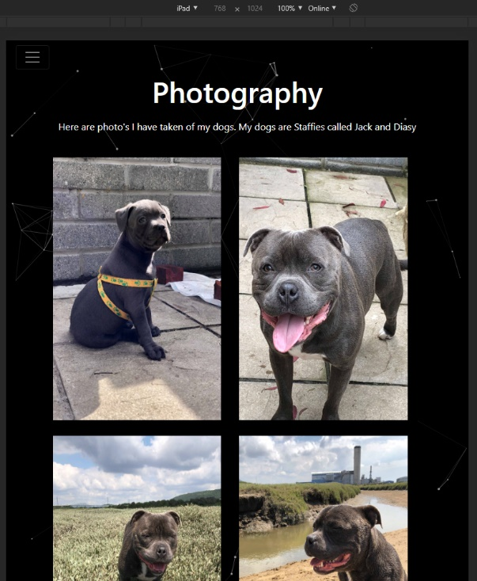
Phone View: Tablet View:

Contact.html

Phone View: Tablet View:
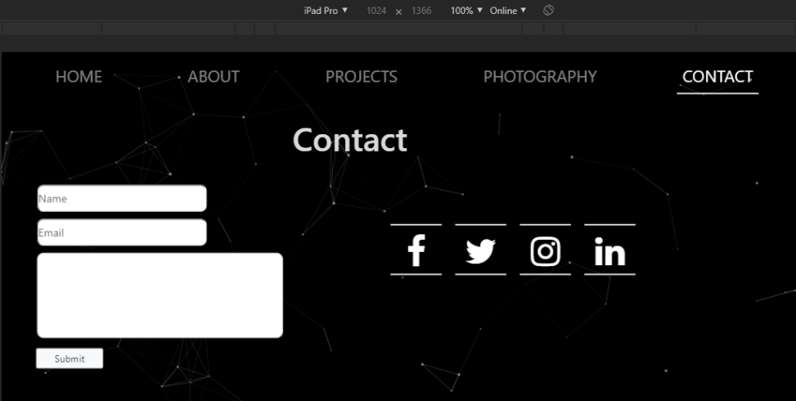
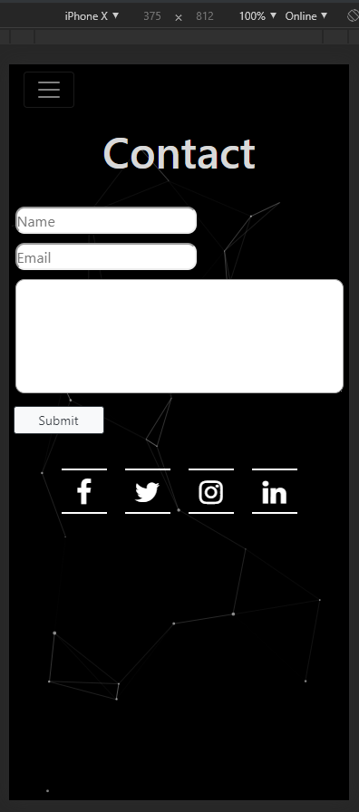

Evaluation

Testing
Test case Description | Prerequisites | Steps | Data used | Expected Result | Actual Result | Status
Content switching: seeing if content on the page swaps while the URL stays on index.html | On index.html | Click any navigation item | Clicked on Photography.html | Swap and display content from photography.html | Swapped content to that of photography.html page | Pass
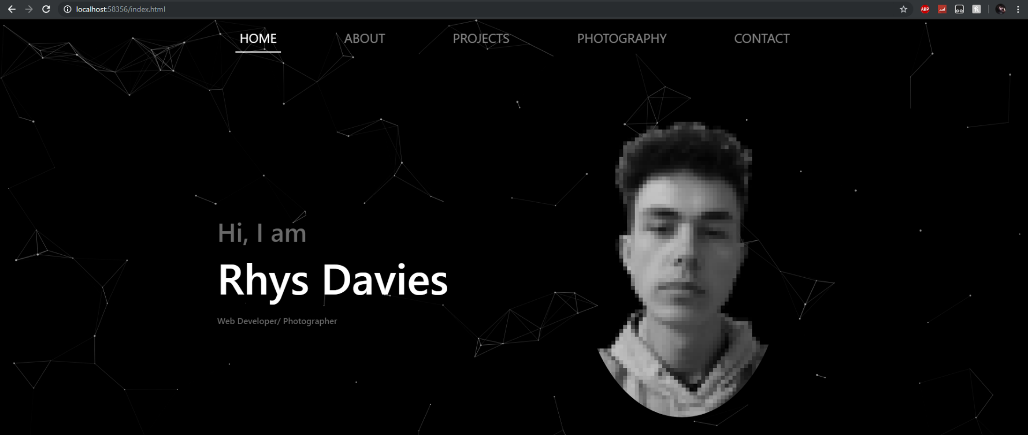
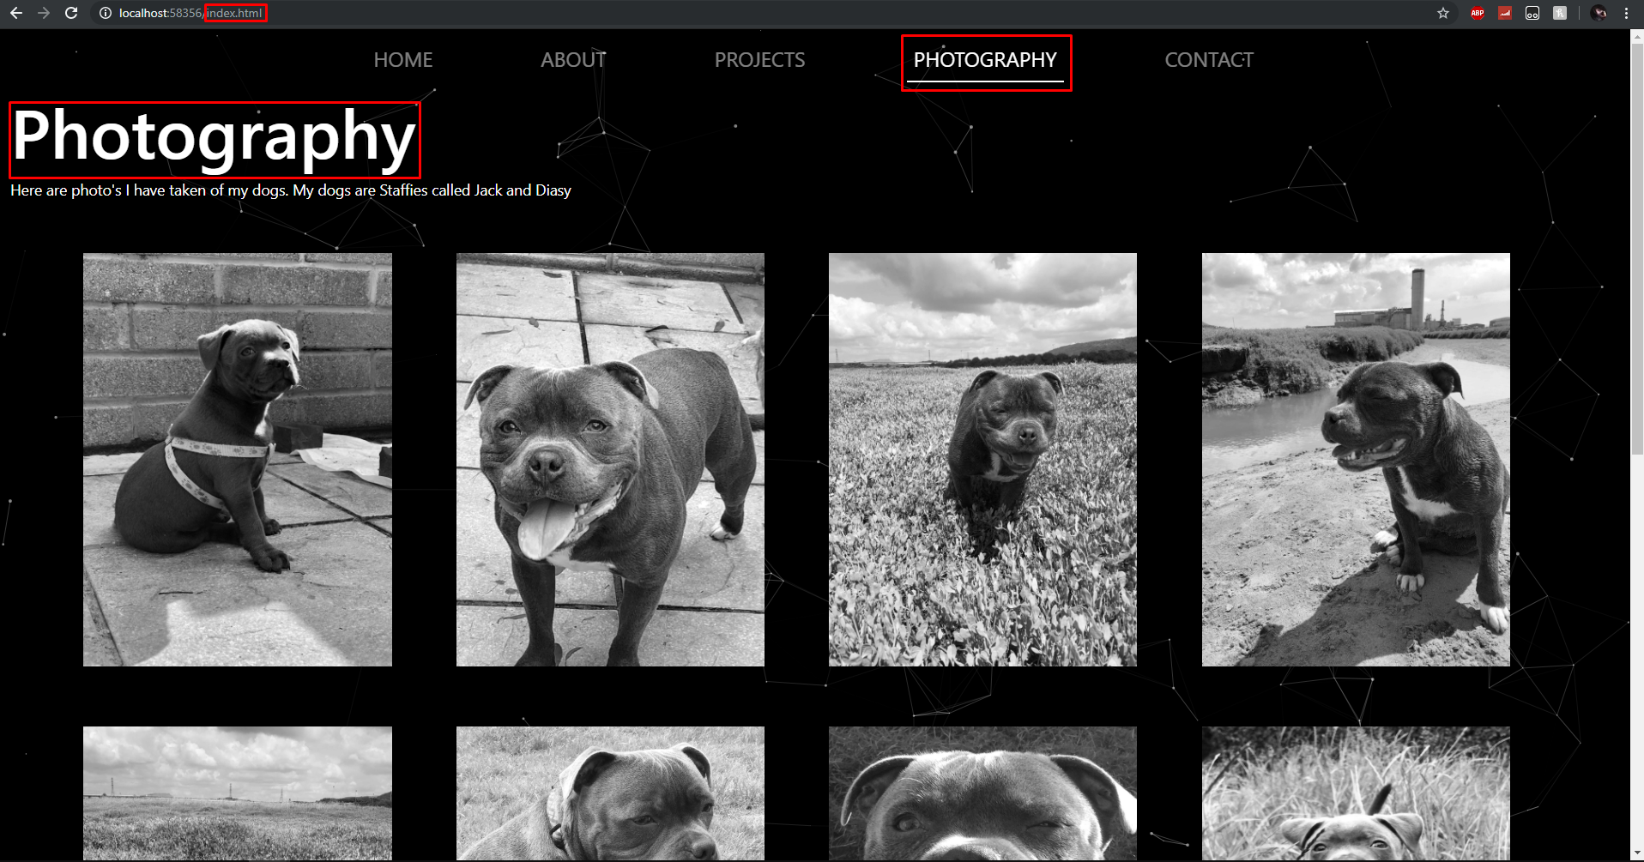
Test case Description | Prerequisites | Steps | Data used | Expected Result | Actual Result | Status
Dogapi.js: Search for dog breed in search bar | On dogapi.html | In search bar search for a dog then click the search button | Bulldog | Display a random image of bulldog | Displayed an image of a bulldog | Pass
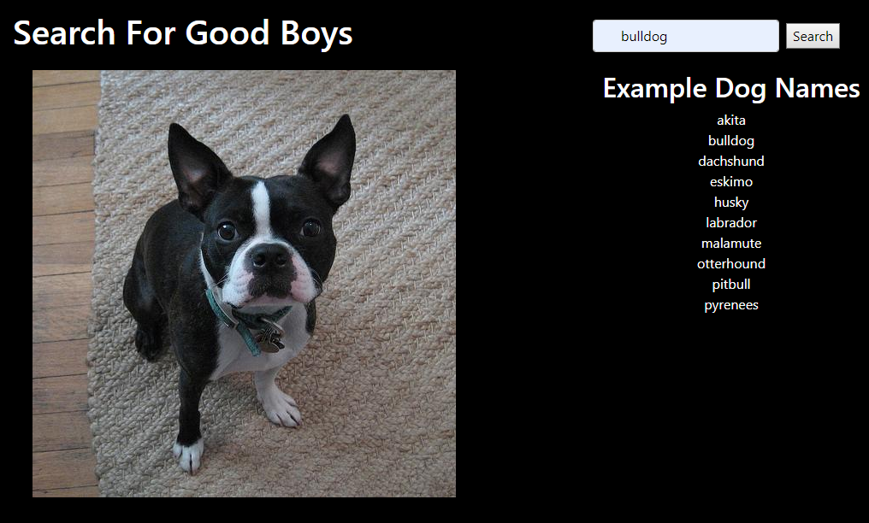

Reflection
The website created meets the initial requirement criteria in the requirement section therefore making it a success. The design turned out much better than expected the motion UI doesn’t get boring even after many hours of development therefore users would find it easy to stay on the site for a period of time to explore work and the website keeping retention up. The website works on all popular web browsers however the API doesn’t work on internet explorer for some unknown reason. The content switching code works exactly as expecting with the slick fade between pages it has turned out very well. The gallery page using the lightbox plugin make the page very attractive. Overall the website is well designed the usability of it is very simple, easy to use and it is responsive. The website is very functional and works exactly how it should for this level of skill and looks attractive and slick as it should.
If there were to be any improvements to the website it would be to have more content ready to go onto the website. Unfortunately, some of the pages are very bare boned and although it suits the simplistic design look there are some areas in which having some sort of content to fill the gap would have made the attraction of the website much better. Following initial plans to use the GitHub and Instagram API to display info on the about page would be something to do next however it was not possible this time due to sheer inexperience and difficult of them APIS to understand.

References

[1] | M. Batic, “Web Development Trends in 2019,” Medium, [Online]. Available: https://medium.com/datadriveninvestor/web-development-trends-in-2019-85b77610e573. [Accessed 06 12 2019].
[2] | S. Sadiq, “Top 10 Web Development Trends to Follow in 2019,” DZone, 25 09 2019. [Online]. Available: https://dzone.com/articles/top-10-web-development-trends-to-follow-in-2019. [Accessed 06 12 2019].
[3] | S. Merenych, “Web Development Trends and the Latest Web Technology Stacks in 2019,” 11 10 2019. [Online]. Available: https://clockwise.software/blog/web-development-trends/. [Accessed 06 12 2019].
[4] | A. Saveen A and R. P. Monfared, “Blockchain ready manufacturing supply chain using distributed ledger,” eSAT, 2016.
[5] | S. B. Agam, T. Lakshit and A. Paarth, “Blockchain and Decentralized Applications,” 2018.
[6] | B. Roman, “Beyond Bitcoin: The Rise of Blockchain World,” IT University of Copenhagen, Copenhagen, 2018.
[7] | I. Siddiqui, “what-the-hell-is-blockchain-and-how-does-it-works-simplified,” Medium, 24 04 2018. [Online]. Available: https://medium.com/coinmonks/what-the-hell-is-blockchain-and-how-does-it-works-simplified-b9372ecc26ef. [Accessed 06 12 2019].
[8] | B. Marr, “30+ Real Examples Of Blockchain Technology In Practice,” Forbes, 14 05 2018. [Online]. Available: https://www.forbes.com/sites/bernardmarr/2018/05/14/30-real-examples-of-blockchain-technology-in-practice/#5434730b740d. [Accessed 06 12 2019].
[9] | LearnDesign, Creative Designer & Director Portfolio Website with Sticky Header & Particle JS #2, 2019.
[10] | OnlineMentor, Personal Portfolio Website Design using HTML, CSS, JAVASCRIPT, 2019.
[11] | V. Garreau, Particles.js.

marking criteria and Student FEEDBACK

This section details the extent to which the assessment criteria are demonstrated by you, which in turn determines your mark. The marks available for each category of skill are shown. Lecturers will use the space provided to comment on the achievement of the task(s), including those areas in which you have performed well and areas that would benefit from development/improvement.

Common Assessment Criteria Applied (Assignment 1) | Marks available | Marks  awarded
1. Engagement with Literature Skills

A very good introduction and overview of current application trends and a very good discussion of the chosen application trend too. The required background from a relevant peer-reviewed study is, however, limited. (Grade mark: 76.00%) | 25 | 19
2. Knowledge and Understanding Skills

3. Cognitive and Intellectual Skills

A good set of test cases and evaluation has been provided. (Grade mark: 67.50%) | 20 | 13.5
4. Practical Application Skills

A good attempt featuring a simple website with some good use of JavaScript functionality. Good use of single page application concept but overall, the website and implemented API is generally a bit too simple and I expected a bit more which I know you are very capable of. Some other things to note - consider opening external links in a new tab and note that some users may find continuously playing animation, and especially as this is on every page, annoying. Your script links should be added before closing </body> tag and not after it. (Grade mark: 68.00%) | 50 | 34
5. Transferable Skills for Life and Professional Practice

The report is of a good standard. See your report for some suggested improvements. (Grade mark: 70.00%) | 5 | 3.5

Assignment Mark (Assessment marks are subject to ratification at the Exam Board. These comments and marks are to give feedback on module work and are for guidance only until they are confirmed. ) | Late Submission Penalties (tick if appropriate) |  | 70%
 | Up to 1 week late (40% Max) |  | 70%
 | Over 1 week late (0%) |  | 70%

