

Entrepreneurship final assignment
Entrepreneurial motivation : John Davison Rockefeller
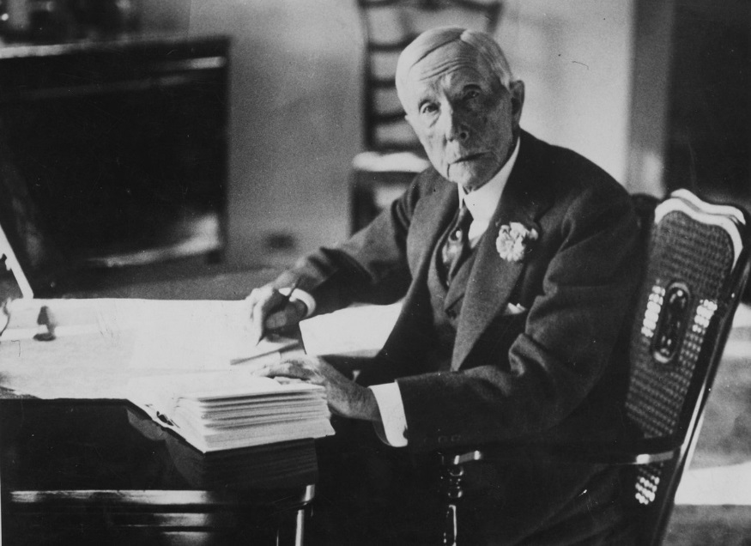

Author: James SABATIER
Supervisor: Christopher Thomas
Submission: 15/01/2019

Table of contents
I. Introduction: 1
II. What is an entrepreneur 2
III. Biography of John D. Rockefeller 3
IV. Why Rockefeller is an entrepreneur and a successful one? 4
V. What has motivated him? 5
VI. Conclusion 7
VII. References 8

Introduction:
Being an entrepreneur is a thing, being a successful is another thing. Indeed there is a huge dedication difference between those two. Anyone can have entrepreneur characteristics but will never succeed. Entrepreneurship is not a new thing. The notion of entrepreneurship was introduced 250 years ago by Richard Cantillon. Back in the days we had some great surprising entrepreneurs who have left their mark. We are going to introduce the life of a 19’s century famous entrepreneur and philanthropist. Anyone who is concerned by entrepreneurship and business in general should know about John Davison Rockfeller. To begin we will explain what an entrepreneur is, then we will give a biography of John D Rockfeller and to finish we will explain why he is such an entrepreneur and what made him so successful.

What is an entrepreneur
At the genesis of entrepreneurship in 1755, Richard Cantillon describes an entrepreneur as an “adventurer” who invests in goods and materials to sell it in the future making profit.
Nowadays this definition have evolved. The term of entrepreneur is designed to individuals who prefer to make their careers running businesses themselves rather than being employed by a third party. “An entrepreneur is someone who has made a conscious decision to choose freedom. Many of us spend years of our lives building someone else's dream and following someone else's rules. As entrepreneurs, we get to choose to work on the things that light us up, that motivate us” (John Lee Dumas).
Those two definitions are way different but the characteristics of the entrepreneur have not changed. The early definition of Cantillon involve the pro-active involvement in trade and travel of the entrepreneur while exercising their ability to take risks and identify business opportunities. This early state of mind of the entrepreneur has not changed, the new definitions involve the same notions and characteristics of the entrepreneur.
Entrepreneurs are people that need achievement, they are strongly motivated to get what they what. They know how to take risks and turn it into motivation. They are determinates, positive, initiative, innovative and trustworthy. Entrepreneurs make their own luck by catching and having the ability to recognize opportunities that other people won’t see. They have an appropriate vision of the business, whatever they are creating is useless if it doesn’t find an audience. They never stop learning and they care about other people feelings because they are open minded. Determination is key, when they have an idea they believe in this idea and they are constantly focus on it whatever it takes they will do anything to achieve it.
There is two main thinks about entrepreneurs. The people that thinks that entrepreneurship is genetic. “Young entrepreneurs are often born, rather than bred”. You are born that way, you got the state of mind of an entrepreneur, extroverted, innovative and determinate. In the other hand some people think that the environment you’re in influences you and makes you entrepreneurial. At the end both nature and nurture makes you an entrepreneur because the two factors can clearly makes you an entrepreneur.

Biography of John D. Rockefeller
When you think about the wealthiest businessman you look at Jeff Bezos or Bill Gates but actually the wealthiest business to have ever lived died almost a century ago.
John D Rockefeller was born July 8, 1839 in upstate New York in the United States. He was the son of a travelling merchant, salesman and philanthropist who was always travelling and was unfaithful. Rockefeller mother assured John that god was the father that would never let him down. John Rockefeller didn’t have an easy childhood, he was living this nomadic lifestyle because his family was always moving from a place to another. Rockefeller would earn any money he could to help his mother by raising turkeys or doing work for neighbors. In 1854 Rockefeller had a chance to use his intelligence when the family moved to Cleveland and when he attended a proper school. He dropped out from that school one year later to work as a bookkeeper at a local produce broker where he would earn 0.50 cents a day or 13$ in 2019. After his boss refused to give him a meaningful raise he decided to start his own produce brokerage company. Because of his good reputation he got a loan of 4000$ which was huge at the time. He traded goods for a year and recorded sales of half a million dollars and at 18 years old every bank in Cleveland was asking him to borrow money. In 1859, the first American oil shaft was discovered just next to Cleveland. Rockefeller launched a refinery company named the standard oil company, he was buying oil from the drillers and was refining it. His company was the biggest one and was outperforming the others. In 1865 there was 26 competing refineries and in 5 years Rockefeller acquired 22 of them. Rockefeller showed his remaining competitors that he could operate at a loss far longer than them. In exchange for a good buyout price, he would offer his competitor’s positions in his company to have the most experienced people of the industry with him. To acquire the persistent remaining competitors Rockefeller eroded the prices of oil and kerosene by 80% lower to strangle them. In 1880 he was refining 90% of the oil production in the United States. At the apogee the company value was estimated of one trillion dollars, he was owning 20.000 oil shaft, 4000 miles of pipeline and employed over 100.000 workers. In 1911 the Supreme Court found Standard oil guilty of anticompetitive practices and broke the company up into 34 separate entities that are nowadays the petrol companies that we know. Rockefeller kept his stake until his death in 1937 and that made him the richest businessman ever with an estimated net worth of 400$ billion. He was American first billionaire, and was responsible for the creation of middle class and the development of American as an industrial power. Rockefeller was deeply religious and followed the spiritual law “Give and it shall be given unto you”. From his teenage years to his dying day, he always gave a portion of his income to charity.

Why Rockefeller is an entrepreneur and a successful one?
John Rockefeller grow up learning how to hustle people for the best deal possible and how to get the most of every penny he got. When he worked as a bookkeeper and his boss didn’t gave him a raise he decided to give it a go and start his own produce brokerage company. He had such confidence and was not worried about failure. The 4000$ loan he got to launch this company was not chance. He was considered as a right and trustworthy person and that is very important as an entrepreneur. In 1859 when the first oil shaft was discovered he recognized this huge opportunity. He recognized that the biggest profits to be made was not drilling for oil but refining it. He is an observing person because he witnessed many people going broke before striking oil he knew that the business was too risky, he did not take reckless risk only worth ones. He waited till 1863 (4 years) that the train line to carry the oil was built to enter the industry, he had all the partner and the bank ready to help him. He his patient and he his sticking to his idea. The early refineries could operate at only 60% of efficiency. Rockefeller recruited a team of chemist and engineers to optimize that percentage, so he had a really good understanding of the industry and how to maximize his profit. Also, what’s makes him an entrepreneur is his incredible business sense. He managed to negotiate and buy 22 out of the 26 refining companies in 5 years thanks to his low price strategy aiming to struggle competitors. He was always kind and attentive to people and that’s another entrepreneur quality. He always rewarded workers at their true value and was following the philosophy that when you give to people they will give you back. He always had one step ahead, when Henry Ford released Model-T he was ready to supply the gas. Rockfeller was dedicated and hardworking even when he did not have a job at his beginnings: “I was working every day at my business — the business of looking for work. I put in my full time at this every day.” John D Rockefeller
Rockefeller always had a backup plan he was constantly thinking about the health of the oil industry and what do if it collapse. The main quality that has John D Rockefeller was tenacity and perseverance. "I do not think that there is any other quality so essential to success of any kind as the quality of perseverance" John D. Rockefeller.

What has motivated him?
At first when he was a boy what motivated him was clearly to help his mother. At the time he was certainly driven by simple avarice but his ambition has grown with time. His motivation was no longer the desire to be rich. His greater goals gave him deeper motivation, and a more long-term perspective that permitted him to build something that can last.
“I know of nothing more despicable and pathetic than a man who devotes all the hours of the waking day to the making of money for money’s sake.” –John D. Rockefeller
“The man who starts out simply with the idea of getting rich won’t succeed; you must have a larger ambition.” –JDR
“I had no ambition to make a fortune. Mere money making has never been my goal. I saw a marvelous future for our country, and I wanted to participate in the work of making our country great. I had an ambition to build.”
Rockefeller motivation was to create jobs, lower the prince of kerosene and gasoline to make it affordable for everyone. This is a cause of the creation of the middle class in the United States. His other motivation was also to help people, he had given away almost 540$ million dollars to all sort of charity organization.

Conclusion
Entrepreneurship is not just the desire of autonomy and company foundation, which have more to do with a businessman. It’s much more than that, it is the capacity and willingness to innovate and develop while controlling the risks. It’s a state of mind that entrepreneurs have to get to achieve and success. John D Rockefeller have a really interesting self-made path. He is really inspiring as a person and he have a lot of entrepreneur faculties such as perseverance as the main one. It’s surprising that no one have succeed to surpass him yet knowing that he died 82 years ago. He did so much good actions during his life but he is still remembered today as a greedy capitalist maybe due to our educational system.

References
References: Christopher Thomas, 2018, Lecture 8: “Definition of entrepreneurship”, Entrepreneurship, Swansea Business School, UWTSD.
References: Christopher Thomas, 2018, Lecture 9: “Entrepreneurial nature”, Entrepreneurship, Swansea Business School, UWTSD.
References: Christopher Thomas, 2018, Lecture 9: “A brief history of entrepreneurial understanding”, Entrepreneurship, Swansea Business School, UWTSD.
Braveen, Kumar. "Why exactly is an entrepreneur and how do you become one today?" Available at: https://www.shopify.com/blog/117049413-what-exactly-is-an-entrepreneur-and-how-do-you-become-one-today/ Posted on June 5, 2017
Unknown. "What is an entrepreneur?" Available at: https://entrepreneurhandbook.co.uk/define-entrepreneur/ Posted on October 24, 2018
Shobhit, Seth. "5 characteristics of successful entrepreneurs?" Available at: https://www.investopedia.com/articles/personal-finance/101014/10-characteristics-successful-entrepreneurs.asp/ Posted on December 15, 2017
Business casual. How Rockefeller Built His Trillion Dollar Oil Empire. [Online Video]. 8 June 2018. Available from: https://www.youtube.com/watch?v=9saLsvWcppw. [Accessed: 11 January 2019].
PragerU. Rockefeller: The Richest American Who Ever Lived. [Online Video]. 5 October 2015. Available from: https://www.youtube.com/watch?v=PYqrFBm7qdA. [Accessed: 11 January 2019].
Brett and Kate McKay. "Rockefeller’s keys to success" Available at: https://www.artofmanliness.com/articles/john-rockefellers-keys-to-success/ Posted on December 15, 2017

