COMPONENT 1 – WEBSITE
REDESIGN FOR ONLINE BUSINESS PRESENCE
Business and Web Management ACCA5019
Narcis Valentin Gorgos
2407130
Table of Contents
1.0 Introduction 3
2.0 Healthy Harvest Website Redesign 3
3.0 Responsive Design Implementation 6
3.1 Definition of Responsive Design 6
3.2 Implications of Responsive Design for Improving User Experience 6
3.3 Implications of Responsive Design to Boost Mobile Sales 7
4.0 Implementation Section 7
4.1 Moodboard and Wireframe Design 9
5.0 Conclusion 24
References 25

1.0 Introduction
E-commerce has transformed the way consumers interact with retailers and make purchases. Creating a website in a good way is essential to attract visitors, meet business objectives and ensure users have a positive experience. There are certain key points to consider about the effective website design process: it is visually attractive, easy to use, accessible and functional. The performance of the e-commerce grocery delivery platform is crucial, affecting product visibility, ease of ordering, and delivery timeliness.
It's a report that seeks a solution to the redesign of a web site for an online grocery store that specializes in organic produce, pantry food and prepared food with organic subscription grocery boxes called Healthy Harvest. This report is to find the weaknesses that exist in the existing website and should provide design suggestions on how the company's website can be more successful in fulfilling its business objectives and customer expectations. This redesign project will take a user centred design methodology by creating a mood board, wireframes and website prototypes. The design activities enable the development of a digital solution, which offers the possibility of enhancements in terms of usability, building of a brand and interaction with customers [3].
The report includes the issues that have been found on the website, provides a suitable design solution, explains the necessity of being responsive in an e-commerce business and gives an understanding of how the mood board and wireframes impact the design. The findings indicate that the structured UI/UX design processes are very important in the creation of high-quality websites, thereby enabling business growth and customer satisfaction.

2.0 Healthy Harvest Website Redesign
HealthyHarvest is having a good turn in their grocery store business (product lines include organic food), but have some problems with design and usability that are obstructing them from doing well in their online business. These disadvantages are only good for the customer, and for the growth of the website and business [1]. A redesign is needed to enhance the user experience, to reinforce the brand message and to increase online conversion rates.
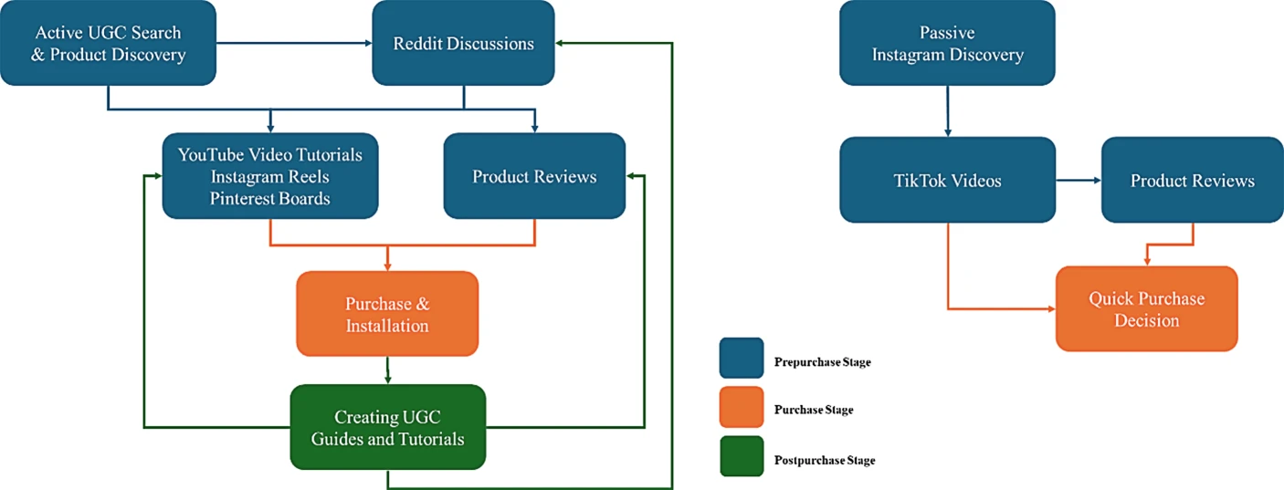
Figure 1: User-generated design and customer journey overview
(Source: [2])
Navigational and information architecture is one of the main problems with the current website. Content is not logically and clearly structured and it's difficult for customers to locate products, subscriptions and key information. Navigation problems will result in time lost and frustrate customers [2]. This is overcome by the redesign of the web navigation system, which has been simplified, with easy-to-identify sections outlined in the menu, such as Home, Shop, Subscription, About and Cart. Furthermore, it's easier for users to find the information they need, making it more accessible.
Another problem is the outdated graphics do not demonstrate the ideals of healthy living and sustainability HealthyHarvest promotes. The existing visual appearance is not representative of the company's brand values and does not create an emotional bond with the customers [3]. It is an upgraded version of that design, featuring organic food and protecting the environment images, readable typeface and green designs. These design decisions can contribute to the creation of a brand's trust, resulting in a more engaging user experience.
The site also doesn't have mobile friendliness. The redesign is based on responsive design principles, so that all content, navigation and interactivity is usable and pleasant on all devices. This will help to maintain consistency of user experience across all platforms.
The other challenge that has been mentioned in the current site is that there is a lack of details of the products. When purchasing organic products, consumers desire plenty of information regarding ingredients, nutrition, the organic product's source and its sustainability characteristics [4]. This is being mitigated by the redesign, which now provides each product with their own detail page and provides the detailed product description, ingredient transparency and sourcing information. Those improvements will help to inform decision-making when buying it and give confidence to consumers.
The other vulnerability is the opacity of the ingredients used. Today's consumers are becoming more conscious of the inclusion of ethical production methods and sustainability practices in the selection of products to buy [5]. The restructured product pages feature the farm origin and organic certification and sourcing. It is this transparency that fosters trust among consumers and elevates HealthyHarvest above other online grocery providers.
Also, the current website has poor quality images, which results in inferior customer experience while viewing the products. In the present era of e commerce, customers are unable to physically see the product they want to purchase, and visual content plays a vital role in e commerce [4]. The redesign features high resolution images that bring the products to life and present them in an attractive and professional manner. Improved images create higher customer engagement and therefore a higher buying behaviour.
One other cause for cart abandonment may stem from a sluggish and lengthy checkout process. If the form is difficult, contains too many steps and/or instructions that are not clear to the customer, they may not complete the transaction. There are also a variety of enhancements to the checkout process, including a streamlined checkout experience, streamlined forms, clear progress indicators, guest checkout and more transparent order summaries [5]. Such enhancements help to decrease friction and promote the successful completion of transactions.
As there is no personalised recommendations on the Website, there are less chances of cross-selling and customer retention [6]. The platform has been revamped to include recommendations of relevant products and subscription options, based on user preferences and browsing behaviour. Through this customisation, not only is the customer satisfaction improving but also the average transaction value.
There must also be accessibility issues taken into account. The site should be designed with accessibility requirements in mind; otherwise there may be a problem for people with disabilities [7]. It is addressed by the redesign through improved colour contrast, legible text, access friendly navigation structures and by considering accessibility throughout the design processes. The changes are intended to allow the website to be accessible to more people.
The website has been re-designed with a company logo, search feature, and the same navigation structure of five main navigation buttons: Home, Buy, Product, Subscription and Cart. These navigation features enhance user experience by allowing users to navigate smoothly between different sections of the website. The prototype included interactive navigation to show the intended user journey and enhance the usability of the website [7]. The new platform also boasts a revamped user interface and enhanced customer engagement features, such as customer feedback and engagement tracking.

3.0 Responsive Design Implementation

3.1 Definition of Responsive Design
One of the Web Design Methods is Responsive Design, which allows to customize the design, the content and the functionality of a Web site based on the screen resolution and the device of use. Responsive design is about providing your users the best user experience in what they're seeing and doing on your website on their desktop, laptop, tablet and smartphone [8]. This is done by using flexible layouts, scalable images and adaptive navigation systems. Due to today's online shopping environment and consumers using all kinds of devices, responsive design is a major determinant for today's e-commerce websites. Responsive design guarantees uniformity throughout devices, boosting ease of use and business performance.

3.2 Implications of Responsive Design for Improving User Experience
By adopting responsive design, websites can deliver a seamless and user-friendly experience on any device, making it easier for people to access them [9]. This leads to a uniform and easy-to-use user experience, and any visitors can access websites from any device. Today's users have come to expect websites to perform well on every device, whether they're using a desktop computer, tablet or smartphone. The lack of mobile optimization may result in issues navigating, reading, interacting with the site, which can frustrate and decrease engagement. Responsive design creates a more user-friendly navigation system, which automatically adjusts the menu size, button size, and the structure of the content to fit different screen sizes. This allows the users to find products, services and information more easily [8]. Responsive navigation enables customers to easily browse grocery categories, subscription services and product information with no usability issues for HealthyHarvest.
This is also a great benefit for readability and accessibility. Responsive websites with scalable text, flexible layouts and images that adapt to various devices to ensure that the content is easily understandable and readable. These are characteristics that make it easier to access for a wider audience, such as those who are visually challenged or have different browsing habits. However, responsive design can also contribute to the website's loading speed and overall performance [9]. The delivery of optimised content minimises wait times and improves user satisfaction. This increases the likelihood that customers will stay on the site, browse the products offered, and complete their desired tasks. Therefore, it is crucial to have a responsive design that ensures your customers have the best user experience and can interact with your business.

3.3 Implications of Responsive Design to Boost Mobile Sales
It has a clear impact on sales on mobile and provides a convenient and effective buying experience for the customers. As mobile commerce has gained in popularity over the last few years, people are increasingly using their mobile phones to research products, make comparisons and make purchases. If a site does not perform well on mobile, visitors are less likely to make purchases or abandon the site [10]. Responsive design instantly optimizes websites for mobile and makes it easy to shop online. Users can easily browse products, check detailed information, add products to their shopping cart and pay without any trouble. Responsive design facilitates easy access to grocery products and subscription services via mobile devices for HealthyHarvest.
Responsive design is another way to minimise cart abandonment. Customers most commonly drop off websites because they are hard to navigate, don't present the content well, or have a checkout process that is not user-friendly [6]. Having a mobile-friendly, easy-to-navigate, well-labeled button layout in the checkout system and simple forms makes these obstacles less likely to succeed and more likely to fail. In addition, responsive design helps to boost customer retention and loyalty [10]. When their cell phone experience is easy, they'll likely come back to your site and sign up for your services again and again. Mobile-friendly websites also get better rankings in search engines as search engines give more weight to mobile-optimised responsive websites.

4.0 Implementation Section
Current Issues
The usability and business performances of the existing HealthyHarvest website were analyzed and a number of issues were discovered. Some of the problems identified in these were: navigation, outdated visual design, lack of mobile responsiveness, limited product information, information transparency regarding the source of ingredients, poor imagery, long checkout procedures, lack of personalisation, accessibility, weak trust signals and poor call to action [6]. The problems impact on customer satisfaction, conversion and retention.
Proposed Solutions
Several solutions were suggested to rectify the problems found. The updated site is easy to use, responsive, has a nice look, product descriptions, an open, clear data flow about sourcing, good product photos, and a streamlined checkout and personalised product recommendations flow [11]. Interactive navigation features were added to the final prototype to enhance user experience and functionality of the website. There is a company logo at the top of every page, a search bar, and 5 navigation buttons for users to navigate between the Homepage, Buy Page, Product Page, Subscription Page and Cart Page. These active components mimic the action of a genuine ecommerce website and enable quick execution of tasks.
Definition of Responsive Design
Responsive design is a website design that makes a site adaptable to different screen resolutions and devices. The responsive design provides a smoother user experience by adjusting the navigation, layout of content, and interactive features to fit the screen size [11]. This means that the information on the website is easier to use, and the user can interact with the site more easily.
Responsive designe in E-Commerce web sites means implications in improving the user experience.
Implications of Responsive Design in E-Commerce Websites for Improving User Experience
Products can be easily scrolled through, product information can be easily seen, and transactions can be completed, irrespective of screen size [12]. Improved navigation, readability and accessibility increases the satisfaction and engagement of visitors with the site. Furthermore, responsive design can help improve the website's speed and make it more user-friendly, which will make it more likely that customers will use the site. Responsive design is a key aspect of better mobile sales because it makes smartphone and tablets users' purchase process easier. Online shopping is easier because you can easily navigate and display products and checkout. An enhanced usability leads to increased customer trust and therefore increases conversion rate [13]. Responsive websites also have improved standing in search engines, leading to more traffic to the website and more sales opportunities.

4.1 Moodboard and Wireframe Design
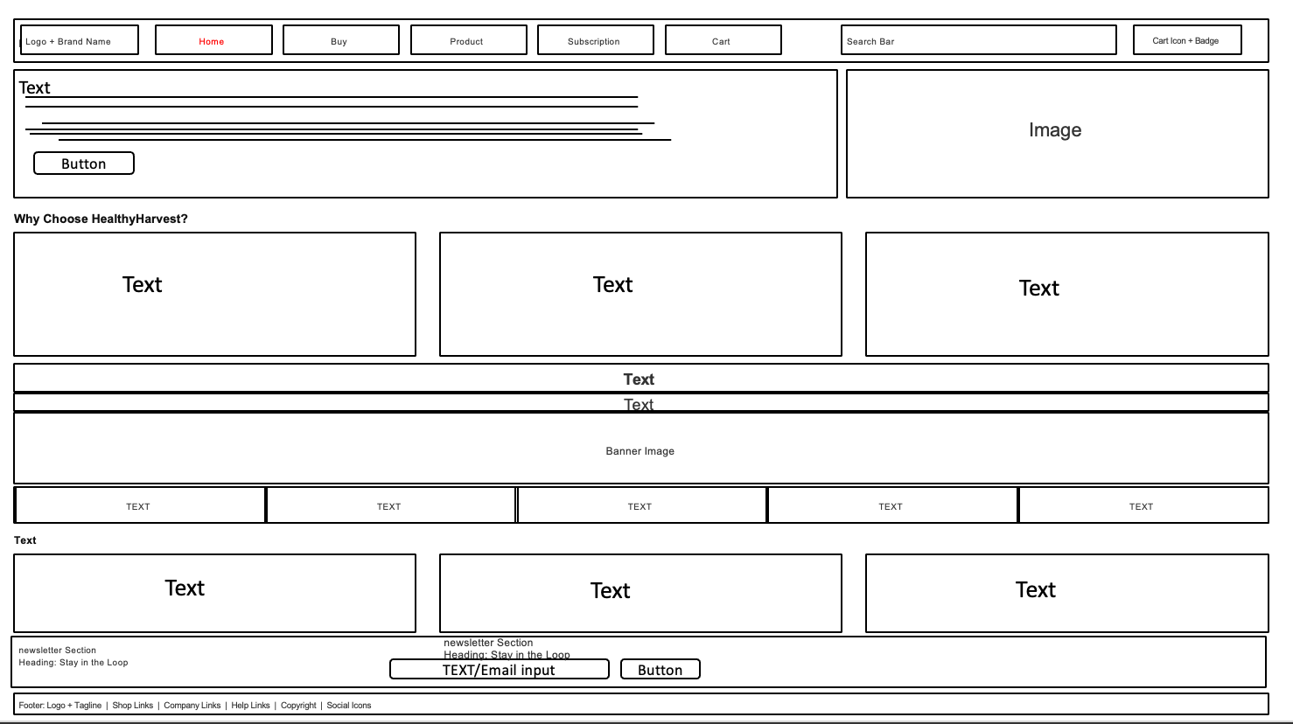
Wireframe Design 1: Homepage
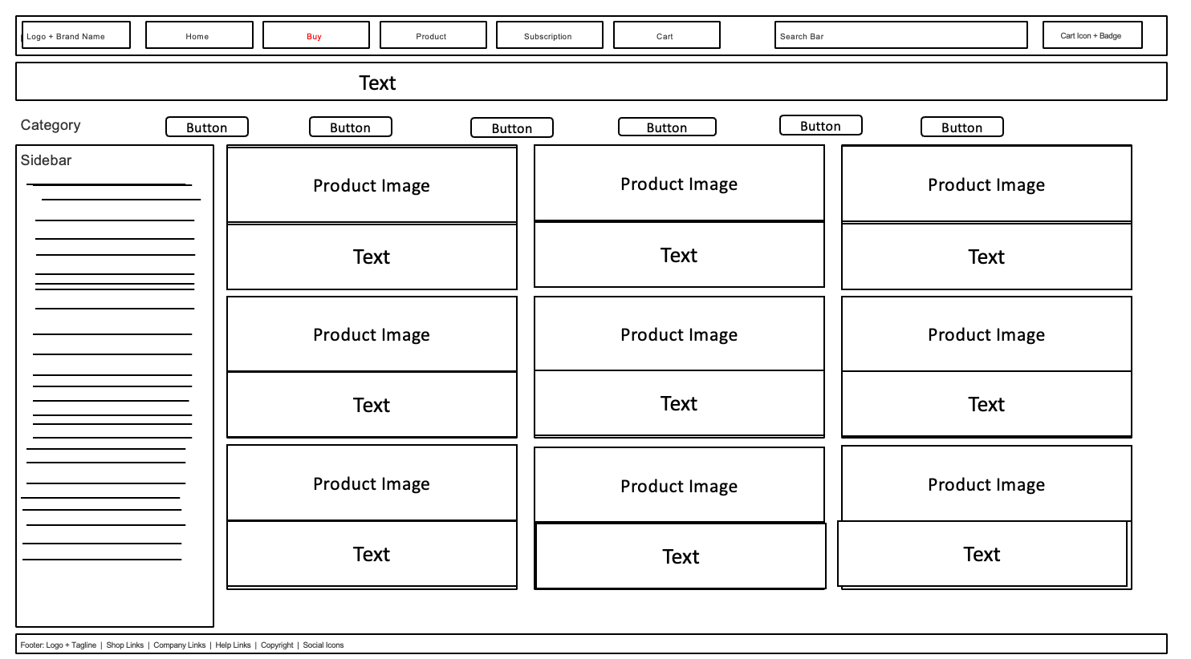
Wireframe Design 2: Shop_Page
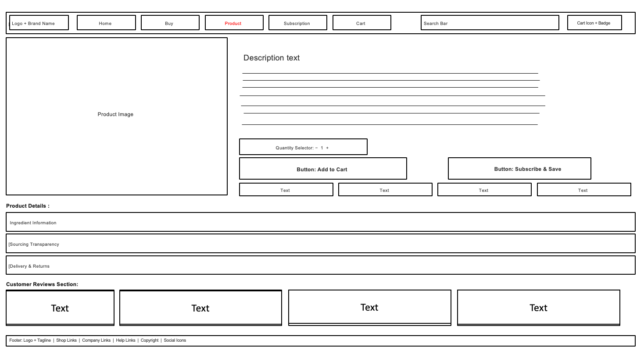
Wireframe Design 3: Product_Page
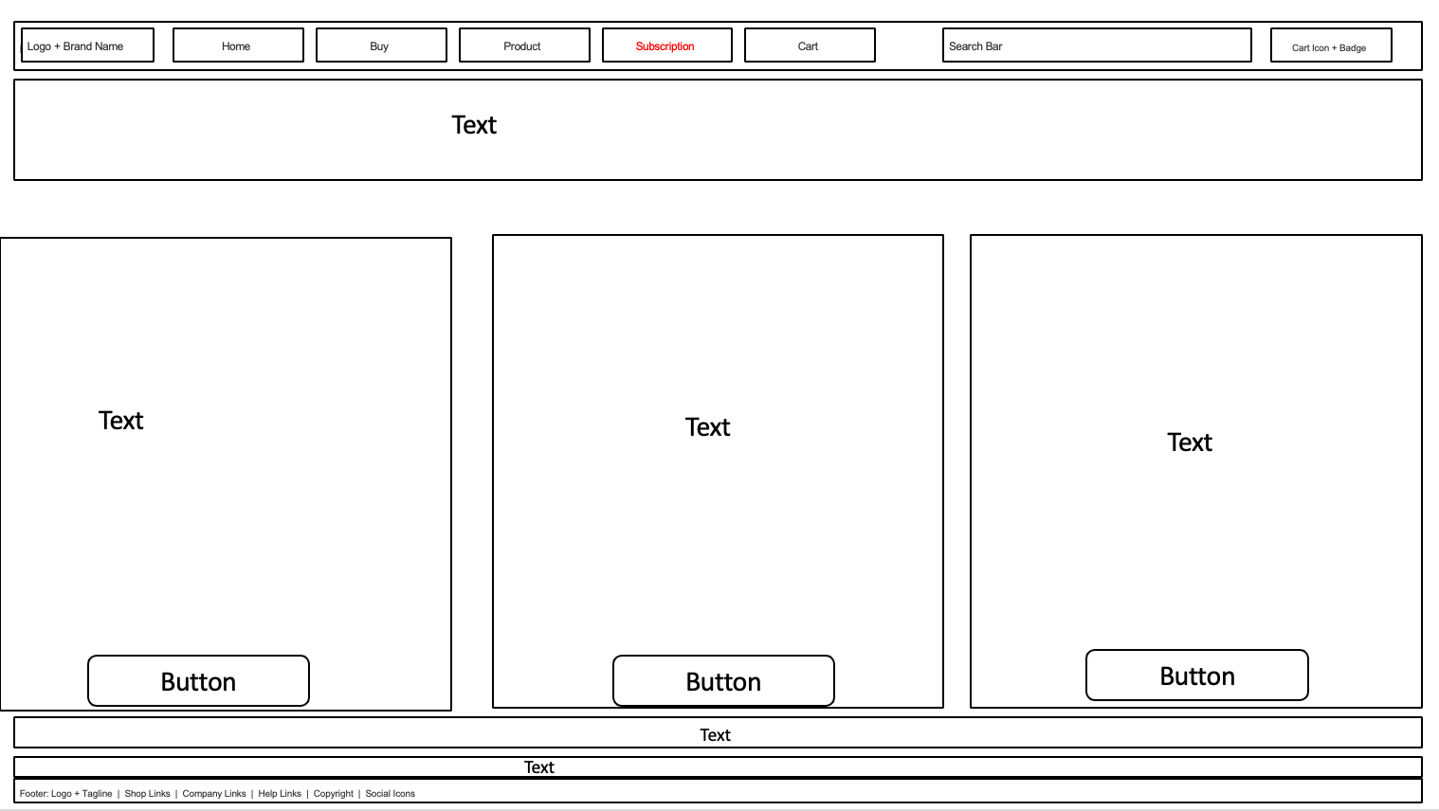
Wireframe Design 4: Subscription
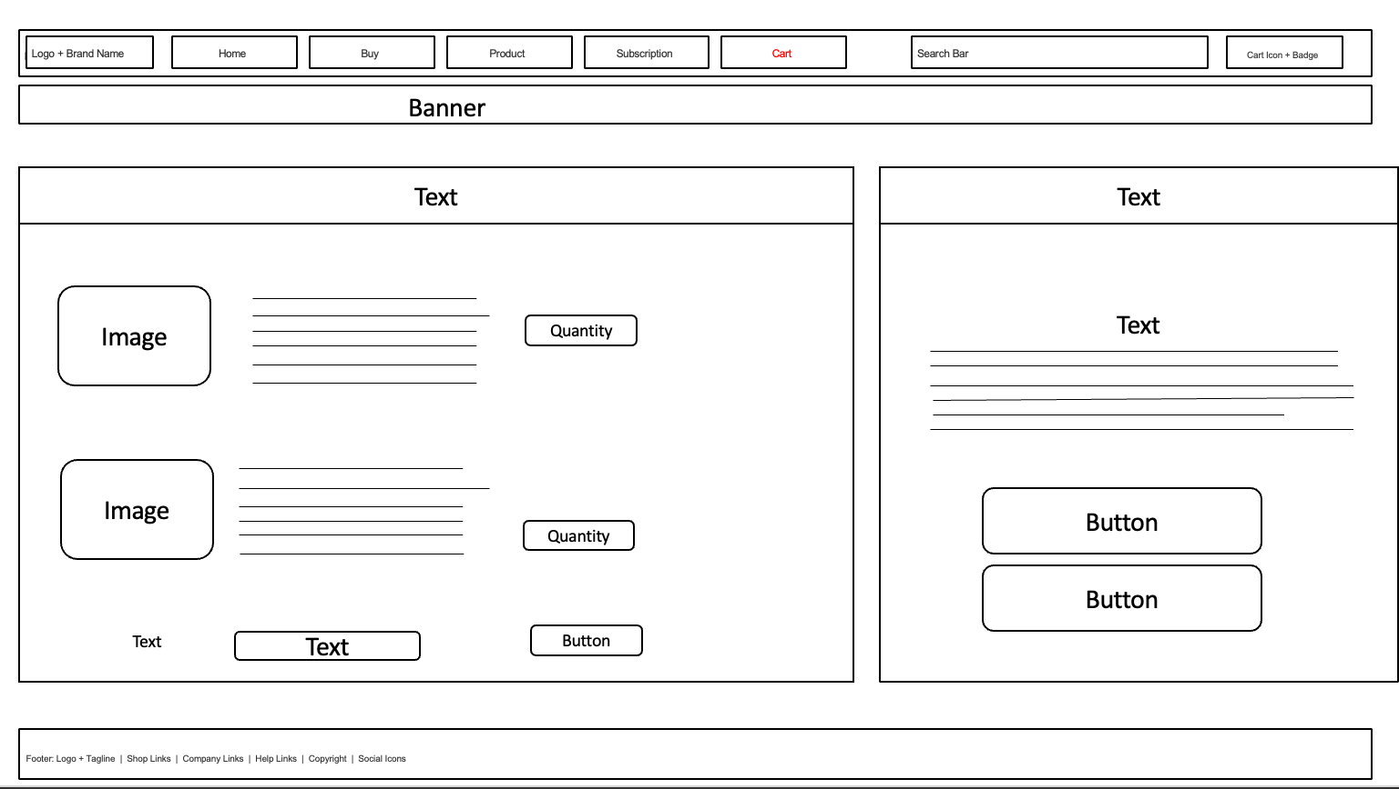
Wireframe Design 5: Checkout
A wireframe is a low fidelity sketch of a Website, displaying the general layout of a Website and where the content will be located and how it will be navigated without including any visual design details. Web layout and user journey planning is often done using wireframes prior to final prototypes. Five different wireframes have been produced for the website of HealthyHarvest – Homepage, Shop Page, Product Page, Subscription Page and Checkout Page. These wireframes helped to establish the structure of every page, and provided a sensible and effective organization of content. The Homepage wireframe emphasized the introduction of services and products with particular emphasis on the key ones, whereas the Shop Page wireframe emphasized the product discovery aspect through search and filtering. The Product Page wireframe showcased product information and transparency in sourcing while the Subscription Page wireframe focussed on recurring purchase options.
Moodboard 1: Brand & Visual Identity
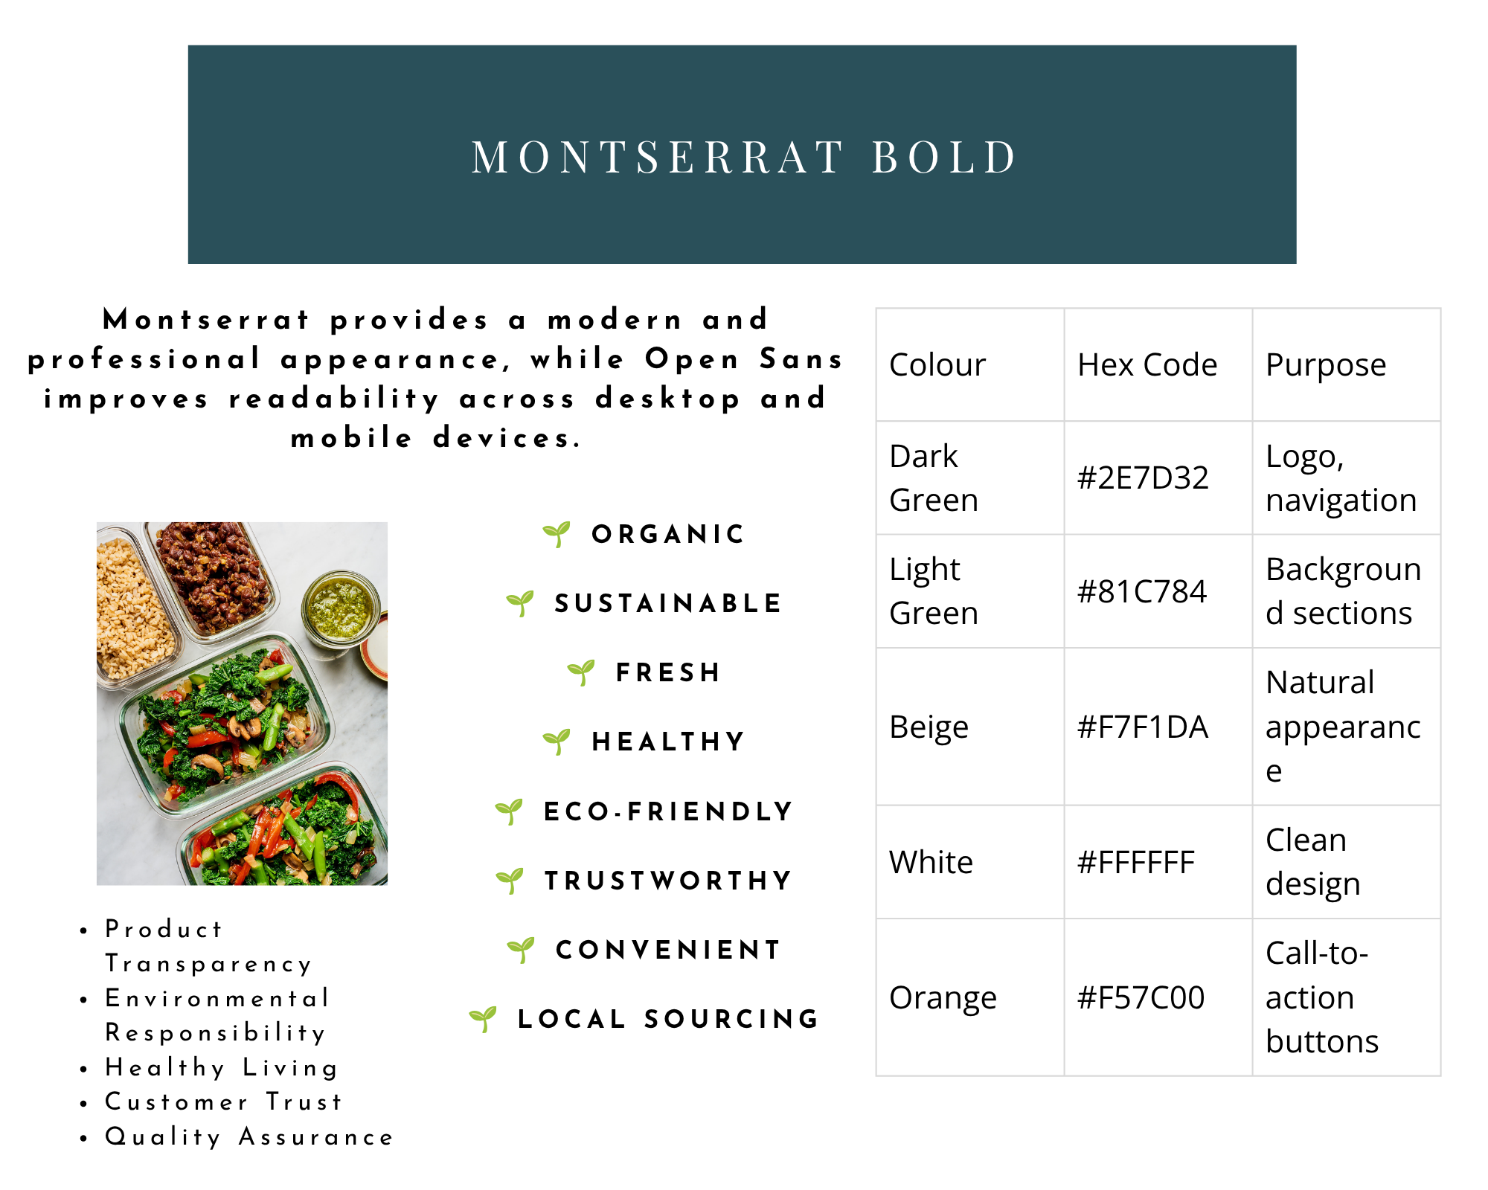
The first moodboard was a tool that was created to establish the image of the HealthyHarvest website redesign. It featured images of organic farming, healthy living, fresh fruits and vegetables, and sustainable packaging. A particular colour palette of dark green, light green, beige, white and orange was also adhered to in the moodboard. The colours were chosen because they bring the message of sustainability, freshness, trust and awareness of the environment.
Moodboard 2: Website & User Experience Inspiration

The second moodboard was related to the layout and the user experience of a website. It specified the interfaces, current e-commerce systems, product card designs, responsive navigation systems, checkout and subscription service layouts.
Final Web Design
Homepage Web Design
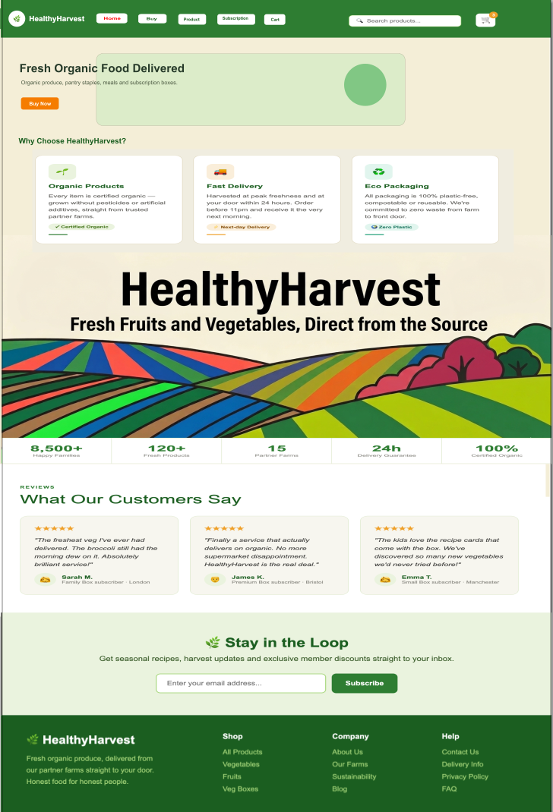
The Homepage was created to make a good impression and to make the brand identity of HealthyHarvest organic and sustainable apparent from the start. Customer interaction was encouraged and the user experience was improved through the use of an eye-catching hero section, intuitive navigation menu and featured product showcases. The green colour way, professional photographs and identifiable buttons such as "Shop Now" help fulfil the conversion target and are in line with the green values of the business.

Shop Page Web Design
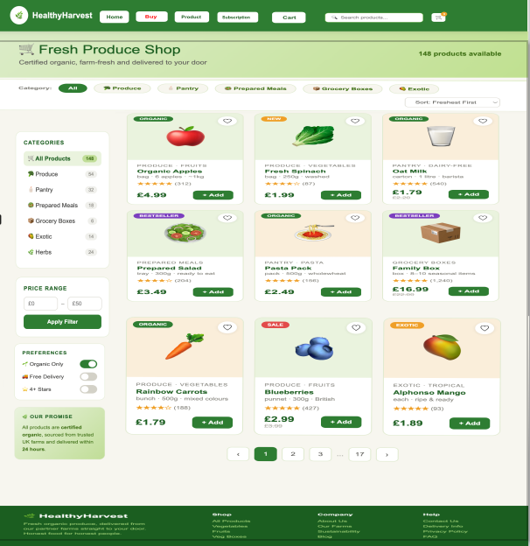
Shop Page has been attempted to be built so that a customer can easily access the product and shop easily. To make it easy for the user to find the right product on the device product filters, search and sorted product cards have been added. Keyboard oriented organized layout makes the site tidy and easy to compare the products…thus increases a shopping experience.

Product Page Web Design
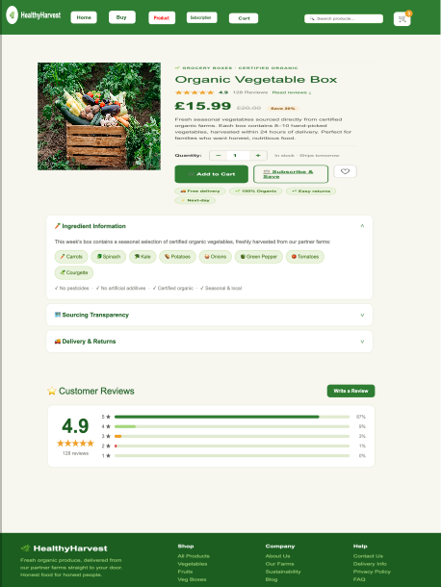
Provides Product details & Gain Customer confidence Product related information like usage , price, ingredients, origin, customer reviews are explained clearly to enable buying decisions & subscription options & Call-to action Buttons are prominently displayed that help customer to stay engaged with the site & increase conversions.

Subscription Page Web Design
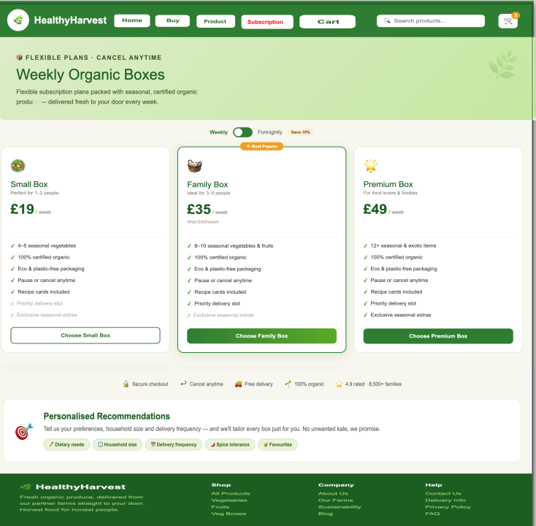
Subscription Page, meant to boost sales and retention using visual clarity, lists the subscription plans in a clean layout and the customer can browser through the plan informatively. It also highlights the benefits of subscribing to the services, which establish a commitment in customers including convenience, flexibility and affordability.
Checkout Page Web Design
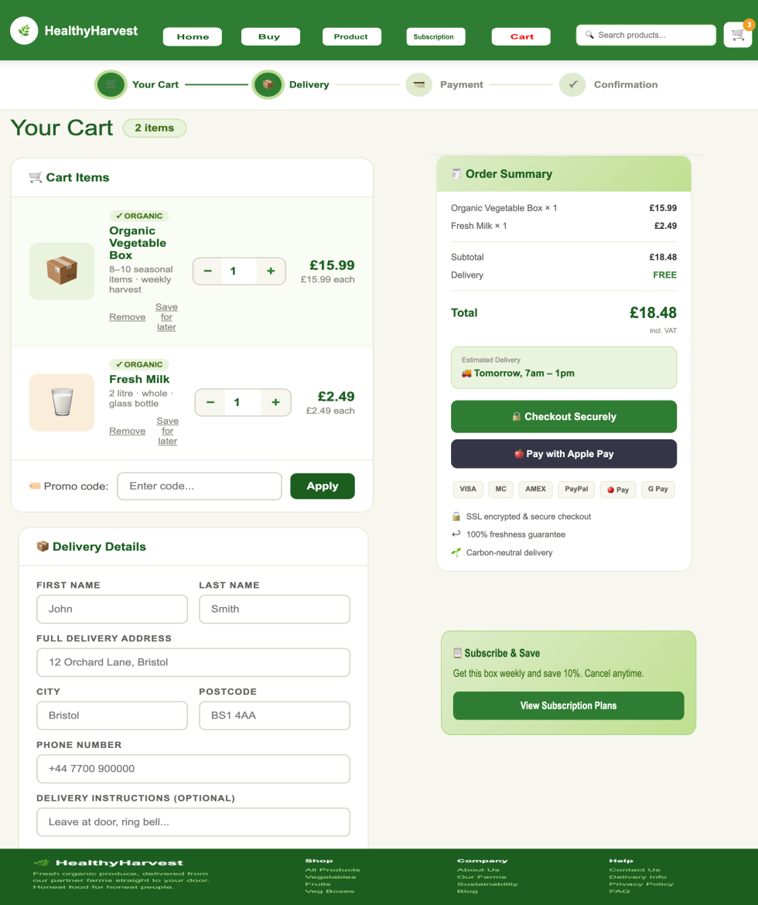
The Checkout Page is optimised to reduce shopping cart abandonment and simplify the checkout process. The cart information, a summary of the order and delivery information are logical and less work for the user. Check-out buttons are easy to understand and trust signals are added to the forms, making the process more user-friendly and putting the consumer at ease at the end of the transaction process.

Challenges Encountered During the Creation of This Project

During the development of this project, I dedicated a significant amount of time to refining details and ensuring that the result matched the intended design. The biggest challenge I encountered was establishing the correct page dimensions in Inkscape, as working with pixels (px) requires a high level of precision. Even the smallest difference in size can have a major impact on the overall appearance of the page, affecting the alignment and proportions of the elements. The process of adjusting and testing the page dimensions took over 3 hours, as it required constant checking and fine-tuning of each detail to maintain a balanced layout and a visually accurate structure.

5.0 Conclusion
The aim was to redesign the HealthyHarvest website to improve its usability, user experience and overall business performance, and this report outlined an extensive redesign plan. The analysis identified a number of problems and weaknesses with the current site: navigation not intuitive, limited product information, website limited in mobile responsiveness, checkout system was inefficient and there was no visual representation of the company's brand values. These problems and the engagement of customers were addressed by providing the solutions for the design.

References
[1]
M. Umar, I. Hussain, T. Mahmood, H. T. Mirza, and M. Nadeem, “Design Strategies to Minimize Mobile Usability Issues in Navigation Design Patterns,” Information, vol. 15, no. 11, pp. 732–732, Nov. 2024, doi: https://doi.org/10.3390/info15110732.
[2]
N. Schröder, C. D. Schultz, F. Paetz, Alicja Grzadziel, and M. Clegg, “Unraveling the Influence: Exploring the Role of User Generated Content Along the Customer Journey and Understanding Its Relevance for Research and Practice,” Schmalenbach Journal of Business Research, Aug. 2025, doi: https://doi.org/10.1007/s41471-025-00214-9.
[3]
P. C.-I. Pang, M. Munsie, and S. Chang, “A Method for Analyzing Navigation Flows of Health Website Users Seeking Complex Health Information with Google Analytics,” Informatics, vol. 10, no. 4, p. 80, Dec. 2023, doi: https://doi.org/10.3390/informatics10040080.
[4]
L. Dahmani and V. D. Bohbot, “Habitual use of GPS negatively impacts spatial memory during self-guided navigation,” Scientific Reports, vol. 10, no. 1, Apr. 2020, doi: https://doi.org/10.1038/s41598-020-62877-0.
[5]
M. Falahat, C. S. Chuan, and C. Liew, “Navigating new product development: Uncovering factors and overcoming challenges for success,” Heliyon, vol. 10, no. 1, p. e23763, Dec. 2023, doi: https://doi.org/10.1016/j.heliyon.2023.e23763.
[6]
A.-S. Riegger, J. F. Klein, K. Merfeld, and S. Henkel, “Technology-enabled Personalization in Retail stores: Understanding Drivers and Barriers,” Journal of Business Research, vol. 123, no. 1, pp. 140–155, Feb. 2021, doi: https://doi.org/10.1016/j.jbusres.2020.09.039.
[7]
A. Yusril, “E-accessibility Analysis in User Experience for People with Disabilities,” IJDS Indonesian Journal of Disability Studies, vol. 7, no. 1, pp. 107–109, May 2020, doi: https://doi.org/10.21776/ub.ijds.2019.007.01.12.
[8]
J. Frank, “Improving Library Accessibility Webpages with Secondary Feedback from Users with Disabilities,” Journal of Web Librarianship, pp. 1–12, Aug. 2023, doi: https://doi.org/10.1080/19322909.2023.2246656.
[9]
J. Ara and C. Sik-Lanyi, “Automated evaluation of accessibility issues of webpage content: tool and evaluation,” Scientific Reports, vol. 15, no. 1, Mar. 2025, doi: https://doi.org/10.1038/s41598-025-92192-5.
[10]
T. T. Irawan, S. Hariani, T. S. Hwee, A. Samee, N. Ab, and A. Fakhrorazi, “Why Do Consumers Abandon the E-Carts?,” Journal of theoretical and applied electronic commerce research, vol. 20, no. 2, pp. 57–57, Mar. 2025, doi: https://doi.org/10.3390/jtaer20020057.
[11]
C. Stamkou, V. Saprikis, G. F. Fragulis, and I. Antoniadis, “User Experience and Perceptions of AI-Generated E-Commerce Content: a Survey-Based Evaluation of Functionality, Aesthetics, and Security,” Data, vol. 10, no. 6, p. 89, Jun. 2025, doi: https://doi.org/10.3390/data10060089.
[12]
W. Surjono, “Factors Influencing Online Shopping Decisions in the Fashion Industry,” International Journal of Management Science and Information Technology, vol. 4, no. 2, pp. 297–311, 2024, doi: https://doi.org/10.35870/ijmsit.v4i2.3004.
[13]
S. Handoyo, “Purchasing in the digital age: A meta-analytical perspective on trust, risk, security, and e-WOM in e-commerce,” Heliyon, vol. 10, no. 8, p. e29714, Apr. 2024, doi: https://doi.org/10.1016/j.heliyon.2024.e29714.

