DR Nadeem Mirza
Professional Career Development
BMSW4005
Yahya Hasan Yusuf Abdalla (1919523)
[Year]
Table Contents

Introduction …………………………………………………………….2
Role play ……………………………………………………………….2
Professional Career Development plan …………………………….4
personal action plan/development plan …………………………….5
Gibbs Reflective Cycle ……………………………………………….6
Description ………………………………………………………………7
Feelings ………………………………………………………………….7
Evaluation …………………………………………………………………7
Conclusions …………………………………………………....................7
Action …………………………………………………………....................7
Reference …………………………………………………………………...8

Appendices ………………………………………………………………….11

Introduction:
This report provides an example of what I learned in an online class, through practice in the class, an explanation of the lecturer and role-play between my colleagues and I, and details I gained about professional career development. This report includes some understanding of literature on the development of professional career. When a person wants to develop a professional career, learns new job skills to enhance opportunities, as happened to me from developments in the class and at work. Wallker. D (2021) Stated that” When a person assumes professional professional development, they learn new job skills to improve existing career opportunities or to enter a completely dissimilar field. Approximately professional fields, for example, require a certain number of continuing education or professional development times in order to uphold certificates and licenses. There are many different ways to learn new skills for such development, including earning a bachelor's or graduate degree, employer-sponsored in-service classes, conducting research, reading professional journals, or attending workshops or conferences.” Heathfield. S (2021) stated that” Career development is the process of choosing a career, improving your skills, and advancing along a career path. It's a lifelong process of learning and decision-making that brings you closer to your ideal job, skillset, and lifestyle”.

Role play
On Saturday 25th of April, we had a role play presentation between students as interview questions for jobs. The lecturer asked us to present our role play to get past the first task and it was a bit difficult for me because I had never done this before and I was a bit scared and confused at the beginning, my colleague and I were the first students to present our roleplay. Firstly, I started to welcome everyone, then I started asking my colleague questions we had prepared in our roleplay. I was playing the role of a manager of the company and it was my colleague answered the questions.
At first, I felt so tense and uncomfortable at the time that I was elected to roleplay. Then I felt that the feeling of fear and confusion had completely subsided, but I had some mistakes, and I was strong on points and weak on some other points. Then the roleplay presentation between my colleague and I ended, and the lecturer thanked us for the work we did. The main fear was the number of students, playing the roleplay in front of everyone and hearing everyone, and this is among my weaknesses. Then the second and third groups ... etc. I was a good listener, I benefited a lot and learned from my mistakes and the lecturer was suspended for us comfortably and smoothly.
At the time, I didn't feel anxious and thinking about the presentation was my disease. I finished the role play presentation without talking to the lecturer or my fellow students. After a few minutes I called my presentation colleague and asked him what the presentation was like and he answered everything fine, don't worry and he made me feel much better. I realised everyone feels nervous at first and might stumble upon the first few starts. My strengths are patience, endurance, writing and good listening. There are points that I have increased confidence, dialogue, and discussion. Weaknesses I have speed in making decisions and this is my weakest point. I always strive for this problem and I work on it to find a solution quickly and change it for the better. I feel that there is some missing experience and that I work on these missing points I have in some exercises and entered another course to fill in the blanks and improve my level. I know for sure that I am not ready for this job if I have had it now, but in the near future I will be ready for every role I play. I have a plan and I am working on it right now.
In the past, I would have done a few things differently. I should have practiced better and returned the lessons better. I should have been more courageous, self-confident, and motivated to achieve the highest standards of success. However, I think the main thing that I learned from the accident is that I have not built my confidence and practiced separation exercises to the fullest and the reason for this is lack of time and I am striving to overcome this problem in the future, and that I had to make an effort to do so. Then I would have been able to explain how nervous I was beforehand.
In the future, I will make sure to build more exercise and build confidence. I am working on these points and I know I will surpass them, and I already started this plan since I finished the roleplay presentation, I have divided it into several stages of my educational and work development.
My personal career goal has three parts. I have divided these three parts into a short-term goal, medium-term goal and long-term goal that indicates our learning in strategic thinking. My short-term goal is to graduate from college in two years. My medium-term goal is to become a Human Resources Assistant, and my long-term goal is to become a Human Resources Officer or CEO of a global company.
My short-term goal is to obtain my bachelor's degree in two years. To achieve this goal, there are several things that I need to do. I need to maintain full time student status. I also need to possess academic study skill so that I can maintain my GPA while working part-time off campus. Working while taking professional career development lessons is challenging, but it is possible if you use a good study skill to use the time wisely.
Professional Career Development plan
Trueba. J (2008) stated that the stage of implementing the career plan, while the career plan defines the career path of the employee, within career development that the employee develops well before moving to the next higher stepladder. An example of this is where I currently work at the beginning of work in the company, I had a plan to rise to the top, but for those whose vision is clear, as I worked hard and wrote step by step. I wrote my goals for the short term, long term and development experiences such as 1-summary statement, 2-education and training, 3- job assignments, 4-developmental activities. my manager offered me a nice service where he encouraged me to use the individual career development plan where He explained to me the value of ICDP. I took that advantage and I worked on it so, I am now a team leader.
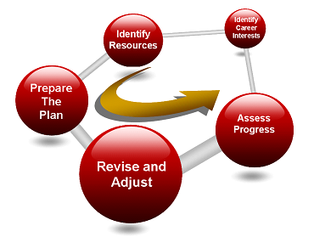
Trueba. J (2008)

Randall. S “et al. (2021) hypothesis your own SWOT analysis to usual a development for your career planning, inspect your current situation. What are your strengths and weaknesses? How can you exploit on your strengths and overcome your weaknesses? What are the external opportunities and pressures in your chosen career field?
key tool in the strategic planning process can also be applied to career planning. This tool is analysis using the SWOT technique. SWOT analysis emphasis on the internal and external environments, examining strengths and weaknesses in the internal environment and opportunities and threats in the external environment. Imagine your SWOT analysis to be structured like the table below:

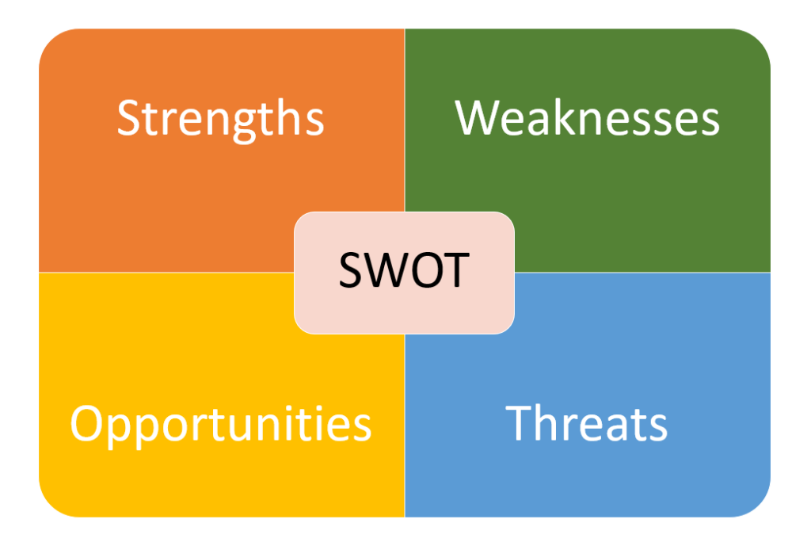

personal action plan/development plan
Rolfe. A (2021) stated that A plan for self-development is a written account of contemplation and improvement of personal development as a detailed action plan to be used to achieve academic, professional and personal goals. You can create it in the workplace or in the study. Under the guidance of your director, teacher, or lecturer at the university. Usually, your coach allows you to define your goals, recognize your strengths and weaknesses, and work on them to improve those points. Such as I have some points that I want to work on and I have drawn up the plan that I will work on, and there may be potential obstacles, and I thought to put an alternative plan for it, which is the emergency plan or plan (B). In the future, I will make sure to build more exercise and build confidence. I am working on these points and I know I will surpass them, and I already started this plan since I finished the roleplay presentation and I have divided it into several stages of my educational and work development.
My personal career goal has three parts. I have divided these three parts into a short-term goal, medium-term goal and long-term goal that indicates our learning in strategic thinking. My short-term goal is to graduate from college in two years. My medium-term goal is to become a Human Resources Assistant, and my long-term goal is to become a Human Resources Officer or CEO of a global company.
My short-term goal is to obtain my bachelor's degree in two years. To achieve this goal, there are several things that I need to do. I need to maintain full time student status. I also need to possess academic study skill so that I can maintain my GPA while working part-time off campus. Working while taking professional career development lessons is challenging, but it is possible if you use a good study skill to use the time wisely.
Griffiths. A (2020) stated that “every employee should have a personal development plan (PDP). Managers can use (PDP) to help employees reflect on abelites and find opportunities to improve”.

Gibbs Reflective Cycle
Dowding. M et al. (2017) stated that “However, this is where Gibbs' Reflective Cycle is useful. You can use it to help your employee make sense of situations at work, so that they can understand what they did well and what they could do better in the future”. The Gibbs Reflective Cycle is a useful that helps you to improve performance in the future, and if you haven't consciously considered any experience of how to improve performance in the future it is difficult for you to understand about Gibbs cycle. The place where the Gibbs Reflex Course is useful for helping employees understand situations at work So that they can better and better understand what they have done and what they are doing in the future. For example, in a roleplay presentation in this report, I mentioned what were the situations that I passed over during the presentation, what were the problems I faced, what I gained, and how I got better in the future, and I tracked the Gibbs cycle and learned from my mistakes in order to improve in the future. So, I advise everyone to follow the Gibbs Reflective Course as it is very useful.
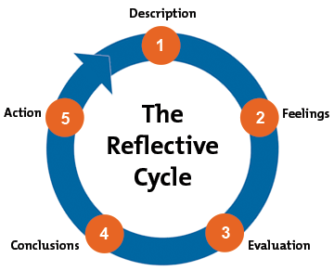

Dowding. M “et al.”, e.g.al (2017)
Description, Feelings, Evaluation, Conclusions, Action.
Description:
Karakas. F (2020) stated that “Primary, question the employee at work you are trying them to define situation in point. At this point, you basically want to know what happened and you'll draw conclusions later”. Such as you were in a job interview or faced a situation in your life that benefited from this position from the negatives and positives and what are the strengths and weaknesses and how you felt at that moment. In short for example, to describe the situation and the location and What happened that recalled.
Feelings:
Philip. S (2020) stated that “encourage yourself to talk about what you thought and felt during the experience. At this stage, don’t avoid commenting on your emotions”. Such as, what your thinking when the question was directed to you by the manager, or your feeling about the question and style, and what everyone felt about your answers, and your experiences are presented in the section.
Evaluation:
Gaynor. A et al. (2013) stated that encourage the person you are training to the topics and methods that have worked and which have not. For example, if you did not succeed in a task at work that was given to you by the manager and was not delivered on time, but the achievement of the work was more than wonderful. Here you encourage the person to the points in which he succeeded and in which he did not succeed, such as delivering the task late, encouraging him to be better and learn from your mistakes.
Conclusions:
Dowding. M et al, (2017) stated that you can help your colleague or help yourself to draw conclusions about what happened. Help think about situations again using the information you have gathered so far and then discuss it with your colleague. Such as I had a colleague at work once who helped me draw out an assignment that was in advance for me and he was asking me and I answered it and I used to write every conclusion in the notes and I had a nice conclusion, this helped me understand the Gibbs cycle.
Action
Jasper. M (2003) stated that” you should have some conceivable activities that your team member can take to deal with similar situations more efficiently in the future. In this last step, you need to come up with a plan that help them make changes. Once you've identified the areas, they will work on it, get them to commit to taking action, and agree a date on which you will both review progress”. Such as Work on a future plan of changing the procedures that you were working on, identifying areas that you will work on, and helping your team member, make him commit to taking measures that help him review them.

Reference

Dowding, M., Mugridge.T, Swift. C, Jackson. K, Hancock. J, Bell. S, Dunne. K, Bishop. L, Hughes. M, Robinson. R, Gledhill. A, 2021. Gibbs' Reflective Cycle: Helping People Learn from Experience. [online] Mindtools.com. Available at: <https://www.mindtools.com/pages/article/reflective-cycle.htm> [Accessed 29 April 2021].
Griffiths, A., 2021. How to manage personal development plans. [online] Tsw.co.uk. Available at: <https://www.tsw.co.uk/blog/leadership-and-management/personal-development-plan/> [Accessed 29 April 2021].
HEATHFIELD, S., 2021. 5 Tips to Improve Your Career Development. [online] The Balance Careers. Available at: <https://www.thebalancecareers.com/improving-career-development-4058289> [Accessed 29 April 2021].
Karakas, F., 2021. How to Apply Gibbs Cycle of Reflection. [online] Medium. Available at: <https://medium.com/an-idea/how-to-apply-gibbs-cycle-of-reflection-f56026a2558> [Accessed 29 April 2021].
Jasper M, J., 2021. [online] Uhbeducation.co.uk. Available at: <https://www.uhbeducation.co.uk/sites/default/files/Gibbs_Reflective_Cycle.pdf> [Accessed 29 April 2021].
Philip S., P., 2021. Sample Report: A Personal Reflection Report | 15 Writers. [online] 15 Writers. Available at: <https://15writers.com/sample-reports/personal-reflection-report/> [Accessed 29 April 2021].
LiveCareer Staff Writer, L., 2021. Using a SWOT Analysis as a Key Career-Planning Tool | LiveCareer. [online] LiveCareer. Available at: <https://www.livecareer.com/resources/careers/planning/swot-analysis> [Accessed 29 April 2021].
Rolfe, A., 2021. Personal development planning: What you need to know | reed.co.uk. [online] reed.co.uk. Available at: <https://www.reed.co.uk/career-advice/personal-development-planning-what-you-need-to-know/> [Accessed 29 April 2021].
Trueba, J., 2021. The Career Development Plan - A Quick Guide for Managers and Supervisors. [online] Associationdatabase.com. Available at: <https://associationdatabase.com/aws/NCDA/pt/sd/news_article/6420/_PARENT/layout_details/false> [Accessed 29 April 2021].
Walker, D., 2021. What is Professional Career Development? (with pictures). [online] Practical Adult Insights. Available at: <https://www.practicaladultinsights.com/what-is-professional-career-development.htm> [Accessed 29 April 2021].

Appendices


