C# Exercise: Calculate an Electricity bill
Write a program in C# Sharp to calculate and print the Electricity bill of a given customer. The customer id., name and unit consumed by the user should be taken from the keyboard and display the total amount to pay to the customer. The charges are as follows:
Unit | Charge / Unit
Up to 199 | @ £1.20
200 and above but less than 400 | @ £1.50
400 and above but less than 600 | @ £1.80
600 and above | @ £2.00

If bill exceeds £400 then a surcharge of 15% will be charged and the minimum bill should be of £100
Output should look like the below: (console Application). Please develop a windows form application as well for the above exercise.
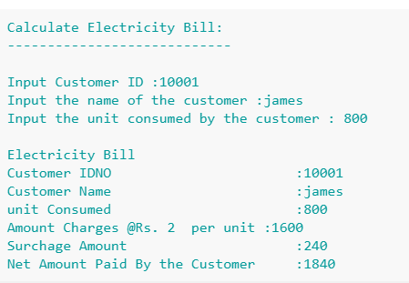

Flow Chart
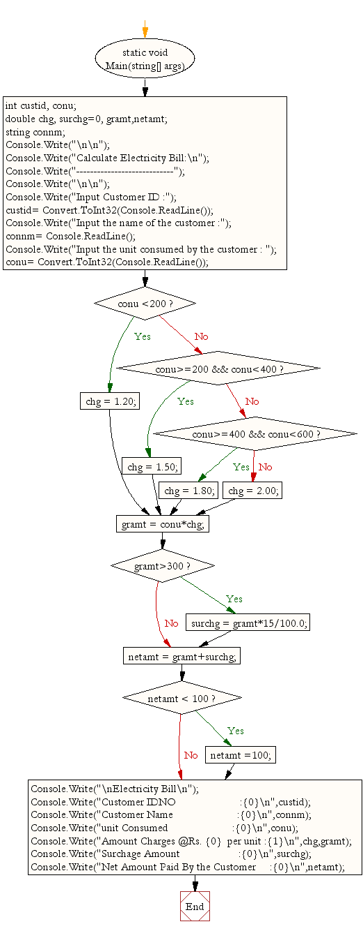

C# Sharp Exercises: A menu-driven program to compute the area of the various geometrical shape

Write a program in C# Sharp which is a Menu-Driven Program to compute the area of the various geometrical shape.
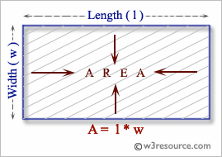
Sample output
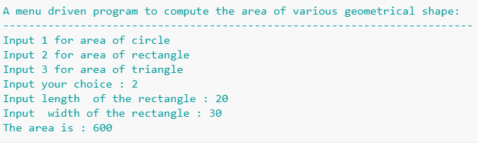

Flow Chart
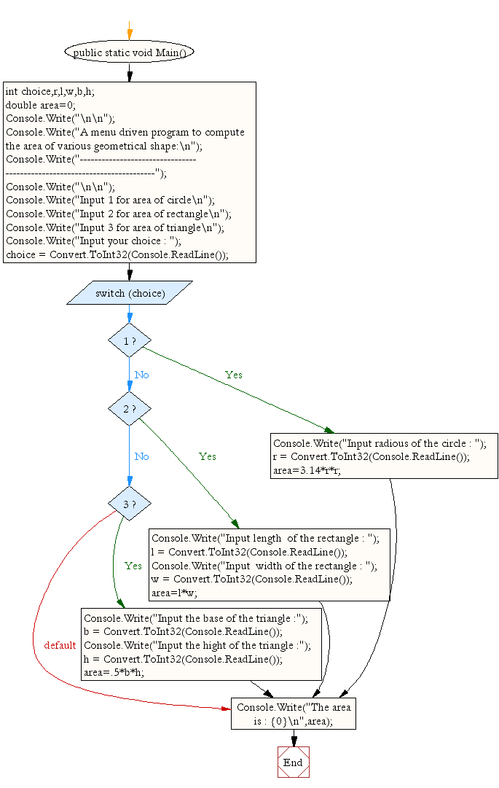

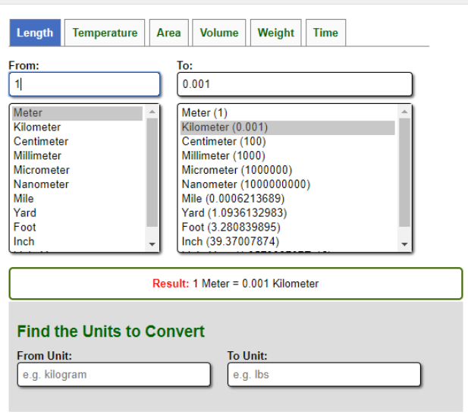
Make a unit converter in C# - Windows Form

Add Windows form Application
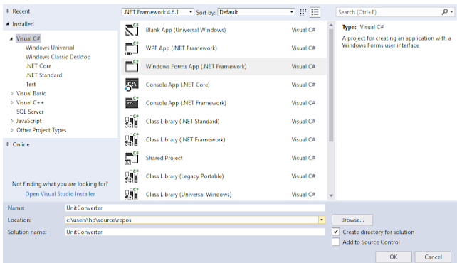

- Add Tab Control from the tool box.
- Add more Tab Pages from Properties
- And also change the Text of Tab Page to Length, Area, Volume, Temperature, Weight and Time.
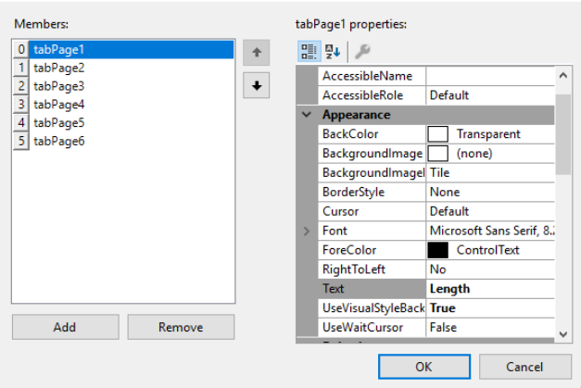
Your form will now look like the picture given below:

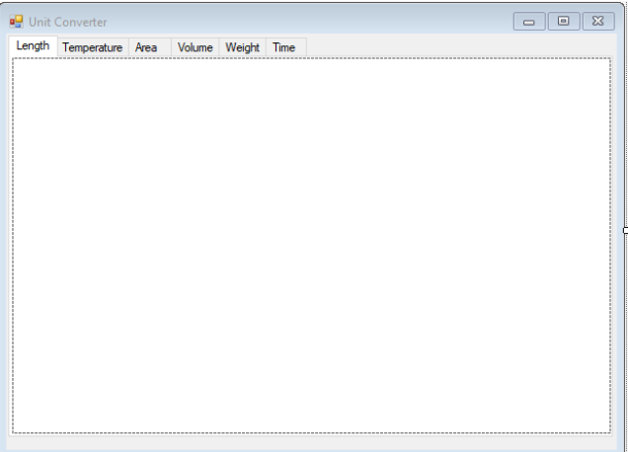

You can also change the Text of your Form from Properties ..
Add two Text Box , List Box , Label , Button from ToolBox.. Do the same for all TabPages .. Change the text of Button & Label...
You must change the name of Text Box (txtLengthTo, txtLengthFrom), List Box (lstLengthTo , txtLengthFrom), Label (lblLengthTo , lblLengthFrom) , Button (btnLengthTo , btnLengthFrom) from Properties. Do the same for Area, Volume, Temperature, Weight and Time.
Add Items from Properties ... Collection include:
- Meter
- Kilometer
- Centimeter
- Millimeter
- Micrometer
- Nanometer
- Mile
- Yard
- Foot
- Inch
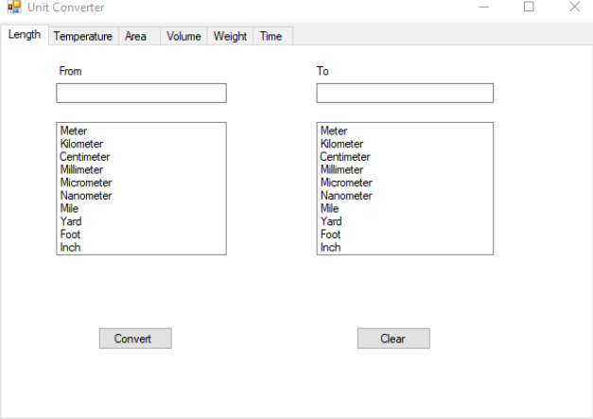
- for Length.

How to code for conversion
Do Double Click on the Convert button and write the code which will convert the Units. For example,
For Meter & Kilometer:
For Example: 1 meter = 0.001 km
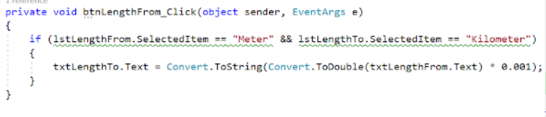
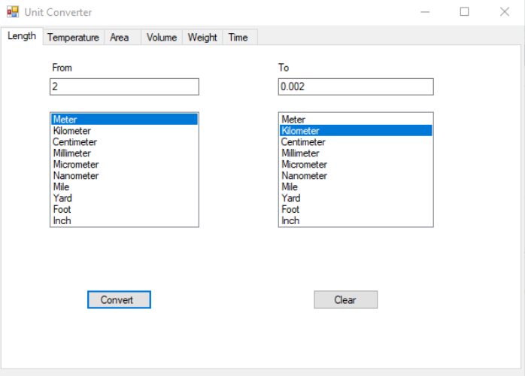
Check the output after first conversion
Then ,
Do the same for ,
- Meter To Meter
- Meter To Centimeter
- Meter To Millimeter
- Meter To Micrometer
- Meter To Nanometer
- Meter To Mile
- Meter To Yard
- Meter To Foot
- Meter To Inch
- Centimeter To Meter
- Centimeter To Centimeter
- Centimeter To Millimeter
- Centimeter To Micrometer
- Centimeter To Nanometer
- Centimeter To Mile
- Centimeter To Yard
- Centimeter To Foot
- Centimeter To Inch
- Millimeter To Meter
- Millimeter To Centimeter
- Millimeter To Millimeter
- Millimeter To Micrometer
- Millimeter To Nanometer
- Millimeter To Mile
- Millimeter To Yard
- Millimeter To Foot
- Millimeter To Inch
- Micrometer To Meter
- Micrometer To Centimeter
- Micrometer To Millimeter
- Micrometer To Micrometer
- Micrometer To Nanometer
- Micrometer To Mile
- Micrometer To Yard
- Micrometer To Foot
- Micrometer To Inch
- Mile To Meter
- Mile To Centimeter
- Mile To Millimeter
- Mile To Micrometer
- Mile To Nanometer
- Mile To Mile
- Mile To Yard
- Mile To Foot
- Mile To Inch
- Yard To Meter
- Yard To Centimeter
- Yard To Millimeter
- Yard To Micrometer
- Yard To Nanometer
- Yard To Mile
- Yard To Yard
- Yard To Foot
- Yard To Inch
- Foot To Meter
- Foot To Centimeter
- Foot To Millimeter
- Foot To Micrometer
- Foot To Nanometer
- Foot To Mile
- Foot To Yard
- Foot To Foot
- Foot To Inch
- Inch To Meter
- Inch To Centimeter
- Inch To Millimeter
- Inch To Micrometer
- Inch To Nanometer
- Inch To Mile
- Inch To Yard
- Inch To Foot
- Inch To Inch

The only change in your CODE is you have to change the name of Unit & the number which after multiply or divide convert a number from one unit to another as follows.
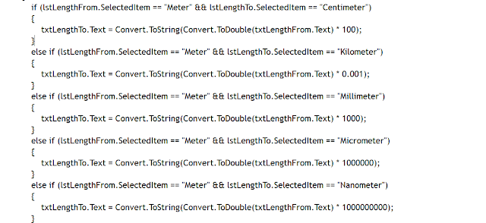

The Units for Temperature are:
- Celsius
- Kelvin
- Fahrenhiet

The collection of Units for Area are:
- Square meter
- Square kilometer
- Square centimeter
- Square millimeter
- Square micrometer
- Hectare
- Square mile
- Square inch
- Square foot
- Square yard
- Acre

The collection of Units for Volume :
- Cubic meter
- Cubic kilometer
- Cubic centimeter
- Cubic millimeter
- Liter
- Milliliter
- Cubic Mile
- Cubic inch
- Cubic foot
- Cubic yard

The collection of Units for Weight are:
- Kilogram
- Gram
- Milligram
- Metric Ton
- Long Ton
- Short Ton
- Pound
- Ounce
- Carrat
- Atomic Mass Unit

The collection of Units for Time are:
- Second
- Millisecond
- Microsecond
- Nanosecond
- Picosecond
- Minute
- Hour
- Day
- Week
- Month
- Year

Please Complete this projects.

