



TESCO PLC

BMMB7012 – Marketing Management

Future Developments in the Field of Marketing

Author: Andrew Morgan 0351590

Executive Summary
Tesco is a multinational retail corporation with its headquarters based in the United Kingdom. It is one of the largest supermarket chains globally, operating as one of the UK ‘Big Four’ supermarkets. Tesco operates stores in various formats and size under different brand names, including Tesco Extra, Tesco Superstore, Tesco Metro, and Tesco Express.
Over the years, Tesco has grown both organically and through acquisitions. It offers a diverse range of products, including groceries, clothing, electronics, household goods, and financial services. Tesco also has a competitive online position through its grocery platform offering customers home delivery and click and collect services.
Tesco has a significant presence in the United Kingdom, it is the largest supermarket chain with a circa 27% market share, whilst also boasting global operations.
Tesco's focus is on its customer’s needs, by providing quality products at competitive prices. The company has faced various challenges and undergone significant changes over the years, but it remains a prominent player in the global retail industry.
This report will critically evaluate Tesco’s Marketing strategy of its UK operations, scoping out the micro and macro environment using a range of marketing management tools such as STEEPLED analysis, Porters five forces and marketing mix.
Tesco has shown it plans to maintain or grow its market share through its customer focus strategy, unrivalled loyalty scheme, and by using innovation and data to become the leading supermarket.
Moving forward, it should focus on meat free alternatives, increasing vehicle charging infrastructure, explore further sustainability methods and broaden its social media presence.

Contents Page

Introduction…………………………………………………….…………………………….….…………………………….4
Marketing Strategy............................................................................................................5
Micro and Macro Emvironment?.......................................................................................5
STEEPLED Analysis……………………………..……..…………..………….………….………………………………..5
Porters Five Forces.………………………………….…………………………….……………………………………….9
Target Market…….………………………………………………………………………………………………………….11
Marketing Mix…………………………………………………….……….……….……………………………………....14
Media Selection………………………………………………………………………………………………………………17
Measuring Success...........................................................................................................18
Conclusion………………………………………………………………………………………………………………………19
Recommendations………………………………………………………………………………………………………….20
Bibliography……………………………………………………………………..……………………………………………21

Introduction
In 1919 Jack Cohen began trading with a small market stall in the east end of London, in 1924 the brand Tesco was born (Tesco, 2023). Tesco PLC has 337,000 employees across 4,100 stores throughout the UK and ROI, with an annual turnover of £57.7bn and operating profit of £2,630m for 2022 (Tesco Key Facts, 2023). Aside from groceries and fuel, Tesco has diversified into clothing, toys, finance services, electronics, telecoms, and internet services (Bedford, 2023a) Tesco is classed as one of the top four supermarkets in the UK and is a leading grocery retailer holding circa 27 percent of the market (Bedford, 2023b)
In 1995, Tesco launched the Clubcard as part of its marketing strategy, a revelation that became highly profitable. It would determine spending habits offering personalised offers whilst boosting itself to the UK’s top supermarket a year later (Winterman, 2013)
In 2022, the Tesco Clubcard loyalty programme was deemed the best reward scheme offered by any supermarket, with the highest customer satisfaction score, beating the likes of Sainsburys, Morrisons, Waitrose and Marks and Spencer’s (Houlton, 2023).
Tesco has recently made significant changes to its marketing strategy through Clubcard pricing, making all in store discounts accessible to Clubcard members only, altering the way points are collected on fuel spend and reducing the value of vouchers on partner rewards (Sayce, 2023)

Marketing Strategy
Tesco bases it marketing plan on three key core purposes: Customers, Communities, and the Planet. The marketing plan starts and end with the customers so that Tesco can focus on their needs and expectations (Tesco plc, 2023). According to Fahy & Jobber, “marketing is about attracting and keeping customers at a profit and aiming at long term customer satisfaction” (Fahy, Jobber, 2019). Neil Borden said, “Marketing is still an art, and the marketing manager, as head chef, must creatively marshal all his marketing activities to advance the short and long term interests of his firm” (Borden, 1964)

Main Findings
Micro and Macro Environment
Marketing strategy is devised through scoping the internal and external environments, this identifies forces that impact the immediate and/or wider environments, these in business terms are defined as micro and macro environment (Jobber, Ellis-Chadwick, 2019)
STEEPLED Analysis
The STEEPLED analysis assesses eight crucial variables that the business has little to no influence over when evaluating the macro-environment. It is very similar to the PESTEL analysis (Frue, 2022). It helps Tesco prevent rival businesses from obtaining a market advantage. The analysis that follows will assist the business in locating important change-related factors that could influence the success or failure of the organisation's strategy (Johnson et al., 2008, pp. 55–56).
Social
There are growing trends in what consumers are buying, more people are switching to alternative diets such as vegan, gluten free, vegetarian, keto and dairy free. Currently the UK has approximately 7.2 million people following a meat free diet with this expected to hit 15.8 million by the end of 2023 (Edwards, 2023). Other socio-cultural trends include more internet and electronic device usage driving the need for additional marketing channels from the traditional bricks and mortar, supermarket model.
Technological
The number of electric vehicles (EV’s) has grown exponentially, in the first quarter of 2023 showed sales of more than 2.3m cars. Tesco must ensure they have the infrastructure to allow greater charging facilities for customers whilst at the store (IEA, 2023). Significant increases in the use of self-service checkouts across supermarkets, Tesco will increase its self-service checkouts due to decline at manned checkouts throughout its stores (Wright, 2022). Some customers have aired frustrations due to a prison like experience in trying to exit the self-serve area due to increased shoplifting (Hill, 2023)
Economic
The cost-of-living crisis is having an impact as people look to save money by switching to cheaper brands or using more supermarkets to obtain the best value for money. Tesco has extended its price lock campaign to strengthen its customer position as the brand reported a seven percent jump in annual sales (wright, 2023)

Environmental
Environmental factors affecting Tesco have included, climate change, crop yields and agricultural issues. Growing environmental awareness driving a need to be more environmentally friendly with less packaging, less waste, and more recycling initiatives. Tesco has aimed to become carbon neutral across the group by 2035 and net carbon zero by 2050 across its full operations (Tesco, 2023)
Political
Tesco has had to overcome many political challenges and has shown that it can adapt and respond to such changes. The most significant being the Russian Ukraine war, impacts on rising costs have impacted suppliers and ultimately been passed on to the customer. Tesco have challenged suppliers for taking advantage and trying to ‘Cash In’ threatening to remove products from their shelves (Roswell, 2023).
Legal
Legal factors include consumer protection legislation and environmental legislation enforced by Trading Standards. Some Clubcard pricing changes have been highlighted by consumer groups as unit prices were unclear, Tesco has reassured compliance after advice from trading standards (Sri-Pathma, 2023)
The Climate Change Act 2008 was introduced to cut emissions and lower carbon footprint by 80% by 2050 (gov.uk). This included powers to charge for single use carrier bags, which Tesco has implemented across its stores.

Ethical
Tesco must ensure it has good Corporate Social Responsibility, Tesco must ensure the way in which it operates is sustainable against the society, environment, and economy (CIPD, 2023). As of 2020 changes to the grocery promotions are only accessible to Clubcard members only, which allows Tesco to obtain more data on shopping habits, whilst offering more personalised offers to the over eighty percent of people using the Clubcard at major stores (McGleenon, 2023).
Demographics
An ageing population, a growing population and a more diverse population brings changes in shopping habits and desires for consumers. The changes to the Clubcard promotion strategy have forced more people to join, enabling Tesco to collate more data on purchases.

Porters Five Forces
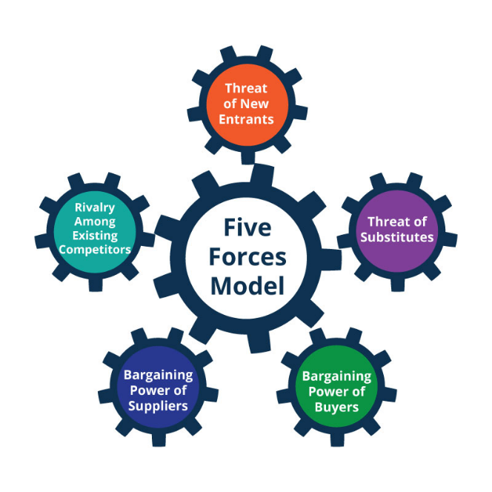
(Planium Pro, 2021)
Threat of new entrants (Low): The threat of new entrants to Tesco would be seen as low, they are well established, financially stable and start-up costs would be significant. There were over 310,000 retail businesses in the UK as of 2022 (retail economics, 2023)
Buyer Bargaining power (High): Buyer power is high because there are few buyers and lots of suppliers. Customers can easily switch to alternative supermarkets for cheaper products. This is why Tesco and other supermarkets negotiate extremely competitive prices with producers. The exception is with large multinationals such as Unilever and Proctor & Gamble, in 2016 Tesco had a dispute with Unilever over the pricing of Marmite, refusing to increase prices across the board by 10%, this was eventually resolved (Butler, Kollewe, 2016)
Supplier bargaining power (Low): Supplier bargaining power in the supermarket industry is extremely low because there are lots of suppliers and very few buyers. It allows Tesco to negotiate low prices for products, in turn increasing profit margins. Top eight supermarkets are holding over 90% of the market share in the UK (Bedford, 2023b).
Competitors (High): Competition for Tesco is high, other big supermarkets have similar supply chains, marketing strategies and finances to support. This causes strong competition against rivals as they each fight for market share. Supermarkets are primarily built on groceries; their locations and pricing are key components that help create differences. As of April 2023, Tesco is still holding the majority with a 27% market share, a position it has maintained for several years. The cost-of-living crisis is also seeing people shop at multiple supermarkets to simply save money.
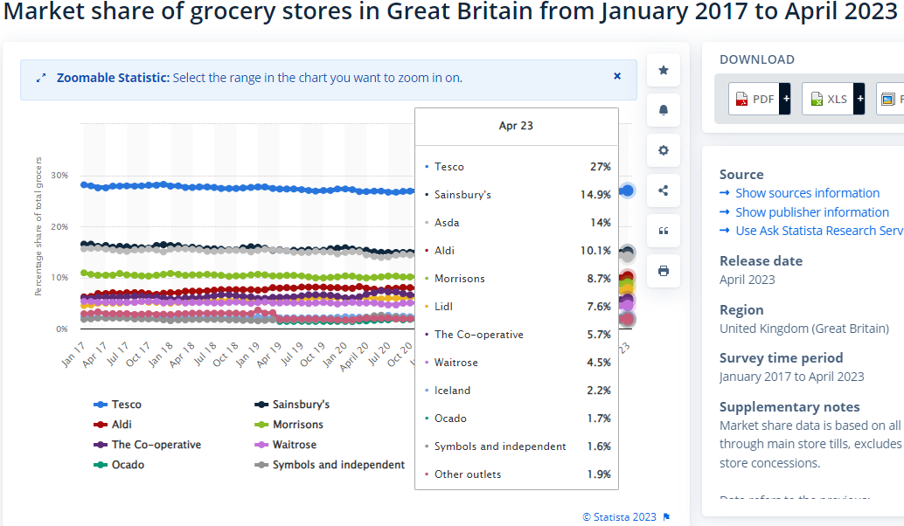
(Source: Bedford, 2023b)
Threat of substitutes (Low): Threat of substitutes for Tesco would be low, Tesco offers a range of products from groceries, homeware, clothing, and electronics that satisfy the needs of its customers. It offers these across the different size stores and through its E-commerce. It also boasts an unrivalled loyalty scheme making it hard for substitutes to rival.

Target Market
Segmentation, targeting, and positioning are the foundations of marketing strategy. A company identifies various consumer needs and groups in the market, focuses on those it can satisfy in a superior way, and then positions its offerings so that the target market recognises it for its distinctive offerings and images (Kotler et al, 2022).
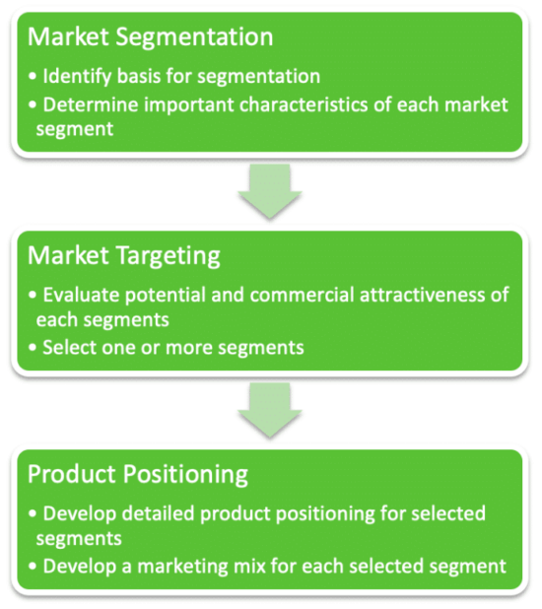
(Hanlon, 2022)

Segmentation
There are four key areas of market segmentation, these are geographic, demographic, behavioural and psychographic. This report focuses on three of the four as the Clubcard data would provide the Psychographic data through the consumer data it holds..
Geographic
Tesco has strategically placed stores throughout the UK, covering rural and urban locations. They range from large superstores to smaller express convenient stores. It can analyse data from the Clubcard to determine store locations and size based on footfall (Poulter, 2011).
Demographic
Tesco’s products cater for all; they offer goods to all people of all ages and cater for almost every dietary requirement with an ever-expanding range. In recent years they have also looked at people who eat or live alone (Wood, 2018).
Behavioural
Tesco has always aimed for cost and quality, where customers feel satisfied with a good quality product at low cost. This in turn can make them brand loyal and likely to continue as Tesco customers.
The result of segmentation allows Tesco to divide the large market into smaller pieces to target.
Market Targeting
Target markets are evaluated in segments, based on the evaluation the potential is determined and prioritised, this evaluation includes the following:
- Criteria size
- Difference
- Money
- Accessible
- Focus on different benefits (Hanlon, 2022)
Tesco’s focus is on its customers, to bring quality products based on customers’ needs and demands, the withdrawal of Jack’s in 2022 seen Tesco launch the Aldi price match, with a primary focus to deliver best value for its customers across the core elements of the business (Tesco Plc, 2022)
Positioning
Tesco is a differentiator in many ways because it differentiates from its competitors such as Lidl and Aldi by offering much wider products and services. It also has a cost focus element via its Tesco Value range. This shows how Tesco positions itself as a differentiator mainly, but also competes on cost with some product ranges, probably due to its large market share.
Tesco position themselves as a supermarket of high quality at low cost, pledging to lock in prices to support its customers as it continues to offer great value for money to its brand.

The Marketing Mix
The Marketing Mix was established in by Jerome McCarthy in the 1960’s, he derived the four P’s by taking multiple marketing activities and splitting them into four kinds: Product, Place, Price and promotion (Kotler, 2017). In the 1990’s this grew to become the seven Ps with the inclusion of Process, Physical evidence and people.
Product
Tesco is renowned for its large selection of groceries, whilst it has also diversified into homeware, stationary, electronics, financial services, and clothing. Products are offered as Tesco Redmere farm (low-cost value brand), standard own brand, Finest range, F&F clothing, go cook and fox & ivy. They also host a range of other branded products throughout its store network.
Stores are stocked on information collected from automated software that determines buying habits, weather, and historical trends, which allows products to be stocked accordingly (Brice, 2013).
Place
Tesco has over 4,100 stores situated throughout the UK with many more worldwide, the bricks and mortar stores range from superstore, extra, metro, and express (Bedford, 2023a). These stores are large to small offering a vast range of products to smaller convenience style shopping.
There is also the online facility to enable customers to conveniently shop from their own home and request either home delivery or collection from store.
Price
Tesco is focused on cost leadership, by doing so can offer low prices for high quality products, it can do this through economies of scale to reduce costs and subsequently pass these onto its customers. In October 2022, Tesco released its low everyday pricing strategy to lock in prices until July 2023 on over 1,000 products, to combat the cost-of-living crisis (Houlton, 2023). There was some recent criticism that 100’s of budget products had been cut which Tesco was quick to respond to (Highfield, 2022)
Promotion
Tesco has generally relied upon is print and media to communicate with its target audience. In recent years Tesco has focused more on digital media with the changes to the Clubcard pricing strategy, where discounts are exclusively available to Clubcard members. Recently Tesco has removed the Clubcard app and replaced it with a new Grocery and Clubcard app, providing more frequent personalised offers which will only be available via the app (McHardy, 2023).
The Clubcard changes in 2020 caused some internal debate, however this paid dividend as Clubcard members increased from 14m to 21m, providing unrivalled customer data (Carroll, 2023). Although loyalty schemes exist elsewhere, it’s about how Tesco engage with its customers, Tesco’s Chief customer officer Alessandra Bellini said that “The mechanics may be the same but what you deliver, the value you deliver, and how you do it can be very different” (Bellini, 2023). Geoffrey Mogre stated, “Without big data analytics, companies are blind and deaf, wandering out onto the web like deer on a freeway” (Mogre, 2021)

People
Tesco employs 337,000 people across the UK and ROI, it has invested a significant amount in creating a development academy, to support the development of its staff whilst also offering a leadership programme to allow individuals to grow and enhance their people management skills (Tesco, 2023). Tesco has offered staff access to virtual doctor’s appointments privately as the struggles within the NHS continue (Goldfingle, 2023). There has been a change at chair level with Gerry Murphy replacing John Allen after he recently stepped down amid allegations of misconduct (Kollewe, 2023)

Process
Tesco has a process of online orders either delivered to the customers door or via the click and collect option. Traditionally they still have the in-store shopping method where customers pick their shopping and either go to a cashier or to the self-service checkouts, of which will increase due to growing demands whilst lowering costs (Wright, 2022)
Physical Evidence
Tesco has a very easy to navigate stores, they are vibrant, modern, colourful, and welcoming to customers. The Tesco logo is big and can often be seen from the roadway, marking its presence in the area. The website and app are very easy to navigate and operate whilst also looking great.

Media Selection
Tesco utilises several different media options to support the marketing strategy, whilst Clubcard data is key, other key components include:
Advertising – various campaigns are run through print, television, radio and digitally including grocery app, to support promotions which aids sales and attracts customers.
Digital Marketing – This has become the main source of marketing for Tesco, it has reduced costs to conventional marketing by utilising emails, social media, and Search Engine Optimisation. Over 47% of searches are organic with just 3% paid searches (Statista, 2023). Tesco.com is the leading supermarket for traffic, it currently sits ahead of its competitors with an average of 31M visits per month, has an average visit of 05.49, a 40.31% bounce rate and 7.73 average page visit (Similarweb.com, 2023).
Social Media – Tesco has many active social media accounts, to showcase promotions and content, either by Tesco or through paid partnerships. Tesco.com receives 35.86% of traffic from YouTube, whilst WhatsApp Webapp sends a mere 3.6% (Similarweb, 2023).
Tesco Magazine – Tesco produces a magazine that showcases new and existing products across the range, it features trends in the market such as healthy meal recipes, seasonal produce and general health and wellbeing.
All the above are effective methods of media, they each engage and reach different levels of customer. Digital marketing is key for Tesco to reach customers directly, whilst social media is becoming more powerful and persuasive, giving Tesco access to direct communications, influencer partnerships and more brand exposure.

Measuring Success
Tesco will utilise many different metrics to measure success, these will be financial and non-financial, including:
Market Share – Tesco currently holds 27% of the market share, the leader out of the ‘Big Four’ with Sainsbury’s second at 17%. Constant monitoring will allow Tesco to evaluate its position and see increase or decrease and act accordingly.
Financial – Finances are measured annually on gross and net profits, ROI, share values, sales growth and operating costs. As of 2022, Tesco had turnover of £57.7m with a group operating profit of £2,630m (Tesco plc, 2023) dividend shares have increased from 2021 to 9.15p to 10.90p in 2023 (Forbes, 2023)
Digitisation – It will continue monitor the growth across its digital platforms, as of 2023, the Tesco Grocery App has seen 6 million downloads, the highest downloads of food delivery and takeaway apps, beating the likes of Uber Eats, Just Eat and Deliveroo (Coppola, 2023) Sales growth can be measured and the footfall as people transition into a more digital way of shopping.
Innovation – Clubcard price strategy seen an increase of 7M members, this leads to more data which Tesco can use to their advantage. As of 2023, 80% of shoppers at bricks and mortar outlets use a Clubcard. The grocery app has meant that all coupons will now move digital, this could impact the elder generation.
CSR and Sustainability - Tesco have set sustainability as a core purpose, they will achieve through strategic objectives and business plans. They aim to become net carbon zero by 2035, which could have a positive impact on market position, operating in a more responsible and sustainable way,

Conclusion
The key findings from this analysis show that Tesco is committed to maintain its presence as one of the big four UK supermarkets. It continues to offer high quality at low cost to customers to win and ensure unrivalled loyalty. A change at chair level will bring new ideas and stability for what is already in great shape.
The changes to the Clubcard pricing strategy have proven to be pivotal for Tesco, a marketing strategy that has increased loyalty scheme members to 21M. This will provide unrivalled data against its competitors giving them significant competitive advantage.
Changes within the Macro environment have had no impact on profits, Tesco has shown resilience as it responds to such impacts, maintaining its significant market share, with the key focus remaining on its customers.
As the recent changes to the Clubcard app merging into the grocery app, it seen Tesco take the number one spot of all food delivery and takeaway apps available for download.
It has pledged to do more on its CSR and sustainability across its operation, pledging to become net carbon zero by 2035, but could be doing more.

Recommendations
Marketing Mix
Tesco needs to constantly review the marketing mix, this allows better planning and anticipation to changes, such as the Ukraine Russian war which impacted on suppliers which Tesco was able to respond to. Key focus on expansion of meat free products, as statistics point to a potential 7m increase by the end of 2023 (Edwards, 2023)
Sustainability
Tesco should look at more new initiatives to bring more environmentally friendly and sustainable packaging and products to its customers. Utilising less packaging, locally sourcing, waste reduction and promoting recycling.
Technology
As electric vehicles increase, the infrastructure should be prioritised to support vehicle charging across its store network. This will reassure customers that they can conveniently charge whilst shopping, and or utilise the café area whilst charging, increasing sales.
Customer loyalty
Whilst the changes to the loyalty scheme have taken place to a digitised format, the usage should be monitored to ensure the elderly who are less savvy with technology don’t miss out on rewards to which they are entitled to.
Social media
New opportunities may be revealed Utilising WhatsApp Webapp by engaging with its customers. This is the weakest social media platform for engagement at less than 3.5%.
Bibliography
BBC (2020) Tesco: Brexit impact on food prices ‘very modest’, BBC News. Available at: https://www.bbc.co.uk/news/uk-55460948
(Accessed: 04 July 2023).
Bedford, E. (2023) Topic: Tesco plc, Statista. Available at: https://www.statista.com/topics/3807/tesco-plc/#topicOverview
(Accessed: 21 June 2023).
Bedford, E. (2023) Great Britain: Grocery market share 2023, Statista. Available at: https://www.statista.com/statistics/280208/grocery-market-share-in-the-united-kingdom-uk/#:~:text=The%20market%20share%20of%20of%20the%20leading%20supermarkets,of%20the%20market%20together%20as%20of%20April%202023
(Accessed: 06 July 2023).
Bellini, A. (2023) Tesco’s CMO on making Clubcard stand out in a sea of Loyalty Schemes, Marketing Week. Available at: https://www.marketingweek.com/tesco-clubcard-stand-out/
(Accessed: 07 July 2023).
Borden, N. H. (1964) The Concept of the Marketing Mix. Journal of Advertising Research. Cambridge, UK: Cambridge University Press. Available from https://motamem.org/wp-content/uploads/2019/07/Borden-1984_The-concept-of-marketing-mix.pdf
[accessed 30 August 2021].
Butler, S. and Kollewe, J. (2016) Tesco and Unilever Settle Marmite dispute, The Guardian. Available at: https://www.theguardian.com/business/2016/oct/13/tesco-unilever-resolve-marmite-dispute-price-supermarket
(Accessed: 16 July 2023).
Carroll, N. (2023) Tesco’s CMO on making Clubcard stand out in a sea of Loyalty Schemes, Marketing Week. Available at: https://www.marketingweek.com/tesco-clubcard-stand-out/ (Accessed: 07 July 2023). CIPD (2022) Corporate responsibility: Factsheets, CIPD. Available at: https://www.cipd.co.uk/knowledge/strategy/corporate-responsibility/factsheet
(Accessed: June 21, 2023).
Edwards, L. (2023) How many vegetarians and vegans are in the UK?, Finder UK. Available at: https://www.finder.com/uk/uk-diet-trends#:~:text=Currently%2C%2014%25%20of%20adults%20in%20the%20UK%20%287.2,beginning%20of%202023%20%2830%25%20of%20the%20adult%20population%29.
(Accessed: 04 July 2023).
Fahy, J. and Jobber, D. (2019) Foundations of marketing. Sixth edition. London: McGraw-Hill Education.
Frue, K. (2022) Steepled analysis: What is it with examples, PESTLE Analysis. Available at: https://pestleanalysis.com/steepled-analysis/
(Accessed: June 11, 2023).
Goldfingle, G. (2023) Tesco offers Staff Private Virtual doctor appointments, Retail Gazette. Available at: https://www.retailgazette.co.uk/blog/2023/07/tesco-private-doctors/
(Accessed: 06 July 2023).
Highfield, A. (2022) Tesco slammed for cutting 100 budget products, available at: https://www.mylondon.news/whats-on/shopping/tesco-slammed-cutting-100-budget-24752951
(accessed 31 June 2023)
Hanlon, A. (2022) STP Marketing: The segmentation, targeting, positioning model, Smart Insights. Available at: https://www.smartinsights.com/digital-marketing-strategy/customer-segmentation-targeting/segmentation-targeting-and-positioning/
(Accessed: 07 July 2023).
Hill, E. (2023) As shoplifting soars, will self-checkout barriers become the norm?, Retail Gazette. Available at: https://www.retailgazette.co.uk/blog/2023/07/self-checkout-barriers/
(Accessed: 10 July 2023).
Houlton, C. (2022) Tesco Clubcard named Best Supermarket Rewards Scheme, Grocery Gazette - Latest Grocery Industry News. Available at: https://www.grocerygazette.co.uk/2022/11/10/tesco-clubcard-rewards-scheme/
(Accessed: 11 June 2023).
Houlton, C. (2023) Tesco extends price lock on over 1,000 products as it drops milk prices, Grocery Gazette - Latest Grocery Industry News. Available at: https://www.grocerygazette.co.uk/2023/04/12/tesco-price-lock-milk/
(Accessed: 05 July 2023).
Hutton, G. (2021) Retail sector in the UK - researchbriefings.files.parliament.uk. Available at: https://researchbriefings.files.parliament.uk/documents/SN06186/SN06186.pdf
(Accessed: 07 July 2023).
IEA (2023) Executive summary – global EV outlook 2023 – analysis, IEA. Available at: https://www.iea.org/reports/global-ev-outlook-2023/executive-summary
(Accessed: 10 July 2023).
Isaac, A. and Partridge, J. (2023) Tesco Chair to stand down after allegations of inappropriate behaviour, The Guardian. Available at: https://www.theguardian.com/business/2023/may/19/tesco-chair-john-allan-steps-down
(Accessed: 07 July 2023).
Jobber, D and Ellis-Chadwick, F (2019) Principles and practice of marketing. Ninth edition. Maidenhead: McGraw-Hill Higher Education.
Johnson, G., Scholes, K. and Whittington, R. (2008) Exploring corporate strategy. Pearson Education UK. P.55-56
Kollewe, J. (2023) Tesco appoints Burberry boss as chair to replace John Allan, The Guardian. Available at: https://www.theguardian.com/business/2023/jul/02/tesco-appoints-burberry-boss-as-chair-to-replace-john-allan
(Accessed: 12 July 2023).
Kotler, P., Keller, K.L. and Chernev, A. (2022) Marketing management. Harlow, England: Pearson Education Limited.
McGleenon, B. (2023) Urgent price warning to Tesco customers without a Clubcard, Yahoo! News. Available at: https://uk.news.yahoo.com/tesco-clubcard-prices-phone-contracts
(Accessed: 21 June 2023).
McHardy, M. (2023) Tesco issues fresh warning to anyone with a Clubcard, The Independent. Available at: https://www.independent.co.uk/news/uk/home-news/tesco-clubcard-points-deadline-app-b2302171.html
(Accessed: 05 July 2023).
Mogre, G. (2021) 5 ways Tesco uses Big Data Analytics, Analytics Steps. Available at: https://www.analyticssteps.com/blogs/5-ways-tesco-uses-big-data-analytics
(Accessed: 07 July 2023).
Planium Pro (2021) Porter’s five forces analysis: Assessing the competitive environment, Planium Pro. Available at: https://www.planiumpro.com/blog/porters-five-forces-analysis-assessing-the-competitive-environment/
(Accessed: 16 July 2023).
Poulter, Sean (2011) Tesco sells Clubcard data for £53m, Insight DIY. Available at: https://www.insightdiy.co.uk/news/tesco-sells-clubcard-data-for-53m/635.htm#:~:text=Not%20only%20does%20this%20let%20Tesco%20chiefs%20know,run%20junk%20mail%20advertising%20campaigns%20for%20particular%20products.
(Accessed: 06 July 2023).
Retail Economics (2023) UK retail stats and facts, Retail Economics. Available at: https://www.retaileconomics.co.uk/library-retail-stats-and-facts
(Accessed: 07 July 2023).
Roswell, J. (2023) Tesco ‘falls out with suppliers’ over whether price hikes are justified, Supply Management. Available at: https://www.cips.org/supply-management/news/2023/january/tesco-falls-out-with-suppliers-over-whether-price-hikes-are-justified/
(Accessed: 10 July 2023).
Sayce, R. (2023) Major changes to Tesco Clubcard from today - all you need to know, Metro. Available at: https://metro.co.uk/2023/06/12/two-major-changes-coming-to-tesco-clubcard-this-week-what-you-need-to-know-18934494/
(Accessed: 21 June 2023).
Similarweb (2023) Tesco.com market share, revenue and Traffic Analytics | Similarweb. Available at: https://www.similarweb.com/website/tesco.com/
(Accessed: 10 July 2023).
Sri-Pathma, V. (2023) Tesco could be breaking law on Clubcard Pricing, says Which?, BBC News. Available at: https://www.bbc.co.uk/news/business-65854124
(Accessed: 15 June 2023).
Tesco (2023) Our history, Home. Available at: https://www.tescoplc.com/about/our-history/
(Accessed: 04 July 2023).
Tesco (2023b) Opportunities to get on | Tesco careers. Available at: https://www.tesco-careers.com/explore-our-world/opportunities-to-get-on/
(Accessed: 06 July 2023).
Tesco PLC (2022) Making our business fit for the future, Home. Available at: https://www.tescoplc.com/news/2022/making-our-business-fit-for-the-future/
(Accessed: 06 July 2023).
Winterman, D. (2013) Tesco: How One supermarket came to dominate, BBC News. Available at: https://www.bbc.co.uk/news/magazine-23988795
(Accessed: 04 July 2023).
Wood, Z. (2018) Tesco targets growing number of Britons who eat or live alone, The Guardian. Available at: https://www.theguardian.com/business/2018/jul/06/tesco-targets-growing-number-of-britons-who-eat-or-live-alone
(Accessed: 06 July 2023).
Wright, G. (2022) Tesco says goodbye to staffed checkouts as it prioritises self-service in store revamp, Retail Gazette. Available at: https://www.retailgazette.co.uk/blog/2022/08/tesco-checkouts/
(Accessed: 04 July 2023).
Wright, G. (2023) 4 ways Tesco is winning shoppers during the cost-of-living crisis, Retail Gazette. Available at: https://www.retailgazette.co.uk/blog/2023/04/tesco-maintaining-customers/
(Accessed: 21 June 2023).

