Flemming’s VAK – visual-auditory-kinaesthetic Model (1920s)
The term “learning styles” speaks to the understanding that every student learns differently. Technically, an individual’s learning style refers to the preferential way in which the student absorbs, processes, comprehends and retains information. For example, when learning how to build a clock, some students understand the process by following verbal instructions, while others have to physically manipulate the clock themselves. Individual learning styles depend on cognitive, emotional and environmental factors, as well as one’s prior experience. In other words: everyone’s different. It is important for teachers and trainers to understand the differences in their students’ learning styles, as well as knowing their own preferred learning style, so that they can plan and implement best practice teaching and learning strategies into their daily activities, curriculum and assessments.

Understanding VARK
One of the most accepted understandings of learning styles is that student learning styles fall into three “categories:” These learning styles are found within educational theorist Neil Fleming’s VAK model of Student Learning. VAK is an acronym that refers to the three types of learning styles: Visual, Auditory, and Kinaesthetic.
- Students’ preferred learning modes have significant influence on their behaviour and learning.
- Students’ preferred learning modes should be matched with appropriate learning strategies.
- Information that is accessed through students’ use of their modality preferences shows an increase in their levels of comprehension, motivation and metacognition.
Identifying your student’s, as visual, auditory or kinaesthetic learners, and aligning your overall curriculum with these learning styles, will prove to be beneficial for your entire classroom. Allowing students to access information in terms they are comfortable with will increase their academic confidence.
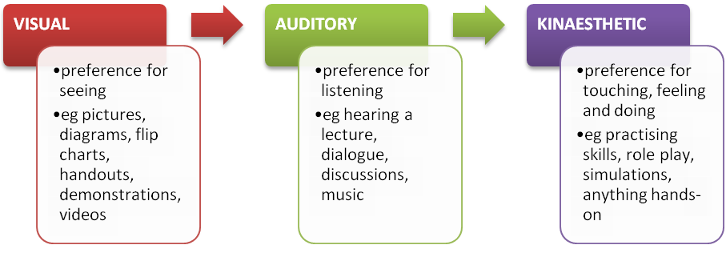

Now complete the questionnaire below, to help determine whether you are a visual, auditory or kinaesthetic learner.

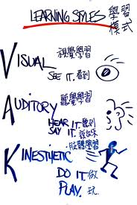

VAK Learning Styles Self-Assessment Questionnaire
Circle or tick the answer that most represents how you generally behave.
- When I operate new equipment I generally:
  - read the instructions first
  - listen to an explanation from someone who has used it before
  - go ahead and have a go, I can figure it out as I use it

- When I need directions for traveling I usually:
  - look at a map
  - ask for spoken directions
  - follow my nose and maybe use a compass

- When I cook a new dish, I like to:
  - follow a written recipe
  - call a friend for an explanation
  - follow my instincts, testing as I cook

- If I am teaching someone something new, I tend to:
  - write instructions down for them
  - give a verbal explanation
  - demonstrate first and then let them have a go

- I tend to say:
  - watch how I do it
  - listen to me explain
  - you have a go

- During my free time I most enjoy:
  - going to museums and galleries
  - listening to music and talking to my friends
  - playing sport or doing DIY

- When I go shopping for clothes, I tend to:
  - imagine what they would look like on
  - discuss them with the shop staff
  - try them on and test them out

- When I am choosing a holiday I usually:
  - read lots of brochures
  - listen to recommendations from friends
  - imagine what it would be like to be there
- If I was buying a new car, I would:
  - read reviews in newspapers and magazines
  - discuss what I need with my friends
  - test-drive lots of different types

- When I am learning a new skill, I am most comfortable:
  - watching what the teacher is doing
  - talking through with the teacher exactly what I am supposed to do
  - give it a try myself and work it out as I go

- If I am choosing food off a menu, I tend to:
  - imagine what the food will look like
  - talk through the options in my head or with my partner
  - imagine what the food will taste like

- When I listen to a band, I can’t help:
  - watching the band members and other people in the audience
  - listening to the lyrics and the beats
  - moving in time with the music

- When I concentrate, I most often:
  - focus on the words or pictures in front of me
  - discuss the problem and the possible solutions in my head
  - move around a lot, fiddle with pens and pencils and touch things

- I choose household furnishing because I like:
  - their colours and how they look
  - the descriptions the sales-people give me
  - the textures and what it feels like to touch them

- My first memory is of:
  - looking at something
  - being spoken to
  - doing something

- When I am anxious, I:
  - visualise the worst-case scenarios
  - talk over in my head what worries me most
  - can’t sit still, fiddle and move around constantly

- I feel especially connected to other people because of:
  - how they look
  - what they say to me
  - how they make me feel

- When I have to revise for an exam, I generally:
  - write lots of revision notes and diagrams
  - talk over my notes, alone or with other people
  - imagine making the movement or creating the formula

- If I am explaining to someone I tend to:
  - show them what I mean
  - explain to them in different ways until they understand
  - encourage them to try and talk them through my ideas as they do it

- I really love:
  - watching films, photography, looking at art or people watching
  - listening to music, the radio or talking to friends
  - taking part in sporting activities, eating fine foods and wines and dancing

- Most of my free time is spent:
  - watching television
  - talking to friends
  - doing a physical activity or making things

- When I first contact a new person, I usually:
  - arrange a face to face meeting
  - talk to them on the telephone
  - try to get together while doing something else, such as an activity or a meal

- I first notice how people:
  - look and dress
  - sound and speak
  - stand and move

- If I am angry, I tend to:
  - keep replaying in my mind what it is that has upset me
  - raise my voice and tell people how I feel
  - stamp about, slam doors and physically demonstrate my anger

- I find it easiest to remember:
  - faces
  - names
  - things I have done

- I think you can tell if someone is lying if:
  - they avoid looking at you
  - their voice changes
  - they give me funny vibes

- When I meet an old friend:
  - I say “It’s great to see you!”
  - I say “It’s great to hear from you!”
  - I give them a hug or a handshake

- I remember things best by:
  - writing notes or keeping printed details
  - saying them aloud or repeating words and key points in my head
  - doing or practising the activity or imagining it being done

- If I have to complain about faulty goods, I am most comfortable:
  - writing a letter
  - complaining over the phone
  - taking them back to the store or posting them back to head office

- I tend to say:
  - I see what you mean
  - I hear what you are saying
  - I know how you feel

Now add up how many A’s, B’s and C’s you selected.
A’s = B’s = C’s =
- If you chose mostly A’s you have a VISUAL learning style
- If you chose mostly B’s you have an AUDITORY learning style
- If you chose mostly C’s you have a KINAESTHETIC learning style

VAK Learning Styles Explanation
The VAK learning styles model suggests that most people can be divided into one of three preferred styles of learning. These three styles are as follows, (there is no right or wrong learning style)

Someone with a visual learning style has a preference for seen or observed things, including pictures, diagrams, demonstrations, displays, handouts, films, flipchart, etc. These people will use phrases such as “show me” , “let’s have a look at that” and will be best able to perform a new task after reading the instructions or watching someone else do it first. These are the people who will work from lists and written directions and instructions.

Someone with an auditory learning style has a preference for the transfer of information through listening: to the spoken word of self or others, of sounds and noises. These people will use phrases such as “tell me” , “let’s talk it over” and will be best able to perform a new task after listening to instructions from an expert. These are the people who are happy being given spoken instructions over the phone, and can remember all the words to songs they hear!
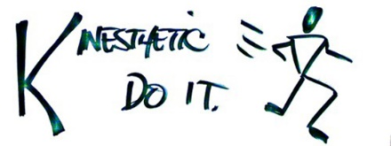
Someone with a kinaesthetic learning style has a preference for physical experience – touching, feeling, holding, doing, practical hands-on experiences. These people will use phrases such as “Let me try”, “how do you feel?” and will be best able to perform a new task by going ahead and trying it out, learning as they go. These are the people who like to experiment, hands-on, and never look at the instructions first.

