

Assessment 1 – Reading Task Template
PART 1: Upload your photo of your A3 in-class notes here:
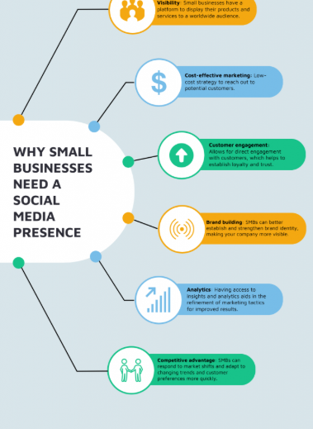

PART 2:
- Answer every question below in 1-3 full sentences.
- Use your own words. Do not use generative AI to answer these questions.
- Include a specific detail from the text when asked.
REMINDER
- The main idea is the overall message of the whole text.
- A key point helps to explain the main idea.
- A specific detail or example from the text shows that the key point is true.

- What is the main idea of the whole text?

Social can help small business to grow by assisting them on their platforms like TikTok, Instagram and Facebook which will increase profit and sales.

- What is one key point that supports the main idea, and which specific example from the text shows this?
Main ideas this platform can assisted small to business to grow fast and to be noticed on a global market maximise sales.

- What is a different key point that supports the main idea, and which specific example from the text shows this?

Another key point is that social media can boost popularity and increase sales, the most obvious to me would be Binley Mega chippy because it has had a positive impact on social media.

- Which part of the text do you think is most important, and why?
Reading and understanding the text by reading serval time has helped me, by highlighting information that helped the most could improve the business.

Reflection:
- What did you find difficult in this task (including in-class components), and why was it difficult?
I found it difficult choosing the right article to use as an example from the main idea

- What helped you with this difficulty, and how did it help you?

