Assessment of Internal Engine Components
Ragulan Pulanthitan (2200662)
ACHA6006: Contemporary Powertrain Design
School of Engineering


Contents
1. Introduction 2
2. Background Research 3
3. Basic Kinematics 4
4. Fatigue Safety Factors 6
5. Connecting Rod Bolt Redesign 11
6. Conclusion 14
7. References 15

Introduction
This analytical assessment will use pressure data and geometric dimensions given from the Ford EcoBoost 1.6 GDTi engine. Basic kinematic equations will be implemented to gain an understanding of the motion observed by the internal components before calculating the forces they experience. Inertia and gas forces are used to calculate the net tensile and compressive forces which are needed to find the force and stresses on the connecting rod, gudgeon pin and con rod bolt. By finding the maximum, minimum, mean, allowable and range of the stresses on each component, a factor of safety can be calculated for each rpm and used to plot a Goodman’s diagram. Using inertia forces, the torque and inertia of each cylinder and crankshaft can be calculated and compared to a cross-plane crankshaft.
Following the initial calculations coupled with stress concentration factors, a redesign of the con rod bolt can be made to view the differences in stresses and factor of safety. This redesign can be made by changing the stiffness of the bolt or material. The pressure data given for the engine can be extended to 9000 RPM through an interpolation function in MATLAB which will allow for a recalculation of the relevant safety factors.

Background Research
Connecting rods will rotate at the same speed as the crankshaft but witness very large tensile and compressive stresses when running as well as shear and bending stresses due to the centrifugal forces during rotation (nautilusshipping.com, 2022). There are different methods of manufacturing rods such as casting which is usually a cheaper and easier. These are adequate for low-power, low-speed applications. Comparatively, forged rods make for good properties like ductility, impact toughness, and fatigue strength. In an internal combustion engine, the piston will experience huge thermal and structural strains due to its high speed and load under tremendous temperature and pressure. (Suchendra, 2024). To avoid fatigue failure, stress concentrations should be reduced to prevent cracks from forming. Regarding the redesign of the conrod bolt, its important to keep track of the bolt stiffness and fatigue safety factors per RPM for each iteration of design. The conrod bolts are subjected to cyclic loading as the engine is running, and repeated tension and compression cycles could lead to fatigue failure if poorly designed. Ensuring the fatigue safety factor remains high will help prevent such failures. Further work from this will include material changes to the bolt which would impact its Young’s Modulus and ultimate tensile strength. Subsequently, the bolt stiffness and fatigue safety factors can be evaluated from this. Common materials used for conrod bolts include carbon steel, alloy steel, stainless steel, titanium, Inconel, brass and bronze (Shigley et al, 2004). Toque differences for different crankshaft designs will also be explored as cross-plane crankshaft engines can typically produce a lot of low-end torque but are limited in their RPM range. Inversely, common flat plane crankshaft engines have less torque, but rev to a relatively higher limit. The two designs also have audible differences in the noise they produce (Edtengineers.com, 2022).

Basic Kinematics
After creating variables in MATLAB to assign component dimensions and characteristics to constraints used in the script, calculations can be made to find the piston position ‘s’ using the crank radius, rod length and the crank angle range between -360° to 360°. By differentiating the piston position, we can easily receive piston velocity and plot the two together in the figure below.
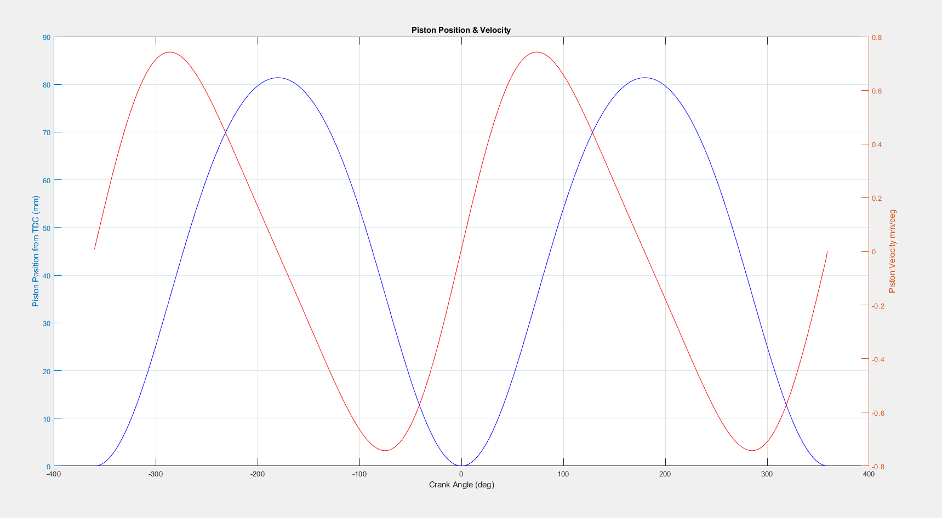
Figure 1: Piston Position & Velocity vs Crank Angle
Using the equation for piston acceleration: $\frac{d^{2}s}{dt^{2}}=Rω^{2}cosθ+\frac{R^{2}}{L}ω^{2}cos2θ$ the acceleration at each RPM and crank angle can be plotted on a 3D plot as shown in figure 2. By splitting the acceleration equation and plotting the two orders, the effects on the combined equation can be clearly seen. As the piston moves towards top dead centre (TDC), both orders act in the same direction with the first having greater magnitude. However, towards bottom dead centre (BDC), the second order opposes the first order. The plot in figure 3 displays the second order repeating at twice the crank speed.
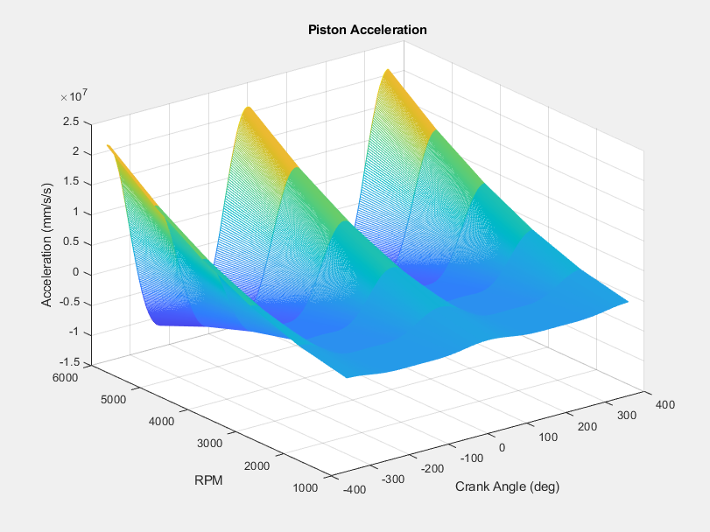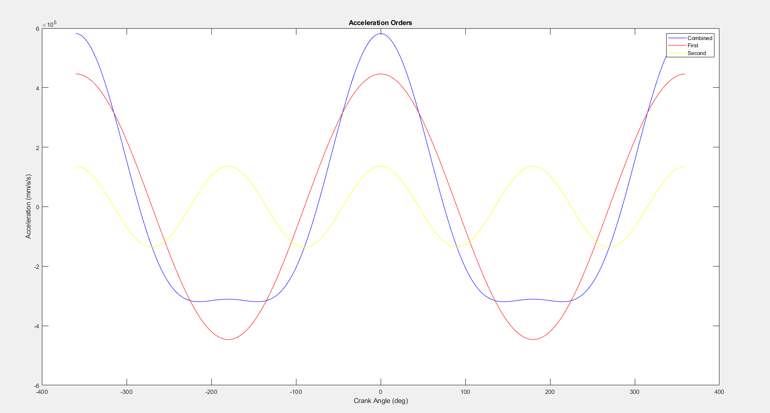
Figure 2: Piston Acceleration Orders Figure 3: Piston Acceleration
To calculate inertia forces on the connecting rod, it’s important to use the reciprocating mass of the rod and not the rotating mass, which will be later used for the cap inertia.
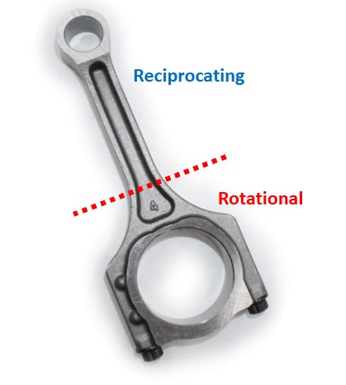
In order to calculate net forces, the gas force is firstly needed which can be obtained using the given pressure data multiplied by the cylinder area. The gas force taken away from the inertia force will provide the net force seen in the figure below. Reversing the order of subtraction in the equation will produce the opposite force. The positive is tensile, and the negative is compressive.

Figure 4: Connecting Rod
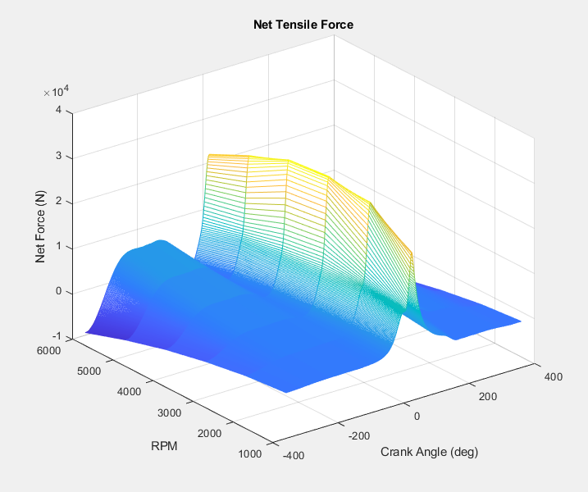
Figure 5: Net Tensile Force

Fatigue Safety Factors
To plot a Goodman’s diagram, the stresses on the mid-point of the con rod need to be calculated with the rod force and the cross-sectional area. After finding the minimum, maximum, mean, range and allowable stress, a factor of safety for each RPM can be calculated for the component.
$σ_{allowable}=2σ_{End-Lim}*(1-\frac{σ_{mean}}{UTS})$ $FSF=\frac{σ_{allowable}}{σ_{range}}$
The Goodman’s diagram shows the upper and lower endurance limits of the material for tensile and compressive stresses, which intercept the dashed lines to show its ultimate tensile strength (UTS). Furthermore, the allowable range is specific to the component of choice and represents the boundaries of stresses it can safely operate from using the previously calculated fatigue factor of safety (FSF). Meanwhile, the actual range shows the stresses which the component is actively subjected to. There are six of these vertical lines plotted for each RPM at a 1000 interval. As seen in figure 6, the con rod experiences stresses well within its allowable range.
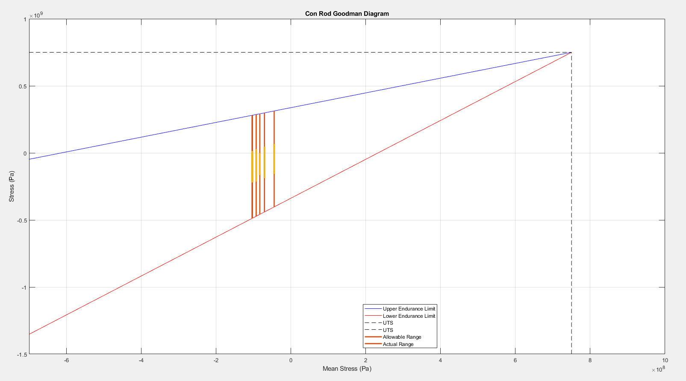
Figure 6: Con Rod Goodman's Diagram
This allows us to assume that the connecting rod has a solid life expectancy length as it doesn’t appear to get near the extremities of the allowable range. However, this also means that there is potential to change the material or design of the component, so it isn’t over engineered as such. Similar Goodman’s diagrams can be plotted for the gudgeon pin and con rod bolt.
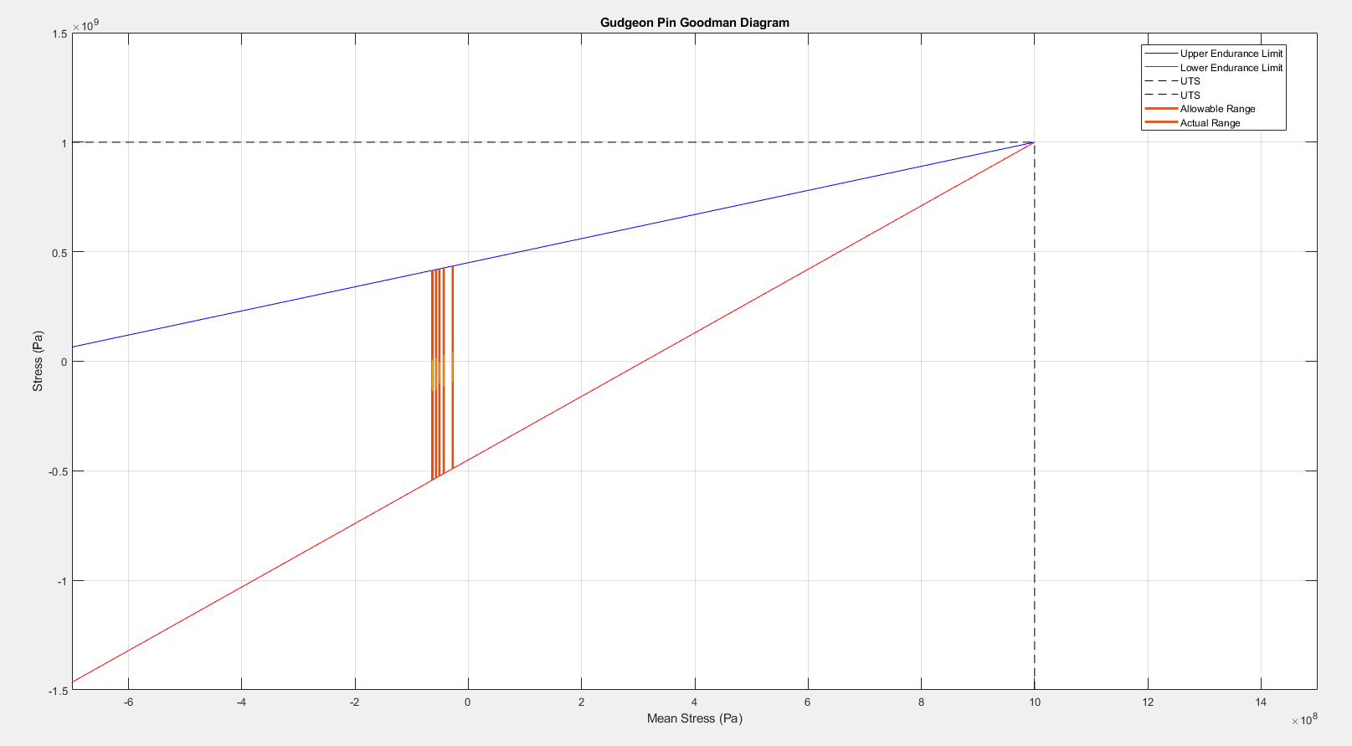
Figure 7: Gudgeon Pin Goodman's Diagram
The gudgeon pin goes under bending in two different directions. During combustion, its forced to bend downwards while inertia forces bend it upwards. The nature of the supports will cause the pin to undergo both bending and shear stresses. Shear stress occurs at the support point while bending occurs from the moment created by the force and the supporting point. As described in the following figure, the inertia forces from the piston, piston rings, circlips and exposed mass of the pin beyond its support act upwards in oppose to the net, compressive forces shared equally per side of the pin, assuming the design is symmetrical.
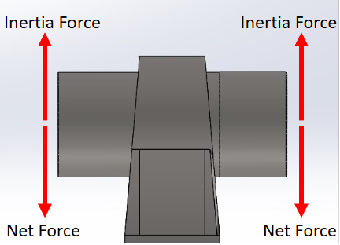
The bending moment will cause one side of pin to be in tension while the other side is in compression. In the middle of them is a neutral axis where these stresses cancel out.

Figure 8: Gudgeon Pin Forces
After using the following equations for bending and shear stress, the resultant stress can be calculated and plotted to display the forces on the pin.
$σ_{bending}=\frac{My}{I}$ $τ=\frac{Force}{Cross Sectional Area}$ $σ_{resultant=\sqrt{{(σ_{\max{bending}})}^{2}+{(2τ)}^{2}}}$
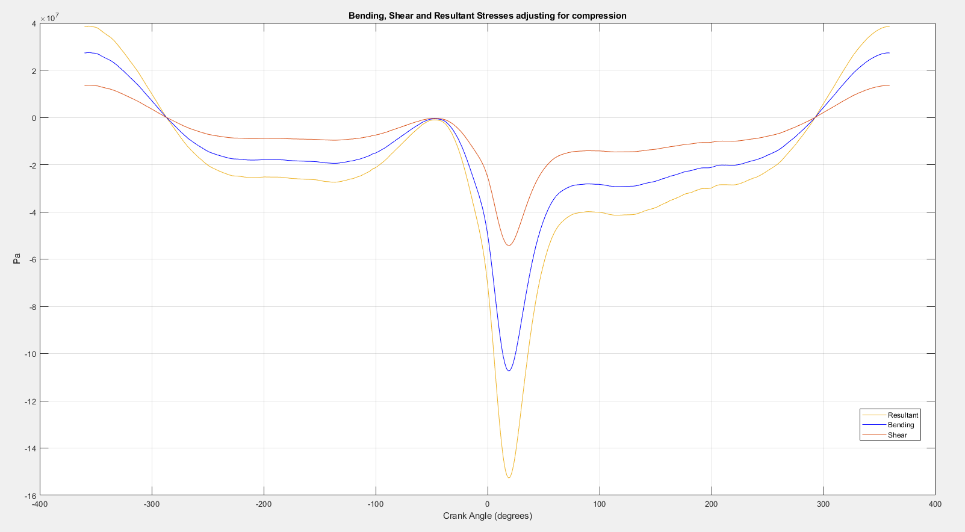
Figure 9: Stresses on a Gudgeon Pin
Changing the crankshaft design can also have significant impact on the forces taken by the gudgeon pin. To reduce the inertia forces that contribute to the bending stresses seen on the pin, a cross-plane crankshaft can be used, where the crankpins are situated at 90-degree intervals, meaning consistently when one piston is speeding up, another one is slowing down, resulting in the inertia forces being effectively cancelled out. This allows for smooth and steady crank rotation (Ash, 2011). The ‘circshift’ function in MATLAB enables the inertia and gas forces to be shifted accordingly to the crankpin intervals for a standard and cross-plane crankshaft. Thus, the torques and torque gas can be plotted and compared in the figures below.
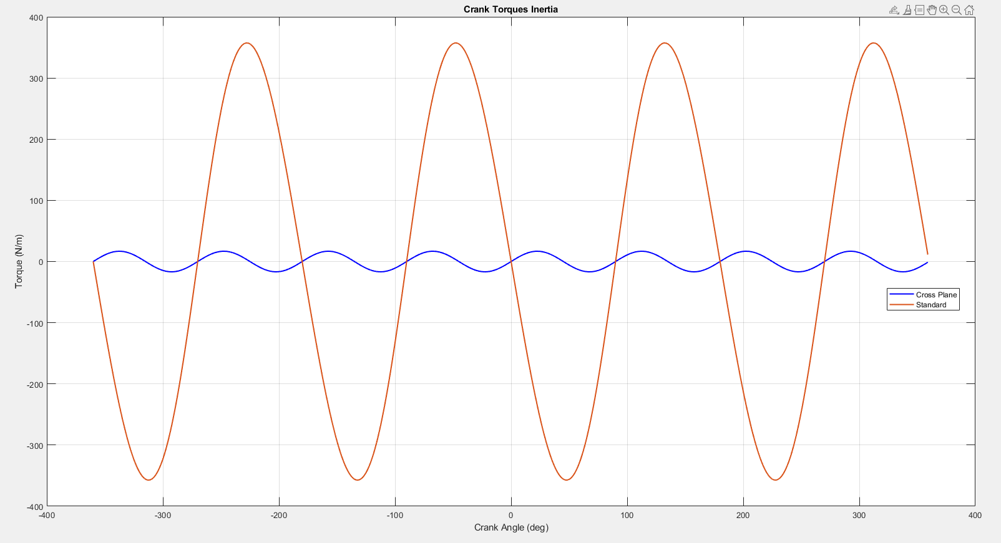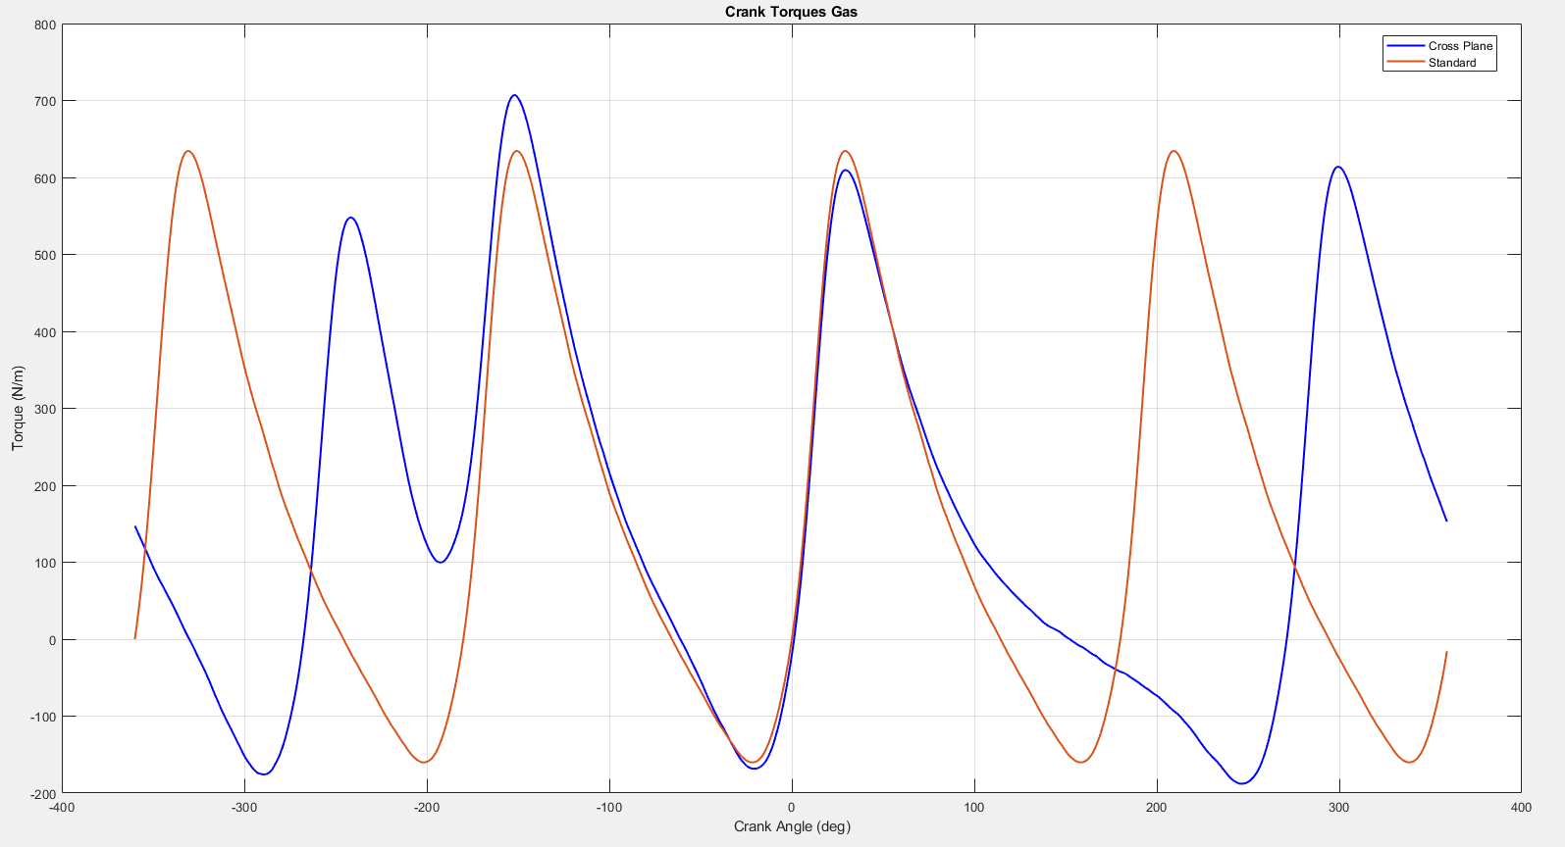
Figure 10: Crank Torque Inertia Figure 11: Crank Torque Gas
By adding the gas torque and inertia torque, the crank torque can then be used to take an average as the work torque is needed to calculate the brake torque of the engine, taking away the total work loss due to ring and side friction. Similar, using the angular velocity (ω), the indicated power taking away the friction power will result in the engine brake power, plotted below. After extending the RPM range to 9000 via a suitable interpolation function, a noticable increase in power is seen through higher RPM, reaching 1.5x10⁵ W, while the torque does drop off further to almost 160 Nm.
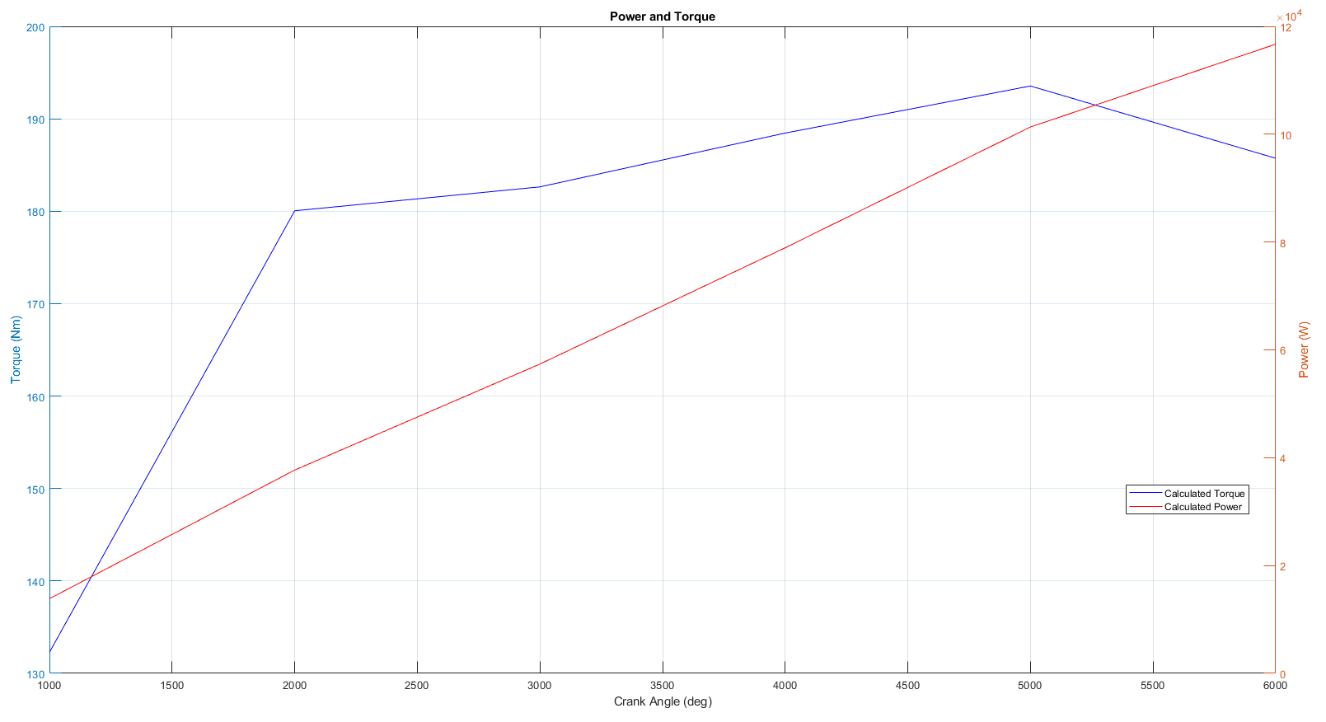
Figure 12: Power and Torque per RPM
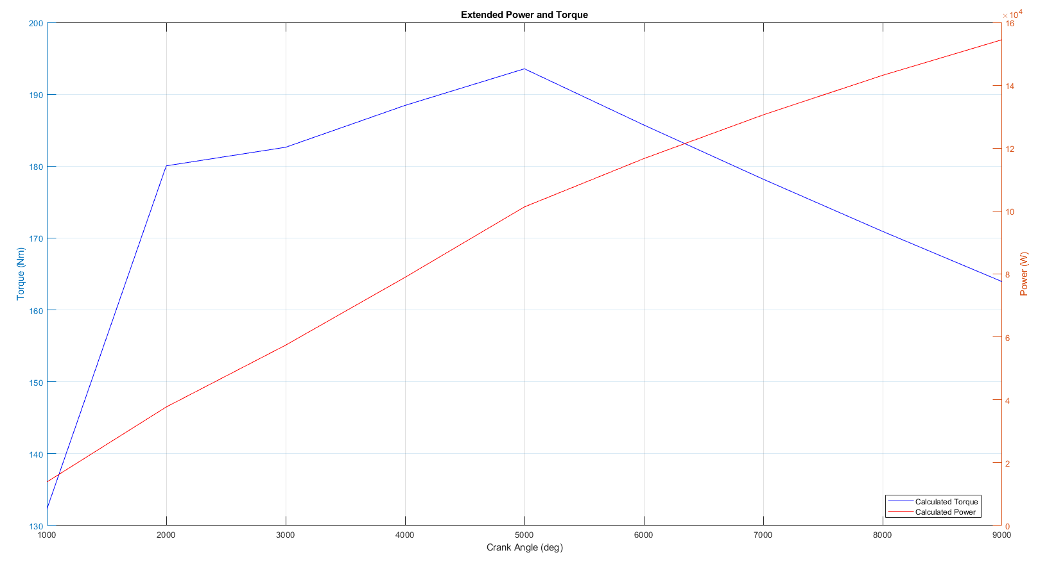
Figure 13: Extended Power and Torque per RPM
Before plotting a Goodman’s diagram for the con rod bolt, a stress concentration factor (K_{t}) should be taken into consideration for the threaded bolt. After applying K_{t} to the allowable stress and subsequently the factor of safety calculation, a more accurate diagram is able to be plotted.
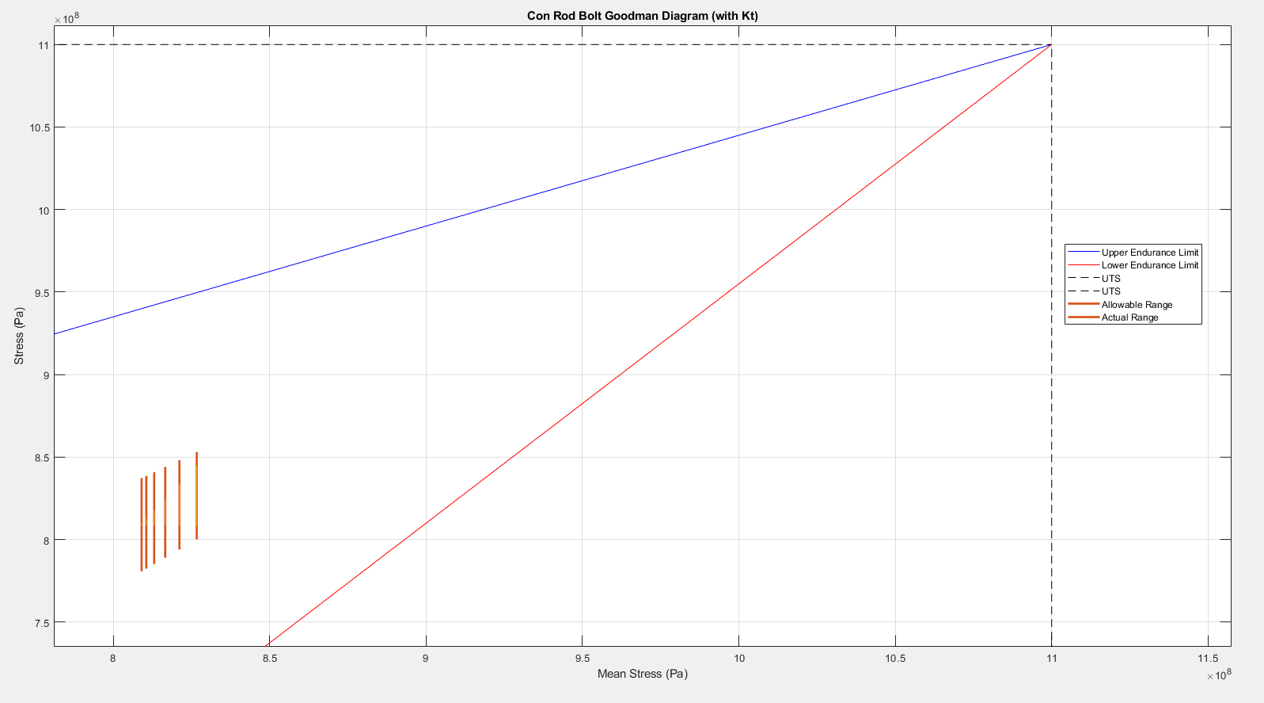
Figure 14: Con Rod Bolt Goodman's Diagram
By accounting for the stress concentration factor, the allowable range shrunk significantly inside the endurance limit of the material.
Once again, by using a method of interpolation, the RPM range can be extended to 9000 with appropriate pressure data added. After recalculating the factor of safety for each RPM interval, it can be inferred that the increased range in RPM produces much higher factor of safeties in low RPMs but remains much similar towards the higher end of the range.
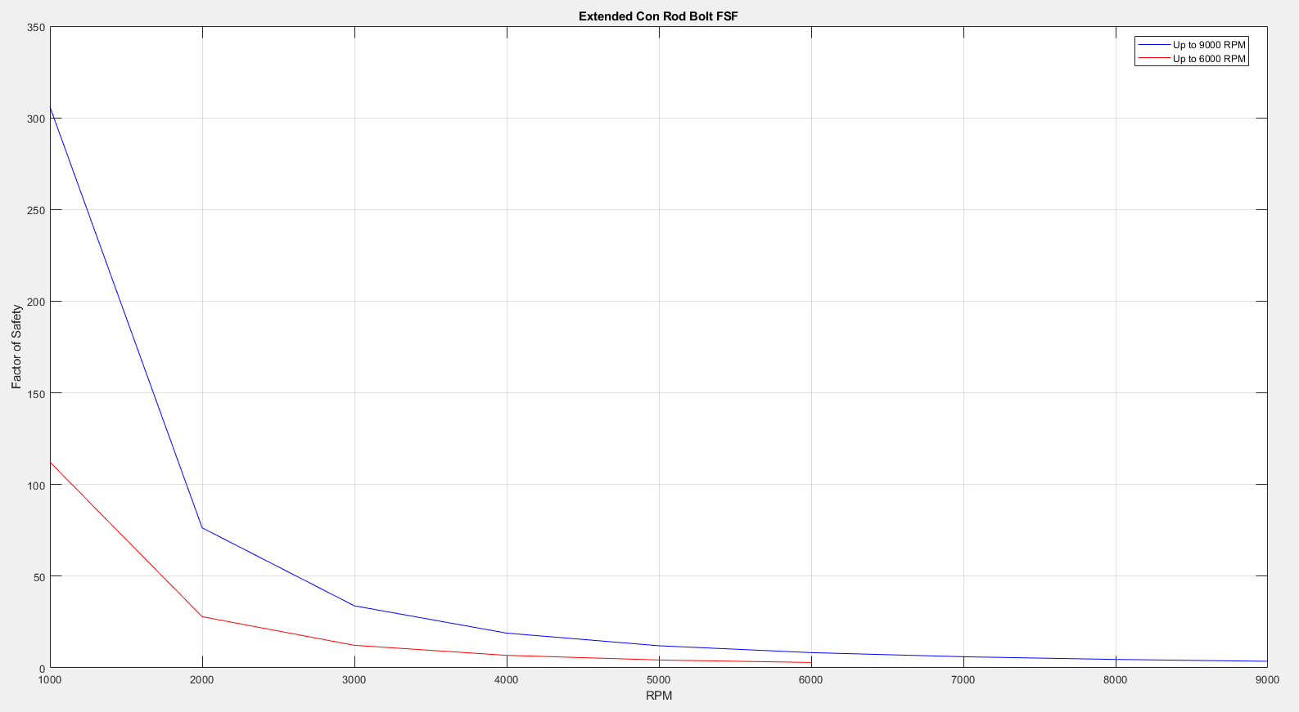
Figure 15: Fatigue Factor of Safety Comparison

Connecting Rod Bolt Redesign
To improve the factor of safety of the conrod bolt, modifications are made to some of its geometry specifications in order to alter its stiffness and optimize its operating performance and life expectancy. The bolt stiffness is calculated by using the equation: $K=E\frac{A}{L}$, where the modulus of elasticity (E), cross sectional area (A) and thread length (L) are all variables to be altered to change the bolt stiffness (K). The first investigation involved varying thread lengths which found that a longer length decreased the stiffness of the bolt resulting in an increased fatigue factor of safety. This is due to the decreased stiffness allowing for more ductility in the bolt, avoiding crack initiation and quick propagation leading to commonly seen failures in brittle material. However, the concern relating to low bolt stiffness is whether it can then withstand the common cyclic loading which it faces while the engine is running.
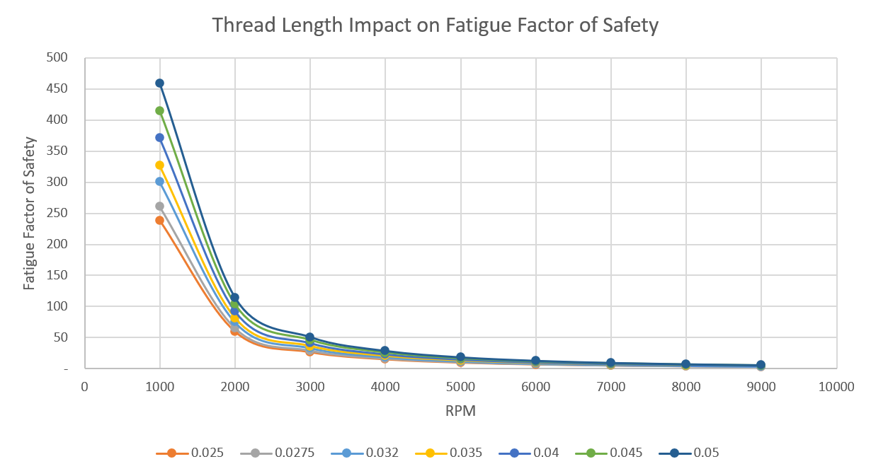
Figure 16: Thread Length Impact on FSF
Threads will naturally cause a rise in stress due to their geometry. The peak stress will typically occur at the first engaged thread near the head. To distribute the load more evenly, more engaged threads can be added. After a certain length however, this will provide diminishing returns in the improvement of fatigue life.
The next factor to change is the cross-sectional area of the bolt. Larger cross-sectional area increases the bolt stiffness which again, reduces its ability to absorb dynamic loading elastically, since it makes the component more brittle. This can increase stress on clamped parts which could lead to premature failure elsewhere. An optimized cross-section would have to balance both strength and flexibility to ensure the component stretches enough to maintain its preload without succumbing to fatigue failure.
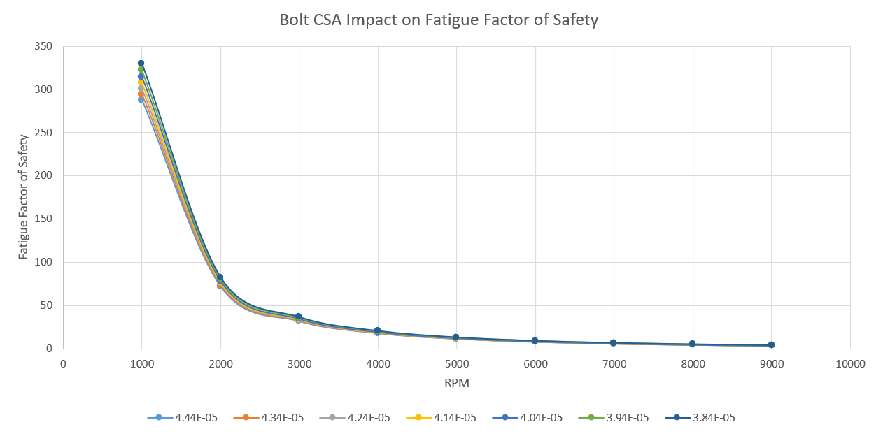
Figure 17: Bolt CSA Impact on FSF
Aside from geometric conditions of the bolt, material selection is another area of investigation. To incorporate this into the MATLAB script, the modulus of elasticity and ultimate tensile strength is changed to the desired material’s properties and the new bolt stiffness is calculated along with the fatigue safety factors. All materials have been heat treated or cold worked in the case of AISI 304 Stainless Steel as it is austenitic.
Table 1: Material Properties
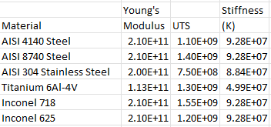
As seen in Table 1, titanium 6Al-4V has about half the stiffness as most variants of steel and nickel-alloy Inconel. This is because it has a lower density and a much lower modulus of elasticity. This allows titanium bolts to be lighter than steel and the reduced stiffness enables it to flex more under load. However, high stiffness steel bolts do provide better preload retention. From the figure below, titanium 6Al-4V clearly has the highest fatigue safety factor, particularly at lower RPM, which is why it will be coupled with the ideal bolt cross-sectional area and thread length to compare to the baseline values gathered earlier.
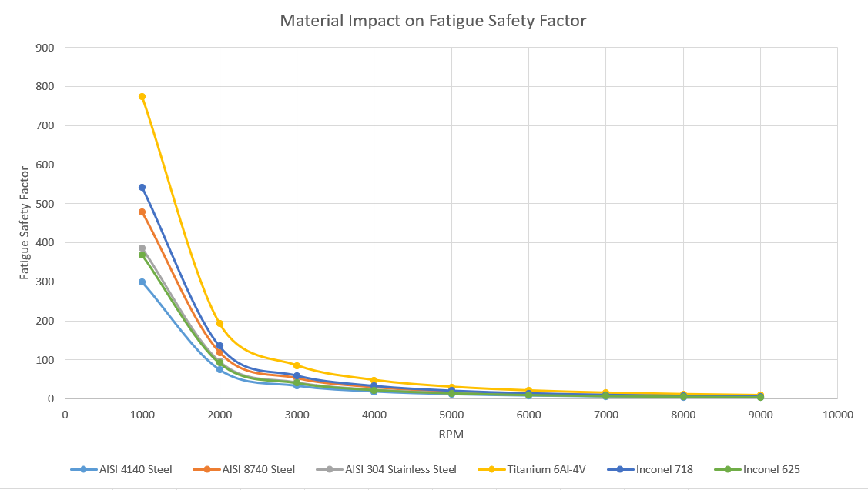
Figure 18: Material Impact on FSF
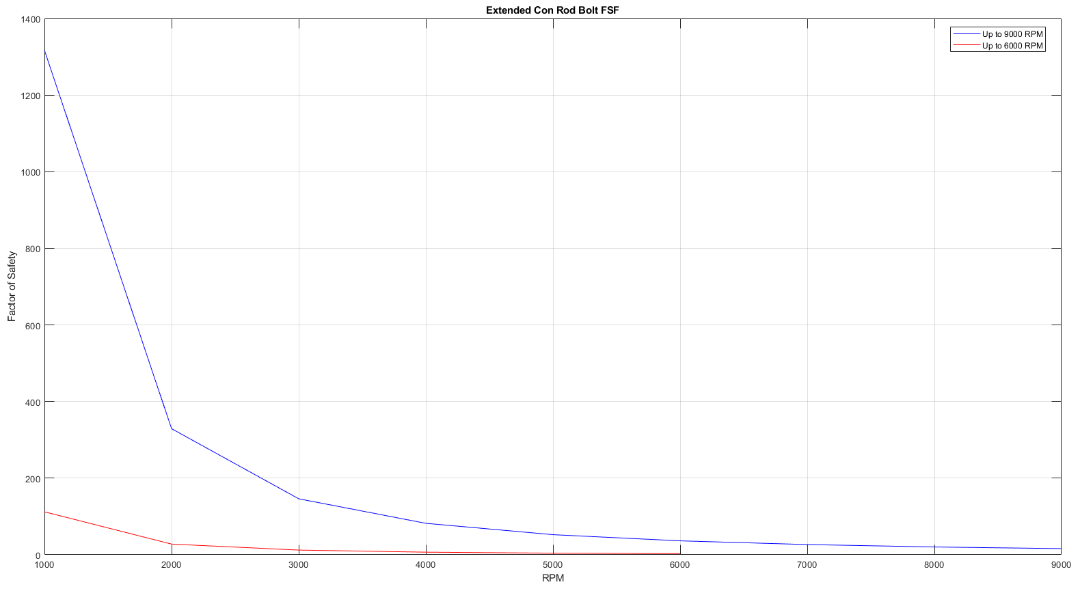
Figure 19: Titanium Con Rod Bolt FSF Comparison
Figure 19 displays the huge increase in fatigue safety factor when using titanium with a smaller cross-sectional area and a larger thread length. However, this significant improvement of FSF does come with a much-reduced stiffness: 2.89x10⁷ N/m. This is likely less than the required stiffness for a connecting rod bolt and so it would be more appropriate to leave the dimensions of the bolt the same as the standard AISI 4140 steel but manufacture them in titanium 6Al-4V.

Conclusion
In conclusion to this investigation, the con rod bolt could be remade with the same dimensions while using titanium 6Al-4V as this is a material less dense and therefore lighter with a reduced stiffness to allow for more flexibility under cyclic loading. However, titanium hardware can often be more expensive, so for a mass production, road vehicle application, a material like AISI 8740 steel can be used for a bolt with reduced cross-sectional area of 3.843x10⁻⁵ m² and enlarged thread length of 5 cm. This produces a bolt stiffness of over 5.3x10⁷ N/m, an acceptable level for a connecting rod bolt (Shigley et al, 2004). The resultant fatigue safety factors in the figure below are significantly higher than the standard bolt with initial geometry.
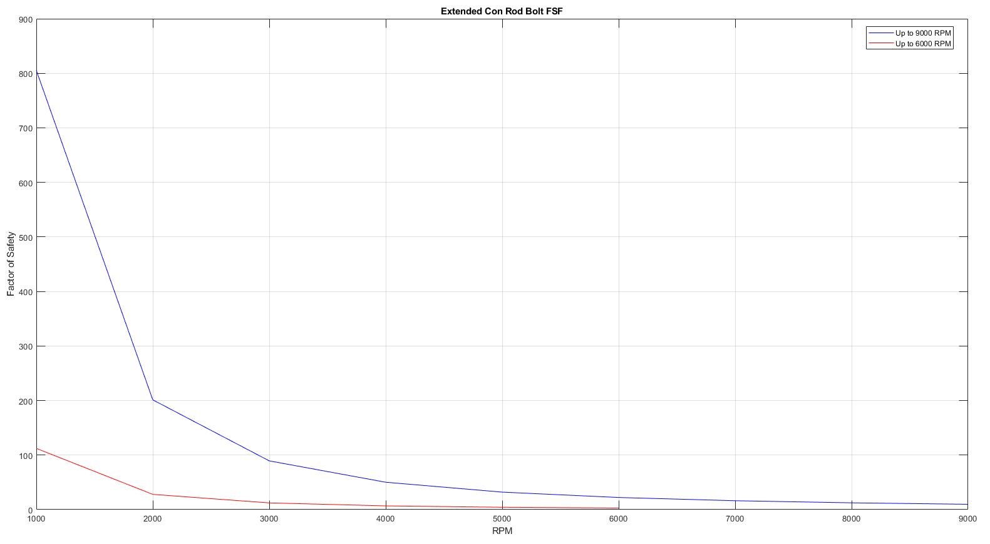
Figure 20: New AISI 8740 Steel Con Rod Bolt FSF Comparison
Extending the RPM range to 9000 has also concluded that more power is achievable with the higher revs and the allowable and actual ranges follow the same trends in the Goodman’s diagrams for each internal component.

References
www.nautilusshipping.com. (2022). Engine Connecting Rod | Types, Parts, Materials, and Stresses Explained. [online] Available at: https://www.nautilusshipping.com/engine-connecting-rod.
Kamble, V.B., Mangrulkar, K.S., Shah, M.D. and Kulkarni, H.B. (2018). Design and Analysis of Gudgeon Pin to Minimize Stress Concentration: A Review. [online] doi:https://doi.org/10.13140/RG.2.2.10889.13925.
Suchendra, K. (2024). OPTIMIZING GUDGEON PIN DESIGN FOR STRESS CONCENTRATION REDUCTION THROUGH FEA ANALYSIS. [online] 56(01), pp.2096–3246. Available at: https://advancedengineeringscience.com/article/pdf/2024/219.pdf [Accessed 13 Mar. 2025].
Jia, D., Cai, C., Li, Y., Deng, X., Lei, J., Deng, W. and Ji, H. (2021). Research on optimizing the axial force of thread connection of engine connecting rod. Engineering Failure Analysis, 130, p.105771. doi:https://doi.org/10.1016/j.engfailanal.2021.105771.
Ash, Kevin. (2011). Inertial torque magnitude | Straight Talking. [online] Available at: https://www.ashonbikes.com/content/inertial-torque-magnitude.
Shigley, J.E., Budynas, R.G. and Mischke, C.R. (2004). Mechanical engineering design. Boston [Etc.] Macgrawhill Higher Education.
‌Edtengineers.com. (2022). EDT Engineers. [online] Available at: https://www.edtengineers.com/blog-post/gearhead-quandary-be-flat-or-be-crossed [Accessed 16 Mar. 2025].

