
GEODEMOGRAPHIC ANALYSIS USING GIS SOFTWARE
Geographical Information Systems – ACCB5027
Lucy Boyt - 2308345
Table of Contents
1. Introduction 2
2. Methodology 2
2.1 Data Processing 2
2.2 Data Acquisition 3
2.3 Datasets 5
2.4 Data Cleaning 7
2.5 Data Manipulation and Transformation 7
3. GIS Build and Thematic Mapping 9
3.1 Workspace Configuration 9
3.2 Layer Joins and Attribute Configuration 9
3.3 Thematic Mapping – Map 1: Income, Health, and Disability 10
3.4 Thematic Mapping – Map 2: Primary Care Coverage 14
3.5 Thematic Mapping – Map 3: Mental Health Service Access and Needs. 16
4. Outcomes 18
4.1 Findings from the thematic maps 18
5. Analysis 20
5.1 - Findings 20
5.2 Challenges 21
5.3 Limitations 21
6. Conclusions 22
References 23
Appendix 24
OneDrive Access to QGIS: 24
AI Usage Paragraph 25

1. Introduction
Geographical Information Systems (GIS) is a computer-based tool which stores, analyses, and visualises spatially referenced data. Within the context of public health and geodemographic analysis, GIS enables decision makers to identify patterns of deprivation, map health outcomes and assess the distribution of services across geographical areas [1, 2].
This report presents the findings of a geodemographic case study focused on Wales, developed using QGIS with the British National Grid coordinate reference system (EPSG:27700) [3,4] . The study investigates two research questions:
- Is lower income associated with a reduced adoption of healthier behaviours and poorer mental health outcomes?
- Are primary care and mental health services adequately distributed in areas with lower income, poorer mental health and reduced healthy behaviours?
Data was acquired from a range of open government sources, including the Office for National Statistics (ONS), DataMapsWales and StatsWales, and organised across five thematic layers joined to a Middle Layer Super Output Area (MSOA) boundary framework. The analytical chain underpinning the study follows the relationship between income deprivation, educational attainment, healthy behaviours, health outcomes, and service distribution across 410 MSOA’s in Wales.

2. Methodology

2.1 Data Processing
The methodology for this study followed a structured data processing pipeline encompassing data acquisition, cleaning, and manipulation prior to the GIS build. Data was sourced collaboratively from reliable open government portals to ensure accuracy and credibility. Each dataset was evaluated for its relevance to the study objectives before being processed through the processing stages.
The processing journey followed four key stages: acquisition, where datasets were identified and downloaded; cleaning, where formatting errors, redundant fields and structural inconsistencies were resolved; manipulation and transformation, where derived fields were calculated and datasets were restructured for spatial compatibility; and finally import into QGIS, where field types were confirmed, joins were executed, and calculated fields were added within the GIS environment.

2.2 Data Acquisition
Data was identified and selected for each thematic layer to align with the case study objectives and the two research questions. The selection process prioritised datasets available at MSOA level to maintain spatial consistency with the boundary framework, except for point-based datasets, which use coordinate data instead of MSOA codes for spatial referencing.
The primary spatial framework was established using the Wales MSOA 2021 boundary dataset sourced from DataMapWales in GeoPackage(.gpkg) format. This provided the polygon base layer to which the majority of attribute data was subsequently joined using the MSOA21CD code field as the common geographic identifier. Point-based datasets specifically the GP main sites and Hospital Locations within the Therapy Wait Time set were managed differently, being projected as individual point layers using latitude and longitude coordinates.
Statistical attribute data was collected from several sources. The income deprivation, physical activity, BMI, and suicide rate datasets were provided in Microsoft Excel (.xlsx) format which were subsequently cleaned and, in some cases, transposed before being exported to Comma Separated Values (.csv) format to ensure compatibility with QGIS. The remaining datasets were available directly in .csv format [5,6,7,8,9,10,11,12,13,14, 15,16] .
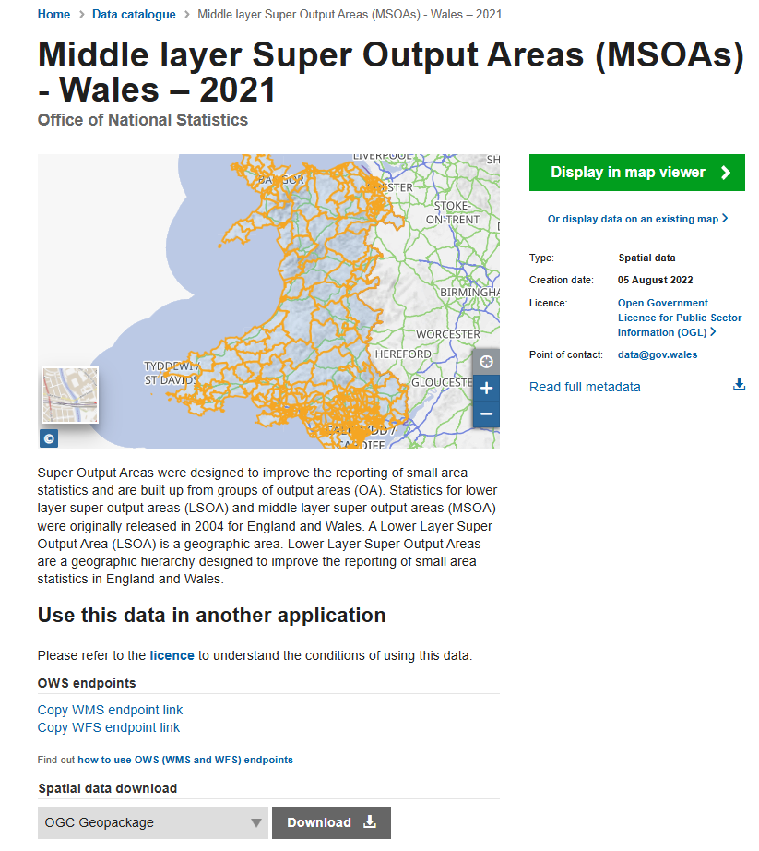
Figure 1 - DataMapsWales - MSOA Boundary Data Download

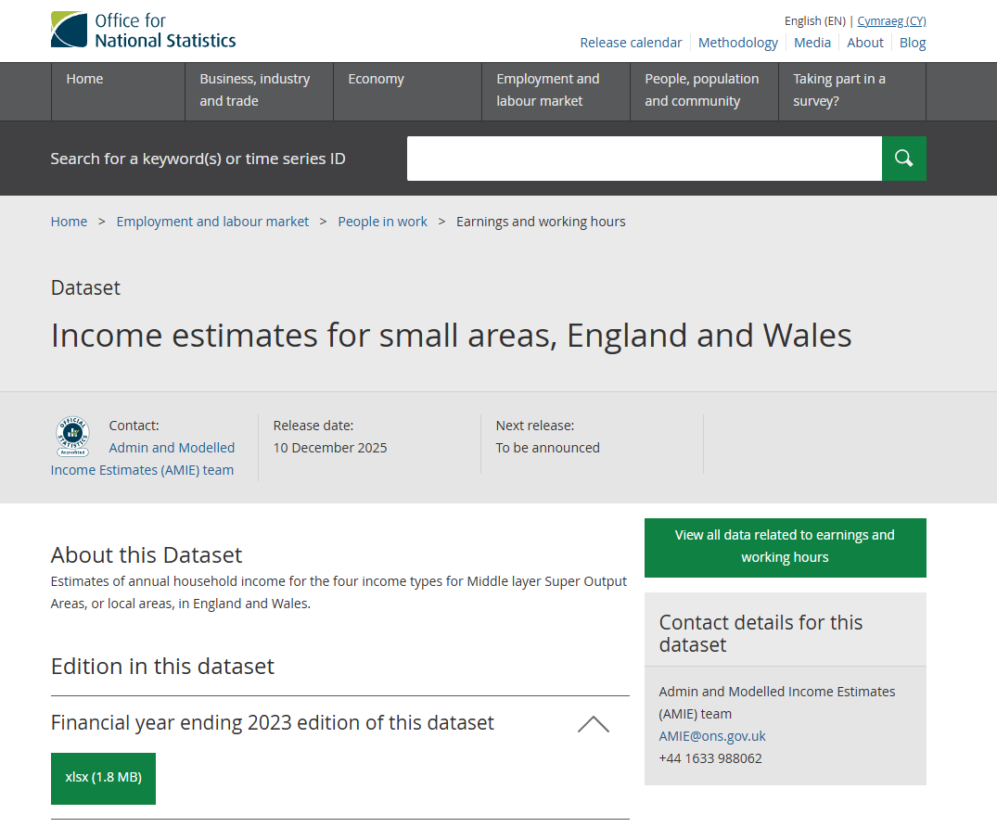
Figure 2 - ONS - Small Area Income Estimates
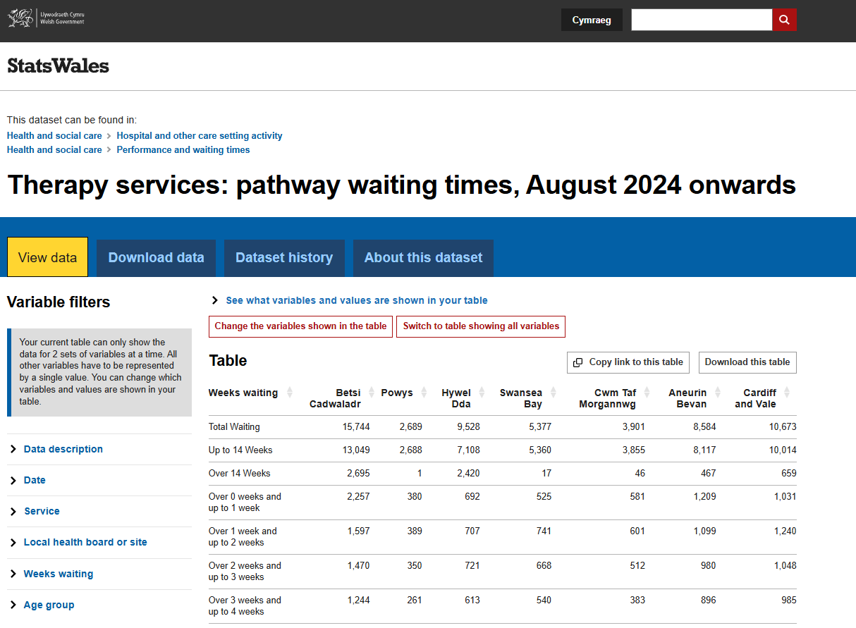
Figure 3 - StatsWales -Therapy Services Pathway Waiting Times

2.3 Datasets
The following datasets were acquired to support the study. Each dataset contributes to the analysis, collectively enabling a multi-layered examination of the relationship between income deprivation, health outcomes, and service distribution across Wales.
Table 1 - Data Acquisition Log. Physical Activity and BMI datasets were acquired and cleaned but excluded from the final map outputs due to spatial accuracy. See Section 2.5.
The table below provides a brief description of each dataset used in the final analysis, including the fields used and their role within the study.

Table 2 - Dataset Descriptions and Field Usage

2.4 Data Cleaning
Prior to import into QGIS, each dataset underwent a data cleaning process to address formatting inconsistencies, removal of redundant fields and ensuring structural compatibility with the GIS environment. Cleaning was conducted primarily in Microsoft Excel before exporting to .csv format.
Several datasets required cleaning, the income deprivation Total Annual Income field was reformatted to numeric, general health and disability datasets had redundant columns removed, fields renamed and percentage fields calculated for analysis. Educational attainment data was transposed to MSOA row format and suicide headings were standardised.

2.5 Data Manipulation and Transformation
Beyond cleaning, several datasets required more substantive manipulation and transformation to make them spatially useable or analytically meaningful within the study framework.
The physical activity and BMI dataset presented a challenge as both were originally sourced from a Welsh Government ad-hoc statistical release at the Upper Super Output Area level rather than MSOA. In order to enable spatial joining to the MSOA boundary layer, MSOA codes were generated using Claude.AI to replicate the dataset at MSOA level. Whilst the process allowed the data to be structured and cleaned it was determined that the resulting dataset could not be considered sufficiently dependable for thematic mapping due to the uncertainty introduced by the AI-assisted code generation. Both datasets were therefore excluded from the final map outputs.
The original therapy waiting times StatsWales dataset provided waiting time figures broken down by individual named hospitals across Wales but did not include geographic coordinate information. This data needed to be rendered as a point layer within QGIS. A list of Welsh Hospitals was extracted from the dataset, and the MMQGIS plugin within QGIS was used to query the OpenStreetMap Nominatim geocoding service and return latitude and longitude coordinates for each hospital. Where the automated process failed to return results for a small number of hospitals, coordination were sourced manually using Google Maps and added directly to the dataset. The resulting geocoded hospital locations file contained 62 hospital sites with verified coordinate data.

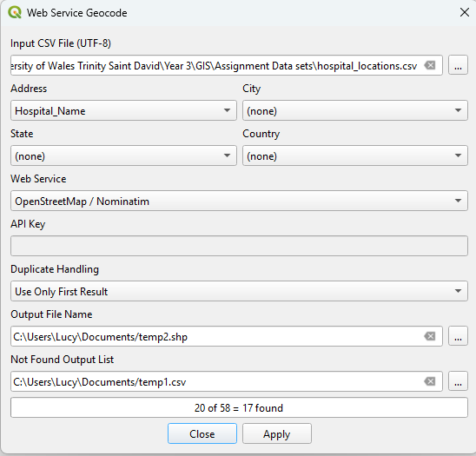
Following import into QGIS, two further transformations were made to the data. First, field type formatting was applied during the CSV import using the Add Delimited Text Layer dialogue to confirm numeric fields were correctly interpreted as integer or decimal values in place of strings. Second, derived fields were calculated using the Field Calculator within the Attributes table of the relevant dataset.
Figure 4 - QGIS MMQGIS Plugin - Geocoding dialogue showing hospital name field and Nominatim service selected.
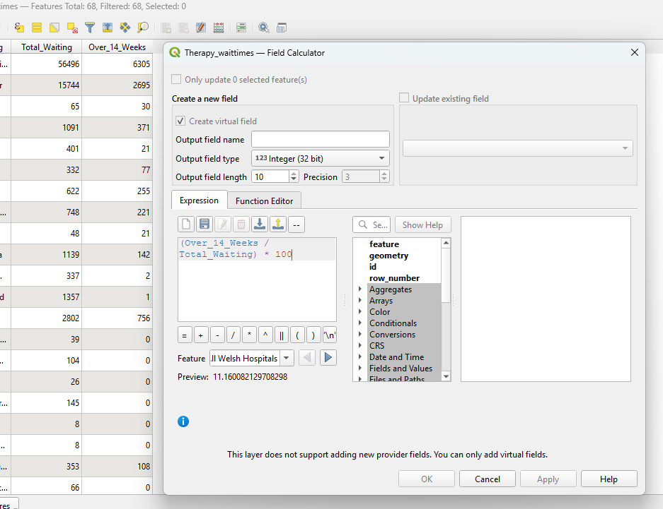
Figure 5 - QGIS - Field Calculator showing pct_over_14_weeks expression and preview value.

3. GIS Build and Thematic Mapping

3.1 Workspace Configuration
The GIS workspace was built in QGIS 4.0.1 using the British National Grid coordinate reference system. The Wales MSOA 2021 boundary GeoPackage was loaded as the base polygon layer, providing the spatial framework across which all thematic data was joined and visualised. The boundary layer confirmed 410 MSOAs covering the whole of Wales, with smaller, denser MSOAs visible in the urban south and larger MSOAs across rural mid and north Wales.
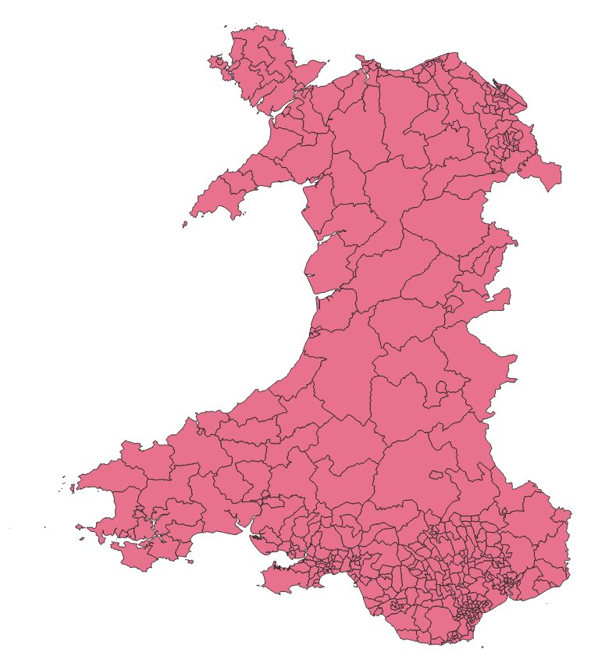
Figure 6 - Wales MSOA 2021 Boundary layer loaded into QGIS.

3.2 Layer Joins and Attribute Configuration
Attribute datasets were joined to the boundary layer using the Join function within layer properties. Each join used the MSOA21CD field in the boundary layer as the target field, matching against the corresponding MSOA code field in each .csv. Only the fields required for analysis were selected during each join to maintain a clean attribute table.
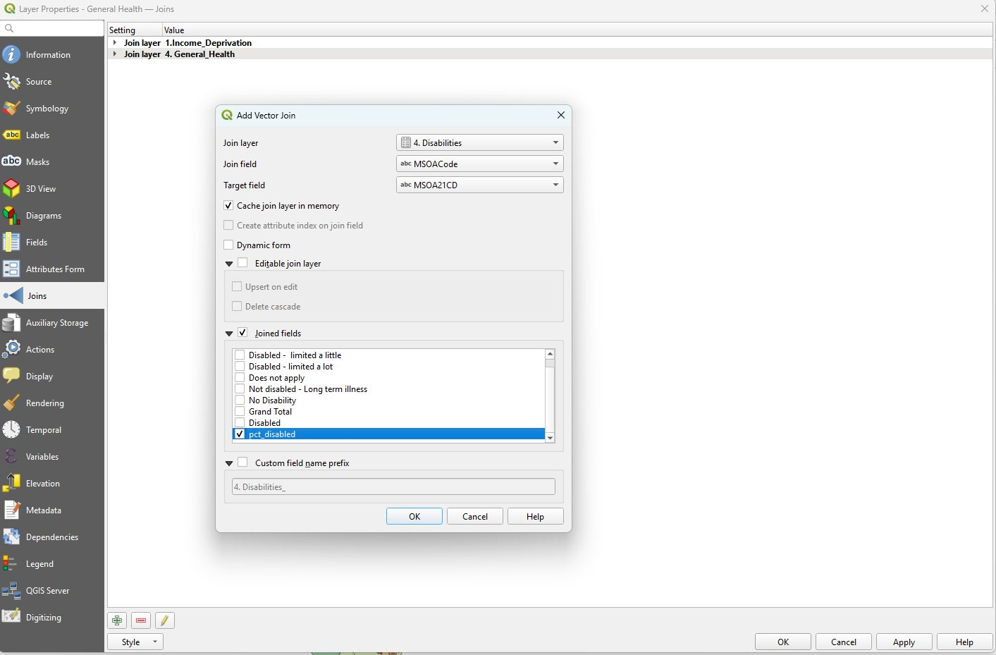
Figure 7 - Add Vector Join dialogue showing Disability layer join with pct_disabled field selected.

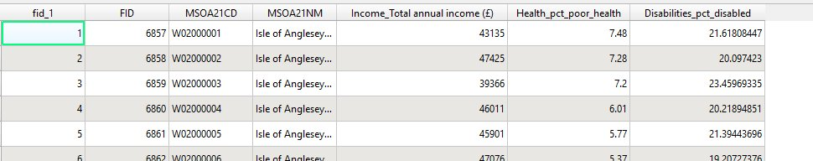
Figure 8 - Attribute table showing income, general health and disability fields joined to MSOA boundary layer.

3.3 Thematic Mapping – Map 1: Income, Health, and Disability
In order to address the primary research question, Map 1 was designed by visualising the spatial relationship between income deprivation, general health outcomes, and disability rates across Wales. Four layers were combined using a transparency overlay technique to allow simultaneous visualisation of all variables.
The income deprivation layer was styled as a graduated choropleth using a Red-Yellow-Green colour ramp with Natural Breaks (Jenks) classification across five classes, with red representing the lowest income MSOAs. The general health layer was duplicated from the boundary layer, styled as a graduated red choropleth, and applied at a 60% opacity over the income base. The disability layer was similarly duplicated and styled as a graduated purple choropleth at 45% opacity. The Rural Urban Classification was applied as a categorised outline-only layer using transparent fill with green outlines for rural MSOAs and blue outlines for urban MSOAs.
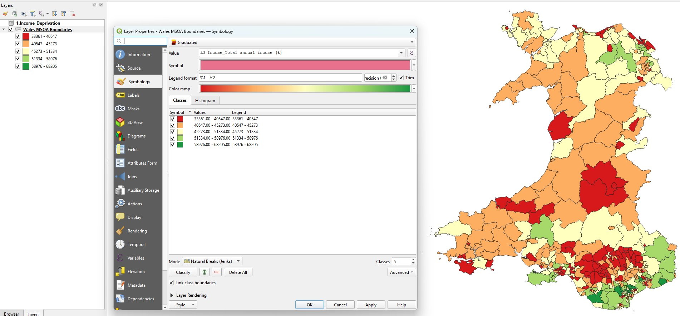
Figure 9 - Income deprivation graduated choropleth symbology dialogue and resulting map.

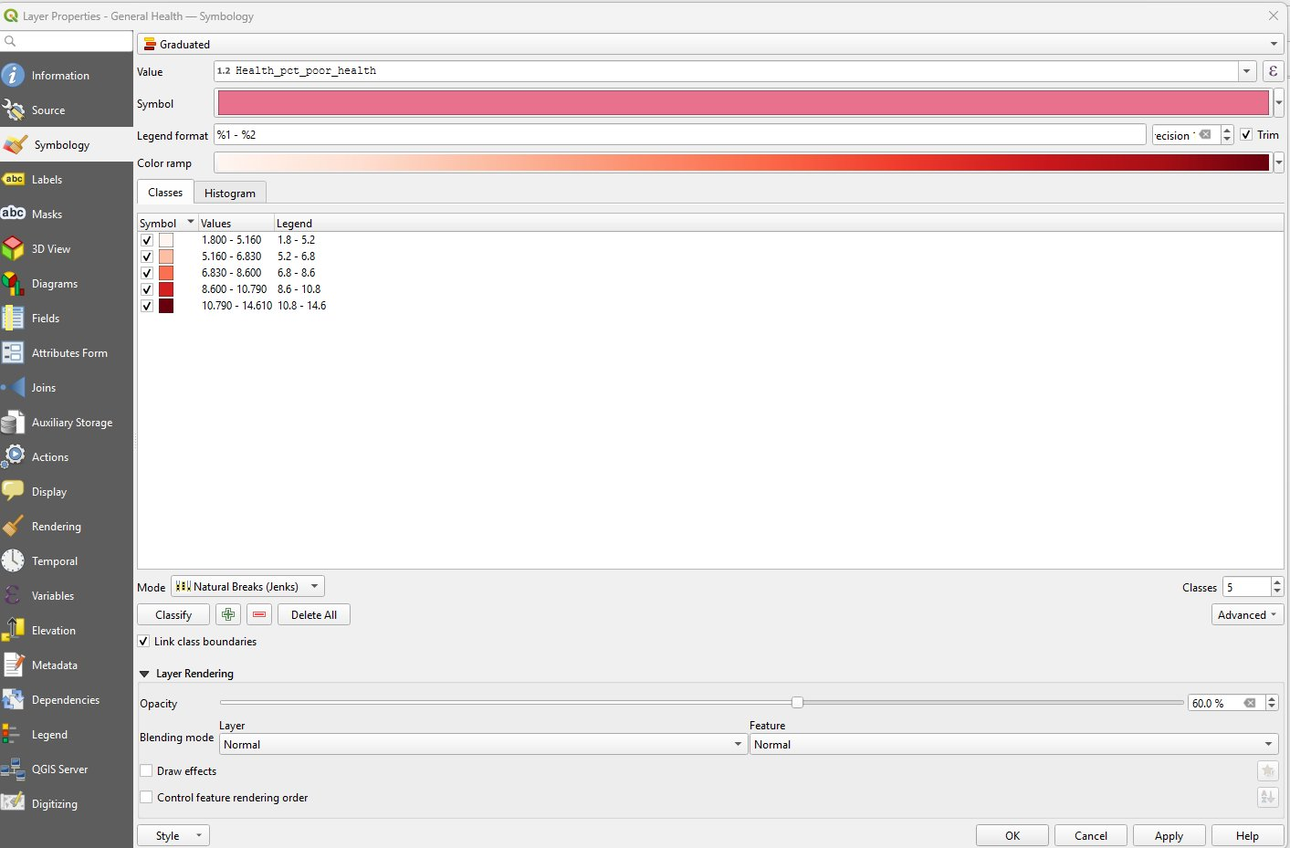
Figure 10 - General Health layer symbology showing a graduated red colour ramp at 60% opacity.
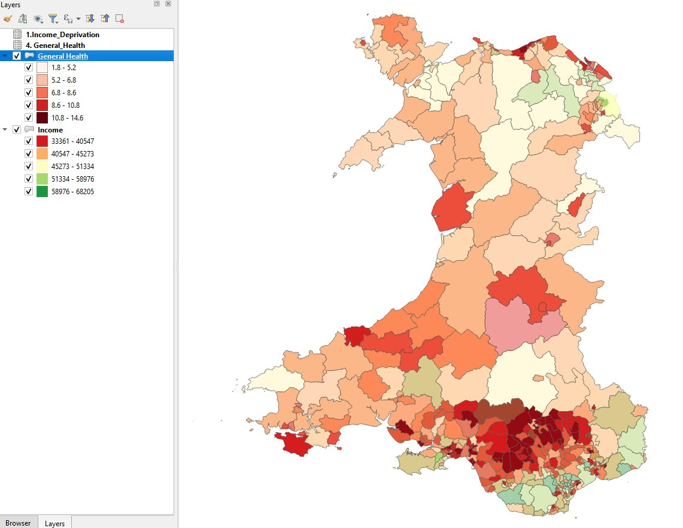
Figure 11 - Two-layer overlay: Income and General Health combined.
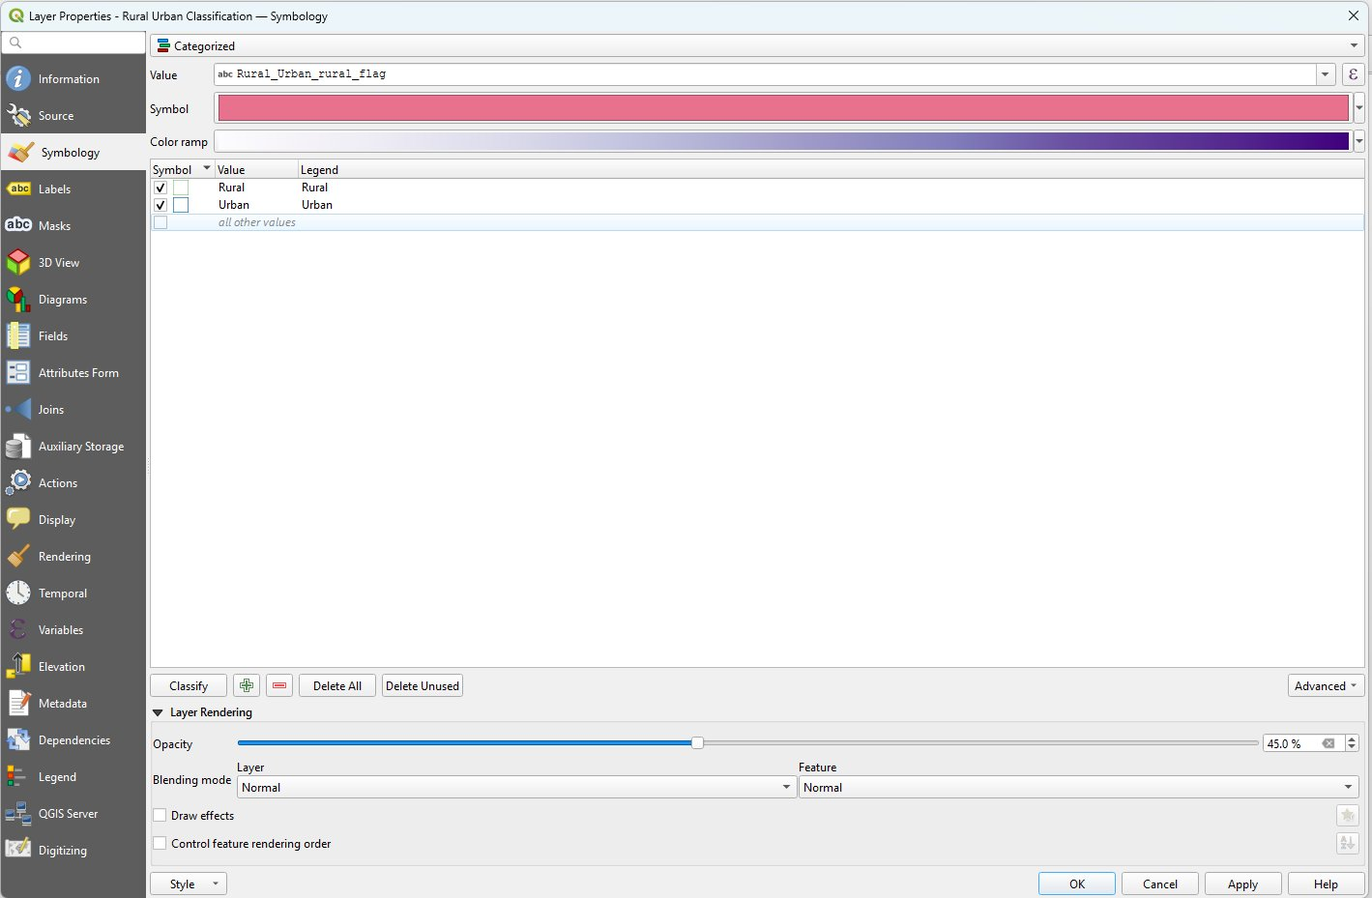
Figure 12 - Rural Urban Classification categorised symbology dialogue box showing categories.
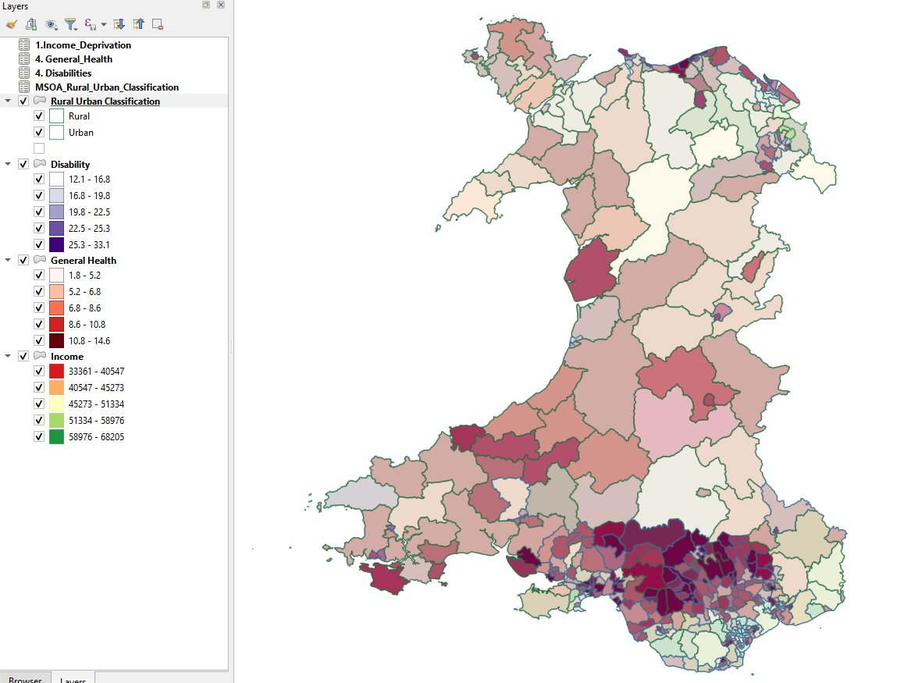
Figure 13 - Complete working view with all four layers applied.

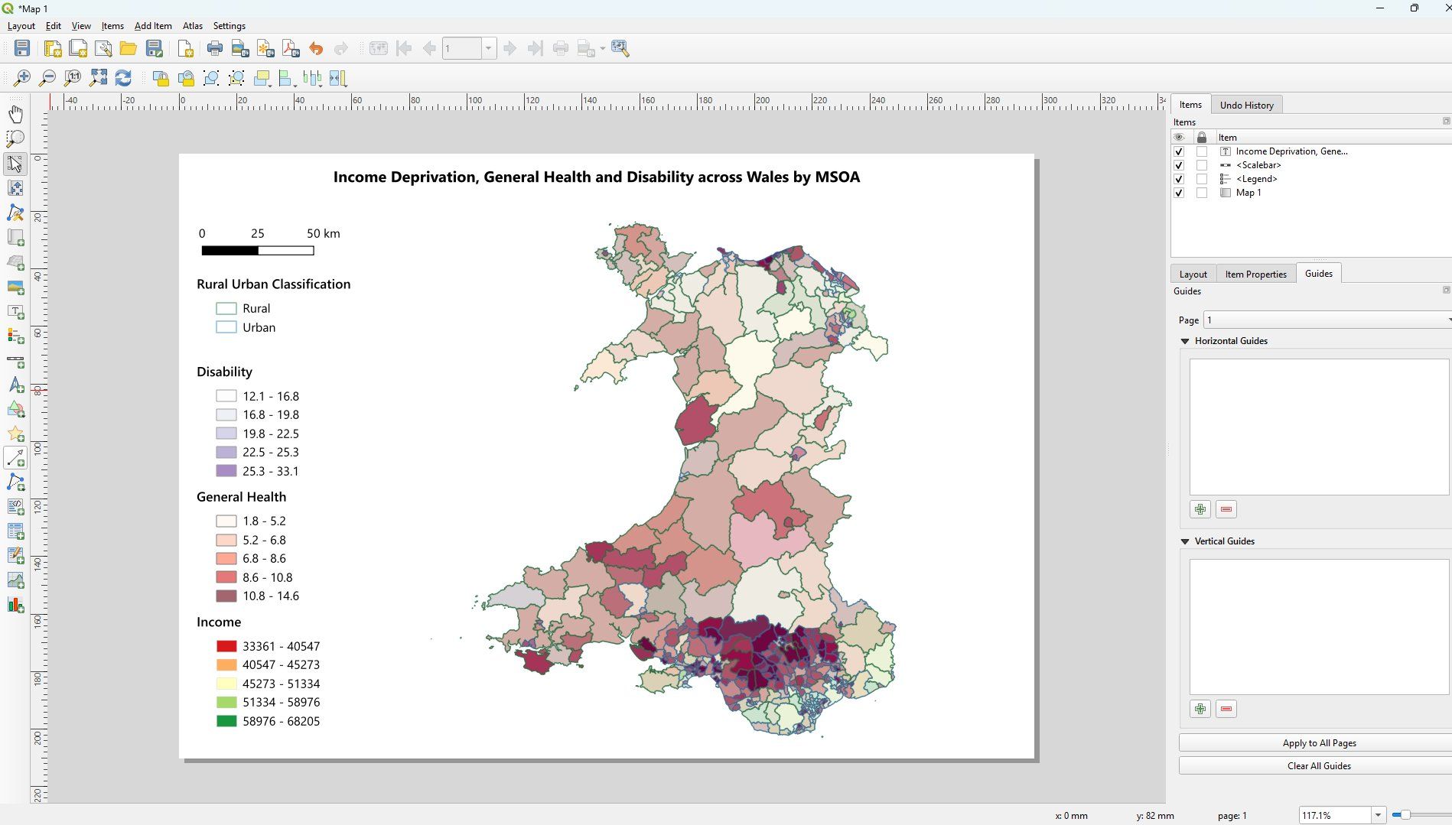
Figure 14 - Print Layout showing Title, Legend, and Scale bar.

3.4 Thematic Mapping – Map 2: Primary Care Coverage
This map was designed to address the secondary question by visualising the distribution of GP services and hospital locations relative to income deprivation. The income choropleth was retained as the base layer with GP main sites and hospital layers being imported as point layers using latitude and longitude coordinates in EPSG:4326, then reprojected to EPSG:27700 for spatial consistency.
A variable catchment buffer was added to reflect differences in access between urban and rural areas. GP sites were filtered by Rural Urban Classification flag, and two separate buffer zones were created: a 2km catchment for urban GP sites and a 5km catchment for rural GP sites. Urban buffers were stylised in purple at 20% opacity and rural buffers in teal. Hospital sites were displayed as red cross symbols and GP sites as navy-blue circles.
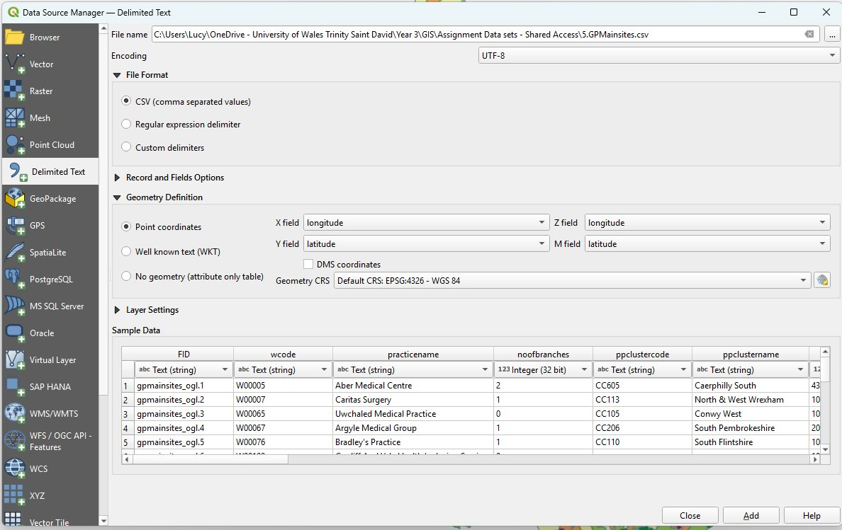
Figure 15 - GP main sites .csv import showing point coordinate configuration.

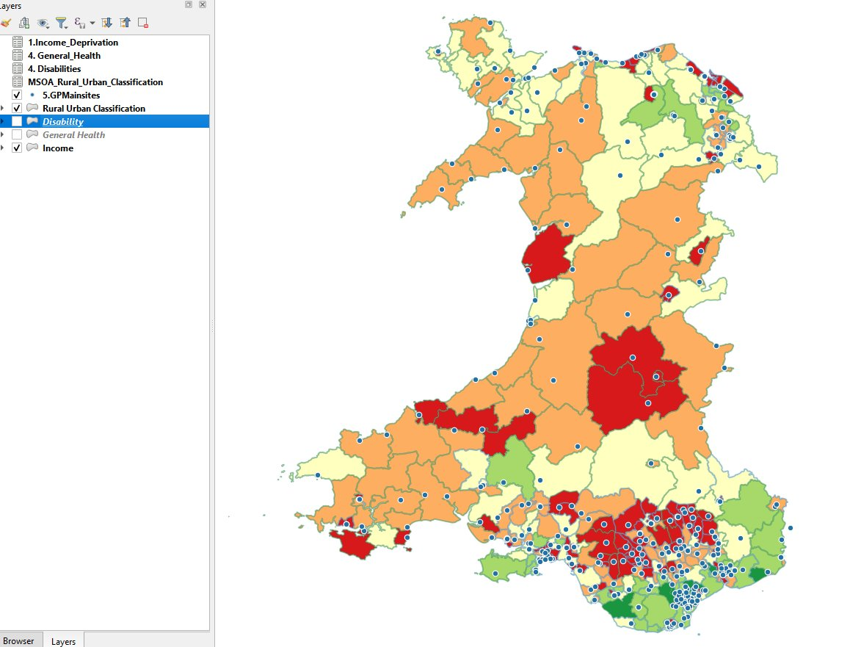
Figure 16 - GP Main sites point layer plotted over the Income base layer.
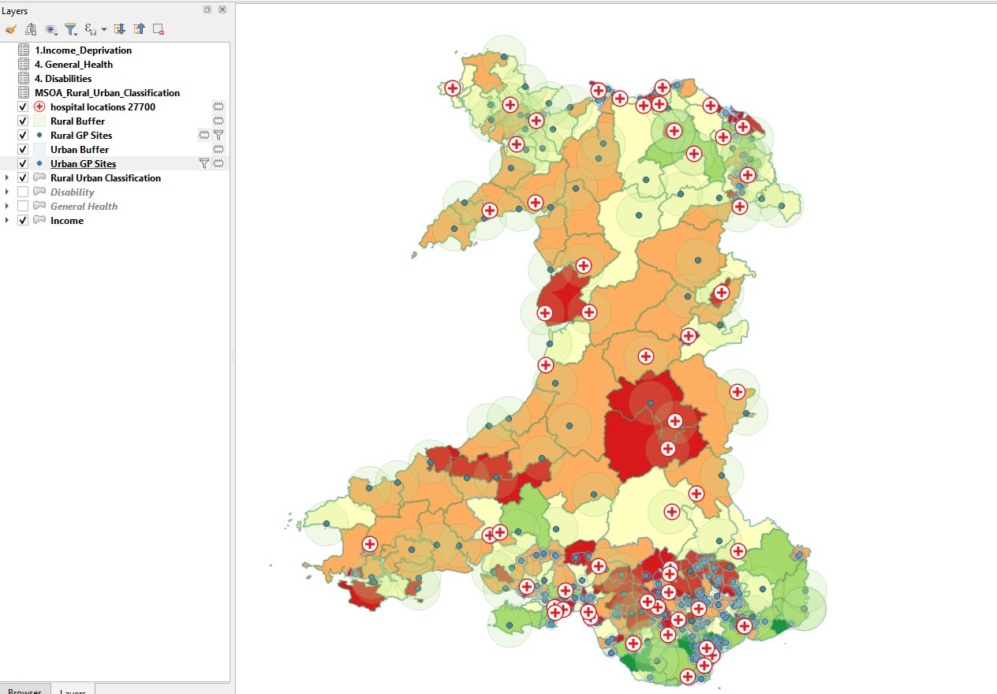

Figure 17 - Reprojected Layer with GP sites and Hospital Locations to EPSG:27700
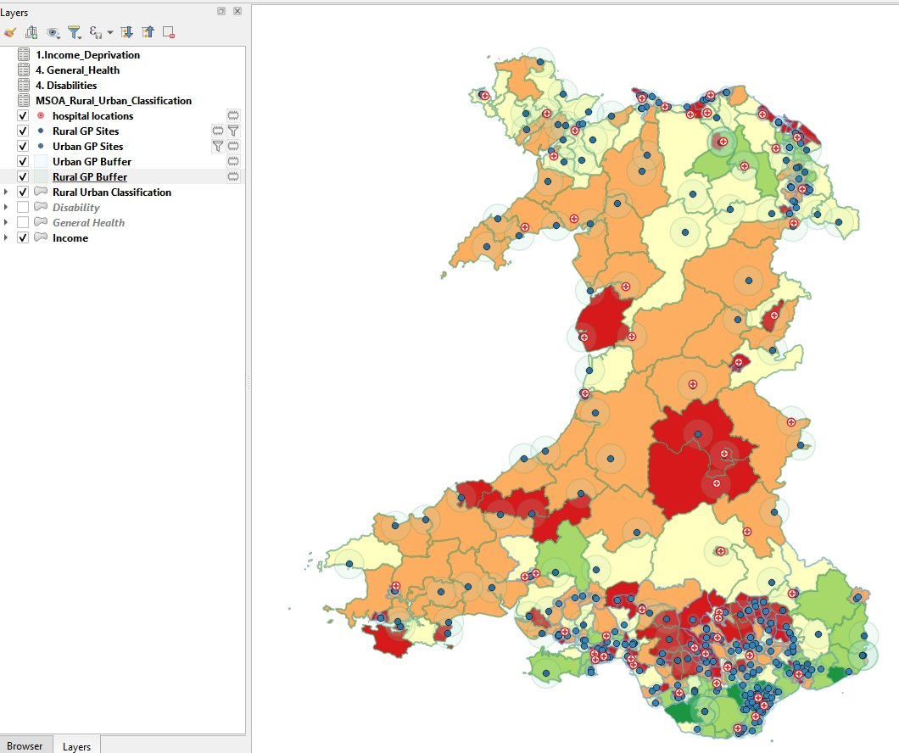
Figure 18 - Working view showing GP sites, hospital locations, variable catchment buffers, and income base.

3.5 Thematic Mapping – Map 3: Mental Health Service Access and Needs.
The last map was designed to examine mental health needs and service provisions by combining suicide rates as a proxy for mental health outcomes with hospital-level therapy waiting time data specifically for mental health therapies. Suicide rates were visualised as a graduated choropleth using a Blues colour ramp with Natural Breaks classification across five classes. The income layer was retained below this at a 35% opacity as a contextual reference layer.
Hospital waiting time data was visualised using a rule-based proportional symbol renderer combining two dimensions simultaneously. Circle size was scaled proportionally to the total wait time using the scale linear expression, ranging from size 3 to size 12, to represent the overall volume of demand at each hospital. Circle colour was distinguished where over 50% of patients were breaching the NHS Wales 14-week therapy waiting time target (dark red outline) from those where the majority were within target (blue). This proportional symbol approach allowed both the scale of demand and the quality-of-service provision to be communicated within a single layer.

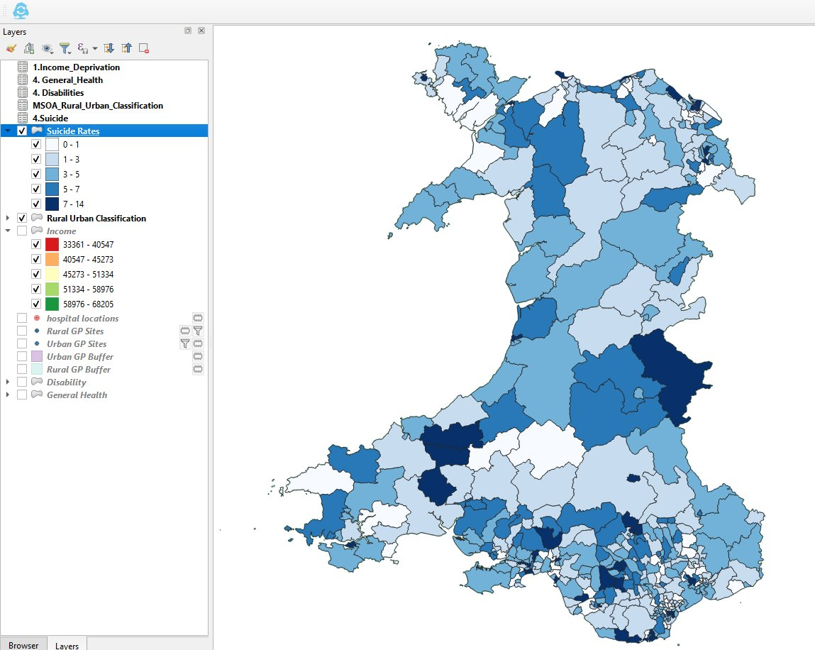
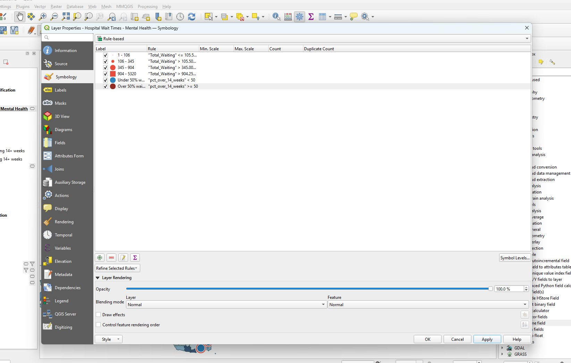
Figure 19 - Suicide Rates choropleth at 100% opacity showing spatial distribution.
Figure 20 - Rule-Based symbology dialogue interface showing proportional circle rules for Total Waiting and pct over 14 weeks.

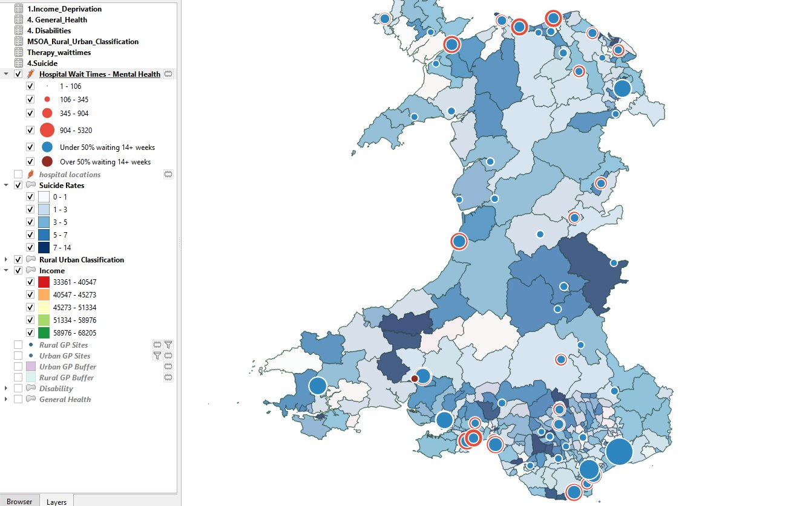
4. Outcomes
Figure 21 - Working view of Map 3 showing proportional circle symbols applied with rule-based rendering - circle size represents Total waiting, red outline indicates over 50% breaching 14-week-target.

4.1 Findings from the thematic maps
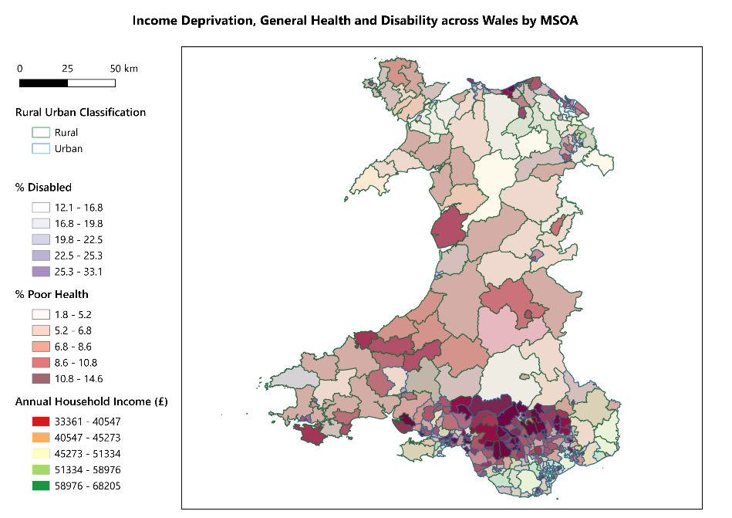
Analysis of the three thematic maps revealed spatial patterns and relationships across Wales in relation to income deprivation, health outcomes, and service distribution.
Figure 22 – Map 1: Income Deprivation, General Health, and Disability across Wales by MSOA

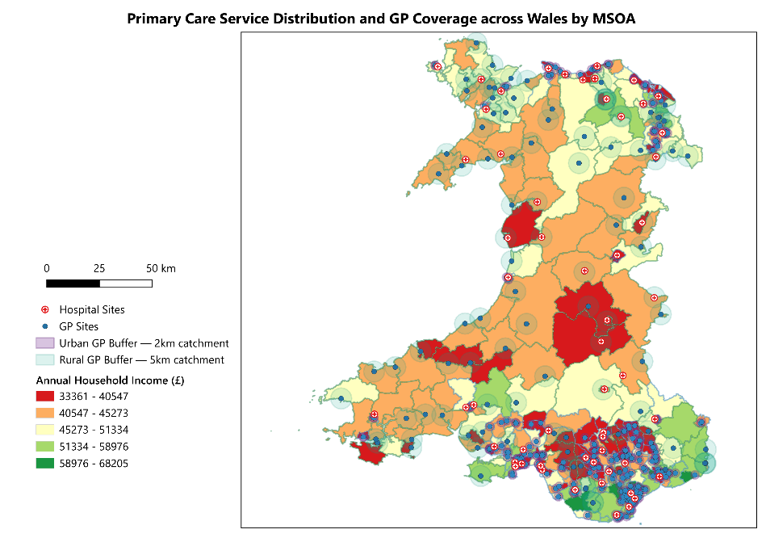
Map 1 reveals a strong spatial concentration of multiple disadvantages is visible in South Wales, particularly across the Valleys, parts of Swansea, Cardiff, and Newport. MSOAs with the lowest annual household incomes consistently overlap with the highest proportions of poor health and disability. Rural mid and north Wales display notably lighter tones across all three variables, suggesting better outcomes despite lower absolute incomes in some areas.[17]
Figure 23 – Map 2: Primary Care Service Distribution and GP Coverage across Wales by MSOA

Map 2 shows the primary care distribution across Wales; it reveals a large concentration of GP Provision in South Wales where urban 2km buffer zones overlap densely in the highest deprivation areas. In contrast, rural mid Wales presents a clear access gap 5km rural buffer zones are widely spaced with significant areas of orange and red income MSOAs falling outside any GP catchment areas. Hospital provision shows a similar pattern with few sites visible across the rural interior.
Map 3 highlights the darkest blue MSOAs indicating 7-14 recorded suicide deaths between 2017 – 2021, are concentrated in southeast Wales and along the north Wales coast corridor. The proportional symbol overlay reveals that several high-need areas are served by hospitals carrying the largest total waiting populations, with red-outlined circles indicating over 50% of patients breaching the NHS Wales 14-week therapy target. Rural mid Wales MSOAs show lower recorded rates but have almost no visible hospital provision suggesting potential underreporting rather than genuinely lower need [18, 19].

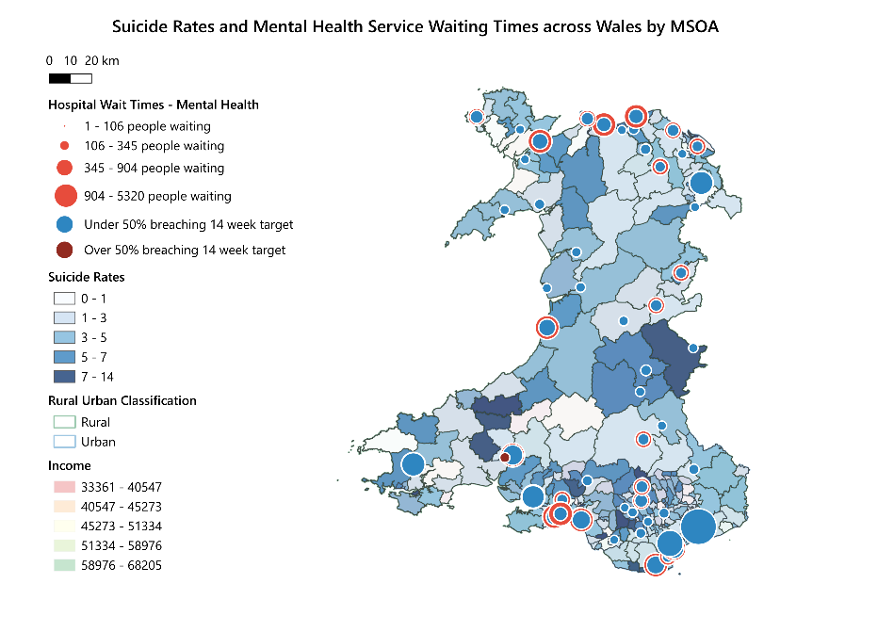
5. Analysis
Figure 24 - Map 3: Suicide Rates and Mental Health Service Waiting Times across Wales by MSOA

5.1 - Findings
The GIS build and thematic maps demonstrate several key principles of thematic mapping and data visualisation central to effective spatial communication.
Each map was designed to present data accessibly using intuitive colour ramps with clearly labelled legend entries. Natural Breaks (Jenks) classification ensured class boundaries reflected genuine clustering in the data instead of arbitrary intervals.
A deliberate decision was made to exclude physical activity and BMI datasets on the grounds of data reliability and to reserve occupation and industry data for future enrichment. This selective approach ensured each map communicated a focused analytical narrative.
Combining choropleth base layers with graduated overlays, point layers and outline classifications enable each map to communicate relationships between multiple variables impossible to convey through individual maps or tabular data alone.
The three maps provide a spatially evidenced responses to both research questions. Map 1 confirms a strong association between lower income and poorer health outcomes in urban south Wales. Maps 2 and 3 reveal that whilst primary care and mental health services are present in high deprivation areas, adequacy of provision is questionable. GP coverage gaps exist in rural deprived MSOAs and mental health therapy services in the highest need areas are significantly over capacity and underperforming against national waiting time targets.

5.2 Challenges
A number of practical challenges were encountered during the GIS build that required problem solving and, in some cases, influenced the scope of the final analysis.
A primary challenge through the data acquisition process was the availability of datasets at the correct geographical level. The MSOA boundary framework used in this study required all attribute data to be joinable at MSOA level. Several datasets of potential analytical value, most notably the physical activity and BMI data sourced from the Welsh Government Ad-hoc statistical release, were only available at Upper Super Output Area (USOA) level. Attempts were made to bridge this gap by generating MSOA Codes using Claude.AI however the resulting dataset could not be considered sufficiently dependable for thematic mapping and therefore was excluded. This challenge highlighted the importance of confirming geographic compatibility of datasets before committing to their inclusion in a GIS study.
The geocoding of hospital locations using the MMQGIS Nominatim plugin presented a technical challenge. The service-imposed rate limiting restrictions, returning an HTTP 429 error this was resolved by introducing delays between requests, a small number of names were not successfully matched by the automated service and required manual coordinate lookup via Google Maps. While the final geocoded dataset was verified and complete, this process underlined the limitations of relying on free geocoding services for non-English place names.

5.3 Limitations
In addition to the challenges encountered, a number of limitations should be considered when interpreting the study.
The datasets in this study span a range of years. Combining datasets from different time periods introduces a degree of temporal inconsistency as conditions in any given MSOA may have changed between collection dates. Ideally all datasets would relate to the same reference period to ensure comparability.
Analysis at MSOA level masks variation within individual areas. MSOA contains on average 7,200 residents and can encompass a wide range of socioeconomic conditions within its boundary. Areas that appear moderate at MSOA level may contain pockets of extreme deprivation or remarkably high service need that are not visible at this scale. A more granular analysis at LSOA level could provide greater spatial precision.
The therapy waiting times dataset is available at hospital location in place of MSOA level. These figures represent catchment-wide demand not MSOA specific need which limits the precision with which service adequacy can be assessed at the local level. Suicide data at MSOA level is subject to small number suppression in some areas and represent only the most extreme outcome of poor mental health rather than the broader spectrum of mental health conditions.

6. Conclusions
This study investigated two research questions using GIS-based thematic mapping across 410 Welsh MSOAs. The three map outputs provide spatially evidenced responses to both.
Map 1 confirms a strong spatial relationship between lower income and poorer health outcomes, concentrated in the south Wales valleys, Swansea and the Newport/Cardiff corridor, where low income, poor health and high disability occur.
Map 2 reveals a significant urban-rural divide. Whilst GP provision exists in deprived urban areas, rural mid Wales shows clear geographic coverage gaps with several high-deprivation MSOAs falling outside any catchment zones.
Map 3 demonstrates that therapy services are under greatest pressure in the highest-need areas, with over 50% of patients at several hospitals breaching the 14-week target in areas already characterised by elevated suicide rates and low income.
Future enrichment could include population weighting, occupation and industry-based data, robust physical activities and BMI datasets, additional mental health indicators such as antidepressant prescribing rates, and green space or leisure facility coverage to explore the relationship between physical infrastructure and health outcomes.

References
[1] P. A. Longley, M. F. Goodchild, D. J. Maguire, and D. W. Rhind, Geographical Information Systems and Science, 2nd ed. Chichester: John Wiley & Sons, 2005.
[2] G. E. Sherman, Desktop GIS: Mapping the Planet with Open Source Tools. Raleigh, NC: Pragmatic Bookshelf, 2008.
[3] QGIS Development Team, "QGIS Geographic Information System, Version 4.0.1 'Norrkoping'," Open Source Geospatial Foundation, 2024. [Online]. Available: https://www.qgis.org
[4] QGIS Development Team, QGIS 3.44 Documentation, Open Source Geospatial Foundation, 2024. [Online]. Available: https://docs.qgis.org/3.44/en/docs/index.html
  - Data Sources
[5] DataMap Wales, "Middle layer super output areas (MSOA) 2021 – Wales high water mark," DataMap Wales, 2021. [Online]. Available: https://datamap.gov.wales/layers/geonode:msoa_2021_w_hwm
[6] Office for National Statistics, "Small area income estimates for middle layer super output areas, England and Wales," ONS, 2023. [Online]. Available: https://www.ons.gov.uk/employmentandlabourmarket/peopleinwork/earningsandworkinghours/datasets/smallareaincomeestimatesformiddlelayersuperoutputareasenglandandwales
[7] Office for National Statistics, "Highest level of qualification (TS067), Census 2021," ONS, 2021. [Online]. Available: https://www.ons.gov.uk/datasets/TS067/editions/2021/versions/3
[8] Welsh Government, "Ad-hoc statistical requests: physical activity and BMI data," Welsh Government, 2023. [Online]. Available: https://www.gov.wales/ad-hoc-statistical-requests-4-29-december-2023
[9] UK Data Service, "INFUSE: General health data, Census 2011," UK Data Service, 2011. [Online]. Available: https://infuse2011gf.ukdataservice.ac.uk/infusewizgeo.aspx
[10] Office for National Statistics, "Disability: long term health conditions (TS038), Census 2021," ONS, 2021. [Online]. Available: https://www.ons.gov.uk/datasets/TS038/editions/2021/versions/3
[11] Office for National Statistics, "Number of suicides by MSOA in England and Wales registered between 2017 and 2021 combined," ONS Ad-Hoc Release, 2022. [Online]. Available: https://www.ons.gov.uk/peoplepopulationandcommunity/birthsdeathsandmarriages/deaths/adhocs/1013numberofsuicidesbymsoainenglandandwalesregisteredbetween2017and2021combined
[12] DataMap Wales, "GP main sites Wales (OGL)," DataMap Wales, 2024. [Online]. Available: https://datamap.gov.wales/layers/geonode:gpbranchsites_ogl
[13] Office for National Statistics, "2021 rural urban classification," ONS, 2021. [Online]. Available: https://www.ons.gov.uk/methodology/geography/geographicalproducts/ruralurbanclassifications/2021ruralurbanclassification
[14] Office for National Statistics, "NS-SEC: National statistics socio-economic classification (TS062), Census 2021," ONS, 2021. [Online]. Available: https://www.ons.gov.uk/datasets/TS062/editions/2021/versions/5
[15] Office for National Statistics, "Industry (TS060), Census 2021," ONS, 2021. [Online]. Available: https://www.ons.gov.uk/datasets/TS060/editions/2021/versions/5
[16] StatsWales, "Therapy services: pathway waiting times, August 2024 onwards," StatsWales, 2024. [Online]. Available: https://stats.gov.wales/en-GB/337263f7-58ac-42a4-ab99-9fa5126057f9
[17] T. Griffiths et al., "Cost of health inequality to the NHS in Wales," BMC Public Health, vol. 22, no. 1, p. 1624, Sep. 2022. DOI: https://doi.org/10.1186/s12889-022-14086-x
[18] L. Maconick et al., "Investigating geographical variation in the use of mental health services by area of England: a cross-sectional ecological study," BMC Health Services Research, vol. 21, no. 1, p. 958, Sep. 2021. DOI: https://doi.org/10.1186/s12913-021-06976-2
[19] H. J. Lowther-Payne et al., "Understanding inequalities in access to adult mental health services in the UK: a systematic mapping review," BMC Health Services Research, vol. 23, no. 1, p. 1050, Sep. 2023. DOI: https://doi.org/10.1186/s12913-023-10030-8

Appendix

OneDrive Access to QGIS:
The complete QGIS project file (Assignment_QGIS_Project.qgz) has been stored and made accessible via the University OneDrive. This file contains all map layers, attribute joins, symbology settings, and spatial configurations produced throughout this assignment. The .qgz format is QGIS's native compressed project file, which packages the project settings and layer references into a single portable file. The project can be accessed at the following link: https://uowtsd-my.sharepoint.com/:u:/g/personal/2308345_student_uwtsd_ac_uk/IQC8sE4TSckzR5RWAB-3UVMbAYI6M5ravN5_hAc5qBQersw?e=ny5ugV

AI Usage Paragraph
I acknowledge the use of Claude (https://claude.ai), developed by Anthropic, as a supplementary academic support tool during the preparation of this assignment.
Claude was used to:
Manipulate and analyse data relating to BMI and Physical Activities, using the following prompt:
"I am working on my GIS assignment, my lecturer has confirmed we can create a dummy data set from an existing set due to the lack of LSOA and MSOA codes. Can you replicate the existing data at USOA level but create an MSOA field for a primary key. Please create two data sets combining the relevant tabs at MSOA Level: 1) healthy_weight, overweight_or_obese, obese 2) physically_inactive with physically_active — both need to be .csv files."
Please note that this data and any associated outputs were subsequently not used within the final submission.
All core analysis, interpretation and written content were completed independently. Academic references were sourced, reviewed, and verified independently to ensure accuracy and relevance.

