

BSc Cloud Computing

Student name: Orlin Petrov Chukov
Student Number: 2029131

Email: 2029131@student.uwtsd.ac.uk

Module: Software Development (Python)

Assignment Title: Assessment 1

Table of contents:
- Variables…………………………………………………………………………………………………3
- If / Else statements………………………………………………………………………………….3
- Loops………………………………………………………………………………………………………4
- Exercises…………………………………………………………………………………………………5

Variables
In Python there is no command to declare variables. They are created the moment when we assign a value to it. In simple words a variable is a container for storing the data value. They don’t need to be declared and they can even change type the moment they’ve been set. A variable most important role is to apply logic to a variety of inputs.

If / Else statements
Those statements execute a block of source code if a certain condition is true. If the condition is false, other code will be executed. For example, as in one of the tasks that I have applied below: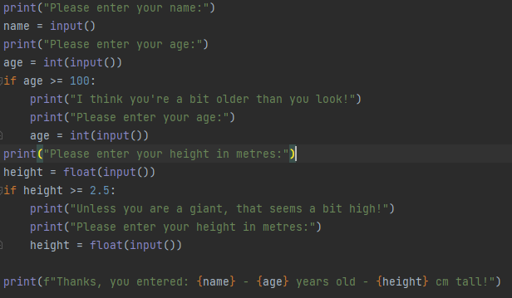
I am specifically using if statements for a different age and height being typed. If the age is more or equal to a hundred, the console prints “I think you’re a bit older than you look!” and if the age is less than a hundred the console keeps running the other variables.

Loops
A for / while loop is flow statement used to execute group of statements repeatedly. Iterative statement is such type. Meaning, the loop is iterative statement. For loops are used when we have a certain range that we should repeat the condition in, and while loop is used without this specific range. For example, as in one of the tasks that I have applied below: 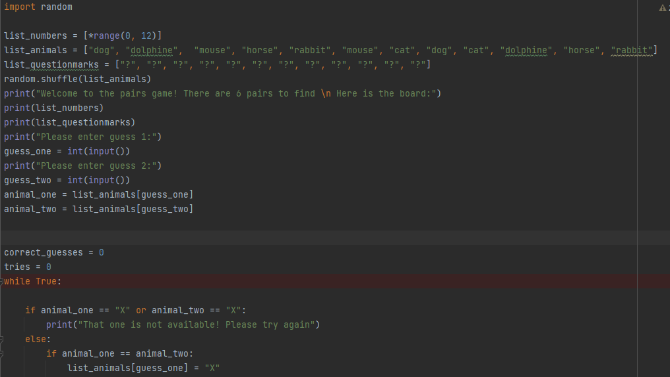
In this task I don’t know how many times I will have to repeat the condition until it becomes true so I’m using while loop because this way the loop will repeat itself until I get the result I wanted to achieve.

Exercise 1:
- print("Please enter your name:")
- name = input()
- print("Please enter your age:")
- age = int(input())
- if age >= 100:
- print("I think you're a bit older than you look!")
- print("Please enter your age:")
- age = int(input())
- print("Please enter your height in metres:")
- height = float(input())
- if height >= 2.5:
- print("Unless you are a giant, that seems a bit high!")
- print("Please enter your height in metres:")
- height = float(input())

- print(f"Thanks, you entered: {name} - {age} years old - {height} cm tall!")

We need three variables [name, age, height]
We need to set the proper inputs[integer, float or string]
We need a leading text before every variable, for example("Please enter your name:")
We need to do a simple if statement to prevent a person to be unable to type inappropriate values.
We need a final “f” string to print the answer on the console.

Exercise 2:
- from math import pi
- print("Please enter radius of cirlce:")
- radius = float(input())
- print("Please enter side of square:")
- side = float(input())
- if side >= radius:
- print("That seems a little big, please try again:")
- print("Please enter side of square:")
- side = float(input())
- print("Please enter width of rectangle:")
- width = float(input())
- if width >= radius:
- print("That seems a little big, please try again:")
- print("Please enter width of rectangle:")
- width = float(input())
- print("Please enter length of rectangle:")
- length = float(input())
- if length >= radius:
- print("That seems a little big, please try again:")
- print("Please enter length of rectangle:")
- length = float(input())

- square = side * side
- rectangle = width * length
- circle = pi * (radius * radius)
- print(f"The shaded area is {circle - square - rectangle :.2f}")

We need to import from math the constant PI in order to be used in the source code below
We need four variables [radius, side, length and width]
We need to set the proper inputs[integer, float or string]
We need a leading text before every variable, for example("Please enter radius of cirlce:")

We need to do if statement to prevent a person to be unable to type inappropriate values.
We need a final “f” string to print the answer on the console.

Exercise 3:
- total_miles = 0
- print("Enter miles for Monday:")
- miles = float(input())
- if miles < 0:
- print("Please try again:")
- print("Enter miles for Monday:")
- miles = float(input())
- total_miles += miles
- print("Enter miles for Tuesday:")
- miles = float(input())
- if miles < 0:
- print("Please try again:")
- print("Enter miles for Tuesday:")
- miles = float(input())
- total_miles += miles
- print("Enter miles for Wednesday:")
- miles = float(input())
- if miles < 0:
- print("Please try again:")
- print("Enter miles for Wednesday:")
- miles = float(input())
- total_miles += miles
- print("Enter miles for Thursday:")
- miles = float(input())
- if miles < 0:
- print("Please try again:")
- print("Enter miles for Thursday:")
- miles = float(input())
- total_miles += miles
- print("Enter miles for Friday:")
- miles = float(input())
- if miles < 0:
- print("Please try again:")
- print("Enter miles for Friday:")
- miles = float(input())
- total_miles += miles
- print("Enter miles for Saturday:")
- miles = float(input())
- if miles < 0:
- print("Please try again:")
- print("Enter miles for Saturday:")
- miles = float(input())
- total_miles += miles
- print("Enter miles for Sunday:")
- miles = float(input())
- if miles < 0:
- print("Please try again:")
- print("Enter miles for Sunday:")
- miles = float(input())
- total_miles += miles
- cost = total_miles / 11.2 * 1.35
- print(f"The total mileage was: {total_miles}")
- print(f"Cost of petrol: £{cost :.2f}")

We write a variable for miles (float)
We need a leading text before every variable, for example("Enter miles for Friday:")
We write a counter (total_miles) and we set it as zero so we can change it’s value later
We do a simple if statement to prevent a person to be unable to type inappropriate values. (for every single day of the week)
We calculate the cost
We need a final “f” string to print the answer on the console.

Exercise 4:

- import random

- list_numbers = [*range(0, 12)]
- list_animals = ["dog", "dolphine", "mouse", "horse", "rabbit", "mouse", "cat", "dog", "cat", "dolphine", "horse", "rabbit"]
- list_questionmarks = ["?", "?", "?", "?", "?", "?", "?", "?", "?", "?", "?", "?"]
- random.shuffle(list_animals)
- print("Welcome to the pairs game! There are 6 pairs to find \n Here is the board:")
- print(list_numbers)
- print(list_questionmarks)
- print("Please enter guess 1:")
- guess_one = int(input())
- print("Please enter guess 2:")
- guess_two = int(input())
- animal_one = list_animals[guess_one]
- animal_two = list_animals[guess_two]

- correct_guesses = 0
- tries = 0
- while True:

- if animal_one == "X" or animal_two == "X":
- print("That one is not available! Please try again")
- else:
- if animal_one == animal_two:
- list_animals[guess_one] = "X"
- list_animals[guess_two] = "X"
- list_questionmarks[guess_one] = "X"
- list_questionmarks[guess_two] = "X"
- print(list_numbers)
- print(list_questionmarks)
- correct_guesses += 1
- print(f"Well done, that's a match on {animal_one}")

- else:
- print(list_animals)
- print(f"Not a match. Position {guess_one} was {animal_one} and position {guess_two} was {animal_two}")

- tries += 1
- print(f"You've had {tries} turn(s) so far")
- if correct_guesses == 6:
- print(f"Well done, you got them all. You did it in {tries} turns")
- break
- print("Please enter guess 1:")
- guess_one = int(input())
- print("Please enter guess 2:")
- guess_two = int(input())
- animal_one = list_animals[guess_one]
- animal_two = list_animals[guess_two]

- we need to import random so we can shuffle the list later
- we create three lists one for the numbers and one for the animals and one for the question marks
- we write the command that will shuffle the list on every single start of the game
- we need a leading text before every variable, for example("Welcome to the pairs game!)
- we write a variable for guess_one and guess_two
- we create two variables for the animals from the list that are going to called be the user by typing numbers for guess one and two
- we set a counter (correct_guesses) and (tries) so we can use it later
- we need a while loop so we can go through every single input choice until we get the correct combination(we use while loop instead of for loop because we are not certain how many tries the user is going to need in order to win the game)
- we need an if / else statement
- we create a variable “X” so we can mark every correct guess
- We need a final “f” string to print the answer on the console.

