Louise Bourgeois and trauma in art

By Ninu Abraham

MA Graphic design
Gavin Kirby
University of wales trinity saint David
30/04/26

Question 2. De/constructing the Human: In what ways do Louise Bourgeois challenge and reconfigure dominant constructions of the human subject through lenses such as psychoanalysis?

Abstraction:
This essay is to discuss the psychology behind Louise Bourgeois specific artwork and the feelings of horror that it evokes. A close look at the artwork with the psychological implications and memories that may have inspired the pieces. As well as the history of art that inspired work, such as the hysteria pose commonly used before then in art.
Questioning how much is relevant to her trauma in the art and the symbolism that may leak through for things remembered or not. What the implications of the trauma have with the in her art and what it means. The feeling of not belonging in her own body even if not expressly said just felt? How these works can often be interpreted by the media and misunderstood. Ending this essay with about how trauma can stay in the body like ghosts in a haunted house once again how it plays into the inner demons for this artist's life. Using her art as a way to heal from what she went through and show the world how it had felt for her as well. Between what can be known of her trauma and what would not have been talked about at that time as well.

Section 1: Introduction
Louise Bourgeois was known for telling her life story and past trauma through art. What psychological factors are behind the unsettling elements of her art. Most of her works are focused on her childhood and her parents Joséphine Fauriaux and Louis Bourgeois. She is known for sculpture,installation, art painting and printmaking. The most notable works of Louise bourgeois are Spider, Cells, Maman,The Destruction of the Father etc. All the artworks she's done has the emphasis of trauma and the feeling of not belonging within one's own body. The destruction of the father and the Arch of hysteria was a way for her to work through this trauma and find peace with how she felt in her own body.

Louise Bourgeois has done variety of themes in her artwork but one that is prevalent is death and the unconscious mind which is of feeling in between the death and the real world while being unconscious just like being in a limbo space of inbetween of something familiar and unfamiliar and that causes a disturbance in the psych of my human mind. The main focus is the reason behind the trauma of Louise bourgeois which focuses on the psych of her and how it relates to the mental distress which started with her father’s affair with his mistress which causes her mother to neglect her in her childhood which was a large impact on much of her artwork in her professional life. This essay is about the psychoanalysis of Louise Bourgeois and a presence of somatization of her trauma in her artwork.
In Freud words the feeling of repression after the trauma of something familiar but returns as mental illness or even physical changes as the mind and body remembers even if not fully accurate and Kristeva explains it as how a person sees everything in their natural order and it feels familiar to the brain but when it goes the opposite the brain will reject the idea as it gets unfamiliar and that’s what abjection is,which similar to how uncanny feels where the brain feels something familiar but it senses something different so it rejects it as being out of natural order.

Section 2: Trauma and repeated symbols
'All the phenomena of the formation of symptoms may justly be described as the 'return of the repressed.' Their distinguishing characteristic, however, is the far-reaching distortion to which the returning material has been subjected as compared with the original" (moses and monotheism; freud, 1939, p. 127)
In the book ‘Moses and monotheism’ by Freud he talks about the impressions of early childhood and demands that come up in the life of a person affect what he does in life. Even if the past or trauma of the child is forgotten it will come back and haunt the child through their life as something that is eerie and forgotten like a haunted house that once held life. Even If Louise had not repressed her childhood trauma of her mothers neglect and fathers infidelity the trauma left a distinct mark on her artwork as a child fighting for who she was in the world between her identity and what being a woman meant. This theory is very similar to dissociation where one forgets for a time but the trauma never truly was. It also pulls to the idea of somatization where the body expresses the invisible anxieties by becoming physical symptoms.
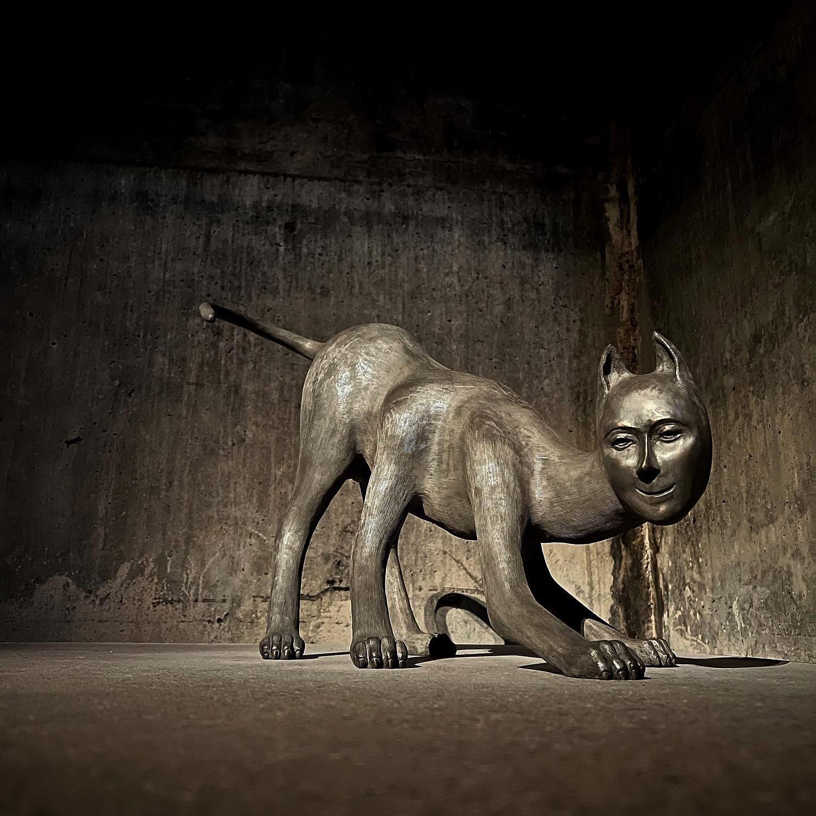
Much if not most of her early works were all simple lineart of her self portrait. Many into her adulthood as well. Feeling like she was looking for an identity inside who she was and would be with her parents' neglectful and sometimes spiteful raising of her.
Along with the most well known of her self portraits which portrays her face on the body of a warped animal possibly a cat which brings to mind the fear and confusion her young self may have felt in the moments of the mind games being held between the adult problems of her parents fights.
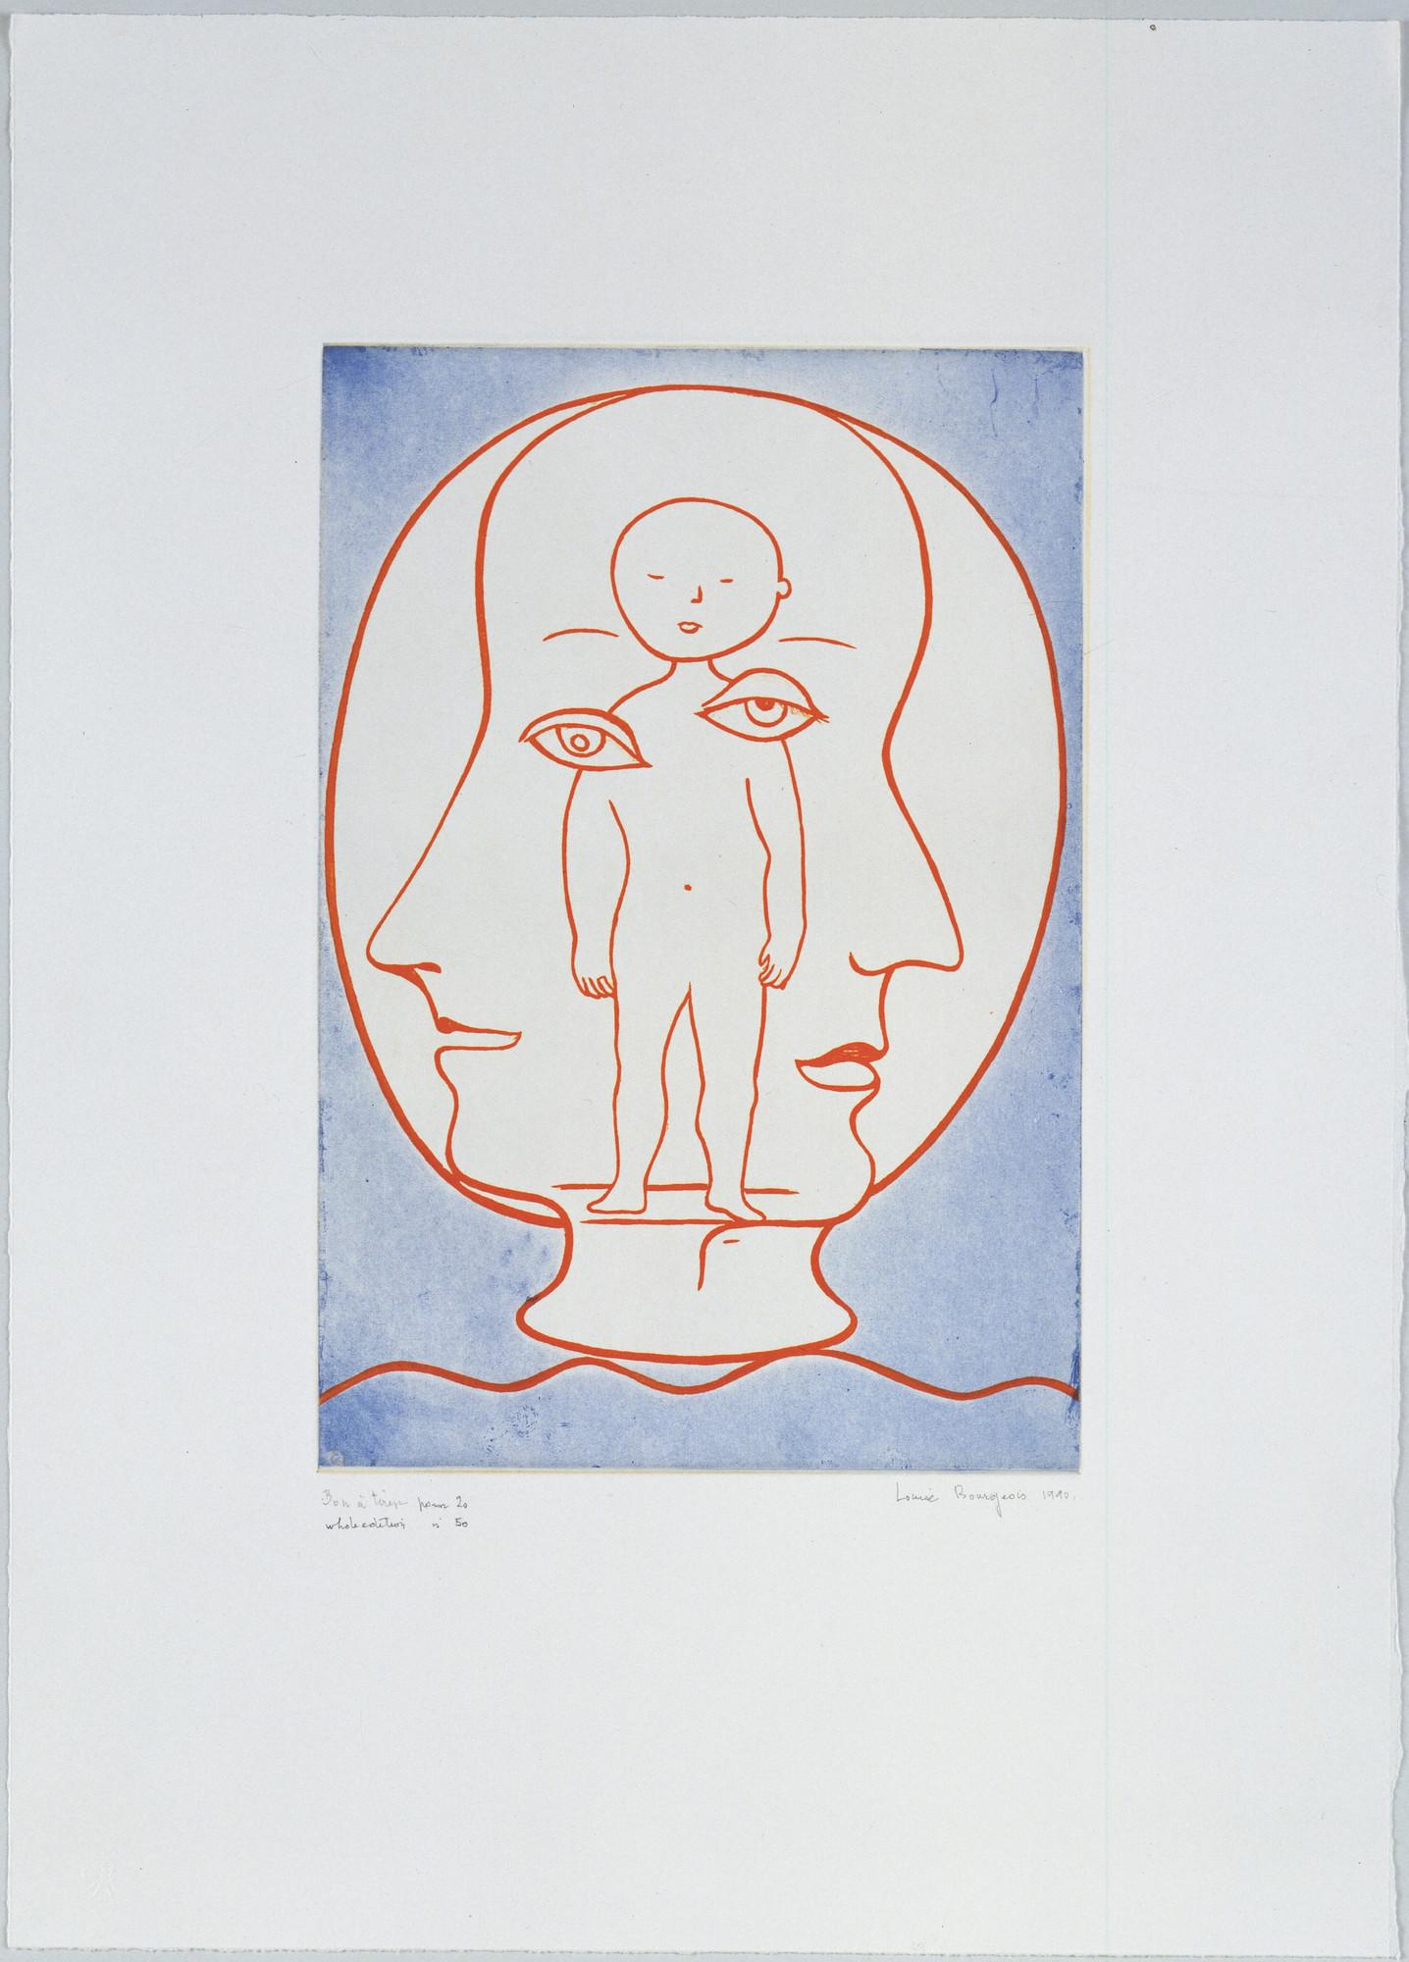
(Self portrait 2007,ref) (Self portrait 1990s,ref)

Femme Maison art series took place over years of working on all following the same idea: paintings, drawings, sculptures all following the idea of women and houses being merged into one shape. The idea of a woman of the house and a woman stuck in her home can be taken either way and has been through the years with feminist movements. How the gender roles are given in society and if they truly fit women for not all are fit in those roles. As well as commentary on the aspect women have been given to be housewives.
‘In Femme Maison, Bourgeois delivers a profound critique of women who are limited and trapped in the domestic sphere. Through the combination of the woman’s body with architecture, she represents the psychological and emotional imprisonment triggered by societal pressures. The association of the body with the house creates a strange and disturbed imagery and hence encourages the viewers to ponder upon the various complexities of gender identity and how women are asked to stick to prescribed roles.’ (singulart, 2024)

Bergoise repeats symbols of the spider like in the Maman 1991 often due to her parents role as carpet making and the idea of breaking and repairing relationships that was done by her mother. A very careful weaving of relationships and peoples opinions using her and her siblings as a way to know what her husband and his mistress were doing. Using her children to find out information from her broken and neglected marriage in order to keep up the appearance of any family. The spider is her most well known sculpture representing this relationship with her mother as someone who stands over her but is not protective in a beneficial way but to keep what control the woman could in her life. Despite this treatment from her mother she still perceived her as having done what she good in her early life. Body parts are another motif common in her work, art like the ‘destruction of the father’ and the other works that display the earlier mentioned body horror. She explores her trauma and sexuality as a human whose parents sex life was so tumultuous and it impacted her. The body parts that fill a table surrounded by breasts like half orbs to symbolize his sexuality at the expense of her family. This piece was completed shortly after the death of her husband who had provided her a safe place to realize and work through her traumas and their three sons. The destruction of the father is another artwork that represents her father as not only someone who was a huge part of her trauma but also how overbearing he felt to her as she was the one in the liminal space of not being able to explore herself as a child where she’s doesn’t have to be involved in adult drama so she felt stuck in between.
Louise Bourgeois self-portrait 1994 is a print art which shows a child in the middle of two adults again showcasing the liminality of being stuck in between her mother and father’s relationship which also looks like a prison and drawing this helped her understand how stuck she felt as a child where her innocent life was filled with no love but just a product of her parents to use to their advantage but at the same time she also knew her mom loved her in a very toxic but messed up way so gain more of it she would be an instrument for her mother like a moth to the light where her mother’s love slowly drains her innocent life of colours. In the art everything is made of lines that connects each other which shows how Louise bourgeois felt as a young child with her mother where she felt stuck but also more connected in a twisted way where the lines are curved showcases, which is a representation of how she felt closer and more connected the more she was doing what her mother wanted her to do and that can be connected how uncanny can be eerie but also give a feeling of calmness and relaxation to something familiar just like how all her artwork of her self exploration can feel like which is a feeling of being stuck and eerie but also peaceful. Her trauma can also be an exploration of questioning who and what she is, a feeling that is very much liminal.

‘All the phenomena of the formation of symptoms may justly be described as the 'return of the repressed.' Their distinguishing characteristic, however, is the far-reaching distortion to which the returning material has been subjected as compared with the original" (moses and monotheism; freud, 1939, p. 127)
In ‘moses and monotheism’by Freud he talks about;
‘The impressions of early childhood and demands that come up in the life of a person affect what he does in life. Even if the past or trauma of the child is forgotten it will come back and haunt the child through their life as something that is eerie and forgotten like a haunted house that once held life.’ (moses and monotheism; freud, 1939)
Even If Louise had not repressed her childhood trauma of her mothers neglect and fathers infidelity the trauma left a distinct mark on her artwork as a child fighting for who she was in the world between her identity and what being a woman meant. This theory is very similar to dissociation where one forgets for a time but the trauma never truly
Much if not most of her early works were all simple lineart of her self portrait. And many into her adulthood as well, like she was looking for an identity inside who she was and would be with her parents' neglectful and sometimes spiteful raising of her. Along with the most well known of her self portraits which portrays her face on the body of a warped animal possibly a cat which brings to mind the fear and confusion her young self may have felt in the moments of the mind games being held between the adult problems of her parents fights.

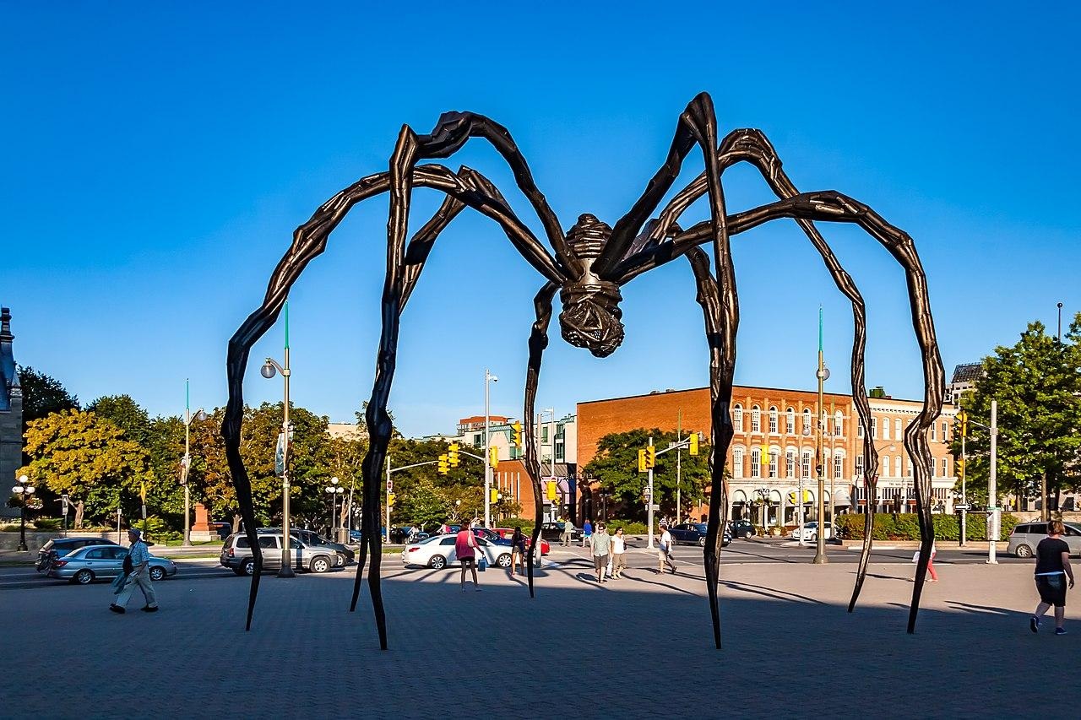

(Maman 1999, ref)

Femme Maison art series took place over years of working on all following the same idea: paintings, drawings, sculptures all following the idea of women and houses being merged into one shape. The idea of a woman of the house and a woman stuck in her home can be taken either way. This has been through the years with feminist movements. How the gender roles are given in society and if they truly fit women for not all are fit in those roles.
‘In Femme Maison, Bourgeois delivers a profound critique of women who are limited and trapped in the domestic sphere. Through the combination of the woman’s body with architecture, she represents the psychological and emotional imprisonment triggered by societal pressures. The association of the body with the house creates a strange and disturbed imagery and hence encourages the viewers to ponder upon the various complexities of gender identity and how women are asked to stick to prescribed roles.’ (singulart, 2024)

Bourgeois repeats symbols of the spider often due to her parents role as carpet making and the idea of breaking and repairing relationships that was done by her mother. A very careful weaving of relationships and peoples opinions using her and her siblings as a way to know what her husband and his mistress were doing. Using her children to find out information from her broken and neglected marriage in order to keep up the appearance of any family. The spider is her most well known sculpture representing this relationship with her mother as someone who stands over her but is not protective in a beneficial way but to keep what control the woman could in her life. Despite this treatment from her mother she still perceived her as having done what she good in her early life.
Body parts are another motif common in her work, art like the ‘destruction of the father’ and the other works that display the earlier mentioned body horror. She explores her trauma and sexuality as a human whose parents sex life was so tumultuous and it impacted her. The body parts that fill a table surrounded by breasts like half orbs to symbolize his sexuality at the expense of her family. This emotional piece was completed shortly after the death of her husband who had provided her a safe place to realize and work through her traumas and their three sons. This event likely caused her to think through her relationship with her father as time had gone on.
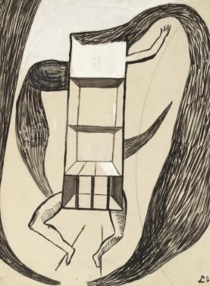
(Femme Maison 1947, ref)

Section 3: A haunted home of not belonging
The many artworks of Louise Bourgeois have aspects of her psychological state,the relation to the psyche behind it. Vidler talks about this in his book ‘The Architectural Uncanny’ where he relates the house as something familiar and the most intimate shelter that feels safe but at the same time a house that can also be filled with the memories of the past which feels so weird and out of place and in the words of Vidler mentions.

“The house provided an especially favored site for uncanny disturbances: its apparent domesticity, its residue family history and nostalgia, its role as the last and most intimate shelter of private comfort…”(Vidler, A (1992) page 17)

This can be seen in The Cells,1980 where she done a house like prison showcasing how she felt trapped within her own home which was a jail to her as it was never a safe place for her to be herself and one of the art piece where a huge spider laying on top of the cell shows how she felt her mother being the one in control of the home which goes back to how Maman,1991 shows the representation of her mother as a spider and self-portrait in 1994 which shows how that connection affected her past. In this power she felt stuck and the one art she made can be similar to how the femme maisson,1946-1947 is as it shows a women with house for a head and a human body which shows the woman as being the authority of the house which is what her mother as the spider represents and many examples of this authority can be seen in many myths where whether good or for evil the women like Kali, Medusa, Nyx etc can be seen as powerful women that brings forth fear in men and that kind of fear is what Louise Bourgeois brought forward in much of her artwork. Women in religions and stories who were known to stand up for themselves and bring peace or war. Themes of feminism and the women's place in society to be thought over if relevant in modern society.
When creating this art Louise bourgeois felt like a voyeur while looking at her past through the cells which shows different types of pain that she herself went through. The thought of integrate, merge, or disintegrate itself showcases how she felt as an outsider and not knowing her identity so this art was a way for her to realise her self identity through doing art where she brought back her forgotten unconscious trauma of the past she has been dealt with in her younger days and how all of these aspects relates to her also being a housewife and how she can keep herself from being the same controlling spider her mother was over her kids.

Her later years brought her to focusing more on mental health. Cell XXVI 2003 is a representation of herself spiralling her mental health goes down and the mirror is the reflection of who she is but the self that is in spiral is her forgetting that part of her and losing mental stability and this art was her way of being afraid of losing herself if she didn’t understand her traumas and working through to find who she is The Last Climb is another Cell art piece she did that shows how freedom looks like a last piece of work that’s optimistic of the future, this showcase how unconsciously she wanted to escape away from the prison of her home so much and the stairway is also an image representing a stairway to heaven where heaven brings a sense of peace and she wanted to find the same peace from leaving the home she was stuck in. This was the same staircase she had used in her previous artwork that she repurposed again
for the last climb. The Cells is different parts of her home that felt confusing to her in many ways and the design itself in her work shows this as each cell is designed in a way that is weird and out of place which isn’t how a normal house would usually look like and this can be said in a quote Le Corbusier says:

'If we eliminate from our hearts and minds all dead concepts in regard to the house, . . . we shall arrive at the ‘House-Machine,’ the mass-production house, healthy (and morally so too) and beautiful in the same way that the working tools and instruments that accompany our existence are beautiful' (Le Corbusier, Toward a new Architecture, pg 253)

Where a house can be seen more complicated if the design is intricate and unusual but if the design is simple and straightforward then the mind doesn’t overthink the complications of figuring out the designs which is what Louise Bourgeois felt while being inside her home where the whole situation was very much a complicated design for a young mind of a child to understand and so she felt herself being stuck in prison where a home is not a safe place anymore for her young self.
The Cells is also her home taken out from different areas of the house like a puzzle pieces that haven’t been attached together allowing a sense of the same complicated designs in the older houses which relates to what Le Corbusier said in Toward a new Architecture book 1923 that if more complicated a house is that is supposed to be simple and efficient the more uncanny it is. Where the house feels more eerie than familiar and that is what The Cells is representing with different architecture of out of place areas that can be unconventional but also familiar. The Cells was how she found herself where she underwent deeply into the psyche of her mind exploring her trauma in a place she felt in a liminal space stuck between a world of something she knew and something she never understood and trying to figure out the answers to the questions that were unanswered. Many of these art pieces are an invitation in the early confusion and maze that her childhood home was to navigate.

Section 4: More and questioned trauma
She would have to wrestle with the abjection from her mother in response to her husband's affairs. Abjection of a mother is the removal of all that is natural to the mother to child. Abjection the removal of all that is natural to one bodily fluids from a corpse ect. A violent displacing of what belongs in the moment of either death or change depending on the context.
‘Essentially different from "uncanniness," more violent, too, abjection is elaborated through a failure to recognize its kin; nothing is familiar, not even the shadow of a memory. I imagine a child who has swallowed up his parents too soon, who fright- ens himself on that account, "all by himself," and, to save himself, rejects and throws up everything that is given to him- all gifts, all objects. He has, he could have, a sense of the object even before things for him are—hence before they are signi- fiable—he drives them out, dominated by drive as he is, and constitutes his own territory, edged by the abject. A sacred configuration. Fear cements his compound, conjoined to an- other world, thrown up, driven out, forfeited. What he has swallowed up instead of maternal love is an emptiness, or rather a maternal hatred without a word for the words of the father;’ (the powers of horror, julia christiva, 1982, pg 5)
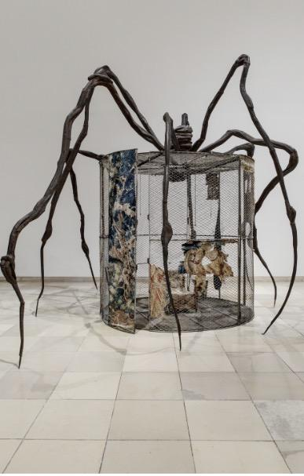
(Spider cell 1947, ref)

Christiva defines the concept of abjection between a mother and children as what would be considered as emotional incest.

Filling the child's life with the mothers problems and things that do not belong to the child but the parents. Holding tighter and tighter to the child ultimately harms the bond between the mother and child so that when the child grows and leaves the home they may so much as go not to contact their mother or create more severe boundaries. Louis Bergoise's early relationship with her mother with her asking her children to find out about her husband's misgivings with his mistress was an incredibly irresponsible action of hers. This stepped over the boundaries between mother and child even if she was trying her best at the time.

‘ In the child's attempts to break away, the mother becomes an abject; thus, in this context, where the child struggles to become a separate subject, abjection becomes a precondition of narcissism' (p. 13). Once again we can see abjection at work in the horror text where the child struggles to break away from the mother, representative of the archaic maternal figure, in a context in which the father is invariably absent (Psycho, Carrie, The Birds).’ (Creed, the monstrous femme)
The image of maman being a spider to convey protection but also off putting in more than a common fear of spiders. It also conveys the feeling of something that preys on those that are smaller, even if as an afterthought. Her mother as she grew up was chronically ill dealing with the stress of an unfaithful spouse and the mistress being the woman she had trusted to hire to watch and raise her two children.
As well as the arch of Hysteria, is based after many illustrations of women in hysteria which was often a diagnosis in women in place of many mental and physical illnesses. Anything from epilepsy to depression could be diagnosed as depression. The common pose portrayed in fetishized artwork from the era shows a woman who is arched like in a moment of a seizure.
This marks severe mental distress that she has experienced before in her life anywhere from depression to mental illness that was yet diagnosed with considering her relationship with her mother and weird and traumatic relationship with her father.

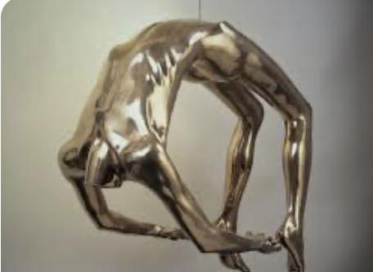
(Arch of hysteria 1993, ref)

She recalls time of being subtly sexualized by her father drawing her into the skin of citrus and then carving it off into a phallic shape as well as him holding his genitals while walking down the hallway.
Things she may have not understood fully in her young years but if so the implication is horrifying and plays into some darker themes of her artwork. Many stories of what she had gone to or may have brought questions into the themes of much of her artwork, besides his unfaithfulness and being domineering to his family. This lack of self identity as well as often trauma is often displayed in the body horror and ‘otherness’ of many artists that have been through often showing a sense of not feeling quite or less than human or that they separate parts of themselves in artwork to individual body parts and what some might criticize as being outrageous or scandalous for today's culture. As a brief example the piece ‘father and son’ 2005 by Bergoise has been criticized even if it is the lesser of her uncanny works of being is the lesser of her uncanny works of being sexual and immoral for various reasons with the father and child sculptures portrayed in nude in the fountain.
Sculpted to show emotional distance between a father and child it has been criticized as something either pedophilic or encouraging gender expression as assumed by right leaning groups in the state it is installed in. Such criticism to even such an innocent and ordinary sculpture shows that even the most obvious of art can be misinterpreted when taken from the context of the artist. This calls into question how Louise Bourgeois's multiple depictions of herself in various pieces titled as ‘self portrait’ as a human face on an animal may be received and interpreted. This calls the art to often be called into context of the artist's lives and words if not just listening to the artist themself explain it. Many assumptions can be made off of her art and mental state but if not proven or disproven by the artist it is not a clear way to assume exactly what the influence was. Art is not made to be understood without its context.

Conclusion:
This essay explores the psychology of Louise Bourgeois artworks that has uncanny feelings to it which allows the viewer to look at it without the explanation of the art as a way to make them experience in an interactive way of what trauma feels like which can confront the viewer with the feeling of uncomfortable and uneasiness sometimes even a sense of calm and relaxation which shows how the psychology of each art is related to how a trauma can feel for those who went through it and try to bury it deep in their consciousness which can come out as the art is being viewed which in turn brings out the uncanny or a sense of relaxation feelings while looking at it. This can also explain how trauma is not something that is experienced but also an embodiment as it is still in the unconscious mind and the body which can be experienced as stems and mental illness sometimes it can even bring forth psychical issues too such as early hair loss,sleeping issues etc which can all be from years of trauma which Louis Bourgeois has gone through herself which can be seen in her artworks all the times as the whole art was a way for her to explore her self identity through exploring her trauma and the psychology behind it helps understand how something so familiar and natural when it’s turned to abnormal can in turn be the cause of trauma which can impact the body and mind in many ways.
Most of the trauma can also be caused within the home as most of her trauma started from her childhood home which was the most of her artwork as the inspiration was from the mental trauma she was put through at her young childhood times so domesticity is common phenomena that occurs in her artworks which relates to her past trauma and pain. Using uncanny as a way to tell a story rather than the focus of it itself, how she lent to the understanding of trauma and how memory is held in the body and tied with how women are seen and treated by even 1st world countries. Trauma is an experience that comes with surviving the worst as it’s painful and can stay hidden in the unconscious mind longer than a physical pain and this artworks of her is important as society tries to figure out what causes the trauma while her art is a proof of it coming from the homes rather than anywhere else more and these pieces helped the world especially in modern times understand how mental health and self identity is very important for mental health and its ties into physical symptoms.

1-Freud, S. (1974). Moses and monotheism : three essays. London: Hogarth Press And The Institute Of Psycho-Analysis.

2-SINGULART (2024). Exploring Femme Maison by Louise Bourgeois. [online] Magazine. Available at: https://www.singulart.com/blog/en/2024/03/13/femme-maison-by-louise-bourgeois/?srsltid=AfmBOoq0uBS4vrsOcICw6GwS-rZWBwaAvQTg72hL1Kr0JtO3LQJ32su3 [Accessed 21 Dec. 2025].
‌

3- Vidler, A. (1992). The Architectural Uncanny: Essays in the Modern Unhomely. Cambridge, Mass. [Etc.] Mit Press.
‌
4-AWARE (2017). Louise Bourgeois – Structures of Existence: The Cells — AWARE Women artists / Femmes artistes. [online] AWARE Women artists / Femmes artistes. Available at: https://awarewomenartists.com/en/magazine/louise-bourgeois-structures-of-existence-the-cells/.
‌
5-Vidler, A. (1992). The Architectural Uncanny: Essays in the Modern Unhomely. Cambridge, Mass. [Etc.] Mit Press.
‌
6-www.guggenheim-bilbao.eus. (n.d.). Cell VII | Guggenheim Museum Bilbao. [online] Available at: https://www.guggenheim-bilbao.eus/en/learn/schools/teachers-guides/cell-vii.

‌7-Souter, A. (2020). Women’s Work: Representing the hysterical body in the late works of Louise Bourgeois. [online] jmartmanagement. Available at: https://www.jmartmanagement.com/post/women-s-work-representing-the-hysterical-body-in-the-late-works-of-louise-bourgeois.

8-Crystal Bridges Museum of American Art. (2015). Mother of Spiders: Louise Bourgeois. [online] Available at: https://crystalbridges.org/blog/mother-of-spiders-louise-bourgeois/.

9- Powers of Horror; An Essay on Abjection
Julia Kristeva: Powers of horror, an essay on abjection (page 5/6 ) 1982 Colombia University press

10- Horror and the Monsterous Femme; An imaginary Abjection Barbera Creed (1986)

