Name: | Mike Wakelyn
Student ID: | 1707800
Module Name: | Application Development (ACCA5012)
Tutor Name: | Dr Kemi Ademoye

Assignment: Application Development: Web Applications

Submitted on: 15/07/2020

Abstract
As part of the university module Application Development, delivered by Dr Kemi Ademoye at the University of Wales Trinity St David, students were required to develop a database driven web application using ASP.NET and SQL integration.
This report details the design and development of a patient management application that:
- Displays data held within the SQL database
- Allows interactive querying and displaying of results
- Provides form validation
- Allows manipulation of data using CRUD operations
Included in the report are an introduction to the application, application requirements, design and implementation methods and an evaluation with test cases.

Table of Contents
Assignment: Application Development: Web Applications 1
Abstract 2
Table of Abbreviations 4
1. Introduction 5
2. Requirements 5
2.1. Limitations 6
3. Design and Implementation 7
3.1. Core Design Features 7
3.2. Model Classes 7
3.2.2. Medication.cs 8
3.2.3. Treatment.cs 8
3.3. Database Contact Class 8
3.4. Controllers 8
3.4.1. HomeController.cs 8
3.4.2. PatientsController.cs 8
3.5. Views 9
3.5.1. Patients 9
3.6. Screenshots – Application Front End 10
4. Evaluation 14
5.1. Test Case – Creating a Record 14
4.2. Test Case – User Login 14
4.3. Test Case – Delete Patient 15
4.4. Future Recommendations 15
5. Conclusion 15
6. References 16
7. Appendices 17
7.1. Appendix A. 17
7.2. Appendix B. 18
7.3. Appendix C. 19

Table of Abbreviations

Abbreviation | Full Description
API | Application Programming Interface
IoT | Internet of Things
MVC | Model-View-Controller
CRUD | Create, Read, Update, Delete
SQL | Structured Query Language

Introduction
.NET is the collective name for a plethora of free, cross-platform and open source development tools that can use multiple program languages, editors and libraries to build web, mobile, desktop, games and IoT applications.
With languages such as C#, Visual Basic and SQL, developers can use the .NET Core platform to build applications that run on any environment (Windows, Mac, Linux) and with the .NET Framework, Windows base applications, websites and services.
Base libraries make working with strings, dates and I/O files developers easier and allow development of a myriad of custom applications
Also available are Xamarin or Mono, which are .NET platforms for developing mobile apps. [1].
The assignment was to implement an ASP.NET MVC web application reflective of a real world scenario, that integrates with SQL Server Express LocalDB for storing and managing its data. Controller technology could be in the form of MVC or MVC Web API controllers with Blazor or Razor and JavaScript for views.
The application level is to demonstrate data display, interactive display and querying of results, data manipulation using the CRUD operations and form validation.
The database is to be normalised to 3NF and consist of a minimum of 3 tables as well as the standard .NET Framework provided user tables.

Requirements
The main requirement was to build an MVC web application that was to reflect the real world.
The application stores a cohort of fictitious Renal patients along with relevant treatment modality histories and medications. The aim was to have a web based application that is accessed by authenticated users only and that allows the creation, reading, updating and deletion of patient records.
On the home page, there is a login button that takes the users to an authentication screen where users can enter a username and password if access has already been granted. For users who have yet to be granted access to the system, there is also the option to register.
The level of access granted to the user could then be defined and controlled with user roles.
Upon successful login, users are again presented with the home page. In the header, there are buttons to access the privacy statement and search for patients, which when clicked, presents a lists all patients from which they are able to create new records, edit existing records, view more patient details and delete records.

The requirements for the application were as follows:
- Data Display
The app should display relevant data to the topic as well as to what feature of the application the user is viewing. For example, when searching for patient demographics, users should be presented with names and addresses of patients.
- Interactive querying and displaying of results
When searching or navigating through the application, results should remain relevant to the users’ needs and adjust dynamically. If the user enters information in the search bar, then only information that includes or relates to the search item should be available to them.
- Data manipulation using CRUD operations
Users should have the ability to Create, Read, Update and Delete information from the application

- Form validation
Validation of user input fields was required. Such as a working login system that validated user credentials.

Limitations
Throughout application development there were a number of limitations.
- Developing on Windows OS with no access to other platforms, such as Apple prevented full testing of the application.
- Significant time constraints and interruption to study time as a result of the 2020 COVID-19 pandemic.

Design and Implementation

3.1. Core Design Features

The patient management system web application consists of a single Visual Studio solution with three projects. Each project consists of Models, which contain the data that needs to be displayed. Views, which are the templates that display the data provided by the model and Controllers that handle process requests and user interaction to update the model and select the appropriate view.

- Web API project
The web API project is an interface for HTTP based services that are built on the ASP.NET framework.
- Shared services project
The shared project contains business and data access logic that is common to all ASP.NET projects within the solution.
- Web project
The web project is the web application side of the solution.

3.2. Model Classes
Within the shared project, a number of models were created to interact with the data source.
3.2.1. Patient.cs
The patient.cs model represents the data stored in the SQL table called Patient. This is the scaffolding to displaying all of the patient demographics such as First Name, Surname, DOB, Address. The underlying SQL ensures that the primary key for each patient exists as a foreign key in all other related tables.

3.2.2. Medication.cs
The medication.cs model represents that data stored in the Medication table. Each row within the medication table relates to a single patient within the Patient table by storing the patientID as a foreign key in the table.

3.2.3. Treatment.cs
As with the medication.cs model, the treatment.cs model represents the data in the Treament table the SQL database. Again, the patientID is stored within the table as a foreign key so that each treatment row can be linked to a patient.

3.3. Database Contact Class

The WebApp2020DbContext.cs class is what maps to the database and represents the application session. Using the connection string, below stored in the appsettings.json file, the DbContext does the difficult work of providing data access for the application.
"DefaultConnection": "Server=(localdb)\\ProjectsV13;Database=WebApp2020;AttachDBFileName=C:\\Users\\mi001511\\Desktop\\Uni Software\\04 - App Dev\\ASP.Net\\Assignment\\1707800\\WebApp2020\\WebApp2020.Shared\\Data\\WebApp2020.mdf;Trusted_Connection=True;MultipleActiveResultSets=true"

3.4. Controllers
The main controllers implemented for the patient management app are:

3.4.1. HomeController.cs

The homecontroller.cs controller ensures that the request to access the application homepage the application is valid and selects the appropriate response and data to be generated by the Home view.

3.4.2. PatientsController.cs

As with the above homecontroller, the patientscontroller.cs ensures that the data is available and relevant in readiness for the Patients view to generate.

3.5. Views

In order to utilise the CRUD functions, a view for the patient demographic data was created. Unavoidable interruptions to development and time constraints meant that further development was not possible.

3.5.1. Patients

The Patients view is responsible for generating and sending the response to the user. It displays all patients stored within the database.
Within the view are buttons to create a new record, edit an existing record, delete a record and expand a record to view the full details.
The limited database columns displayed within the view are:
- FirstName - Patient first name
- LastName – Patient Surname
- DateOfBirth – Patient DOB
- Email – Patient Email
- HomeAddress – First line of patient address
- Postcode – Patient postcode
- ContactPhoneNo – Patient preferred contact number
- DateCreated – Date that the record was created
- CreatedBy – User that created the database. This is auto populated from the ASP.NET standard user tables.

3.6. Screenshots – Application Front End

3.6.1. Homepage – User logged out
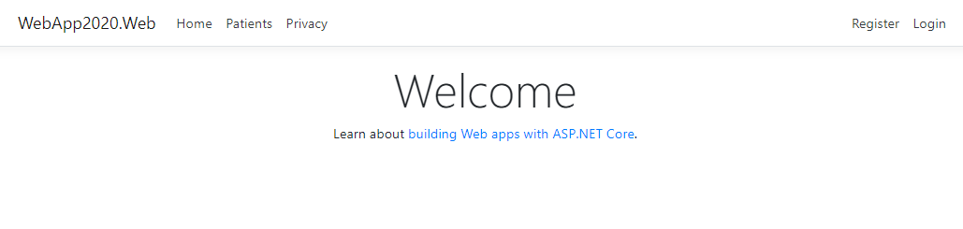

3.6.2. Registration Page
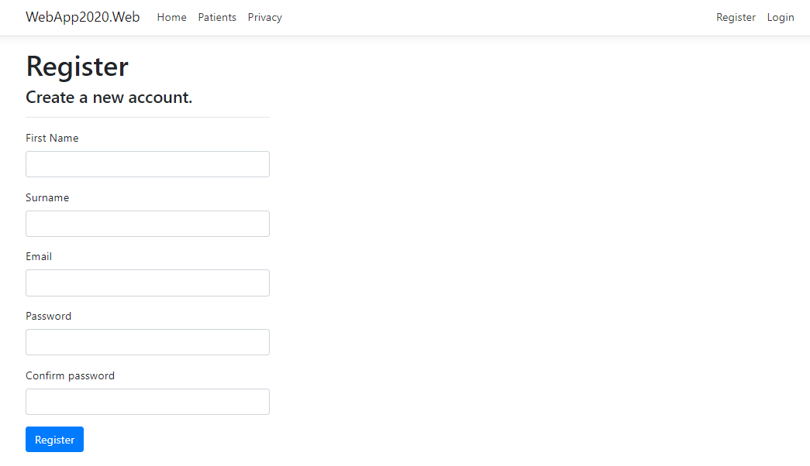

3.6.3. Login Page
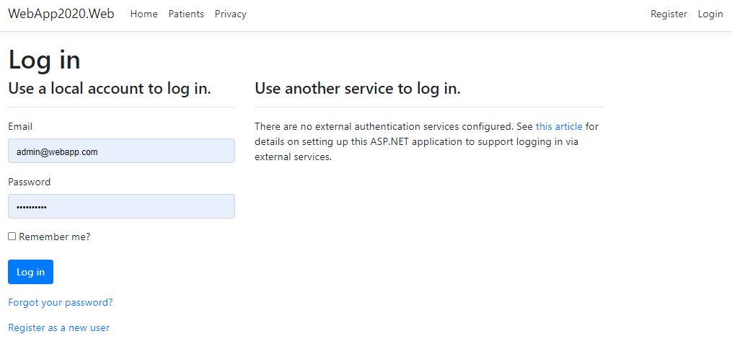

3.6.4. User Profile Page
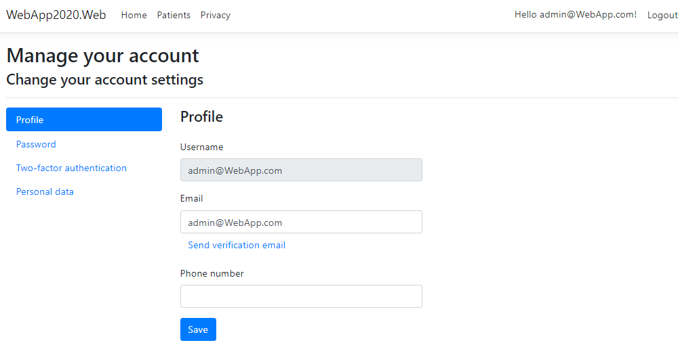

3.6.5. Homepage – Logged in user
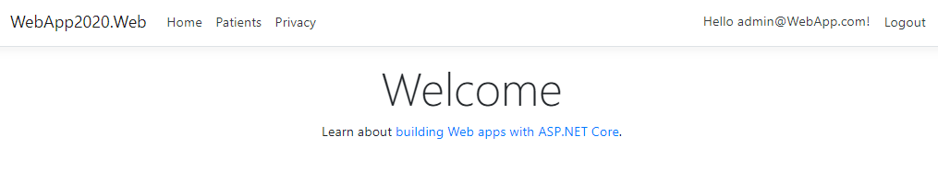

3.6.6. Patients Page
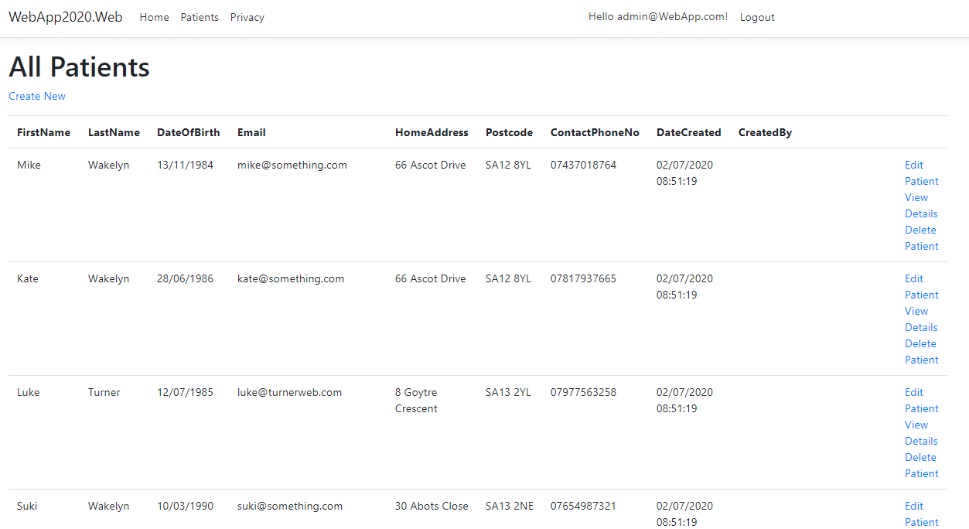

3.6.7. Create New Patient
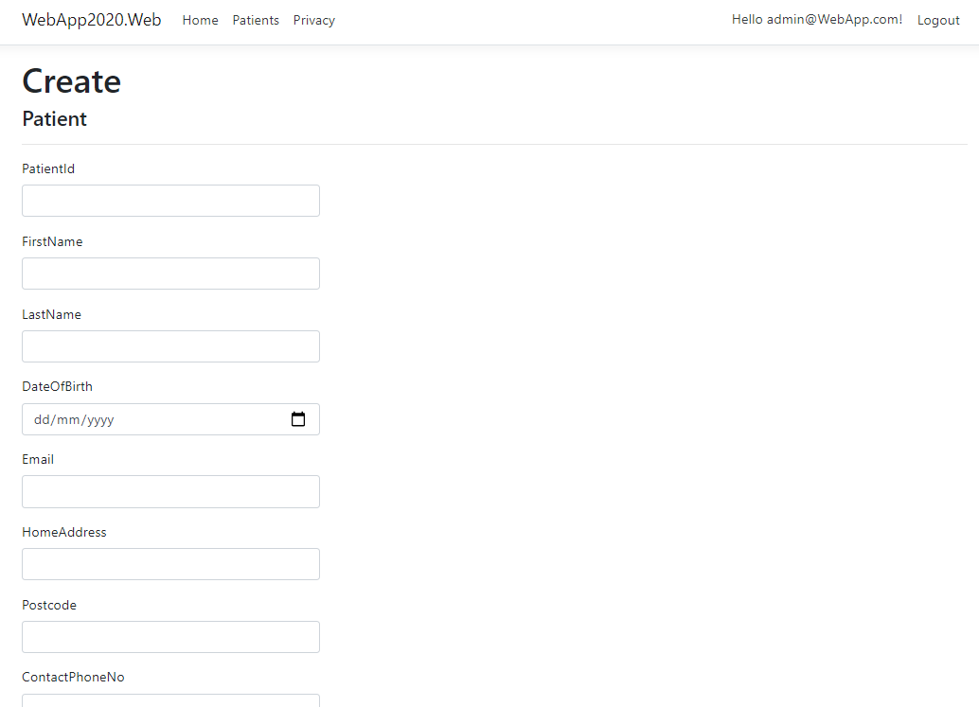

3.6.8. Edit Existing Patient
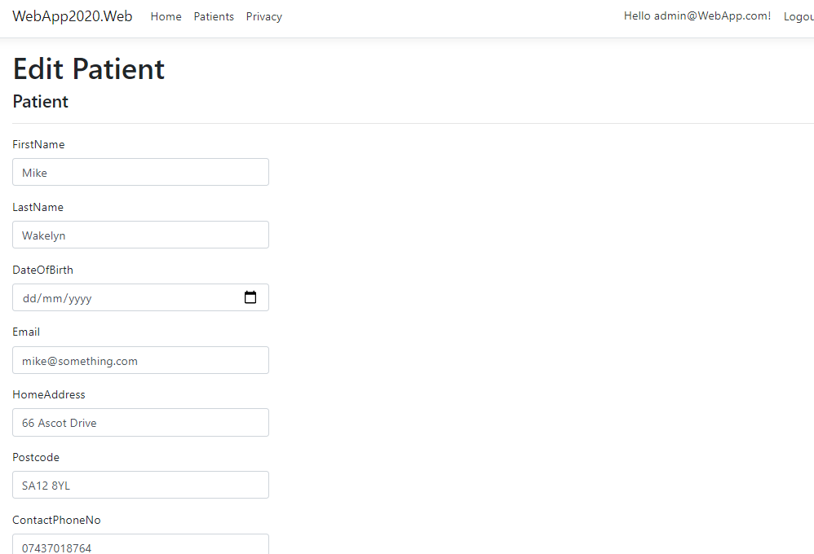

3.6.9. View Details of Patient
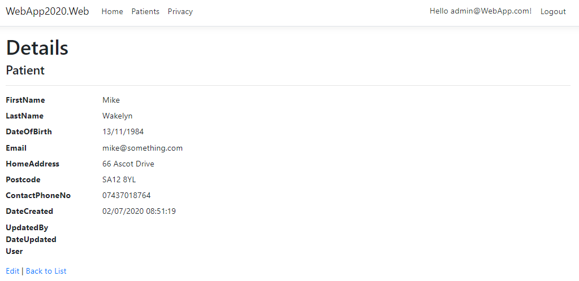

3.6.10. Delete Patient
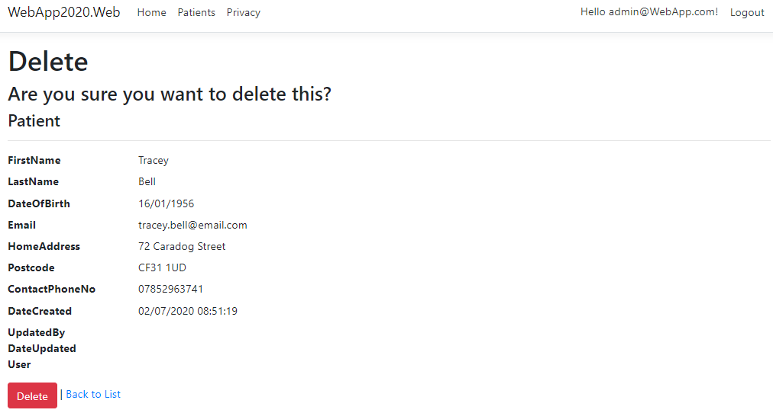

Evaluation

The patient management web application developed is lacking in appropriate functionality evident in the following test cases. Although log in, registration and simple CRUD operations are available, further development of the application is needed to ensure proper implementation of key features, such as deleting record with associated foreign keys.
Add to this, the basic front end web development, the application as a whole would likely not appeal to many. However, the application does demonstrate use of the basic CRUD functions along with authentication with scope to expand in to a fully functioning and real world system.

5.1. Test Case – Creating a Record

Appendix A is a test case for creating a new record within the patient table. It addresses the fields with in-built constraints to ensure that incomplete or inappropriate data cannot be entered in to the patients table

Test Case – User Login

Appendix B is a test case for user login. It tests the response of the application upon entering both correct and incorrect login details.

Test Case – Delete Patient
Appendix C is a test case for deleting a patient from the database. It first looks at deleting a patient that has associated records in other tables throughout the database. As referential integrity would be compromised by deleting a patient without first deleting associated foreign keys, the result of this test was a fail. This is something that should be considered among future application improvements.

Future Recommendations

With further development of the application and before it would be usable in a real world scenario, the introduction of appropriate controllers and views for the remaining tables would be necessary. To be a fully functioning web app, it would be necessary to be able to view and manipulate data in all tables.
Further development of the front end application would also be required. The user interface would need to be refined and a more appropriate environment provided.
As well as the above, a search feature would add to the usability of the application and provide a way for users to dynamically search for patients based on a multitude of parameters such as current modality, surname starting with and patient ID.
When creating a new record, it would be suitable for the DateCreated field to be automatically populated with the ‘current date’. That is, the date on which the record is being created. Likewise, the DateUpdated and UpdatedBy fields could also be implemented and developed to automatically populate based on the user updating the information and the date on which they are doing so.
As well as the above, when deleting a patient record without first deleting associated foreign keys, users are presented with an error and prevented from deleting the patient record as it breaches referential integrity. The application needs to be further developed to handle referential integrity and allow the deletion of a patient and all associated data.
Finally, when entering information in to fields that contain check constraints, such as they cannot be NULL or must be of an accepted format, appropriate error message handling should be considered. In order to improve usability and the experience, complex and technical error messages should be caught and replaced with more descriptive and user appropriate narratives.

Conclusion
In conclusion, the patient management application built would not be suitable to be implemented in to the real world as it is under developed. There are a number of key functions that, although they work, provide users with meaningless information that would likely confuse and cause disengagement.
As well as this, there are a number of features that appear to not work correctly, such as deleting patients whilst maintaining referential integrity. These features are important and fall under the virtue of the CRUD operations.

References
[1] “What is ASP.NET? | .NET.” https://dotnet.microsoft.com/learn/aspnet/what-is-aspnet (accessed Jul. 13, 2020).

Appendices

7.1. Appendix A.

Test Scenario | Test Case | Pre-conditions | Test Steps | Test Data | Expected Result | Actual Result | Pass/Fail
Creating a Record | Check successful insertion of new patient record | PatientID conforms to accepted format (Pnnnnnn)  Example: P753951 | Enter incorrect patient ID format  Click “Create” | PatientID = P123456789 | Error: PatientID too long | Error:  Data would be truncated | Pass
Creating a Record | Check successful insertion of new patient record | PatientID is not NULL | Leave PatientID field empty  Click “Create” | PatientID = | Error: PatientID cannot be blank | Error: Primary key property PatientID is null | Pass
Creating a Record | Check successful insertion of new patient record | ContactNo conforms to accepted formats (nnnnnnnnnnn) | Enter incorrect number format  Click “Create” | ContactNumber: 01235 1235698 | Error:  ContactNumber incorrect format | Error:  Data would be truncated | Pass
Creating a Record | Check successful insertion of new patient record | DateOfBirth cannot be NULL | Leave DateOfBirth field empty  Click “Create” | DateOfBirth = | Error:  The DateOfBirth field is required | Error:  The DateOfBirth field is required | Pass
Creating a Record | Check successful insertion of new patient record | Postcode conforms to accepted formats | Enter incorrect postcode format  Click “Create” | PostCode = 12345 | Error: Incorrect postcode format | Error: INSERT statement conflicted with the CHECK constraint | Pass

Appendix B.

Test Scenario | Test Case | Pre-conditions | Test Steps | Test Data | Expected Result | Actual Result | Pass/Fail
User Login | Check application accessible with correct username and password | Correct username and password entered by user | Enter correct username and password | Username: admin@webapp.com  Password: Password1! | Access to application granted | Access to application granted | Pass
User Login | Check application NOT accessible with incorrect username and password | Incorrect username and password entered by user | Enter incorrect username and password | Username: admin@webapp.com  Password: Password2 | Error: Incorrect username and/or password | Error: Invalid login attempt. | Pass

Appendix C.

Test Scenario | Test Case | Pre-conditions | Test Steps | Test Data | Expected Result | Actual Result | Pass/Fail
Delete records | Delete a patient record with associated data in other tables | Patient exists in database and primary key is linked to other tables (e.g. Treatment/Medication) | Delete a patient from the database | Delete patient = Tracey Bell | Record deleted | Error: DELETE statement conflicted with REFERENCE constraint | Fail
Delete records | Delete a patient record without associated data in other tables | Patient exists in database with no primary key reference in other tables | Delete a patient from the database | Delete patient = Spider Man | Record deleted | Record deleted | Pass

