  Component One:  What are the key skills required when working in the housekeeping team? 750 words (+/- 10%)  Contribution to Overall Module Assessment: 25% | Student  No: | Vasile – Florin Apostol  2131343
 | Module Title: | Operating Hotel Facilities
 | Module Code: | BMIH4006
 | Lecturer: | Kathryn Roberts
The housekeeping department in the hotel industry is incorporated into the management of overall cleanliness, hygiene and maintenance of infrastructure with a proper focus on the safety and security of guests (Choy, Cheng and Yu, 2021). Housekeeping staff has been considered responsible for keeping guests satisfied with their services and content with the presence of positive recognition in the competitive field. With the presence of proper skills, the housekeeping staffs ensure the attainment of a higher degree of customer contact and engagement. I have noticed that the housekeeping staff and engrossed in labour-intensive tasks which need to be encompassed with interpersonal aptitudes and basic skills for better interaction and performance. Housekeeping skills include a range of hard and soft competencies, which can be used for keeping private and public facilities clean (Tra, 2020). I have seen the presence of proper housekeeping skills has allowed me to be job oriented and considerate of the needs and necessities of clients and peers.
The topic of narrating key skills in the housekeeping team is of utmost importance as this can allow the creation of a clean, healthy and safe environment for staff and guests. I have seen the skills used by the housekeeping staff are concerned with the proper response to guest requests, which affiliates its outstanding guest service and boosts its financial profitability. Communication skills are impeccable to help housekeeping staff to interact with different guests and navigate such interactions appropriately and politely (Indeed, 2023). While I was in industrial training, I made use of my communication skills to interact with my team to dictate my necessities and knowledge gaps of proper service. I have provided customers with personal supplies and have been considerate of their issues with dirty bed sheets and air conditioning problems. In future, I will aim the enhancement of my communication skills with detailed learning of different languages to meet the expectation of customers effectively.
In Hilton Hotels, housekeeping staff are expected to clean guest rooms and be responsible for deep cleaning and disposal of trash to maintain cleanliness in the hotel premises (Hilton, 2023). They should be well adapted to respond to customer queries and grievances and be encompassed with proper determination to follow company values, mission and goals. Housekeeping staff in Hilton Hotels should be possessed with team working, leadership and customer-centric skills and be adaptable and accountable for their actions. In my training, I have been taught that housekeepers need to pay attention to minute details and be involved in the organisation of household objects. The skills of housekeepers are measured by their meticulous nature portrayed in their duties and responsibilities. Flexibility of housekeeping staff is measured by their ability to meet client requirements and be present for undertaking additional duties and responsibilities for more income. I have worked on night shifts and holidays during my training and have made use of my flexibility to the achievement of the same. This knowledge can be applied in future to make up my mindset to provide service on national holidays and organise my work-life balance.
Customer service skills are necessary for the housekeeping department to ensure the happiness and satisfaction of guests (Olimovich, Bakhtiyorovich and Salimovna, 2020). I have been dedicated to my allotted tasks during my training and have been honest while being accountable for breaking the plates of guests. This is important in the industry as housekeepers are expected to take responsibility for their own actions and improve to ensure the non-occurrence of the same in future. Time management skills are immaculate to allow housekeeping staff to complete a set of tasks every day, avoid delays in cleaning appointments, and be prepared to serve the guests. In my opinion, the improvement of time management skills can be done with the development of priority lists daily which ensures the noting of important tasks and fulfilment of daily goals.
I think the procurement of opportunities to be working with a housekeeping team can be achieved with the presence of self-discipline and a healthy and fit body which can be achieved with daily exercise and running. I have to be considerate of not sharing of credentials and personal information of customers with others for the maintenance of their confidentiality. Housekeepers need to be well accustomed to housekeeping supplies and equipment and have a mental determination to clean bathrooms and bedrooms. Covid cleaning guidelines need to be developed by me in the contemporary period with thorough reading of online books and articles. Being cooperative with others has helped me in past to solve customer issues and will be installed in future to tactfully deal with such problems.
Word Count | 771

Component Two:
Contribution to Overall Module Assessment: 25%
In this scenario– You have just been promoted to team leader for a floor within the hotel. A guest complains that on their arrival, their room had not been properly cleaned. Create an action plan and answer the following questions.

Problem | Why did it happen? | What are you going to do? | How will you prevent this from happening in the future? | What measures would you introduce to improve team effectiveness?
Dirt stains on a bathtub | Staff forgot to clean the bathtub with detergent and cleaning agents | I am going to supervise the issue and directly communicate with the staff assigned to the room and assess the accountable staff | In future, I am going to provide training to supervisors so that can minutely check the remaining dust and debris in the room | Team effectiveness will be improved with the creation of discussion sessions, which will allow me to notify of the accountability of staff regarding such incidents.
Wine stains over the carpet | A conflict had emerged between staff regarding who had spilt wine on the carpet and thus both of the refrained from cleaning the same | I will arrange a meeting with the two staff and address their lack of interpersonal and collaboration abilities which has created a loss of recognition in the company | In future, I will try to arrange a team of three where two staff will be engaged in cleaning rooms and the third staff will make a checklist | Team effectiveness can be improved with the organisation of team dinner plans on weekends.
Used cutlery left on the bed | Lack of proper concentration of staff regarding items left on the bed has rustled in the creation of such mishap | I am going to hold meetings with seniors and try to reduce the pressure on employees which will allow them to be focused and concentrate on their responsibilities | I will try the avoidance of such incidents in future by conducting monthly training and development seminars for ground staff | Team effectiveness will be enhanced with the organisation of group meditation sessions
The trash bin is full | Negligence of staff has resulted in the non-cleaning of the trash bin and the replacement of the same with a new one | I am going to provide staff with proper training where they must fulfil every duty represented in daily checklists | In future, supervisors will accompany each team and check the proper disposal of waste bins to refrain from the occurrence of such issues to customers | Team effectiveness will be ensured with the development of group discussion sessions.
Dirty curtains | Irregular cleaning and replacement of curtains have resulted in the presence of dirty curtains | Staff have to be trained effectively to engage in the daily replacement of curtains and handing over the same to the laundry department | In future, this will be prevented with the enrolment of a checklist for daily curtains washed in the laundry room which will prevent such incidents | The effectiveness of the team will be improved through face-to-face interaction sessions.

Component Three:
Contribution to Overall Module Assessment: 50%
Your task is to create and prepare a presentation following the detailed scenario provided below.

As the floor housekeeping manager and given the recent guest complaints you need to put together a basic training presentation for your colleagues within the housekeeping team to get the best out of them, ensure that brand standard is being achieved and that Health and Safety procedures are also being followed.

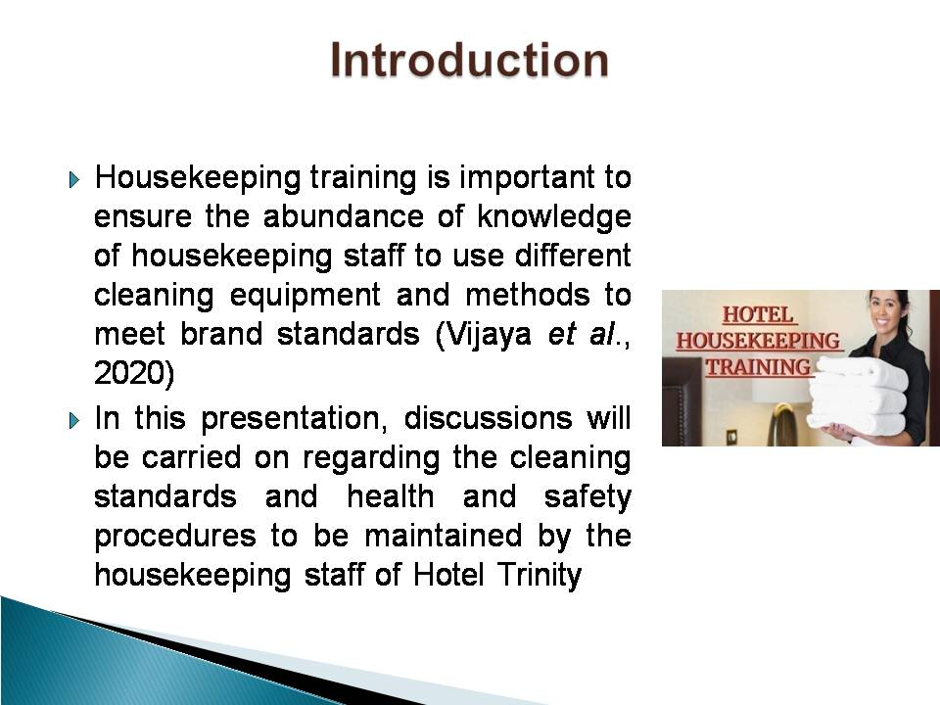
Training Notes: It will further describe an employee engagement model and best industry practices to enhance knowledge of the housekeeping team in accordance with guest complaints. The installation of this presentation will be necessary so that the team members are well aware of their duties and can uphold brand recognition amongst its target customer base.
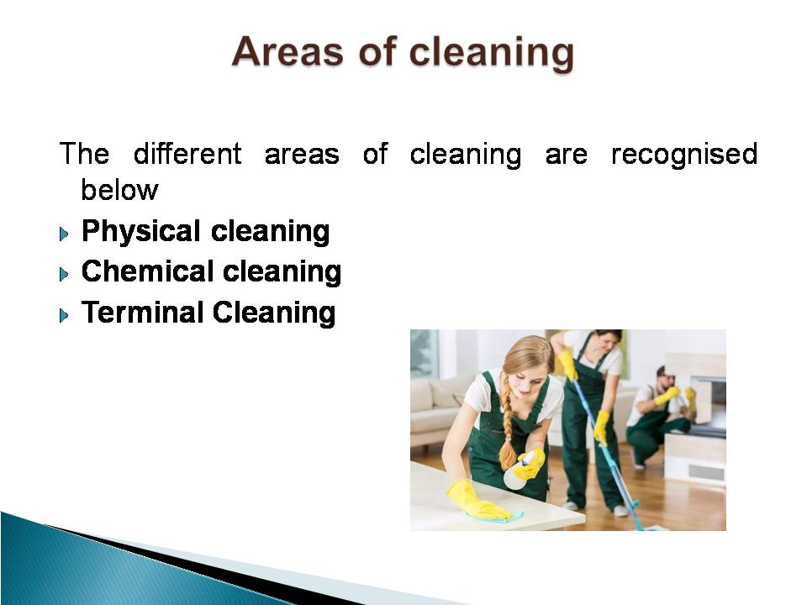
Training Notes: Physical cleaning marks the wiping of a surface from dust and dirt and is essential to gain the attention of arriving guests (Yusof, Mohammad and Ismail, 2021). Chemical cleaning involves the clearance of harmful chemicals which can cause burn and damage to an individual if handled without proper equipment. Terminal cleaning includes sensitisation necessary for the removal of pathogenic microbes.
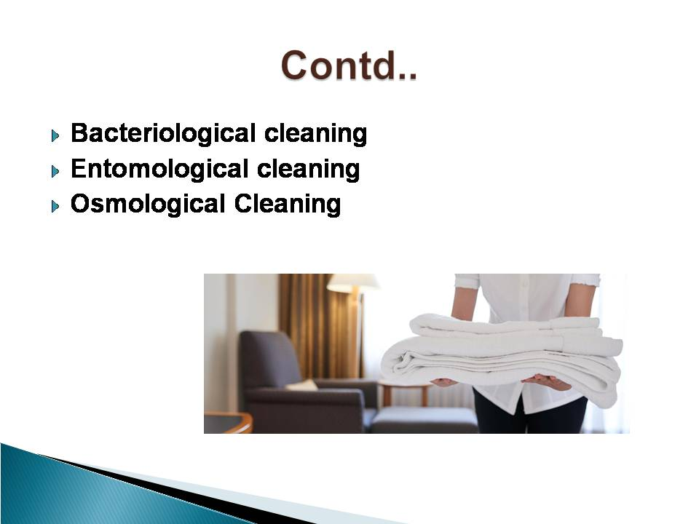
Training Notes: Harmful bacteria which can cause diseases and affect the provision of high-quality service to guests are erased with Bacteriological cleaning. Entomological cleaning prioritises the presence of health and safety of individuals from pests and insects. Lastly, the clearance of organic and inorganic matter is handled with an Osmological Cleaning process (Ginthotavidana and Waidyasekara, 2020)
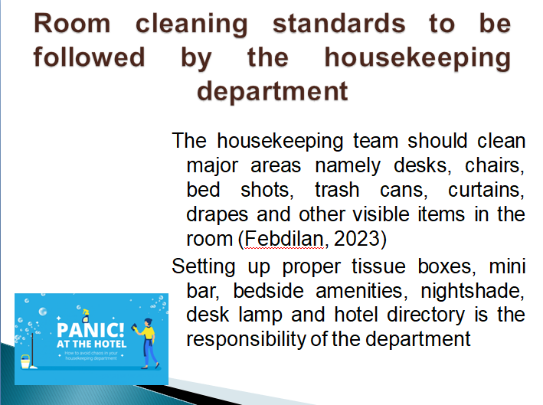
Training Notes: Housekeeping attendants should be engaged in respecting the privacy of guests and following the cleaning standards mentioned by the establishment. The entire team should be prepared to perform an actual cleaning and the final checks are to be carried on by supervisors. Deep cleaning should be performed to reduce the chances of the presence of dust and germs. This will ensure proper retention and engagement of customers to services of the brand and engross future visits and promotion with positive reviews (Samah et al., 2019)
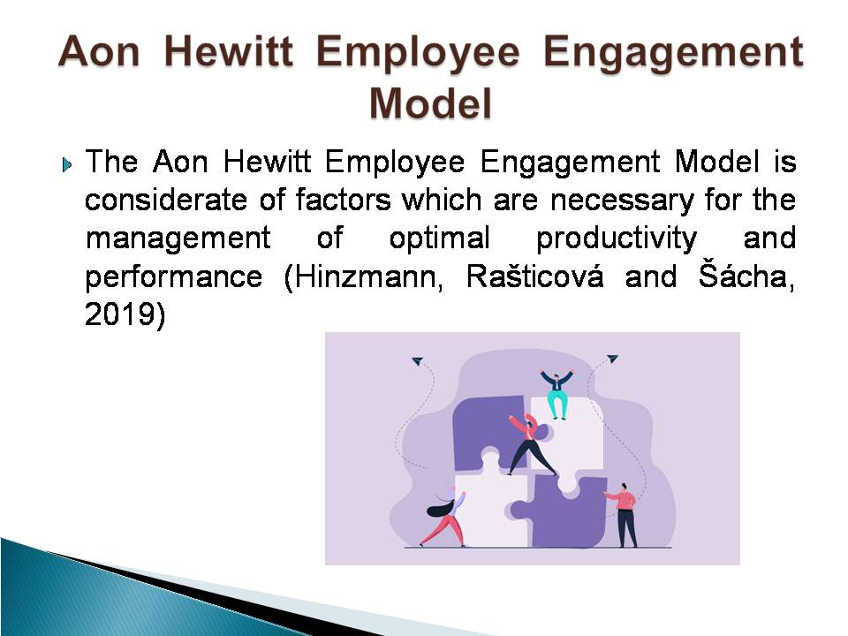
Training Notes: The Aon Hewitt Employee Engagement Model is impeccable for the clarification of the importance of rational thoughts, feelings and behaviour of organisations that shape employee performance and engagement. This model is integral for understanding the role of employees in being aligned with company goals and mission, which enhances its overall reputation and recognition among the industry rivals. The model justifies the importance of the presence of engagement, which can lead to the improvement of customer experiences and develops unmatched customer loyalty over time.

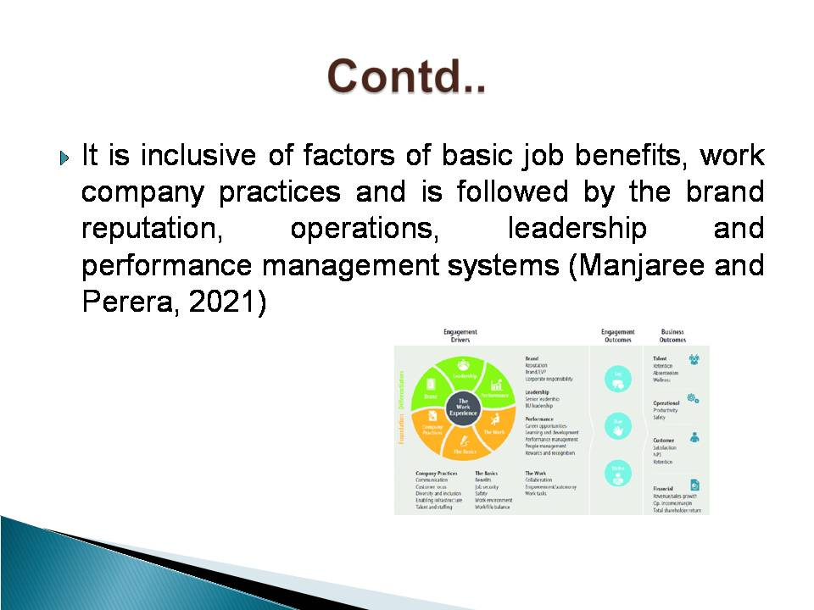
Training Notes: The basic driver of the model is characterised by the positive benefits, pay, job security and friendly work environment, which allows the management of work-life balance of staff. Work represents the empowerment and autonomy of staff to fulfil tasks. Company practices to diversity and inclusion and talent staffing are followed by the regulation of the overall reputation and employee value proposed by the brand. The guidance of able leaders in a company is important to boost engagement and felicitates better career opportunities and proper management.
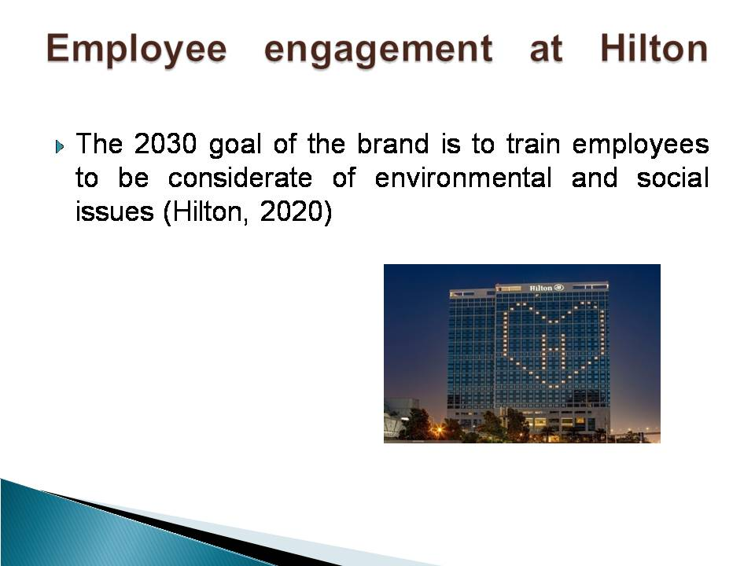
Training Notes: In Hilton hotels, employee engagement has been achieved with its continuous training and development mindsets, which make employees aware of the relevant environmental and societal issues. This has been achieved with the training of members regarding the occurrence of human trafficking. Hotel General managers and engineers have been trained with LightStay systems since 2017, which is essential to locate service issues and narrating progression strategies. Thrive at Hilton was launched in 2017 to promise its staff ample opportunities for growth and the flourishing of body, spirit and mind.
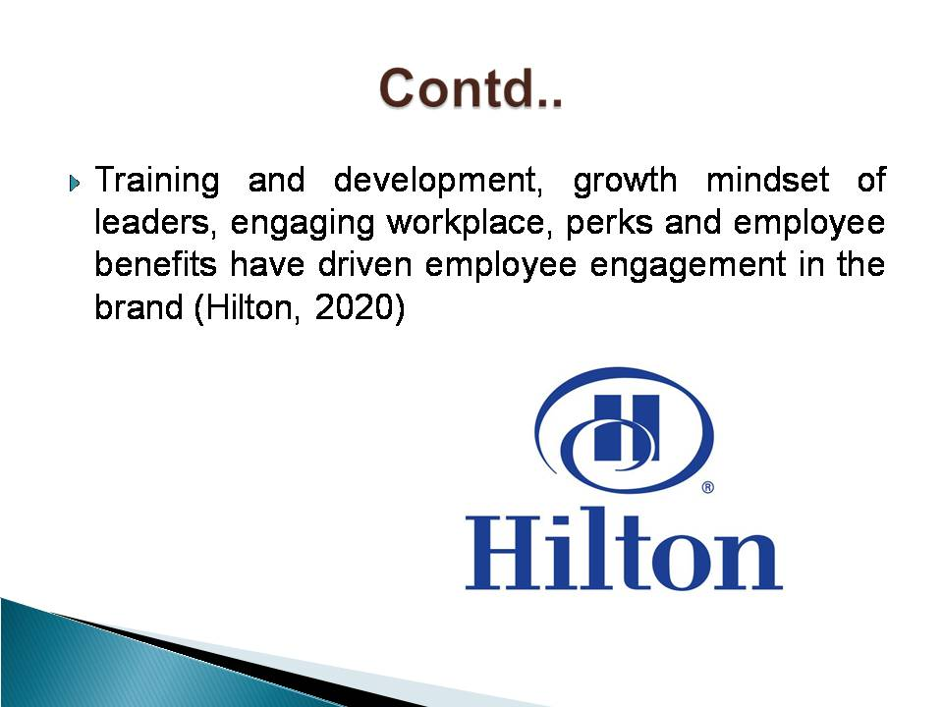
Training Notes: The brand has incorporated the Aon Hewitt Employee Engagement Model for the depiction of proper drivers of excitement and accountability within its workforce. Job benefits of parental leaves, financial assistance and family support have been essential to engage employees and reducing absenteeism. Further, the creation of a positive workplace has helped them celebrate Team contribution during International Housekeeping Week. Learning and development opportunities have surfaced via online learning platforms of SkillSoft, Culture Wizard and ThriveGlobal
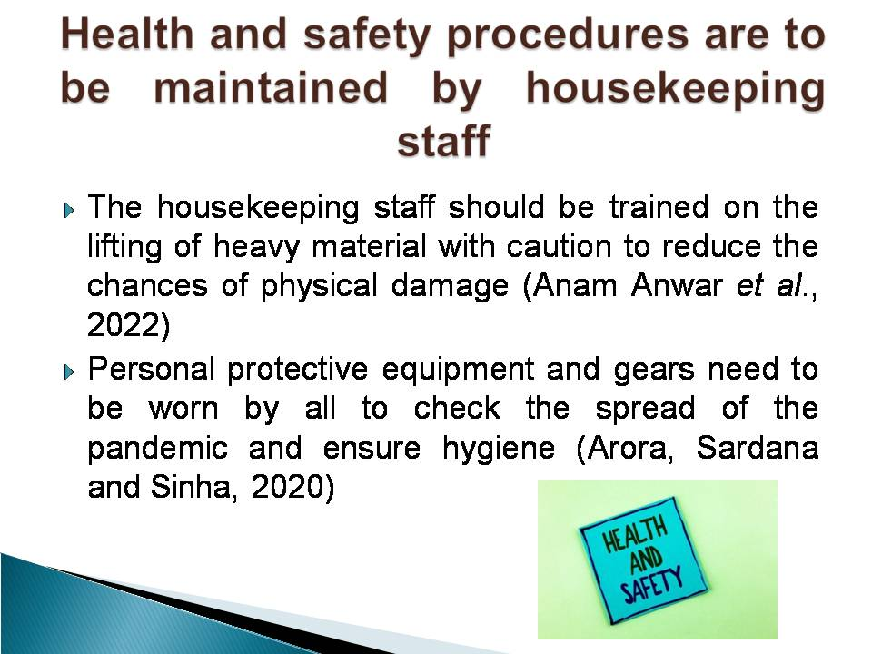
Training Notes: The housekeeping staff should be cautious regarding the handling of sharp and harmful equipment and be cautious of damages to be caused by the same. A provision caution and wet signs should be allocated throughout the organisational premises to reduce the chances of fatal accidents. The mental health and well-being of employees should be checked to make a balance between their duty hours to avoid excessive stress.
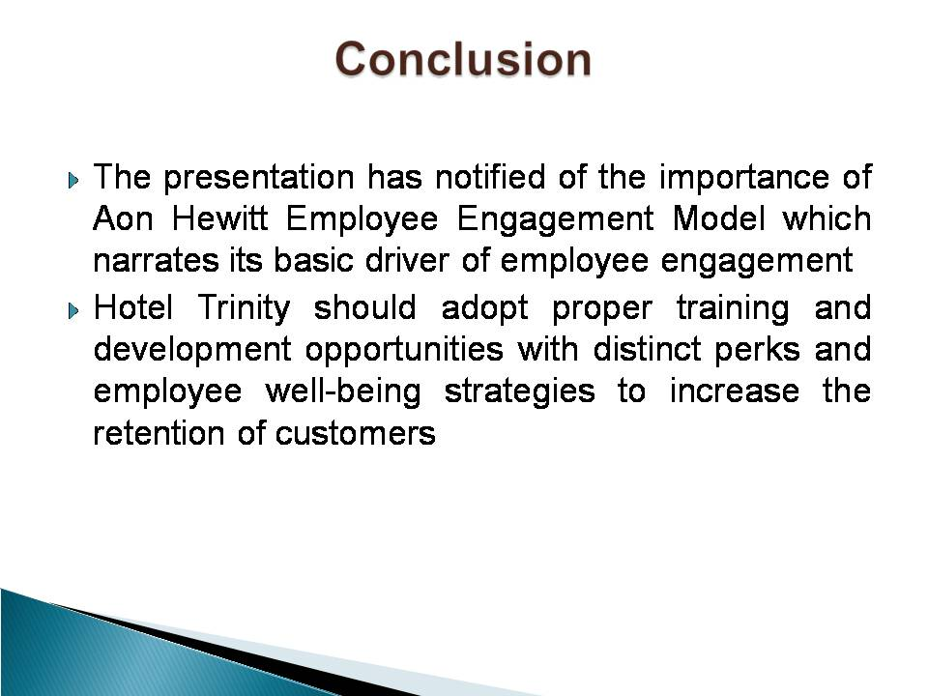
Training Notes: The different types of cleaning and brand standard should be observed by the brand for the reduction of occurrences of customer complaints and to ensure the effective engagement of staff.

References
Component 1
Choy, M., Cheng, J. and Yu, K. (2021) Evaluating the environmental sustainability strategies of the housekeeping department: the case of an international hotel chain in Hong Kong, China. Tourism Critiques: Practice and Theory, 2(1), 115-132.
Hilton (2023) Housekeeper Full time or Part Time. Available at: https://jobs.hilton.com/us/en/job/HOT08CXM/Housekeeper-Full-time-or-Part-Time (Accessed: 10 March 2023).
Indeed (2023) Essential Housekeeping Skills (Definition And Examples). Available at: https://in.indeed.com/career-advice/career-development/housekeeping-skills (Accessed: 10 March 2023).
Olimovich, D. I., Bakhtiyorovich, T. M. and Salimovna, N. G. (2020) Improving of personnel training in hotel bussines. Academy, (2 (53)), 18-19.
Tra, T. (2020) Action plan for training new Housekeeping Employee: case: Hotel Indigo Helsinki.
Component 2
Acharya, M. P., Mahapatra, S. S and RDM, H. (2022) EXAMINING CLEANING STANDARDS OF HOTELS'GUESTROOMS DURING COVID-19 PANDEMIC. Ann. For. Res, 65(1), 1724-1734.
Chatterjee, P. (2022) Role of Housekeeping Cleaning Equipment and Agent in the world of Hospitality Industry.
Khymdeit, J. (2022) Project work on entrepreneurship topic: Housekeeping.
Rinekasari, N. R., Jubaedah, Y. and Sobariah, S. N. (2019) Standard Operating Procedure of Housekeeping Adaptation: The Development of Assessment Tools in Cleaning Bathroom Practices at Vocational High School. KnE Social Sciences, 150-161.
Swann, C., Jackman, P.C., Lawrence, A., Hawkins, R.M., Goddard, S.G., Williamson, O., Schweickle, M.J., Vella, S.A., Rosenbaum, S. and Ekkekakis, P. (2022) The (over) use of SMART goals for physical activity promotion: A narrative review and critique. Health Psychology Review, pp.1-16.
Component 3
Anam Anwar, Z. H., Asjad, S., Saleem, K., Kauser, S. and Zaryyab, W. L. (2022) Musculoskeletal Disorders among Housekeeping Staff in Hospitals of Lahore. Pakistan Journal of Medical & Health Sciences, 16(06), 140-140.
Arora, P., Sardana, K. and Sinha, S. (2020) Real‐world assessment, relevance, and problems in use of personal protective equipment in clinical dermatology practice in a COVID referral tertiary hospital. Journal of cosmetic dermatology, 19(12), 3189-3198.
Febdilan, F. K. (2023) EFFORTS TO INCREASE THE CAPACITY OF RECEPTING GUESTS AND ROOM CLEANING IN STANDARD HOMESTAY BUSINESS IN MANDALIKA TOURISM VILLAGE, CENTRAL LOMBOK. International Journal of Social Science, 2(5), 2123-2136.
Ginthotavidana, S. S. C. and Waidyasekara, K. G. A. S. (2020) An insight into the housekeeping practices of Sri Lanka healthcare facilities in private sector.
Hilton (2020) TEAM MEMBER ENGAGEMENT. Available at: https://cr.hilton.com/wp-content/uploads/2020/04/Hilton-Team-Member-Engagement.pdf (Accessed: 9 March 2023).
Hinzmann, R. A., Rašticová, M. and Šácha, J. (2019) Factors of employee engagement at the workplace. Do years of service count?. Acta Universitatis Agriculturae et Silviculturae Mendelianae Brunensis.
Manjaree, H. M. S. and Perera, D. A. S. (2021) Determinants of Employee Engagement during COVID 19 Pandemic (Case of Sri Lanka Technological Campus). International Journal of Research and Innovation in Social Science, 5(7), 2454-6186.
Samah, I. H. A., Shamsuddin, A. S., Rashid, I. M. A. and Amlus, M. H. (2019) Functional organizational structure and employee engagement in Malaysian hotel sector. International Journal of Scientific & Technology Research, 8(12), 3454-3456.
Vijaya, R., Sharma, A., Daga, A. and Gopichandran, L. (2020) Effectiveness of structured training programme on infection control measures among housekeeping workers in selected intensive care units at tertiary hospital. JoNSP, 10, 51-56.
Yusof, M. F. M., Mohammad, R. and Ismail, S. H. (2021) Work-Related Low Back Pain among Hotel Housekeeping Workers at Kuala Lumpur. Journal of Advanced Research in Applied Sciences and Engineering Technology, 25(1), 80-93.

Appendix


