
Programme: BA in Business Management
Module: Project Management
Module code: LCBB5005
Student Name: Yanislav Georgiev
Student ID: 2219323
Lecturer: Dr Molly Jack
Submission Date: 04/08/2024



Table of Contents
Introduction 3
Main Body 3
Conclusion 12
Reference List 13
Appendix 17

Introduction
Project management is the process of planning, organising, and managing a project to achieve a specific and predetermined outcome. It is the responsibility of a project manager to successfully manage a project work using specific principles, methodologies, skills, and tools (Project Manager, 2023). Projects are often undertaken by companies to achieve various short-term and long-term objectives. There are various approaches to project management such as predictive, adaptive, and hybrid project management styles. The scale, significance, and complexity of a project determine the variation of skill and expertise required in a project team (Phoebe, 2024, p.23). The project that will be discussed in this report is the building of a new headquarters for Google.
An overview of the project will be given at the beginning of this report. It will include a brief background of Google Llc, an explanation of the project, and the various features that will be included in this project. After that, the core elements of the project will be illustrated. It will contain the budget allocated for this project including land, construction, tax, building and design fees, and other such expenses. The time scale of this project will be given along with it. The necessary precautions that will be required to complete the project on time will be mentioned as well. Then, the stakeholders and risk holders of the project will be mentioned and their relationship with the project will be analysed. Finally, the whole project plan will be evaluated to predict its success and identify areas of improvement.

Main Body
The lifecycle of the project is composed of five stages which are planning, initiating, monitoring, executing and closing. The first stage is initing which stands for the determination of the purpose of conducting the project. This stage includes goal setting and outlining the overall map of the project for successful conduction. The second phase of the project life cycle is making a comprehensive plan to execute them to complete the project. This phase encompasses developing schedules, budget making, allocating resources and addressing the risk to take proper precautions. The third phase is execution which stands for executing the developed strategies or plans to coordinate the project. The fourth stage involves monitoring the progress of the project to ensure the quality of the project. The fifth stage is the last stage which declares the closure of the project after checking all the variables. In the case of a construction project, the project lifecycle perspective is effective in designing the project (Halttula et al., 2020, p.193). The maintenance of this project lifecycle process might be also helpful for the new construction project of Google.
A notable revolution is spotted in the process of project management which increases the strategic competencies of the firms (Mcgrath and Kostalova, 2020, p.2). In this regard, a total of 10 core elements are mainly prioritised in the process of project management. The elements are communication, quality management, schedule, resource management, cost management, risk management, stakeholders, leadership, integration management and scope. All the elements play a crucial role in ensuring the successful completion of a project by maintaining quality, budget and the given period. The process of construction project management is also associated with the reduction of risks (Fobiri et al., 2022, p.1381). The adoption of project management can be also beneficial for Google to ensure the quality of their construction project.

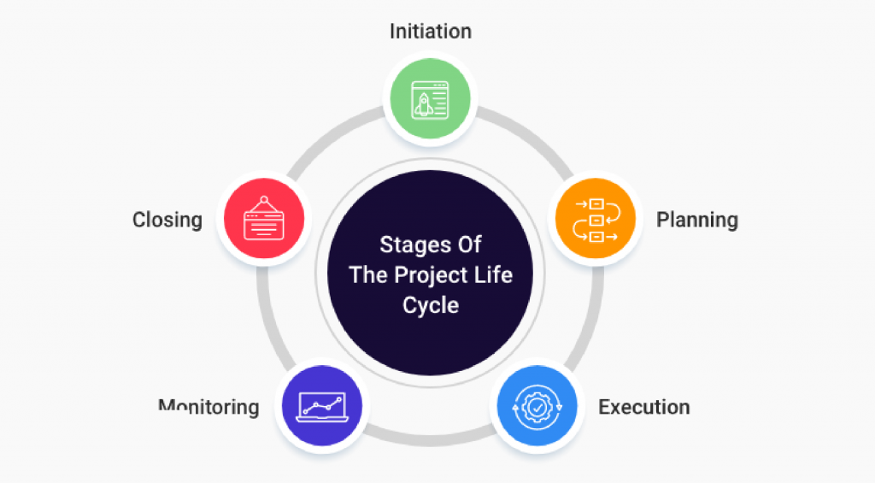
Figure 1: Project Life Cycle
(Source: Miller, 2020)

Google is one of the most famous and top tech giants which has its operational roots in the USA (Levy, 2021, p.5). Founded in 1998 by Larry Page and Sergey Brin, the organisation operates across the global countries with a workforce of 182502 staff worldwide (Google,2024) The organisation has undertaken an initiative, the main theme of which is based on the construction of its headquarters in King's Cross, based in London, by the end of the next year. It is a project which will incorporate the use of a greater area of land in the location of Kings Cross Station. The floor area of the headquarters will incorporate 60400 sqm which will intake a larger area of the location.
Budget of Google's New HQ Project
Areas of expense |  | Expense (in GBP)
Real estate | Land (650,000 sq ft.) | At 1.8 million per Acre  (1.8 × 14.9219)  = 26.85942 million  Or, 27 million (approx.)
Real estate | Construction | At 311,500 per 100m²  = (311,500 × 604)  = 188 million
Real estate | Taxes | 11 million (approx.)
Cosmetics | Design and building fee | 50 million
Cosmetics | Interior decoration fee | 20 million
Technology | System units (4500) | (600 × 4500)  = 2,700,000
Technology | High-end computers (50) | (2000 × 50)  = 100,000
Technology | Data centres | 275 million
Technology | Laboratories | 200 million
Technology | Miscellaneous | 50 million
Other expenses | Labour cost | 100 million
Other expenses | Security systems | 70 million
Total expenses |  | 1 billion (approx.)
Table 1: Resource Allocation for Google HQ
(Source: Self-created)
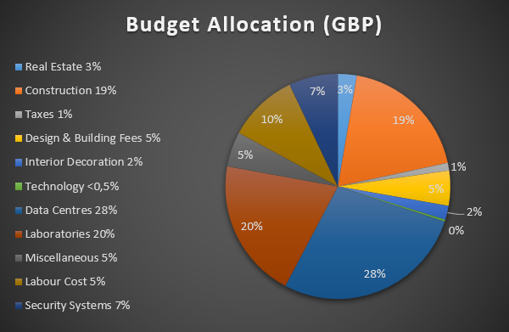

Figure 2: Budget Allocation for Google's New Headquarters Project
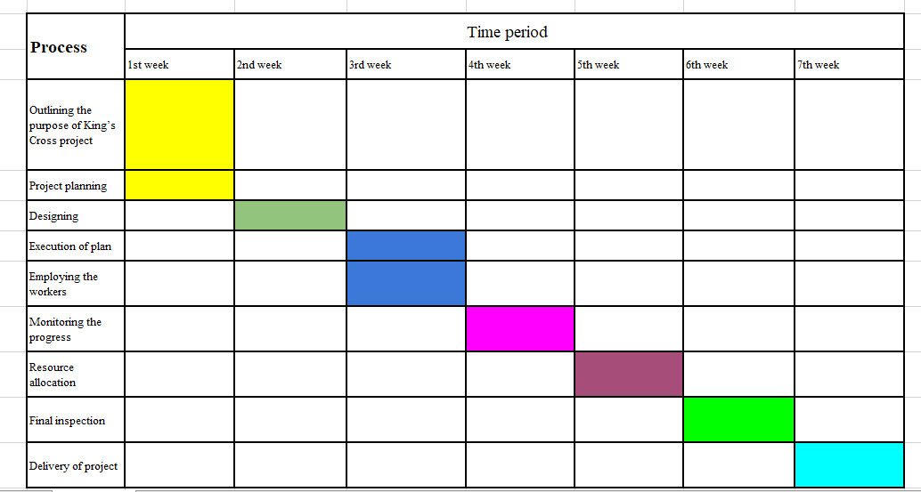
Figure 3: Gantt-Chart
(Source: Self-created)
Google’s plan to expand its headquarters in the United Kingdom is part of a bigger project of building a Google campus for the first time outside of the United States of America. Google has planned to spend a billion pounds on this project which involves building two new skyscrapers for different purposes. This massive project needs to be completed by next year (Gillespies, 2023). The project will be carried out at Kings Cross London which can be considered the very heart of the city which drives up the expenses of the construction and dictates a strict time frame. On the ground floor of the building, there will be a retail area, an event space as well as a training centre. This area will be built first and will be finished in a month. It will be an 11-story building with a 60400 square meter floor area that incorporates office spaces and accommodation for 4500 employees (Gillespies, 2023). The entire construction of the basic structure of the building should not take more than 3 months. After that, the building will be decorated tastefully as per the predetermined design choice which shall require another 3–4 months. Luxury amenities for the staff members who will work there include cafes, a gym, a multi-use games area (MUGA) as well as a pool and these will require another 3 to 4 months to be completed. The rooftop of the building will include landscaped terraces and a 200 m running track to provide an opportunity for physical exercise to the people and these will be completed within 2 months. A similar project such as Millennium Dome which was planned to be constructed in Greenwich, London has also faced the situation like failure due to several issues. In 1996, the initiative was taken to continue the construction project in London but the cost overrun was the main issue of the failure of this project at the initial stage (West-Knights, 2020). This is because the lack of funding and proper schedules has prolonged the delivery of this project. It highlights that budget overrun is a serious concern for the construction project which needs to be focused on by the project management. This example outlines that Google should be prepared for this kind of issue to mitigate it at an early stage. Preparing an effective and realistic budget will be helpful for Google to avoid these issues of budget overrun during their King's Cross construction project. This is because cost overrun is one of the biggest issues in the construction project for the stakeholders (Asiedu and Adaku, 2020, p.66). Therefore, it can be said that creating resilience to deal with the issues like budget and cost-overrun will be beneficial, for Google to complete their project.
Stakeholders of the project can be analysed using Mendelow's stakeholder matrix, which divides stakeholders according to power and interest levels. The high power high-interest stakeholders are the people with the power to influence the decisions of the organisation as well as have a great deal of interest in the organisation's success (Farshid, 2022, p.104). In the case of this project, the owners of Google's parent company Alphabet as well as Google itself fall in this category. These people make important decisions about the project and also are largely responsible for funding it. Another high-interest, high-power stakeholder group is the shareholders of the company whose financial interests are tied to the project's success. The customers of Google should be considered high-interest low-power stakeholders since they do have an interest in the success of the company but do not possess much power to swing decisions in any way (Cieśla, 2023, p.5). The Government of the United Kingdom is a low-interest but high-power stakeholder since it possesses the ability to regulate the company and its operations by enforcing the legal code. Should the company do anything that wallets the law, the government can shut it down and penalise the company. However, the government may not have any particular interest in the success of one company above another (Kivits et al., 2021, p.30).
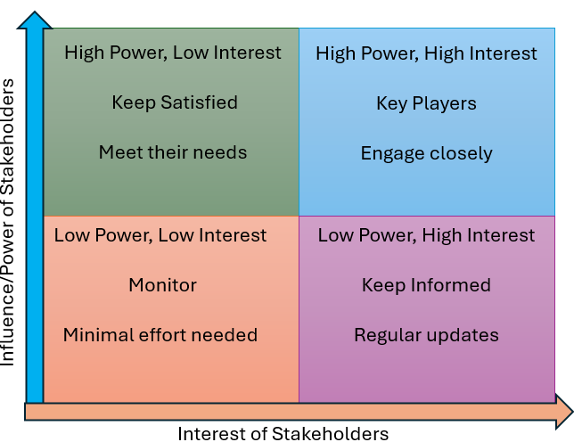
Figure 4: Mendelow's stakeholder matrix
(Source: Self-created)
The risk holders of the project are people or group groups who bear most of the risk associated with it directly or indirectly. The company Google is the primary risk holder since they have made monetary investments in the project and stand to lose it if the project is unsuccessful (Mahatma, 2024, p.501). The Government of the UK is an important risk holder since it has to answer for its actions to the people. Therefore if the project in any way harms the local environment and the community the government shall be held accountable. The local community on the other hand is a significant risk holder since they will be impacted directly by the potential negative impacts of the project (Ramyashree, 2024, p.30). The environmental protection groups that work to conserve the environment are also significant risk-holders.
Google's envision to inaugurate its multi-facility and technologically advanced headquarters at the King's Cross of London, UK is reckoned as one of the massive projects that the company is going to handle. Project management has substantially emerged as a significant discipline in the past few decades because of its importance and visibility in integrating different techniques and tools to achieve the overall objectives of a project (Varajão et al., 2020 p.225).
A strategic approach to project management often encapsulates the involvement of specific objectives and goals in which effective collaboration and interaction shape the scope for adhering to those goals (Alade et al., 2020, p.01). In addition to highlighting effective benefits, strategic project management often determines a radical transformation in the hierarchical and functional structure of an organisation. Like, The reason for selecting such a prime location by Google is to ensure seamless transport facilities for the employees who will opt for daily travelling. The attainment of this strategic priority has further been extended through the incorporation of other amenities in the newly developed infrastructure such as a gym, cafe, MUGA, cafe and pool facilities. Moreover, to enhance employee satisfaction, a rooftop is designed with scenic landscapes, and outdoor recreation along with running tracks for fitness. The core purpose behind the affiliation of such luxuries and indulgences is to secure the psychological well-being of the employees staying abroad far from their families. Hence, an overall 650,000 sq ft. of land will be bought. Employee well-being refers to a subjective phrase that describes the satisfaction, happiness, fulfilment of desire and enhancement of affective as well as cognitive commitment of the workforce (Kundi et al., 2020, p.739). The amelioration of hedonic satisfaction of the employees is directly proportional to organisational productivity and performance. A positive employment relationship between hierarchies and subordinates offers enormous scope to gain mutually whether employees or employers (Salas‐Vallina et al., 2021, p,333)
The project plan for Google’s new headquarters also includes the presence of stakeholders as stakeholder management is essential for the successful completion of the project. It is found that stakeholder engagement is supportive of the high performance of firms (Gupta et al., 2020, p.1870). Both the external and internal stakeholders will hold value in executing the King’s Cross project plan of Google. The most important and notable stakeholders are the owners of Alphabet Inc. and shareholders of Alphabet as they hold the ultimate power and high interest in the outcomes of this project. This is because the successful execution of this project will align their interest in creating value and accelerating innovation for the future betterment of Google. Apart from that, this project will also include Alphabet employees as their stakeholders in the segment of low power and high interest. This is because the success of this project will be beneficial for the employees as they will get appraisals or incentives for contributing their best. Henceforth, the employees will not be able to make any critical decisions on behalf of this company related to this King’s Cross project or any upcoming project. It highlights that the employees of Alphabet Inc. will be treated as important stakeholders but not as high-powered stakeholders. However, the overall performance of the firms relies on the creativity and performance of the employees (Yamin, 2020, p.447).
A project like King's Cross by Google will focus on risk management to mitigate uncertain risks to maintain the quality of this project. Risk management is found as a mediating component for the successful execution of projects (Jarrah et al., 2022, p.258). In this regard, Google will identify the risk holders to take proper precautions. This firm might face protests from the local communities during the conduction of this project which might create potential challenges for Google. The fear of displacement and an increase in congestion might be the reason for the local communities to participate in the protest. Similarly, the difficulties might be faced during the approval of the project planning from the government due to health and safety issues. It is known that mitigation of risks is important to maintain the safety performance of the construction project (Sanni-Anibire et al., 2020, p.15). Apart from that, the conduction of this project might face objections by the Environmental Prevention Groups as this project might be harmful to local ecosystems. The utilisation of advanced technologies and raw materials might increase the pollution levels of the local environment which will be harmful to the local communities. The Environmental Prevention Group stands for the interventions of environment-related issues for a better atmosphere (Vera, 2020, p.6).

Conclusion
Hence, it can be concluded that project management is an integral part of handling a project efficiently and ensuring its success. It is the role of a project manager to manage their team effectively and align every team member with the common goals and outcomes of the project. The report depicted a new project undertaken by the tech giant Google to build new headquarters in King’s Cross, London. An overview of the project was provided that includes a brief overview of the company, the scope of this project, and its various specifications. After that, the core elements of the project were demonstrated. Under the core elements, the budget allocated for this project was mentioned. It includes real estate, technology, cosmetics, and more. Then, the timeline of this project was mentioned along with the necessary steps required to meet the project deadline. Next, the stakeholders and risk holders of this project were identified and their connection to the project was explained in detail. Finally, a detailed evaluation of the project plan was done. The project plan was analysed along with its benefits and areas of improvement were identified.
However, there are a few ways to boost the construction project undertaken by Google. The implementation of technology can significantly enhance the efficiency of this project and reduce costs as well. Google is a technological company, so the deployment of technological resources can be easier for them. Project management software and collaboration tools such as Asana, Zoom, and Google's own Google Meet can increase the productivity of workers involved in this project. Communication is another major element of project management. Effective communication between stakeholders, and risk holders of this project can clearly define the project goals and the plan of action. Lastly, it is recommended to use a prefabricated building system for this project. Prefabrication is the process of constructing a building, or a component of the building on a separate location other than the job site. It helps in overcoming various issues and challenges that can occur at the actual project site. It takes significantly less time compared to the original project. These steps can enhance the construction project of new headquarters for Google, and increase its efficiency.

Reference List
Alade, T.A., Bukoye, O.T., Roehrich, J.K. and Edelenbos, J. (2022) Cross-national collaboration in strategic transport projects: The impact on benefits realization. International journal of project management, 40(4), pp.411-425. https://doi.org/10.1016/j.ijproman.2022.03.009
Asiedu, R.O. and Adaku, E. (2020) Cost overruns of public sector construction projects: a developing country perspective. International Journal of Managing Projects in Business, 13(1), pp.66-84. https://wlv.openrepository.com/bitstream/handle/2436/623519/Asiedu_et_al_Cost_Overruns_Paper_IJMPB.pdf?sequence=3
Cieśla, M. (2023) Determining the strategic position of car-sharing services in Poland based on the stakeholder analysis method. Journal of civil engineering and transport, 5. pp.1-9. https://yadda.icm.edu.pl/baztech/element/bwmeta1.element.baztech-dec70298-e54a-4df1-a872-801d81c9a5e5/c/DETERMINING_THE_STRATEGIC_POSITION_OF_CAR-SHARING_SERVICES.pdf.
Farshid, M., Goharrostami, H.R. and Ramezani Nejad, R. (2022) Analysis the amount of power and interests of Talent Management system stakeholders in Guilan province sport based on Mendelow matrix. Sport Management Studies, 14(74), pp.103-126. https://smrj.ssrc.ac.ir/article_3722_0175830e4f9199a7a99d4666dfce9e78.pdf.
Fobiri, G., Musonda, I. and Muleya, F. (2022) Reality capture in Construction Project Management: A review of opportunities and challenges. Buildings, 12(9), p.1381. https://doi.org/10.3390/buildings12091381
Gillespies. (2023) Google Headquarters — Projects. [online] Gillespies. Available from: https://www.gillespies.co.uk/projects/google-headquarters (Accessed 27 July 2024).
Google. (2024) How we started and where we are today - Google. [online] about.google. Available at: https://about.google/intl/ALL_in/our-story/ (Accessed 27 July 2024).
Gupta, K., Crilly, D. and Greckhamer, T. (2020) Stakeholder engagement strategies, national institutions, and firm performance: A configurational perspective. Strategic Management Journal, 41(10), pp.1869-1900. https://onlinelibrary.wiley.com/doi/pdf/10.1002/smj.3204
Halttula, H., Haapasalo, H. and Silvola, R. (2020) Managing data flows in infrastructure projects: the lifecycle process model. https://dx.doi.org/10.36680/j.itcon.2020.012
Jarrah, M.A., Jarah, B. and Altarawneh, I. (2022) Toward successful project implementation: Integration between project management processes and project risk management. Problems and Perspectives in Management, 20(3), pp.258-273. https://www.businessperspectives.org/images/pdf/applications/publishing/templates/article/assets/16921/PPM_2022_03_Jarrah.pdf
Kivits, R., Sawang, S., Kivits, R. and Sawang, S. (2021) Stakeholder Analysis. The Dynamism of Stakeholder Engagement: A Case Study of the Aviation Industry, pp.29-43. https://doi.org/10.1007/978-3-030-70428-5_4.
Kundi, Y.M., Aboramadan, M., Elhamalawi, E.M. and Shahid, S. (2020) Employee psychological well-being and job performance: exploring mediating and moderating mechanisms. International Journal of Organizational Analysis, 29(3), pp.736-754. https://www.emerald.com/insight/content/doi/10.1108/IJOA-05-2020-2204/full/pdf
Levy, S. (2021) In the plex: How Google thinks, works, and shapes our lives. Simon & Schuster. https://media-1.carnegiecouncil.org/import/studio/In_the_Plex.pdf
Mahatma, L.M. (2024) LEGAL PROTECTION OF POLICY HOLDERS AGAINST INSURANCE COMPANIES EXPERIENCED BANKRUPTCY. JILPR Journal Indonesia Law and Policy Review, 5(3), pp.500-510. https://ejournal.aissrd.org/index.php/jirpl/article/view/275/223.
Mcgrath, J. and Kostalova, J. (2020) Project management trends and new challenges 2020+. https://digilib.uhk.cz/bitstream/handle/20.500.12603/261/McGrath%2C%20Ko%C5%A1%C5%A5%C3%A1lov%C3%A1%20%281%29%20%281%29.pdf?sequence=1&isAllowed=y
Miller, D. (2020). What is Project Life Cycle and What Are its Phases. [online] ProProfs Project Blog. Available at: https://www.proprofsproject.com/blog/project-life-cycle-and-its-phases/. (Accessed 01 August 2024)
Phoebe, Q. (2024) Relationship between Project Complexity and Project Success in International Development Projects in Kuwait. International Journal of Project Management, 6(3), pp.1-12. https://doi.org/10.47672/ijpm.2138
Project Manager (2023) Project Management. [online] ProjectManager. Available from: https://www.projectmanager.com/guides/project-management. (Accessed 27 July 2024)
Ramos, D. (2020) Construction Project Management 101. [online] Smartsheet. Available from: https://www.smartsheet.com/construction-project-management-101. (Accessed 27 July 2024)
Ramyashree, A. (2024) A STUDY ON POLICY HOLDERS PREFERENCE TOWARDS LIFE INSURANCE POLICY IN ERODE DISTRICT. International Journal of Management, Economics and Commerce, 1(2), pp.29-33. https://ijmec.org.in/index.php/ijmec/article/download/25/21.
Salas‐Vallina, A., Alegre, J. and López‐Cabrales, Á. (2021) The challenge of increasing employees' well‐being and performance: How human resource management practices and engaging leadership work together toward reaching this goal. Human Resource Management, 60(3), pp.333-347. DOI: 10.1002/hrm.22021
Sanni-Anibire, M.O., Mahmoud, A.S., Hassanain, M.A. and Salami, B.A. (2020) A risk assessment approach for enhancing construction safety performance. Safety science, 121, pp.15-29. https://doi.org/10.1016/j.ssci.2019.08.044
Sketchbubble. (2022) Benefits of Project Management. [online] Available from: https://www.sketchbubble.com/en/presentation-benefits-of-project-management.html. (Accessed 27 July 2024).
Varajão, J., Fernandes, G. and Silva, H. (2020) Most used project management tools and techniques in information systems projects. Journal of Systems and Information Technology, 22(3), pp.225-242. https://www.academia.edu/download/90161464/9._PR_Jurnal_Project_Management.pdf
Vera, E. (2020) A prevention agenda for 2020 and beyond: Why environmental interventions matter now more than ever. Journal of Prevention and Health Promotion, 1(1), pp.5-33. https://doi.org/10.1177/2632077020937690
West-Knights, I. (2020) Was the Millennium Dome so bad? The inside story of a (not so) total disaster. The Guardian. [online] 12 Mar. Available from: https://www.theguardian.com/uk-news/2020/mar/12/millennium-dome-experience-disaster-inside-story-new-labour. (Accessed 02 August 2024)
Yamin, M.A.Y. (2020) Examining the effect of organisational innovation on employee creativity and firm performance: the moderating role of knowledge sharing between employee creativity and employee performance. International Journal of Business Innovation and Research, 22(3), pp.447-467. https://doi.org/10.1504/IJBIR.2020.108009

‌

Appendix
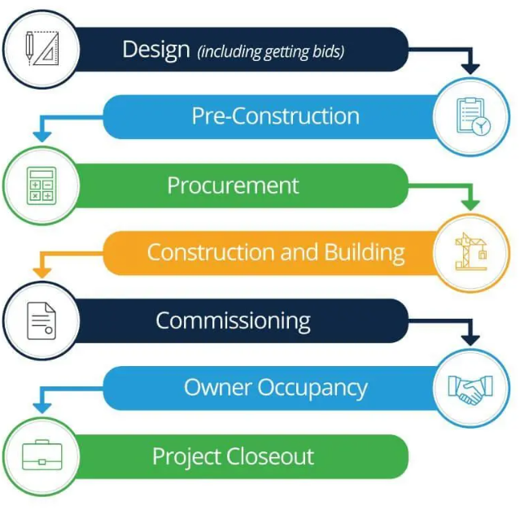

Figure 5: Stages of a Construction Project
(Source: Ramos, 2020)
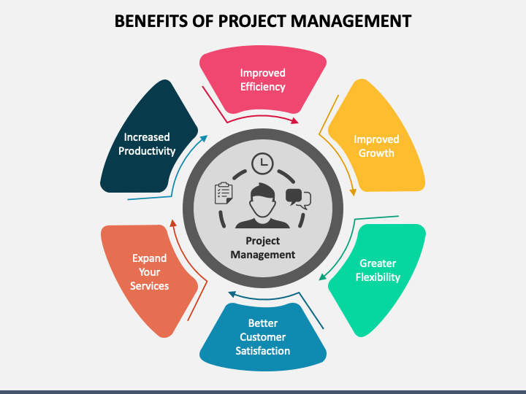
Figure 6: Advantages of Project Management
(Source: Sketchbubble, 2022)

