

Student Name :- Patel Manthan Sureshbhai
Student Id :- 2241308
Programme :- MBA- Master Of Business Administration
Module :- Strategic Management
Module Code :- LCMB 7003
Lecturer Name :- Jayalakshmi Gopalkrishnan
Submission Date :- 03/01/2024

STRATEGIC MANAGEMENT OF RESTAURANT PINE
Table of Contents
Introduction 3
Vision 3
Mission 3
Objectives 4
Internal and External environmental audit 5
External Environment Analysis: PESTLE analysis 5
Internal Environmental Analysis: Porter’s 5 Forces 6
Industry Attractiveness and Market Strategies 7
Best Strategy to Attain Sustainable Competitive Advantage using Porter’s Generic strategy 9
Critical Analysis 9
BCG Matrix 9
Ansoff Matrix 10
VRIO analysis 11
SWOT Analysis 12
Value Chain Analysis 14
Ways to implement and execute the strategy, structure and systems 16
Strategy Implementation 16
Critical Analysis 17
Structural Alignment 17
System Integration 18
Critical Evaluation 18
KPI as monitoring tool to monitor the Strategy 19
Critical Evaluation of Green Strategy, Sustainability, and CSR activities that can be undertaken by Restaurant Pine 20
Green Strategy and Sustainability 20
Corporate Social Responsibility (CSR) 21
Conclusion 22
References 23

Introduction
Companies can't survive in today's complicated and ever-changing business climate without strategic management, which is the backbone of long-term success. It lets businesses plan ahead, evaluate their internal and external surroundings, distribute resources effectively, and respond quickly to changes in the market. Businesses may find ways to expand, stay ahead of the competition, and reduce risk by implementing a strategic management plan. This methodical strategy promotes well-informed decision-making and long-term viability by ensuring that the organization's various levels are in sync with its overall objectives (Barney and Hesterly, 2019). Any company that wants to survive and prosper in this age of rapid change needs strategic management, which is more than simply a good idea.

Vision
Restaurant Pine's vision is to become a beacon of culinary excellence and sustainable dining in the UK. Their vision is to create an exceptional dining experience that transcends the traditional restaurant model, blending innovative gastronomy with environmental stewardship. They aim to be recognized not just for our outstanding cuisine but also for their commitment to sustainability, community engagement, and promoting local agriculture. At Pine, they envision a future where dining is an experience that nourishes not only the body but also the soul and the environment. They aspire to become a leader in the farm-to-table movement, showcasing the best of British produce in their dishes. Their vision extends beyond the plate, encompassing an atmosphere where guests feel a sense of belonging and connection, both with the food they eat and the community around them. In their journey, they see themselves evolving, adapting, and setting new benchmarks in the culinary world (restaurantpine.co.uk, 2020). Pine will be a place where innovation in the kitchen meets responsibility towards the planet. Their dream is for Pine to be more than a restaurant – it becomes a destination, a symbol of sustainability, and a source of inspiration for others in the industry.
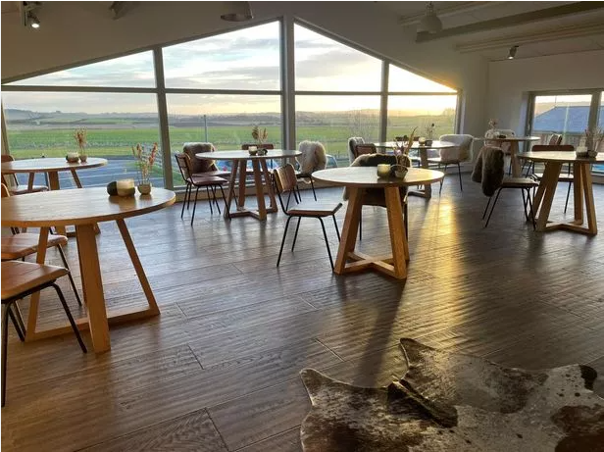
Figure 1: Restaurant Pine

Mission
With an emphasis on sustainability and community, Restaurant Pine strives to provide an unrivaled dining experience that honors the diversity and depth of British food. Finding the best local ingredients, lending a hand to farmers in the area, and highlighting the variety of the UK's agricultural produce are their top priorities. Every meal is an expression of our commitment to quality and innovation in the kitchen, and we strive for culinary perfection in all that they do. They are committed to more than just the culinary arts. In the Pine family, they want to make every one of their guests feel like they belong. They want to set an example for eco-friendly eating by educating and raising awareness about sustainable practices, which are fundamental to Their approach. Their company is committed to making a good difference in the world via recycling more, cutting down on carbon emissions, and supporting other environmentally friendly projects. Pine is based on the belief that community is powerful (restaurantpine.co.uk, 2020). To promote a feeling of togetherness and mutual development, the restaurant collaborate with nearby craftspeople, farmers, and companies. Defining themselves is their dedication to sustainability, community participation, and quality. When a consumer dine with them, they are doing more than just filling bellies, they are building connections, making a difference, and ensuring a better, more sustainable future.

Objectives
- To continuously innovate and elevate their menu, incorporating the latest culinary techniques and trends while staying true to the essence of British cuisine.
- To implement sustainable practices in every aspect of their operations, from sourcing ingredients to waste management, aiming to reduce our environmental footprint significantly.
- To actively engage with the local community through events, partnerships, and educational initiatives, strengthening their ties and contributing to local economic growth.
- To consistently provide exceptional service and a memorable dining experience, ensuring every guest leaves with a positive impression and a desire to return (restaurantpine.co.uk, 2020).
- To invest in their staff through continuous training and development opportunities, fostering a supportive and inclusive workplace culture.
- To achieve steady financial growth and stability, ensuring long-term success and the ability to invest in their mission and objectives.
- To establish Restaurant Pine as a leading name in sustainable dining in the UK and explore opportunities for thoughtful expansion, either through new locations or diverse culinary offerings.
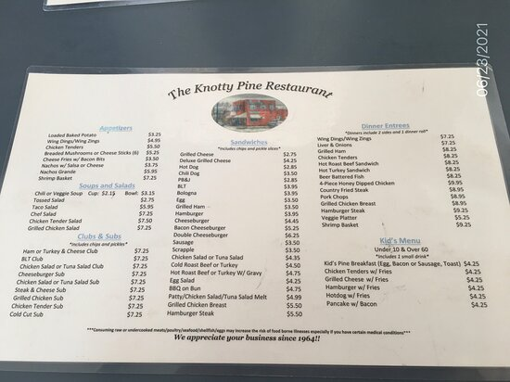
Figure 2: Restaurant Pine Menu
Source: (restaurantpine.co.uk, 2020)

Internal and External environmental audit

External Environment Analysis: PESTLE analysis
In preparation for its impending expansion to other UK sites, Restaurant Pine must do a PESTLE study. Considerations of environmental, social, technological, legal, and political aspects are included in this study of potential influences on the restaurant's growth plan.
Political: The current state of British politics has the potential to greatly impact the growth ambitions of Restaurant Pine. Important factors to think about include government legislation regarding food safety, health regulations, and labor laws. Imported ingredients and trade policies are both affected by the Brexit transition (BUSH, 2019). To overcome these obstacles, Pine Restaurant has to keep up with political developments like new tax legislation and minimum wage rules.
Economic: People's willingness to spend money is very sensitive to general economic trends. Consumer spending and restaurant preferences may be affected by factors such as the rate of inflation, the number of people employed, and the UK's economic recovery after the epidemic. Pine Restaurant should think about how the economy is doing in various parts of the UK and adjust prices and menu items appropriately (BUSH, 2019). For continued profitability, it is also important to account for the effect of currency changes on the cost of importing foreign materials.
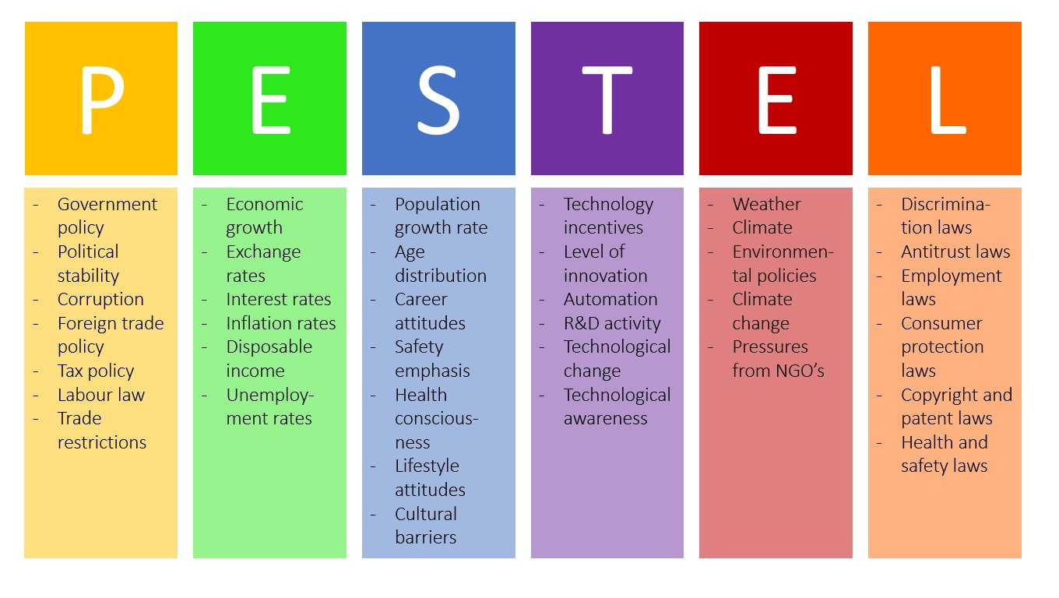
Figure 3: PESTLE analysis
Source: (Bruin, 2016)
Social Factors: Restaurant Pine considers UK social trends, such as the rise of plant-based meals and health awareness, to be of utmost importance. Organic, locally produced cuisine is becoming more popular, which is great news for the restaurant's eco-friendly mission. When planning menus and advertising campaigns, it's crucial to have an understanding of local tastes and cultural subtleties (Bruin, 2016). The restaurant may increase its popularity among locals by becoming involved in community activities and supporting local causes.
Technology: The restaurant sector is heavily reliant on technology. Expanding your customer base requires the use of online booking systems, social media marketing, and meal delivery services. To improve both the quality of their meals and the efficiency of their service, Restaurant Pine should use cutting-edge culinary technology (George, 2021). Its environmental pledges are further supported by the use of sustainable technology, such as energy-efficient home appliances.
Legal: Attending to the law cannot be negotiated and Restaurant Pine is subject to the employment laws, licensing restrictions, and food safety rules of each area in the United Kingdom. Additionally, data privacy rules are of the utmost importance in the realms of digital marketing and online bookings (Bruin, 2016).

Figure 4: Restaurant Market Size in UK
Source: (statista.com, 2021)

Internal Environmental Analysis: Porter’s 5 Forces
Its expansion aspirations across many UK sites, Restaurant Pine must do a Porter's Five Forces study. With this model in hand, we can better comprehend the market dynamics and competitive pressures that may affect the restaurant's growth plan.
Threat of New Entrants: The ever-present danger of new entrants is a result of the low barriers to entry in the UK dining business. Sustainable and locally sourced food is Restaurant Pine's USP, which gives them an advantage over their competitors. The best way for the restaurant to deal with this danger is to work on its brand, keep the quality good, and make customers loyal (Chaudhry et al., 2023). Creating one-of-a-kind eating experiences and capitalizing on community ties may also act as obstacles to prospective entrants.
Bargaining Power of Suppliers: The supplier network plays a vital role in Restaurant Pine's dedication to using local and sustainable foods. The suppliers' negotiating strength is affected by how rare and accessible certain substances are. Restaurant Pine may diversify its supply chain and lessen its reliance on any one source by cultivating good ties with several local vendors. Securing advantageous terms and reinforcing supply chain resilience may also be achieved via participating in long-term contracts and supporting local agricultural projects (Jiang, 2023).
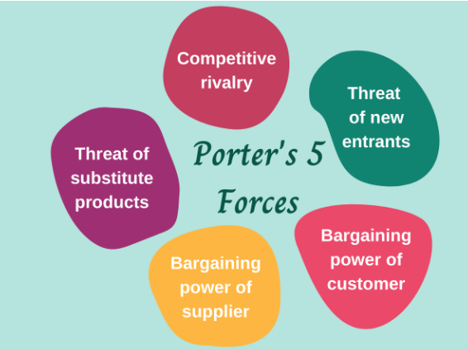
Figure 5: Porter’s Five Forces
Source: (Pratyush, 2021)
Bargaining Power of Buyers: Customers in the restaurant business have a lot of negotiating power since there are so many different places to eat. Restaurant Pine may lessen its influence by setting itself apart from the competition and providing customers with an unforgettable meal. Customer loyalty and price sensitivity may be enhanced by the restaurant's emphasis on great service, unique dishes, and a compelling brand narrative. Personalized experiences and loyalty programs are two more ways to keep customers coming back (Jiang, 2023).
Threat of Substitute Products or Services: The restaurant industry is subject to intense competition from comparable products or services due to the fact that customers have a broad range of options to pick from when it comes to dining and cooking, including fast food, takeaway, and cooking at home (Jiang, 2023). A few of the ways in which Restaurant Pine differentiates itself from its rivals include the use of environmentally friendly practices, the provision of high-quality cuisine, and the provision of an amazing dining experience. Building a powerful brand identity and using marketing methods that are effective are two of the most critical things you can do to differentiate yourself from other options.
Rivalry Among Existing Competitors: The restaurant business in the United Kingdom is a highly competitive one since there are so many restaurants competing for the same customers. Due to the presence of competition, there is a possibility that price wars, decreasing earnings, and a saturated market will occur (Jiang, 2023). When it comes to differentiating itself from other restaurants, Pine should focus mostly on providing exceptional service, unique menu options, and environmentally responsible practices. It is essential to have a strong local presence, to take part in community programmes, and to continually respond to the tastes of customers in order to differentiate oneself from the other businesses present in the market.

Industry Attractiveness and Market Strategies
Restaurant Pine's growth strategy and the attractiveness of the sector in the UK may be summarized using the following data from the PESTLE and Porter's Five Forces analyses:
Industry Attractiveness:
The special selling advantage that Restaurant Pine has makes it an appealing contender for the very competitive eating sector in the United Kingdom. This market as a whole is getting more attractive as a result of the growing demand among consumers for goods that are grown in the area and produced in a sustainable capacity. The recovery of the economy after the epidemic and the relative stability of the political climate create a perfect environment for growth (Vo-Thanh et al., 2022). Breakthroughs in technology make it feasible for service development and marketing innovations to be implemented. However, in order to successfully navigate hurdles such as environmental regulations, legal compliance, and the competitive landscape, careful navigation is essential.
Approaches to the Market:
- In order to differentiate itself from its rivals, Restaurant Pine need to emphasise its commitment to sustainability and locally, therefore capitalising on the growing demand for experiences of this kind. According to the PESTLE analysis, this approach is consistent with the social and environmental trends that are occurring at the present time.
- In order to mitigate the risks associated with the negotiating power of local suppliers, Restaurant Pine need to establish strong ties with other local suppliers that are mutually beneficial. This strategy is compatible with the environmental ideals that the restaurant adheres to and ensures that there is a steady supply of cuisine of the highest quality (Vo-Thanh et al., 2022).
- Due to the growing buying power of customers and the risk of replacements, loyalty programmes and client interaction are particularly important in today's industry. This technique will not only ensure that you stand out from the competition, but it will also assist you in developing a customer base that is loyal to your brand.
- As Restaurant Pine expands into other locations in the United Kingdom, it will need to adapt to the preferences and tastes of the local community. While simultaneously appealing to a diverse group of customers, this strategy goes up against the fierce rivalry that exists in the market.
- The ability of Restaurant Pine to effectively navigate the competitive and regulatory climate in the UK dining industry is contingent on the restaurant's capability to use its unique approach to sustainable and local sourcing, in combination with intelligent customer contact and efficient utilisation of technology.

Best Strategy to Attain Sustainable Competitive Advantage using Porter’s Generic strategy
For Restaurant Pine, Porter's Generic Strategies offer three distinct paths to achieve a sustainable competitive advantage: Cost Leadership, Differentiation, and Focus.
Cost Leadership: This strategy involves becoming the lowest-cost producer in the industry (Singh and Mather, 2017). While it can attract a broader customer base through lower prices, it might not be suitable for Restaurant Pine if it compromises the quality of food or service, which are crucial in the hospitality industry.
Differentiation: This approach focuses on making Restaurant Pine stand out with unique offerings. This could be through exceptional culinary experiences, a unique ambiance, superior customer service, or a niche menu. Differentiation can help Restaurant Pine create a strong brand identity and customer loyalty, allowing for premium pricing.
Focus Strategy: This involves concentrating on a particular market segment or niche. Restaurant Pine could specialize in a specific type of cuisine, target a specific demographic, or focus on unique dietary needs like vegan or gluten-free options.

Critical Analysis

BCG Matrix
BCG Matrix study of Restaurant Pine in the UK would classify the company's SBUs, or products and services. Allocating resources and developing strategies are both aided by this paradigm. They will classify example SBUs to demonstrate this approach, assuming that Restaurant Pine is a single corporate entity:
Stars (High Market Growth, High Market Share):
Restaurant Pine's sustainable gourmet cuisine and other main items might be categorized as 'Stars' due to its high market share and rapid growth. These things are trendy, and they've gotten a lot of fans because they're different and they fit in with the current market trend for eco-friendly products and food made from local ingredients (Crab, 2020).
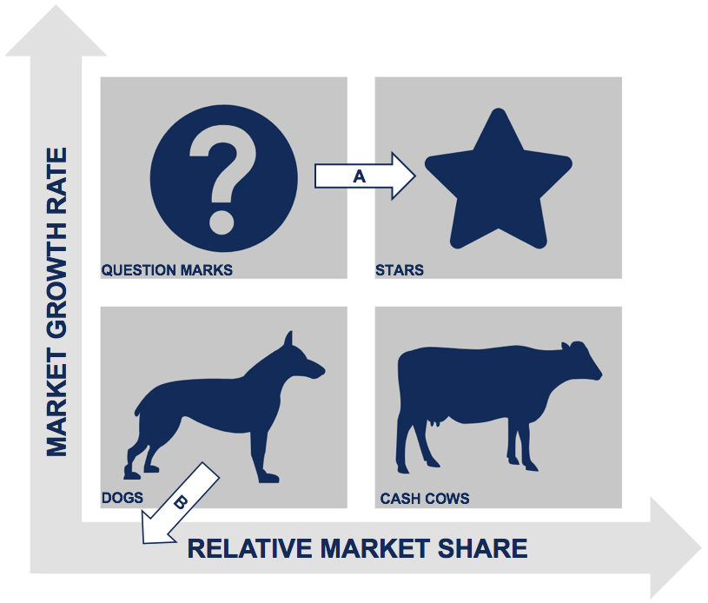
Figure 6: BCG Matrix
Source: (Crab, 2020)
"Cash Cows" (Medium Market Share, Low Growth):
Classic British foods that have always been well-liked by many different types of consumers are examples of this. They need less capital and have a consistent portion of the market. Restaurant Pine may rely on the consistent income from these things to support other aspects of its operation.
Question Marks (High Market Growth, Low Market Share):
In this area, one may find creative culinary experiments or recipes that are freshly introduced and made sustainably (Crab, 2020). Despite the rising demand for novel eating experiences, these products and services have not yet established a solid foothold in the market.
Dogs (Low Market Growth, Low Market Share):
Products that have not done well with customers or are seeing a fall in sales as a result of shifting tastes are considered "Dogs" (Low Market Growth, Low Market Share). It might be wise for Restaurant Pine to rethink these offers or at least revamp them to match current market demands.

Ansoff Matrix
Market Penetration (present Products, Current Market):
This approach concentrates on expanding the portion of the present market that Restaurant Pine's current goods occupy. Boosting advertising, raising the bar on service, launching customer loyalty programs, or using price cuts are all ways to get there (Jelonek et al., 2022). The UK restaurant market is quite competitive thus, Restaurant Pine would be wise to concentrate on growing its clientele and brand recognition at its current locations.
Promoting Current Products in New Markets:
Promoting current products in Restaurant Pine would mean reaching out to new demographics or regions in the UK. One option is to expand into underdeveloped areas, while another is to focus on a certain demographic, such as younger customers or corporate clients (Jelonek et al., 2022). To learn about the tastes and eating habits of these untapped consumers, market research is essential.
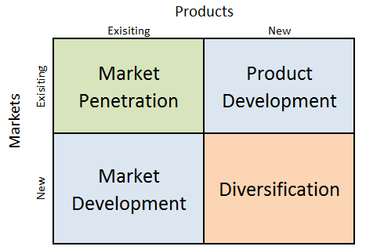
Figure 7: Ansoff Matrix
Source: (Dudovskiy, 2023)
Developing New Products for the Current Market:
This approach comprises providing the current clientele with novel food options or dining experiences. Pine Restaurant could shake things up by trying out seasonal menus, experimenting with sustainable foods, or providing unique themed dinners (Jelonek et al., 2022). To remain relevant and competitive, this method takes into account the changing preferences of present clients.
Diversification (New Products, New Markets):
The fourth and most daring growth approach is diversification, which entails Restaurant Pine entering new areas with totally new products. This may include trying out a new kind of food, creating a chain of more informal eateries, or even getting into the delivery business. Although there is a bigger potential for loss with this approach, it may also lead to substantial gains in income.
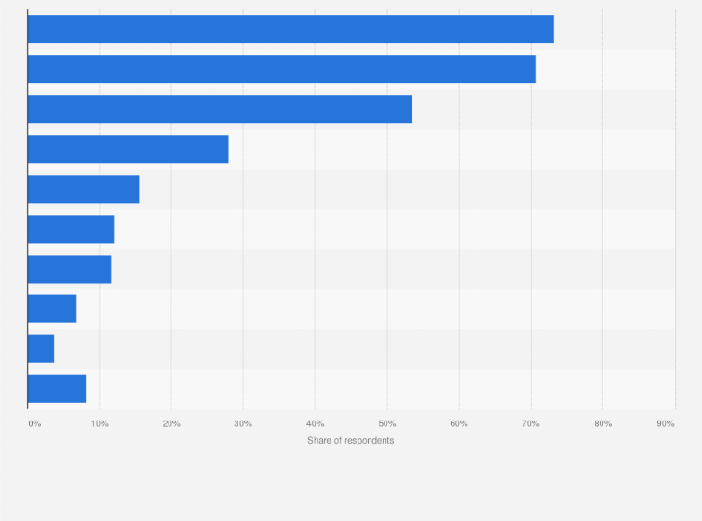
Figure 8: Opportunities for fine dining restaurant in UK
Source: (statista.com, 2021)

VRIO analysis
Value:
Its one-of-a-kind emphasis on eco-friendly and regionally produced food, Restaurant Pine adds value to the industry. This strategy is in line with worldwide trends toward sustainability and is sure to win over the expanding demographic of eco-conscious shoppers (Yoon et al., 2020). Restaurant Pine stands apart from the competition and adds value to its brand and offers by providing a one-of-a-kind dining experience that prioritizes quality and ethical sourcing.
Uncommon:
Few restaurants adhere to the principle of integrating fine dining with a firm dedication to eco-friendliness and regional produce (Yoon et al., 2020). Restaurant Pine stands out from the crowd because it incorporates sustainability into its business strategy and food choices to a much greater degree than other restaurants. A specialized market that prioritizes ecological responsibility and gastronomic quality might be attracted by this peculiarity.
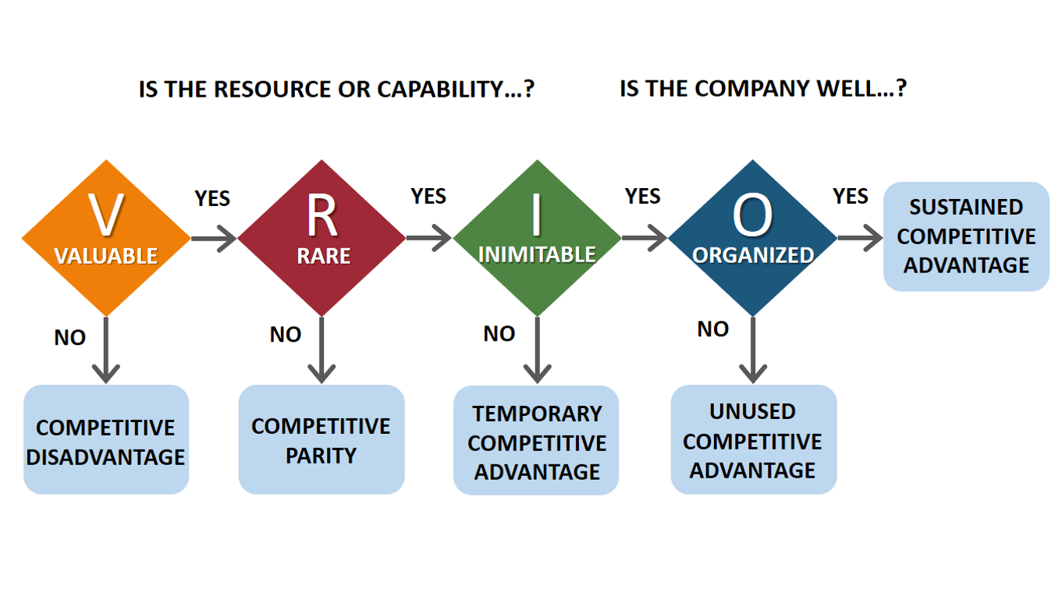
Figure 9: VRIO framework
Source: (Bruin, 2016)
Imitability:
It's easy to replicate Restaurant Pine's success without pouring resources into sourcing, training, and upholding quality and sustainability requirements. Due to this difficulty and expense of duplicating this, Restaurant Pine has a leg up on the competition.
Organization:
The management and staff of Restaurant Pine are set up in a way that makes good use of these rare, expensive, and highly desirable resources. By prioritizing customer service, staff development, and quality control, the restaurant has shown that it can make the most of its distinctive assets and remain ahead of the competition.

SWOT Analysis
Strengths:
- Unique Selling Proposition (USP): Restaurant Pine's commitment to sustainability and locally sourced ingredients sets it apart in the market, catering to a growing demand for ethical and environmentally friendly dining experiences.
- Quality and Innovation: High culinary standards and innovative menus enhance customer experience and retention (Bharwani et al., 2019).
- Strong Brand Reputation: A reputation for quality, sustainability, and community involvement strengthens customer trust and loyalty.
- Skilled Team: A talented culinary team and well-trained staff ensure high service standards and operational efficiency.
Weaknesses:
- Limited Market Reach: Currently operating in a niche market, which may limit its appeal to a broader audience.
- Dependency on Local Suppliers: Relying heavily on local suppliers could pose challenges in consistency and pricing, especially if supply issues arise.
- Higher Price Points: Sustainability and quality come at a cost, potentially alienating price-sensitive customers.
- Scalability Challenges: Maintaining quality and sustainability standards while scaling up could be challenging.
Opportunities:
- Expanding Consumer Base: Increasing awareness and demand for sustainable dining options presents an opportunity to attract more customers.
- Market Expansion: Potential to expand into new locations, both within and outside urban areas.
- Partnerships and Collaborations: Opportunities for collaborations with local farmers, artisan producers, and environmental organizations (Bharwani et al., 2019).
- Technological Advancements: Utilizing technology for better customer engagement, efficient operations, and marketing.
Threats:
- Intense Competition: The UK dining sector is highly competitive, with new concepts continually emerging.
- Economic Fluctuations: Economic downturns can reduce consumer spending on dining out.
- Changing Consumer Preferences: Rapid shifts in consumer tastes and preferences could affect demand.
- Supply Chain Disruptions: Vulnerability to disruptions in local supply chains, including weather-related impacts on agriculture.
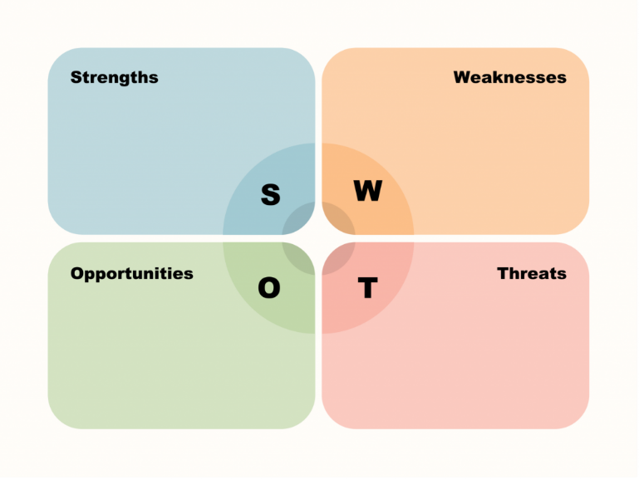
Figure 10: SWOT analysis
Source: (Indra et al., 2022)

Value Chain Analysis
Primary Activities: Inbound Logistics
Restaurant Pine's focus on local and sustainable sourcing is a critical value creator. The establishment of a robust network of local suppliers ensures the delivery of fresh, high-quality ingredients.
Operations
The kitchen operations, where ingredients are transformed into culinary delights, are central to Restaurant Pine's value creation. Emphasizing sustainable cooking practices and innovative culinary techniques enhances the dining experience.
Outbound Logistics
Although typically minimal in restaurants, this includes effective management of takeaway services or any delivery aspects, ensuring food quality and timely delivery.
Marketing and Sales
Restaurant Pine's marketing strategy, focusing on its sustainability and unique culinary experience, attracts a specific customer segment. Effective use of social media, community engagement, and word-of-mouth are crucial for driving sales.
Service
The customer service experience, from the ambiance of the restaurant to the interaction with staff, significantly impacts customer satisfaction and retention.
Support Activities: Infrastructure
This includes organizational structure, management systems, and facilities. Restaurant Pine’s management of its infrastructure should align with its business goals of sustainability and quality.
Human Resource Management
Staff recruitment, training, and development are vital. Training staff in sustainability practices and exceptional service standards is a key value-adding activity.
Technology Development
Investing in kitchen technology for efficient cooking and adopting digital tools for reservations and customer relationship management can enhance operational efficiency and customer experience.
Procurement
The procurement process is crucial, especially in sourcing unique, high-quality, and sustainable ingredients. Effective procurement supports the restaurant's USP and impacts the overall quality of the dining experience.
Restaurant Pine's allure and market position is enhanced by each link in its value chain. The restaurant stands apart in the competitive UK dining sector because of its emphasis on sustainable methods, excellent food, and great service, all of which contribute to producing value for consumers.

Ways to implement and execute the strategy, structure and systems
To successfully implement and carry out a plan for Restaurant Pine in the United Kingdom, a complete approach is required. This method includes the design of the strategy, the alignment of the structure, and the integration of the system. The discussion, evaluation, analysis, and critical analysis of these components are all necessary steps to do to guarantee success.

Strategy Implementation
- Clear Articulation of Strategic Goals: The primary step is to clearly define the strategic goals based on the restaurant's vision and mission. For Restaurant Pine, this would involve expanding its footprint while maintaining its commitment to sustainability and quality. These goals should be communicated effectively across the organization.
- Resource Allocation: To support the strategic objectives, it is necessary to provide sufficient resources, including financial, human, and technical resources. The funding for marketing, personnel training, and technical updates are all included in this component.
- Staff Engagement and Training: The employees at every level should be aware of the role that they play in the accomplishment of the strategic objectives. It is essential to have training programs that provide an emphasis on effective customer service, sustainable business practices, and maximum operational efficiency (Sharma et al., 2021).
- Marketing and Brand Positioning: Both the brand's commitment to sustainable practices and its support of local economies are unique selling propositions (USPs) that need to be vigorously pushed. The approach includes several different strategies, including internet marketing, communicating with locals, and capitalizing on favorable evaluations.
- Operational Excellence: It is essential to streamline processes to guarantee operational efficiency, quality control, and consistency across all of the numerous sites. The standardization of recipes, the implementation of quality control inspections, and the optimization of supply chain management are all potential steps in this direction.
Strategy Evaluation:
- Performance Metrics: Through the establishment of key performance indicators (KPIs) for many aspects of the organization, such as the satisfaction of customers, the performance of the firm's finances, and the effectiveness of the supply chain, you can constantly monitor and analyze the effectiveness of the plan.
- Feedback Mechanisms: It is possible that receiving feedback from customers and staff regularly might provide useful insights into areas that could be improved and validate the effectiveness of the strategy once it is made operational (Sharma et al., 2021).
- Market Analysis: To ensure that the strategy continues to be effective and relevant, it is vital to perform a continuous analysis of the changes in the market, the preferences of customers, and the actions that are being carried out by rivals.

Critical Analysis
Adaptability: The plan has to be malleable enough to adjust to changing customer preferences, new obstacles, and shifting market circumstances. Pine Restaurant has to be flexible enough to modify its approach based on customer input and outside factors.
Risk Management: It is critical to identify possible risks, such as changes in customer behavior or interruptions in the supply chain, and create backup plans to lessen the effect of negative outcomes on the strategy (Sharma et al., 2021).
Sustainability Integration: To make sustainability more than simply a marketing gimmick and a fundamental operating concept, the strategy has to analyze how the company incorporates sustainability into all it does.

Structural Alignment
- Organizational Structure: Restaurant Pine’s organizational structure should support its strategic objectives. A decentralized structure might be beneficial for managing multiple locations, allowing for some level of autonomy in catering to local preferences while maintaining overall brand consistency.
- Leadership and Culture: Leadership plays a key role in driving the strategy and shaping the organizational culture. A leadership style that fosters innovation, accountability, and a commitment to sustainability is essential (Fu et al., 2022).
- Communication Channels: In addition to facilitating the flow of information, ensuring alignment with the strategic objectives, and cultivating a culture of openness and cooperation, effective communication channels inside the organization are essential to the success of the organization.
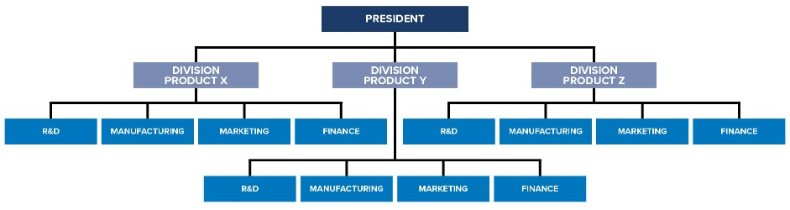
Figure 11: Organizational Structure
Source: (shrm.org, 2022)

System Integration
- Technology Systems: Implementing integrated technology systems for inventory management, customer relationship management (CRM), and data analytics can streamline operations and provide valuable insights for decision-making.
- Supply Chain Management: A robust supply chain management system is critical, particularly for a restaurant that relies on local and sustainable sources. This system should ensure consistency, quality, and adherence to sustainability standards (Fu et al., 2022).
- Performance Management Systems: Systems for tracking performance against KPIs and for staff appraisals are important for maintaining operational standards and ensuring continuous improvement.

Critical Evaluation
Alignment with Long-Term Goals: The Restaurant Pine has to do a comprehensive review of its business strategy, organisational structure, and operational processes in order to determine whether or not they are in accordance with the organization's long-term goals. Among them are the assessments that determine whether or not these components contribute to the integrity of the brand and to the development of sustainable practices (Fu et al., 2022).
Scalability: It is of the highest significance that the strategy, structure, and procedures be scalable, especially when taking into mind the growth goals that are being pursued. It is necessary for the business model to be scalable without compromising the core concepts or the level of service that is provided.
Innovation and Continuous Improvement: It is necessary for the strategy to foster innovative thinking and provide an environment that is receptive to continually improving its performance. In order to do this, it is vital to continually analyse and improve upon strategies, structures, and processes in light of new information and changing market circumstances (Fu et al., 2022).
It is required to adopt a complete approach that encompasses well-defined strategic goals, an organisational structure that is aligned with those objectives, and effective processes in order for Restaurant Pine's strategy to be effectively implemented and carried out in the United Kingdom. This is necessary in order to ensure that the strategy is carried out successfully. It is necessary for this approach to be adaptable, scalable, and subject to continuous development in order to maintain a competitive edge and react to changes in the market. It is vital to put into action techniques for critical evaluation and feedback in order to ensure that the strategy will be effective and will be in accordance with the core values and long-term objectives of the restaurant.

KPI as monitoring tool to monitor the Strategy
To effectively monitor the strategy of Restaurant Pine, Key Performance Indicators (KPIs) can be strategically utilized:
Revenue Growth: Track monthly and annual revenue to assess financial health and growth, in line with strategic goals (Tripska, 2023).
Customer Retention Rate: Monitor the rate at which repeat customers return to gauge loyalty and satisfaction.
Average Table Turnover Rate: Evaluate how quickly tables are occupied and cleared, reflecting operational efficiency and customer demand (Tripska, 2023).
Food Waste Percentage: Measure the amount of food waste to assess inventory management and menu efficiency.
Online Review Ratings: Regularly check ratings on review platforms to gauge public perception and service quality.
Employee Satisfaction Levels: Use periodic surveys to ensure a motivated and productive workforce.
Restaurant Pine is able to continuously adjust their strategy and ensure alignment with their company goals and consumer expectations because to the actionable information provided by these key performance indicators.

Critical Evaluation of Green Strategy, Sustainability, and CSR activities that can be undertaken by Restaurant Pine

Green Strategy and Sustainability
Discussion:
- The reduction of environmental impact should be the primary goal of a green strategy for Restaurant Pine. This may be accomplished by activities like sustainable sourcing, energy efficiency, waste reduction, and low-carbon operations.
- The practice of obtaining products from local, organic, or fair-trade sources is an example of sustainable sourcing strategies (Lee et al., 2020). Help to support local businesses and decrease emissions from transportation.
- It is possible to achieve energy efficiency by making investments in energy-saving appliances, lighting that uses LEDs, and perhaps renewable energy sources such as solar panels.
- Composting, recycling, and reducing the amount of food that is thrown away are all useful waste reduction measures. An innovative strategy might consist of putting into action a concept of a circular economy in which waste goods are allowed to be repurposed.
Analysis:
- Putting into action a green strategy calls for an initial investment, but it has the potential to result in long-term cost savings and increased profitability. Using energy-efficient equipment, for instance, may result in lower monthly power expenditures over time (Lee et al., 2020).
- Restaurant Pine has the potential to take advantage of its dedication to sustainability as a significant difference, attracting consumers who emphasize environmental responsibility.
Critical Evaluation:
- It is essential for a green strategy to be implemented in a manner that is consistent across all aspects of the company and to be integrated into the core operations of the restaurant for it to be effective.
- There is a possibility of "greenwashing" occurring if the approach is not executed honestly or if it is utilized just as a marketing tool without considering the significant environmental advantages it offers.

Corporate Social Responsibility (CSR)
Discussion:
- Activities related to corporate social responsibility (CSR) for Restaurant Pine may include participating in staff volunteer programs, providing assistance to local community projects, and collaborating with environmental organizations.
- The restaurant's connections to the community may be strengthened by providing financial support to community initiatives such as community gardens or programs that educate people about food.
- The influence that Restaurant Pine has on larger sustainability concerns may be amplified via partnerships with environmental organizations, who also give important knowledge in the implementation of green projects from Restaurant Pine.
Analysis:
- The restaurant's credibility and positive association with socially and environmentally conscious principles are bolstered by its CSR initiatives.
- Avoiding the appearance of superficiality or disconnection by making sure that CSR efforts are in line with the restaurant's main business and principles could be a difficulty.
Critical Evaluation:
- For corporate social responsibility (CSR) programs to be successful, they must be genuine and appeal to society as a whole as well as internal stakeholders (Usmani et al., 2022).
- To make sure CSR initiatives don't detract from the restaurant's main goals, it's important to strike a balance between the two.

Conclusion
A green strategy, sustainability, and corporate social responsibility (CSR) initiatives are examples of Restaurant Pine's innovative thinking that reflects the ideals and trends of modern consumers. Although there are obstacles to overcome, such as the need for upfront expenditures and a meticulous cost-benefit analysis, the potential advantages of implementing these techniques are substantial. Among them include a positive effect on society and the environment, increased operational efficiency, strengthened consumer loyalty, and an improved reputation for the brand.

References
Barney, J.B. and Hesterly, W.S., 2019. Strategic management and competitive advantage: Concepts and cases. Pearson.
Bharwani, S., Mathews, D. and Ghura, A.S., 2019. Business model innovation in the Indian hospitality industry: A study of the willingness to outsource specialty restaurants in luxury hotels. Worldwide Hospitality and Tourism Themes, 11(4), pp.362-377.
Bruin, L. d., 2016. Scanning the Environment: PESTEL Analysis. [Online]
Available at: https://www.business-to-you.com/scanning-the-environment-pestel-analysis/
BUSH, T., 2019. PESTLE ANALYSIS. [Online]
Available at: https://pestleanalysis.com/pestle-analysis-of-the-food-industry/
Chaudhry, S., Crick, D. and Crick, J.M., 2023. I'll be there for you: coopetition and competitor-oriented activities among South Asian restaurants in two UK regional clusters. International Journal of Entrepreneurial Behavior & Research.
Crab, M.A., 2020. Customer Experience in a Hungarian Fine Dining Restaurant: A Marketing Perspektive (Doctoral dissertation, Universidade do Algarve (Portugal)).
Dudovskiy, J., 2023. Ansoff Matrix. [Online]
Available at: https://research-methodology.net/apple-ansoff-matrix-2/
Fu, Q., Abdul Rahman, A.A., Jiang, H., Abbas, J. and Comite, U., 2022. Sustainable supply chain and business performance: The impact of strategy, network design, information systems, and organizational structure. Sustainability, 14(3), p.1080.
George, R., 2021. The Tourism and Hospitality Marketing Environment. In Marketing Tourism and Hospitality: Concepts and Cases (pp. 183-219). Cham: Springer International Publishing.
Indra, F., Christabel, V.N., Vania, A. and Juliana, J., 2022. SWOT ANALYSIS BUSINESS FEASIBILITY STUDY (CASE STUDY: ITALIAN RESTAURANT). INTERNATIONAL JOURNAL OF SOCIAL, POLICY AND LAW, 3(2), pp.30-40.
Jelonek, D., Tien, N.H., Dao, M.T.H. and Minh, D.T., 2022. Comparative analysis of business strategy of Vietnamese real estate developers: the use of Hoffer matrix. International journal of multidisciplinary research and growth evaluation, 3(1), pp.197-204.
Jiang, Y., 2023. SWOT-PEST-Porter’s 5 Force Analysis for Post-pandemic the Cheesecake Factory. In 2022 3rd International Conference on Big Data Economy and Information Management (BDEIM 2022) (pp. 480-488). Atlantis Press.
Lee, S., Han, H., Radic, A. and Tariq, B., 2020. Corporate social responsibility (CSR) as a customer satisfaction and retention strategy in the chain restaurant sector. Journal of Hospitality and Tourism Management, 45, pp.348-358.
Pratyush, 2021. How Porter’s Five Forces helps in E-commerce Business Analysis?. [Online]
Available at: https://www.anscommerce.com/blog/how-porters-five-forces-help-in-e-commerce-business-analysis/
restaurantpine.co.uk, 2020. RESTAURANT. [Online]
Available at: https://www.restaurantpine.co.uk/restaurant
Sharma, B., Arora, R. and Kharub, M., 2021. Critical success factors affecting the restaurant industry: Insights from restaurant managers. FIIB Business Review, p.23197145211042429.
shrm.org, 2022. Understanding Organizational Structures. [Online]
Available at: https://www.shrm.org/resourcesandtools/tools-and-samples/toolkits/pages/understanding-organizational-structures.aspx
Singh, T. and Mather, G., 2017. Generic business strategy-Now and Then.
statista.com, 2021. Market size of the full service restaurant sector in the United Kingdom (UK) from 2012 to 2021, with a forecast for 2022. [Online]
Available at: https://www.statista.com/statistics/1285352/the-full-service-restaurant-sector-market-size-uk/
Tripska, T., 2023. Key performance indicators and its occurrence among restaurants in the Czech Republic (Master's thesis, Eesti Maaülikool).
Usmani, M.S., Wang, J., Ahmad, N., Ullah, Z., Iqbal, M. and Ismail, M., 2022. Establishing a corporate social responsibility implementation model for promoting sustainability in the food sector: A hybrid approach of expert mining and ISM–MICMAC. Environmental Science and Pollution Research, pp.1-22.
Vo-Thanh, T., Zaman, M., Hasan, R., Akter, S. and Dang-Van, T., 2022. The service digitalization in fine-dining restaurants: a cost-benefit perspective. International Journal of Contemporary Hospitality Management, 34(9), pp.3502-3524.
Yoon, B., Chung, Y. and Jun, K., 2020. Restaurant industry practices to promote healthy sustainable eating: A content analysis of restaurant websites using the value chain approach. Sustainability, 12(17), p.7127.

