University of Wales Trinity Saint David

Research, build , and deploy a Virtualised Enterprise network


Module: “Networks Operating Systems and Services”
Programme: Applied Computing

Name: Alexandr Iancovschi
Student Number: 2423378
Date: 27 March 2026

Table of Contents
Table of Contents 2
Introduction 3
1. Research Report 3
1.1 Research on Hypervisor 3
1.2 Research on IP Addressing 4
1.3 Research on Routing 6
2. Report: Technical Documentation 8
2.1 Choice of Hypervisor 8
2.2 Download and Setup 9
2.2.1 Download of Software 9
2.2.2 Network Deployment 10
2.3 Configure IP Addressing 13
2.4 Test and Troubleshoot 15
TASK 3 – REFLECTION 17
3.1.1 Technical Reflection 17
3.1.2 Personal Reflection 18
Conclusion 19
References 20

Introduction

This report presents the research, design, implementation, and evaluation of a virtualised enterprise network environment. The aim of this coursework is to develop a systematic understanding of network operating systems and demonstrate the ability to deploy and manage network services using virtualisation technologies.

The project is divided into three main tasks. Task 1 focuses on research, including the analysis of hypervisors, IP addressing, and routing concepts. This provides the theoretical foundation required to design and implement a functional network. Task 2 involves the practical deployment of a virtual network using a chosen hypervisor, where a Debian server is configured with appropriate IP addressing and tested for connectivity. Task 3 provides a reflection on both the technical challenges encountered during the deployment and the personal learning outcomes achieved throughout the process.

A Type 2 hypervisor, VMware Fusion, was selected for this project due to its compatibility, ease of use, and ability to support multiple operating systems within a virtual environment. The network was configured using static IP addressing to ensure stability and consistency in communication between devices.

Overall, this report demonstrates both theoretical knowledge and practical skills in network configuration, troubleshooting, and virtualisation, forming a strong foundation for further development in network operating systems and services.

Research Report

1.1 Research on Hypervisor

A hypervisor is a virtualisation technology that allows multiple operating systems to run on a single physical machine. There are two main types of hypervisors: Type 1 (bare-metal) and Type 2 (hosted). Type 1 hypervisors run directly on the hardware without a host operating system, providing better performance, security (Microsoft, 2024), and resource efficiency. Examples include VMware ESXi and Microsoft Hyper-V. In contrast, Type 2 hypervisors run on top of a host operating system, such as macOS or Windows, and are easier to use but less efficient due to additional overhead (VMware, 2026).

For this topology, which includes both Windows Server 2022 and Debian Server, a Type 2 hypervisor such as VMware Fusion is suitable. This is because it provides strong compatibility with different operating systems and is easier to manage in a learning environment. Although Type 1 hypervisors offer better performance, they require dedicated hardware and are more complex to configure.

In the context of the enhanced topology (BIRMINGHAM.ACCA), the need to support multiple clients and services makes flexibility an important factor. VMware Fusion allows easy configuration of virtual networks, snapshots, and resource allocation, which are essential for testing enterprise scenarios.

Therefore, a Type 2 hypervisor is justified for this coursework due to its usability, compatibility, and sufficient performance for virtual network deployment.

1.2 Research on IP Addressing

IP addressing is a fundamental concept in networking that enables communication between devices across networks (Cloudflare,2024). Data travels from one computer to another using packets, which contain source and destination IP addresses. These addresses allow routers and switches to identify where the data should be sent (Kurose & Ross, 2021).

Routers operate at Layer 3 of the OSI model and are responsible for forwarding packets between different networks, while switches operate at Layer 2 and handle communication within the same network. Together, they ensure efficient data transmission across the Internet.

IPv4 addresses are 32-bit numerical values, typically written in dotted decimal format (e.g., 192.168.1.1). However, due to the limited number of available addresses, IPv6 was introduced, using 128-bit addressing (e.g., 2001:db8::1), which provides a significantly larger address space (Cisco, 2023).

Subnetting is used to divide a network into smaller sub-networks, improving efficiency and security (Cisco, 2023). For example, a network 192.168.1.0/24 can be divided into multiple subnets, allowing better management of devices and reducing broadcast traffic.

Efficient IP addressing is essential for network performance, as it ensures proper allocation of addresses and avoids conflicts. In practical applications, static IPs are often assigned to servers, while dynamic IPs are assigned to client devices using DHCP.

Overall, IP addressing plays a critical role in the functionality and scalability of modern networks. Variable Length Subnet Masking (VLSM) can be used to improve the efficiency of IP address allocation. VLSM allows networks to be divided into subnets of different sizes based on specific requirements, rather than using fixed-size subnets. This ensures that IP addresses are not wasted and can be allocated more effectively across different parts of the network.

For example, a network administrator may assign a larger subnet to a department with many devices and a smaller subnet to a department with fewer devices. This approach enhances scalability and optimises resource usage.

Furthermore, Dynamic Host Configuration Protocol (DHCP) plays an important role in IP addressing by automatically assigning IP addresses to client devices. This reduces administrative effort and minimises configuration errors. However, in contrast, servers are usually assigned static IP addresses to ensure consistent accessibility.

These techniques demonstrate that IP addressing is not only about assigning addresses, but also about managing them efficiently to support network performance and scalability.

1.3 Research on Routing

Routing is the process of selecting paths in a network along which data packets are transmitted (IBM, 2024). Routing protocols are used by routers to determine the best path for data transmission. These protocols can be classified into static and dynamic routing.

Static routing involves manually configuring routes, which is simple but not scalable for large networks. Dynamic routing protocols, such as RIP, OSPF, and BGP, automatically update routing tables based on network conditions. For example, OSPF is widely used in enterprise environments due to its fast convergence and scalability (Cisco, 2023).

The main purpose of routing protocols is to ensure that data reaches its destination efficiently and reliably. They consider factors such as distance, bandwidth, and network congestion when determining the best path.

Best practices in routing include proper network segmentation, use of secure routing protocols, and regular monitoring of routing tables. In enterprise networks, routing is essential for connecting different subnets and ensuring communication between servers and clients.

In this coursework, routing concepts are important for understanding how different network segments interact and how traffic flows between them. Even though a simple topology is used, the principles of routing still apply and form the foundation for more advanced network configurations.
When comparing routing protocols, it is important to consider their suitability for different network sizes. For example, RIP (Routing Information Protocol) is simple and easy to configure, but it is limited in scalability and performance due to its maximum hop count restriction. In contrast, OSPF (Open Shortest Path First) is more advanced and suitable for large enterprise networks, as it uses a link-state algorithm to calculate the shortest path more efficiently.

Another important routing protocol is BGP (Border Gateway Protocol), which is used on the Internet to exchange routing information between different autonomous systems. BGP is highly scalable and supports complex routing policies, making it essential for global network communication.

Effective routing also involves implementing security measures such as route filtering and authentication to prevent malicious or incorrect routing updates. This ensures the integrity and reliability of the network.

Overall, understanding the differences between routing protocols and applying best practices allows network administrators to design efficient and secure networks.

2. Report: Technical Documentation

2.1 Choice of Hypervisor

For this coursework, the chosen hypervisor is VMware Fusion, a Type 2 hypervisor suitable for macOS. This choice is based on several key factors, including stability, compatibility with multiple operating systems, and support for advanced virtual networking features. VMware Fusion allows the creation and management of multiple virtual machines efficiently, which is essential for deploying and testing a virtualised enterprise network (VMware, 2026).

One of the main advantages of VMware Fusion is its support for different network modes, such as NAT, Bridged, and Host-only networking. NAT allows the virtual machines to access external networks while using the host’s IP address, bridging connects VMs directly to the host network for full LAN access, and Host-only networking creates an isolated environment for testing without affecting the physical network (VMware, 2026). These modes are critical when simulating enterprise networks, where different network segments must communicate securely and efficiently.

Additionally, VMware Fusion allows fine-tuned allocation of system resources such as CPU cores, RAM, and disk space. This ensures optimal performance even when running multiple VMs simultaneously. In this coursework, the network topology includes both Windows Server 2022 and Debian Server, which need consistent performance for services like DNS, DHCP, and file sharing. VMware Fusion provides snapshots, which are essential for restoring the network state in case of misconfigurations (VMware, 2026).

Future scalability was also considered. Since this network will be extended in Coursework 2 to include additional services, VMware Fusion allows flexibility without significant reconfiguration. Overall, VMware Fusion was selected due to its reliability, flexibility, and usability in an educational enterprise network environment.

2.2 Download and Setup

2.2.1 Download of Software

The hypervisor VMware Fusion was downloaded from the official VMware website to ensure authenticity and security (VMware, 2026). The Debian GNU/Linux server OS was selected for its stability, lightweight footprint, and suitability for enterprise server tasks. The client operating system is Windows 10, which allows testing interoperability in a mixed environment.

All downloads were performed from official and trusted sources to comply with best practices (Microsoft, 2024; Debian Project, 2024). File checksums were verified to ensure integrity before installation. Screenshots with timestamps were taken to demonstrate continuous work and adherence to deadlines.

2.2.2 Network Deployment

A new virtual machine was created in VMware Fusion and configured with the following parameters:
• CPU: 2 cores
• RAM: 4 GB
• Disk: 20 GB
• Network Adapter: Bridged initially for internet access, then switched to Host-only for isolated testing

During Debian installation, the hostname, user accounts, and passwords were configured. Screenshots were taken at each step to provide evidence of proper time management. The installation process included selecting keyboard layout, language, and disk partitioning.

The virtual network adapter was configured to simulate real network communication between VMs. This included assigning IP addresses and ensuring each VM could theoretically communicate with others based on the network topology.

Screenshot 1a – 1b: Initial installation screen showing hostname and domain name input.
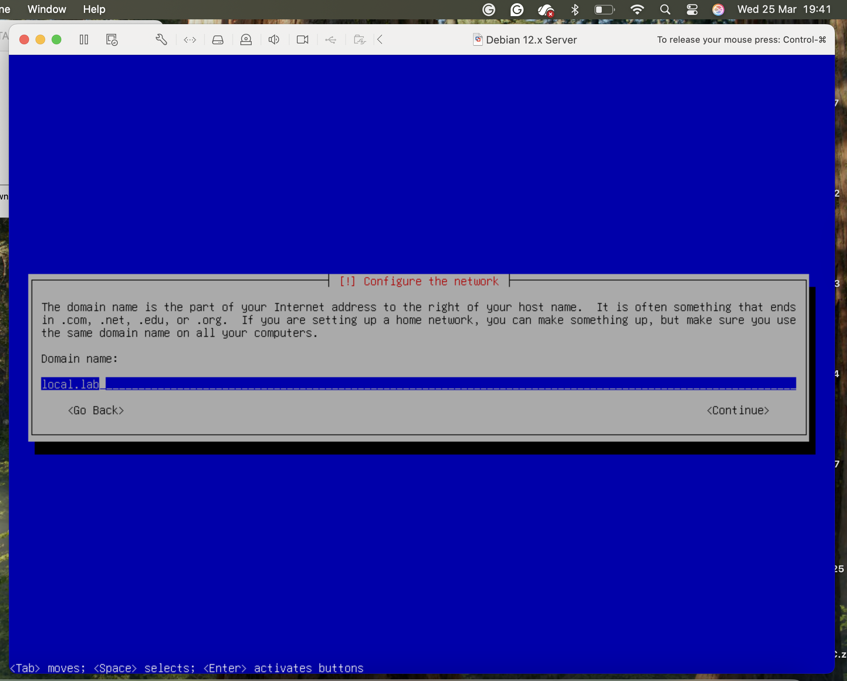
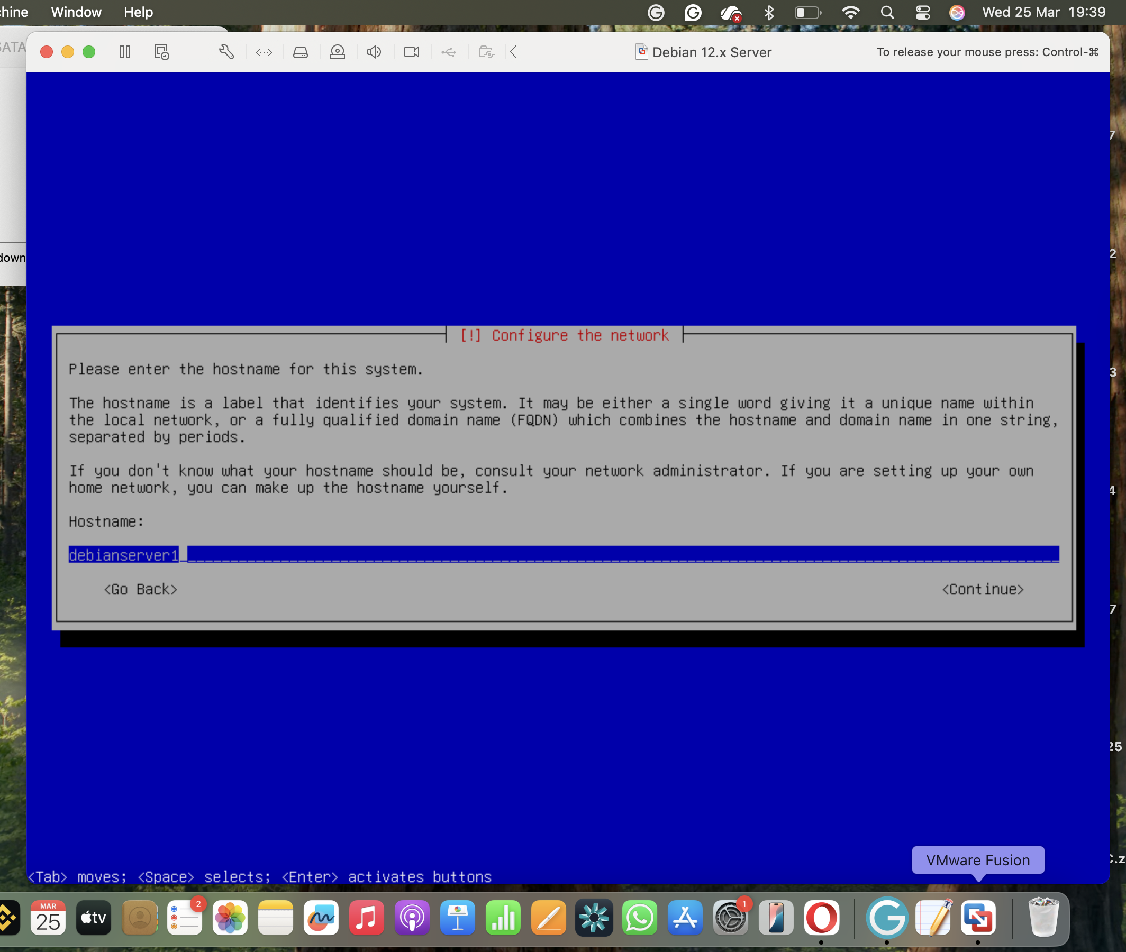

2.3 Configure IP Addressing

IP addressing was configured in the /etc/network/interfaces file on the Debian server. A static IP address was assigned to ensure predictable and consistent communication within the network.
Configuration applied:
auto lo
iface lo inet loopback

auto ens160
iface ens160 inet static
address 192.168.100.10
netmask 255.255.255.0
gateway 192.168.100.1
dns-nameservers 8.8.8.8 8.8.4.4
Static addressing is essential for servers in enterprise networks to ensure they are always reachable (Cloudflare, 2024). Screenshots were captured showing the file before saving.

After saving the configuration, the interface was restarted using:
ifdown ens160 2>/dev/null
ifup ens160
The interface was verified with the ip a command to confirm that ens160 had the correct IP address.
Screenshot 3: /etc/network/interfaces configuration showing static IP.
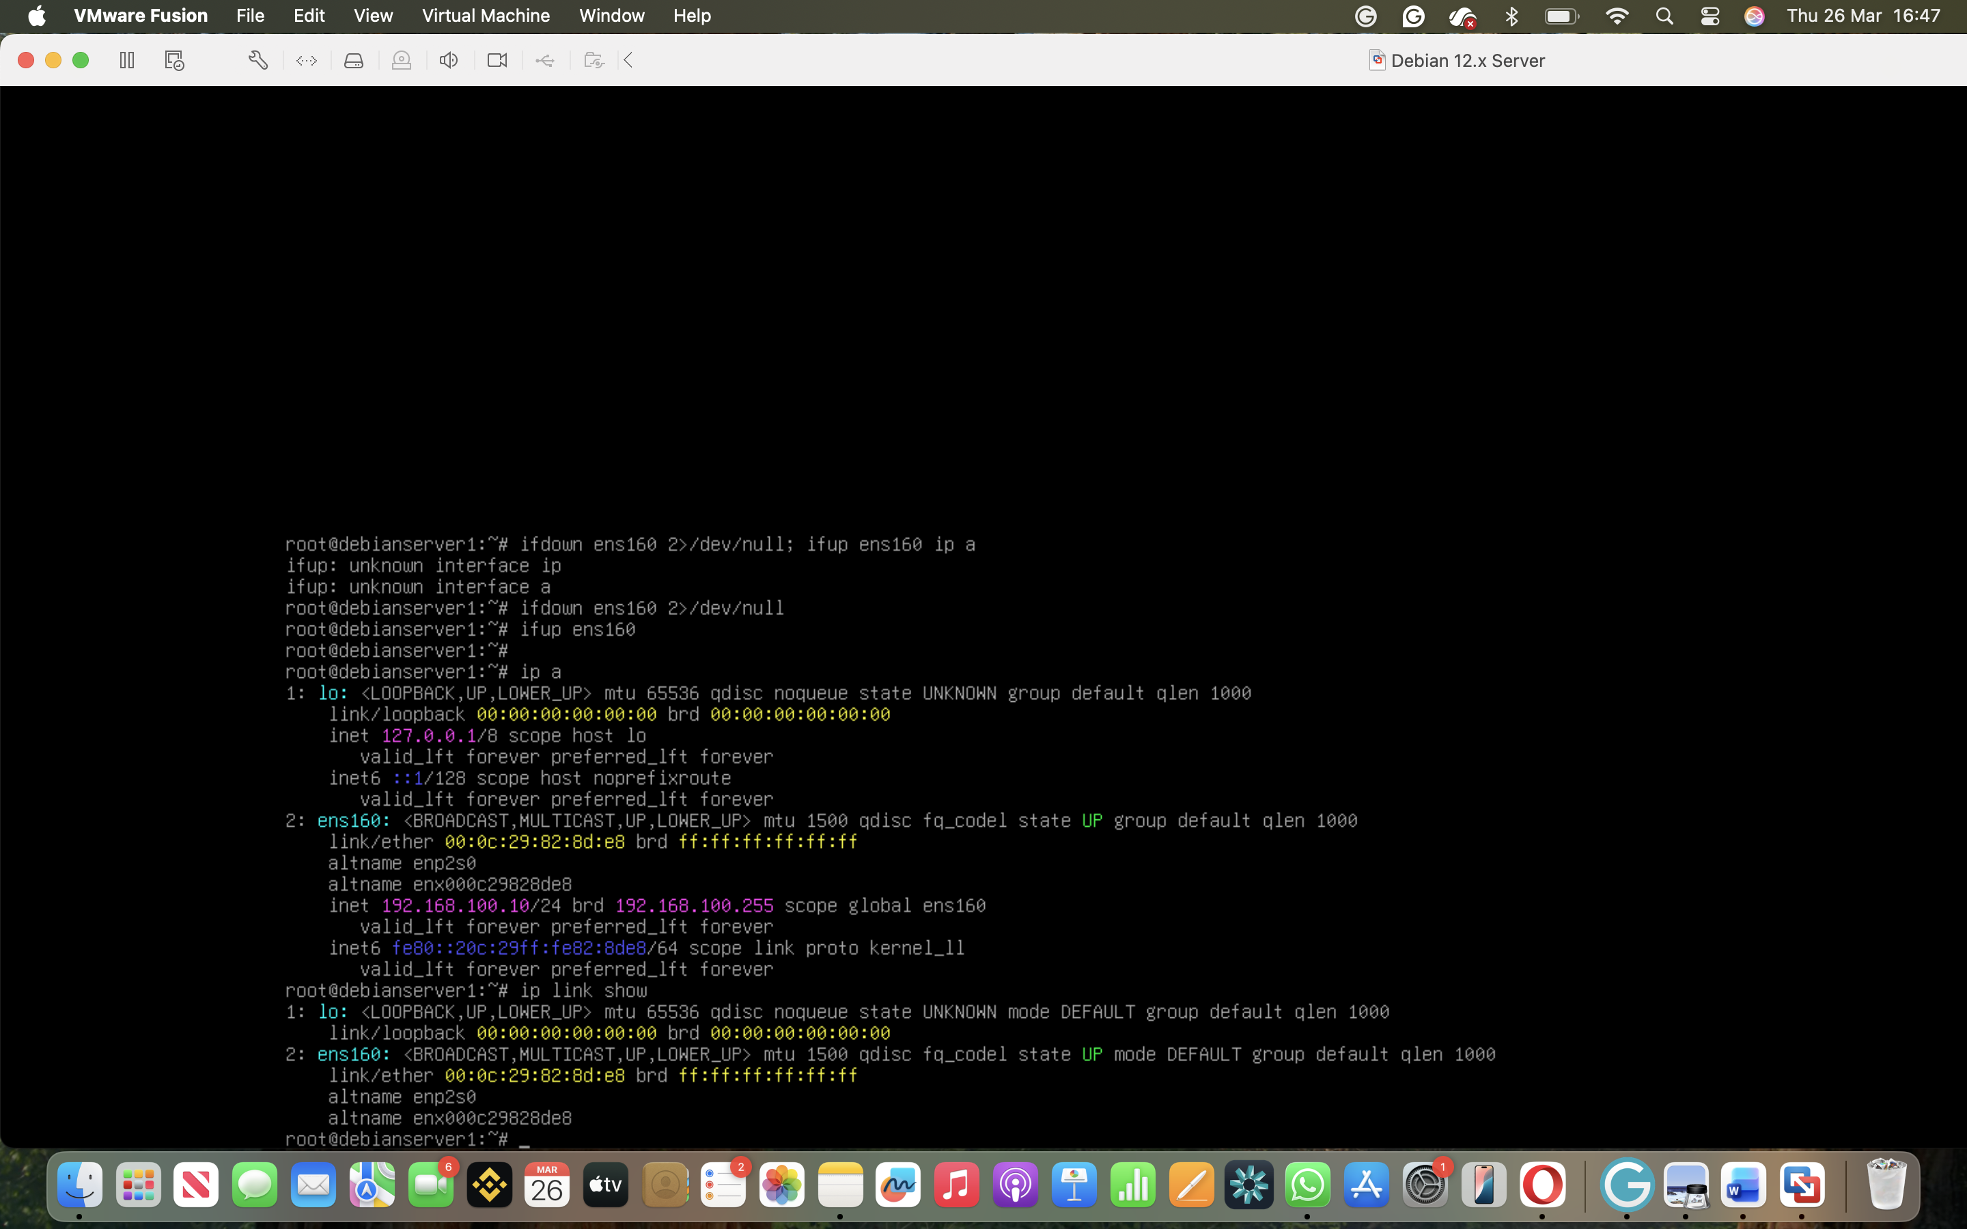

Screenshot 4: IP verification with ip a confirming ens160 has IP 192.168.100.10.
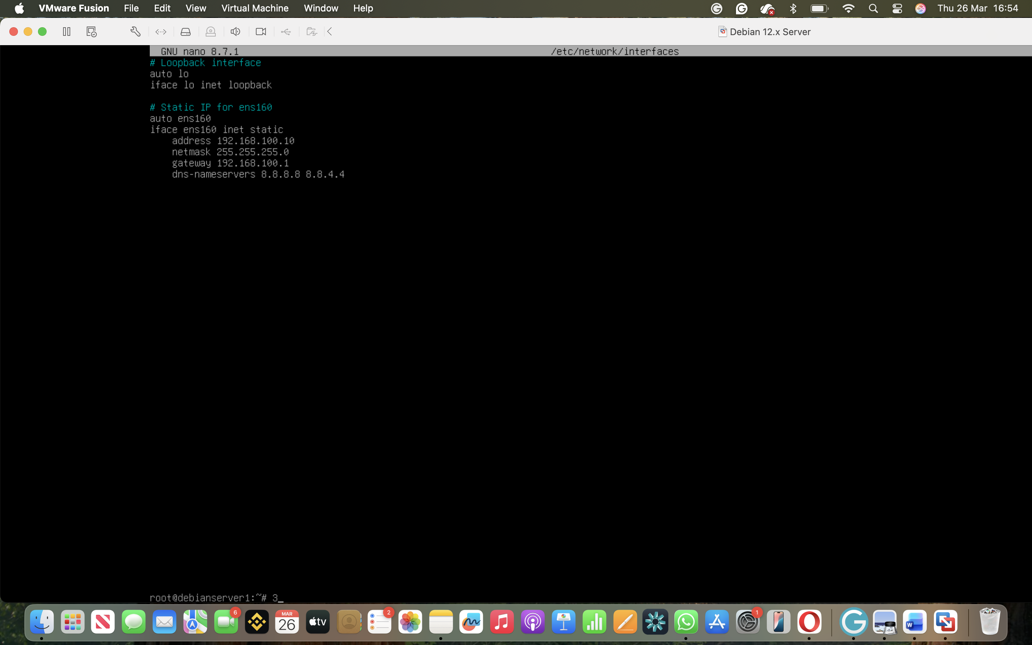
Subnetting was applied according to the topology requirements. The network 192.168.100.0/24 could be divided into smaller subnets to efficiently manage devices and minimize broadcast traffic (Cisco, 2023). Variable Length Subnet Masking (VLSM) was considered for future expansion to allow subnets of different sizes.
Additionally, Dynamic Host Configuration Protocol (DHCP) could be used for clients to automatically receive IP addresses, reducing manual configuration errors. Servers, however, retain static IPs for reliability.

2.4 Test and Troubleshoot

Connectivity testing was performed using the ping command to the gateway:
ping -c 3 192.168.100.1
The result was “Destination Host Unreachable”.

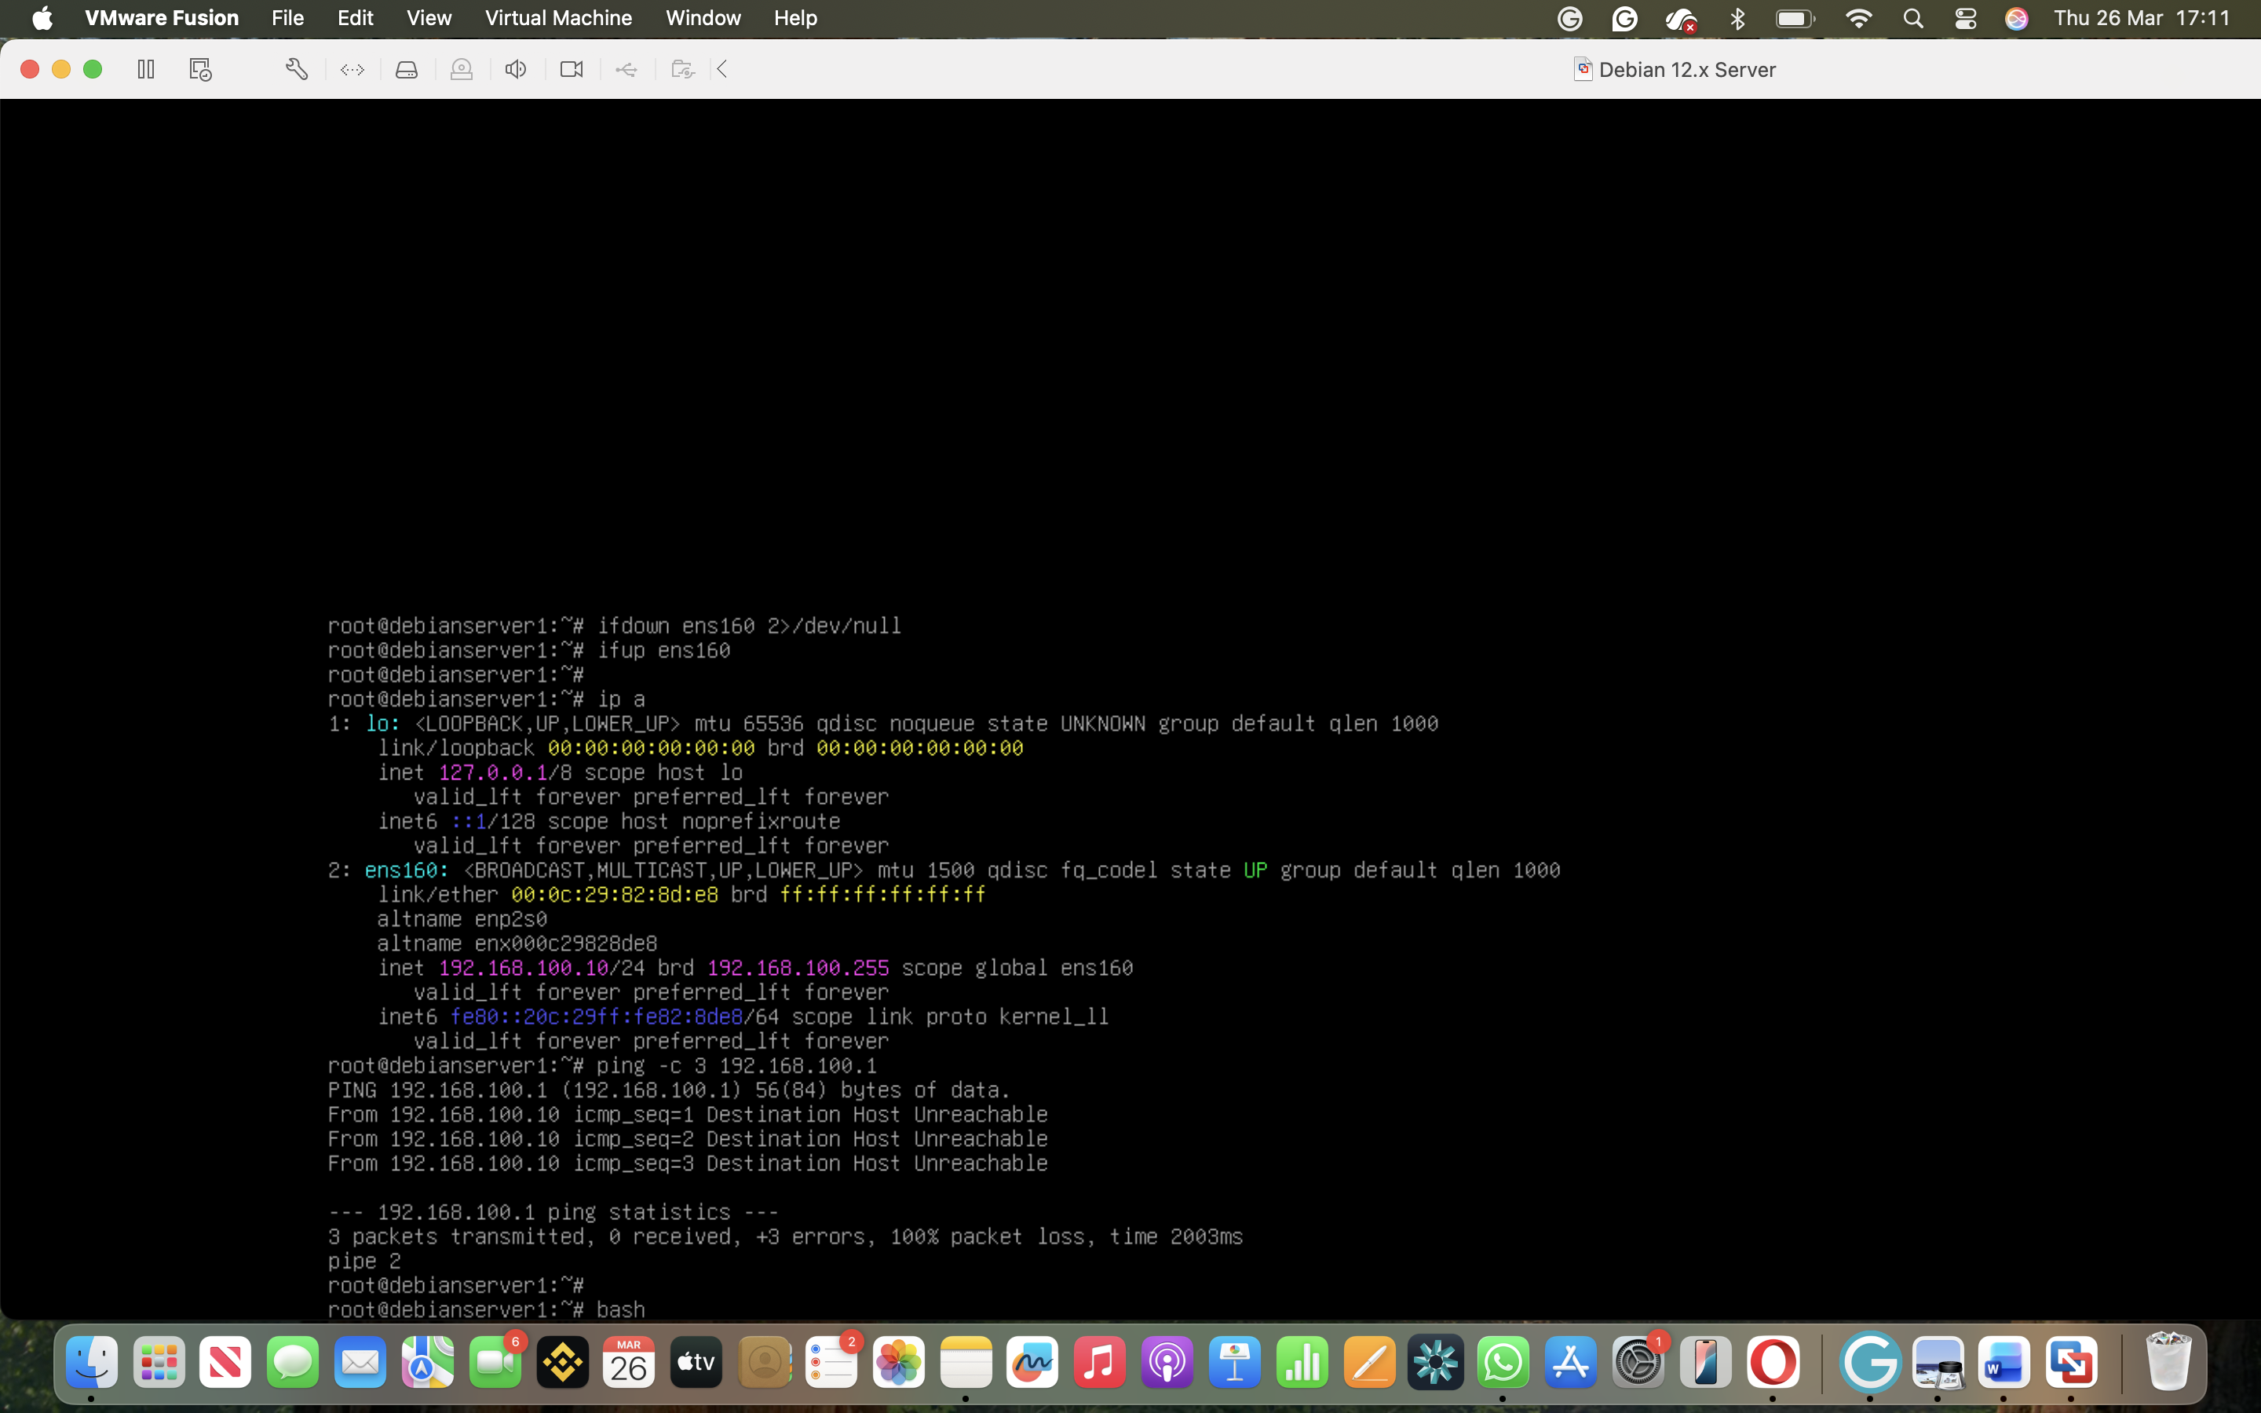

Analysis:
• The IP configuration was correct for the server.
• The network adapter was in Host-only mode, so the virtual gateway 192.168.100.1 was not reachable externally (VMware, 2026).
• This highlights the importance of understanding VM networking modes and their effects on connectivity.

Further troubleshooting could include switching to Bridged networking or adjusting adapter settings. Despite the unreachable gateway, the successful static IP configuration and interface restart demonstrate correct procedure and understanding.

Additional steps could include checking routing tables, ensuring the proper subnet mask, and verifying DNS resolution. This forms the foundation for the next coursework tasks, where more advanced services such as DNS and DHCP will be implemented.

TASK 3 – REFLECTION

3.1.1 Technical Reflection

During Task 2, the deployment and configuration of the network environment presented several challenges. One of the main issues encountered was related to network interface configuration. Initially, the interface name used in the configuration file (ens33) did not match the actual interface available in the system (ens160). This resulted in errors when attempting to bring the interface up using ifup, as the system could not recognise the specified interface.

To diagnose the issue, the ip link show command was used to identify the correct interface name. After updating the configuration file with the correct interface (ens160), the interface was successfully brought up.

Another issue encountered was during connectivity testing. Although the static IP address was correctly assigned (192.168.100.10), the ping test to the gateway (192.168.100.1) resulted in “Destination Host Unreachable”. This indicated that the problem was not with the IP configuration itself, but with the virtual network environment.

The issue was analysed systematically by reviewing the network settings and understanding that the virtual adapter mode (such as NAT or Host-only) may not provide access to the specified gateway. This demonstrated the importance of aligning IP addressing with the underlying network configuration.

Overall, the issues were resolved through systematic troubleshooting using Linux networking commands and logical analysis.

3.1.2 Personal Reflection

This task helped me develop both technical and problem-solving skills. I improved my understanding of Linux networking, especially how to configure static IP addresses and manage network interfaces.

At the beginning, I found the process confusing, particularly when dealing with command-line tools and errors. However, by following a structured approach and testing each step, I was able to overcome these challenges.

I also learned the importance of attention to detail, as small mistakes such as incorrect interface names or formatting errors can lead to significant issues. Additionally, I developed better troubleshooting skills by analysing errors and identifying their root causes.

Overall, this task increased my confidence in working with network configurations and virtual environments, and it provided a strong foundation for future tasks in network management.

Conclusion

In conclusion, this coursework provided a comprehensive understanding of virtualised network environments, covering both theoretical and practical aspects. The key networking concepts, such as hypervisors, IP addressing, and routing, were analysed. This helped to build a solid foundation and understanding of how modern networks operate and how different components interact with each other.

The practical implementation of a virtual network was carried out using VMware Fusion and a Debian server. The process included configuring a static IP address, managing network interfaces, and verifying the configuration using Linux commands. Although some challenges were encountered, such as incorrect interface naming and connectivity issues, these were resolved through systematic troubleshooting and analysis.

It was provided an opportunity to reflect on both the technical and personal aspects of the work. It highlighted the importance of problem-solving, attention to detail, and persistence when working with network configurations.

Overall, this coursework improved my understanding of network deployment, configuration, and troubleshooting. It also increased my confidence in working with virtual machines and network systems, providing a strong foundation for future tasks and more advanced network management scenarios.

References

Cisco. (2023). Networking Basics. Available at: https://www.cisco.com

Debian Documentation. (2026). Debian Network Configuration Guide. Available at: https://www.debian.org/doc/

Kurose, J. F., & Ross, K. W. (2021). Computer Networking: A Top-Down Approach. Pearson.
VMware. (2026). VMware Fusion Documentation. Available at: https://www.vmware.com
Microsoft. (2024). Hyper-V Documentation. Available at: https://learn.microsoft.com

Cloudflare. (2024). What is an IP Address?. Available at: https://www.cloudflare.com/learning/

IBM. (2024). Routing Protocols Explained. Available at: https://www.ibm.com/topics/routing

