
Master of Business Administration (MBA)
Module: International Business Concepts (LCMB7034)
ASSESSED REPORT
Evaluating International Market Entry:
A Critical Analysis of Cadbury and the Prospect of Entry into USA
Student name | Makwana rajesh rameshbhai
Student ID number | 2518402
Programme | Master of Business Administration
Module / Code | International Business Concepts (LCMB7034)
Lecturer | Akshay Narayanan Mansoob Murshed
Assignment title | Report
Word count | 5000
Submission date | 14 August 2026

Table of Contents
1 Section 1: Market Entry Analysis 3
1.1 Introduction 3
2 Organisational Classification and Global Strategy 3
2.1 Strategic categorisation 3
2.2 Global configuration and value creation 4
3 Macro-Environmental Appraisal and Market Attractiveness 5
3.1 Political factors 6
3.2 Economic factors 6
3.3 Legal factors 8
3.4 Cultural factors 8
3.5 Synthesis: Dunning's eclectic (OLI) paradigm 10
3.6 Overall market attractiveness 12
4 Entry-Mode Strategy and Strategic Synthesis 12
4.1 Historical pattern recognition 12
4.2 Strategic fit and justification 13
4.3 Conclusion and recommendations 15
5 Section 2: Reflective Account 16
5.1 Description 16
5.2 Feelings 16
5.3 Evaluation 17
5.4 Analysis 17
5.5 Conclusion 18
5.6 Action plan 18
6 References 19

Section 1: Market Entry Analysis

Introduction
The Cadbury brand is one of the most familiar confectionery brands in the world and was established in 1824 in Birmingham, UK, and is now part of Mondelēz International, which was created when Cadbury plc was demerged from Kraft Foods in 2012, in a de-merger that saw Kraft Foods acquire Cadbury plc for approximately £11.5 billion in 2010 (Mondelēz International, 2010; Johnson et al., 2020). This report looks at the potential for the Cadbury brand to enter the United States (US) market, a one-of-a-kind situation because Mondelēz does not operate the Cadbury brand in the US. The exclusive rights to manufacture, market and distribute Cadbury chocolate in the United States have been held by The Hershey Company since 1988, where it produces its own distinct and reformulated Cadbury chocolate (The Hershey Company, 2005; Quartz, 2015). This means that Mondelēz does not produce or sell Cadbury chocolate in the United States and imports of Cadbury chocolate from the United Kingdom were restricted after the 2015 trademark enforcement action by Hershey's (Time, 2015). The USA therefore meets the criteria of a country in which there is no substantial operational presence, but at the same time it provides an unusually high level of analysis. This report reviews the attractiveness of the markets based on the typology of Bartlett and Ghoshal (1989) and Dunning's (1988) eclectic paradigm, and suggests an evidence-based entry-mode strategy.

Organisational Classification and Global Strategy

Strategic categorisation
Bartlett and Ghoshal (1989) classify multinational companies based on the pressures for global integration and for local responsiveness to give four types of archetypes: international, global, multidomestic and transnational. Mondelēz can best be considered 'transnational' because it is efficient on a global scale, yet adapts and shares knowledge at a local level ( Johnson et al., 2020). It operates in some 150 countries worldwide, enabling centralised procurement and manufacturing, enterprise systems and coordinated research and development (Mordor Intelligence, 2026; Food Business News, 2024). Cadbury, at the same time, is responsive to the local preferences, as the differences in the recipe, sweetness, packaging, and pricing reflect it (Time, 2015).
This classification, however, should be done with caution. According to Bartlett and Ghoshal (1989) the transnational is an ideal that few companies are able to completely realize. There are also several aspects of multidomesticism in Mondelēz, in cases where the control of locals is stronger than the global standardisation. Thus, it might be said that Mondelēz is transnational in intent if not in practice, a condition that calls into question the capabilities of the framework in capturing power and constraints in markets.
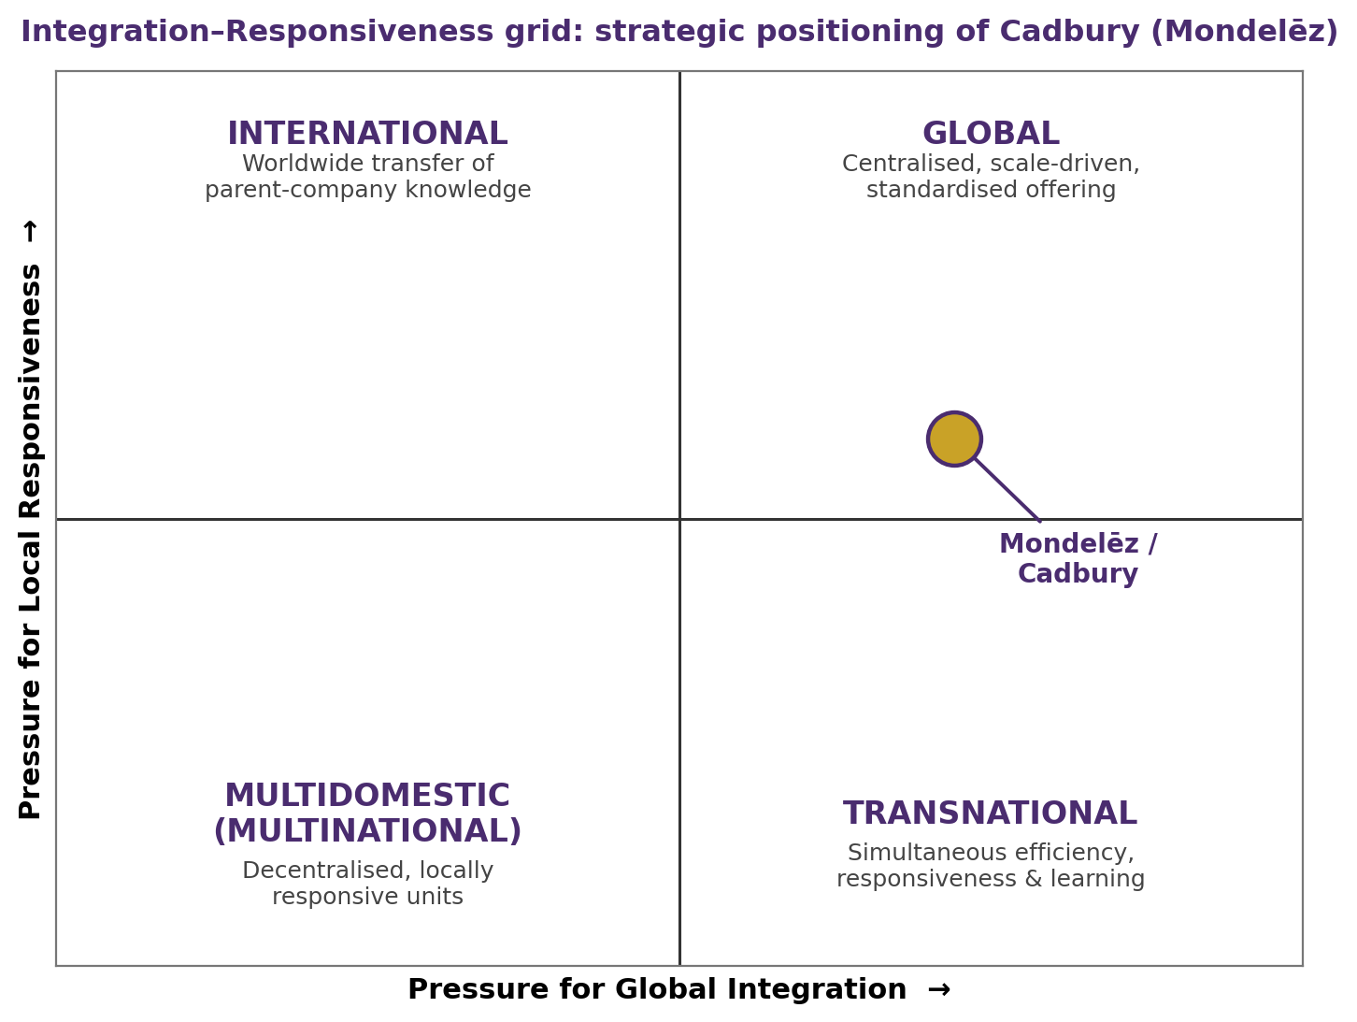
Figure 1: Integration–Responsiveness grid — strategic positioning of Cadbury (Mondelēz).
Source: Bartlett and Ghoshal (1989).

Global configuration and value creation
Geographically, Mondelēz has a scale and local sensitivity architecture in four regions: North America, Europe, Latin America, and Asia, Middle East and Africa. There are several reinforcing mechanisms for international operations to create competitive advantage. One is the unit economies of scale in procurement and manufacturing that reduce unit costs in a cocoa-intensive category and provide some level of bargaining power over commodity inputs, which is particularly important during the cost shocks discussed later. Secondly, with a diversified brand portfolio, biscuit, chocolate and gum spreads risk across geographies, categories and price levels; meaning weakness in one geography/category/price line can be balanced out by strength in another (Mordor Intelligence, 2026). Third, a high distribution reach and retailer relationship provide shelf space in both modern and traditional trade, which is a major hurdle to be overcome in imitating. Fourth, the firm's expertise in acquiring the right brands, including Hu (a clean-label brand in 2024), enables it to acquire growth in emerging sub-categories instead of the gradual route. (Food Business News, 2024)
These global efficiencies have been packaged with local brand equity, and Cadbury has been a market leader in places like the UK, India, Australia and South Africa. When using a resource-based lens, attributes of the brand, scale of the firm, and its distribution network are valuable, rare, and hard to imitate, and therefore a sustainable source of advantage (Johnson et al., 2020).This is the logic of the resource based view, where valuable, rare, imperfectly imitable and non-substitutable resources lay the foundation for sustainable competitive advantage (Barney, 1991). Importantly, the transnational "configuration" also allows for cross-market learning, as recipes, formats, and marketing innovations developed in one geography can be learned from and adapted in others, and the network is thus stronger than the sum of its parts: a capacity that is pertinent to a sound US entry. The obvious exception to this value-creating logic is the US where the dominant chocolate asset of the firm is not owned by Mondelēz but by its licensee Hershey. The firm's otherwise unified global setup has a strategic gap right in the world's largest chocolate market, the question to which this report responds to (see Table 1).
Table 1: Mondelēz International / Cadbury corporate snapshot
Indicator | Detail
Parent company | Mondelēz International, Inc. (NASDAQ: MDLZ)
Cadbury founded | Birmingham, UK, 1824
Route to ownership | Kraft acquired Cadbury (2010, ≈£11.5bn); Mondelēz demerged from Kraft (2012)
2024 net revenue | ≈ US$36 billion
Global reach | Sales in ≈150 countries; ≈12 billion-dollar brands (e.g. Oreo, Cadbury, Milka)
US Cadbury status | Manufactured and sold under long-term licence by The Hershey Company since 1988; Mondelēz has no direct operational presence for the brand
Source: compiled from Mondelēz International (2010); The Hershey Company (2005); Food Business News (2024); Mordor Intelligence (2026).

Macro-Environmental Appraisal and Market Attractiveness
The political, economic, legal and cultural (PECL) criteria are used to focus on the elements most relevant to a confectionery entrant and are selected on purpose rather than illustrated in the same detail as other environmental attributes. This focus is an analytical judgement: the legal and political setting proves to be the key element for this firm and this industry, while other factors which are traditionally given more weight are less important. Then the findings are synthesized using Dunning's (1988) eclectic paradigm to equate the environmental analysis with an entry decision and put into Table 2.

Political factors
The staunchly rules-based market and stability of the U.S. political landscape has turned decidedly protectionist, and this has a direct impact on the confectionery newcomer. The administration began in April 2025 imposing a 10% baseline reciprocal tariff on almost all imports, with an additional 10% on goods from the E.U. and a 21% tariff on Swiss confectionery imports, while the U.S. continued to have preferential access as part of the USMCA framework (ConfectioneryNews, 2025). As a result the UK will be liable to a 10% baseline duty on all imports, which would apply to British-made Cadbury – another key drawback of the historic grey-import route, both commercially and legally.
Protectionism extends upstream along the supply chain, too. Tariffs are imposed on cocoa paste imported from West African suppliers (approximately 10%) and on refined sugar, which increase the cost of input materials even for locally produced confectionery, and compromise the cost advantage that producing in-country might provide (New Hope Network, 2025). The tandem effect has been described as a tax on a product which can't be cultivated on a large scale in the USA. Outside of tariffs, the political system is institutionally sound, featuring independent regulators and robust enforcement of property rights, precisely the conditions that support investors also support Hershey's contractual and trademark rights. Politically, in other words, the environment simultaneously works against import based strategies, squeezes margins all along the value chain, and reinforces the legal constraint discussed in Section 3.3.

Economic factors
In terms of the economy, the US chocolate market is huge, growing, and fits perfectly with Cadbury's mission statement. It is estimated to be worth around US$27.4 billion in 2025, and is projected to grow to US$37.4 billion by 2031, with milk and white chocolate making up approximately 61% of demand (Mordor Intelligence, 2026). Alternatively, direct-to-consumer (DTC) opportunities existed as e-commerce accounted for 16.4% of the US food and beverage sales in 2024. But, high cocoa prices, hitting their peak at around US$13,000/tonne in 2024, exert a lot of margin pressure (New Hope Network, 2025). Differentiated positioning is also beneficial by premiumisation and demand for healthier and lower sugar snack products (Konar et al., 2022). Cadbury's heritage is boosted by its seasonal gifting around the holidays including Valentine's Day, Easter and Christmas, but the competition is fierce. In total, the market is favourable, but the volatility of the cost is conducive to a premium and differentiated approach to entering the market, and not price competition.
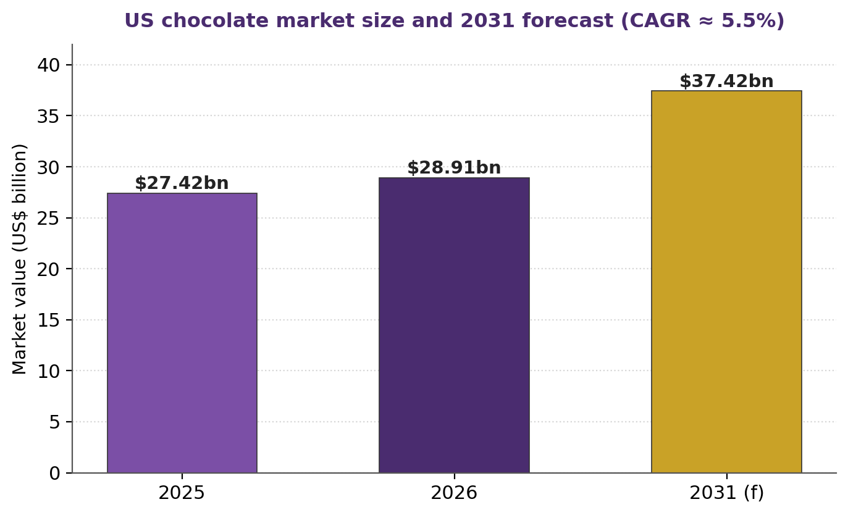
Figure 2: US chocolate market size and 2031 forecast.
Source: Mordor Intelligence (2026).
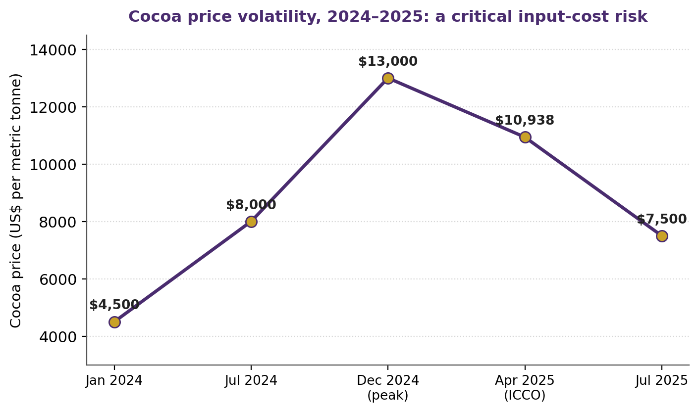
Figure 4: Cocoa price volatility, 2024–2025 — a critical input-cost risk.
Source: New Hope Network (2025).
These economic factors are exacerbated by competition. The chocolate market in the United States is very concentrated, with Hershey being around 35.5% of sales, followed closely by Mars, which makes up a significant share of sales combined with Hershey (Statista, 2025; Figure 3). They both have strong relationships with retailers, scale their advertising budgets and have control of prime shelf space – all of which are formidable obstacles on the way of a new company trying to compete on the incumbents' terms. At the value and artisanal ends, respectively, come private-label and craft players. So, for Mondelēz, the perspective is that attacking the mainstream milk-chocolate shelf would be expensive and take time, while the premiumisation and better-for-you categories would be more competitive, and channels such as digital and specialty would erode shelf edge advantages. So the competitive environment strengthens the economic argument for a differentiated, rather than a volume-based entry.

Legal factors
The law is the most important hurdle to Cadbury's U.S. expansion. Hershey has a long-term, exclusive licence of the Cadbury trademark in the US since 1988, which prevents Mondelēz from producing or selling Cadbury chocolate without permission from Hershey (The Hershey Company, 2005; Quartz, 2015). Hershey has been proactive in fighting for and defending these rights, such as by suing for the importation of British Cadbury products and other confectionery (Time, 2015). This means Cadbury's most attractive market is legally capped on their key asset.
The barrier could be broken with an acquisition of Hershey, but the deal would likely be subject to heavy scrutiny by the antitrust regulators due to the companies' similar roles in a concentrated confectionery industry. This is complex from a legal perspective and is also commercially uncertain.
There are further challenges in product regulation. Milk chocolate is defined differently by US FDA standards than by UK and EU standards, so Cadbury will have to reformulate or label with great care in order to meet the standards of the US (Food and Drug Administration, n.d.). Packaging will also need to be adapted for allergen declarations and mandatory nutrition and added-sugar labelling. So, the question is not only which of the markets are attractive, but whether Cadbury will be able to get legal access to the brands. The traditional direct entry is very difficult due to trademark rights and regulatory issues and potential antitrust issues.

Cultural factors
One class of entry barrier is removed at the level of national culture while another is preserved, as the US and UK are extremely similar. The two nations have almost the same scores on power distance (US 40; UK 35) and individualism (US 91; UK 89) and are similar on motivation towards achievement and indulgence, the only difference being long-term orientation (Hofstede et al., 2010; Table 3). This low psychic distance allows for transfer of managerial, organisational and marketing practices, mitigates the liability of foreignness a firm from a distant culture would have if it applied to a foreign market, and means that go-to-market playbooks, retail relationships and advertising conventions are broadly portable. The concept of shared language, individualistic self-treat consumption and similar indulgence norms all support branded confectionery.
Yet, while there may be a cultural similarity on aggregate, there is a key difference in consumer taste at the level of the product. Over a 100 years, American consumers have grown accustomed to Hershey's more tangy, less creamy milk chocolate, while Britain's “Cadbury” consumers have been inured to the sweeter, creamier version, and by common testimony, that's a very different cookie (Time, 2015). This is important because the Cadbury name becomes a contested name — and a really British Cadbury will have to fight for the brand association that most US consumers have with the Cadbury name, rather than taking it by default. An important qualification reinforces the conclusions on this point. Hofstede's model has been influentially challenged because it has been viewed as static, equating nations with internally homogeneous cultures, and deriving values from limited survey data (McSweeney, 2002), and, more recently, individualism scores of Anglophone economies have been questioned.Also, the evidence gathered through the meta-analytical approach shows that the effect of cultural distance on entry-mode choice is not a constant, but rather depends on the specific context, thus warning against making simple inferences from the national scores (Tihiani, Griffith and Russell, 2005). The practical implication is positive — there is sizeable heterogeneity, for example the Anglophile and expatriate, gifting and premium market segments, and the younger health-oriented segment — that could be exploited by an entrant that is differentiated, even where the mass-market palate has been formed by the incumbent.
Another cultural trend is the rising trend towards health, wellness and ethical consumption, particularly among consumers aged under 40. Demand is shifting to 'Better for You' products, dark chocolate placed on health grounds, clean labels and transparently sourced cocoa (Mordor Intelligence 2026). It is particularly relevant to the latter recommendation, one that covers the fact that growth is found in premium and wellness segments that do not include mainstream milk chocolate, and to the fact that Mondelēz has existing assets to deliver on—such as Green & Black's organic, and Hu, its clean label. Culturally, the winning entrant will be the one who brings in a proposition that resonates with the new ideas and values of health and provenance, rather than just copy/pasting a traditional confectionery offer.
Table 3: Hofstede national-culture comparison — USA vs UK
Dimension | USA | UK | Implication for entry
Power distance | 40 | 35 | Flat, comparable hierarchies — easy managerial transfer
Individualism | 91 | 89 | Individual, self-treat consumption — supports branded indulgence
Motivation/achievement | 62 | 66 | Competitive, success-oriented — aggressive incumbents
Uncertainty avoidance | 46 | 35 | Openness to new products — receptive to novelty/premium
Long-term orientation | 26 | 51 | US short-term, promotion-driven purchasing
Indulgence | 68 | 69 | Both indulgent — favourable for confectionery
Source: Hofstede et al. (2010)

Synthesis: Dunning's eclectic (OLI) paradigm
On the one hand Dunning's (1988, 2000) eclectic paradigm suggests that a company will make foreign direct investment only if it has all three advantages: ownership, location and internalisation advantages. If one of these is not present, then another type of servicing mode is expected: exporting or licensing.Although there is some doubt about the predictive power of this logic, as it has been suggested that the OLI framework is more descriptive than normative as a rule for the best-performing mode (Brouthers, Brouthers and Werner, 1999), its central tenet, which holds that a firm with no internalisation capability will tend to opt for a contractual servicing arrangement like licensing, is supported by the evidence (Contractor, 1984). The framework is here applied to Cadbury's U.S. launch (Table 4) in an unusual way because it illuminates a structure miss fit instead of a comfortable fit.
The ownership (O) benefits are staggering, to be sure: Cadbury's heritage brand value goes back to 1824, the scale of Mondelēz, its cocoa procurement strength, its R&D expertise, its distribution strength in some twelve billion-dollar brands. But the paradigm assumes that those benefits can be exported to the host market, and in this case, the key factor — the Cadbury trademark — is effectively unavailable, and the meaning of the brand has been changed by the established licensee. The ownership advantage of the firm is real but, in this market, non-transferable. These location advantages (L) are real: A large, growing, milk chocolate-based market with sophisticated retail and a rapidly expanding e-commerce channel. These will be offset, however, by import tariffs, record cocoa and sugar costs, and Hershey's approximately 35.5% incumbency (Figure 3), which combined make entry more expensive and less rewarding. The main point is the internalisation (I) logic. A strong O and L would normally internalise to preserve their know-how and brand, but Cadbury-branded internalisation is off the table under the licence, and the obvious internalising move – buy out Hershey, to unite the brand and become a market leader – was pushed back in 2016 (a US$23 billion bid) and again in December 2024, when the Milton Hershey School owners – the Hershey Trust as the sole beneficiary – rejected Mondelēz's new offer as too cheap (CNBC, 2024; Food Business News, 2024). A hostile route is virtually impossible with the dual class governance.
Based on the above, the OLI synthesis provides a clear conclusion: that conventional Cadbury-branded foreign direct investment is not supported, because there is no possibility of incorporating the ownership advantage in the host market and the possibility of an internalising acquisition is governance blocked. It is necessary for a viable path to either replace the asset in which the firm is not able to straddle or to modify the path of entry — in this case, the question addressed in Section 4.
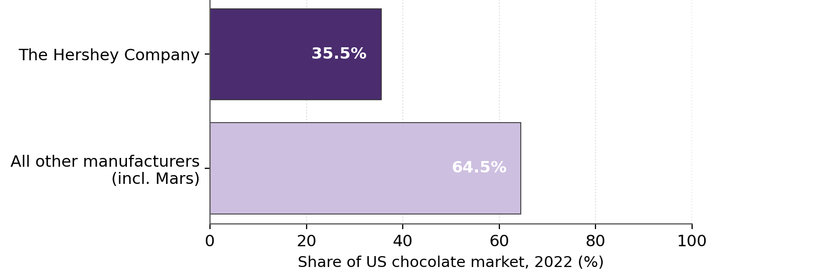
Figure 3: Hershey's dominance of the US chocolate market (2022).
Source: Statista (2025).
Table 4: Dunning's eclectic (OLI) paradigm applied to Cadbury's US entry
OLI component | Assessment for Cadbury–US | Verdict
Ownership (O) | Strong brand heritage, Mondelēz scale, procurement, R&D and distribution — but the Cadbury trademark is licensed to Hershey and cannot be used | Strong yet legally stranded
Location (L) | Large, growing, milk-chocolate-led market; advanced retail/e-commerce — offset by tariffs, cocoa costs and Hershey's ≈35.5% incumbency | Attractive but contested
Internalisation (I) | Branded FDI barred; acquisition of Hershey rejected (2016; 2024) due to Trust's ≈80% voting control | Blocked for flagship brand
Source: Dunning (1988, 2000); data from CNBC (2024), Food Business News (2024), Statista (2025).

Table 2: Focused macro-environmental (PECL) appraisal of the US market
Factor | Key evidence | Strategic implication
Political | 10% baseline import tariff (incl. UK) from 2025; tariffs on West African cocoa; rising protectionism | Import-led entry penalised; margins squeezed
Economic | ≈US$27.4bn market (2025), 5.5% CAGR; milk/white ≈61%; cocoa peaked ≈US$13,000/t; premiumisation growth | Attractive but cost-pressured; reward differentiation
Legal | Hershey holds perpetual Cadbury trademark licence (since 1988); FDA 21 CFR §163 standards; FALCPA labelling | Branded entry effectively blocked; product adaptation required
Cultural | Low psychic distance (Hofstede); but US palate conditioned to Hershey recipe; premium/Anglophile niches exist | Operational fit high; demand-side taste barrier for mass, niche opportunity

Overall market attractiveness
Overall, the US is a paradox when considering this individual firm and brand; high intrinsic attractiveness coupled with low practical accessibility. Taken at face value, the market is very promising: it's the world's largest market, it's expanding at about 5.5% a year, it's predominantly milk chocolate – Cadbury's specialty – and it's culturally close to Cadbury's UK home base.However, the conventional approach to market-sizing is what the distance literature cautions against, because companies often underestimate the actual costs of market entry, such as cultural, administrative, geographic and economic distances (Ghemawat, 2001). But, according to the factor-by-factor analysis, the most critical factors are not the demand-side attractiveness of the market, but the supply- and access-side constraints: the trademark lock, incumbent dominance and protectionist tariffs/ cocoa-cost inflation, which are not captured by conventional market-sizing approaches. The proper answer is thus not just an “enter” or a “do not enter” but that it is attractive only as long as the firm can find a legally permissible but different way to enter which neutralises the legal restriction. This reframing will then directly translate into the entry-mode analysis that follows.

Entry-Mode Strategy and Strategic Synthesis

Historical pattern recognition
The presence of Mondelēz and its Cadbury heritage indicates a preference for equity-based entry modes, and a high commitment approach. The key driver of the group's international expansion has been FDI through the acquisition route, with the £11.5 billion Kraft-Cadbury deal leading the way, and a series of bolt on acquisitions, including Chipita, Clif Bar, Ricolino and the clean label chocolate brand Hu, following suit, alongside selective joint ventures in emerging markets (Food Business News, 2024; Mordor Intelligence, 2026). This is a revealed preference, in line with the prediction of entry-mode theory that firms with significant hard-to-codify brand and marketing assets go for high-control modes in order to be able to defend those hard-to-codify assets from dissipation (Anderson and Gatignon, 1986; Hill, Hwang and Kim, 1990).Consistent with a previous review of the literature, the control–commitment trade-off, influenced by transaction-cost considerations, resource-based arguments and institutional factors, continues to be a central factor in the understanding of these choices (Brouthers and Hennart, 2007); and the national differences in trust are also found to affect firms' decisions to enter by licensing or direct investment (Shane, 1994). It is notable that Cadbury is the only major market where the sale of a business has been effected by a low commitment licensing and divestment route, with Cadbury exiting the US market in 1988 when it saw the competitive position as being untenable (Quartz, 2015). The firm's revealed preference is therefore control and internalisation in all but the United States, where it has a legacy license that it lacks control over and does not have a direct presence and the strategic gap that this section is intended to address.

Strategic fit and justification
Based on the entry-mode theory, the option is viewed as a balance between control, resource commitment and risk: high-control equity modes that provide control and protection of proprietary assets and rich returns require more resources and involve more risk to the firm, while contractual modes like licensing allow for reduced resources and flexibility while sacrificing control (Anderson and Gatignon, 1986; Hill, Hwang and Kim, 1990; Root, 1994). This menu has been expanded in recent times to non-traditional, digital and platform-based modes and warns against using classical make-or-buy dichotomy as an exhaustive list of options (Brouthers et al., 2021; Hennart, 2022; Agnihotri, Bhattacharya and Yannopoulou, 2023). The realistic options are summarized and assessed here with respect to those criteria (Table 5).
No change is low commitment, low risk and cash generative, but it means the loss of brand value, the loss of growth in the world's biggest chocolate market to a new competitor and no control over the use of the Cadbury brand. It is not viable to import UK Cadbury because of the 10% import tariff, as well as being blocked by the trademark. The combined sales, approaching $50 billion, would give the company the US market leadership and also combine two brands, but the approximate 80% voting control of the Hershey Trust's acquisition, achieved through a dual-class structure, has twice thwarted Mondelēz's advances and makes a hostile transaction virtually impossible, and the acquisition premium and integration costs introduce significant financial and political risk (CNBC, 2024; Food Business News, 2024). The return of a US license is also unlikely as Hershey has all the reason to keep a valuable and profitable asset that is also a good defensive position.
The most defensible option is the most direct of the OLI and transaction-cost logic. If internalisation of the flagship brand is not legal, and governance of the internalising acquisition is blocked, the firm must internalise a substitutable ownership asset over which it has full control. The alternative wholly owned brand, such as the organic, premium Green & Black's brand or the clean-label Hu acquired in 2024, will be introduced to the US through a blend of a bolt-on acquisition and direct-to-consumer and e-commerce distribution. This path avoids the trademark lock altogether, leverages the real and transferable assets Hershey has in the areas of procurement, product development and brand building, and focuses on premium and the “better-for-you” categories where cocoa-cost inflation can be more easily passed along, where digital channels can boost distribution, and where Hershey's mass-market product suite is less prevalent. It retains flexibility while giving Cadbury the control necessary to safeguard the company's proprietary capabilities, and it also allows for a staged scale-up that will give the company the opportunity to reconsider its Cadbury-branded entry if the legal situation ever changes.
Table 5: Evaluation of candidate entry modes
Option | Control | Risk | Resource commitment | Overall assessment
Maintain Hershey licence | Low | Low | Low | Passive; forfeits value and growth
Export UK Cadbury | Medium | High | Low | Blocked by trademark; tariff penalty — not viable
Acquire Hershey | Very high | Very high | Very high | Blocked by Trust's 80% voting control
Alternative owned brand (FDI/bolt-on) | High | Medium | Medium | Recommended: sidesteps lock, targets premium niche
Source: Anderson and Gatignon (1986); Hill, Hwang and Kim (1990); Root (1994).

Conclusion and recommendations
This is a rare situation, where a world class brand is being excluded from the world's largest chocolate market by its own historic licensing decision - which means that the recommendation must overcome a legal constraint, not just optimize a market-attractiveness score. The analysis suggests adopting a flanking strategy with a phased approach instead of a frontal attack, in 3 moves. In the short term, Mondelēz should preserve and optimise the Hershey licence, in a stealth approach that does not involve value-destructive litigation that the precedent set in 2015 suggests it would lose. Secondly, in the medium term, it needs to move into the U.S. market on a direct-to-consumer, market-direct and e-commerce basis, and also through a 100 per cent premium brand acquisition, through targeted acquisitions in the fast-growing premium and better-for-you segments where the incumbents are least effective, markets where digital channels cut out the shelf space, and where the cocoa-cost inflation can be passed on to less price-sensitive consumers. Third, it should continue to have the acquisition optionality should the Trust's posture ever cool, but it should make it clear that if the Trust's posture ever cools, it will reject a hostile offer in the governance reality.
Key risks and mitigations should be dealt with in a specific manner. Political and tariff risk is reduced by the domestic production of goods and away from the import of competition, input-cost risk is reduced by the economies of scale in procurement and by the power to command premiums, and operational risk is reduced by a focus on the e-commerce and premium retail side rather than the mass grocery side of the business. Success should be measured by clear metrics such as premium-segment share, distribution points won, direct-channel contribution margin and repeat-purchase rates. Overall, the suggested sequence is about both control and flexibility, with political and financial risk, and it leverages the genuine and portable Cadbury-brand assets—namely, its ownership advantages—and matches Mondelēz's declared acquisition approach, while providing a realistic and evidence-based route to the market that Cadbury cannot, at present, legally access.

Section 2: Reflective Account
The Gibbs' reflective cycle (description, feelings, evaluation, analysis, conclusion, action plan) is used to analyse and reflect on my research, analysis and preparation of Section 1 (Figure 5).

Figure 5: Gibbs' reflective cycle.
Source: Gibbs (1988).

Description
The assignment involved choosing a multinational corporation and a target country where the MNC did not have any major operations, analysing the entry decision in the light of the existing frameworks of international-business theory and then drafting a reasoned recommendation and this reflection. I selected Cadbury, which belongs to Mondelēz International and is about to enter the United States. I went through several steps in my process, including identifying the corporate ownership structure and finding out that it was more complicated than anticipated, collecting data regarding the political, economic, legal and cultural context in which the company operates, from various corporate documents, government regulations, industry sources and recent news, and using the Bartlett and Ghoshal typology and Dunning's eclectic paradigm before developing my recommendation on entry modes. In all, I tried to write a critical, not descriptive, approach with references to a credible, up-to-date source for each claim.

Feelings
In the beginning, I was sure that Cadbury was just a British brand, and that I would be able to import or manufacture it anywhere in the world, if I wished. When I learned it's not Mondelēz that owns the Cadbury brand, but rather The Hershey Company, that confidence was replaced by a feeling of genuine surprise and initially, some confusion, as it was under a licence since 1988. That was intellectually exciting because it was the beginning of an expected “routine” market entry exercise that turned into a more complex institutional puzzle, so the more I was able to dig in the more engaged I was. Meanwhile, I was feeling a bit stressed and worried about whether I could provide an accurate history of the cases, about the varying case size numbers I was seeing, and whether I could still have an interesting case within the word count. I found it helpful to acknowledge these emotions so that I could redirect the initial shock and surprise as a more focused research direction, instead of frustration.

Evaluation
Overall it was a successful process, albeit challenging. What proved effective was the use of multiple complementary frameworks that helped to structure the analysis and avoid a loose narrative, and the reliance on the most recent evidence, from the size of the market to the 2025 tariff changes, to the cocoa-price shock and the December 2024 takeover approach, making the argument credible and relevant. Not only did triangulating company filings and regulatory sources with news reporting add to my confidence in the facts, but it also allowed me to ask more questions.The triangulation of company filings and regulatory sources with news reporting not only gave me confidence in the facts but also let me ask more questions. Sometime, the volume of conflicting data released by various market research firms did make it hard to make explicit decisions on which numbers to believe (and which ones to ignore), and how many words to put into the case when so much of it has analytical twists. I also was paying close enough attention to notice that there was a tendency to talk about developments, and not critically assess them, which I had to be very mindful about correcting as I redrafted.

Analysis
But, looking back, the lesson that needs to be learned is that theory needs to be put into practice in the context of institutions and not abstractly. Dunning's unorthodox model did most to illuminate the point where it failed: the ownership advantage was clearly present, but legally inaccessible, and acknowledging this put the whole question of whether the market was attractive in a different perspective, namely whether it was legally accessible. The module's education of entry modes and the control-risk-commitment trade-off (Anderson and Gatignon, 1986; Hill, Hwang and Kim, 1990; Root, 1994) gave me an understanding of the reasons behind why the firm's traditional acquisition strategy was undermined by the Hershey's dual-class governance system. The fact that I learned that I had to critically engage with the limitations of Hofstede's model (McSweeney, 2002) has led me not to take a model's outputs for granted, but to ask what it hides and in the case of Hofstede's model, it hides exploitable taste and segment heterogeneity beneath the national averages. The struggle with conflicting sources improved my critical thinking about the credibility of the evidence, not only making me more aware of the importance to look for primary sources – like regulatory documents and company filings – but also giving me greater preference to look at them over secondary sources – like commentary.

Conclusion
In between, I think my best effort was synthesis (linking political, economic, legal, and cultural evidence together in an integrated way more than considering each one of them separately); and my main weaknesses were my first instinct in the beginning of the process was to go with a descriptive approach and my time-management, which, due to the word-limit, was not as perfect as it could have been. In more general terms, I learned that legal and institutional context can be a very powerful force that can overwhelm more traditional indicators of market attractiveness; triangulation of sources is a critical skill when data wares; and that critical evaluation – not description – is the hallmark of post-graduate work. If I had been aware of this, I would have been able to get to the insight much earlier, and would have used my word count more effectively analyzing rather than on background.

Action plan
I will start with looking at the institutional and legal constraints on a decision before evaluating market attractiveness, in future assessments so that its matrix is built right from the start and I do not have to redo it. I will use a reference manager that will help me to keep track of the sources and citations systematically, which would have saved me some time here in reconciling my Harvard references. I will give each section a more limited word count at the planning stage, in order to ensure that the analysis is not lost among the description, and will deliberately write from an evaluative register (asking why, how and so what questions of each point) rather than sticking to the description. The combination of these steps should produce better, clearer and faster analysis in the future, enhance my professional judgement in actual strategic analysis tasks outside of this module, and also supplement my analysis in this module with these tasks.

References
Agnihotri, A., Bhattacharya, S. and Yannopoulou, N. (2023) 'Foreign market entry modes for servitization under diverse macro-environmental conditions: taxonomy and propositions', International Marketing Review, 40(4), pp. 561–584.
Anderson, E. and Gatignon, H. (1986) 'Modes of foreign entry: a transaction cost analysis and propositions', Journal of International Business Studies, 17(3), pp. 1–26.
Barney, J. (1991) 'Firm resources and sustained competitive advantage', Journal of Management, 17(1), pp. 99–120.
Bartlett, C.A. and Ghoshal, S. (1989) Managing across borders: the transnational solution. Boston, MA: Harvard Business School Press.
Brouthers, K.D., Chen, L., Li, S. and Shaheer, N. (2021) 'Charting new courses to enter foreign markets: conceptualization, theoretical framework, and research directions on non-traditional entry modes', Journal of International Business Studies, 53(1), pp. 1–28.
Brouthers, K.D. and Hennart, J.-F. (2007) 'Boundaries of the firm: insights from international entry mode research', Journal of Management, 33(3), pp. 395–425.
Brouthers, L.E., Brouthers, K.D. and Werner, S. (1999) 'Is Dunning's eclectic framework descriptive or normative?', Journal of International Business Studies, 30(4), pp. 831–844.
CNBC (2024) Mondelez has made a takeover approach for Hershey, sources say. 9 December. Available at: https://www.cnbc.com/2024/12/09/hershey-stock-mondelez-takeover-offer.html (Accessed: 3 August 2026).
ConfectioneryNews (2025) US tariffs raise costs and stall innovation for global confectionery brands. 23 April. Available at: https://www.confectionerynews.com/Article/2025/04/23/us-tariffs-raise-costs-and-stall-innovation-for-global-confectionery-brands/ (Accessed: 3 August 2026).
Contractor, F.J. (1984) 'Choosing between direct investment and licensing: theoretical considerations and empirical tests', Journal of International Business Studies, 15(3), pp. 167–188.
Dunning, J.H. (1988) 'The eclectic paradigm of international production: a restatement and some possible extensions', Journal of International Business Studies, 19(1), pp. 1–31.
Dunning, J.H. (2000) 'The eclectic paradigm as an envelope for economic and business theories of MNE activity', International Business Review, 9(2), pp. 163–190.
Food and Drug Administration (no date) 21 CFR Part 163 — Cacao products. Available at: https://www.ecfr.gov/current/title-21/chapter-I/subchapter-B/part-163 (Accessed: 3 August 2026).
Food Business News (2024) Reported Mondelez bid for Hershey surrounded by question marks. 27 December. Available at: https://www.foodbusinessnews.net/articles/27433-reported-mondelez-bid-for-hershey-surrounded-by-question-marks (Accessed: 3 August 2026).
Ghemawat, P. (2001) 'Distance still matters: the hard reality of global expansion', Harvard Business Review, 79(8), pp. 137–147.
Gibbs, G. (1988) Learning by doing: a guide to teaching and learning methods. Oxford: Further Education Unit, Oxford Polytechnic.
Hennart, J.-F. (2022) 'How much is new in Brouthers et al.'s new foreign entry modes, and do they challenge the transaction cost theory of entry mode choice?', Journal of International Business Studies, 53(9), pp. 2116–2132.
The Hershey Company (2005) Annual report (Form 10-K) for the fiscal year ended 31 December 2004. Washington, DC: US Securities and Exchange Commission. Available at: https://www.sec.gov/Archives/edgar/data/0000047111/000004711105000107/d16234_10-k.htm (Accessed: 3 August 2026).
Hill, C.W.L., Hwang, P. and Kim, W.C. (1990) 'An eclectic theory of the choice of international entry mode', Strategic Management Journal, 11(2), pp. 117–128.
Hofstede, G., Hofstede, G.J. and Minkov, M. (2010) Cultures and organizations: software of the mind. 3rd edn. New York: McGraw-Hill.
Hymer, S.H. (1976) The international operations of national firms: a study of direct foreign investment. Cambridge, MA: MIT Press.
Johnson, G., Whittington, R., Scholes, K., Angwin, D. and Regnér, P. (2020) Exploring strategy: text and cases. 12th edn. Harlow: Pearson.
Konar, N., Gunes, R., Palabiyik, I. and Toker, O.S. (2022) 'Health conscious consumers and sugar confectionery: present aspects and projections', Trends in Food Science & Technology, 123, pp. 57–68.
Kostova, T. and Zaheer, S. (1999) 'Organizational legitimacy under conditions of complexity: the case of the multinational enterprise', Academy of Management Review, 24(1), pp. 64–81.
McSweeney, B. (2002) 'Hofstede's model of national cultural differences and their consequences: a triumph of faith – a failure of analysis', Human Relations, 55(1), pp. 89–118.
Mondelēz International (2010) Kraft Foods succeeds in offer for Cadbury Plc. [Press release]. 2 February. Available at: https://ir.mondelezinternational.com/news-releases/news-release-details/kraft-foods-succeeds-offer-cadbury-plc (Accessed: 3 August 2026).
Mordor Intelligence (2026) United States chocolate market size & share analysis — growth trends & forecasts (2026–2031). Available at: https://www.mordorintelligence.com/industry-reports/united-states-chocolate-market (Accessed: 3 August 2026).
New Hope Network (2025) Chocolate prices soar as tariffs threaten to worsen industry crisis. 1 August. Available at: https://www.newhope.com/brands/chocolate-prices-soar-as-tariffs-threaten-to-worsen-industry-crisis (Accessed: 3 August 2026).
Quartz (2015) How Cadbury lost the right to sell its own chocolate in the US. Available at: https://qz.com/334333/how-cadbury-lost-the-right-to-sell-its-own-chocolate-in-the-us (Accessed: 3 August 2026).
Root, F.R. (1994) Entry strategies for international markets. New York: Lexington Books.
Shane, S. (1994) 'The effect of national culture on the choice between licensing and direct foreign investment', Strategic Management Journal, 15(8), pp. 627–642.
Statista (2025) Chocolate: market share of leading companies in the United States. Available at: https://www.statista.com/statistics/238794/market-share-of-the-leading-chocolate-companies-in-the-us/ (Accessed: 3 August 2026).
Tihanyi, L., Griffith, D.A. and Russell, C.J. (2005) 'The effect of cultural distance on entry mode choice, international diversification, and MNE performance: a meta-analysis', Journal of International Business Studies, 36(3), pp. 270–283.
Time (2015) 'Hershey's lawsuit bars British chocolate importation in US', Time, 26 January. Available at: https://time.com/3683147/cadbury-chocolate-america-britain-hershey/ (Accessed: 3 August 2026).

