Creativity and Value Creation

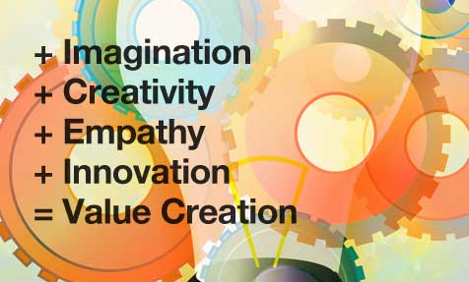

NAME: NATALIE TULLY
Student number: 2025743
Module code: BMHP5014_BIRM
Lectures Name: AZORA HURD

Table of Contents
Introduction. 3
MIND MAP 4
BLOG 7
References. 10

Introduction.
In this assessment, I’m going to be researching and assisting the effects and awareness that mental health has on young children. I will be developing a campaign to advocate teaching mental health awareness, within the state-school sector and become part of the learning curriculum. It will also be exploring the effects it has on young children’s experiences of their mental health within a school setting. I will be processing a mind map and doing a blog to gather support for my campaign.

MIND MAP

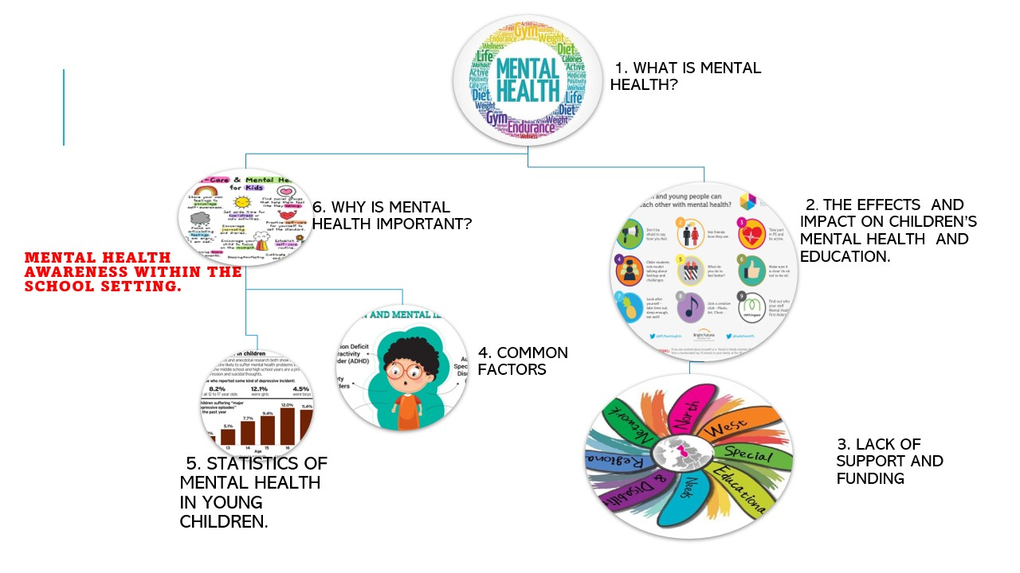

Image 1, What is Mental Health?
It refers to a person’s wellbeing also known as our emotional wellbeing. We all have good and bad days but people with mental health have more bad days than good ones. Mental health affects the way a person feels thinks and behaves. There are many types of mental illness/health disorders with different signs and symptoms. figure 1 (Grout,2019).
Image 2 Effects and impact on children’s mental health and education.
Good mental health is also important within the school setting as mental health problems can damage children’s education and can affect their schoolwork, schools do not have the right resources to manage or recognise the signs of mental health, which can lead to children being disciplined for their behaviour instead of being supported with their mental health needs. (O’Reilly et al., 2018). Figure 2 (Bright futures alliance for learning,2019).
Image 3 Lack of support and funding
A lack of funding for mental health services has a big impact on resources being available to meet the needs and demands for access to child and adolescent services which CAMHS has seen a rise in since 2010 (Neufeld, Jones and Goodyer, 2017). Also, rise in the number of hospitality admissions with our young people self-harming increased by more than 50 percent, Funding fell from £3.2 billion per year in 2010/11 to £1.4 billion in 2015/16, a reduction of 55 percent (in, 2017). figure 3 (www.bing.com, n.d.).
Image 4 Common factors and signs
Many factors can affect mental health. Being a young person growing up in sociality with all the latest trends and social media it can affect the way our young people are influenced by social media which are big platforms it’s hard for young people to feel valued which affects self-esteem and confidence (Berryman, Ferguson and Negy, 2017). Let’s talk about depression that another huge impact on all ages, that can lead to mental health illness knowing the difference between the two is also an important factor to develop a healthy mind and understanding how these impact on child’s life and how to deal with day-to-day stresses and when to reach out for help and support from professional. Signs and symptoms can vary in different children and young people (digital.nhs.uk, n.d.). figure 4 (www.bing.com, n.d.)
- Getting into lots of arguments
- Sense sad all the time
- Feeling anxious all the time.
- Mood swings

Image 5 Statistics of young people with mental health
- According to estimates, 10% of children and teenagers suffer from mental health issues that are severe enough to affect not just their daily lives but also, if ignored, will last into adulthood. (Membride, 2016)

- According to mind.org.uk “96% of 1271 young people surveyed across England reported that their mental health had affected their schoolwork at some point.” (www.mind.org.uk, n.d.).

- Due to service cuts and an increase in mental illness, secondary schools are being forced to pick up the pieces. In 2016, 90% of secondary school administrators reported an increasing incidence of mental health conditions, such as anxiety and depression, among their pupils than in the five years before (Saunder, 2016). Figure 5 (www.bing.com, n.d.).

Image 6 Why is mental health important?
Good Mental health is extremely important for young people’s emotional wellbeing just as important physical health also helps prevent development delays and other health issues. A child's proper growth depends in large part on their mental health. It aids in the development of children's good social, emotional, behavioural, cognitive, and communication abilities (Kingston and Tough, 2013). My campaign is important to teach and learn young people from an early age at school to understand their feelings and emotions, where to get help and support, and recognise symptoms of mental health. Figure 6 (www.bing.com, n.d.)

BLOG

My name is Natalie.
Posted on 28th June 2022.

WE NEED YOU! SAVE OUR CHILDREN’S MINDS!
OUR CHILDREN DESERVE CHANGE!

Our campaign
The mental health system is failing our children, it’s not good enough, we’re fighting for change, join us in our fight!
This campaign is calling on the UK government to fund Mental health awareness in the state school settings, for young people from the ages of 10-18 years old. Our young people aren’t getting enough support from our school setting or mental health services due to a lack of funding and resources which in turn is affecting our children and young people’s education and how their emotional development in the future, impacting adulthood experiences and relationships, we need our children to be able to understand their feelings and support them to understand the early signs and awareness of mental health to reduce the high risk of self-harm and lack of understanding the importance of early intervention. (Saunder, 2016)

Why is mental health important?
After looking into more research on mental health it has made me more aware that it is a huge issue for young people which is why It is now more important than ever to protect and guide our young children’s mental health and wellbeing by offering early intervention through our school settings. Mental health can have an impact on their future adulthood which is direct links to adverse childhood experiences according to mental health statistics by young minds. “One in six children aged five to 16 were identified as having a probable mental health problem in July 2021, a huge increase from one in nine in 2017. That’s five children in every classroom” (YoungMinds, n.d.)

What’s the plan?
We are calling for the government to put in place the following steps:
- health professionals to work in partnership with school settings to gain quicker and more assessable access to local resources.
- Faster referrals and work alongside the schools.
- Ofsted to work with care quality commission to undertake to join targeted area for mental health.
- Mental health awareness to be taught in schools.

Why do we need mental health awareness taught at schools?
- It will ease pressure on other support networks like CAMHS, early diagnosis, and referral professionals.
- Help enable a wider culture within schools that values mental health and wellbeing.
Here is a video on making changes in our school sector on TED TALK. Click on the link below
End of an Era: Mental Health in Schools | Susanna Grace Johnson | TEDxGEMSWellingtonAcademyAlKhail - YouTube
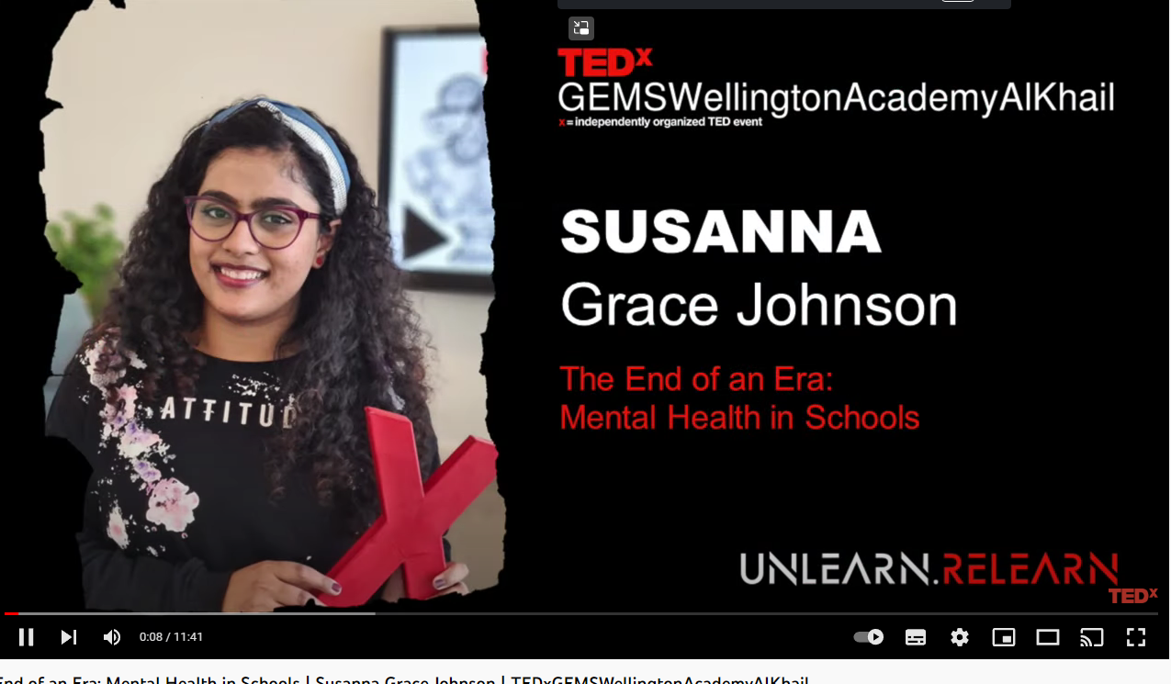

Become a campaigner
We need your help to share the word on social platforms: Facebook Twitter and Instagram. Sign our petition. #FundMentalHealthAwareness#joininthefight#becomeacampaigner.
Have your say!
We would like to hear from our young people’s experiences and join the family

Thank you for your time, please join us in the fight to combat mental health. Should you need more support or information please follow this link: CAMHS (Child and Adolescent Mental Health Services) (acamh.org)

References.

Berryman, C., Ferguson, C.J. and Negy, C. (2017). Social Media Use and Mental Health among Young Adults. Psychiatric Quarterly, [online] 89(2), pp.307–314. doi:10.1007/s11126-017-9535-6.
‌
www.bing.com. (n.d.). Mental Health - Bing images. [online] Available at: https://www.bing.com/images/search?q=Mental+Health&form=IRMHRE& [Accessed 6 Jul. 2022].
digital.nhs.uk. (n.d.). NHS Digital Website. [online] Available at: https://digital.nhs.uk/data-and-information/publications/statistical/. Kingston, D. and Tough, S. (2013). Prenatal and Postnatal Maternal Mental Health and School-Age Child Development: A Systematic Review. Maternal and Child Health Journal, 18(7), pp.1728–1741. doi:10.1007/s10995-013-1418-3.
‌
in (2017). Education, education, mental health: Supporting secondary schools to play a central role in early intervention mental health services. [online] IPPR. Available at: https://www.ippr.org/publications/education-education-mental-health.

Kingston, D. and Tough, S. (2013). Prenatal and Postnatal Maternal Mental Health and School-Age Child Development: A Systematic Review. Maternal and Child Health Journal, 18(7), pp.1728–1741. doi:10.1007/s10995-013-1418-3.
‌
Neufeld, S.A.S., Jones, P.B. and Goodyer, I.M. (2017). Child and adolescent mental health services: longitudinal data sheds light on current policy for psychological interventions in the community. Journal of Public Mental Health, 16(3), pp.96–99. doi:10.1108/jpmh-03-2017-0013.
‌
Meltzer, H., Gatward, R., Goodman, R. and Ford, T. (2003). The mental health of children and adolescents in Great Britain. International Review of Psychiatry, 15(1-2), pp.185–187. doi:10.1080/0954026021000046155.

‌
Membride, H. (2016). Mental health: early intervention and prevention in children and young people. British Journal of Nursing, 25(10), pp.552–557. doi:10.12968/bjon.2016.25.10.552.

O’Reilly, M., Adams, S., Whiteman, N., Hughes, J., Reilly, P. and Dogra, N. (2018). Whose Responsibility is Adolescent’s Mental Health in the UK? Perspectives of Key Stakeholders. School Mental Health, [online] 10(4), pp.450–461. doi:10.1007/s12310-018-9263-6.s-mental-health/improving-mental-health-support-for-young-people/.www.mind.org.uk. (n.d.). Improving mental health support for young people. [online] Available at: https://www.mind.org.uk/news-campaigns/campaigns/children-and-young-people

Rahman, M.A., Todd, C., John, A., Tan, J., Kerr, M., Potter, R., Kennedy, J., Rice, F. and Brophy, S. (2018). School achievement as a predictor of depression and self-harm in adolescence: linked education and health record study. The British Journal of Psychiatry, 212(4), pp.215–221. doi:10.1192/bjp.2017.69.
‌
Saunder, L. (2016). On-line role play in mental health education. The Journal of Mental Health Training, Education and Practice, 11(1), pp.1–9. doi:10.1108/jmhtep-07-2015-0031.

YoungMinds. (n.d.). Mental Health Statistics UK | Young People. [online] Available at: https://www.youngminds.org.uk/about-us/media-centre/mental-health-statistics/#:~:text=Mental%20health%20is%20a%20big%20issue%20for%20young

‌

