Tricia Rees-Jones – 1800824

‘Portfolio which presents evidence of the way in which you will have developed your Welsh language skills during the year’
YouTube Link to Video Evidence:
https://youtu.be/eT_XpQpKBJs
ee

Lesson Plan – New TOPIC
Student-teacher | Tricia Rees-Jones | Class: | Year 3/4
AoLE or Subject | Welsh language development | Date: | 6/1/20
Lesson Focus: | Pwnc- Subjects
Meaningful links to Curriculum | Welsh second language  Learners should be given opportunities to:  -To communicate clearly and confidently and use intelligible Welsh pronunciation and intonation  - view and listen carefully responding orally  - reinforce Welsh syntax by the accurate use of a variety of sentence patterns
Meaningful links to:  Cross Curricular Responsibilities | New curriculum – 4 purposes  -Ambitious, capable learners who can communicate effectively in different forms and settings, using both welsh and English.  - Ethical informed citizens who are ready to be citizens of Wales and the World.  LNF (Oracy)  - To contribute to group discussion and help everyone take part  - Explain information and ideas using relevant vocabulary  LNF (Listening)  - listen carefully to presentations and show understanding of main points  (Collaboration and Discussion)  -contribute to group discussion and help everyone take part  (Writing)  - Welsh-medium statement: use the most common mutations correctly  Digital Competency Framework (DCF)  - Find relevant information using different keywords and search techniques  - Modify and present a range of text and images
Personal Targets (Linked to QTS and identifed in weekly review)
A focus on integrating the new four purposes into my lessons. To make the children aware of what skills they are using and to get them more familiar with the words/phrases that are proposed in the new curriculum. I want to meet the QTS standard of 'the teacher demonstrates a knowledge and understanding of the needs of all learners in planning, preparation and teaching, ensuring that the four purposes are the drivers for learners’ experiences. '

Learning Objectives (focus on Learning- use accessible vocabulary):
The pupils will learn to:

-Be confident with the pronunciation of new welsh phrases

-To create a welsh poster stating your likes/dislikes on subjects

Success Criteria (clearly linked to each Learning Objective and related to the process and/or product of learning) | Assessment of Pupils’ Learning  Evidence  (What have the learners to say/write/do/produce – to demonstrate learning)
- I can pronounce given words correctly.  - I can match the correct word to the picture.  - I can create a poster stating my opinion | The children will participate in slot drillio which will consist of the children getting familiar with the pronunciation of new words, but also being given the opportunity to have a go at spelling them.

Time  9.15- 10.30 | Activities/Methodology/Key Concepts  (Teacher’s Role – including key teaching points, differentiation strategies and key questions) | Pupil Tasks  (Pupils’ role –including differentiation, engagement in formative assessment and homework) | Resources  (Including Health and Safety requirement)
Opening phase (with links to prior learning)  25 minutes | Introduce PowerPoint Presentation on Subjects.  Get the children to repeat the welsh word after the teacher ensuring that they are confident with the understanding. Introduce new sentence patterns and verbs.  Hand out the snap cards- Mixed ability tables  The children should now be confident at matching the cards, which is just a re-cap of their new phrases.  Matching activity – Match the correct subject to the correct picture. This is just a quick activity to see how much the children have learnt. | Repeat phrases on PowerPoint.  Engage as a team to complete the snap card activity the quickest.  Complete matching activity independently. | PowerPoint presentation  Snap cards  Matching activity
Teaching & Core Learning  40 minutes | Hwb poster  Create a poster on Hwb with images to support, stating likes/dislikes and favourite subject.  Depending on the ability- they should state why they like/do not like the subject.  Teacher – Working with low ability  TA- working between Higher ability and middle ability.  Ensure that children have full understanding to print off their work once completing it. | Higher ability- This table should be able to use their Hwb logins themselves and work independently. They should state 4 likes/dislikes and which subject is their favourite. New sentence pattern should be used and stating the reason why the topic is their favourite.  Middle ability- Majority to log in independently. TA is there for support for those who need it. They should state 3/likes and dislikes and state which subject is their favourite. New sentence pattern should be attempted and stating reasons why if able. They can use a word mat for support.  Lower ability- Login will be done by class teacher. A WAGOLL will be provided so they know what is expected of them. Images and subject name should be stated for 3 likes and 3 dislikes. Here, the focus is on spelling of the subject. They can use a word mat for support. | Laptop  Hwb Logins  Word mat
Plenary  10 minutes | Lesson Recap of key phrases- Using lollypop stick method, select a child at random to tell you their favourite subject and why (In welsh).  Complete a reflection card- Child must state what they enjoyed about the lesson and what they would have liked to have more help with. This provides the teacher with further guidance to see where they can help give the class more support and assistance. | All children to complete reflection cards. Here, they can be completely honest about what they enjoyed, but most importantly, what they would like more help with. | Lollypop sticks  Reflection cards

ARC Evaluation of the Learning Experience

When reflecting on my lesson, I think that overall, the experience for both the children and I was very good. The children seemed to enjoy the lesson and were very much engaged. During the introduction, the children all communicated well and grasped the new topic of subjects. They showed previous knowledge on sentence patterns and understood the new patterns given. The lesson contained many different elements, especially within the introduction. The children interacted with an oral drilling session assisted with a PowerPoint (see appendix 1), group snap card challenge and a matching activity. (see appendix 2) The only element of the lesson that seemed to be slightly disappointing was that some laptops within the class would not work and therefore could have left us short. But this was easily resolved as we borrowed some from next doors class. I always knew that logging into their HWB accounts may cause some difficulty. To avoid wasting time, I logged on the lower ability into their accounts as I knew that this could save some time.

Some aspects of assessment for learning took place both during the introduction and plenary as I was choosing a child at random and testing their knowledge. The children also had the opportunity to have a go at spelling the new words on a white board with their partner. This activity worked well as the welsh language was being used both orally and through writing the word down. Allowing children time to concentrate on spelling is very important and Cook (2008) agrees with this by stating that the amount of time teachers spend concentrating on pronunciation far outweighs the time given to spelling. Although, Cook (2008) goes on to state that speech is the primary form of the language and therefore writing may depend on this. Here, it is important to remember that communication is a massive factor of learning the welsh language, but as the children go higher up through the school, both reading and writing need to be greatly incorporated.

My next steps will be to continue to develop their welsh skills. I think it is important to introduce new topics but is vital that you are recapping previous knowledge in order for children to store it in their memory. Also, I would love to do more practical welsh activities that incorporate both the outdoors and physical activity sessions. I think that by making the lessons fun and rememberable, it will allow the children to engage better.

I think that my pronunciation is very good, but at times, I find myself talking too fast. The use of repetition is used during the introduction, to drill the new phrases to the children. Montessori states that repetition helps a child to master, practice and retain knowledge but also to internalise concepts. (Pound, 2008) By giving both the middle and lower ability a word bank, it encouraged correct spelling and allowed them to cross reference words that they did not know or could not remember. Although, it was noticed when marking that the high ability work has more spelling corrections due to not being given support with a word bank. Although, the focus here was on challenging my MAT pupils to see how they can apply their knowledge to their work. When differentiating for the higher ability, I overestimated how much time we had and therefore they did not complete the expected amount. But, it was interesting to see that some children were using two adjectives to state why they liked/disliked a subject which was pleasing.

In relation to my lesson, Estyn (2013.p.23) state that ‘the Annual Report for 2010-2011 states that writing is the least developed of the three Welsh language skills in most settings and schools.’ But they do also go on to state that in a few schools, the level of writing is evident through a variety of sentence patterns that children are able to write in Welsh. However, we do need to ensure that children are not just copying writing, and actually using their knowledge and imagination.

Marton (1988) discusses four overall teaching strategies that look at how you can approach teaching the welsh language. This includes the receptive strategy; that relies primarily on listening; communicative strategy: relies on students attempting to learn through communication; reconstructive strategy; students participate in activities based on text and the eclectic strategy; a combination of two or more of the previous strategies. Within the lesson taught, the eclectic strategy was used as both listening, communication and text work was completed. If I was to carry out this lesson again, I could have incorporated a reading task that could have been done during the introduction. This would have allowed the children to be covering all areas of language, literacy and communication.

During the lesson, I could have most definitely used more assessment for learning (AFL) strategies. This would have allowed me to provide the children with more formative feedback. Estyn (2013.p.40) state that ‘Assessment for learning is one of the weakest aspects of the teaching of Welsh’. AFL is so important because pupils may have a vague idea of how well they are progressing in the different skills in Welsh, but they need to know how they can improve, in order to make progress.

When looking at my marking skills, I think it is important that the children have a full understanding of the comment. I believe that you should gradually introduce the welsh language to the comments, as it may be more value to the children understanding how they can improve, but in English to start with. I would also be beneficial to the child if a key was placed in the child’s book that explained exactly what is being stated. For example, some lower ability children might not be able to understand what the comment in welsh says. (see appendix 3)

I think to improve pupils love of learning would be to make the activities more child led. Previously, I have told children to lead the start of the drillio by recapping previous knowledge. This caused high engagements levels in the class with excellent concentration. Children were thrilled at the fact it could be there turn to be the ‘teacher’ next. Baker (2011) states that young children pick up languages easily, especially through play and concrete situations. This highlighted the importance of the welsh language being taught effectively within the primary school setting. Donaldson (2015), in Success Futures, also highlights the importance of the welsh language in schools. He believes the focus should be on communicating through welsh, in both conversation and understanding. He also believes in the significance of everyone learning welsh up to the age of 16.

Due to different circumstances, I was unable to receive feedback from my teacher on the lesson taught and therefore I could not reflect upon a target given to me. Although, you can find comments made about my welsh language development found in both my report and summative assessment on SWWCTE. (See appendix 4). These comments were very pleasing as I am constantly trying to develop my welsh language skills. During PTE2, myself and a fellow student decided to set up a ‘Dathlu Cymraeg’ club after school. This club consisted of games, songs, and many different activities that would help a child enhance their welsh literacy skills. (See appendix 5). This club was available to reception children and it was interesting to see how it also helped developed their confidence due to the different games and activities. As well as this, it also helped our own development and helps build our confidence on speaking the language. In the first after school club, we had 17 children interested, which we were very pleased about. This just highlights how many children enjoy learning and being part of the language.

One target that was first given to me by my teacher was to ‘expand the use of my incidental welsh’ within my lessons. I enjoyed being given this target as it was then a challenge for me to be able to bring more welsh into the classroom. I thought that the best way to achieve this would be to set up a development plan. (see appendix 6). I created a weekly plan that would allow me to try and achieve a certain amount of incidental welsh words per week. This was very easily achieved and will definitely be something that I continue to use in the future. I also wanted to take a further step in my welsh language development and recently have completed an online course. This was done through The National Centre for Learning Welsh and I achieved a certificate in the online course that was specifically aimed at teachers. (See appendix 7) As previously mentioned, the children complete a reflection card after the lesson. (see appendix 8) This allows me to use the children’s reflection to actually reflect on my own practice in order to see where I can make improvements to my pedagogy. It also shows me if any children need more help or guidance with particular aspects of the lesson.

The QTS standard descriptor states that ‘The teacher actively seeks opportunities to apply and extend their understanding and skills in the use of the Welsh language.’ (QTS, 2019) My desired goal will be to become fluent and confidence with the welsh language in order to have an impact on the children I teach. It is the teacher’s job to signify the importance of the welsh language to the child from a very young age, but most importantly to make sure they are ready to be citizens of Wales and the world. (Donaldson, 2015)

References

- Estyn (2013) Welsh Language Development in the Foundation Phase

- Marton. W (1988) Methods in English Language Teaching. Hemel Hempstead: Prentice Hall.

- Cook. V (2008) Second language learning and language teaching. Fourth Edition. Hodder Education

- Pound, Linda. How Children Learn. Book 2. London: Practical Pre-School, 2008. How Children Learn Ser. Web.

- Baker, C. (2011) Foundations of Bilingual Education and Bilingualism, 5th Edition. Clevedon: Multilingual Matters.

- Donaldson, G. (2015) Successful Futures: Independent Review of Curriculum and Assessment Arrangements in Wales. Crown copyright. Available at: http://gov.wales/docs/dcells/publications/150225-successful-futures-en.pdf [Accessed 24 April, 2020]
- QTS (2019) Professional standards for teaching and leadership. Welsh Government. Crown copyright.

APPENDICIES

APPENDIX 1- PowerPoint Presentation

APPENDIX 2- Matching activity template

APPENDIX 3- Marked Work

APPENDIX 4 – SWWCTE comments

APPENDIX 5 – Dathlu Cymraeg Evidence

Appendix 6- Welsh Development Plan

Appendix 7- Welsh Course Evidence

Appendix 8 - Reflection Cards

APPENDIX 1- PowerPoint Presentation
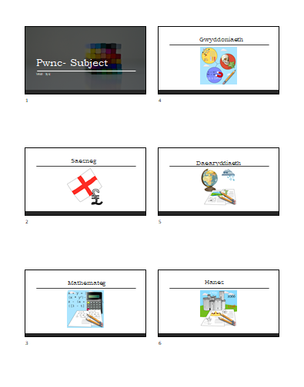

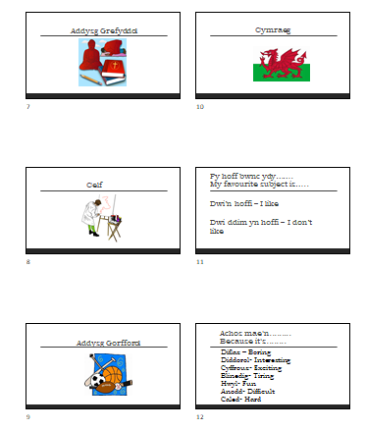

APPENDIX 2- Matching activity template

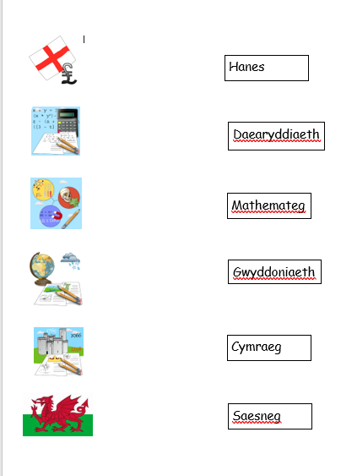

APPENDIX 3- Marked Work

Lower ability example 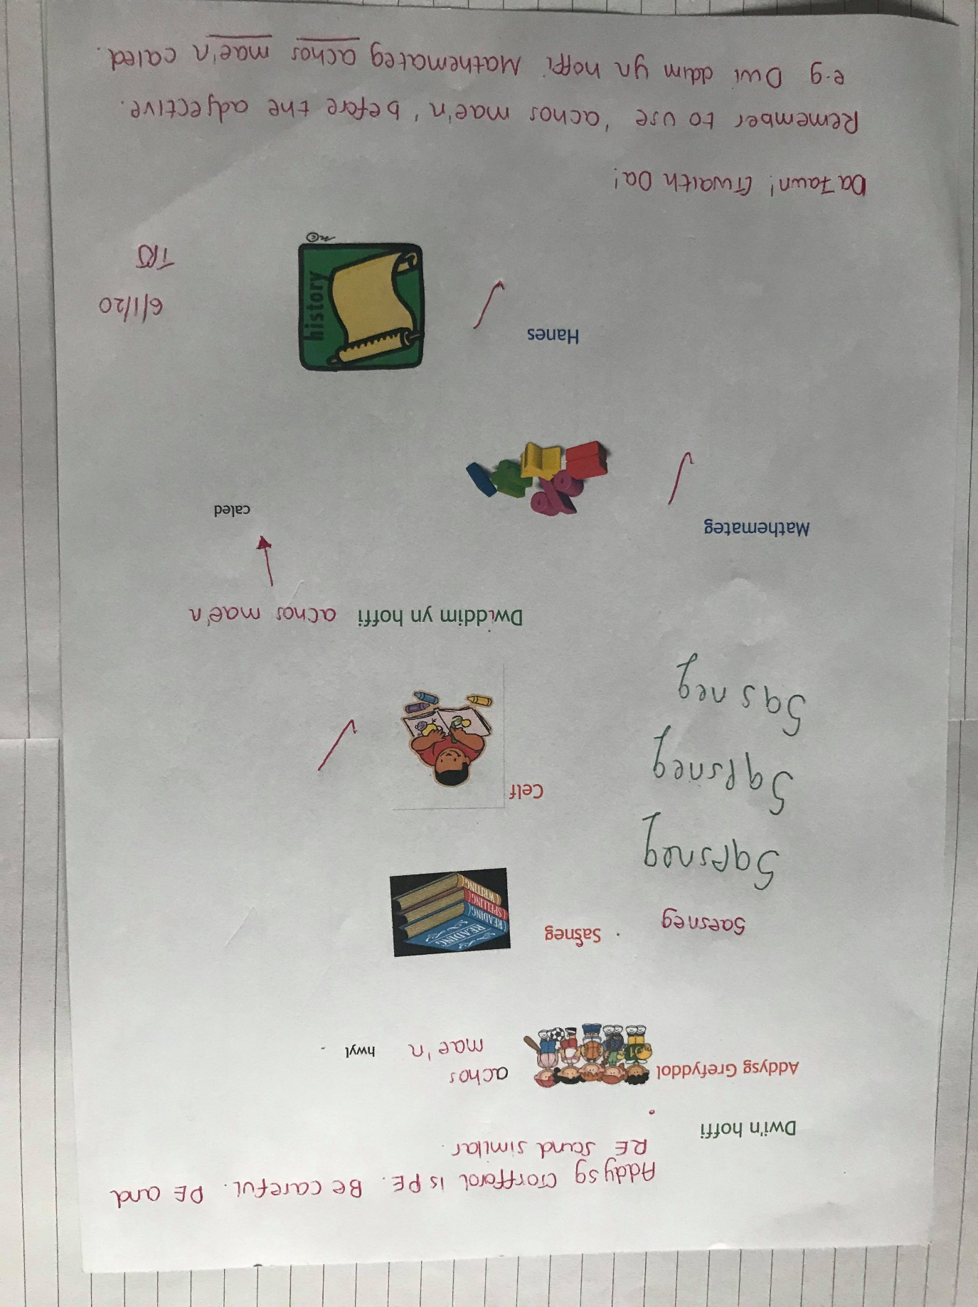

Middle ability example

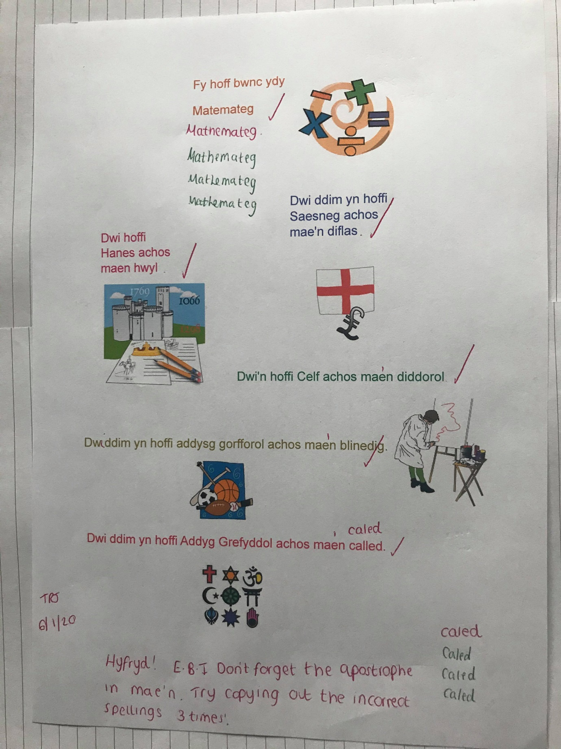

Higher ability example

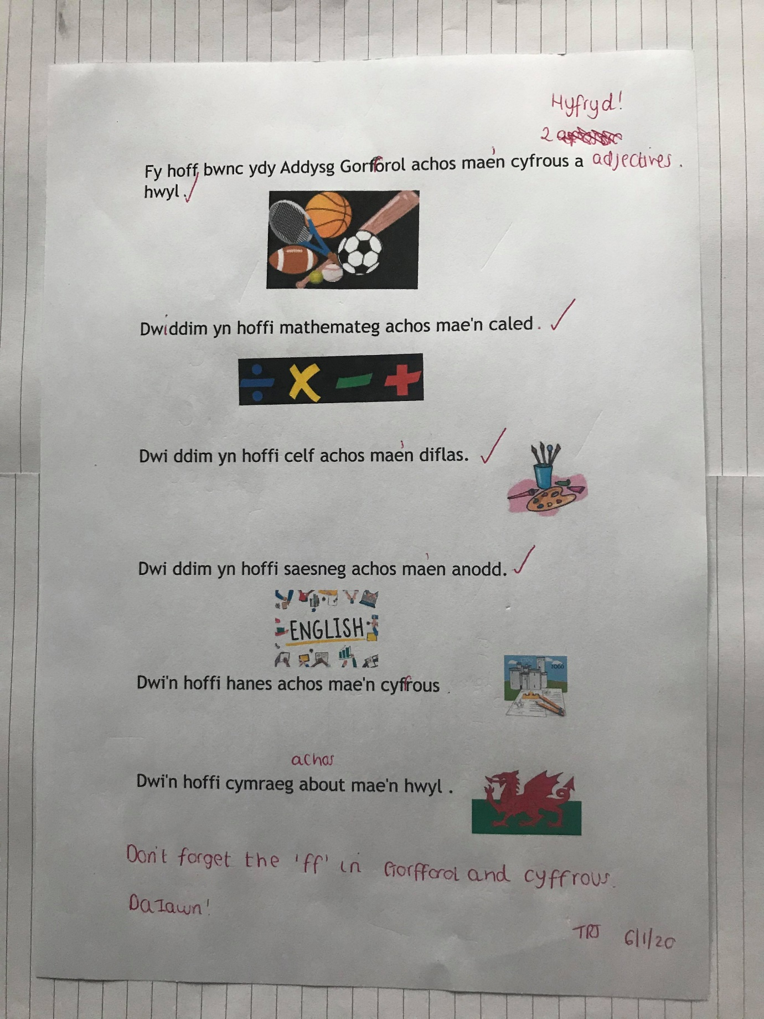

APPENDIX 4 – SWWCTE comments

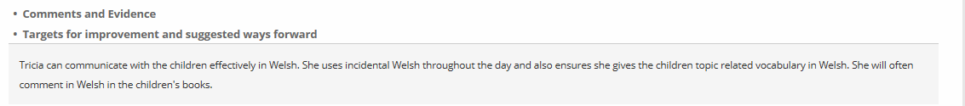

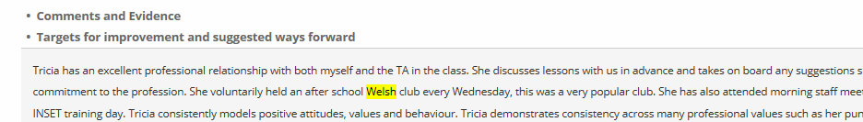

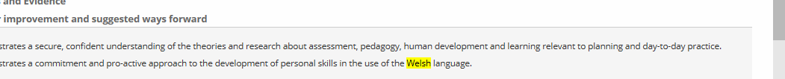

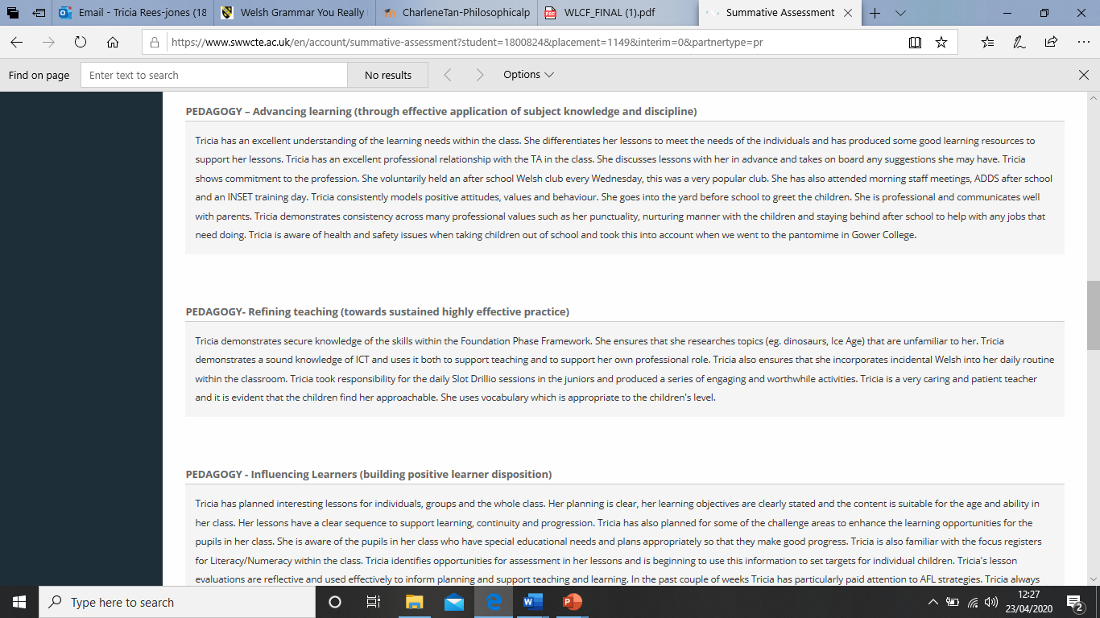

APPENDIX 5 – Dathlu Cymraeg Evidence

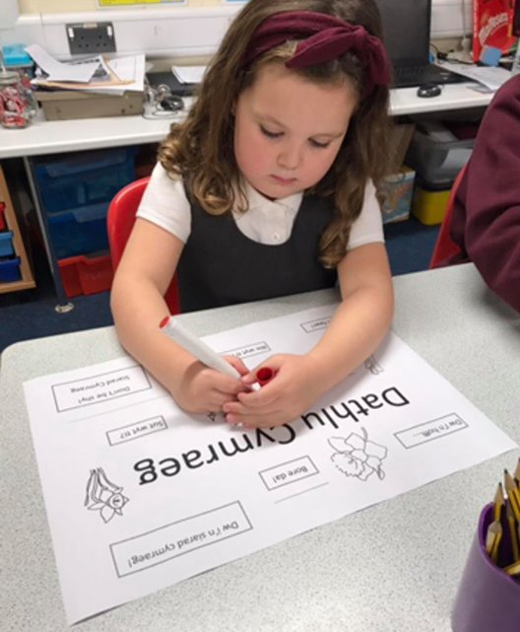

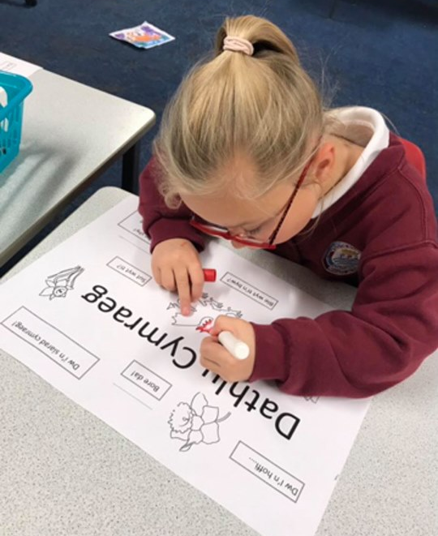

Appendix 6- Welsh Development Plan

Foundation Phase

 | Week 1 | Week 2 | Week 3 | Week 4 | Week 5
KEY TOPIC WORDS | Deinosor |  |  | Dwr  Cerrig  Anifeiliaid  Oed  Arfau
INCIDENTAL WELSH | Bore da Prynhawn da Eisteddwch Dim siarad Gwrandewch Bant a chi  Mae hi’n amser chwarae Cinio Gwasanaeth Llaeth a ffrwyth | Hwyl fawr  Barod  Tacluswch  Bant a chi  Dewch i mewn  Diolch  Ble mae?  Dyma….  Da iawn Diolch | Edrychwch arna i  Ewch Allan  Ga i….?  Ga I fynd I’r ty bach os gwelwch yn dda?  Cei/Na Chei  Sut mae’r tywydd heddiw?  Pa liw ydy hwn? | Dwylo I fyny  Pwy sy’n cael cinio?  Cinio- un deg dau  Beth wyt ti eisiau?  Beth sy’n bod?  Grwp yma, ewch allan | Gwisgwch eich cotiau  Wyt ti’m hoffi…?  Ydw, Dwi’n hoffi  Wyt ti’n eisiau?  Dydy hi ddim yn…
    Achieved? DATE | 15/11/19 | 22/11/19 | 29/11/19 | 6/12/19 | 13/12/19
Welsh Language Development – Placement 2- Foundation Phase

Key Stage 2

 | Week 1 | Week 2 | Week 3 | Week 4 | Week 5
KEY TOPIC WORDS | Broga  Pwll | Hwyaden  Penbwl  Pili Palar | Alarch | Creyr Glas
INCIDENTAL WELSH | Wyt ti’n barod?  Ydych chi’n barod?  Pawb yn barod  Pawb yn dawel  Dim siarad  Dim sŵn | Ble mae…? -  Dyma….  Sawl un? -  Pa liw ydy hwn? -  Pa liw wyt ti eisiau? -?  Dwylo ynghŷd llygaid ynghau -  Dwylo i fyny | Tawelwch  Tacluswch  Ysgrifennwch  Darllenwch  Cerddwch  Rhedwch | Arhoswch funud  Ar unwaith -  Y tro yma -  Wyt ti wedi gorffen? -  Ymlaen â’r gwaith  Rhaid gorffen  ..gwaith cyn cinio ….. | Llongyfarchiadau  Pob lwc  Gyda’ch gilydd -  Digon yw digon -  Gofynnwch i ffrind  Ateb da iawn
Achieved? DATE | 10/1/20 | 17/1/20 | 24/1/20 | 31/1/20 | 7/1/20
Welsh Language Development – Placement 2- Key Stage 2

Appendix 7- Welsh Course Evidence

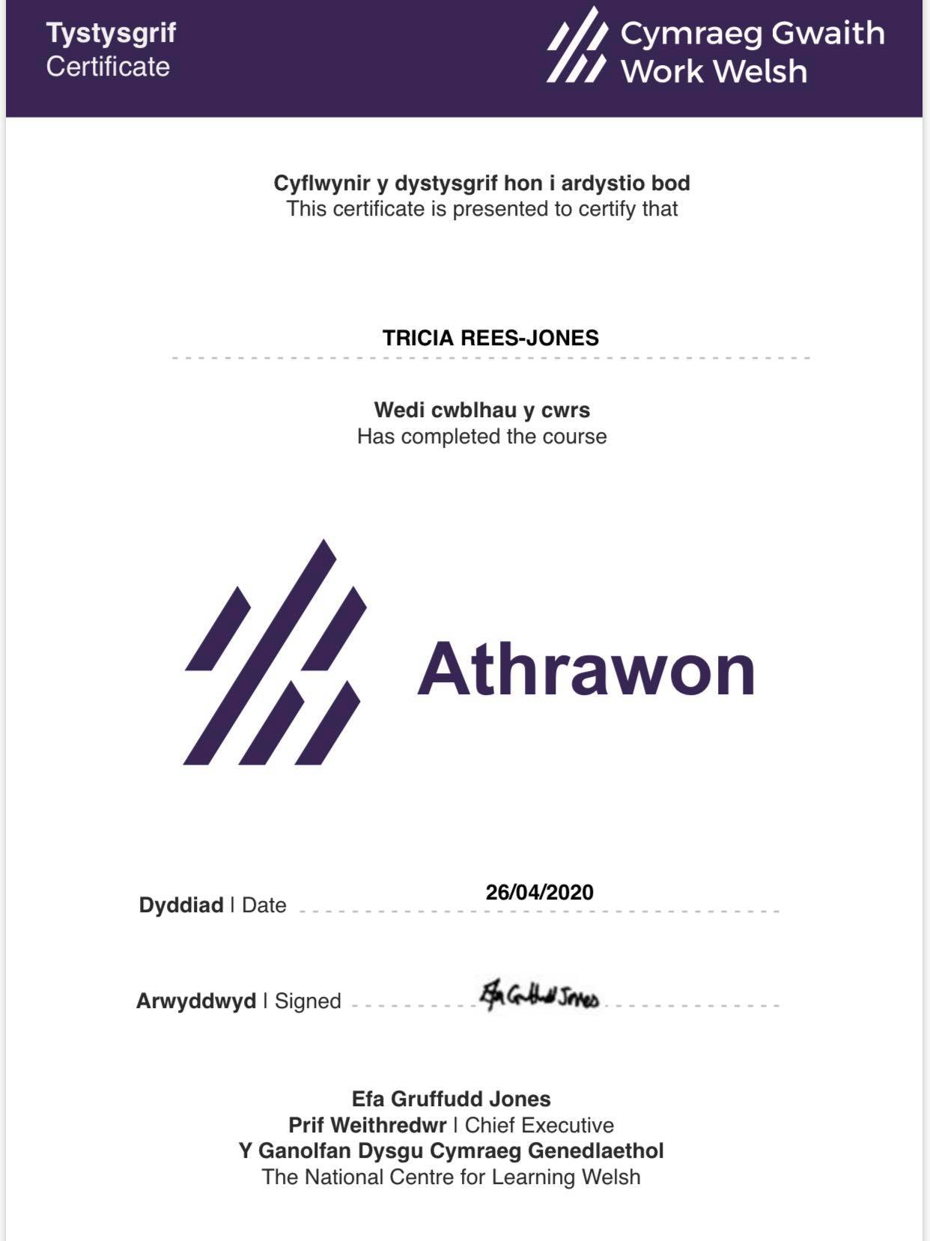

Appendix 8 - Reflection Cards



