

University of Wales

Trinity Saint David

EIGP 2 – Individual Report

Enterprise & Innovation Group Project

Ryan Lee Morgan

Software Engineering
1706559
James Williams

Hand-in Date
16th March 2020

Contents

1.0 Ideation 2
1.1 Product Illustration 2
1.2 Minimum Viable Product 2
1.3 Differentiation 3
2.0 Product Development 4
2.1 Branding 4
2.2 Web Application 4
2.3 Components and Circuitry 5
3.0 Trading and Start-up 5
3.1 Legal Classification 5
3.2 Mission Statement 6
4.0 Team Management 6
4.1 Team Members 6
4.2 Roles and Responsibilities 6
5.0 Conclusion 7
Bibliography 8
Appendix 9

Ideation

The United Kingdom is home to 32.5 million passenger cars, and the number inevitability rises each year [1]. With so many drivers on the road, safety continues to be a matter of priority for most. Cark-E is an exciting new product that could help provide such a solution.

Using biometric technology, Cark-E provides a secure way of unlocking and starting a vehicle with just a finger print. This not only helps significantly reduce car crime, but provides accountability if the worse should happen. In the event of a serious accident, the key acts as a point of contact for emergency services, providing vital medical information, along with details of the users next to kin.

1.1 Product Illustration

Cark-E is made up of a number of components… because of this, and to ensure both continuity and compatibility, an illustration of the prototype has been drawn up. This not only helps humanise the product, but provides a basis of the core functionality and features that the device will include.
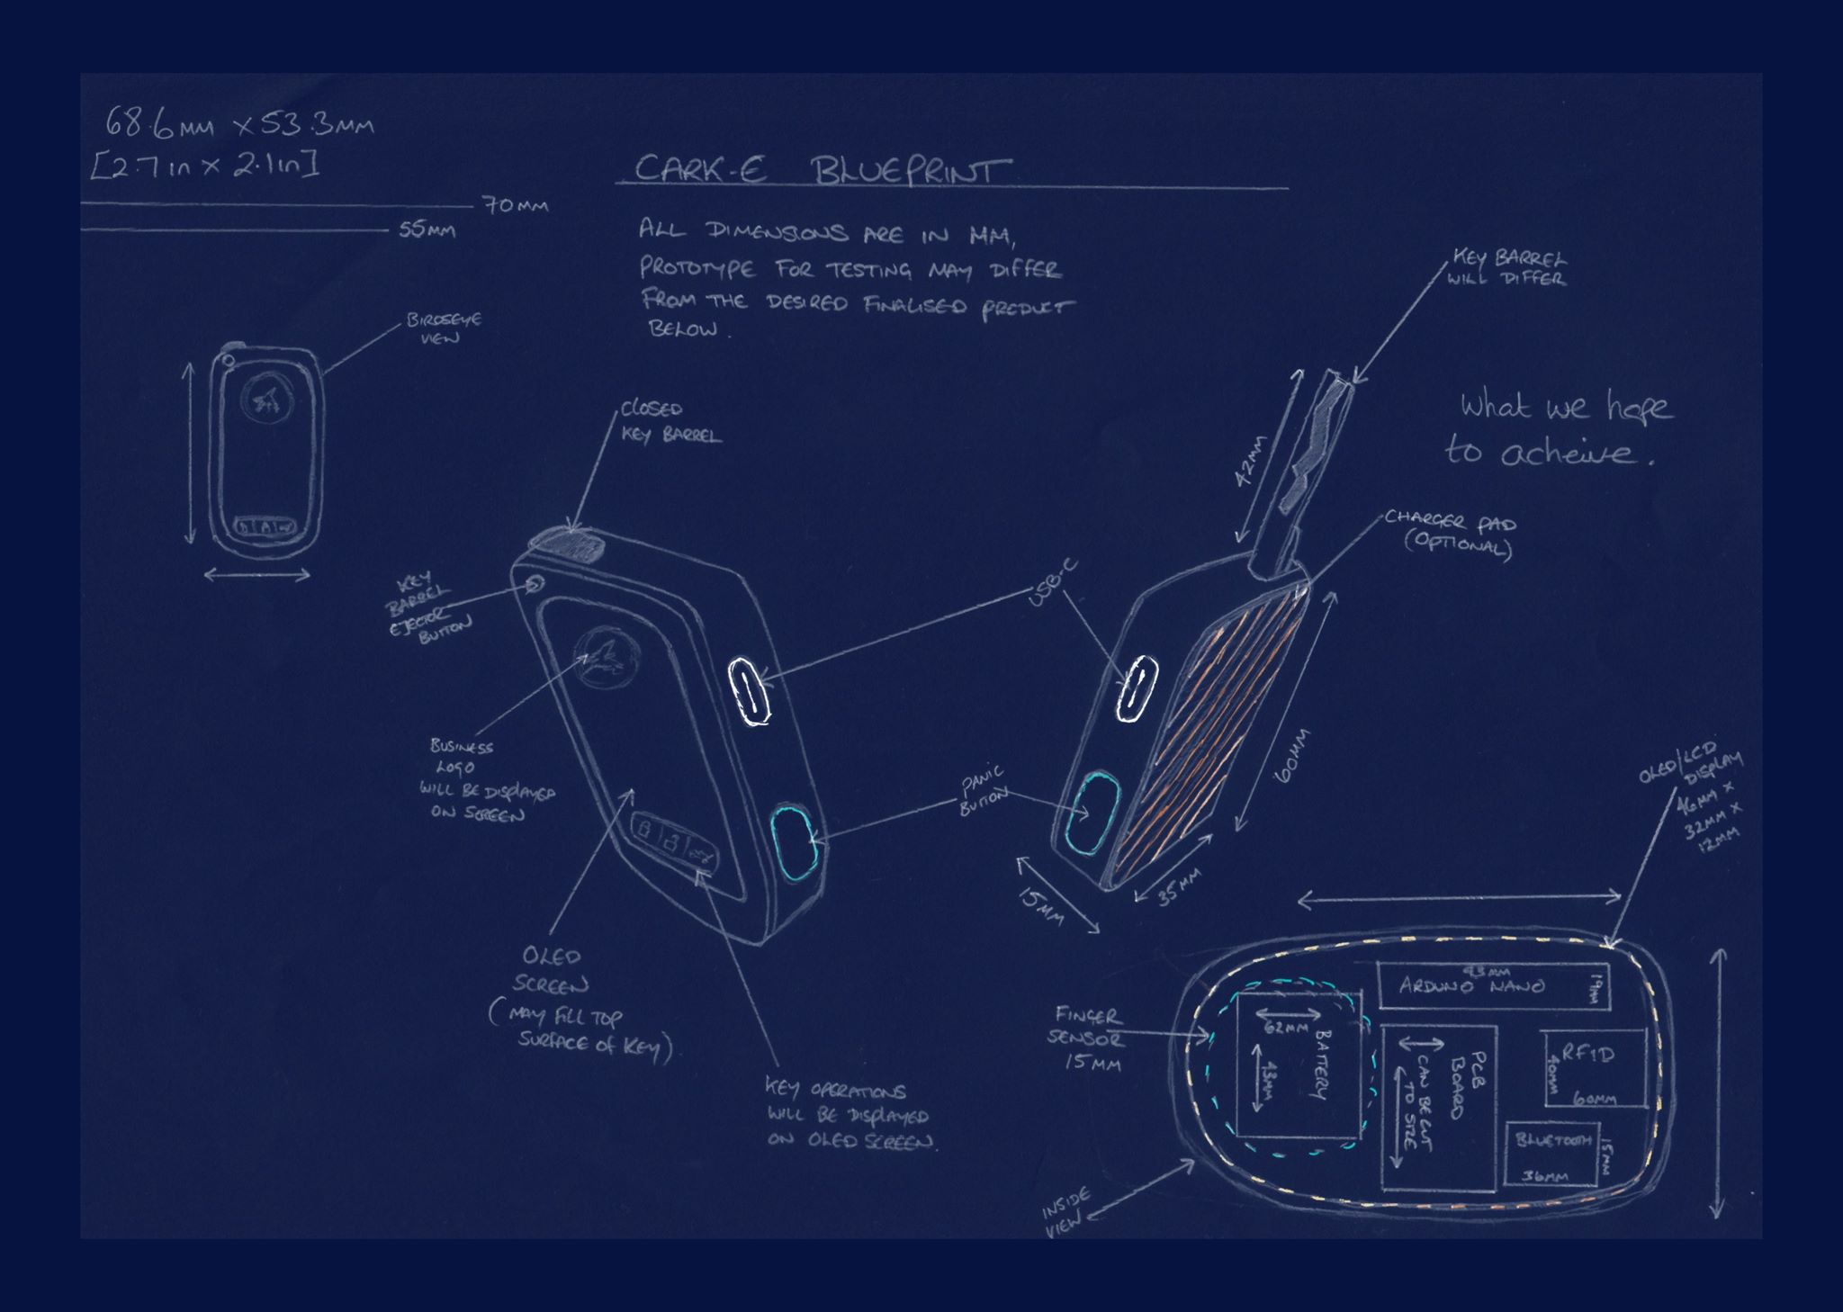

1.2 Minimum Viable Product

Research was conducted firstly into competitor analysis to gain a better understanding of what similar companies were offering, and into the market share available. The data obtained allowed the development team to construct an idea that would better fit the market share, while devising a product that was different from that of our competitors.

Further research was conducted in the form of surveys via social media platforms, this allowed the team to build a picture of the target market, while getting a feel for potential features that could be added to the design both in the short, and long term.

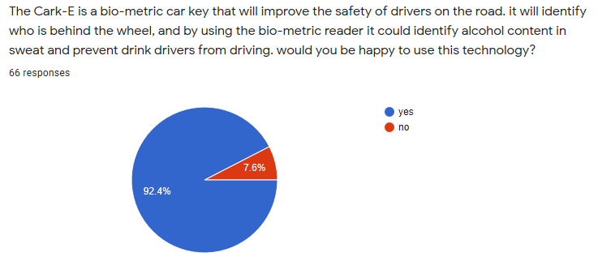
92.4% of people surveyed agreed that a device which could identify the driver of a vehicle in the event of an accident would be of interest, further more a device with the potential to obtain the alcohol content of road users via biometrics was established has a key feature of the Cark-E device.

1.3 Differentiation

Smart car keys with inbuilt modern technologies do exist, but are often marketed towards high-end, luxury car owners and manufacturers [2]. These gadgets are great, but often come with a high price tag, and do very little to increase safety for the majority of road users and pedestrians.

Cark-E however is marketed to any road user, no matter the make or model of the vehicle. While remaining aesthetically pleasing, it uses cheaper components making it easier to reproduce, and more affordable for the average user.

Safety and accountability are key elements in the design of Cark-E. Helping to reduce car crime by securing access to the vehicle. While in the event of an accident, it can provide road safety organisations like the DVLA and Police with legitimate evidence about vehicles driver, and the journey it followed.

2.0 Product Development

2.1 Branding

Ryan Morgan and Antony Smith undertook the important task of creating a brand image for Cark-E. Both felt a clean, consistent image was required to establish the identity of the product, while increasing awareness of the company. Ensuring the correct imagery, font and colour scheme was used became a fundamental task in the development of the brand, allowing customers to easily identify, and distinguish the Cark-E brand from that of our competitors.
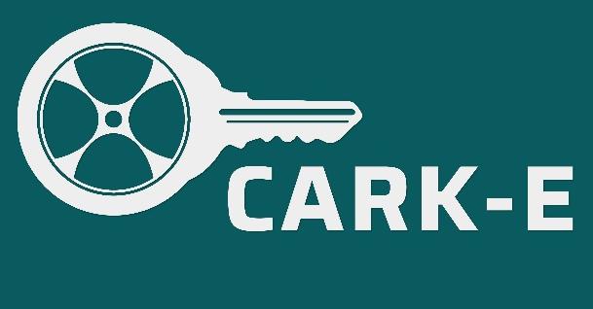
The team selected a simple logo, incorporating the two themes of the product, vehicle (in the form of a wheel), combined with a key. A neutral, solid colour was chosen to best highlight the brand, along with a simple bold font to help ensure rememberability of the product name.

2.2 Web Application

A mobile application will be required to provide new Cark-E customers with a platform to access product information, create purchases and register their personal details to the service. The platform itself will be designed and implemented by Ryan Morgan, who will be solely responsible for ensuring an easy to navigate user interface is created. The web app should also provide existing users will the ability to register additional users, and fingers prints, will offering a support services in the event of device problems arising.
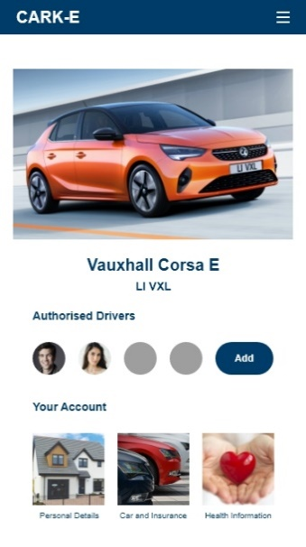
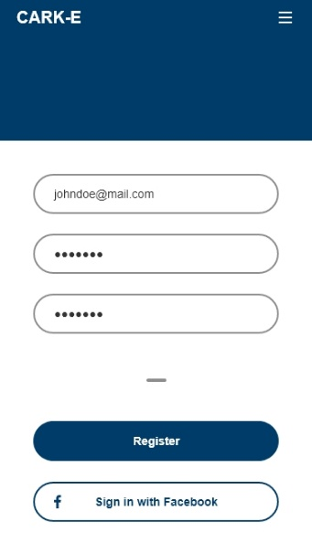
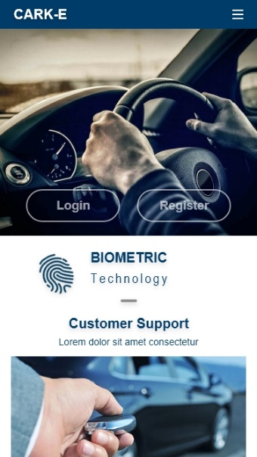

The construction of the application back-end is under taken by database technician Daniel Algie. Daniel regularly meets with the web developer to establish compatibility, while constantly ensuring customer data remains secure at all times.

2.3 Components and Circuitry

A big part of the Cark-E product is affordability for the customers, ensuring quality and individuality of the product is the job of chief engineer Nathan Morgan. Nathan ensures the components selected adhere to the keys core functionality, while remaining widely available and cost effective ready for mass production.

Assembling the circuitry for the prototype was no easy task. The demonstration model is assembled using Arduino components. Arduino is a widely used open source prototyping platform that allowed the team to construct a practical prototype on a tight timescale.

3.0 Trading and Start-up

The company trades under the enterprise name Ddraig Goch Enterprises, this allows the company to develop and add additional products in the future. The team meets regularly to discuss start-up options wile undertaking regular analysis of our competitors.

3.1 Legal Classification

Although no legal entity for Ddraig Goch Enterprises is officially registered at the present time, the team have discussed a number of classification options and come to a consensus of which type of entity will be appropriate for the organisation.

Cark-E will register with Companies House to become a limited company when a working prototype has been successfully implemented. Incorporating a business means to decrease the financial exposure of the company. This allows no one team member to be held personally responsible for any debts occurred within the eyes of the law and personal finances will remain separate from that of the business. While protecting the teams from potential debts in the event of failure, registering in this manner creates a business that is more attractive to potential investors.

In time ownership of the limited company will be held by shareholders who can invest personal money for a share of the Cark-E company. A director will be appointed to manage the day to day running of the business, and have the power to make important decisions regarding the company’s future.

3.2 Mission Statement

Our mission is to enhance the safety of public roads through the medium of exciting and affordable technologies for both drivers and pedestrians alike.

4.0 Team Management

To ensure successful coordination of the project and prototype development, the team have adopted a number of core values, including setting of realistic targets and offering a network of support to ensure communication between roles is upheld.

Rather than assign one person to the role of project manager, the team have a collective responsibility over the project. Combined with regular team meetings, this helps maintain both a confident and effective working relationship.

4.1 Team Members

To help increase productivity and overall job satisfaction, each of the team have been assigned a job role based on their personal strengths.

Website | Database | Design | Software | Engineer | Marketing
Ryan  Morgan | Daniel  Algie | Antony  Smith | Martin  Dunn | Nathan  Morgan | All Team  Members

4.2 Roles and Responsibilities

The job roles required for the product development have been carefully devised to ensure the workload is shared equally amongst the team, these roles include;

Web  Developer | The web developer is responsible for designing, implementing and maintaining the functionality of the web application, a key role ensuring customers of Cark-E benefit from a front-end that is easy to navigate and understand.
Database  Technician | A skilled worker to ensure compatibility with the front-end web application, and continuous communication with the device, while protecting sensitive customer information in-line with GDPR.
3D Design  Engineer | Providing creativity and functionality to the product, the 3D Developer is responsible for designing, and production of the end product. The engineer must ensure a design that conforms to the products specifications.
Software  Engineer | Continuously communicating with other areas of the development team, the engineer is responsible for developing, testing and implementing the prototypes core functionality to deliver a working product.
Electrical  Engineer | Responsible for sourcing and acquiring suitable components, while ensuring the design of the product remains cost effective. The engineer will implement the hardware required for a functional prototype and end product.
Marketing  Team | Obtain and develop a relationship with the target market. Creating brand awareness through online surveys and marketing campaigns, while opening channels of communication with potential investors.

5.0 Conclusion

With an ever-increasing number of road users on todays roads, the Cark-E development team set out to create and establish a product that will increase road safety using biometric technology. Using low cost components, the team endeavours to make a product that could be widely available to everyone at an affordable price. Though research, modern marketing techniques and a continuous high standard of team working the Cark-E prototype will be the stepping stone to safer roads for drivers and pedestrians alike.

Bibliography

[1] Statista. (2020). Number of cars in the UK 2000-2016 | Statista. [online] Available at: https://www.statista.com/statistics/299972/average-age-of-cars-on-the-road-in-the-united-kingdom/ [Accessed 27 Feb. 2020].

[2] Business Insider. (2020). These car keys are so ridiculously high-tech you won't even recognize them. [online] Available at: https://www.businessinsider.com/8-amazing-car-keys-2016-3?r=US&IR=T#paganis-aluminum-key-does-more-than-just-look-good-8 [Accessed 27 Feb. 2020].

Appendix

------------------- TEAM PROGRESS SHEET -------------------------
Team Name: Ddraig Coch Enterprise
Team Member Names & Roles:
DA: Dan Algie- Web Development / Database Management / Marketing.
RM: Ryan Morgan – Web Development / Database Management / Printing Engineer.
NM: Nathan Morgan- Software Engineer / Electronic Engineer / Marketing.
MD: Martin Dunn – Software Engineer / Electronic Engineer / Marketing.
AS: Anthony Smith – Web Development / Database Management / Printing Engineer / Current PM
------------ ---------- ----------- ------------- ------------- ------------ ----------- ------------ --------- --------- ---------- ---
Weekly Progress report 1:
Date: 06/11/2019
In-Attendance: AS, DA, RM, NM, MD. Apologies: - Absent: -
Team Goals:
To implement an innovated project which will obtain a group consensus.
> Individual Updates:
AS Update: Amass a list of different ideas which could be used as the group project, and research how unique each concept is.
NM Update: researched different parts for the project, including alternatives with different size footprints for adapting to the consumer needs.
DA Update: Researched different types of keys to see which would be more suitable type of key to suit our ideas.
RM Update: Researched different methods of creating web applications.
MD Update: Forming a list of innovative projects to talk in the group
> Team discussion:
Notes: As a group, it was decided to individual submit ideas that could potentially become the focus of the group project. After many debates, it was decided that the biometric Car Key would be the most viable choice.
Individual team roles have been set.
Compile a list of components required to create the device.
Contact sources, that will be necessary to fund the product and supply equipment to create the prototype.
Design a business logo and distribute a survey as part of the marketing strategy.
> Individual Actions:
AS Actions: design the group logo and cement each individual position within the group.
NM Actions: Converted survey into a digital format and market it amongst social circles using an online medium https://forms.gle/JVc8jqfbpSwbzCJD9
DA Actions: researched different types of car keys around the world.
RM Actions: Will investigate similar competitors.
MD Actions: investigate other products to make ours unique
------------ ---------- ----------- ------------- ------------- ------------ ----------- ------------ --------- --------- ---------- ---
Weekly Progress report 2:
Date: 13/11/2019
In-Attendance: AS, DA, RM, MD. Apologies: - Absent: - NM
Team Goals:
Compile a Moscow Chart, which will identify possible features for the product.
Investigate potential competitors in the market and complete a competitor Analysis
Research legal requirements, trends in the market and identify what is needed to create the product. This can be summed up in a PEST Analysis.
Contact Potential Partners that may benefit from the prototype or may be pivotal in the design and implementation of the device.
> Individual Updates:
AS Update: make a list of potential organisations and create a form of communication.
NM Update: Some interesting reading: https://sciencediscoveries.degruyter.com/non-invasive-method-measure-blood-alcohol-levels/
List compiled of parts, for the prototype
https://docs.google.com/spreadsheets/d/1bmgemsgvt0YmwMwqHBTbwHeinoKVUz9n5ISqxN2S8CI/edit?usp=sharing
Spreadsheet of survey results:
https://docs.google.com/spreadsheets/d/1RlzjcpFbTmgHmKoOgZpqktBENGMoUMPC47GWu_-tfgI/edit?usp=sharing

DA Update: educating myself on PEST analysis looking into government regulations and looking into the economic growth & costs and how our company can help grow technology.
RM Update: Investigated similar competitors of the car key industry, generally car manufactures prefer to manufacturer their own keys in house, however there is a market of universal car keys, with gadget like features
MD Update: checked price points on competitor products
> Team discussion:
Notes: The decision was made to separate into small groups and tackle the team goals. The members of the group that were present, completed a MOSCOW chart, highlighting the functionality of the device which could be adopted to the prototype.
MD and DA to complete competitor Analyse.
RM and Nm to complete PEST Analyse.
AS to Identify potential partners.
> Individual Actions:
AS Actions: Sent communication to several organisations that may have influence on the prototype, or display interest in a financial manner.
NM Actions:
DA Actions: got up to date with the government regulations on products
RM Actions: Looking into web applications, UI design concepts to make Cark-E more user friendly
MD Actions: finding any products that would relate to ours.
------------ ---------- ----------- ------------- ------------- ------------ ----------- ------------ --------- --------- ---------- ---
Weekly Progress report 3:
Date: 20/11/2019
In-Attendance: AS, RM, NM. Apologies: - Absent: - DA, MD
Team Goals:
To come together as a group and start to put forward concepts, that will define the key features.
> Individual Updates:
AS Update: tried to identify what would be possible for the requirements of the key
NM Update: researched alternative micro controllers to look for more memory overhead and integrated Wi-Fi.
DA Update: absent due to illness
RM Update: Finalised UI Design, put concept forward to team. Daniel Algie to provide database relationship diagram to aid in design process.
MD Update: Absent due to family emergency
> Team discussion:
Notes: As a group, we highlighted what would be possible for the project by creating a Moscow chart, which created clarity on the path we would take with the key.
> Individual Actions:
AS Actions: Start to gather information and look at other tech that is available
NM Actions:
DA Actions: Looked into Entity relationship diagrams
RM Actions: Design a logo that better reflects the brand image of Cark-E, Prepare PowerPoint theme.
MD Actions: Look into what level of programming would be needed for the prototype.
------------ ---------- ----------- ------------- ------------- ------------ ----------- ------------ --------- --------- ---------- ---
Weekly Progress report 4:
Date: 27/11/2019
In-Attendance: AS, DA, RM, NM, MD. Apologies: - Absent: -
Team Goals:
Create a complete presentation that is coherent by piecing together our individual PowerPoints.
> Individual Updates:
AS Update: The presentation was split in to five sections and I would identify the initial ideas section
NM Update:
DA Update: started working on my section of the initial pitch of the cark-e
RM Update: Produced a logo that is clean and simple in design, portrays the meaning of the product in question, implemented a generalised theme for group PowerPoint and encouraged team members to begin designing their slides.
MD Update: working towards creating a section for a group PowerPoint about market competitors.
> Team discussion:
Notes: we came together as a group to help each other identify what was to be included in the PowerPoint for the presentation
> Individual Actions:
AS Actions: completed the ideas section
NM Actions:
DA Actions: made PowerPoint on parts and software for the cark-e
RM Actions: Look into resources for 3D design, types of software that would better aid us. I.e. Tinker cad, finalise presentation on team management for next week
MD Actions: complete market competitors PowerPoint section.
------------ ---------- ----------- ------------- ------------- ------------ ----------- ------------ --------- --------- ---------- ---
Weekly Progress report 5:
Date: 04/12/2019
In-Attendance: AS, DA, RM, NM, MD. Apologies: - Absent: -
Team Goals:
To present first pitch as a group
> Individual Updates:
AS Update: presented my section of the PowerPoint
NM Update: presented my section of the PowerPoint
DA Update: presented the pitch
RM Update: Present resources to the team for creating 3D imagery of the Cark-E prototype, Complete team presentation
MD Update: Present market competitors' section of PowerPoint
> Team discussion:
Notes: talked about the good and bad parts of the pitch to move forward for the next pitch
> Individual Actions:
AS Actions: discussed my research data
NM Actions: discussed lack of referencing on a per slide basis.
DA Actions: presented and discussed my section of the power point pitch
RM Actions:
MD Actions: Discussed different competitors on the market, and what makes us different
------------ ---------- ----------- ------------- ------------- ------------ ----------- ------------ --------- --------- ---------- ---
Weekly Progress report 6:
Date: 11/12/2019
In-Attendance: AS, DA, RM, NM. Apologies: - Absent: - MD
Team Goals:
Create a plan of action to move forward with the concept.
> Individual Updates:
AS Update: helped create a timescale with the group to move forward
NM Update: Researched techniques for reducing form factor of prototypes, looking at alternative proto boards to fit form factor of key
DA Update: looked how long it will take to create the database section and discussed the time frame
RM Update: Discussion regarding prototype timescale before Christmas break, RM makes team aware the construction of web application will begin once brand image is finalised
MD Update: Absent
> Team discussion:
Notes: show action plan in Gantt charts and discuss reasonable timetables
> Individual Actions:
AS Actions: helped create a chart using my input.
NM Actions: Researched different time management techniques for keeping the project on track
DA Actions: helped create the Gantt chart an discussed the time frame of the database section
RM Actions:
MD Actions: Absent but was showed the charts the group had made
------------ ---------- ----------- ------------- ------------- ------------ ----------- ------------ --------- --------- ---------- ---
Weekly Progress report 7:
Date: 18/12/2019
Christmas Break
------------ ---------- ----------- ------------- ------------- ------------ ----------- ------------ --------- --------- ---------- ---
Weekly Progress report 8:
Date: 25/12/2019
Christmas Break
------------ ---------- ----------- ------------- ------------- ------------ ----------- ------------ --------- --------- ---------- ---
Weekly Progress report 9:
Date: 01/01/2020
Christmas Break
------------ ---------- ----------- ------------- ------------- ------------ ----------- ------------ --------- --------- ---------- ---
Weekly Progress report 10:
Date: 08/01/2020
In-Attendance: AS, DA, RM, NM, MD. Apologies: - Absent: -
Team Goals:
start production on our sections of development
> Individual Updates:
AS Update: discuss with DA the options to create a database
NM Update: Ordered parts
DA Update: discuss with AS (Anthony Smith) options to create a database
RM Update: RM update team of any delays in web application production due to Christmas break, provides ideas to include within its construction
MD Update: Checking the work timetable as Christmas wasn’t planned for, updating the team on any delays
> Team discussion:
Notes: make sure the group is aware of their sections to work on
> Individual Actions:
AS Actions: researched different software to produce the best database.
NM Actions: await parts
DA Actions: researched different software applications to create the cark-e database
RM Actions: Research into effective user interfaces, prepare examples of mission statements for team approval
MD Actions: Researched into Arduino programming for the development of the prototype.
------------ ---------- ----------- ------------- ------------- ------------ ----------- ------------ --------- --------- ---------- ---
Weekly Progress report 11:
Date: 15/01/2020
In-Attendance: AS, DA, RM, NM, MD. Apologies: - Absent: -
Team Goals:
team members advancing with their sections of development
> Individual Updates:
AS Update: Finalise the program options with DA to create the database
NM Update: awaiting parts
DA Update: finalised the program options with AS on how the database will be created
RM Update: RM delivers several examples of mission statement and request team vote to implement
MD Update: Looking into different ways to program different components of the Arduino, e.g. screen and fingerprint scanner
> Team discussion:
Notes:
> Individual Actions:
AS Actions: Researched data protection legislation guidelines.
NM Actions: awaiting parts
DA Actions: researched data protection protocol
RM Actions: Begin research into legal classification of a company, present findings at meeting next week
MD Actions: Begin some light programming tests within the Arduino suite to familiarise myself with the software
------------ ---------- ----------- ------------- ------------- ------------ ----------- ------------ --------- --------- ---------- ---
Weekly Progress report 12:
Date: 22/01/2020
In-Attendance: AS, DA, RM, NM. Apologies: - Absent: -MD
Team Goals:
Discuss in a group our positions in the development of the Key.
> Individual Updates:
AS Update: consultation with DA to discuss the tables and what information is needed for database
NM Update: awaiting parts
DA Update: discussed with AS what fields will store the data and what data will be stored
RM Update: Mission statement chosen; RM raises points regarding brand image, presents findings of legal classification, Cark-E will be established has a limited company once successful implementation of a prototype has been completed
MD Update: Absent
> Team discussion:
Notes: discussed our implementations
> Individual Actions:
AS Actions: Researched other database concepts used by other businesses. Consult DA with my findings.
NM Actions: awaiting parts but preparation and research has begun
DA Actions: sharping up on SQL ready for creating the database
RM Actions: Research into why brand image is important, present findings to team at meeting next week
MD Actions: Absent, was told the stages of peoples development via instant messaging
------------ ---------- ----------- ------------- ------------- ------------ ----------- ------------ --------- --------- ---------- ---
Weekly Progress report 13:
Date: 29/01/2020
In-Attendance: AS, DA, RM, NM, MD. Apologies: - Absent: -
Team Goals:
Check on the progress made by all members of the team and if any unseen situations have arisen.
> Individual Updates:
AS Update: created the tables for the database with DA, just need to populate them.
NM Update: awaiting parts – found all relevant libraries for the components
DA Update: created all tables needed for the database with AS
RM Update: Discuss the need for creating brand image to increase Cark-E awareness
MD Update: Adding Relevant libraries to Arduino suite
> Team discussion:
Notes:
> Individual Actions:
AS Actions: investigated marketing and branding
NM Actions: Research similar projects and get guide prices for report
DA Actions: investigating into php to connect database
RM Actions: Prepare brand image examples for meeting next week
MD Actions: additional research into market competitors
------------ ---------- ----------- ------------- ------------- ------------ ----------- ------------ --------- --------- ---------- ---
Weekly Progress report 14:
Date: 05/02/2020
In-Attendance: DA, RM, NM, MD. Apologies: - Absent: - AS
Team Goals:
> Individual Updates:
AS Update: Absent due to illness
NM Update: some parts received, still awaiting sensor
DA Update: due to illness of AS I tested if the tables would store data manually
RM Update: Discussion regarding brand image, present examples to team
MD Update: researching how to program specific components using their libraries
> Team discussion:
Notes:
> Individual Actions:
AS Actions: Absent due to illness
NM Actions: bought a sensor from amazon, didn’t arrive with the relevant plug and cables ordered them
DA Actions: dropped all manual data to check database works
RM Actions: Complete Brand image proposal
MD Actions: Creating notes on market competitors and their key features
------------ ---------- ----------- ------------- ------------- ------------ ----------- ------------ --------- --------- ---------- ---
Weekly Progress report 15:
Date: 12/02/2020
In-Attendance: AS, DA, RM, NM, MD. Apologies: - Absent: -
Team Goals:
Continue with progress on development
> Individual Updates:
AS Update: Discussed the branding with RM and spoke to DA about teething problems with the database.
NM Update: extra parts arrived, construction has begun, the missing component is due on the 20th, but we are moving on without the component and hoping it turns up
DA Update: Accepted Rm finalised brand and discussed issues with database AS
RM Update: Present finalised Brand image of Cark-E to team for approval
MD Update: Accepted Cark-E Band image, great work by RM
> Team discussion:
Notes:
> Individual Actions:
AS Actions: looking into ways to iron out problems with database
NM Actions: constructing the product, tested individual components with their relevant libraries
DA Actions: looking at ways to improve database
RM Actions: Begin artboard of web application design
MD Actions: gaining more experience with the Arduino software
------------ ---------- ----------- ------------- ------------- ------------ ----------- ------------ --------- --------- ---------- ---
Weekly Progress report 16:
Date: 19/02/2020
In-Attendance: AS, DA, RM, NM, MD. Apologies: - Absent: -
Team Goals:
get together as a group and show any progression in the development
> Individual Updates:
AS Update: present the database to team for approval
NM Update: Handover prototype for martin to do the programming.
DA Update: present database to team for approval
RM Update: Present web application design to team for approval
MD Update: begin the programming for the prototype that has been built by NM
> Team discussion:
Notes:
> Individual Actions:
AS Actions: With DA, discuss how to store information via the sensor
NM Actions: Key required extra modifications due to a cable break
DA Actions: discussing and looking at how to store fingerprint into database with AS
RM Actions: Begin construction of web application
MD Actions: testing code on some of the components, wire breakage on fingerprint sensor
------------ ---------- ----------- ------------- ------------- ------------ ----------- ------------ --------- --------- ---------- ---
Weekly Progress report 17:
Date: 26/02/2020
In-Attendance: AS, DA, RM, NM, MD. Apologies: - Absent: -
Team Goals:
> Individual Updates:
AS Update: awaiting web application from RM, in the meantime continue creating a functioning database with DA.
NM Update: fixed cable break
DA Update: waiting for completion of web application to connect to database
RM Update: Web application on way to completion, will finalise ready for delivery to DA and AS
MD Update: received repaired prototype

> Team discussion:
Notes:
> Individual Actions:
AS Actions: research data on how to merge web application and database. Attended a presentation by Sean Varney on the topic of Virtual Production.
NM Actions: Further research into the financial side, finding manufacturers, looking at a cost break down
DA Actions: looking into ways to receive data from website to store database, attended Sean Varney talk on virtual production
RM Actions: Finish web application ready for delivery to DA to begin database implementation
MD Actions: continuing programming for the prototype
------------ ---------- ----------- ------------- ------------- ------------ ----------- ------------ --------- --------- ---------- ---
Weekly Progress report 18:
Date: 04/03/2020
In-Attendance: AS, DA, RM, NM, MD. Apologies: - Absent: -
Team Goals:
> Individual Updates:
AS Update: Attended a meeting with RM and DA to discuss web application and connecting the database
NM Update: Converged with the team to help with their sections while waiting for MD.
DA Update: meeting with RM and AS on finalising web application and discussing the database connection to website
RM Update: Meet with DA and AS to finalise web application design
MD Update: Programming
> Team discussion:
Notes:
> Individual Actions:
AS Actions: applying the ideas suggested as a group with RM and DA
NM Actions: Showed my theoretical DB design.
DA Actions: moving forward with what was discussed with RM and AS
RM Actions: Begin testing of web application
MD Actions: programming
------------ ---------- ----------- ------------- ------------- ------------ ----------- ------------ --------- --------- ---------- ---
Weekly Progress report 19:
Date: 11/03/2020
In-Attendance: AS, DA, RM, NM, MD. Apologies: - Absent: -
Team Goals:
> Individual Updates:
AS Update: Testing the database with the website to ensure its problem free with team.
NM Update : unit testing and adjustments
DA Update: testing the database with the website to read in data results shared with team
RM Update: Confirmation of web application testing, results shared with team
MD Update: Finishing programming
> Team discussion:
Notes:
> Individual Actions:
AS Actions: attend a group session with DA and RM awaiting the programmed circuit to fuse it all together.
NM Actions: unit testing and adjustments
DA Actions: Meeting with AS RM connected database to website read in data and stored to database
RM Actions: Meet with DA and AS to finalise web application connection to database, Attend Paul Harwood seminar
MD Actions: Finalising testing of the prototype
------------ ---------- ----------- ------------- ------------- ------------ ----------- ------------ --------- --------- ---------- ---
Weekly Progress report 20:
Date: 18/03/2020
In-Attendance: AS, DA, RM, NM, MD. Apologies: - Absent: -
Team Goals:
> Individual Updates:
AS Update: make sure everything connects and works with no problems, before the final pitch
NM Update: polishing and testing and pitch prep
DA Update: me and AS showed Working database to team ready for final demonstration
RM Update: Confirmation of working web application ready for demonstration
MD Update: Presentation prep
> Team discussion:
Notes:
> Individual Actions:
AS Actions: get together with the group to prepare for final presentation.
NM Actions: polishing and testing and pitch prep
DA Actions: preparing for the final pitch
RM Actions: Prepare for final pitch and demonstration next week
MD Actions: Joining the group for practise on the presentation.

