Paula Smith 1903588 Module HPHI6020. Due 13th October 2024.
Write a 2500 word commentary on a primary source document related to
Ireland between 1880-1997.
I have chosen the 1916 Proclamation of the Irish Republic. It contributes to my understanding of the Irish Question by capturing the spirit of the time. It begins and ends with religious belief and sacrifice, declaring the signatories to be the Provisional Government of a Sovereign Independent State, in the face of overwhelming military opposition. Choosing Easter Monday as the day of uprising, it calls on the protection of God and dreams of equality in a world of suppression and discrimination, at a time of war and similar sacrifice elsewhere. In making the declaration they made themselves a direct target, calling the enemies of the British allies, in the face of the Defence of the Realm Act (DORA) making it a court-martial offense
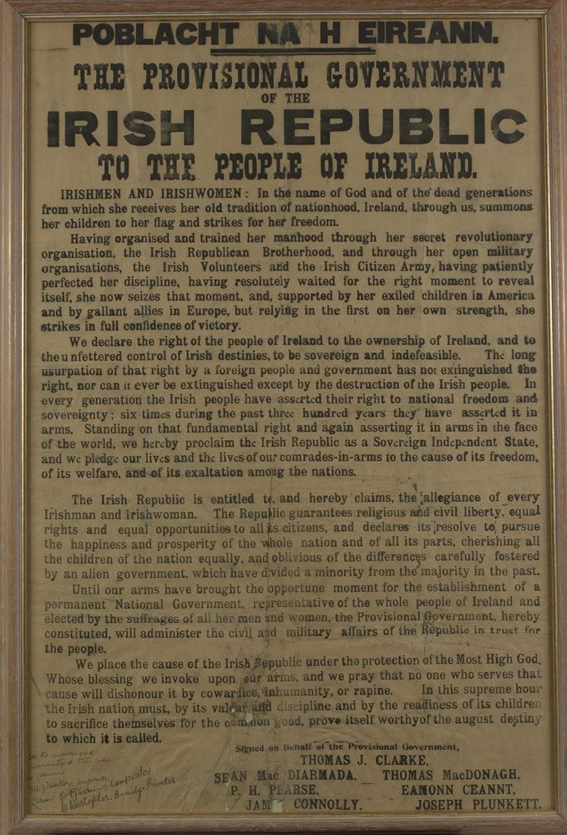
Image 1 -National Museum of Ireland. 1916 Proclamation.

This document was printed in secrecy in Liberty Hall on Easter Sunday and the early morning of Easter Monday by printer Christopher Brady, and compositors Michael Malloy and Liam O’Briain . It was printed on a Warfdale Press in two sections as the limited available typeface required it to be broken up and reformed for the second half. More recently, the National Print Museum reproduced the process, seen in the image below.

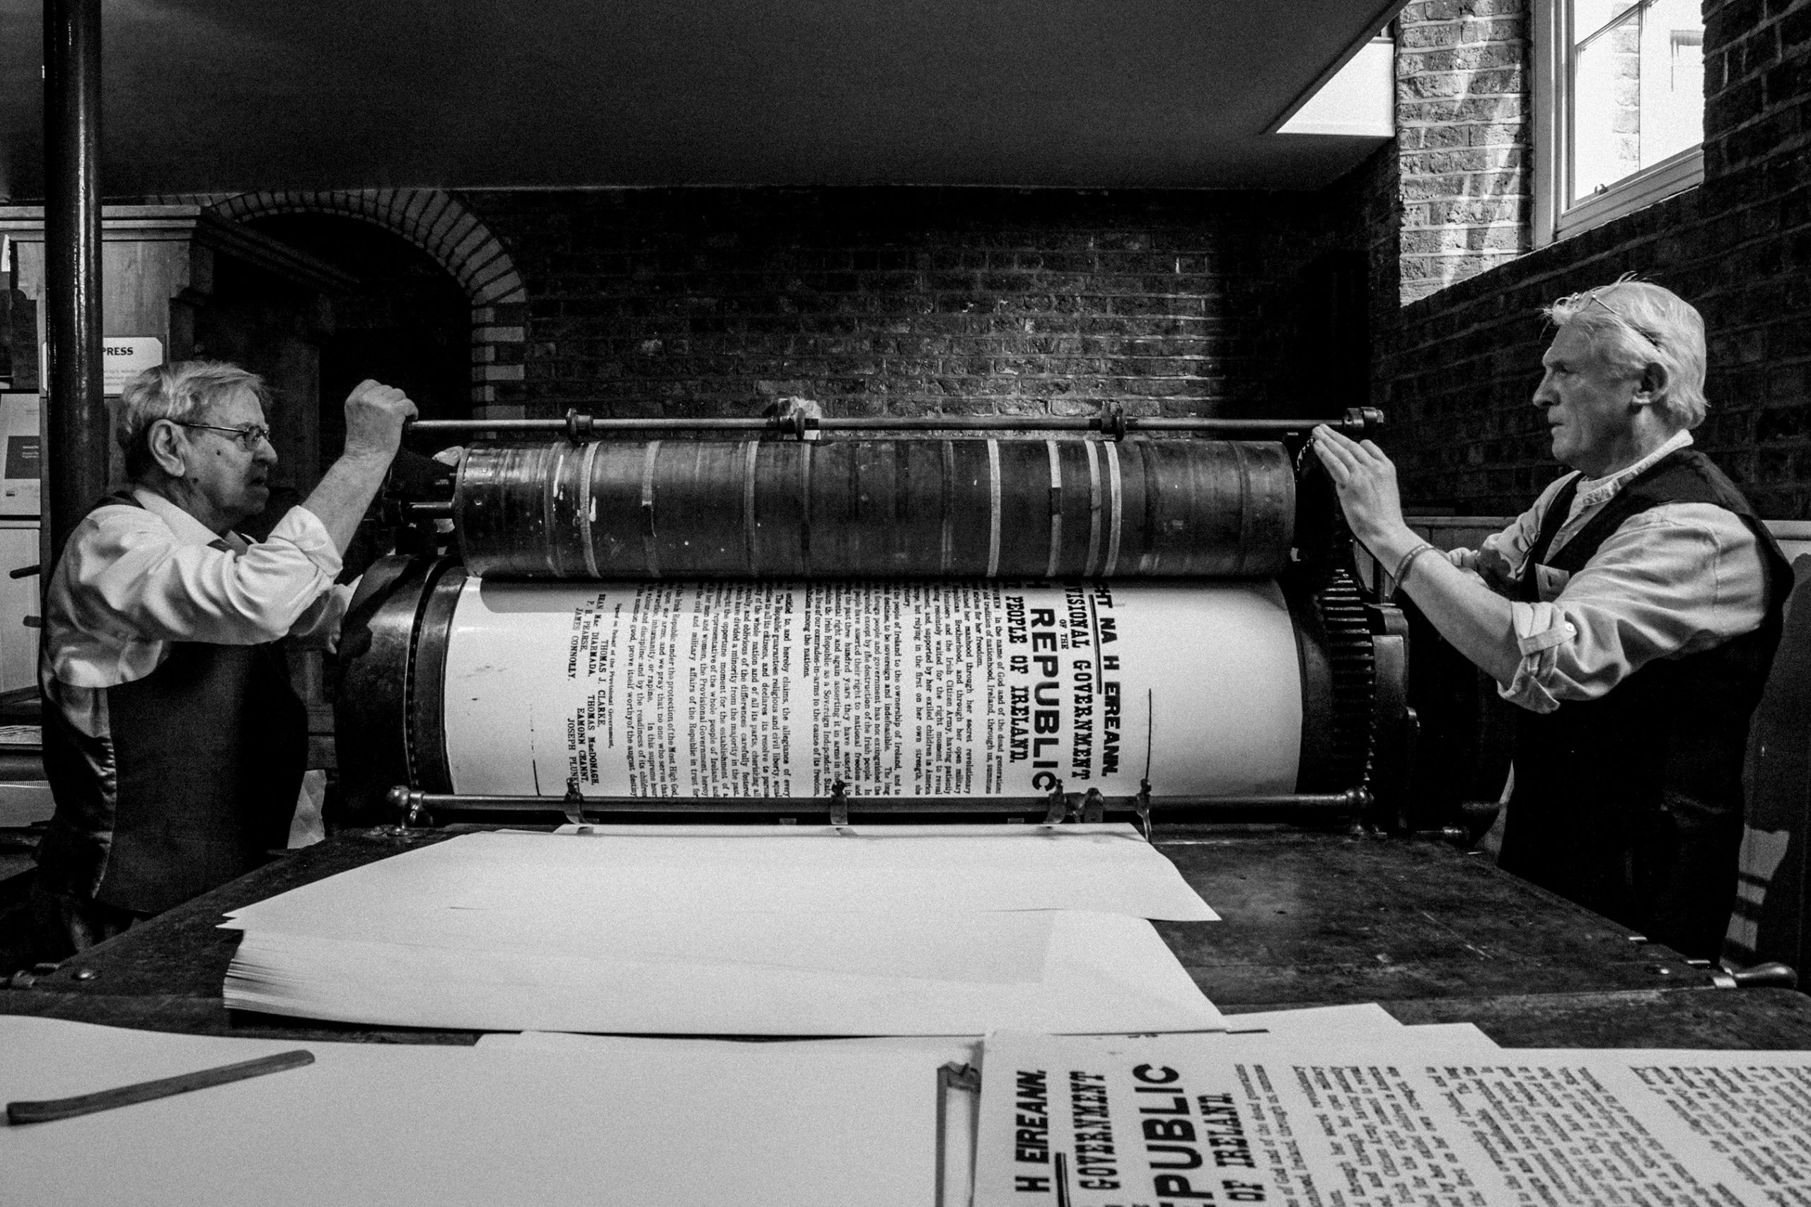

Image 2. National Print Museum. Reproduction of the Proclamation.

Some of the original copies show a difference in inking quality top and bottom, the type changed font for the letter ‘e’, and the ‘R’ was damaged - sealing wax was added to a ‘P’. It is thought 1000 copies were printed and posted around Dublin city walls when the uprising began, but most were destroyed in the fires that followed.

The author.

The Proclamation was drafted by the Military Council of the Irish Republican Brotherhood (IRB) and thought to be mostly composed by Padraig Pearce .
It was read by Pearce (some sources say Thomas Clarke ) a fluent writer and orator he had been chosen to performed speeches at occasions remembering heroes of the Republican movement, such as the Emmet commemoration in 1911, and at the grave of Wolfe Tone in 1913 , as well as over the grave of O’Donovan Rossa in 1915 when he spoke of self-sacrifice- “Life springs from death: and from the graves of patriot men and women spring living nations”.
Pearce was a poet and writer, having got his B.A. and being called to the Bar in 1905. He defended a Donegal farmer who had inscribed his name in Irish letters on his cart . In 1908 he founded a bi-lingual school in Dublin, following educational ideas in advance of their time, combining liberal methods and unyielding nationalism. He saw no incompatibility between roles of educator and propagandist, and after 1910 physical force nationalism. He joined theIRB, progressing to the centre stage, being militant and eloquent at a time when the IRB were rejuvenating and appreciating his potential .
At the point of the uprising, Pearce was the Director of Organization of the Volunteers and in the three-man committee drafting the plan for the insurrection .
The other signatories on this document- Éamonn Ceannt, James Connolly, Joseph Plunkett, Seán MacDiarmada, Thomas MacDonagh, Tom Clarke- would have agreed on the wording, and the influence of Connolly can be seen in the reference to the “ownership of Ireland” being “the right of the people of Ireland”.

The proclamation had many objectives. Its immediate purpose was to communicate an uprising precipitated by armed action in Dublin- to claim occupation in the city and beyond. It called for support and justified the violence and disruption that was to follow. DORA had censored the radical press , and communication between people was difficult and took time, so spreading the word was crucial to the success of the uprising.

The Proclamation was read outside the General Post Office (GPO) in Dublin at around 12.45 on Easter Monday 1916 to a bemused crowd and copies were pasted on walls throughout Dublin. The building had been taken as headquarters by the Provisional Government as a stronghold and centre of communication. A telephone call being made by the Volunteers got through to Cork saying “Dublin has risen: let Cork rise”.

The timing was precipitated by the insurgent’s knowledge that British Intelligence based in Dublin Castle was about to round up activists, but also, they believed a protest in arms was necessary to revive a sense of nationalism . Choosing Easter Monday took advantage of the relaxed holiday sending British officials off to Fairyhouse Races, but also referenced the resurrection symbolism of Easter .

With the First World War waging and Britain facing many losses, support from Germany was sought at a time when it seemed Britain was weak. An arms shipment from Germany, organised by Roger Casement was intercepted and Casement arrested, and with British Intelligence closing in the choice was made by the Military Council to declare the uprising was going ahead. Eoin McNeil, the head of the Volunteers, countermanded this order seeing the impossibility of success, standing down all Volunteer activities for the weekend, placing an advertisement in the Sunday Independent. This lack of coordinated action weakened the uprising.

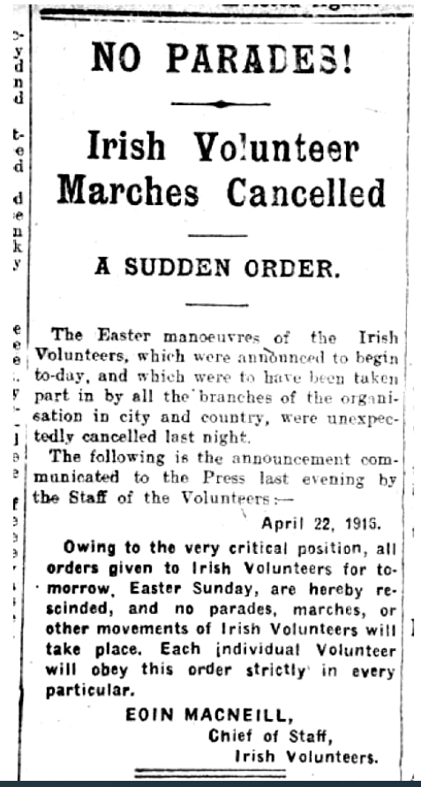
MacNeill’s Irish Volunteer order to call off the Rising that ran April 21, 1916.
Image 3- from Irish America Feb/March 2016

On Easter Monday Pearce, Connolly and Plunket met for a final meeting and took the head of a march accompanied by a handcart carrying their weaponry, to Dublin Castle. The city being relatively undefended because of the holiday, the insurgents attacked the Castle, shooting an unarmed Policeman as he tried to shut the gates, using the guardroom to fire on British forces within the Castle . Sir Arthur Hamilton Norway, Secretary of the Post Office, left the GPO in response to a call for help at the Castle. The insurgents moved into the recently renovated building . The Post Office staff raised the alarm to London via Amiens Street station which remained open (Image 4). Beneath the Tricolour and bearing the words “Irish Republic” in place of the Union Jack, this seat of communication became their stronghold, while other strategic buildings were also occupied ( Image 5) .

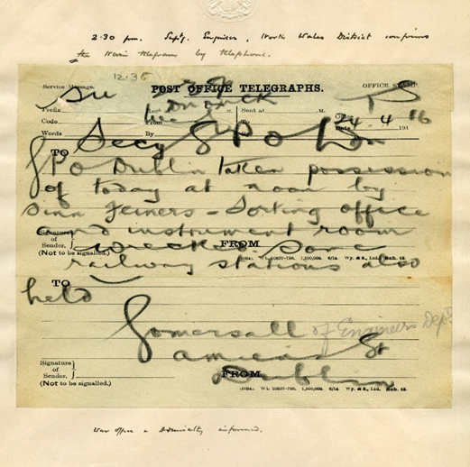
Image 4- from Amiens Street to London. The Postal Museum. 2024.

At this time of War, it was vital for the British to supress this uprising as quickly as possible. They were able to mobilise around 6,000 men from the Dublin barracks and Curragh camp , the main British garrison, known for a mutiny two years previously when officers resigned in the face of imminent action in Ulster, refusing to fire on Unionist resistance to Home Rule .
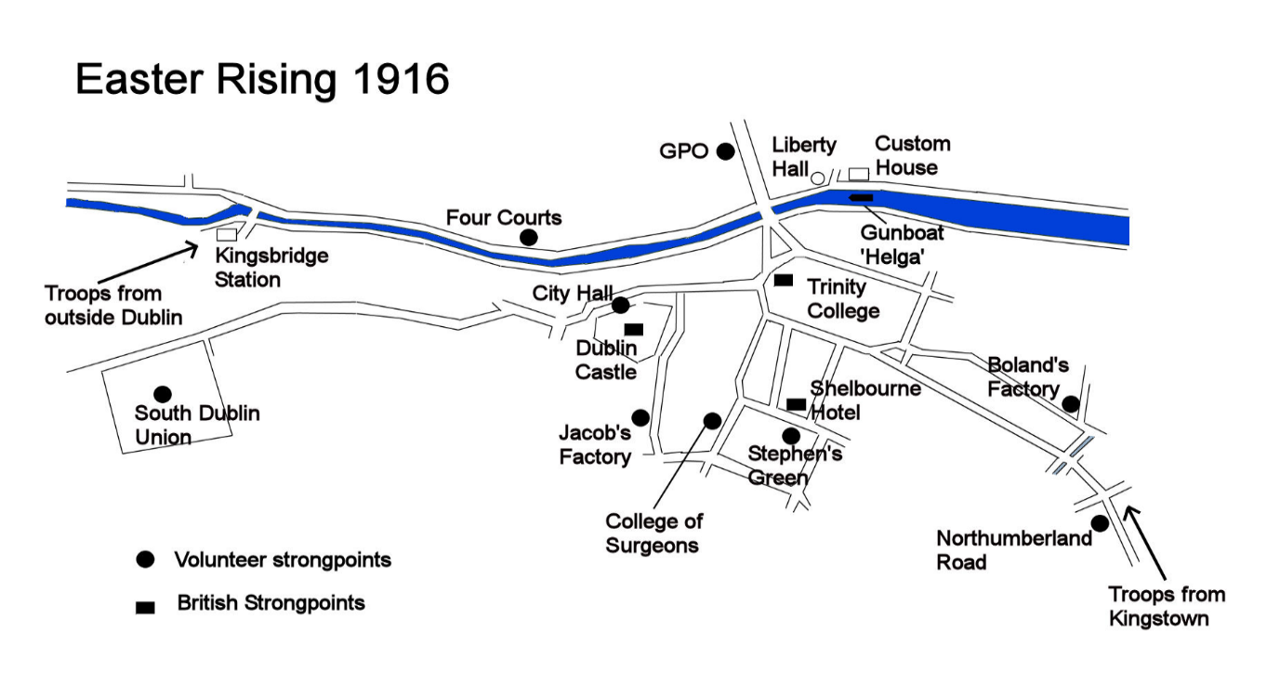
Map showing locations of Irish Volunteers and British Forces during the Rising.
Image 5- from Dublin has Risen. The Postal Museum.

Although armed by German weapons the rebels were driven back in violent street fighting, until only the GPO was held. Men tunnelled through the walls of the houses along Moore Street, to mount an attack on the British barricade, but just prior to action Sean McDermott told them of the decision to surrender .

The destruction of the city burnt most copies of the Proclamation, but a few survive- one taken from the GPO wall by Army Officer Major Tamworth now resides in Trinity College Dublin. It had been pasted over British Army recruitment posters, so particularly resonates with the sentiments of that time.

Content.

With the eloquence of Pearce, the words chosen refer to the long history of abuse of the Catholic Irish, the deliberate division of communities and the removal of land.
In laying out the injustices, it claims “allegiance of every Irishman and Irishwoman”, unusual at the time by including women, and promises equality and liberty to all citizens- laying the blame for divisions on the alien Government.
“Cherishing all the children of the nation equally” was a reference to different religious and political identities .This was a romantic hope that once the alien Government is removed, the population will be able to live alongside eachother, without conflict.
The chronic issue of land is addressed in “the right of the people of Ireland to the ownership of Ireland”, recognising the Land Act is not enough to remedy the history since Plantation, and being only 70 years since the Famine particularly poignant.
Linking the Republic to the Church in the first and last paragraphs, it uses the language of sacrifice as proof of worthiness for the cause of liberation. This is a strongly Catholic symbolism and speaks of the faith of both signatories and the movement. Priests were giving rebels Communion and hearing Confessions before action, and during the uprising and aftermath they ministered to the leaders prior to execution .

Comparison.

The 1916 Proclamation was less radical in terms of class consciousness and internationalism than the one written by the IRB in 1867, delivered to newspapers in London, Australia Belgium and Germany. This uprising was quickly supressed, but the proclamation puts the movement firmly on the international stage, in terms of a Marxist perspective. It uses the language of revolutionaries, in phrases including oligarchy, serfdom, Monarchical Government and aristocratic locusts, and calls on “Republicans of the entire world, our cause is your cause” . It names the English working class “our brethren… it is not only your hearts we wish, but your arms”, and places the uprising alongside international unrest “in the coming struggle for human freedom”. It is an outward looking document speaking to “Republicans of the entire world” and separates Church and State in “absolute liberty of conscience”.

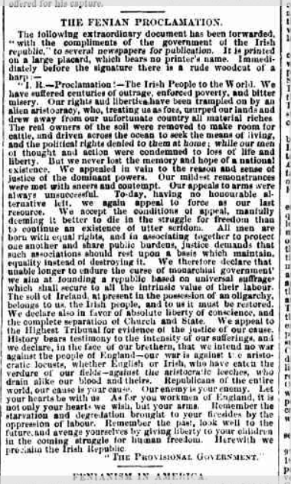
Image 6. The Maitland Mercury and Hunter River General Advertiser.
16th May 1867. Page 2. The Fenian Proclamation.

The 1916 document also calls out for support, but specifically to Ireland’s “exiled children in America” and “gallant allies in Europe” by which it means a German government set on undermining Britain through Ireland in the First World War. There is no concept of the English working class being potential allies, and with many Irish fighting on the Western Front, being allies with the German government would not be popular with many Irish families either.
Having a strong religious stance, the 1916 Proclamation declares “In the name of God….under the protection of the Most High God”, reflecting the beliefs of the signatories and the support received from priests and some orders .

Conclusion.

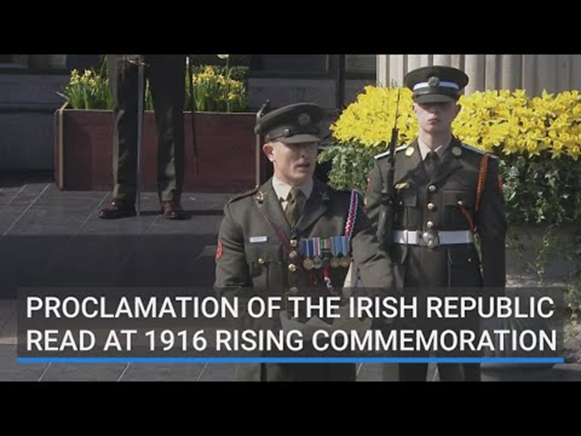
https://youtu.be/nvZwbK0E_i0?si=ZWFJnhpeP0CiU7JG
The reading of the Proclamation now commands reverence and ritual, an attentive audience unlike the bemusement of the original crowd . It is possibly one of the most influential documents in Irish history , and has become powerful, performance poetry, representing all the grief and extreme action required for the Republic to become what it is today.
Analysing the 1916 Proclamation has revealed a complex story of generations of suffering culminating in this doomed uprising, enacted by men who saw the value of blood-sacrifice . The mass production of the document was done in haste and secrecy , and intended to be seen by the population of Dublin and beyond. In straightforward language posted on walls it bypassed DORA and spoke directly to the people. Combined with the takeover of the GPO, the printed Proclamation demonstrated the importance of the written word for the movement. Printing so many for distribution ensured a widespread knowledge of what was happening and enabled some to survive- although the authors and printers would never have guessed the impact it would have through time.
The martyrdom of the signatories and others rapidly led to a swing in public opinion, and a political shift that led to a version of their dream in the form of the Free State. The Proclamation and the uprising were a clear answer to the Irish Question at that time and a turning point in the story of Ireland.

2491.
Images.
- The Proclamation of the Irish Republic. National Museum of Ireland. 2024. Available at: https://www.museum.ie/en-IE/Collections-Research/Collection/Resilience/Artefact/Test-3/fb71e3dc-2e95-4406-bc46-87d8d6b0ae5d Accessed on 20-9-24.
- National Print Museum.2024. Available at: https://www.nationalprintmuseum.ie/product/replica-of-the-1916-proclamation/#:~:text=The%20Proclamation%20is%20intriguing%20from,printers%20were%20short%20of%20type. Accessed on: 25-9-24.
- Image from Irish America Feb/March 2016. Available at: https://www.irishamerica.com/2016/02/eoin-macneill-the-man-who-cried-halt-2/ Accessed on 28-9-24.

- And 5. The Postal Museum. 2024. Available at: https://www.postalmuseum.org/blog/dublin-has-risen/#:~:text=The%20GPO%20became%20the%20Headquarters,the%20steps%20of%20this%20building.&text=Despite%20the%20element%20of%20surprise,to%20secure%20the%20communications%20systems. Accessed on 25-9-24.
- The Maitland Mercury and Hunter River General Advertiser. 16th May 1867. Page 2. The Fenian Proclamation. Available at: https://trove.nla.gov.au/newspaper/article/18718311 Accessed on: 2-10-24.
Bibliography.
A Replica of the 1916 Proclamation of the Irish Republic. National Print Museum. 2024. Available at: https://www.nationalprintmuseum.ie/product/replica-of-the-1916-proclamation/#:~:text=The%20Proclamation%20is%20intriguing%20from,printers%20were%20short%20of%20type. Accessed on 20-9-24.
BBC. Wars & Conflict. The Curragh mutiny.24 September 2014. Available at: https://www.bbc.co.uk/history/british/easterrising/prelude/pr06.shtml Accessed on: 28-9-24.
BBC Wars & Conflict. 1916 Easter Rising. Insurrection. 24 September 2014. Available at: https://www.bbc.co.uk/history/british/easterrising/insurrection/in04.shtml#:~:text=The%20drafting%20of%20the%20Proclamation,the%20others%2C%20particularly%20James%20Connolly. Accessed on 2-10-24.
Burtenshaw, R & Fallon, D. Ireland’s Other Proclamation. Tribune. 05-03-2020. Available at: https://tribunemag.co.uk/2020/03/irelands-other-proclamation#:~:text=However%2C%20a%20little%20over%20150%20years%20ago%2C,unable%20longer%20to%20endure%20the%20curse%20of Accessed on 22-9-24.
Coogan, Tim Pat. Michael Collins: The Man Who Made Ireland. Palgrave Macmillan, 2002. Available at: https://books.google.co.uk/books?hl=en&lr=&id=xscRAhBt2JgC&oi=fnd&pg=PR7&dq=the+man+who+made+ireland&ots=8u14ocoR_N&sig=qnMKFD215A5fIzcy2LEhPyvq1OY&redir_esc=y#v=onepage&q=the%20man%20who%20made%20ireland&f=false Accessed on: 28-9-24.
Cottrell, Jordan. "THE HISTORIOGRAPHY OF THE EASTER RISING." Cover Art & Design: 72. Available at: https://www.csuchico.edu/hist/_assets/documents/chico-historian-2019.pdf#page=86 Accessed on: 25-9-24.
Dublin has Risen. The Postal Museum. 2024. Available at: https://www.postalmuseum.org/blog/dublin-has-risen/ Accessed on 25-9-24.
Easter Rising. National Army Museum. 2024. Available at: https://www.nam.ac.uk/explore/easter-rising Accessed on: 25-9-24.
Geoghegan, P. The Proclamation – The Spirit of 1916 Captured on a Piece of Paper . Trinity College Dublin. 1. February 2016. Available at: https://www.tcd.ie/news_events/articles/the-proclamation--the-spirit-of-1916-captured-on-a-piece-of-paper/#:~:text=Emmet's%20rising%20in%201803%20was%20the%20direct,people%20think%20they%20are%20Napoleon%20or%20God%22. Accessed on: 5-10-24.
Irish Archives Resource. Capuchin Papers relating to the Irish Revolution.2024. Available at: https://iar.ie/archive/capuchin-papers-relating-to-the-irish-revolution/ Accessed on 2-10-24.
Kelly, James. "Official List of Radical Activists and Suspected Activists Involved in Emmet's Rebellion, 1803." Analecta Hibernica 43 (2012): 129-200. Available at: https://www.jstor.org/stable/23317181 Accessed on 5-10-24.
Kelly, M. Is Catholicism being scrubbed from Ireland’s ‘Easter Rising’? CRUX. April 22, 2016. Available at: https://cruxnow.com/church/2016/04/is-catholicism-being-scrubbed-from-irelands-easter-rising Accessed on: 5-10-24.
Kilkenny Archaeological Society. James Stephens. 20th Aug. 2024. Available at: https://kilkennyarchaeologicalsociety.ie/james-stephens-2018/ Accessed on:29-9-24.
Lemass, Seán F. “I Remember 1916.” Studies: An Irish Quarterly Review, vol. 55, no. 217, 1966, pp. 7–9. JSTOR, http://www.jstor.org/stable/30088625. Accessed 2 Oct. 2024.
McDonald, Henry. Original copy of Irish independence proclamation goes on show in Dublin. 2016. The Guardian. Available at: https://www.theguardian.com/world/2016/feb/15/irish-independence-proclamation-display-trinity-college Accessed on: 25-9-24.
Mitchell, Angus, ed. One Bold Deed of Open Treason: The Berlin Diary of Roger Casement 1914-1916. Merrion Press, 2016. Available at: https://books.google.co.uk/books?hl=en&lr=&id=jXVTDQAAQBAJ&oi=fnd&pg=PT7&dq=one+bold+deed+of+treason&ots=gc10fOEpgP&sig=NVXyRv8rpJNqcM50lvTY98o2ztI#v=onepage&q=one%20bold%20deed%20of%20treason&f=false Accessed on: 25-9-24.
No Other Law. Fenian Proclamation, 1867 Proclamation of the Irish Republic, issued February 10th, 1867, by the Irish Republican Brotherhood.1867. Available at: https://www.nootherlaw.com/archive/1867-proclamation.html#:~:text=The%20soil%20of%20Ireland%2C%20at,the%20justice%20of%20our%20cause. Accessed on: 2-10-24.
Norway, Hamilton, The Sinn Fein Rebellion as I Saw It (Project Gutenberg) Available at: https://librarysearch.uwtsd.ac.uk/permalink/44WHELF_UWTSD/1ir6fgh/cdi_gutenberg_primary_43470 Accessed on 5-10-24.
Novick, Benjamin Z. “DORA, Suppression, and Nationalist Propaganda in Ireland, 1914-1915.” New Hibernia Review / Iris Éireannach Nua, vol. 1, no. 4, 1997, pp. 41–57. Available at: https://www.jstor.org/stable/20557442?read-now=1#page_scan_tab_contents Accessed on: 8-10-24.
O’Brien, Connor Cruise. Britannica. Charles Stewart Parnell. Irish leader. 2024. Available at: https://www.britannica.com/biography/Charles-Stewart-Parnell/Parliamentary-maneuvers Accessed on 28-9-24.
O'Dowd, Thomas John, Remembering the Constitution: The Easter Proclamation and Constitutionalism in Independent Ireland (August 3, 2010). UCD Working Papers in Law, Criminology & Socio-Legal Studies Research Paper No. 36/2010, Available at SSRN: https://ssrn.com/abstract=1652843 Accessed on 20-9-24.
‘PROCLAMATION 1625: America’s Enslavement of the Irish’, Kirkus Reviews (Austin: Kirkus Media LLC, 2017) Available at: https://librarysearch.uwtsd.ac.uk/permalink/44WHELF_UWTSD/1ir6fgh/cdi_proquest_reports_1933159448 Accessed on 20-9-24.
Roche, Barry. Proclamation ‘superior’ to US declaration of independence. Historian says 1916 document should be read in entirety not judged on individual phrases. The Irish Times. May 3. 2016. Available at: https://www.irishtimes.com/culture/heritage/proclamation-superior-to-us-declaration-of-independence-1.2633740 Accessed on 22-9-24.
Savage, John, ed. Fenian heroes and martyrs. Boston: P. Donahoe, 1868. Available at: https://books.google.co.uk/books?hl=en&lr=&id=iPULAQAAMAAJ&oi=fnd&pg=PA11&dq=Fenian+Heroes+and+Martyrs.+Edited,+with+an+historical+introduction+on+%E2%80%9CThe&ots=qoNmCQp83B&sig=8JlG69Bw1P9O3npClWPpgXYh3HU&redir_esc=y#v=onepage&q=Fenian%20Heroes%20and%20Martyrs.%20Edited%2C%20with%20an%20historical%20introduction%20on%20%E2%80%9CThe&f=false Accessed on 29-9-24.
The Maitland Mercury and Hunter River General Advertiser (NSW : 1843 - 1893) Thu 16 May 1867 p2 THE FENIAN PROCLAMATION. Available at: https://trove.nla.gov.au/newspaper/article/18718311 Accessed on 29-9-24.
The Proclamation of the Irish Republic. National Museum of Ireland .2024. Available at: https://www.museum.ie/en-IE/Collections-Research/Collection/Resilience/Artefact/Test-3/fb71e3dc-2e95-4406-bc46-87d8d6b0ae5d Accessed on 20-9-24. Accessed on 20-9-24.
The 1916 Proclamation: controversial document that declared an Irish republic. 2024. The Irish Times. Available at: https://www.irishtimes.com/culture/heritage/the-1916-proclamation-controversial-document-that-declared-an-irish-republic-1.2362874#:~:text=The%201916%20Proclamation%20is%20one,for%20more%20than%20%E2%82%AC700%2C000. Accessed on: 25-9-24.
Thornley, David. “Patrick Pearse.” Studies: An Irish Quarterly Review, vol. 55, no. 217, 1966, pp. 10–20. JSTOR, http://www.jstor.org/stable/30088626. Accessed 25 Sept. 2024.
Thornley, David. “Patrick Pearse and the Pearse Family.” Studies: An Irish Quarterly Review, vol. 60, no. 239/240, 1971, pp. 332–46. JSTOR, http://www.jstor.org/stable/30088734. Accessed 25 Sept. 2024.
University College Cork. Easter Week Timeline: Wednesday 26 April 1916. 5 Nov. 2021. Available at: https://www.ucc.ie/en/theirishrevolution/collections/the-story-of-1916/chapter-4-the-uprising-itself/easter-week-timeline-wednesday-26-april-1916/ Accessed on 5-10-24.
University College Cork. 2024. 1916 Proclamation: Home. Available at: https://libguides.ucc.ie/1916Proclamation Accessed on 23-9-24.
World War 1 Articles. The golden locket, the hidden grave and the forgotten soldier : Ireland April 1916. 2013. Available at: https://www.westernfrontassociation.com/world-war-i-articles/the-golden-locket-the-hidden-grave-and-the-forgotten-soldier-ireland-april-1916/ Accessed on: 28-9-24.

Novick, Benjamin Z. “DORA, Suppression, and Nationalist Propaganda in Ireland, 1914-1915.” New Hibernia Review / Iris Éireannach Nua, vol. 1, no. 4, 1997, pp. 41–57. P42.
The Proclamation of the Irish Republic. National Museum of Ireland .2024.
A Replica of the 1916 Proclamation of the Irish Republic. National Print Museum.2024.
University College Cork. 2024. 1916 Proclamation: Home.
Coogan, Tim Pat. Michael Collins: The Man Who Made Ireland. Palgrave Macmillan, 2002.
The 1916 Proclamation: controversial document that declared an Irish republic. 2024. The Irish Times.
Thornley, David. “Patrick Pearse.” Studies: An Irish Quarterly Review, vol. 55, no. 217, 1966, pp. 10–20.
Coogan, Tim Pat. Michael Collins: The Man Who Made Ireland. Palgrave Macmillan, 2002.
Thornley, David. “Patrick Pearse.” Studies: An Irish Quarterly Review, vol. 55, no. 217, 1966, pp. 10–20.
Thornley. pp10–20
Thornley. pp10–20
Geoghegan, P. The Proclamation – The Spirit of 1916 Captured on a Piece of Paper . Trinity College Dublin. 1. February 2016.
Novick, Benjamin Z. “DORA, Suppression, and Nationalist Propaganda in Ireland, 1914-1915.” New Hibernia Review / Iris Éireannach Nua, vol. 1, no. 4, 1997, pp. 41–57. P42.
The Proclamation of the Irish Republic. National Museum of Ireland. 2024.
Coogan, Tim Pat. Michael Collins: The Man Who Made Ireland. Palgrave Macmillan, 2002.
Dublin has Risen. The Postal Museum. 2024.
Coogan, Tim Pat. Michael Collins: The Man Who Made Ireland. Palgrave Macmillan, 2002.
Coogan, 2002.
Kelly, M.Is Catholicism being scrubbed from Ireland’s ‘Easter Rising’? CRUX. April 22, 2016.
Mitchell, Angus, ed. One Bold Deed of Open Treason: The Berlin Diary of Roger Casement 1914-1916. Merrion Press, 2016.
World War 1 Articles. The golden locket, the hidden grave and the forgotten soldier : Ireland April 1916. 2013.
Norway, Hamilton, The Sinn Fein Rebellion as I Saw It (Project Gutenberg)
Coogan, Tim Pat. Michael Collins: The Man Who Made Ireland. Palgrave Macmillan, 2002.
Coogan, Tim Pat. Michael Collins: The Man Who Made Ireland. Palgrave Macmillan, 2002.
BBC Home. The Curragh mutiny. Wars & Conflict. 24 September 2014.
Easter Rising. National Army Museum. 2024.
Lemass, Seán F. “I Remember 1916.” Studies: An Irish Quarterly Review, vol. 55, no. 217, 1966, pp. 7–9.
McDonald, Henry. Original copy of Irish independence proclamation goes on show in Dublin. 2016. The Guardian.
O'Dowd, Thomas John, Remembering the Constitution: The Easter Proclamation and Constitutionalism in Independent Ireland (August 3, 2010). UCD Working Papers in Law, Criminology & Socio-Legal Studies Research Paper No. 36/2010,
Hunter, R.J.2018. Plantations In Ulster.
Kelly, M.Is Catholicism being scrubbed from Ireland’s ‘Easter Rising’? CRUX. April 22, 2016.
The Maitland Mercury and Hunter River General Advertiser (NSW : 1843 - 1893) Thu 16 May 1867 p2 THE FENIAN PROCLAMATION.
Savage, John, ed. Fenian heroes and martyrs. Boston: P. Donahoe, 1868. pp174.
No Other Law. Fenian Proclamation, 1867 Proclamation of the Irish Republic, issued February 10th, 1867, by the Irish Republican Brotherhood.1867.
Irish Archives Resource. Capuchin Papers relating to the Irish Revolution.2024.
Coogan, Tim Pat. Michael Collins: The Man Who Made Ireland. Palgrave Macmillan, 2002.
The 1916 Proclamation: controversial document that declared an Irish republic. 2024. The Irish Times.
Coogan, Tim Pat. Michael Collins: The Man Who Made Ireland. Palgrave Macmillan, 2002.
The Proclamation of the Irish Republic. National Museum of Ireland .2024.

