Living with care: The older person
Assignment 2

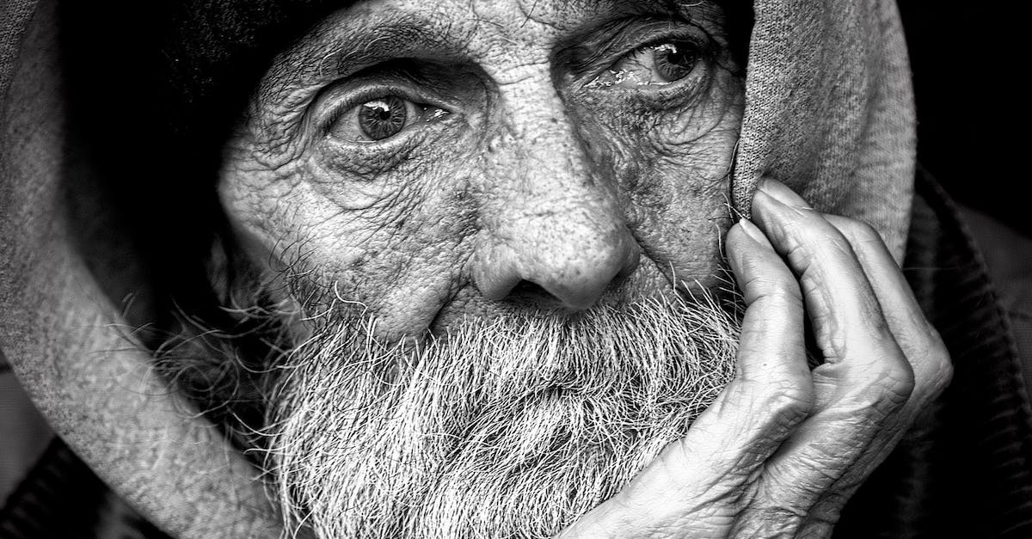

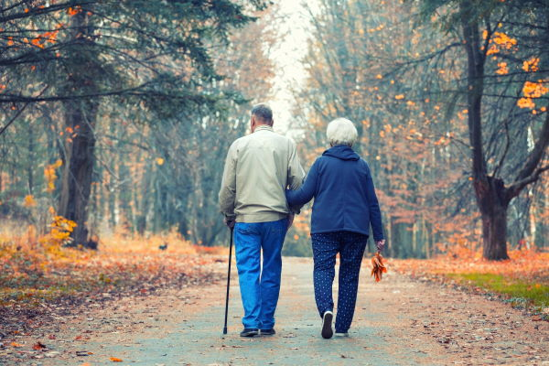

Student Name: Natalie Tully
Student Number: 2025743
Lecture: Joanne Davies
Module code: BMHP6009_BIRM

Content

Introduction
This report’s objective is to assess the support needs of an elderly gentleman, who has medical health problems while exploring how these conditions affect his day-to-day life. By also considering the seven physical needs of the elderly which can be met by using Maslow's theory and person-centered approach. This report will aim to explore how the legislation and rights of the elderly are upheld and if there is a gap within the health services what is being done to meet standards of care for the elderly. This report will also investigate how vulnerable a person could be through different forms of abuse and discrimination. Furthermore, this report will outline the need for health provisions to be more accessible and affordable by looking into A.I technology aid support to enable him to be more independent. For this report, Ezra Taylor will be known as ET (see Appendix 1).
According to (UNHCR, n.d.) someone who is over 60 is considered an older person. Families and communities, however, frequently use additional socio-cultural indicators, such as family status (grandparents), appearance, or age-related health issues, to define age. There are many more definitions of old age, for this report will explore how the impact of how society sees older people.
According to World Health Organization, (2022) “In 2050, 80% of older people will be living in low- and middle-income countries” This indicates the growing pace is much faster than in the past. With the world's growing population over 60 nearly doubling over time, older people are living longer due to medical advances and improvements in social and environmental changes as stated by the World Health Organization, (2022), “improving physical and mental capacity and delaying care dependency” At the same time, exploring health services and interventions, including policy in place.
If we don’t improve the way, we provide support to older people then the NHS will struggle to meet the increasing demand for resources as well as changing patient needs.
Ezra’s Background
ET is a 65-year-old male who has a diagnosis of diabetes, urinary incontinence, and early signs of arthritis. He lives on his own on the third floor of a flat which he can only access via the stairs. Although he has been diagnosed with health needs, he is very active and attends the local gym several times a week and regularly walks to the shops.ET is independent and does not like to rely on family, friends, or services around him.
There is a potential that his health needs can be impacted due to his health needs worsening. ET has an early diagnosis of arthritis, and as he gets older, this may impact him more physically. Personally, this will impact ET's love for the gym as he will not be able to do what he can. This is emotionally worrying for ET as he is aware this may stop him from physically being mobile, and this will impact him socially by stopping him from going out. ET’s arteritis will impact ET as he will be limited to going out as he does not have access to a lift to enter and leave his property which in turn will make him more dependent on others.
ET was diagnosed with type 2 diabetes in his late 40s and from this, he developed a love for the gym to manage this as the diagnosis impacted his mental health. ET.
Health and social care needs.
According to the NHS England, (2014) “Care needs to be just as important as treatment. Older people should be properly valued, listened to, and treated with compassion, dignity, and respect always. They need to be cared for by skilled staff who are engaged and understand the needs of older. people and have time to care” (NHS England, 2014). These are core principles that need to be considered for ET to remain empowered and independent within his own home if support is needed.
Medical care -ET's medical needs can be managed at home and therefore he does not require medical care however if his medical needs become unmanageable, he may need to be cared for in a setting. If this was the case, then ET could be supported by a geriatrician, who is experienced in supporting older people with compassion and they can adopt a holistic, patient-centric approach. But also enable patients to be supported at home. Which is valuable for ET to maintain independence as much as possible (NHS, 2015).
Mental health issues - Several illnesses are linked to depression.
Both arthritis and depression are dependent on each other. Arthritis can cause depression and chronic depression may further lead to the worsening of the symptoms of the disease.
According to a study by Onubogu (2014), depression symptoms are brought on by pain in addition to other chronic symptoms of arthritis in older people.
Mobility- ET has arthritis, and is struggling with his joints sniffing up, at times finding it hard to walk up the stairs to his flat, also in turn can affect him going to the gym less often than he likes. This has a huge impact on ET's health and well-being. Could request a referral to physical therapy, which can assess his mobility limitations. According to nhs.uk, (2017), Pain can be lessened and prevented by exercising. Regular exercise can additionally: increase the range of motion in your joints, strengthen muscle power, decrease stiffness, and regain energy.
Social care needs - Social needs are crucial fundamental human needs. Unfulfilled social needs might result in issues with one's physical and mental health. The requirement for older persons to maintain their health and live in the community makes it crucial to meet their social demands. Diversity, proximity, the significance of the relationship, and reciprocity emerged as themes. These themes had numerous consequences for interventions. involvement in hobbies, and volunteer work, both a sense of independence and a sense of belonging to others, a community, or a neighbourhood, promote well-being. Social requirements are met by remaining engaged through volunteer work or involvement in (leisure) social activities. Interventions should therefore have a special emphasis on the older adult's freedom, engagement, and sense of connection (BRUGGENCATE, LUIJKX and STURM, 2017).
ET's social care needs are met by his interaction at his local gym, where he has built core relationships by attending exercise classes and feels a part of his local community. Covid had a huge impact on his social care needs, as he could not access the gym. Which made ET isolated as he has no family networks.
Covid-19 - Over the past couple of years, the Covid-19 pandemic has had a detrimental impact on the world. The pandemic has been particularly hard on older people with existing medical conditions, and those who were shielded were less likely than those who did not to be experiencing increased anxiety since the lockdown. As stated by Age UK, (2020) “Research finds that some older people are coping with the pandemic, but a sizeable minority are finding life incredibly tough. Those who are not very well and have long-term health conditions were particularly likely to report that this is an extremely challenging time for them. The study shows that many older people are enduring increased and sometimes devastating levels of anxiety, in part because they know they are at serious risk from the virus – an invisible deadly enemy”.
Due to ET’s age and medical conditions, he was classed as vulnerable during the pandemic which impacted his mental health and general health.
Diabetes patients noticed that they were eating less nutritiously and having become less active than normal. Consequently, this has a significant effect on the blood sugar levels of diabetics, increasing their likelihood of long-term problems from the disease, as well as various other aspects of their general health (Diabetes UK, n.d.).
Due to ET’s diabetes and arthritis, he attended his GP pre-covid for his diabetic and regular health check-ups, this supported his independence and the opportunity to socialise, however, due to the lockdown, he was unable to attend appointments as they were mainly virtual or over the phone. This impacted him as he was unable to leave to go to his GP however his medical needs were still being met as he had a nurse visit him to check his diabetes and arthritis although this was not as regular as his GP appointments.

Support and intervention
For the best interests of ET, there needs to be early intervention put before the distortion

THEORY
According to Study.com (2022), Psychosocial theories emphasise the social, mental, and emotional elements of aging. Activity theory, disengagement theory, and continuity theory are the three main psychosocial theories on aging.

The Disengagement theory
Elaine Cumming and William Earle Henry introduced the disengagement theory in their 1961 book "Growing Old," which is a theory of aging. According to this theory, everyone tends to isolate themselves from the greater community, including social standards, their position in the community, and other members of society (Group, 2019).
This is one thing that is worrying ET, He values himself as being independent and not having to rely on anyone, but he also is aware that he could become isolated if his arthritis worsens and unable to get to his local gym, as ET feels the gym makes him feel empower and he is encouraged to maintain a healthy diet and exercise regularly by his peers. If this is an issue in the future, ET will need support from services to prevent isolation from his peers, as ET does not have any family networks or socialise outside the gym.
Activity theory
In 1961, Gerontologist Robert J. Havighurst created the activity theory of aging. The concept underpinning it is that older adults who are active are content with their lives compared to individuals who are not. According to the activity hypothesis of aging, by taking on new roles in place of their old ones, older persons can maintain the same amount of activity and social involvement as they did in their younger years. For instance, the function of volunteering can take the place of the role of employment. According to activity theory, taking on new tasks and staying active help people improve their feelings about themselves and cope with aging (Nimish Biloria, Sebag and Robertson, 2023 and Nieboer et al., 2005).
Due to ET's background as a personal trainer, he has always tried to maintain his fitness levels, and has been quoted by ET “Respect is everything, I’m nothing without that!” (See appendix 1). Meaning that he would not want to be seen as being weak or vulnerable, and that being active is his purpose in life it’s all he knows and loves. which could be a great concern if he needed support services, ET would need a person centre approach to engage and encourage him to reach out for support if needed (see appendix 2), thinking of him as an individual, not as statics of the older generation.

Continuity theory
In the late 1960s, Havighurst and colleagues recognized that neither activity, subculture nor disengagement theories fully explained successful aging (Havighurst, Neugarten, & Tobin, 1968). Borrowing from psychology, they created Continuity. eory, which hypothesizes that personality in? uences the roles we choose and how we enact them. ? is in turn in? uences satisfaction with living. Continuity? eory suggests that personality is well developed by the time we reach old age and tends to remain consistent throughout our lives.

At the same time that activity theory was being developed, Maslow (1954), a psychologist, published the human needs theory. In this theory, Maslow surmised that a hierarchy of? ve needs to motivate human behavior: physiologic, safety and security, love and belonging, self-esteem, and self-actualization. ? These needs are prioritized such that more basic needs like physiological functioning or safety take precedence over personal growth needs (love and belonging, self-esteem, and self-actualization). THIS NEEDS TO BE REWORDED TO FLOW TO MASLOW
Atchley R (1989) USE THIS AS A REFERENCE

As ET was unable to socialise and maintain his independence

• Is domiciliary care needed or a nursing home? Conditions may get worse, no family networks
• Would third-sector support be needed, for charities…?
• Would advocacy be beneficial to Ezra? Housing?
• Will the support be person-centered?
• Is the support readily available and is there any gap between the need and availability? (now and in the future) ? funding and resources
• What policy and legislation are relevant to this? Care act, safeguarding, mental health act.
• What theory links in with this, Maslow…

According to the Centers for Disease Control and Prevention (CDC), arthritis is more common among adults aged 65 years or older, but people of all ages (including children) can be affected. "Nearly two-thirds of people with arthritis are younger than 65. Arthritis is more common among women (26%) than men (19%) in every age group, and it affects members of all racial and ethnic groups. Arthritis is also more common among adults who are obese than among those who are normal weight or underweight

References

‌ Atchley R., 1989. A continuity theory of normal aging. The Gerontologist 29: 183-190.
ONS.Gov.UK (2018). Living Longer - Office for National Statistics. (online) Ons.gov.uk. Available at: https://www.ons.gov.uk/peoplepopulationandcommunity/birthsdeathsandmarriages/ageing/articles/livinglongerhowourpopulationischangingandwhyitmatters/2018-08-13 (Accessed: 22nd August 2023).

BRUGGENCATE, T.T., LUIJKX, K.G. and STURM, J. (2017). Social needs of older people: a systematic literature review. Ageing and Society, (online) 38(9), pp.1745–1770. doi:https://doi.org/10.1017/s0144686x17000150.
‌
Diabetes UK. (n.d.). The effects of coronavirus on the health of people with diabetes. (online) Available at: https://www.diabetes.org.uk/research/our-research-projects/scotland/effects-of-coronavirus (Accessed: 19 August 2023).

‌Group, S. (2019). Definition of the Disengagement Theory of Aging. (online) Sociology Group: Welcome to Social Sciences Blog. Available at: https://www.sociologygroup.com/disengagement-theory/#google_vignette (Accessed: 13th August 2023).
NHS (2015). Geriatric medicine. (online) Health Careers. Available at: https://www.healthcareers.nhs.uk/explore-roles/doctors/roles-doctors/medicine/geriatric-medicine (Accessed: 18 August 2023).

‌ NHS England (2014). England Safe, compassionate care for frail older people using an integrated care pathway. (online) Available at: https://www.england.nhs.uk/wp-content/uploads/2014/02/safe-comp-care.pdf (Accessed: 23rd August 2023).

nhs.uk. (2017). Arthritis - Living with arthritis. (online) Available at: https://www.nhs.uk/conditions/arthritis/living-with/#:~:text=As%20long%20as%20you%20do (Accessed: 24 August 2023).

Nieboer, A., Lindenberg, S., Boomsma, A. and Bruggen, A.C.Van. (2005). Dimensions Of Well-Being And Their Measurement: The Spf-Il Scale. Social Indicators Research, 73(3), pp.313–353. doi:https://doi.org/10.1007/s11205-004-0988-2.

Nimish Biloria, Sebag, G. and Robertson, H. (2023). The Empathic City. Springer Nature.

Onubogu, U.D. (2014). Pain and Depression in Older Adults With Arthritis. Orthopaedic Nursing, 33(2), pp.102–108. doi:https://doi.org/10.1097/nor.0000000000000035.

Study.com. (2022). Available at: https://study.com/academy/lesson/psychosocial-theories-of-aging-activity-theory-continuity-theory-disengagement-theory.html#:~:text=Psychosocial%20theories%20focus%20on%20the (Accessed: 20 August 2023).

‌

UNHCR. (n.d.). Older persons. (online) Available at: https://emergency.unhcr.org/protection/persons-risk/older-persons (Accessed: 22nd August 2023).

‌

‌

World Health Organization (2022). Aging and health. (online) World Health Organization. Available at: https://www.who.int/news-room/fact-sheets/detail/ageing-and-health (Accessed: 22nd August 2023).

‌ Age UK (2020). Age UK Research on Impact of the Pandemic on Our Older Population’s Health. (online) Age UK. Available at: https://www.ageuk.org.uk/latest-press/articles/2020/10/age-uk--research-into-the-effects-of-the-pandemic-on-the-older-populations-health/ (Accessed 22nd August 2023).

‌

‌

