

Module name: Foreign Languages and Cultural Awareness
(BMIH5003)
Lecturer name: Giulia Chifari
Student Name: Daniela-Elena Zota
Student ID number: 2240973
1st Assignment
Number of words: 1639 + Presentation
Portfolio

Component 1
Cultural misunderstandings occur when individuals act according to their own cultural norms and values, which are then misinterpreted by others (Ting-Toomey, 1999). Spencer-Oatey and Franklin (2009) add that these misunderstandings happen when people fail to recognise or correctly interpret cultural signals, resulting in inappropriate or ineffective responses.
During dinner service at the Novotel Southampton Hotel restaurant, I observed a situation where a Hindu guest was advised on the dinner specials, which included the Chef’s special beef burger and steak. The guest appeared uncomfortable and politely declined the recommendations, explaining their dietary restrictions due to religious beliefs.
Cultural misunderstandings within the hospitality industry are frequent, owing to its global reach and diverse clientele. These misunderstandings often arise from disparities in values, customs, and beliefs. In the presented situation, the misunderstanding originated from a failure to recognise the guest's cultural and religious dietary constraints. Hinduism, renowned for its multifaceted practices, frequently entails dietary principles that prohibit the consumption of beef due to the revered status of cows.
Effectively managing cultural problems requires a thorough understanding of different cultures and strategies to handle cultural differences. However, cross-national or cross-cultural parties do not always make efforts to manage these differences, and some may even ignore their impact. Neglecting or misunderstanding cultural differences can result in either minor or significant consequences (Fila & Wilson, 2018).
To avoid similar cultural misunderstandings in the future, I acknowledge the significance of gaining specific skills and adjusting my behaviour. Firstly, I aim to undergo cultural awareness trainings to deepen my comprehension of diverse cultural customs, especially concerning dietary limitations. Engaging in such training sessions will provide me with the requisite insights to discern and honour the dietary preferences and constraints of guests from diverse cultural backgrounds.
Enhancing my communication skills is imperative to sensitively engaging with guests from varied cultural backgrounds. This entails actively listening to their needs and preferences, posing pertinent questions, and offering alternatives or adjustments to accommodate their requirements with respect and consideration.
Cultivating empathy towards guests and fostering sensitivity to their cultural beliefs and practices is paramount. By empathising with guests and contemplating how my actions and suggestions might be interpreted from their cultural standpoint, I can mitigate the risk of unknowingly causing offence or discomfort.
I am committed to actively soliciting feedback from colleagues and supervisors concerning my interactions with guests, especially regarding cultural sensitivity. By integrating this feedback into my professional growth, I can continually enhance and fine-tune my approach to ensure that I deliver inclusive and respectful service to all guests.
In conclusion, the incident at the Novotel Southampton Hotel restaurant underscores the critical significance of cultural awareness and sensitivity in the food and beverage industry. Research indicates that culturally sensitive employees deliver superior service to foreign customers by adapting their serving styles to meet diverse needs (Sharma et al., 2012). This adaptability is highly beneficial, as it allows these employees to create a favourable impression on hospitality settings’ guests, leading to increased revenue through effective suggestive selling.

Component 2
Maintaining cultural awareness in the provision of services is essential within the hospitality sector, especially within varied settings such as Novotel Southampton Hotel, where we host thousands of guests annually, due to the regular transit of cruise ships. The objective of this training program is to provide all staff members with the essential expertise and capabilities to avoid and effectively manage cultural misinterpretations, such as suggesting guest foods that would offend their cultural or religious beliefs.
1. Cultural Awareness Training
We will conduct interactive training sessions on cultural awareness for all F&B staff, emphasising diverse cultural practices, beliefs, and food preferences. Our sessions will cover dietary restrictions observed by various cultures, such as Islam and Hinduism, and stress the importance of avoiding religiously sensitive items like beef or pork. Our hotel staff are as diverse as our guests; therefore, our training could benefit from our colleagues sharing personal insights about their cultural background and traditions. This training aims to enhance our staff's understanding and respect for our guests' dietary needs and social habits, ensuring a more inclusive and respectful altogether experience while not crossing the fine line towards stereotyping. Individuals engaged in intercultural training, education, or development must understand the significance of culture and cultivate effective cross-cultural communication skills to effectively engage with foreign guests (Abramson & Moran, 2017).
2. Communication Skills Training
We will provide communication skills training that emphasises successful cross-cultural communication and interpretation of non-verbal signals. This program will incorporate instructions on delicately addressing dietary preferences and offering alternative choices tailored to guests' cultural backgrounds. Kuhnke (2016) highlights the importance of body language, intensity of smiles, use of a certain hand or tone of the voice in establishing effective cross-cultural communication. Improving our communication abilities will enable us to comprehend and address our guests' requirements effectively, fostering a respectful and inclusive setting.
3. Menu Adaptation and Recommendations
We will explore methods of adjusting the menu to accommodate a variety of dietary preferences, such as vegetarian and non-beef choices. Our goal is to empower our staff to suggest culturally suitable dishes to patrons in line with their preferences, thereby preventing any cultural insensitivity. Foskett, Paskins & Pennington (2021) advise that catering to guests' food preferences on on a cultural level is one of the crucial aspects in the hospitality industry. By adopting this approach, we aim to cater to our guests' dietary preferences effectively and to create a welcoming and inclusive dining environment.
4. Conflict Resolution Training
We will offer conflict resolution training to empower our employees to address misunderstandings or complaints in a sensitive and efficient manner. This training will underscore the significance of active listening, empathy, and discovering mutually agreeable resolutions for cultural differences. By strengthening these abilities, we aim to guarantee a respectful and proficient method for addressing all concerns, thereby enhancing guest satisfaction, and fostering a harmonious atmosphere.
5. Role-Playing Scenarios and Feedback
We will engage in role-playing activities to replicate cultural miscommunication situations, offering valuable feedback on our team members' reactions. We promote an environment where team members are encouraged to share their perspectives and experiences to improve our collective understanding and cultural proficiency.
Novotel Southampton Hotel can make its staff more understanding of different cultures by using this training plan. This will help avoid cultural misunderstandings and make guests feel welcome and valued, no matter where they come from.

Component 3
My personal experience with cultural awareness has started the moment I moved from my home country, Romania, first to Italy where I worked in the F&B industry. However, the true impact over my experience has constituted my moving to UK where I was exposed to the most diverse mix of cultures. In this process of self-examination, I intend to critically evaluate my grasp of the importance of cultural awareness in the hospitality sector. Using reflective analysis, I will review how my understanding of cultural awareness has evolved, pinpoint essential insights gained, and underscore the value of this journey. The reflective approach employed is rooted in Kolb's experiential learning theory, encompassing four phases: concrete experience, reflective observation, abstract conceptualisation, and active experimentation (Kolb, 1984).
Concrete Experience
At first, my understanding of cultural awareness within the hospitality industry was confined to basic familiarity with diverse cultures, languages, and traditions. Joining the International Hotel Management program widened my understanding of other cultures and modern procedures of the industry. Yet, being part of a multicultural team in a high-end hotel broadened my horizons by exposing me to a variety of viewpoints and methods, prompting a reevaluation of my initial assumptions. It was a very enlightening experience to notice how coworkers with a deeper cultural understanding effortlessly managed these distinctions by adjusting their service approach to fulfil the distinct requirements of every guest. Engaging with guests from assorted cultural backgrounds emphasised the significance of offering tailored, personalised services that cater to individual preferences.
Reflective Observation
Upon reflecting on my experiences, I have come to understand that cultural awareness transcends mere superficiality. It entails the recognition and respect for diversities, adjustment of communication strategies, and anticipation of needs guided by cultural intricacies. I have gained an appreciation for the significance of cultural competence in enhancing customer satisfaction and fostering loyalty. As an instance, I have witnessed how engaging in casual conversations about guests' cultural customs not only improved their overall experience but also cultivated a strong sense of rapport and connection. As advised by Hofstede (2010), surviving in a multicultural world requires understanding one's own cultural values first, followed by the cultural values of others with whom cooperation is necessary.
Abstract Conceptualisation
From this experience, I found out that understanding different cultures is not just about noticing how they are different, but also about valuing and including those differences when serving people. Being culturally aware will positively impact the guests, this resulting in good reviews and establishing loyalty. Reisinger and Turner (2003) say that cultural differences affect how tourists act and what they expect, so it is very important for people in hospitality to know about different cultures. Mendenhall et al. (2012) also say that being able to adapt to new cultures, which they call cultural intelligence, is equally important in international hospitality.
Active Experimentation
To improve my understanding of different cultures, I took active steps like reading more on cultural sensitivity, picking up simple phrases in various languages, and asking colleagues and guests for advice. By using these methods in my everyday interactions, I noticed better guest satisfaction ratings and got positive comments about my cultural awareness and consideration.
To sum up, this journey of self-reflection has changed how I see cultural awareness in hospitality. I have moved from just knowing about cultural differences to truly understanding how they affect customer experiences. Embracing cultural diversity and actively working on cultural awareness has made me more prepared to handle the challenges of the global hospitality world.

Component 4 – Presentation
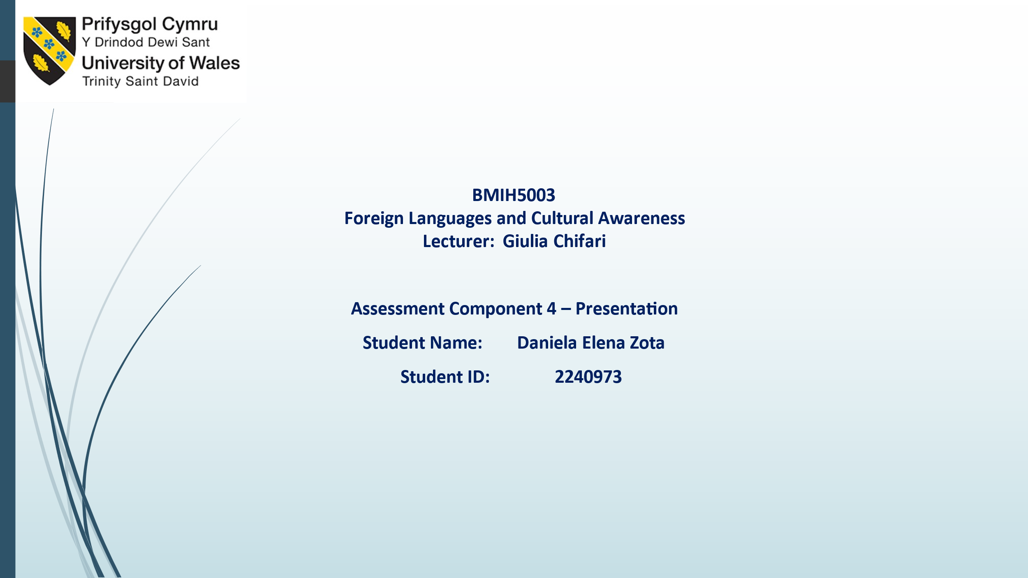


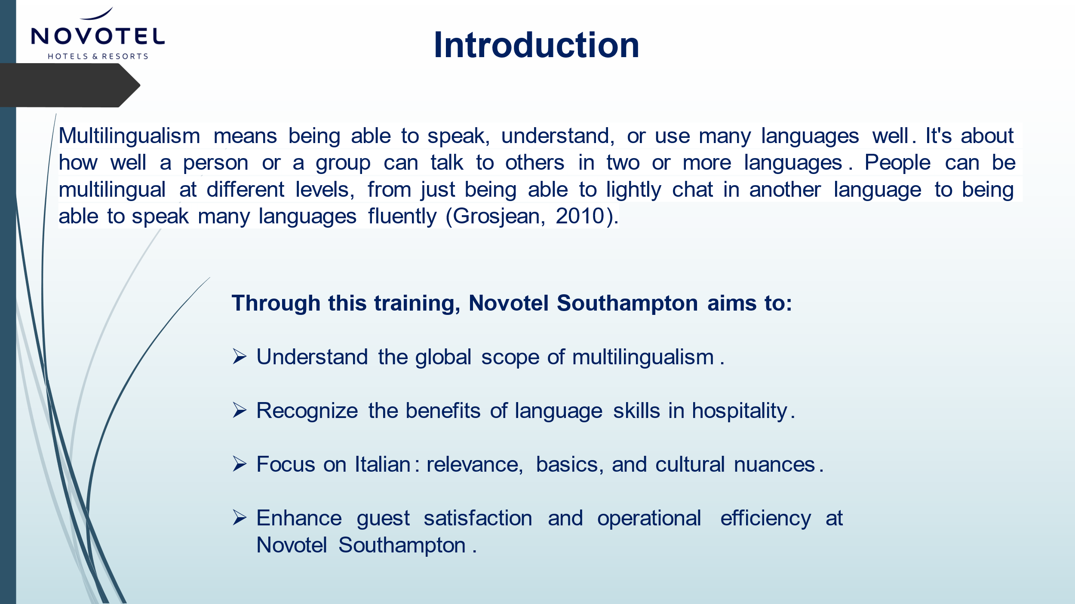

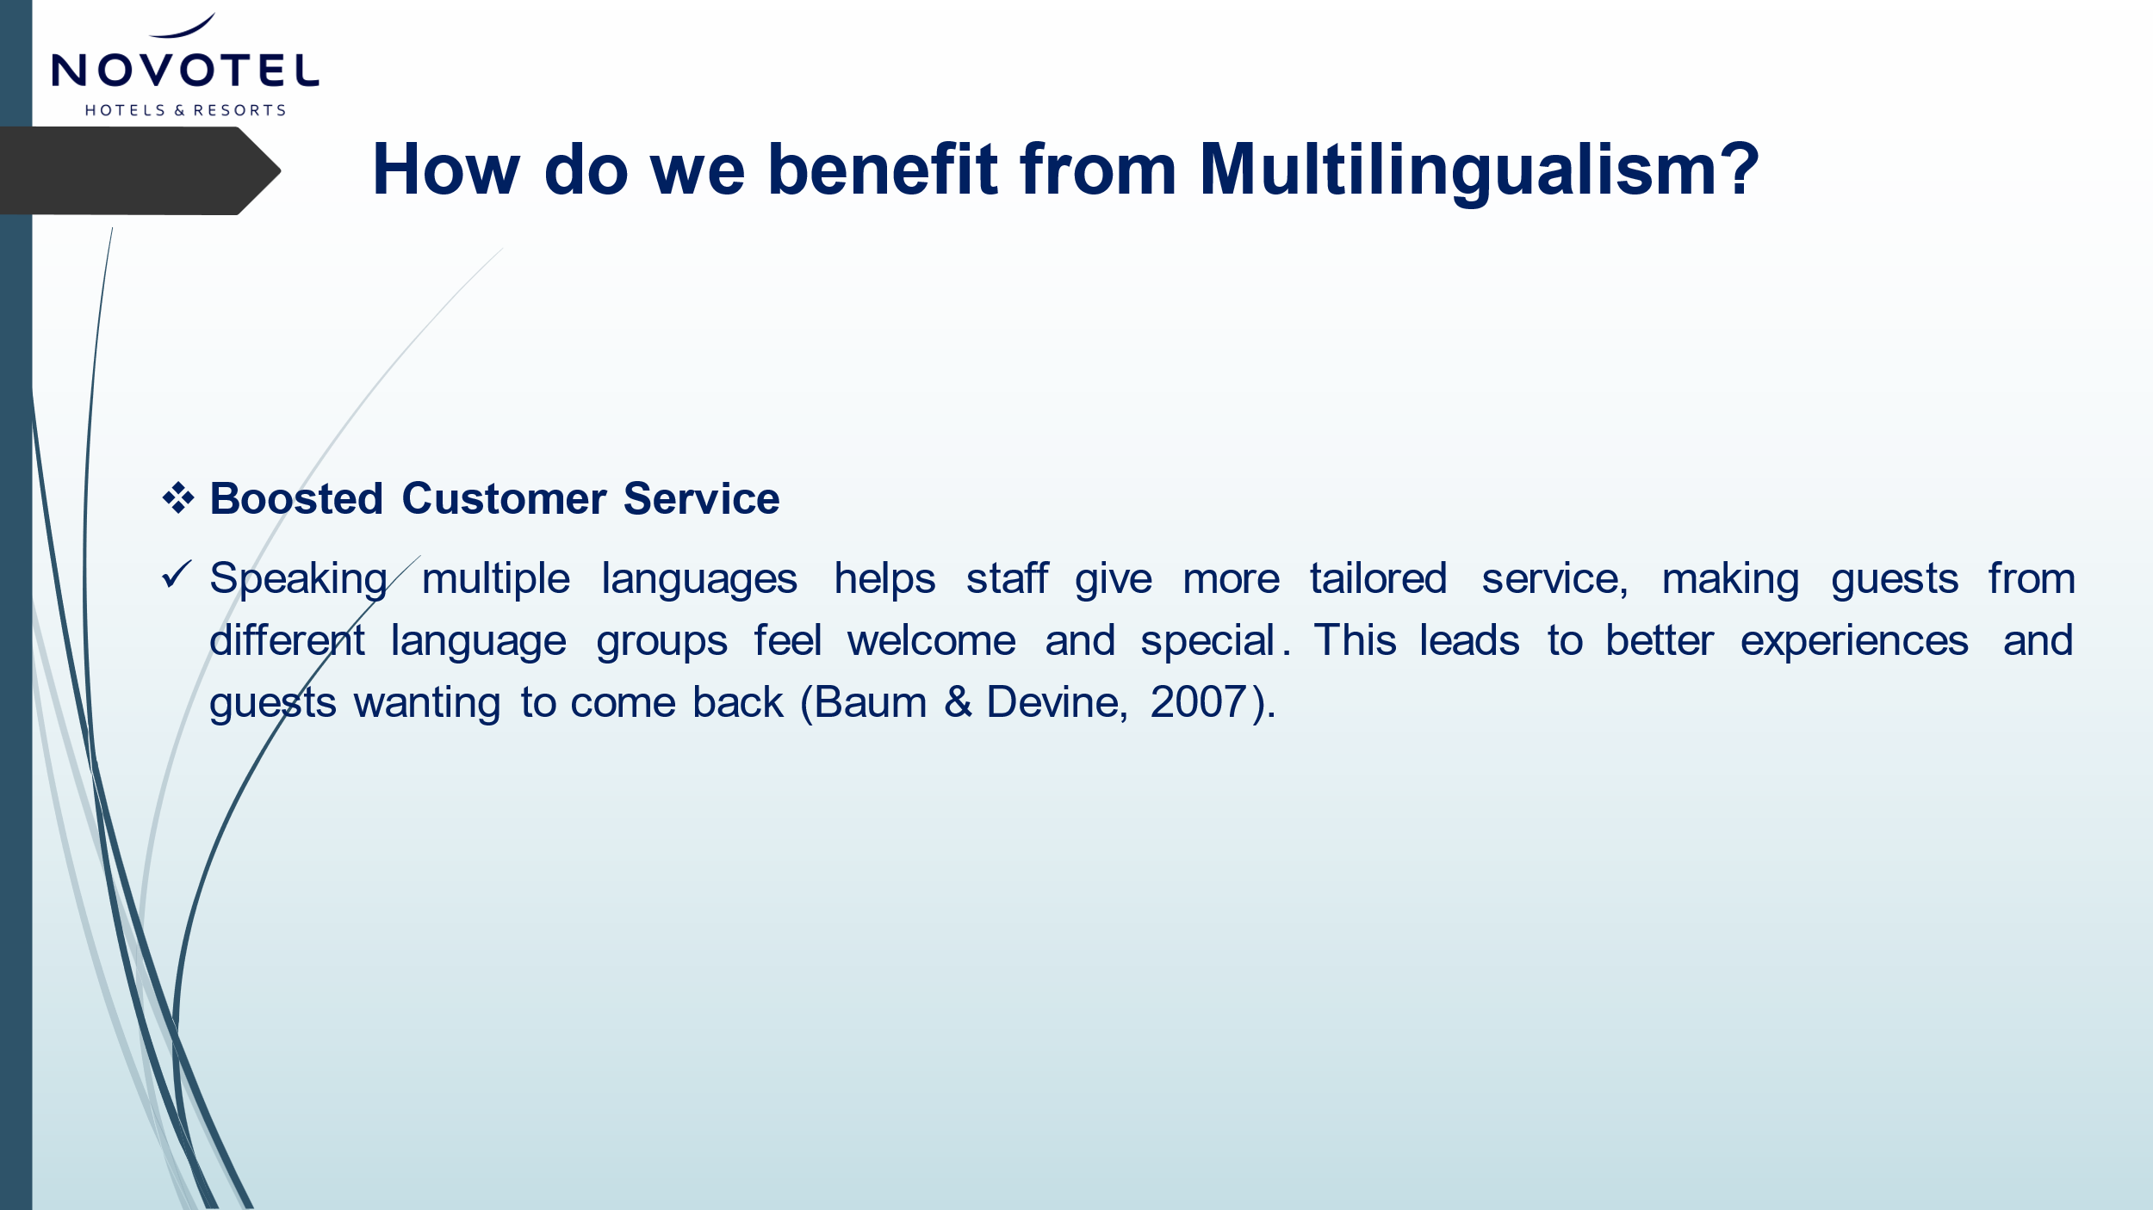
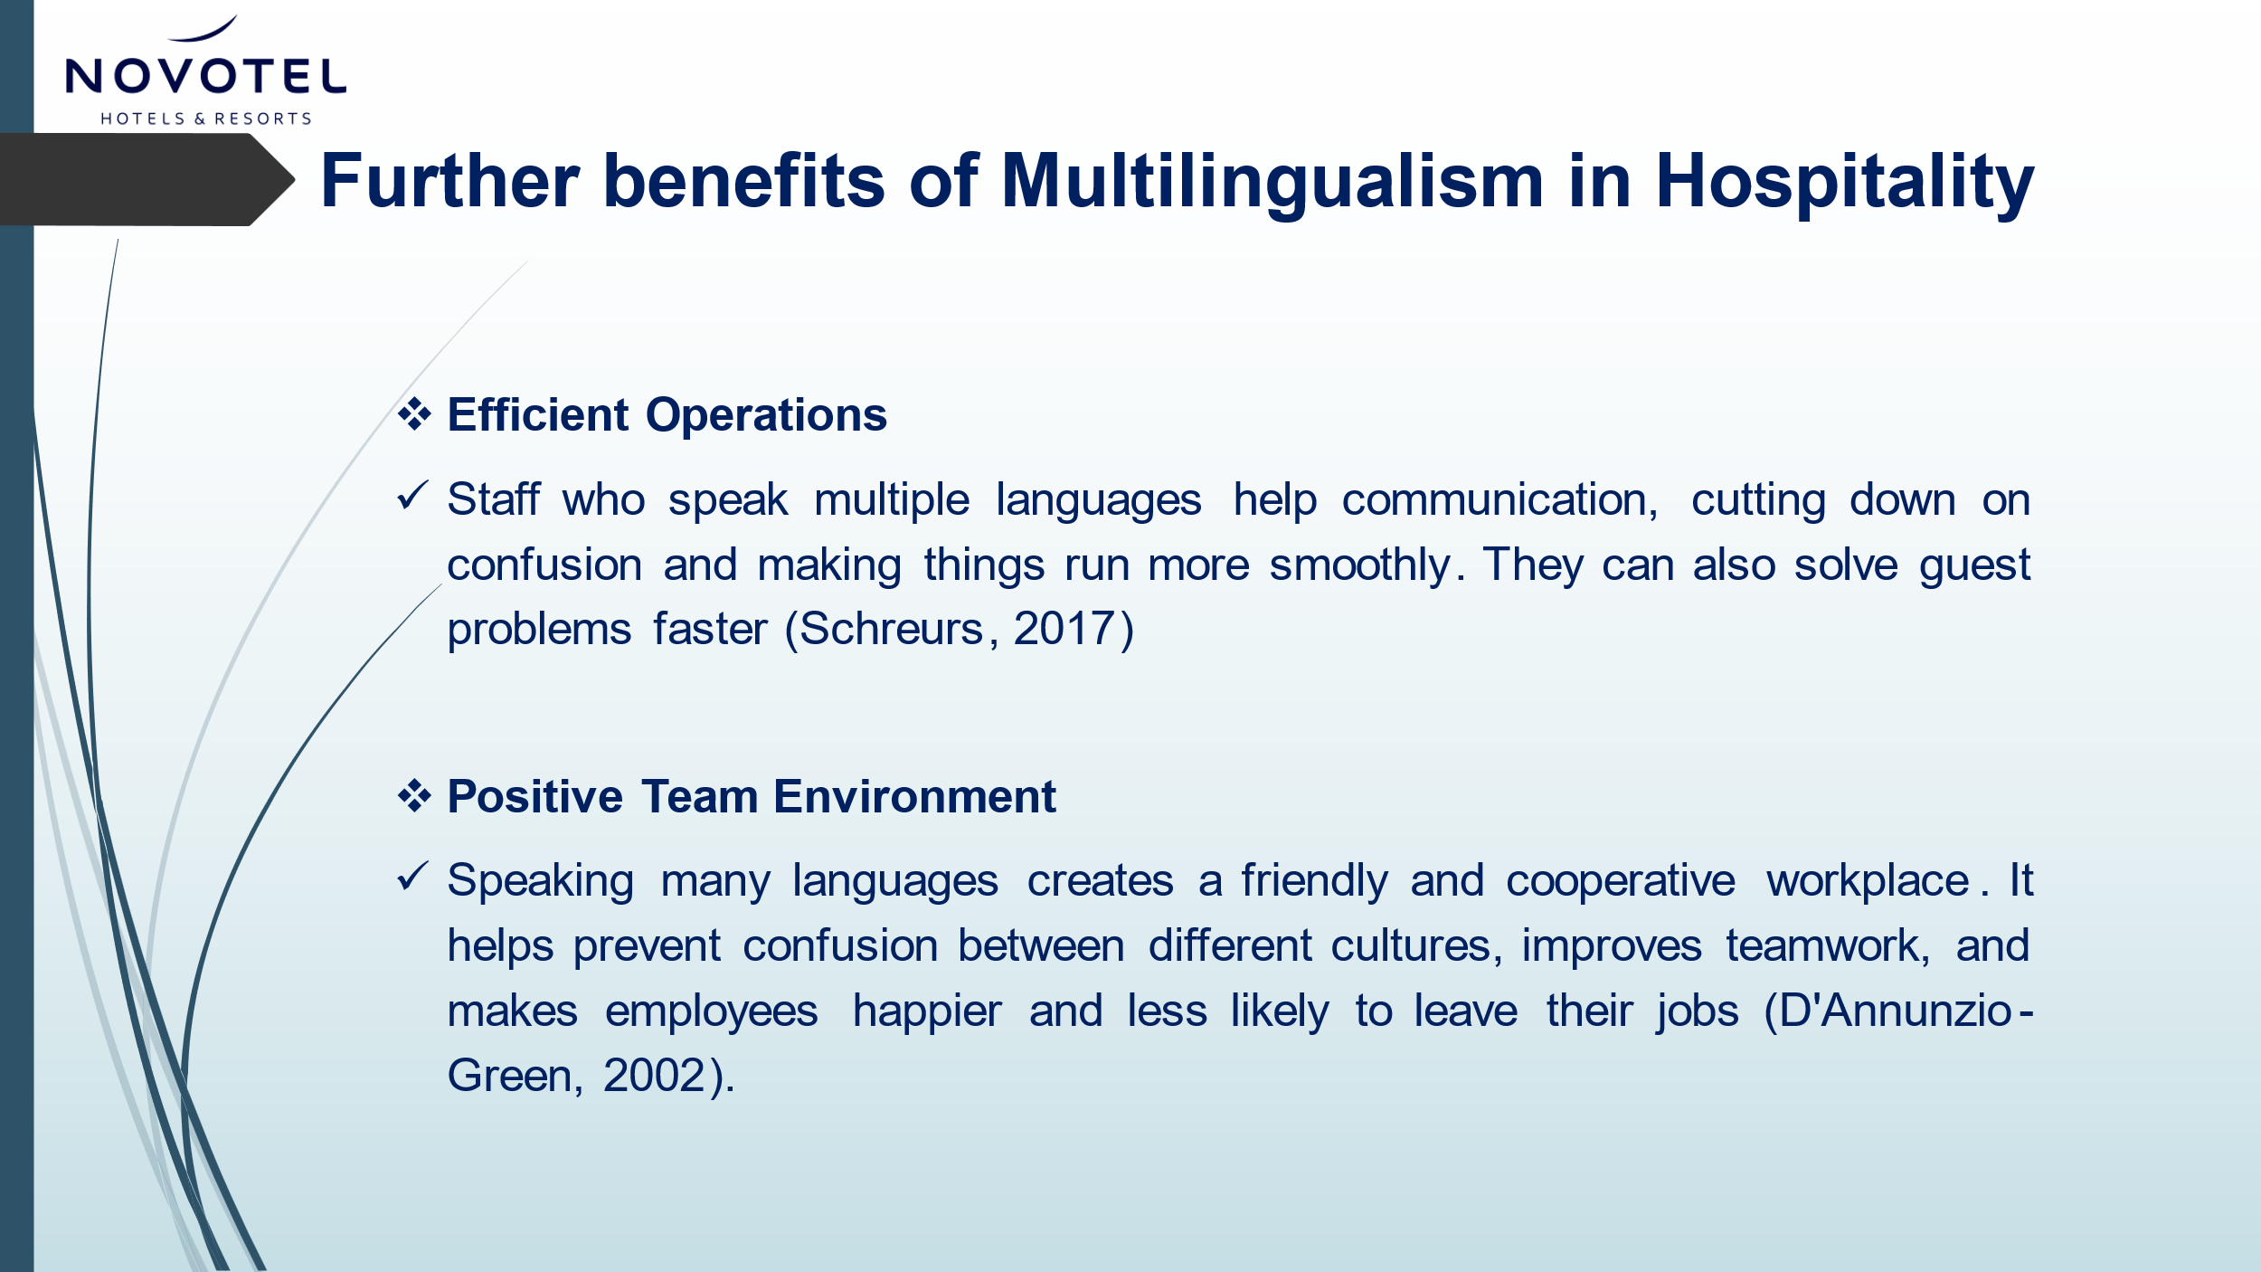

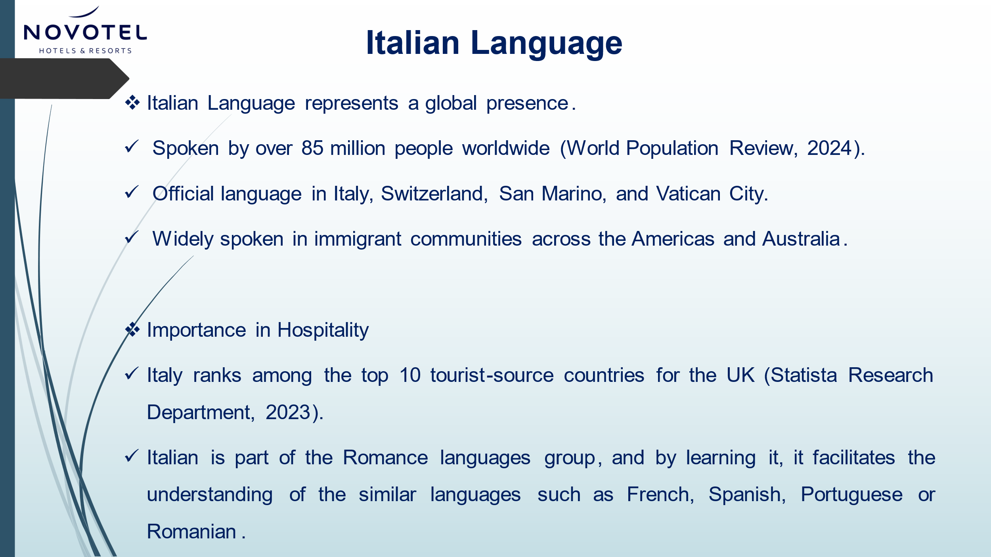

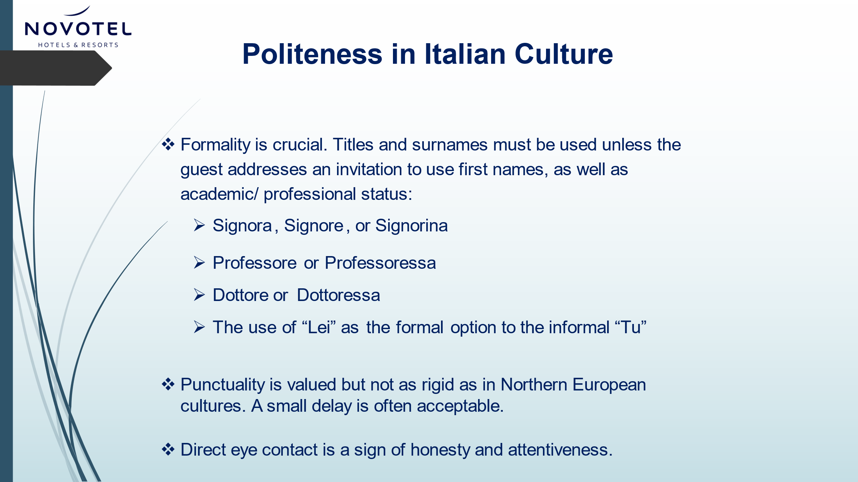

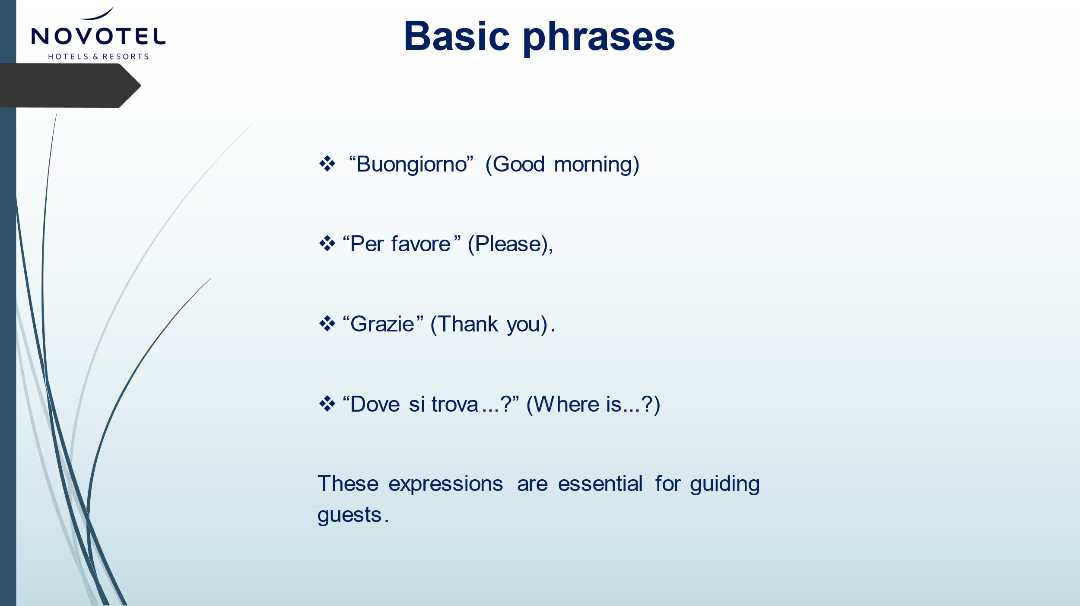

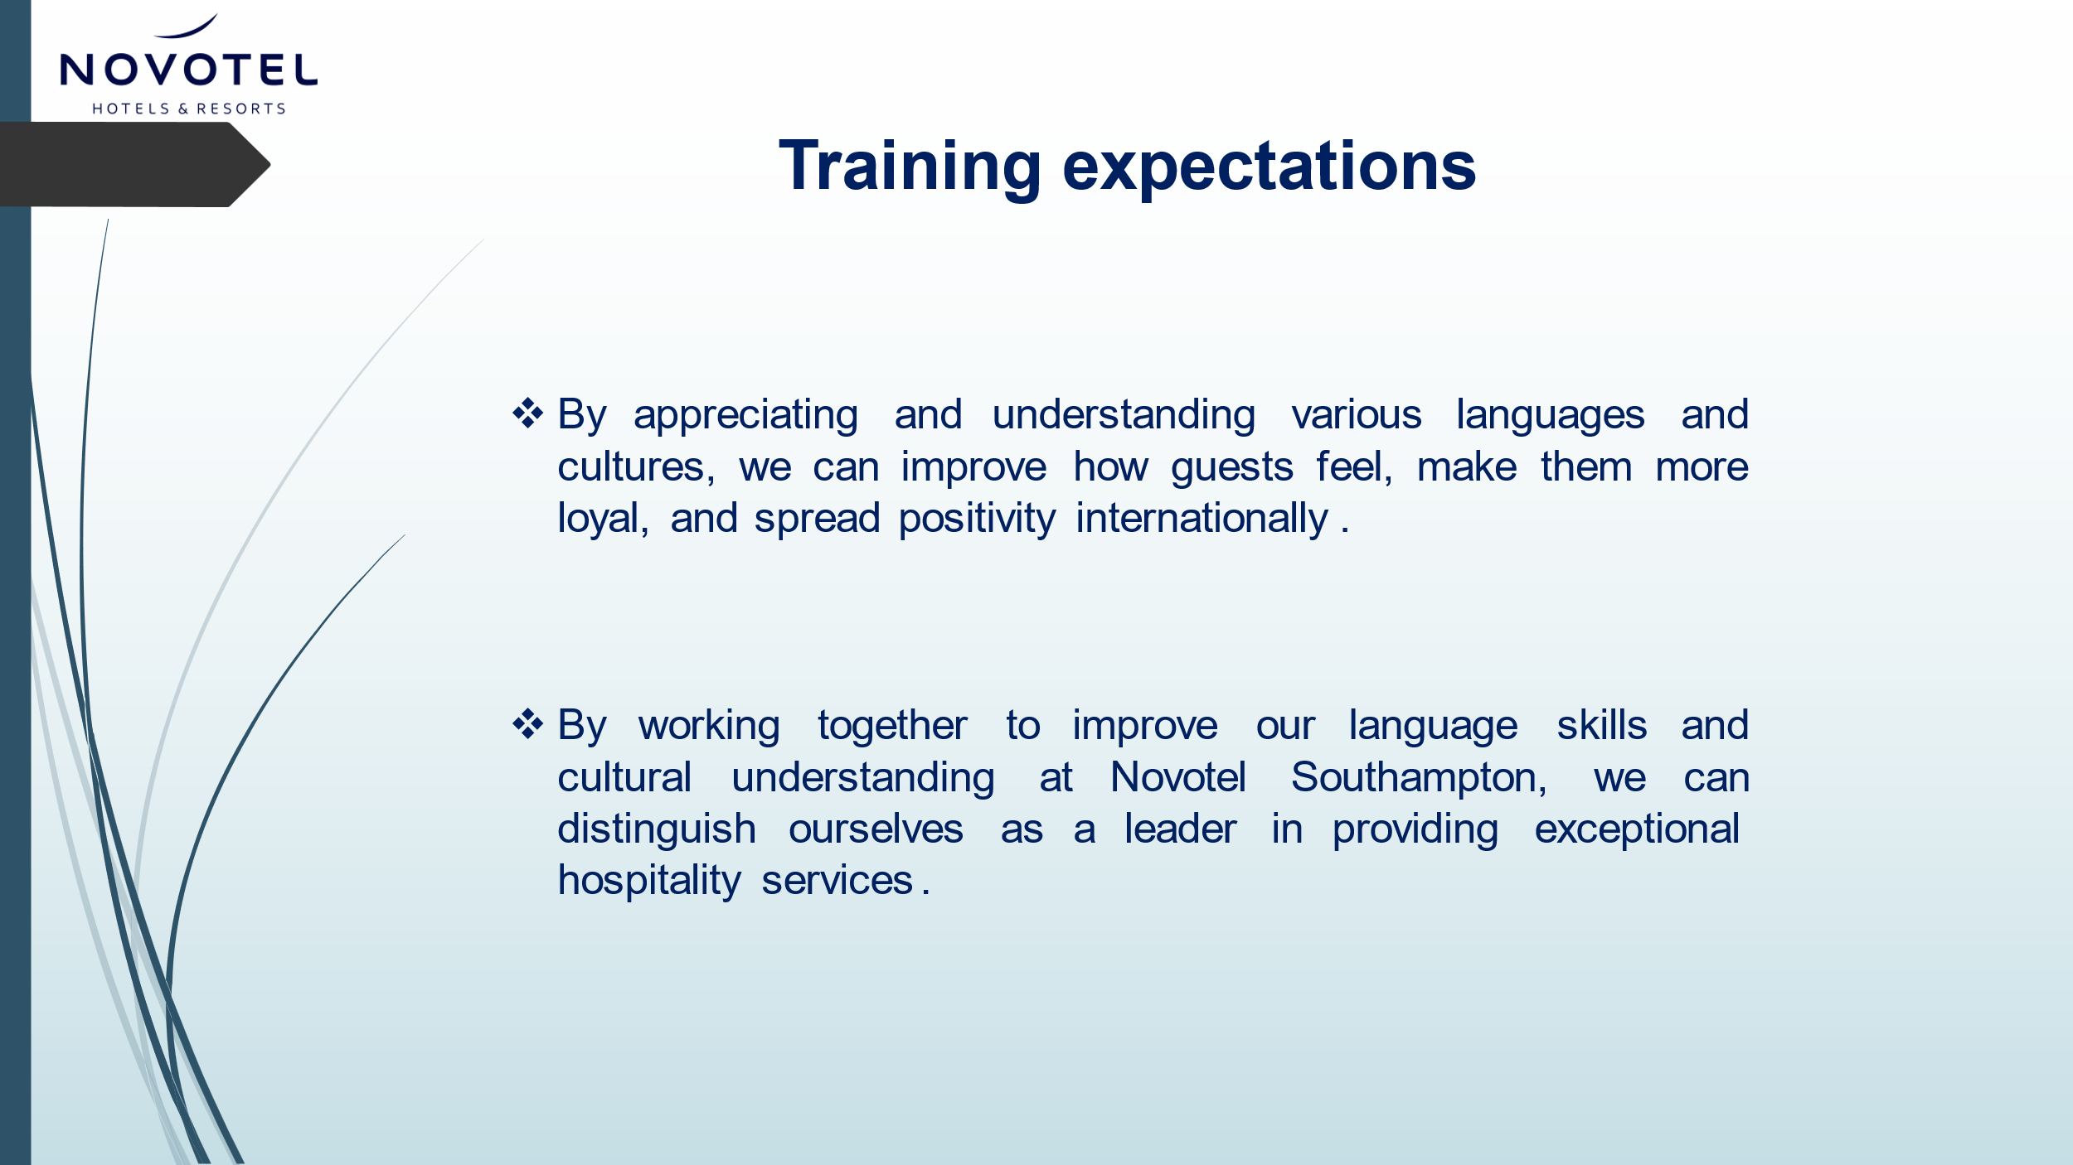

References
Abramson, N. R., & Moran, R. (2017) Managing Cultural Differences: Global Leadership for the 21st Century. (10th ed.). Routledge.
Baum, T., & Devine, F. (2007) “Skills and training in the hotel sector: The case of front office employment in Northern Ireland”. Tourism and Hospitality Research, 7(3-4), 269-280.
D'Annunzio-Green, N. (2002) “An examination of the organizational and cross-cultural challenges facing international hotel managers in Russia”. International Journal of Contemporary Hospitality Management, 14(6), 266-273.
Fila, M. J., & Wilson, M. S. (2018). “Understanding cross-cultural differences in the work stress process”, In Maheshkar, C. & Sharma, V. (Eds.), Handbook of research on cross-cultural business education. IGI Global, pp. 224-249.
Foskett, D., Paskins, P., & Pennington, A. (2021) The Theory of Hospitality and Catering. 14th ed. London: Hodder Education.
Grosjean, F. (2010) Bilingual: Life and Reality. Harvard University Press.
Hofstede, G., Hofstede, G.J. and Minkov, M. (2010) Cultures and organizations: software of the mind. 3rd Ed. New York: McGraw-Hill.
Kolb, D. A. (1984). Experiential learning: Experience as the source of learning and development. Prentice Hall.
Kuhnke, E. (2016) Body Language: Learn How to Read Others and Communicate with Confidence. Newark: John Wiley & Sons, Incorporated.
Mendenhall, M. E., Osland, J. S., Bird, A., Oddou, G. R., & Maznevski, M. L. (2012) Global Leadership: Research, Practice, and Development. Routledge.
Reisinger, Y., & Turner, L. (2003) Cross-Cultural Behaviour in Tourism: Concepts and Analysis. Oxford: Butterworth-Heinemann
Schreurs, L. (2017). “Observing hospitality speech patterns”. In C. Lashley (Ed.), The Routledge handbook of Hospitality Studies (pp. 169-179). London: Routledge.
Sharma, P., Tam, J. L. M. and Kim, N. (2012) “Intercultural service encounters (ICSE): an extended framework al empirical validation”. Journal of Services Marketing, 26(7):521-534

Spencer-Oatey, H. and Franklin, P. (2009) Intercultural Interaction: A Multidisciplinary Approach to Intercultural Communication. Palgrave Macmillan.
Statista Research Department. (2024) Leading inbound travel markets for the United Kingdom (UK) in 2019 and 2022, by number of visits. Available at: https://www.statista.com/statistics/616972/inbound-travel-country-markets-united-kingdom-uk-international-visits/ (Accessed: 15 May 2024).

Ting-Toomey, S. (1999) Communicating across cultures. The Guilford Press.

World Population Review (2024) Italian Speaking Countries 2024. Available at: https://worldpopulationreview.com/country-rankings/italian-speaking-countries (Accessed: 15 May 2024)

