Student Name | Nabil Shawgi Khalil Akasha
Student ID | 2537857
Portfolio submission part 1 | DS1- My Digital Skills
 | University of Wales Trinity David

University Digital Learning
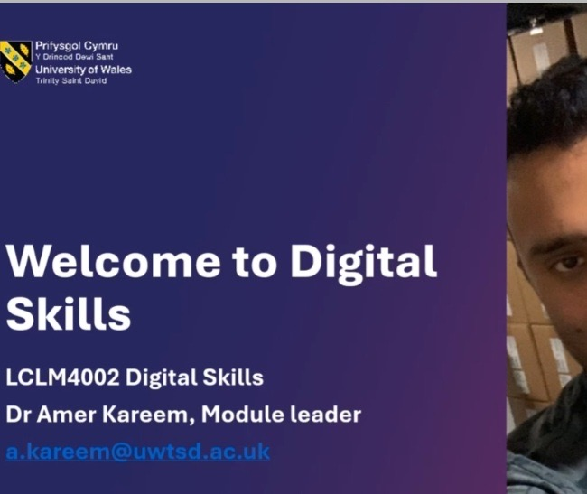
I have started my digital skills by learning a module at the University of Wales Trinity Saint David. It represents how online learning platforms and digital resources to improve my academic skills.
Using a card payment terminal
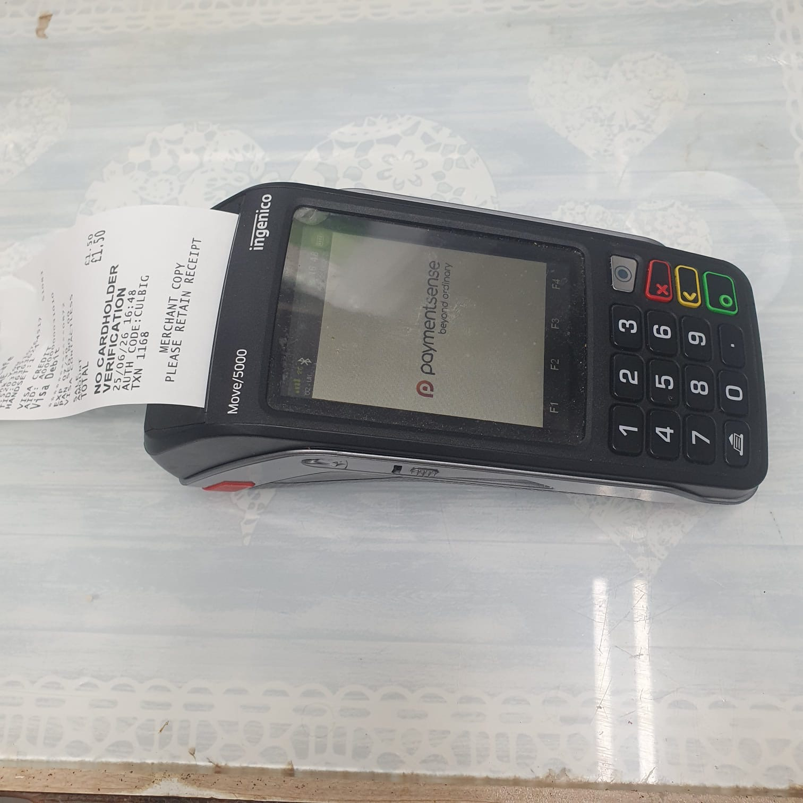
This payment terminal helps my understanding of digital transactions and cashless payments. I learned how digital technology makes business faster and more secure.

Online Banking
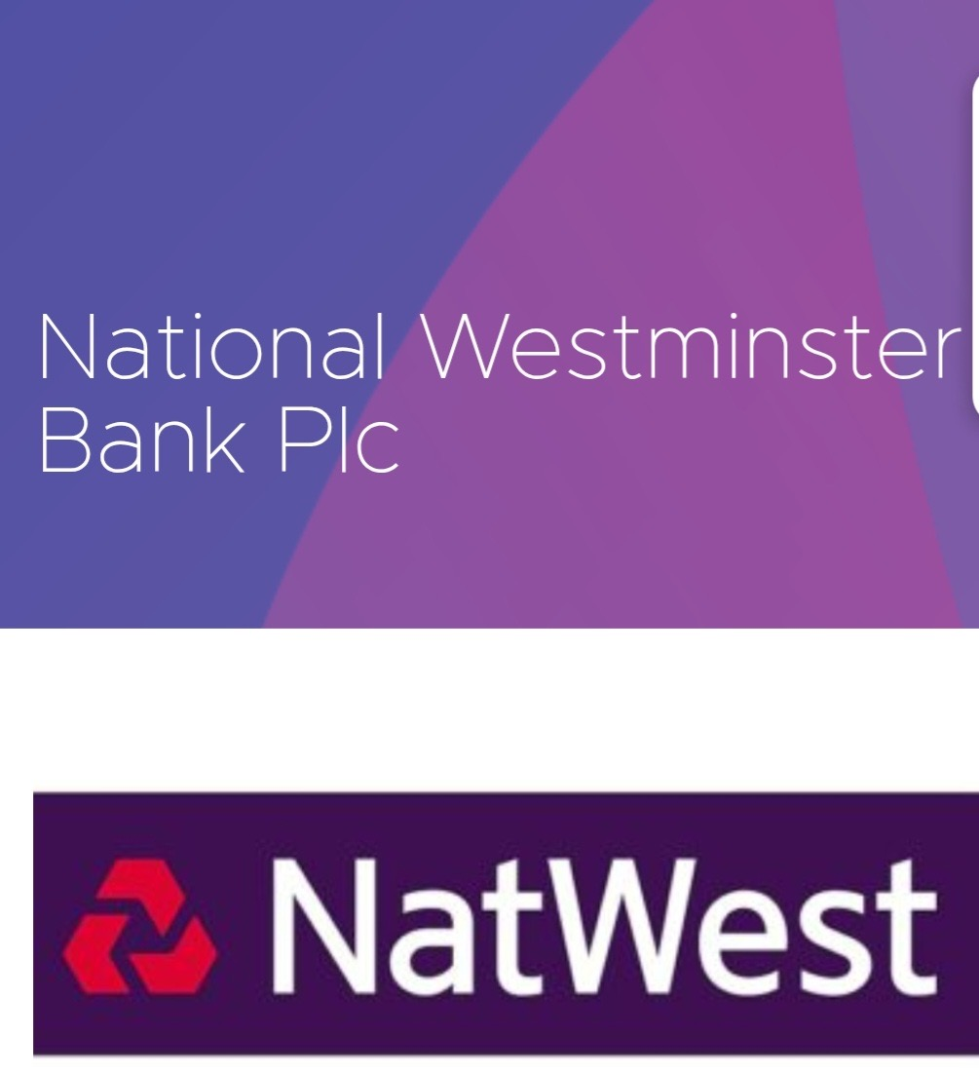
One of the new digital skills I have learned is doing online banking. It's very important to have online banking, password protection and two-factor authentication for keeping financial information secure.
Using a Smartphone
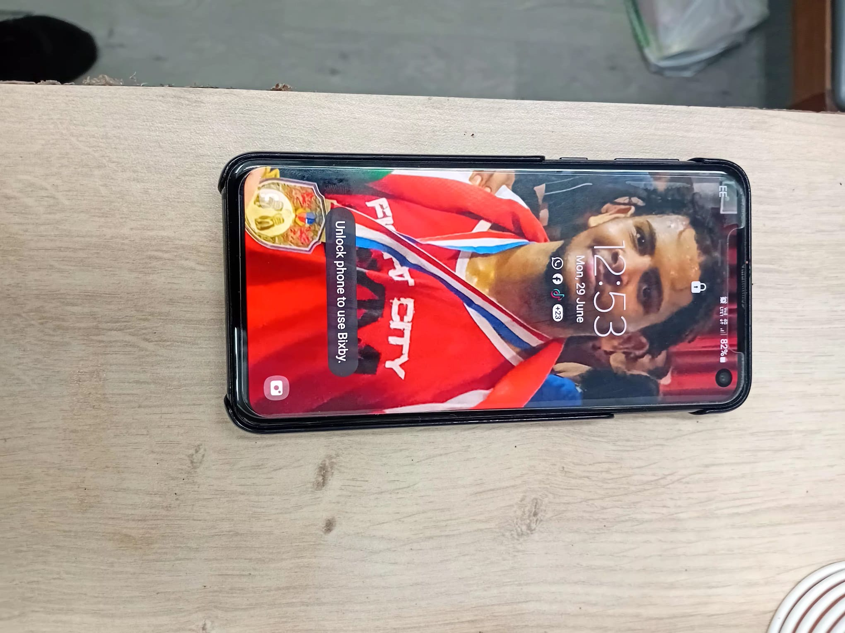
My smartphone is one of my most important digital devices. I use it to communicate, access university materials, online banking and manage daily activities.

Using Microsoft Word
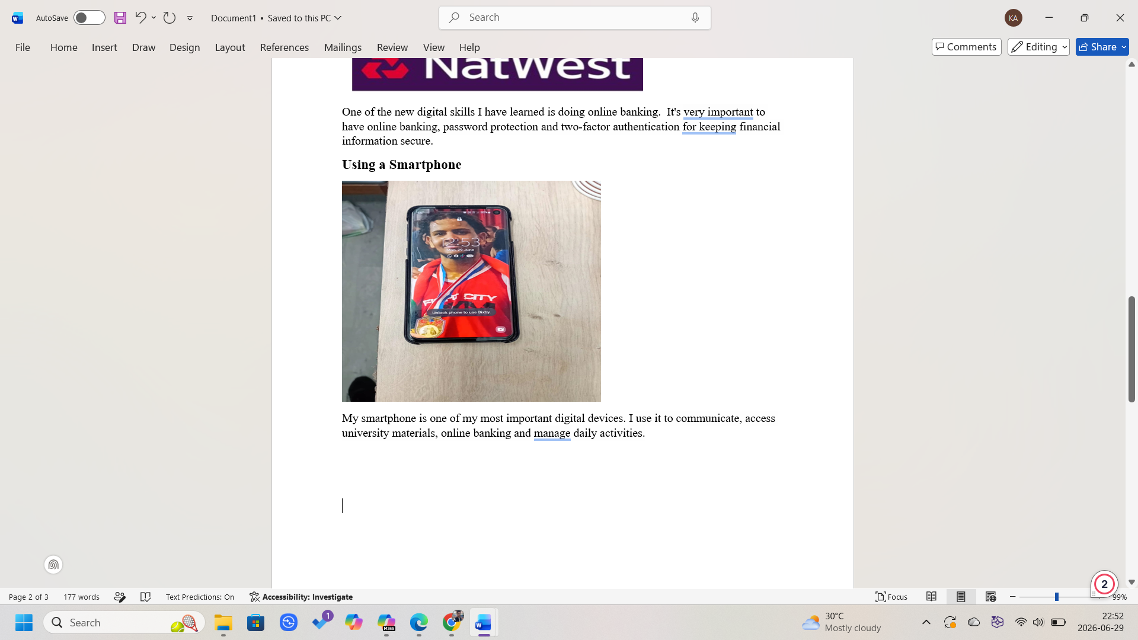
I am using Microsoft Word to create, edit, and format my assignments and notes. Now I can use features such as adding pictures to a document and page layout and produce clear and well-organised work.
Email Communication
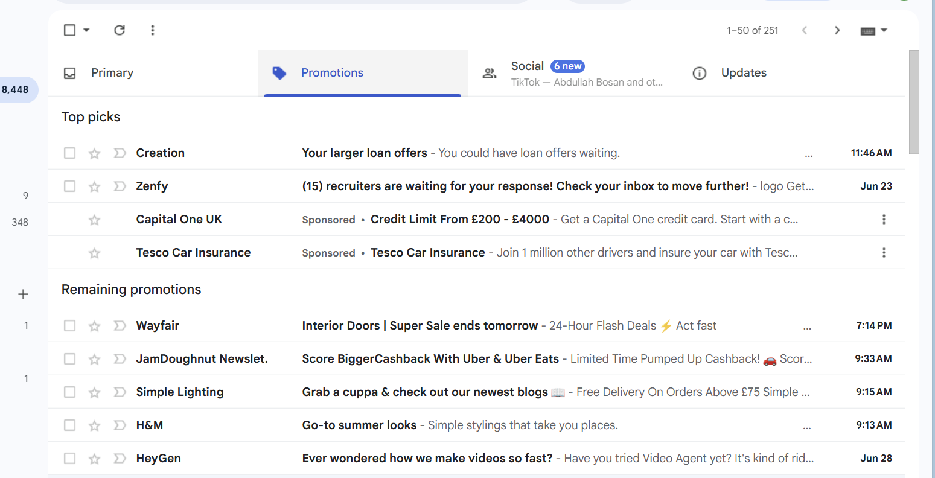
I have been using the email for a while now, and I can communicate by email professionally and effectively. I can write emails, manage inboxes, attach documents and respond to messages on time.
My Reflection
This portfolio helped me understand that digital skills are part of everyday life. From learning at university and using smartphones to making payments and banking online, technology supports both my studies and personal life. I will continue developing my digital skills to become more confident and prepared for future employment.

