
The Role of Artificial Intelligence in Transforming HR Recruitment and Selection Processes in the IT Sector
Programme: MBA International Business
Module: Dissertation
Module Code: LCMB7035
Student Name: Yash Vijaybhai Patel
Student id: 2421695
Lecturer Name: Xavier Matieni
Supervisor Name: Jia Miao
Word: 15822

Declaration

Acknowledgements
I would like to express my sincere gratitude to all those who have supported me throughout the completion of this project. I am especially thankful to my professor for providing valuable guidance and encouragement. Their insightful suggestions and constructive criticism helped me to improve the quality of my work.
I extend my thanks to my family and friends for their constant motivation and understanding during the course of this project. Without their support, this project would not have been possible.
Finally, I would like to acknowledge all the resources and references that helped me gather the necessary information for this project. This experience has greatly contributed to my knowledge and skills.
Thank you all for your generous help and support.
Abstract
This dissertation will be pursuing for the effects of “Artificial Intelligence (AI)” to HR “recruitment and selection” in the UK. It regulates the efficiency, fairness, transparency, and experience of candidates with AI-driven recruitment tools. The work identifies advantages of AI including quicker decision-making and less biases and discussing the problem of algorithmic fairness, privacy, and visible access. The research offers practical recommendations to make AI implementation in recruitment ethically and responsibly through critical analysis of the available literature and existing practises to prevent its contradiction with any organisational values and legal regulations and make the complete recruiting procedure more positive and comprehensive. The methodology framework of the research is based on the Research Onions of Saunders. It follows an interpretivist philosophy, inductive approach, grounded theory strategy, and the qualitative mono-method based on secondary data. Content analysis serves the objectives of the research directly since it provides the possibility to carry out a comparative evaluation of different views, and is capable of synthesising the evidence provided by different sources. The discussion critically analyses the results of AI applications in the recruitment process, including efficiency improvements and concerns about bias, transparency, and moral responsibility. These insights are summed up in the conclusion, which proves that AI helps in decision-making in the process of recruitment, but it must be controlled by humans. Altogether, the research can build upon theory and practice as it highlights the responsible and human-oriented approach in the application of AI in the recruitment procedures.

Table of Contents
Chapter 1: Introduction 11
1.1 Introduction 11
1.2 Background 12
1.2.1 Increasing usage of AI in HR 12
1.2.2 HR Recruitment in the IT Sector 13
1.3 Rationale and Problem Statement 14
1.3.1 Rationale of the Study 14
1.3.2 Problems and Challenges Statement 15
1.4 Objectives and Aims 16
1.4.1 Goal of the Dissertation 16
1.4.2 Research Objectives 16
1.5 Research Questions 16
1.6 Significance 17
1.7 Structure 17
1.8 Summary 18
Chapter 2: Literature Review 19
2.1 Introduction 19
2.2 Foundational Concepts and Theoretical Lens 19
2.2.1 Defining Key Constructs 19
2.2.2 Theoretical Framework 21
2.3 The Value Proposition: Efficiency and Productivity 24
2.3.1 Automation of Routine Tasks in Recruitment and Selection 24
2.3.2 Predictive-based Data-Driven Decision Making 26
2.4 Ethical and Legal: Equity, Prejudice, and Virtue 29
2.4.1 Equity (Fairness) and Algorithmic Bias 29
2.4.2 Transparency and Explainability 30
2.4.3 Data security, Legal risks, and privacy 31
2.5 Candidate Experience and the Human-AI Dynamic 33
2.5.1. Impact on Candidate Experience 33
2.5.2 Human-AI Coercion: Improvement of HR 34
2.6 Synthesis, Literature Gaps, Research Justification 35
2.6.1 Synthesis of Key Debates 35
2.6.2 Identification of the Literature Gap 35
2.6.3 Justification of Research 36
Chapter 3: Research Methodology 37
3.1 Overview 37
3.2 Research Philosophy 38
3.3 Research Approach 38
3.4 Research Strategy 39
3.5 Methodological Choice 40
3.6 Data Collection 40
3.7 Data Analysis 41
3.8 Ethical Considerations 42
3.9 Research Reliability and Quality 43
3.10 Methodological Limitations 43
3.11 Summary 43
Chapter 4: Findings 45
4.1 Overview 45
4.2 The suitability of AI in the simplification of the recruitment and selection procedure in the IT industry 46
4.3 The fairness and justice of IT-based AI-informed recruitment in a bid to decrease bias and enhance the diversity of candidates in the IT industry 48
4.4 The degree of rigour and convenience of AI-driven recruitment systems to HR professionals and job applicants in the IT industry 50
4.5 The ethical issues associated with introducing AI in the hiring process of the IT industry 52
4.6 Rules to make the organisational decision-making process fair, transparent, and trustworthy 54
4.7 Summary 56
Chapter 5: Discussion 57
5.1 Overview 57
5.2 Recruitment and Selection AI-Based Efficiency and Automation (RQ1) 57
5.3 AI Recruitment Fairness, Bias, and Diversity Implications (RQ2) 59
5.4 AI-Based Hiring Transparency, Explainability, and Trust (RQ3) 60
5.5 AI Recruitment Ethical, Legal, and Data Privacy issues (RQ4) 61
5.6 Human-AI Partnership and the evolving HR position 62
5.7 Contribution to Knowledge and Practice 63
5.8 Summary 63
Chapter 6: Conclusion 64
6.1 Overview 64
6.2 Research Aim and Research Questions Re-statement 64
6.3 Summary of Key Findings 65
6.4 Discussion of the Research Questions 66
6.5 Literature Gap and Research Contribution 66
6.6 Contributions to Theory 67
6.7 Contributions to Practice 67
6.8 Limitations of the Study 68
6.9 Future Research Recommendations 68
6.10 Final Reflective Conclusion 68
Reference List 70

List of Figures
Figure 1.1: Pertinence of AI in Recruitment and Selection Procedures 11
Figure 1.2: AI in HR-focused Market Size 12
Figure 1.3: Application of AI to different HR Practices 14
Figure 2.1: Defining Key Constructs 20
Figure 2.2: Recruitment and Selection (RandS) 21
Figure 2.3: Technology Acceptance Model (TAM) 22
Figure 2.4: Resource-Based View (RBV) 23
Figure 2.5: AI Automation and Synthesis of Evidence 25
Figure 2.6: Predictive-based Data-Driven Decision Making 26
Figure 2.7: Predictive Tools for Candidate Sourcing and Matching 27
Figure 2.8: Fairness and Bias in Algorithmic Hiring 30
Figure 3.1: Research Onion 37
Figure 4.1: Part of the hiring process replaced by AI 46
Figure 4.2: The most common features of recruitment software and systems 48
Figure 4.3: Influence of Artificial intelligence on the performance of recruitment functions 50
Figure 4.4: Algorithmic BIAS in AI-Based Hiring Systems 53

Chapter 1: Introduction

1.1 Introduction
This dissertation will discuss the revolutionary nature of the use of “Artificial Intelligence (AI)” in the “recruitment and selection” of employees in HR, precisely in relation to its application and usage in the UK. With the increasing adoption of technology by businesses to improve operational efficiency, AI has become one of the essential means of improving the recruitment process, mitigating bias, and advancing the experience of candidates (Oman, Siddiqua and Noorain, 2024). In the IT industry, AI is fundamentally transforming the way organisations recognise, assess and recruit talent with particular technical expertise necessary to drive innovation and tackle complicated challenges. The OS software is already being used throughout the hiring cycle in the IT sector), such as resume screening, sourcing of candidates, scheduling interviews, and automated interviews.
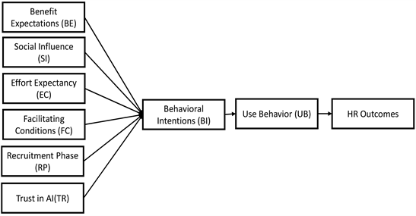

Figure 1.1: Pertinence of AI in Recruitment and Selection Procedures
(Source: Hewage, 2023)
Machine learning algorithms used in AI tools to process large amounts of data help the HR departments to make more informed and faster decisions. Repetitive HR activities can be automated to enable the HR practitioners to attend to strategic areas of recruitment, which are significant in the highly competitive and dynamic IT industry (Sundari et al., 2024). The opportunity of introducing the unconscious bias is removed through AI and could be utilised in developing a more level process of choosing candidates based on their professional qualifications, regardless of their sexual orientation, race, and other discrimination factors. Artificial intelligence-based applications are increasingly being obligatory in the IT recruiting procedures and include resume parsing, candidate referencing framework, interview administration, and performance measurement (Uma, Velchamy and Upadhyay, 2023).

1.2 Background

1.2.1 Increasing usage of AI in HR
This AI has transformed the HR practises particularly in the IT industry because it has enhanced efficiency in recruitment. IT recruitment is commonly hectic because of the requirement of high trained professionals having niche technical understanding and capacity to operate on intricate technological structure (Moreno, Rojas and Morales, 2024). The conventional recruitment strategies cannot withstand the number of applications and specialisation in regards to skills. The use of the AI-based tools contributes to the process of narrowing down and finding the most suitable applicants depending on experience, technical ability, and other pertinent advantages, which is crucial in the competitive IT employment industry.
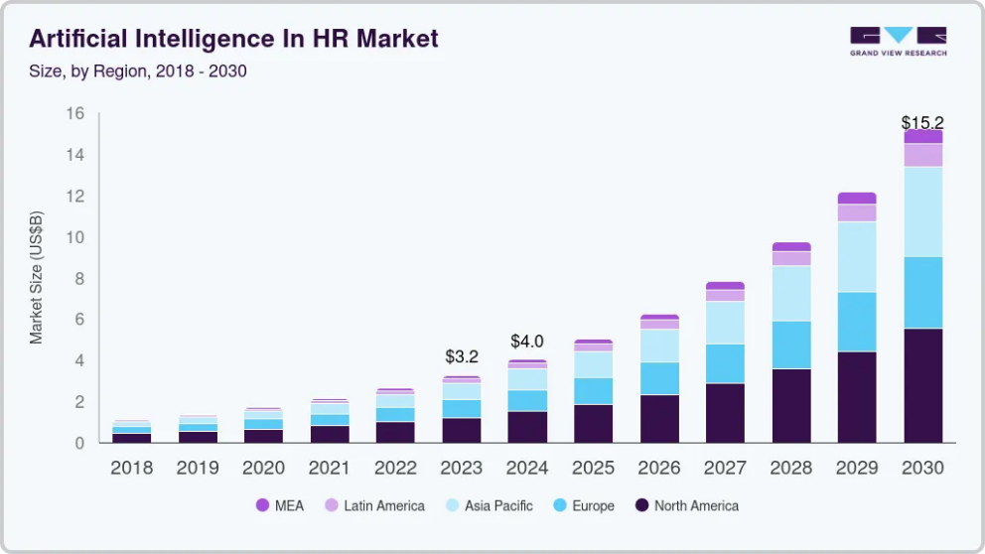

Figure 1.2: AI in HR-focused Market Size
(Source: Grand View Research, 2023)
Also, AI is applied to such tools as candidate sourcing and chatbots to interpret the first interactions and “predictive analytics systems” to estimate the accomplishment of an applicant in position. The tools are beneficial in facilitating the recruitment process, making sure that the decisions are driven by data and not influenced by human factors (Shenbhagavadivu, Poduval and Vinitha V, 2024). However, the introduction of AI to the recruitment process correspondingly causes some concern about the issues of algorithmic fairness/transparency, which will be discussed.

1.2.2 HR Recruitment in the IT Sector
The IT sector recruitments present challenges that include acquisition of competent talent, large numbers of applications, and diversity in recruitment. Contrary to most of the other industries, the IT industry necessitates the continuous flow of well-skilled experts, who are able to be innovative and handle complicated technological infrastructure (Moreno, Rojas and Morales, 2024). Recruitment strategies should therefore be targeting to rationalise the process to satisfy these requirements in an efficient manner. Conventional methods of recruitment usually fail in IT, where speed, accuracy and filtering out of certain technical aptitudes are all important. AI-based tools beneficial in dealing with the volume of applications, to understand precise requirements in the industry.
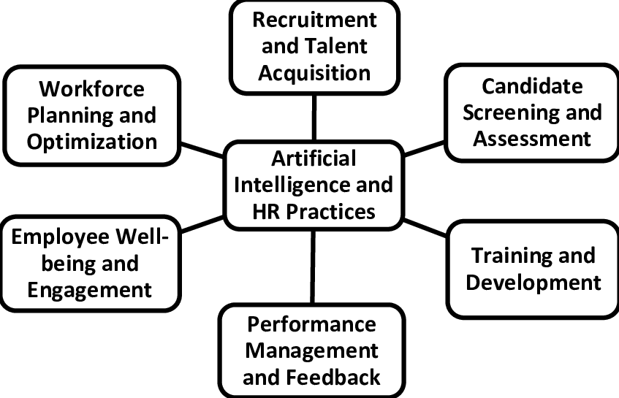

Figure 1.3: Application of AI to different HR Practices
(Source: Joshi, Singh and Rani, 2024)
The IT industry presents distinct problems in the recruitment process and includes finding qualified talent, process high volumes of applicant applications, and professional diversity in the hiring process. With the high rate of technological changes, organisations in the IT sector have to keep attracting professional talents with the capacity to keep up with the emerging technology (Farayola et al., 2023). The instruments built under AI come in handy especially in overcoming such constraints, where the HR department can narrow down on the applications and align the applicants with certain technical skills demanded by organisations.

1.3 Rationale and Problem Statement

1.3.1 Rationale of the Study
The present study is crucial because of the increasing adoption of AI in HR and particularly in the UK. As AI systems are becoming a consistent tool that most organisations employ, it is imperative to consider their efficiency and effectiveness on businesses and applicants (Paramita, Okwir and Nuur, 2024). Although AI has serious benefits in the context of efficiency, cost decrease, and exclusion of human biases, little is known about the implications of its worldwide application.
It is extremely important to contemplate the larger impacts of AI on recruitment practises, especially its fairness, transparency and impacts on the candidate experience to uphold the correct utilisation of AI tools ethically and effectively (Hunkenschroer and Luetge, 2022). The study will enable human resources practitioners and organisations of the Information and Technology Sector to go through these obstacles as they stand to be responsible for the adoption of AI.

1.3.2 Problems and Challenges Statement
AI application in HR hiring and selection systems in the IT industry provokes a number of critical issues. Algorithms bias is one of the significant problems, whereby AI systems can possibly reproduce and propagate bias contained in the training samples. This may cause unfair practises in the context of IT recruitment, especially when algorithms are used to favour a certain candidate because of the previous hiring practises or even the historical information that might be reflective of the existing prejudices based on gender, race, or other demographical characteristics (O'Connor and Liu, 2023). Even though the possibilities of AI are to minimise human bias, it is possible that untrained algorithms or biassed sets of data, will still lead to discriminatory results, which will destroy the objectivity of the recruitment process.
There is one more issue transparency in AI decision-making. Lack of understanding of AI systems on how they assess the applicants can result in mistrust and distrust in the process being a level of unfairness by the AI systems. Moreover, there is a privacy concern where Artificial Intelligence (AI) finds its use in the recruitment process. Being widely used, personal data, including resumes, work history, and internet profiles, create certain questions of the data security and the ethical treatment of sensitive data. The ethical practise of collecting, storing and using candidate information is an urgent issue in the IT industry, where the topic of data breaches and cybersecurity threats is a concern at all times (Raab, 2020). The high data protection requirements and the adherence to the privacy laws should be discussed to align with the responsible utilisation of AI in the recruitment process of the IT sector.

1.4 Objectives and Aims

1.4.1 Goal of the Dissertation
The dissertation is going to examine how Artificial Intelligence (AI) is affecting HRs in the recruitment and selection processes in the UK. In particular, the research will discuss the way AI-based technologies are changing the current organisational process of attracting, evaluating, and selecting candidates in the IT industry. It will evaluate the opportunities that AI has in enhancing efficiency, fairness and transparency, but will also discuss the risks and problems that it comes with. The dissertation will contain an exhaustive review on the use of AI in improving the process of recruitment taking into account issues concerning privacy, ethics and bias in AI-based hiring systems.

1.4.2 Research Objectives
- To investigate the suitability of AI in the simplification of the recruitment and selection procedure in the IT industry
- To determine the fairness and justice of IT-based AI-informed recruitment in a bid to decrease bias and enhance the diversity of candidates in the IT industry
- To determine the degree of rigour and convenience of AI-driven recruitment systems to HR professionals and job applicants in the IT industry
- To understand the ethical issues associated with introducing AI in the hiring process of the IT industry and recommend rules to make the organisational decision-making process fair, transparent and trustworthy

1.5 Research Questions
- What is the effectiveness of AIs in automation of the recruitment and selection processes within the IT industry?
- How might AI technologies be used to minimise or add bias into the IT occupational hiring and selection practises?
- To what extent are the HR and applicants in the IT industry able to understand and see AI-based recruitment systems?
- What are the ethical issues that organisations in the IT industry need to take into consideration using AI in recruitment practises to enable fairness, transparency and privacy of candidates?

1.6 Significance
The research is relevant in HR practice because it has completed a critical analysis of how “Artificial Intelligence (AI)” transforms the procedure of “recruitment and selection”. As AI is becoming a significant part of the talent acquisition process, it is significant to comprehend how AI influences efficiency, fairness, and the experiences of the applicants (Christstmass Setyawan et al., 2024). By discussing the advantages and issues of AI, this study will offer beneficial information to those organisations that would like to automate their recruitment strategies and procedures without compromising fairness and transparency.
In the case of organisations, the study will give some feasible commendations on how AI can be ethically utilised in employment procedure to make sure that these systems are established in a way that complies with the law and ethics, also with the values and culture of the organisation.

1.7 Structure
Chapter 1: Introduction gives an insight into the research topic, “aims and objectives and research questions”. Chapter 2: “Literature Review” critically analyses the literature on AI in recruitment, covering key themes, “challenges and gaps in the literature”. Chapter 3: Methodology summaries the research design, which includes the methodology of “data collection and data analysis”. Chapter 4: “Data Analysis” summarises and discusses the research outcomes. Chapter 5: Discussion- the final chapter appraises the implications of the outcomes. Chapter 6: Conclusion is the last part of the work, summarising important findings and recommendations to HR practise and future research.

1.8 Summary
The dissertation introduced in this chapter deliberated how AI can be used to transform the HR recruitment and selection procedures. It highlighted the study aims, objectives and research questions, which were productivity, fairness, transparency and experience of the candidates. The pertinency of the research to the HR practises and the existing literature was correspondingly brought out.

Chapter 2: Literature Review

2.1 Introduction
The main purpose of the dissertation is the critical analysis of the use of Artificial Intelligence (AI) in changing the process of Human Resource (HR) recruitment and selection in the UK. The analysis will be based on a balanced and critical review of the perceived opportunity of AI and the risks related to it, taking into consideration the key themes of productivity/efficiency, fairness, transparency, and ethical concerns. The outcome is to create informed resolutions to be responsible and fruitful integration of AI within HR practice.
Peer-reviewed academic journals have been selected as the primary sources for the review, given their relevance to the major fields of HRM, business strategy, and applied ethics. This is enhanced with the industry seminal reports, white papers and legal analysis to maintain a balance between theoretical rigour and practical relevance. It has also been ensured that there is a substantial focus on the sources that were published in the past five years to ensure that this study remains current in this rapidly changing area.

2.2 Foundational Concepts and Theoretical Lens

2.2.1 Defining Key Constructs
Artificial Intelligence (AI) in HRM: Artificial Intelligence (AI) in the framework of Human Resource Management (HRM) refers to the utilising of computer systems that are meant to simulate human-like intelligence (Kambur and Yildirim, 2022). These include decision-making, pattern recognition, and problem-solving, to improve HR performance. This is to improve and accelerate HR decisions.
Machine Learning (ML) Algorithms: These are at the heart of a number of AI applications. During recruitment, predictive analytics systems apply ML in estimating future achievement of a candidate or filtering large numbers of applications on the basis of keywords, based on the patterns learned from historical data (Căvescu and Popescu, 2025).
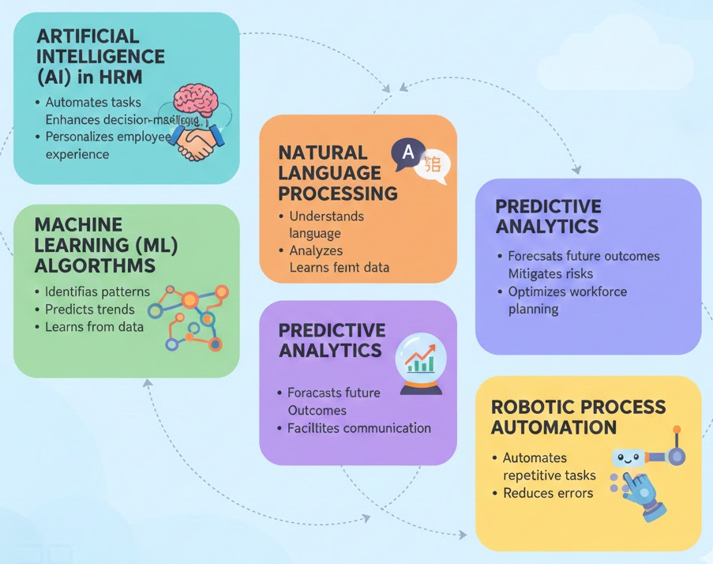

Figure 2.1: Defining Key Constructs
(Source: Influenced by Căvescu and Popescu, 2025)
Natural Language Processing (NLP): It is the technology that drives chatbots and other communication products utilised in recruitment to process the preliminary interactions between the candidates and the recruiter (Devaraju, 2022). NLP can also be used in the search and recommendation of resumes, and these are analysed using unstructured text data.
Predictive Analytics: Although this is an ML outcome, it is an important element in HR to predict the accomplishment of an individual and make decisions using data, which is less dependent on the human factor (Hülter, Ertel, and Heidemann, 2024).
Robotic Process Automation (RPA): RPA is not classified as a type of advanced learning AI, but a keystone AI-powered technology that is extensively used in HR practices. RPA correspondingly automates recruiting procedures mainly based on rules like information sorting of the CVs, interview scheduling, candidate data entry and compliance checks (Sharma, 2024).
Recruitment and Selection (RandS)
Recruitment and Selection (RandS) involve the entire procedure of identifying and attracting, evaluating, and employing capable employees to meet the talent requirements of an organisation. Artificial intelligence is being added to different phases of this organisational procedure in UK companies.
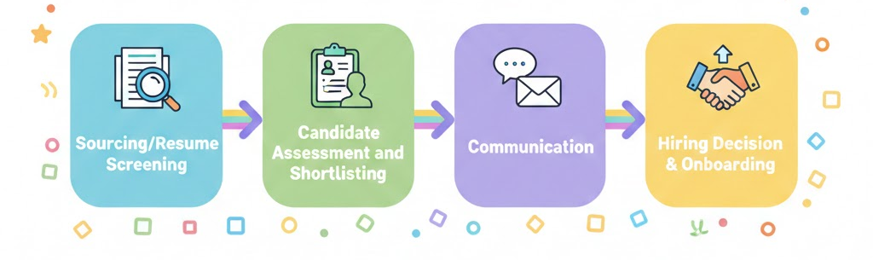

Figure 2.2: Recruitment and Selection (RandS)
(Source: Influenced by Akram, Buono and Lanzilotti, 2024)
Sourcing/Resume Screening: These applications are more prevalent and correspondingly one of the most popular ones since AI philtres large numbers of CVs according to keywords, working experience, and qualifications, which would be cumbersome for human HR functions (Abraham, Paripoornam and Sharma, 2025).
Candidate Assessment and Shortlisting: AI technologies are applied in improved short-listing and matching of candidates, which is often completed by virtual interviewing and is also implemented in the practice of interview scheduling and rating.
Communication: AI-driven chatbots completely conduct the preliminary communications with the candidates, which improves the communication and complete experience of the applicants, particularly when it comes to high-volume recruitment (Akram, Buono and Lanzilotti, 2024).

2.2.2 Theoretical Framework
Foundational Theories
A dual theoretical lens that includes a combination of both the Technology Acceptance Model (TAM) and the Resource-Based View (RBV) is the most effective replacement that will be used in this dissertation, intending to critically scrutinise the delivery and effects of AI in HR.
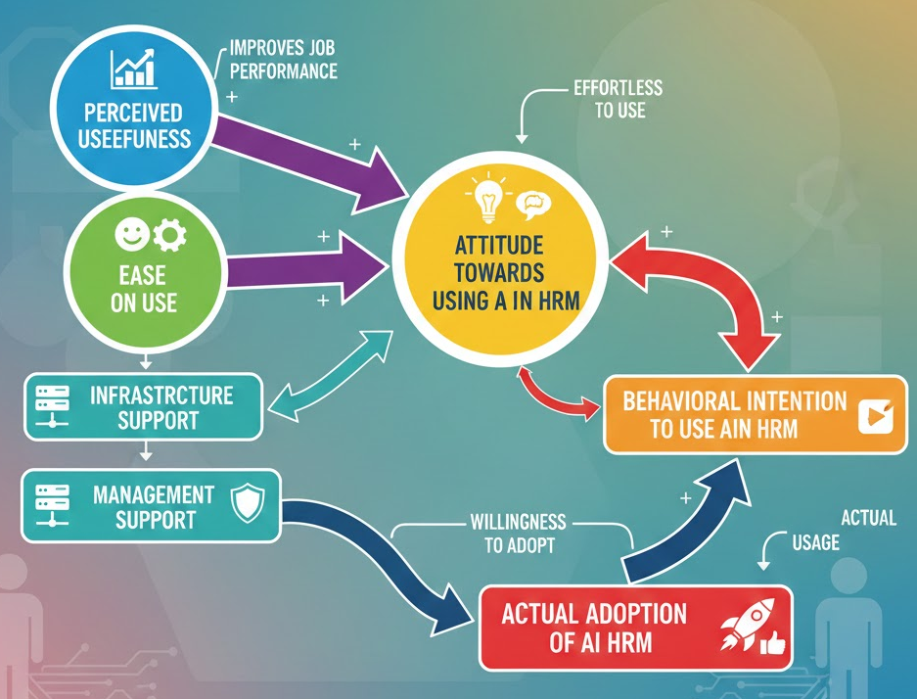

Figure 2.3: Technology Acceptance Model (TAM)
(Source: Influenced by Ishengoma, 2024)
Technology Acceptance Model (TAM): TAM is a popular model of theory that enlightens and predicts the variability of adoption of information technology by an individual. Its main predictors are Perceived Usefulness (the extent to which an individual think that the usage of a system will lead to performance improvement at the workplace) and Perceived Ease of Use (the extent to which an individual contemplates that the usage of a system will not be accompanied by any effort) (Ishengoma, 2024). These aspects have a direct impact on the adoption of AI in HRM, and perceived utility is one of the substantial factors that determine the adoption. Infrastructure and management support are correspondingly something that promotes acceptance.
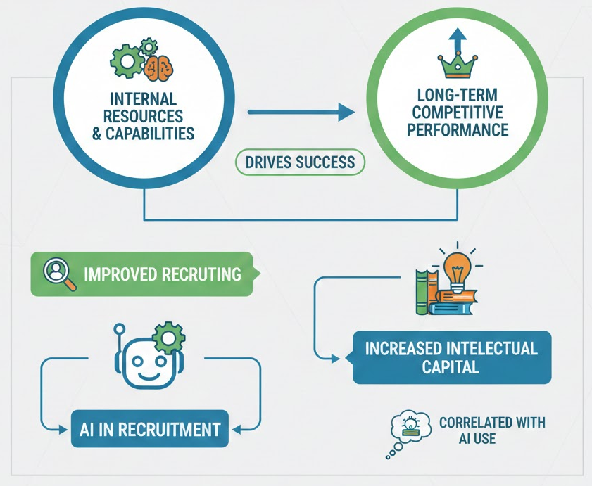

Figure 2.4: Resource-Based View (RBV)
(Source: Influenced by Nayak, 2022)
Resource-Based View (RBV): RBV is an approach to strategic management that posits that internal resource and capabilities that a firm have under its control are what are behind its long-term competitive performance (Nayak, 2022). Recruiting can be improved to increase intellectual capital, and this is correlated with the use of AI in recruitment. This model raises a concern about the competitive advantage and strategic value.
Critical Justification of the Framework
High Implementation Costs vs. Universal Savings: Whereas AI has major benefits in terms of cost and time conservation, the initial investment is high mainly to small IT firms. These early costs are insignificant when compared to the long-term gains, which encompass, but are not limited to, enhanced efficiency and quicker recruitment processes. The companies should however weigh well the level of their hiring requirements before committing the investment.
HR Staff Training is Necessary: The effectiveness of AI in the recruitment process greatly relies on the competence of HR staff. AI tools can make things more efficient, and inefficient without proper training, the HR teams can be unable to make the most of it. Adoption of AI in the IT market is not possible without investment in upskilling HR personnel.
Efficiency vs. Human Touch: AI will increase efficiency and speed; however, it will ever eliminate the necessity of human judgement due to its imperfection. There should be complement of AI in HR practises in the IT field, where cultural fit and innovativeness are valued more, instead of a substitution (Passalacqua et al., 2024).

2.3 The Value Proposition: Efficiency and Productivity

2.3.1 Automation of Routine Tasks in Recruitment and Selection
The most recognised and supported declaration about the usefulness of AI in Recruitment and Selection (RandS) is that it will enable the automation of repetitive and time-intensive activities, thus significantly boosting efficiency and speed.
AI Automation and Synthesis of Evidence
Resume Screening and Sourcing: AI applications, characteristically driven by the use of Machine Learning (ML), are widely used in sorting a large number of applications and also filter resumes as per keywords, experience, and qualification (Abhishek et al., 2025). This automation plays an important role in the rapid identification of candidates and is a thing that would have been monotonous for human HR functions.
Early-Stage Communication: Recruitment technology, such as chatbots and communication software, involves screening of candidates at their first levels of interaction (Koivunen et al., 2022). This improves communication and time-saving, particularly in mass hiring.
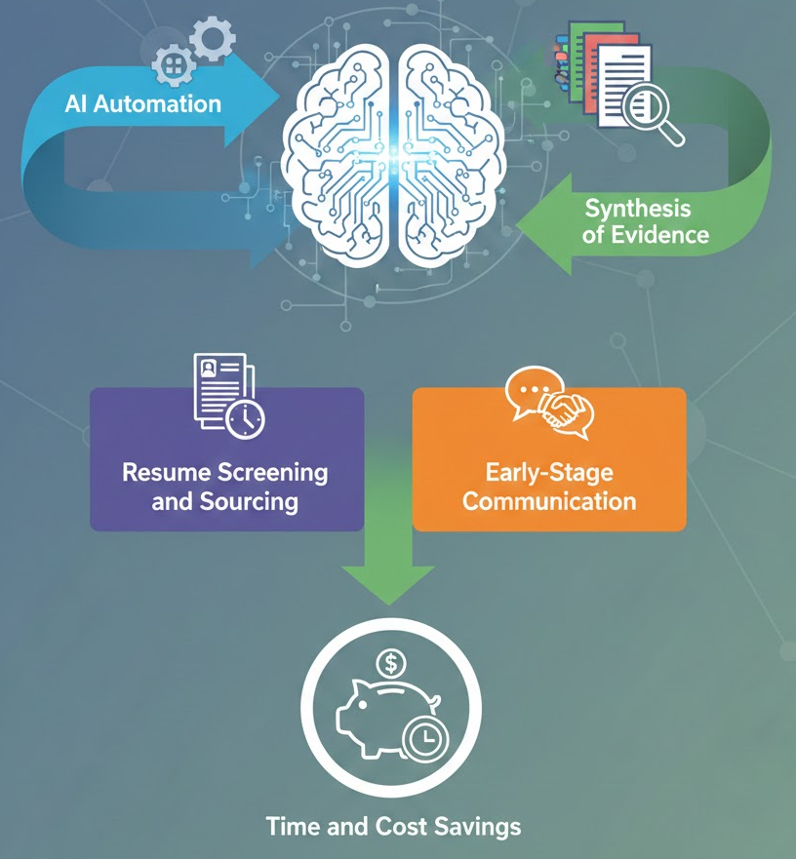

Figure 2.5: AI Automation and Synthesis of Evidence
(Source: Influenced by Koivunen et al., 2022)
Time and Cost Savings: It is acknowledged that time and money are saved through automation by numerous sources. AIs are capable of performing diverse tasks within a lesser time frame and create quicker and effective job applicant detection (Twyman, Pentland and Spitzley, 2020). To organisations, it is reduced work in receiving the large number of job applications.
Critical Evaluation: Justification of Investment
Recreation of Past Bias: Albeit AI can help in enhancing consistency, there is a possibility that it might be able to recreate past biases unless it is trained on historical data which is inclusive in the practise of discrimination. IT is a highly diverse industry that innovations cannot be done without diversity, so AI systems must be audited on a regular basis to enhance fairness and inclusiveness (Kordzadeh and Ghasemaghaei, 2021).
Pseudo External Validity Problems: Some predictive models are based on previous performance and this may not necessarily reflect performance in the future especially in an industry that changes rapidly such as IT. Predictive analytics does not supersede human judgement but can be used simultaneously to determine the potential of a candidate to become a better employee and would be flexible enough to work in the changing positions.

2.3.2 Predictive-based Data-Driven Decision Making
An increasing trend in the value offering of AI is the application of predictive analytics, which considers more than just the automation of administrative functions in the value offering but has an influence on the quality and consistency of hiring decisions.
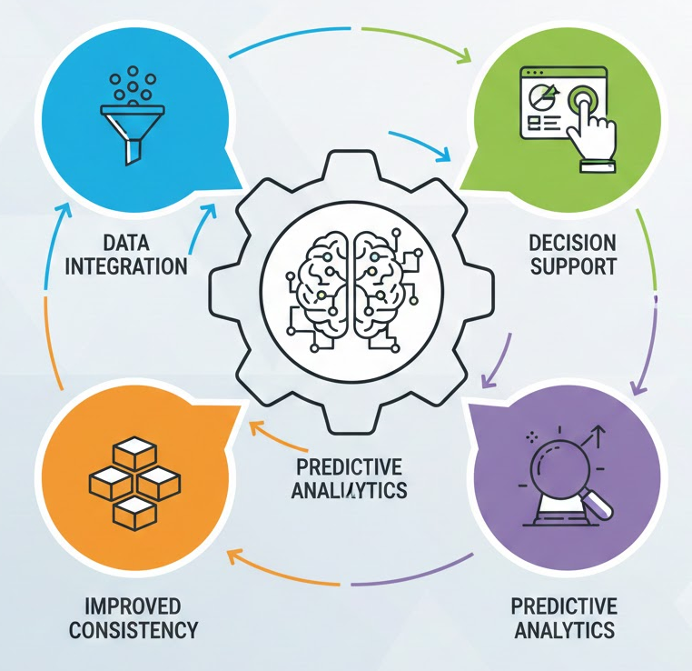

Figure 2.6: Predictive-based Data-Driven Decision Making
(Source: Influenced by Passalacqua et al., 2024)
Data Integration: Predictive analytics tools combine various data sources, such as CVs, the history of their applications, and their performance database, to inform a hiring decision.
Decision Support: The machine learning algorithms would provide correlations of candidate attributes and job performance after selection to enable recruiters to shift towards those applicants who statistically have a high probability of accomplishment (Koenig et al., 2023).
Improved Consistency: Based on data, minimise cognitive load among the staff of the HR department, and lead to increased consistency in the first screening and selection. This method allows the use of the data to make decisions instead of referring to human factors.
Predictive Tools for Candidate Sourcing and Matching
The predictive analytics process based on the outcomes of the Machine Learning (ML) has changed the cycle of candidate sourcing and the job-candidate matching.
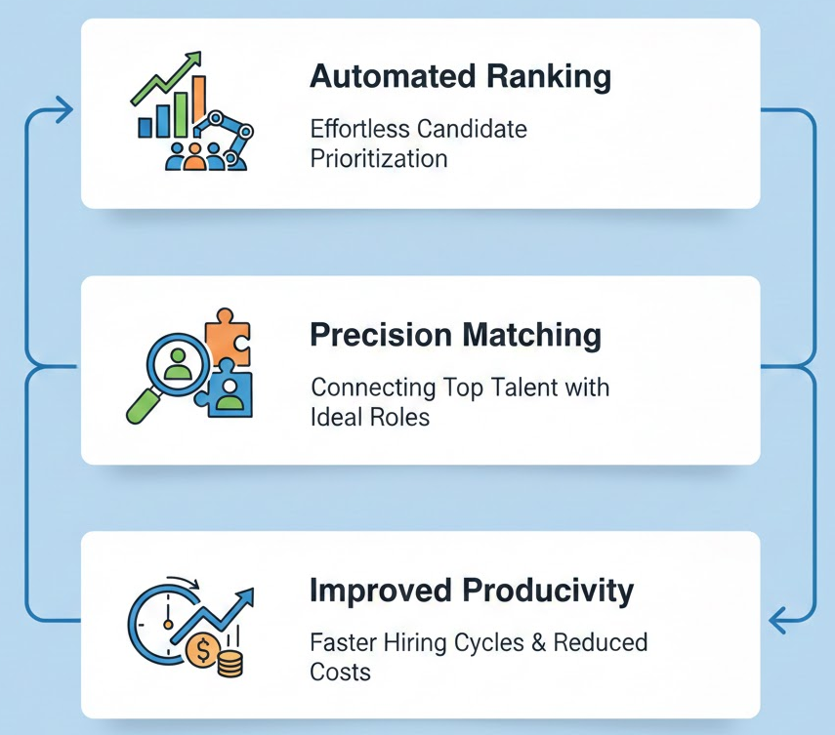

Figure 2.7: Predictive Tools for Candidate Sourcing and Matching
(Source: Influenced by Chavan et al. 2024)
Automated Ranking: AI-based systems and talent analytics software systematically rank the candidates and compare their characteristics to the performance standards that are based on past employee statistics (Faqihi and Miah, 2023).
Precision Matching: These are the tools that use Natural Language Processing (NLP) to recognise the information out of the unstructured CV and to match it with job specifications with high accuracy.
Improved Productivity: As mentioned by Chavan et al. (2024), the systems have often been shown to increase the productivity of the recruiter by reducing the applicant pool to only the most relevant applicants and making the process of shortlisting and interview selection quicker.
Assertions of Enhanced Quality of Hire
Superior Prediction: Although empirical inquiries have frequently proclaimed that judgment of human and algorithmic hiring choices yield similar job success forecasts, and particularly empirical research has demonstrated significantly better accuracy in high-volume recruitment situations.
Strategic Value: Organisations that are employing predictive analytics tend to indicate better personnel stability and less turnover in the early stages, which supports the argument that data-driven hiring positively increases the long-term performance of an organisation and contributes to the formation of intellectual capital.
Critical Evaluation: Bias and Validity Debate
Recreation of Past Bias: Algorithms are conditioned using historical data of recruitment and performance and might incorporate previous organisational biases. Predictive systems will pose a threat of reproducing previous and fruitful, but non-diverse employee profiles in the name of impartiality (Kordzadeh and Ghasemaghaei, 2021).
External Validity Issues: The past performance records might not be good indicators of future success in the dynamism of the current labour markets, where job position changes very fast. This calls into question the external validity of models of predictive hiring and their capacity to follow the dynamic skills needs.

2.4 Ethical and Legal: Equity, Prejudice, and Virtue

2.4.1 Equity (Fairness) and Algorithmic Bias
According to Kammerer (2021), AI video interview systems can increase legal discrimination because they rank the candidates under the influence of the uncertainties of the behavioural analytics, which are not beneficial to systemic discrimination. Rigotti and Fosch-Villaronga (2024) continue to suggest that fairness frameworks are symbolic and not practical on the ground since organisations are guided by efficiency rather than compliance. On the one hand, Kammerer (2021) wants the applicants to be legally secured, while Rigotti and Fosch-Villaronga (2024) believe that the issues in governance are the collapses in ethics, but not in the law. They both agree that it is biased but disagree on which is the necessary solution. Kammerer (2021) is of the opinion that regulation will put things in place, yet this is limited by the reality that real execution in the countries is otherwise. The focus of the normative frameworks by Rigotti and Fosch-Villaronga (2024) has not been empirically demonstrated to be effective in real-world hiring systems. Thus, the subsequent research must bear in mind the measures of fairness in the practical implementation, which does not necessarily rely on the conceptual or legislative instruments.
Fabris et al. (2025) conduct a massive level of multidisciplinary review and reach a conclusion that the bias is brought about by the information asymmetry, modelling choice, and organisational incentives. On the contrary, Yanamala (2022) states that the possibility of bias minimisation can be achieved through dynamic multimodal AI systems that are not pre-programmed. Fabris et al. (2025) disagree with the technological optimism model and argue that mitigation instruments remain people-biased. Yanamala (2022) assumes that engineering can be used to counter discrimination. This conflict is justified by the fact that Yanamala (2022) offers technical solutions and fails to demonstrate how they can be used in any industry, but Fabris et al. (2025) offer a critique and do not offer an alternative operational option. Neither of the papers presents field-based evidence of the outcomes of HR hiring, which requires application-level studies.
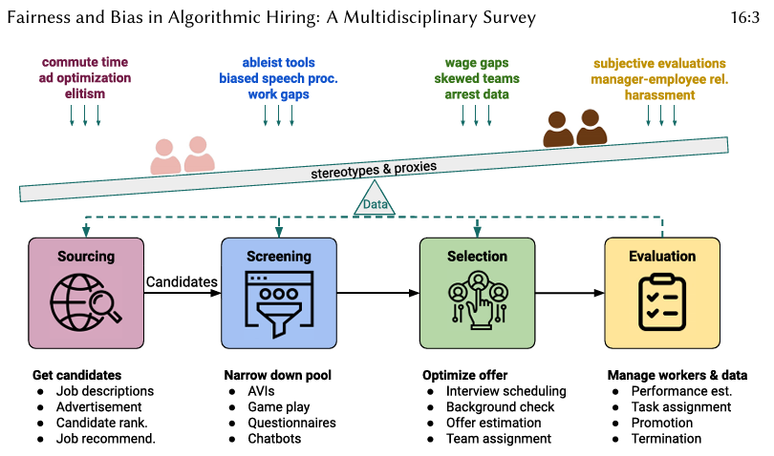

Figure 2.8: Fairness and Bias in Algorithmic Hiring
(Source: Fabris et al., 2025)
Busari (2025) specifies diversity protection as a strategic aspect, and the recommendations include inclusive datasets and bias reviews. Busari (2025) is much closer to Fabris et al. (2025) and acknowledges socio-technical impacts, which is not the case with the belief in algorithms by Yanamala (2022). Compared to Kammerer (2021), Busari (2025) does not give as much attention to the legal exposure. Among the weaknesses, one can distinguish the fact that the work by Busari (2025) is theoretical. The diversity protection measures proposed are not researched in longitudinal terms. More studies are required to establish the fact that such fairness policies lead to measurable hiring diversity.

2.4.2 Transparency and Explainability
Studies on transparency have shown that explainable AI (XAI) is generally understood as trustworthy, but there is a dispute on how it could be put into practice. Yanamala (2023) argues that ethical HR AI is a state of transparency, privacy, and accountability infrastructure, but these are more of a concept of governance rather than a process. Ghoneim (2024) goes further and proposes a strategic framework of the ways in which explainable AI can be integrated into the recruiting process, and that when the algorithms are able to provide the reasons, it gives the stakeholders more confidence. Where Yanamala (2023) believes that transparency is based on compliance, Ghoneim (2024) believes it is a way of trust building. The weakness is that both of them lack empirical validation of the influence of transparency on acceptance of hiring, and this shows the need to conduct behavioural research on the perception of recruiters and applicants.
According to Eva-Uzosike et al. (2024), autonomous screening algorithms must have explainable actions to explain their rationale to the recruiters. They also highlight productivity benefits over stakeholder ethics, unlike Ghoneim (2024). Naseer et al. (2025) state that there is a dilemma between efficiency and fairness and point out that transparency is to be founded on speed and equal feedback. This is contrary to Evans-Uzosiki et al. (2024), who indicate that transparency optimises and not trade-offs. These opposing positions reveal that transparency is not always an ideally treasured principle, and some see it as a beneficial efficiency, while others see it as a safeguard for a fair process. One of the gaps in the research is that they both still argue on the significance of transparency, and do not consider the cost of transparency, such as the fact that transparency may incentivise intellectual property risks or reduce predictive power when models can be interpreted.
Another one is a gap associated with the response by the candidates. Ghoneim (2024) assumes that transparency will make the stakeholders more trusting, but Naseer et al. (2025) note that total transparency may saturate the stakeholders or expose them to the risks of manipulation. None of the research has an experiment with a transparent design in a real recruitment situation. In order to explore the possibility of testing different explainability models, further research is required to find out which level is more advantageous in terms of fairness, efficiency, and confidentiality.

2.4.3 Data security, Legal risks, and privacy
Scholars agree that AI in recruitment has a greater compliance risk, although the opinions on the matter are split. Shaheen et al. (2024) write about HR cloud systems and state that one of the structural issues is data security, which involves governance and access control. They propose enterprise-level security models. However, they are not generalisable owing to their focus on US-based organisations. Du (2024) continues by pointing out that ethical and legal problems of algorithmic opacities and power imbalance between employers and applicants are ethical and legal issues that are raised. Shaheen et al. (2024) focus on the technical protection, and Du (2024) views privacy as an issue of rights. The weaknesses are that Du (2025) lacks any tangible risk-controlling measures, and Shaheen (2025) does not refer to consent or openness to ethics. More studies should combine the technical and ethical paradigms to assess the organisational capacity and the contribution to society.
Hristova (2022) studies the sphere of recruitment and the ICT industry and finds that the digitalisation of the industry has simplified the recruitment process but posed a risk of clash of privacy since the HR managers are not ready to deal with the danger. Ore and Sposato (2022) argue the same by saying that AI presents opportunities but also creates legal challenges in legal matters, especially when organisations adopt tools without knowing about accountability. Contrary to Shaheen et al. (2025), both Hristova (2022) and Ore and Sposato (2022) adopt an organisational behaviour method rather than technical security. Hristova (2022) assumes that the training gap is one of the risk causes, whilst Ore and Sposato (2022) suggest that structural risk is possible and may be determined by overreliance on automation. In both works, there is no information on the national differences in law or the rights of the candidates. This creates a gap in the literature on cross-jurisdictional compliance and the use of risk perception in adoption.
In their comparison studies, Du (2024) and Ore and Sposato (2022) concur when it comes to the ambiguity of the laws, yet they disagree on the reason. The latter believes that the reason is the absence of clarity, whereas the former sees it as an addiction to automation. Both of them ignore technical mitigation measures, such as encryption and role-based access, considered by Shaheen et al. (2024). Hristova (2022) state that the exposure of the HR capabilities with the help of legislation is due to the absence of the same, disagrees with the structural ethical argument of Du (2024). One of the weaknesses is that security breaches are not empirically measured, and compliance failures are not measured. Thus, the argument is highly hypothetical. Future research should carry out case studies of violations and experiment on the framework of privacy governance.

2.5 Candidate Experience and the Human-AI Dynamic

2.5.1. Impact on Candidate Experience
The professionals do not argue about the fact that AI is changing candidate engagement, but they are divided about how positive or neutral an experience it may be. According to Abumere (2025), AI can improve the experience of candidates, making communication timely and personalised, while reducing waiting time. To the contrary, Palenius (2021) stresses that the experience of the candidates is conditional on the influence of the emotional dimension of trust, respect, and human touch, according to which the relational expectation is not fulfilled by AI alone. The two also acknowledge that experience matter, but they do not empirically evaluate emotional response or level of satisfaction, which limits generalisation. Future research must be carried out to establish the variation in the perception of the candidates in automated and human-assisted recruitment.
Balasundaram et al. (2022) indicate that AI chatbots and automated scheduling can be used more effectively to interact with applicants However, they are aware of the dangers of depersonalisation when the candidates are speaking to AI rather than to a human being. This is contrary to Palenius, (2021) who considers that there is a need to be emotionally involved, but encourages Balasundaram et al. (2022) to state that digital interfaces are positive but conditional, where their effectiveness can only be attained when volume dictates the need to automate. Their case study is limited by the fact that their findings can be applied under high-volume corporate environments, but not specialised or senior talent. Therefore, the difference between the experiences of the types of jobs and industries should be researched by scholars.
Nyathani (2022) confirms the value of AI as related to the digital job hiring transformation but assumes that applicants will be comfortable with the algorithmic assessment process. This goes against the views of Palenius (2021) that human interaction and transparency are more significant. The drawback of the work by Nyathani (2022) is that it lacks negative experience, such as anxiety or mistrust towards automated decisions. Collectively, all the literature portrays two aspects that are optimistic adoption and relational critique. The gap in knowledge lies in the literal preference of the applicants and the evaluation of the hybrid experience implementations on the platform of the AI support, but not the human interaction.

2.5.2 Human-AI Coercion: Improvement of HR
The research on the collaboration between humans and AI proves that it is assumed that AI can successfully replace human recruiters, yet it does not agree with how such collaboration should be organised. Fugener et al. (2025) mention that AI will not replace human judgment, but it will supplement it. They argue that human beings must make systems work because AI cannot discriminate context and morality. Hridoy et al. (2025) give the same recommendation and suppose that AI should be analysed, and that humans should deal with relations and strategic aspects. The two focus on the process of augmentation, but Hridoy et al. (2025) discuss collaboration as friendly in comparison with Fugener et al. (2025) who focus on the possible risks of substitution, skills deficits, and overdependence on the algorithmic direction. Their argument provides some sense of doubt regarding whether AI is empowering or disempowering HR agencies.
Another argument that Abumere (2025) repeats addresses the claim to augmentation and is that AI can improve the performance of HR by assisting in filtering down applications and making data-driven decisions. However, he assumes that the HR specialists will not be unwilling to embrace AI. In a relative sense, Fugener et al. (2025) note organisational resistance whereby the human resource professionals fear losing power. The two works do not evaluate behavioural adaptation or training needs, which makes them less applicable. The second direction of research to be pursued is whether capabilities, position redesigning, and psychological acceptance can be developed among the HR personnel.
Hridoy et al. (2025) believe that the collaboration between humans and AI plays a role in the strategic change in HR. However, they give inadequate attention to such ethical questions of dependency or responsibility for decisions. Nyathani (2022) also focuses on the benefits of automation but does not investigate the issue of collaboration difficulties. Thus, the sources, which are working on collaboration, do not consider the organisational barriers, and the warning studies do not provide the solutions. This demonstrates that the gap in research regarding models of governance that separate responsibility between AI and human decision-makers is present.

2.6 Synthesis, Literature Gaps, Research Justification

2.6.1 Synthesis of Key Debates
The literature reveals that there is a high agreement on the issue that AI is introducing efficiency, time-saving, and accuracy in the analytical process of recruiting and hiring. Simple explanations show that artificial intelligence and machine learning, NLP, and predictive analytics are transforming the HR processes into evidence-based and not intuition-based decision-making. However, this becomes controversial since efficiency and perceived objectivity are more significant than ethical, experiential, and strategic risks. Researchers observe that automation will reduce the human effort in the operations, though other researchers fear that it will eliminate the human touch, equity, and trust. TAM-related descriptions define adoption as perceptions of usefulness, and RBV-based perceptions define AI as a potential competitive advantage when it is used in a responsible way. The positive attitude towards the digital convenience has an inverse nature in the candidate experience studies, in the fear of depersonalisation and an emotionless state. Another area of disagreement between the two sides of the argument is the possible outcome of the collaboration, which is to increase the augmentation that will make the HR agency stronger. The collaboration is also expected to diminish human judgment and responsibility. These tensions evidence that the literature is aware of the fact that AI could be transformative, but it is not certain how to balance it in the most effective manner, efficiency, fairness, human values, and organisational benefit.

2.6.2 Identification of the Literature Gap
Empirical assessment has scarcely been done despite its extensive coverage. Firstly, the research in the area of candidate experience is not unanimous yet and most of the studies suppose the existence of the benefits but rarely concentrate on the subjective experiences of the candidates across the industries or the types of jobs. Second, cooperation research fails to consider behavioural change and skills development in HR workers. Thirdly, the predictive hiring studies hardly worry about the dynamic labour markets or the external validity of performance modelling. Fourth, ethical arguments consider the presence of the algorithmic bias, yet they do not imply any tangible comparative analysis of the mitigation outcomes of real organisations. Finally, there is the absence of theoretical combination where both TAM and RBV knowledge were cited but barely combined in the explanation of both adoption and strategic value.

2.6.3 Justification of Research
These gaps are the ones that justify the present study, as organisations in the IT sector are now applying AI in ways that are not proven to be fair, and are accepted by individuals, and lead to positive experiential changes and strategic value. The study is useful for the IT sector in the sense that it links the variables of individual level adoption (TAM) and organisational competitive value (RBV), giving a two-pronged approach of explaining which has not been widely exploited in the empirical research specially in IT sector. It is also relevant because it investigates the impact of AI on the experience of the candidates and HR evaluation simultaneously in the IT sector, a correlation that the current independent research does not consider.

Chapter 3: Research Methodology

3.1 Overview
The chapter provides the methodology of the study, which is used to identify how the IT industry of the UK can transform staffing and selection processes through the use of Artificial Intelligence. The chapter is based on the Research Onion advanced by Saunders to explain the reason why the research is justified based on the philosophy of the research, approach, and design. The secondary research approach has been adopted, and only the peer-reviewed academic materials, industry reports, and reputable professional materials are used. The chapter explains the rationale of implementing content analysis as the primary technique of analysis to find the patterns and themes that were repeated across the literature. The ethical issues, the limits of research quality and methodology are also addressed in such a way that they bring about transparency, rigour, and academic integrity.
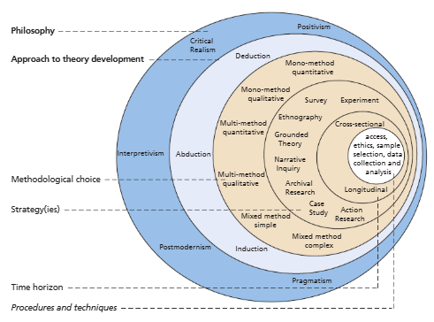

Figure 3.1: Research Onion
(Source: Saunders, Lewis and Thornhill, 2023)

3.2 Research Philosophy
Interpretivist research philosophy is used in the research since the study is focused on comprehending the multifaceted and socially constructed nature of Artificial Intelligence (AI) in recruitment and selection, and not quantifying it. The key principles of interpretivism are that it is subjectively inclined, contextually oriented, and seeks to explore multiple positions, posed in the existing scholarly and professional literature (Saunders, Lewis and Thornhill, 2023). According to the Research Onion by Saunders, interpretivism assumes that the areas of organisational practices, like ethical judgment and values towards fairness and transparency, have human interpretation and contextual factors.
Interpretivism is chosen because the work is expected to be critical in terms of the themes of bias, candidate experience, ethical concerns, and trust in AI-based recruitment systems, which could not be built properly without the assistance of objective and statistical analysis. The selected work relies solely on secondary qualitative sources. Thus, interpretivism is rather suitable to interfere with the arguments, discussions, and interpretations that might be generated by academics and professionals on bias, candidate experience, ethical concerns, and trust in AI-based recruitment systems. This is the reason why positivism is not used as it is preoccupied with hypothesis testing, quantification, and variables that can be measured, which are not suited when primary numerical data is not available and the investigative nature of the study (Maretha, 2023). Even pragmatism is not taken into consideration, as it normally promotes the mixed methods or problem-solving approach in using primary data, which is not within the scope of this study. By using the interpretivism approach, the study meets its goals and objectives since it is able to provide a contextualised and in-depth understanding of how AI is transforming the recruitment and selection processes, particularly with regard to fairness, transparency, and ethical accountability.

3.3 Research Approach
In this case, the research approach is an inductive type of research that is appropriate for the research as it is exploratory and interpretive. The metaphor of the inductive approach takes the change of some observations in the literature to larger patterns, themes, and conceptual insights (Kumar and Ujire, 2024). With the help of the method, this study aims at evaluating the opportunities that AI has in enhancing efficiency, fairness and transparency, but will also discuss the risks and problems that it comes with. The research does not presuppose some pre-tested hypotheses but helps to unveil the insights using the data. In the current case, it is represented by published academic sources, industry reports, and case studies on AI in the sector of recruitment and selection. Induction would be particularly suitable in a secondary type of qualitative research under the direction of Saunders Research Onion, where it is planned to build the theory and develop concepts.
The inductive approach is chosen because the literature that is available in the industry of AI in HR offers different opinions regarding the efficiency, fairness, transparency, and ethics, which are conflicting. The co-construction of these views is facilitated by the fact that the themes are allowed to develop in a natural way. The deductive method was not selected as it would require testing of hypotheses and the predetermined variables that could not be integrated into the reality on which the research was founded, based on existing qualitative evidence rather than primary quantitative data (Hall, Savas-Hall and Shaw, 2023). Using the induction, the study is able to give support to the aims and objectives of the study through the definition of powerful patterns, challenges, and implications of AI adoption, thus forming a more contextualised and better detailed view of how AI is changing recruitment and selection practices.

3.4 Research Strategy
The research design that has been adopted in the research is the Grounded Theory. The goal of grounded theory is to form a conceptual knowledge and theoretical meaning out of data in a direct connection through the systematisation of data coding and comparison (Stough and Lee, 2021). Available academic and professional literature constitutes the data in this work in opposition to the primary empirical observations. The selected approach is appropriate because the research is expected to develop a multifaceted perspective on the use of AI in recruitment and selection, and not to prove the existence of a model that has already been identified.
The grounded theory is chosen because it enables identifying general ideas and associations, such as the creation of efficiency, algorithmic bias, transparency problems, or ethical issues, in a succession of studies. These ideas are gradually reduced to incremental planes of explanation of the overall impact of AI in HR. It could not be conducted using other methodologies, such as experiment or survey, since it was not suitable due to the ease of access and sensitivity of HR information. Grounded theory can be used to justify the research goals because it allows theory to be developed based on adequate evidence, it helps in filling gaps that exist in the literature, and gives a rational explanation of the AI-based revolution in recruitment and selection.

3.5 Methodological Choice
The research is qualitative in terms of the mono-methodological selection. It is based on the analysis of the secondary data. The qualitative methodology is appropriate because the study is interested in understanding meanings, arguments, and ethical concerns surrounding AI in the job recruitment process and not quantitative implications. The mono-method design gives consistency in a methodology since all the data is extracted using textual materials such as journal articles, reports, and case studies (Vivek and Nanthagopan, 2021).
The specified methodological decision is selected because it is in line with the interpretivism philosophy and the inductive approach of the research. It could be applied to investigate in specifics a complicated matter such as fairness, transparency, and candidate experience, which are engaged in the research purposes. This approach did not use mixed-method or quantitative methodology since, in that case, one would receive primary or vast data that are not affordable or time-wise feasible for this research. The research has employed a qualitative secondary mono-method to systematise the previous knowledge and identify trends in the situations, and provide a comprehensive overview of how AI is transforming the recruitment and selection procedures in line with the stated goals and objectives.

3.6 Data Collection
The research is entirely premised on the secondary data collection, and no primary data, such as interviews, surveys, and observations, is conducted. The information that is already compiled and published by some other researcher or organisation is the secondary data. According to the research objectives, the data are collected by using peer-reviewed journal articles, academic books, industry reports, conference papers, and reputable organisational publications on AI application in recruitment and selection. Besides the other sources are sector reports, industry reports, and company-level reports. In order to ensure the validity and topicality of sources, one can refer to the fact that Google Scholar, ScienceDirect, and ResearchGate are the most significant academic databases (Singh, Srichandan and Lathabai, 2022).
The fact that the secondary data collection technique is chosen is that this would provide access to numerous varying opinions, industries, and geographical locations that would otherwise not be possible to attain during the primary data collection within the time that is available (Cheong et al., 2023). It also assists the study to utilise research that has undergone rigorous examination upon scrutiny and to test and enhance the credibility of the findings. Moreover, the information in connection with HR is confidential and delicate, and access to the primary organisational data is rather difficult and morally complicated.
The selection of the sources has been done according to specific inclusion criteria, and they are connected to the relevance of AI in the area of HR recruitment and selection, along with their publication in reputable sources, and whether the sources answer the research questions or not. It has academic rigour, which is ensured by the use of no outdated or non-peer-reviewed resources. The approaches to primary data collection were not employed due to time constraints, barriers of access, and ethical considerations of personal and organisational HR data (Idowu and Oluremi, 2025). The secondary data enables the study to support its goals and objectives by developing a synthesis of the current knowledge, diagnosing parallel patterns and issues, and provide a general view of the effects of AI on recruitment and selection practices.

3.7 Data Analysis
The data analysis of the current study is conducted using the qualitative content analysis, which suits the analysis of the textual secondary data in a systematic way. Content analysis is a complex process of reading, coding, and categorisation which presupposes the detection of recurrent themes, patterns, and relationships in the selected literature (Kleinheksel et al., 2020). This helps to decode the discourse of different authors concerning the advantages, difficulties, and ethical consequences of the use of AI in recruitment and selection.
The provided analysis begins with the familiarisation of the sources gathered, and the next step involves the open coding process to define such common conceptions as efficiency, bias, transparency, and experience of a candidate. These codes are subsequently further synthesised into larger themes in what is called the constant comparison process, and this is what is aligned with the inductive and grounded theory approaches. It is not based on quantitative analytical approaches since this study does not involve numerical data and a test of hypotheses.
Content analysis serves the objectives of the research directly since it provides the possibility to carry out a comparative evaluation of different views, and is capable of synthesising the evidence provided by different sources. The plan contributes to the aim of grounding the conclusions on the existing research that provides a more specific and realistic understanding of the effects of transformations concerning the recruitment and selection practices related to AI.

3.8 Ethical Considerations
The research is concerned with ethics in spite of the secondary data that is adopted. As no primary data has been collected, the issue of informed consent and anonymity of the participants is reduced to a minimum. However, this ethical responsibility can be maintained by ensuring that all of the sources are referenced and reported appropriately, without plagiarism and misinterpretation of the results (Lalwani, 2025). Only the credible and reputable academic and professional publications are used to ensure integrity and reliability. The study is conducted in accordance with the principles of academic honesty, transparency, and respect for intellectual property in the process of conducting the research as directed by the Saunders Research Onion. Additionally, the confirmation bias is avoided by considering the ethical care attributes. It helps to represent the AI in recruitment and related perspectives. The balanced attributes are instrumental in in presenting information on ethical scholarship and AI.

3.9 Research Reliability and Quality
The methodology in this study is well and clearly structured, and this ensures the quality and dependability of the study. Peer-reviewed and highly established academic resources are employed to enhance credibility (Steer and Ernst, 2021). The description of the data collection and analysis methods also ensures reliability because it can be replicated. The interpretations are also founded on literature, which has been reviewed to ensure confirmability as opposed to subjectivity. The evidence-based strategy of various settings and industries helps to support the transferability. All these measures ensure that the findings are credible, coherent, and consistent with the established standards of the quality of qualitative studies. Additionally, the exclusion and inclusion criteria regarding data sources are taken seriously to avoid any methodological complications. Besides the research bias is eliminated through systematic approach where the sources are only related to IT recruitment.

3.10 Methodological Limitations
This research is limited in terms of the various methodological limitations that affect the interpretation of the findings. To start with, the limited use of primary data narrows the range of depth and contextual richness of the analysis, because the information is obtained based on existing research works, but not on actual organisational operations or stakeholder experiences. The lack of primary data restricts the possibility of checking the real-life applicability of conclusions since it is not possible to examine how AI recruitment tools are implemented and seen in the context of IT organisations. Moreover, publication bias can exaggerate the positive effects of AI use, and the application of reported results as opposed to observed behaviours diminishes the possibility of evaluating the practical performance and organisational impact.

3.11 Summary
The chapter has stated the methodology framework of the research based on the Research Onions of Saunders. It presented the usage of an interpretivist philosophy, inductive approach, grounded theory strategy, and the qualitative mono-method based on secondary data. In the chapter, the cross-sectional time horizon, data collection, analysis methodology, ethical considerations, research quality, and limitations were also outlined. All of these methodological choices can ensure a strict and logical methodology, which provides a strong platform for analysing the role of Artificial Intelligence in recruitment and selection practices in the subsequent chapters.

Chapter 4: Findings

4.1 Overview
The chapter provides the findings of a qualitative content analysis of the secondary sources on the issue of the use of Artificial Intelligence (AI) in recruitment and selection in the IT industry. The criticism of how AI changes the hiring process is a critical analysis, which questions the findings of efficiency, fairness, and objectivity in the existing research. The findings hint at the issue of disagreement with the concept of AI as a non-stakeholder technological answer, but rather, they signify the conflict of the advantages of operationalisation and possible dangers of AI (ethical, social, and organisational). The chapter addresses the research objectives by synthesising evidence from studies in a systematic way to determine the suitability, fairness, rigour, and ethical issues of AI-based recruitment. One more significant problem that is also mentioned in the chapter is the governance mechanisms that are necessary to introduce transparency, accountability, and trust in organisational decision-making.

4.2 The suitability of AI in the simplification of the recruitment and selection procedure in the IT industry
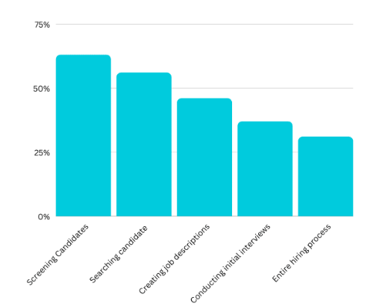

Figure 4.1: Part of the hiring process replaced by AI
(Source: Kumar, 2025)
The outcomes indicate that Artificial Intelligence (AI) can be used in the context of simplifying the recruitment and selection processes right at the start of the IT sector, but the more complex the hiring decisions and the human nature of the latter, the lower its efficiency. The IT industry has been characterised by huge applications, skills imbalance, and rapid technology transformation, hence, time-consuming and resource-intensive conventional recruitment approaches (Vărzaru and Bocean, 2024). The role of the AI-generated tools is thus, in the literature, as a tool of efficiency and not a replacement for human judgment.
As Figure 4.1 demonstrates, the most frequent hiring process components that can be replaced or supported by AI are the ones that are most common. The most AI-intensive one is checking the candidates (around 65%), then the close search of the candidates (around 55%) (Kumar, 2025). The outcome advocates arguments that AI is most applicable in tasks that comprise extensive volumes of data, are rule-driven, and produce CV screening, matching, and ranking of candidates by keywords. The AI will save administrative costs and time to hire within the IT industry, where technical skills and certifications can be algorithmically determined (Albassam, 2023). However, such suitability depends on the quality of input information and work requirements that most studies assert is frequently ill-posed or biased.
The further streamlining of the processes is illustrated by the fact that job descriptions are developed with the help of AI (around 45% and more) (Kumar, 2025). The automation job description tools, in their turn, contribute to the standardisation of language and optimisation of the posting to the search algorithms that might become more effective in reaching the applicants (Hosain et al., 2025). However, the unwilling installation of existing norms of competences in the area of IT with this standardisation, not permitting novelty and omitting non-stereotypical applicants.
It is noteworthy that the graph shows that the application of AI has reduced considerably in preliminary interviews approximately 35% and throughout the hiring process approximately 30% (Kumar, 2025). It means that the suitability of AI has a certain boundary. Although asynchronous interviews and chatbots are applicable in making the initial contacts with ease, it has always been repeated that the next stage of assessment of cultural fit, ethical decision-making, and problem-solving in IT professions are the areas that require the involvement of human beings (Mohammadali Shahbandi, 2025). This is because housing and complete automation of the hiring process can be said to be operationally risky and non-strategic.
The most significant is the fact that the outcomes show that AI has the greatest optimisation of recruitment when it is used as a supportive infrastructure rather than a decision-maker. This suits its functionality, which needs to improve the capacity of HR, such as regarding speed, consistency, and scalability, and activity of human oversight is needed to make interpretive and value-based decisions (Pratap, 2023). Thus, in terms of the first question and objectives, it can be interpreted that AI can be perceived as a means of a selective shortcut in the IT recruitment process rather than a solution.

4.3 The fairness and justice of IT-based AI-informed recruitment in a bid to decrease bias and enhance the diversity of candidates in the IT industry
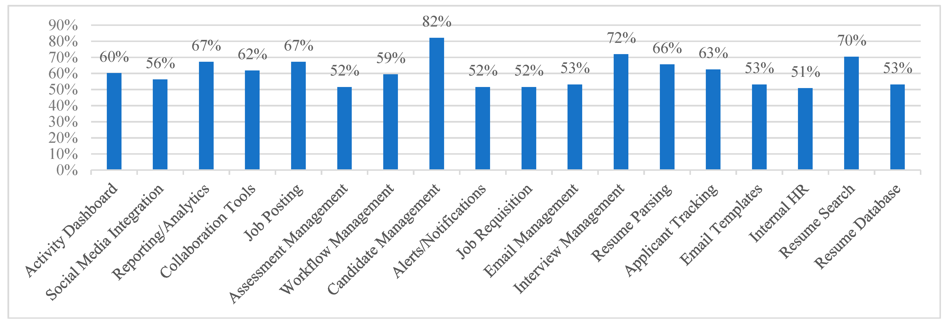

Figure 4.2: The most common features of recruitment software and systems
(Source: Koman, Patrik Boršoš, and Kubina, 2024)
The AI-based recruitment systems in the IT industry are considered as a way of enhancing fairness, consistency, and diversity, but the extent to which they have realised these claims remains a controversial topic. The creation of AI systems is intended to reduce the subjectivity of human beings by standardising the criteria of the evaluation process, but it is not only a technical but a socio-technical process relying on the decisions made in the design, data, and organisational objectives (Alawamleh et al., 2024).
The most popular features inherent in recruitment software and systems are identified in Figure 4.2. The percentage of the candidate management (82), interview management (72), and resume search (70) proves that AI is the most important component of the organisation of the process of filtering, tracking, and comparing candidates (Koman, Patrik Borsos, and Kubina, 2024). Under the fairness consideration, these systems would have the capability of reducing the discrepancies that are associated with manual screening since the same requirements are applied when screening all the applicants. This is particularly applicable in the IT industry, where the number of applicants in a given sector is quite high and human resource decision-making is largely heuristic in nature, with the least privileged groups not being represented.
However, there is a serious conflict in reporting/analytics (67%), resume parsing (66%), and applicant tracking (63%) (Koman, Patrik Borsos, and Kubina, 2024). Though analytics is sold as a way to find out bias and monitor diversity metrics, the literature points out that analytics can be as unbiased as the data on which it is created and the assumptions within it. Considering that there is a history of hiring discrimination based on gender, ethnicity, or educational inequities in the IT business, the AI systems that would be trained based on such data would reproduce and promote structural inequities rather than prevent them.
The mean application of the assessment management (52%), job requisition tools (52%), and email templates (53%) means that the decision-making communication is partially automated (Koman, Patrik Borsos, and Kubina, 2024). Procedural justice can be supported by the use of standardised tests, as all candidates are assessed by the same standards. However, AI-based testing is aimed at restricting the definition of merit, which is commonly conjunctive with the established technical criteria, and this restrains those who do not fit the standardised backgrounds or possess varied skill configurations (Khan et al., 2024).
It is worth noting that fairness is also determined by transparency and contestability. The factors, such as activity dashboards (60%) and workflow management (59%), can be improved to improve the organisational control, yet do not necessarily result in the transparency of the applicants (Koman, Patrik Borsos, and Kubina, 2024). The findings show that, although AI systems may appear to be neutral, the job candidates do not get a chance to understand the process of decision-making, thus undermining the perception of distributive and procedural justice (Luo, Zhang and Mu, 2025).
The evidence, in general, serves to prove the notion that AI can contribute to the reduction of the open human bias and the increase in the consistency of IT hiring, but it does not yet suggest fairness and diversity (Mitra Madanchian, 2024). The lack of conscious control, biased auditing, and inclusive design can contribute to the increase of the existing power imbalances in the name of objectivity by AI systems. Thus, in terms of the second research question and objective, it can be interpreted that the AI-assisted recruitment is to be perceived as a prerequisite of fairness, contingent on continued human oversight and ethical accountability, but not a self-reinforcing solution.

4.4 The degree of rigour and convenience of AI-driven recruitment systems to HR professionals and job applicants in the IT industry
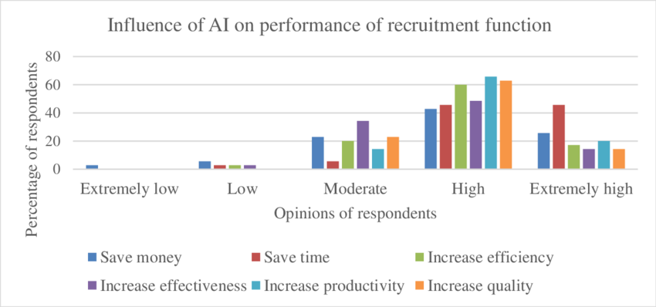

Figure 4.3: Influence of Artificial intelligence on the performance of recruitment functions
(Source: Pandya and Al Janahi, 2021)
The findings demonstrate that AI-based recruitment systems are now correlated with a high degree of operational rigour and procedural convenience among HR professionals in the IT sector, and offer more conditional advantages to job seekers (Rathore, 2023). Rigour, in this situation, can be conceptualised as consistency, standardisation, and reliability in recruitment decisions and convenience as fast, accessible, and less administrative (Oyadiran, Musa and KOLA, 2023). The literature is always placed in the context according to which AI is perceived as a performance-enhancement mechanism, which should be subjected to critical analysis.
Figure 4.3 demonstrates the perceptions of the respondents in terms of the effect of AI on the primary performance measures of the main recruitment, including cost savings, time, effectiveness, productivity, and quality. In all dimensions, the majority of the responses are high, particularly on the increase in productivity (approximately 65 percent), increase in quality (approximately 62 percent), and increase in efficiency (approximately 60 percent) (Pandya and Al Janahi, 2021). It means that AI systems are considered to be a significantly superior means of raising the structural rigour of the recruitment process as they reduce manual errors, put similar requirements into practice, and streamlining the processes (Almeida et al., 2025). Such automation enhances the decision discipline and scalability in the IT industry, where HR professionals are constantly under pressure to hire.
It is also known to have the benefits of time saving, where a high percentage of respondents have referred to AI effects as high or very high. This once again confirms the thesis that the AI-based screening, scheduling, and applicant tracking system reduces the amount of repetition and allows the HR specialists to focus on the strategic and relationship components of the hiring process (Pratap, 2023). The relatively few extremely high ratings on most of the categories, however, indicate that AI does not eliminate the inefficiencies, but rather rearranges the work in the recruitment role.
In relation to rigour, AI makes the procedures more consistent, yet raises concerns related to the mechanistic decision-making. Even though standardised testing and algorithmic shortlisting reduce the level of human discretion, it has been highlighted that such rigour might lead to the absence of contextual sensitivity, particularly in the creative roles of IT that require flexibility, and the ability to work in a team (Hunkenschroer and Kriebitz, 2022). The medium values of the graph on the characteristics of improving effectiveness imply the indecisiveness of the actual ability of AI to improve the quality of decisions beyond the surface-optimalisation.
The convenience to the job applicants can be perceived as the faster feedback, electronic correspondence, and online versatility. These qualities may be useful in raising the perceived accessibility, particularly in large IT firms (Sigal Kordova and Hirschprung, 2023). However, it is also possible that the perceived fairness and personal engagement are also reduced by the same systems. The AI-based recruitment is seen as opaque by the candidates, and it does not allow the candidate to challenge or understand the outcomes (Mamun et al., 2025). Thus, distance to applicants, psychologically, can be convenient to organisations.
The issue of AI will not adopt efficient assessment over meaningful assessment, unless there is an addition of human input to it, which further supports the importance of hybrid and balanced recruitment formats that would be more consistent and rely on human judgment (Reddy Yanamala, 2024). Therefore, the third research question and objective pinpoint that AI-based recruitment systems are highly operational, rigorous, and organisationally convenient, especially to the HR specialists who must contend with scale and efficiency in the IT sector. This rigour is rather technical than relational.

4.5 The ethical issues associated with introducing AI in the hiring process of the IT industry
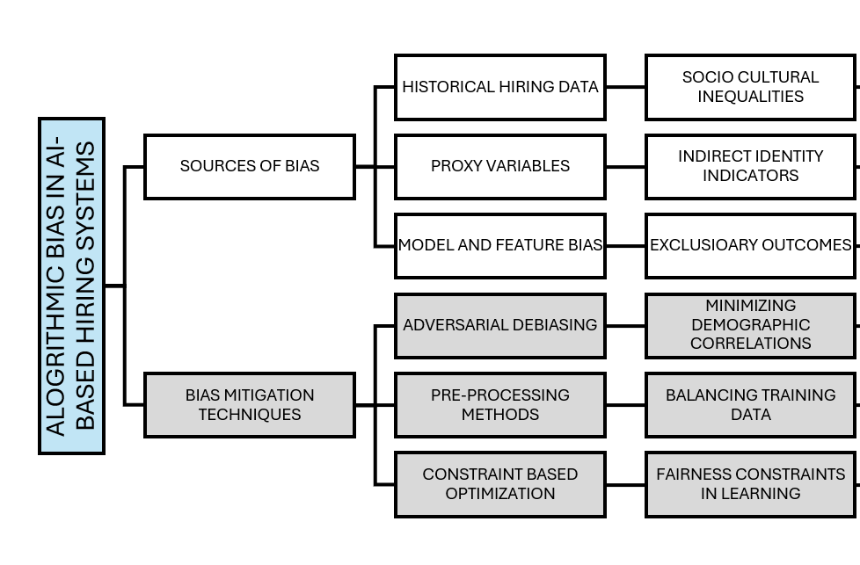

Figure 4.4: Algorithmic BIAS in AI-Based Hiring Systems
(Source: RIAZ, 2025)
The findings show that implementing AI in the recruitment processes in the IT industry poses systemic ethics threats, particularly in the realms of algorithmic discrimination, accountability, and validity of the decisions made (Zuzana Sýkorová et al., 2024). The conceptualisation of algorithmic bias, as conceptualised in Figure 4.4, is based on interdependent socio-technical processes that result in undermining the dominant discourse of the AI-driven recruitment as something neutral or objective (RIAZ, 2025).
The historical data of hiring is one of the major ethical concerns that encodes the socio-cultural differences that the IT industry already possesses. The AIs can be conditioned on historic recruitment outcomes, which are probably at least partially affected by gendered, racialised, or elitist biases, and thus promote the discrimination at scale process (Drage and Mackereth, 2022). Rather than removing bias, AI can automate it and hide it to present exclusionary findings that may appear to be based on data and, therefore, difficult to refute (Jarrahi et al., 2026). This introduces the problem of distributive justice that the marginalised groups may be filtered in a systematic way, with no discriminatory intent.
The proxy variables make ethical accountability a more challenging aspect. Figure 4.4 shows that the educational background and job gaps, or even geography, are some of the indirect indicators of identity that can be used as an alternative to the safeguarded facts (RIAZ, 2025). These variables may be useful in improving the accuracy of prediction. However, they are ethically inappropriate because they enable subtle discrimination. In the IT industry dominated by elites, where certain career trajectories and career paths are emphasised and rewarded, proxy-based filtering endorses the limited definition of merit and suppresses the goals of diversity.
The other ethical dilemma is model and feature bias, which refers to creating an algorithm in favour of certain competencies or behavioural indicators (Hanna et al., 2025). This is particularly regarding in the case of IT jobs where one needs to be creative, collaborate, and make ethical decisions that cannot be measured. This reliance on the reductive performance indicators creates the danger of giving preference to conformity, rather than potential, and is epistemically unfair and also excludes other forms of expertise.
The diagram also suggests bias mitigation techniques, such as pre-processing, adversarial debiasing, and constraint-based optimisation. Despite the fact that these strategies are sensitive to bias in terms of their technicalities, their implementation findings show that they are largely implemented as a way of complying rather than as an ethical requirement (RIAZ, 2025). Such minimisation strategies of demographic correlations or balancing training information can promote statistical values of fairness, but not address more basic structural disparities that constitute labour market participation in the IT industry. Rather than being resolved, the ethical risk is transferred.
The ethical discourse is not confined to prejudice only, but also to transparency and accountability. AI systems may be highly black box, limiting the explanatory capabilities of the HR practitioners, and the candidates (Chen et al., 2025). This is a weakness of procedural justice since rejected applicants are unable to understand, challenge, and appeal. This invisibility is morally unacceptable in the recruitment of IT, which is a high-stakes process where the economic and social mobility of an economy and a society greatly rely on the result of the employment.
Overall, the findings indicate that the issue of ethics in the field of AI-based recruitment is not peripheral but core. It also supports the research question by interpreting that without effective governance, human agency, and ethical reflexivity, AI will transform the recruitment process into a biased computational regime rather than a biased human administration and facilitate inequality and innovation against efficiency.

4.6 Rules to make the organisational decision-making process fair, transparent, and trustworthy
The findings indicate that in order to attain fairness, transparency, and trustworthiness in AI-based organisational decisions, the governance guidelines ought to be followed rather than sticking to technological neutrality. Within the framework of the IT industry, where AI is increasingly being integrated into the hiring procedure, fairness should be established as an organisational value, rather than a natural result of an algorithmic optimisation (Albaroudi, Mansouri and Alameer, 2024).
Firstly, organisations must come up with accountability systems. The application of AI systems should not replace the human decision-maker, and HR professionals will remain liable for the ultimate decision in hiring (Hosain et al., 2025). This will render the decisions challenging and ethically based. Their rights to the outputs of the algorithms should also be clear to prevent a case of the responsibility being diffused between the vendors, the developers, and the HR departments.
Second, explainability and algorithmic transparency must be put into focus. Organisations should adopt AI tools that provide explanatory decision logic instead of black-box models of decisions (Ali et al., 2023). When AI is used, it must be clarified to the candidates the nature of the data processed and how the decision was arrived at. Transparency enhances procedural justice, since, in this way, the applicants could understand the results and even doubt them, which would raise the institutional trust (Lambros Roumbanis, 2025).
Third, regular bias auditing and validation should be mandatory. The AI-based systems must be continuously tracked in terms of discrimination patterns according to gender, ethnicity, age, and socio-economic status because, in the past, the IT sector has faced various diversity challenges (Stypinska, 2022). It is important to note that the audits should not be limited to technical indicators and also include a qualitative assessment of justice and inclusion.
Fourth, there should be inclusive data governance. The training information will be periodically checked to ensure that it does not replicate the old or discriminatory hiring measures. Business organisations must actively increase data volumes of input and incorporate non-traditional capacity indicators besides traditional credentials (Fabris et al., 2024).
Finally, the use of ethics will require continuous human surveillance and ethical training of the HR experts. Failure to be competent enough to perceive AI outputs critically implies that organisations will be encouraging algorithms to make decisions. Combined, these rules render AI a decision-support system that will become part of the ethical governance, and not the autonomous force that would determine the organisational futures and fulfil another research question and objective.

4.7 Summary
The outcomes of the research on the application of Artificial Intelligence in recruitment and selection in the IT business are critically discussed in this chapter. The discussion has noted the suitability of AI at the phase of streamlining the recruitment, questioning its capacity to facilitate fairness, rigour, and ethical legitimacy, and self-acting. The findings showed that there existed uniform risks of algorithmic bias, obscurity, and exclusion, and efficiency and consistency gains. It is interesting to note that the chapter has established that the performance of AI-based recruitment does not depend more directly on technology but on organisational governance and human controls. The findings provide a sound empirical guide to the subsequent discussion chapter through which conclusions are made in terms of relevant theory and in line with the research objectives of the study.

Chapter 5: Discussion

5.1 Overview
In this chapter, the results provided in the previous chapter have been critically discussed by explaining their meaning, significance, and implications in relation to the objectives of the research, research questions, and the available academic literature reviewed. The four research questions are used to create the discussion and set the framework of the study based on the Technology Acceptance Model (TAM) and Resource-Based View (RBV), which were identified as the models that guide the discussion. In a combination of the findings of this research with those that have already been conducted by various researchers in the area of artificial intelligence-mediated recruitment, algorithmic discrimination, transparency, ethics, and human-AI interaction, this chapter locates the present study within the broader discourse of artificial intelligence in human resource management. Therefore, it demonstrates how the findings prove, extend, and in some cases disprove the existing arguments of the existing literature and provide a glimpse of what it takes to apply artificial intelligence to the recruitment and selection processes.

5.2 Recruitment and Selection AI-Based Efficiency and Automation (RQ1)
The findings of Chapter 4 demonstrate that artificial intelligence can be used positively to improve the efficiency of the recruitment and selection process in the first stages, such as screening of resumes, shortlisting of the applicants, and monitoring of the applications. It is complementary to the already published literature that highlights that AI has the capability to automate repetitive and high-volume recruitment processes. Using AI-based resume screening applications as an example, the process of screening resumes is more accurate and quicker because the code can analyse a profile of candidates using machine learning and natural language processing (Abhishek et al., 2025). The sophisticated applicant tracking systems prove to be helpful in simplifying the recruitment process and reducing the administrative burden (Chavan et al., 2024).
It is possible to argue on the basis of the results of the study that the introduction of AI might assist organisations in saving time-to-hiring and increasing their efficiency in operations (Albassam, 2023; Pratap, 2023). However, it is also discoverable that AI has not been utilised yet to replace, but support, human decision making. AI performs better on specific phases of the recruitment process as opposed to the entire recruitment process (Hewage, 2023; Nyathani, 2022). The real-world data show that the application of AI tools to organisations is biased in giving priority to those areas where organisations can definitely achieve tangible benefits, particularly in large-scale recruitment scenarios.
The Technology Acceptance Model could be used to explain these findings on a theoretical basis. The perceived usefulness to be a key aspect in AI acceptance by recruiters (Almeida et al., 2025). The positive attitudes towards efficiency and accuracy identified in the results can support this statement, since this is why the use of AI technologies is becoming more widespread, as far as hiring by organisations is concerned. There is a need to match TAM with innovative technologies, which the research findings have validated as the acceptance is not only determined by usefulness but also organisational preparedness and perceived risks (Ishengoma, 2024).
Resource-Based View also puts these findings into perspective by explaining AI-enabled recruitment systems as a significant source of organisational resources, and it becomes significant when it is operated together with human expertise. AI may be employed in the intellectual capital when it is contextualised within the context of HR competencies rather than dealing with it as a singular solution (Sandeep et al., 2025). The findings support this point of view, in that the hypothesis was that AI-based efficiency will boost organisational performance when complemented with talented HR specialists who will decode and place the results of the algorithmic analysis into perspective.
The findings of the current research demonstrate that AI has a tremendous positive impact on the growth in efficiency within the recruitment and selection process, particularly at the initial stages of the procedure. When considering the information analysed and the sources of information regarding the industry, AI appears to be the most helpful tool as a screening and filtering tool, and not a final decision-making tool. Robotisation of personnel is time-saving because recruitment is time-consuming and indicates that the recruiter is able to redirect their focus to more essential activities, such as interviews and communication with candidates. However, these findings can be used to signify the disparity of efficiency gains, too, and they will depend on how AI is utilised. The efficiency of organisations may be realised at the cost of candidate fit or organisational values in case organisations over-rely on automation and make judgements in certain situations. Therefore, the study concludes that AI can respond to RQ1 since it can be applied to enhance the efficiency of the operations in the scenario where they are utilised as a supportive system inherent in human-based recruitment decisions, yet not as a solution to them.

5.3 AI Recruitment Fairness, Bias, and Diversity Implications (RQ2)
These findings suggest that the relationship between the implementation of AI and the views on fairness in the hiring process is quite complex. Although the subjects were aware that AI would reduce the impact of human bias in the form of standardisation of decision-making criteria, there were significant apprehensions about algorithmic bias in the training data and system design. This view of both parties indicates the broader academic discussion, where AI is viewed as weakening or strengthening discrimination during the hiring process.
The issues are adequately justified in the available literature. The algorithm bias is predisposed to be grounded on the historical scope of data, which reflects historical disparities, and such a bias can be harmful to some groups of individuals. The findings of the research agree with the claims that AI does not remove bias, but it can be shrouded in the illusion of objectivity (Drage and Mackereth, 2022). Similarly, the theme of age-related discrimination in algorithms confirms the aspect that AI bias has different forms.
However, the findings demonstrate that AI can reduce bias if it is developed and operated in a responsible fashion (Oman et al., 2024; Yanamala, 2022). This means that the outcomes of fairness are reliant on the organisational practices and not a property of technology. According to RBV, discriminatory AI systems may influence the perception and credibility of organisations and, hence, decrease the competitive edge in the long run. Equal and fair recruitment procedures thus become strategic resources and not compliance needs.
TAM also gives an insight into these findings. The perceived fairness and trust influence the acceptance of AI systems by users since recruiters will hesitate to use technologies that they believe to be discriminatory. The findings of the study indicate that organisations have to deal with the issue of bias actively to guarantee the continued adoption and successful use of AI recruitment tools.
Regarding the problem of fairness and bias, the outcomes indicate that there is an evident discrepancy between the perceived objectivity of AI and its actual limitations. Even though the minimisation of human bias is often claimed to be the advantage of AI, analysis indicates that it may not necessarily produce more impartial results. Instead, AI systems will tend to represent the reflection of the data and assumptions embraced in the system. This means that the imbalance in the recruitment process in the past may be repeated or even aggravated as long as there is no sharp eye on the systems. It highlights the fact that fairness is not only a technical issue but an organisational responsibility. In order to respond to RQ2, the findings reveal that AI is potentially beneficial in terms of enhancing diversity and fairness due to the fact that organisations audit algorithms, diversify the training data, and retain human control. Without these precautions, AI can only serve to increase the existing biases rather than mitigate them.

5.4 AI-Based Hiring Transparency, Explainability, and Trust (RQ3)
The key variables of trust in the AI-mediated recruitment systems have been found to be explainability and transparency. Black-box algorithms were of particular issue to interviewees when the result of a decision-making procedure could not be easily explained or supported. The outcomes can be likened to that explainable artificial intelligence (XAI) is one of the keys to building any reliable AI systems (Ali et al., 2023). Evans-Uzosiki et al. (2024) also make similar conclusions and underline the importance of explainability in the autonomous screening algorithms to facilitate confidence among the stakeholders.
The findings of the work also align with those of Ghoneim (2024), who supposes that the ethical decision-making in AI-based recruitment is based on the concept of transparency. The responsible AI use should be coupled with accountability mechanisms to promote transparency in AI use (Yanamala, 2023). Thus, AI processes have a negative impact on the perception of procedural justice and organisational attractiveness, which may deter high-quality applicants on the candidate side.
These findings, together with TAM, indicate that ease of understanding and perceived transparency make a significant impression on technology acceptance. The state-of-the-art technologies require bigger acceptance models that consider trust and are explainable (Ishengoma, 2024). The findings can be put into this perspective and reveal that transparency is a technical requirement, a social and organisational requirement. Consequently, the organisations must strike a balance between the interpretability requirement and the complexity of algorithms to develop trust between the recruiters and the candidates.
As discussed, transparency and explainability are the most important aspects of trust in AI-based recruitment systems. The analysis of the results conducted demonstrates that the gap in understanding the way decisions are made by AI is what causes doubts on the part of recruiters and potential job seekers. The absence of transparency in the decision-making process results in the loss of trust and acceptance despite the right AI result. This means that explainability and accountability are components of trust in addition to performance. In addressing RQ3, the research reveal that the trust in AI recruitment is conditional: it increases in situations where organisations can explain the algorithms of decision-making and situations where human beings are still accountable for the final outcomes. Consequently, black box AI systems are more likely to be mistrusted or considered unethical regardless of their efficiency or predictability.

5.5 AI Recruitment Ethical, Legal, and Data Privacy issues (RQ4)
The results involved ethical and legal concerns, namely, privacy of the data, its accountability, and monitoring. It was unclear who the decision makers in AI-related issues were, and this is a common issue in the literature. Du (2024) and Hunkenschroer and Luetge (2022) shed some light on the ethical problem of delegating hiring to algorithmic solutions, but Hunkenschroer and Kreibitz (2022) contextualise AI recruitment as a human rights issue.
There were also legal issues that were evidenced, particularly where transparency and candidate protection were concerned. The video interviewing method based on AI raises critical legal issues related to fairness and consent, whereas the possibilities of AI-based video interviews should be regulated through the development of regulatory frameworks (Kammerer, 2021; Rigotti and Fosch-Villaronga, 2024). The findings are also highlighting the problem of ethical data management in HR information systems. Under ethical AI practices, according to RBV, the organisational reputation and trust can hardly be emulated by the competition. The findings suggest that the organisations that adopt the system of ethical governance have the opportunity to transform the compliance requirements into strategic advantages. It proves that the ethical considerations are not to be presented as the external constraint on the organisational culture (Zuzana Sykorova et al., 2024; Riaz, 2025).
The ethical, legal, and data privacy issues proved to be the crucial constraints to the application of AI in the recruitment process. These issues are the focal points, not the fringe factors, to decide the acceptability and rightfulness of AI systems. Consent, data security, and responsibility-related problems indicate that AI recruitment is in a sensitive ethical setting. Responding to RQ4, the findings suggest that the issues of ethics are improved in such situations when the process of decision-making is entirely decentralised to automated systems. This helps in arriving at the conclusion that recruitment in the context of ethics requires a well-established framework of accountability and compliance with data protection regulations. The paper therefore recommends that AI should be controlled through a robust code of ethics that will guarantee that the effectiveness of technology does not hurt legality and moral accountability during the hiring choices.

5.6 Human-AI Partnership and the evolving HR position
The findings indicate that the application of AI redefines, but does not wipe out, the roles of HR professionals. AI is regarded as an assistant to the work of analytical and administrative tasks; thus, the HR practitioners can be engaged in strategic choices. This conforms to the paradoxes of AI in HR as written by Charlwood and Guenole (2022), in which the efficiency benefits are accompanied by the increased rates of human judgment.
This concept of AI is the concept of augmentation and not automation, which is confirmed in the study (Fugener et al., 2025). The necessity to have human-AI cooperation in the future of human resource management. The partial automation is more productive and generates skills and motivation, which proves the expediency of hybrid recruitment schemes. According to RBV, human knowledge is a rare resource of an organisation that can hardly be imitated. The findings suggest that the successful application of AI is linked to the need to train human resources and enhance the process of collaborative decision-making to enhance organisational competency and strength.

5.7 Contribution to Knowledge and Practice
Another contribution that the paper makes to academic research is that it is empirically integrated with TAM and RBV in the context of AI-based recruitment. The research is important to the existing knowledge base related to the concept of AI acceptance and strategic HR management since it links the perceptions of usefulness, fairness, and transparency in the eyes of the recruiter to the ability to build organisational capability. It also throws light on the finer parts of the ethical and social aspects of AI recruitment, which have been lacking in past studies.
In practice, the results can be used as evidence-based information that can be used by organisations that desire to adopt the use of AI in a responsible manner. They stress the importance of governance, transparency, and human control in the achievement of sustainable recruitment outcomes. The research provides useful suggestions to human resource practitioners and decision-makers because it demonstrates that the efficiency of AI depends not only on technological development but also on organisational circumstances.

5.8 Summary
This chapter has critically discussed the findings of the study in combination with the existing literature and theoretical frameworks through empirical evidence. It also addressed all the research questions, and the consequences of the AI-based recruitment are described in terms of efficiency, fairness, transparency, ethics, and the cooperation between humans and AI. These observations are formulated in the next chapter, where the study findings are concluded, including practical recommendations and research directions.

Chapter 6: Conclusion

6.1 Overview
It is the last section of the dissertation that demonstrates the conclusion of the entire research process that was used throughout the study. The goal of this conclusion is to bring a summary of the key findings, specifically address the research questions, and comment on the overall implications of the research to theory and practice. This chapter gives a more advanced approach as compared to the discussion chapter, wherein the analysis of the findings was interpreted descriptively, since the primary challenge in this chapter is on synthesis, contribution, and closure.
In this paper, the authors have explored the application of artificial intelligence (AI) in recruitment and selection processes regarding efficiency, fairness, transparency, and ethical issues. According to the outcomes of the literature review and the findings of the research, this chapter explains how the research objective has been achieved and how the study has contributed to the existing scholarly issues and practice. The chapter is also concluded by the limitations of the study, the suggestions for future research, and the final reflective statement regarding the significance of the research.

6.2 Research Aim and Research Questions Re-statement
The primary purpose of this paper was to present the topic of the use of artificial intelligence in recruitment and selection and to examine the perceived benefits, challenges, and ethical issues of its use. The research could provide empirical evidence of experience and perception of AI in organisational recruitment, and thus, by addressing this gap in the existing body of literature, the majority of studies have concentrated on the technical capabilities of AI systems.
In order to achieve this aim, a set of research questions informed the paper, and they investigated such as how AI may be applied to encourage efficiency and decision-making in recruitment and selection; the extent to which AI influences fairness, biases, and transparency of employment; and the organisational and ethical challenges associated with the AI-based recruitment procedures.
These research questions assisted in having a clear outline of data collection and analysis of data, which made the study limited on practical and theoretical issues. Such questions are also delivered back to the conclusion, bearing in mind the findings and expressing how the research has served its initial objectives.

6.3 Summary of Key Findings
The outcomes of the study demonstrated that AI can be a significant aspect of enhancing efficiency in recruitment and selection activities. The ability of the AI solutions to automate the routine of screening the CVs, shortlisting the candidates, and initial assessment was also of interest to the respondents. This automation was perceived to save time-to-hire and reduce the workload of the administrative staff, and allow human recruiters to put more of their resources towards the more strategically oriented and relationship-oriented hiring.
The same results also indicated that efficiency gains could not be made without considering issues of fairness and bias. Though it was generally assumed that AI became a means of eroding the subjectivity of human participants, the respondents shared their worries about the problem of the algorithmic bias, particularly in situations where AI systems are trained with the recruitment data of the past. This questioned the fact that the existing inequalities were going to be intensified without considering the fact that they would be eliminated. The issue of transparency was also found to be a related one, with certain participants stating the difficulties of explaining or interpreting AI-driven decisions to candidates.
The most dominant theme of the results was moral issues. Concerns were raised on data privacy, informed consent, and accountability issues, especially on the issues involving candidate trust. According to the respondents, the necessity to engage humans was mentioned, which meant that AI should help, and not replace human discretion in the course of recruitment. Overall, it was found that there is a fine balance between technological performance and moral responsibility, and that AI usage in recruitment has to be used with caution and under strict control.

6.4 Discussion of the Research Questions
The first research question was how AI can be used in the performance and decision-making during the recruitment and selection processes. It was also evident in the results that the operations can be made more efficient through AI by means of automating time-consuming and high-volume tasks. It creates the conclusion that AI can be a helpful tool to rely on in regard to the rapidity and accuracy of decisions in relation to recruitment in the early stage, particularly when comprehensive recruitment is involved.
The second research question was that of fairness, bias, and transparency. The authors concluded that even though AI would reduce personal human bias, it opens new dangers of algorithmic bias and obscurity. According to respondents, they were scared that, given the ambiguity of the processes involved in AI decision-making, some suspicion of unfairness among the candidates could be present. The study, thus, concludes that AI alone does not guarantee that the recruitment process can make any progress towards being fair unless properly designed, supervised, and audited.
The third research question was changed to ethical and organisational concerns of the adoption of AI. The findings revealed that the data privacy, accountability, and trust ethical issues are key constraints to the universal acceptance. It turned out that organisations are becoming conservative in providing AI with full-time capabilities of decision making and instead prefer to retain the human touch in the whole process. All these findings could be used to provide evidence-based and clear answers to the research questions and demonstrate that the application of AI in recruitment is both beneficial and challenging.

6.5 Literature Gap and Research Contribution
The literature review found a gap in the empirical research that investigates the experience and assessment of AI in an actual organisational recruitment context, especially on a practitioner level. This paper helps fill this gap by offering qualitative information about the perceived benefits and issues of AI-based recruitment.
The results build upon the current body of knowledge by stating that only efficiency gains cannot be sufficient to justify the adoption of AI without also factoring in ethical and other issues related to fairness. Although other studies tend to underline the objectivity of AI in other situations, this study proves that perceptions of bias and transparency are still at the centre of acceptance. In this manner, the research adds to the body of original empirical evidence that enhances the knowledge on the negotiated aspect of AI in practice, but not in theory.

6.6 Contributions to Theory
Theoretically, the current study leads to knowledge contributions because it supports and expands on the current frameworks regarding technology adoption and human-technology interaction. The results confirm the opinion that technological instruments are socially instilled and influenced by organisational ideals, administration, and human opinion.
The paper is also a contribution to the discussion of the subject of algorithmic decision-making because it proves that AI is not an impartial actor. Rather, their results are affected by data entries, organisational goals, and human control. Empirically demonstrating the conflict between automation and ethical responsibility, the research provides a sophisticated addition to the theories that focus on the effect of AI on the decision-making process and development of organisational competence.

6.7 Contributions to Practice
Practically, the findings will be useful to organisations that are planning or are already using AI in recruitment and selection. The paper points out that despite its ability to contribute to much efficiency, AI should not be implemented as a cost-effective or time-saving measure. Instead, organisations need to emphasise transparency, fairness, and ethical governance.
The findings can be used by the practitioners to appreciate the need to have human oversight during the recruitment process. To develop trust, it is necessary to communicate to applicants clearly about how AI will be used and to conduct frequent audits of algorithms and how they meet the standards of ethics and the legal field. The research thus offers practical pieces of information that may help in the responsible and sustainable adoption of AI in recruitment practices.

6.8 Limitations of the Study
The study is however, limited in a number of ways, notwithstanding its contributions. One, the research was restricted in terms of the scope to a particular organisational context, and this could limit the generalisability of the results. Second, the research used qualitative data, which, though very rich in terms of depth, might not be able to reflect the entire experience of various industries or even geographical settings. Besides, the proprietary AI systems and algorithms were not easy to access, and thus, the research was aimed at perceptions and experiences, not the technical analysis of AI output. These shortcomings do not diminish the worth of the results but ought to be considered when applying the results.

6.9 Future Research Recommendations
The current research can be extended to future research by using a mixed-method research design that incorporates qualitative research with quantitative indicators of the effectiveness of recruitment. It is also possible to conduct longitudinal studies to analyse the changing perceptions of AI with time, when the systems are more developed and better known.
Additional studies are suggested to investigate the views of the candidates regarding AI-oriented recruitment, especially concerning trust, transparency, and fairness. Comparison between industries or even cultural settings can also be informative learning on the effect of organisational norms on the adoption of AI. This research would enhance the knowledge and contribute to the creation of more inclusive and ethical ways of recruitment.

6.10 Final Reflective Conclusion
To summarise, this research has illustrated that artificial intelligence can revolutionise the recruitment and selection processes by making them more efficient and consistent. However, it has some serious ethical, fairness, and transparency issues that cannot be ignored during its adoption. This study can make contributions to scholarly knowledge and practice by offering empirical information about AI experiences in organisations during recruitment. Finally, the paper highlights the need to adopt a balanced human-centred approach to the adoption of AI, a balanced approach that acknowledges the potential of technology, but remains ethically responsible and trusting in organisational decisions.

Reference List
Abhishek, K.L., Niranjanamurthy, M., Aric, S., Ansarullah, S.I., Sinha, A., Tejani, G. and Shah, M.A., (2025) ‘Developing an Intelligent Resume Screening Tool With AI‐Driven Analysis and Recommendation Features’, Applied AI Letters, 6(2). doi: https://doi.org/10.1002/ail2.116.
Abraham, S., Paripoornam, R. and Sharma, G. (2025) ‘The Role of Artificial Intelligence in Recruitment and Talent Acquisition-An Empirical Study’, Journal of Informatics Education and Research, 5(1). doi: https://doi.org/10.52783/jier.v5i1.2007.
ABUMERE, P. (2025). How Artificial Intelligence Is Reshaping Recruitment, Employee Experience, and Talent Management. https://www.researchgate.net/profile/Princewill-Abumere-2/publication/397449467_How_Artificial_Intelligence_Is_Reshaping_Recruitment_Employee_Experience_and_Talent_Management/links/6911d84a9708d52f2da6c3d8/How-Artificial-Intelligence-Is-Reshaping-Recruitment-Employee-Experience-and-Talent-Management.pdf
Akram, S., Buono, P. and Lanzilotti, R. (2024) ‘Recruitment chatbot acceptance in a company: a mixed method study on human-centered technology acceptance model’, Personal and ubiquitous computing, 28(6). doi: https://doi.org/10.1007/s00779-024-01826-4.
‌Alawamleh, M., Shammas, N., Alawamleh, K. and Bani Ismail, L. (2024). Examining the limitations of AI in business and the need for human insights using Interpretive Structural Modelling. Journal of Open Innovation: Technology, Market, and Complexity, [online] 10(3), p.100338. https://www.sciencedirect.com/science/article/pii/S219985312400132X
Albaroudi, E., Mansouri, T. and Alameer, A. (2024). A Comprehensive Review of AI Techniques for Addressing Algorithmic Bias in Job Hiring. AI, [online] 5(1), pp.383–404. https://www.mdpi.com/2673-2688/5/1/19
Albassam, W.A. (2023). The Power of Artificial Intelligence in Recruitment: An Analytical Review of Current AI-Based Recruitment Strategies. International Journal of Professional Business Review, [online] 8(6), p.e02089. https://www.researchgate.net/publication/371792898_The_Power_of_Artificial_Intelligence_in_Recruitment_An_Analytical_Review_of_Current_AI-Based_Recruitment_Strategies
Ali, S., Abuhmed, T., El-Sappagh, S., Muhammad, K., Alonso-Moral, J.M., Confalonieri, R., Guidotti, R., Del Ser, J., Díaz-Rodríguez, N. and Herrera, F. (2023). Explainable Artificial Intelligence (XAI): What we know and what is left to attain Trustworthy Artificial Intelligence. Information Fusion, [online] 99, p.101805. https://www.sciencedirect.com/science/article/pii/S1566253523001148
Almeida, F., Junça Silva, A., Lopes, S.L. and Braz, I. (2025). Understanding Recruiters’ Acceptance of Artificial Intelligence: Insights from the Technology Acceptance Model. Applied Sciences, [online] 15(2), p.746. https://www.mdpi.com/2076-3417/15/2/746
Balasundaram, S., Venkatagiri, S., and Sathiyaseelan, A. (2022). Using AI to enhance candidate experience in high volume hiring: A conceptual review and case study. Proceedings of the Replenish, Restructure and Reinvent: Technology Fueled Transformation for Sustainable Future, New Delhi, India, 21-22. https://www.researchgate.net/profile/Sathiyaseelan-Balasundaram/publication/359199987_Using_AI_to_enhance_candidate_experience_in_high_volume_hiring_A_conceptual_review_and_case_study/links/622dacc2a39db062db999714/Using-AI-to-enhance-candidate-experience-in-high-volume-hiring-A-conceptual-review-and-case-study.pdf
Busari, M. (2025). Algorithmic Bias in Hiring Automation: Ensuring Fairness and Diversity in AI-Driven Recruitment. https://www.researchgate.net/profile/Muhammed-Busari/publication/390141550_Algorithmic_Bias_in_Hiring_Automation_Ensuring_Fairness_and_Diversity_in_AI-Driven_Recruitment/links/67e2065c72f7f37c3e8ad8d5/Algorithmic-Bias-in-Hiring-Automation-Ensuring-Fairness-and-Diversity-in-AI-Driven-Recruitment.pdf
Căvescu, A. M. and Popescu, N. (2025) ‘Predictive Analytics in Human Resources Management: Evaluating AIHR’s Role in Talent Retention’, AppliedMath, 5(3), p. 99. doi: https://doi.org/10.3390/appliedmath5030099.
Charlwood, A. and Guenole, N. (2022) ‘Can HR adapt to the paradoxes of artificial intelligence?’, Human Resource Management Journal, 32(4), pp. 729–742. doi: https://doi.org/10.1111/1748-8583.12433.
Chavan, P.R., Chandurkar, Y., Tidake, A., Lavankar, G., Gaikwad, S. and Chavan, R., (2024) ‘Enhancing recruitment efficiency: An advanced applicant tracking system (ATS)’, Industrial Management Advances, 2(1), pp. 6373–6373. doi: https://doi.org/10.59429/ima.v2i1.6373.
Chen, X., Martínez-Ruiz, M.P., Bulmer, E. and Yáñez-Araque, B. (2025). Unpacking the Black Box: How AI Capability Enhances Human Resource Functions in China’s Healthcare Sector. Information, [online] 16(8), p.705. https://www.mdpi.com/2078-2489/16/8/705
Cheong, H., Lyons, A., Houghton, R. and Majumdar, A. (2023). Secondary Qualitative Research Methodology Using Online Data within the Context of Social Sciences. International Journal of Qualitative Methods, [online] 22. https://journals.sagepub.com/doi/10.1177/16094069231180160
Devaraju, S. (2022) ‘Natural Language Processing (NLP) in AI-Driven Recruitment Systems’, International Journal of Scientific Research in Computer Science Engineering and Information Technology, 8(3), pp. 555–566. doi: https://doi.org/10.32628/cseit2285241.
Drage, E. and Mackereth, K. (2022). Does AI Debias Recruitment? Race, Gender, and AI’s ‘Eradication of Difference’. Philosophy & Technology, [online] 35(4). https://pmc.ncbi.nlm.nih.gov/articles/PMC9550152/
Du, J. (2024). Ethical and legal challenges of AI in human resource management. Journal of Computing and Electronic Information Management, 13(2), 71-77. https://www.researchgate.net/profile/Jiaxing-Du-4/publication/382689856_Ethical_and_Legal_Challenges_of_AI_in_Human_Resource_Management/links/66a973f94433ad480e87a7cb/Ethical-and-Legal-Challenges-of-AI-in-Human-Resource-Management.pdf
Evans-Uzosike, I. O., Okatta, C. G., Otokiti, B. O., Ejike, O. G., and Kufile, O. T. (2024). Optimizing Talent Acquisition Pipelines Using Explainable AI: A Review of Autonomous Screening Algorithms and Predictive Hiring Metrics in HRTech Systems. https://shisrrj.com/paper/SHISRRJ2472144.pdf
Fabris, A., Baranowska, N., Dennis, M. J., Graus, D., Hacker, P., Saldivar, J., ... and Biega, A. J. (2025). Fairness and bias in algorithmic hiring: A multidisciplinary survey. ACM Transactions on Intelligent Systems and Technology, 16(1), 1-54. https://dl.acm.org/doi/pdf/10.1145/3696457
Faqihi, A. and Miah, S. J. (2023) ‘Artificial Intelligence-Driven Talent Management System: Exploring the Risks and Options for Constructing a Theoretical Foundation’, Journal of Risk and Financial Management, 16(1), p. 31. doi: https://doi.org/10.3390/jrfm16010031.
Farayola, O.A., Abdul, A.A., Irabor, B.O. and Okeleke, E.C., (2023) ‘Innovative Business Models Driven by AI Technologies: a Review’, Computer Science & IT Research Journal, 4(2), pp. 85–110. doi: https://doi.org/10.51594/csitrj.v4i2.608.
Fügener, A., Walzner, D. D., and Gupta, A. (2025). Roles of artificial intelligence in collaboration with humans: Automation, augmentation, and the future of work. Management Science. https://pubsonline.informs.org/doi/full/10.1287/mnsc.2024.05684
Ghoneim, M. (2024). Strategic integration of Explainable AI in Recruitment: Towards a framework for Ethical decision-making and Stakeholder confidence. https://www.diva-portal.org/smash/get/diva2:1871584/FULLTEXT02
Grand View Research (2023) Artificial Intelligence In HR Market Size & Share Report, 2030, Grandviewresearch.com. Available at: https://www.grandviewresearch.com/industry-analysis/artificial-intelligence-hr-market-report.
Hall, J. R., Savas-Hall, S., and Shaw, E. H. (2023). A deductive approach to a systematic review of entrepreneurship literature. Management Review Quarterly, 73(3), 987-1016. https://www.researchgate.net/profile/Selen-Savas-Hall/publication/360260172_A_deductive_approach_to_a_systematic_review_of_entrepreneurship_literature/links/627d85a4107cae2919a1267b/A-deductive-approach-to-a-systematic-review-of-entrepreneurship-literature.pdf
Hanna, M.G., Pantanowitz, L., Jackson, B., Palmer, O., Visweswaran, S., Pantanowitz, J., Deebajah, M. and Rashidi, H.H. (2025). Ethical and Bias Considerations in Artificial Intelligence/Machine Learning. Modern Pathology, [online] 38(3), p.100686. https://www.sciencedirect.com/science/article/pii/S0893395224002667
Hewage, A. (2023) ‘Exploring the applicability of artificial intelligence in recruitment and selection processes: a focus on the recruitment phase’, Journal of human resource and sustainability studies, 11(03), pp. 603–634. doi: https://doi.org/10.4236/jhrss.2023.113034.
Hosain, M.S., Amin, M.B., Debnath, G.C. and Rahaman, M.A. (2025). The use of Artificial Intelligence (AI) in the hiring process: Job applicants’ perceptions of procedural justice. Computers in Human Behavior Reports, [online] 19, p.100713. https://www.sciencedirect.com/science/article/pii/S2451958825001289
Hridoy, A. I. S., Raha, A. A., Kibria, U., Bipasha, M. S., and Ani, N. A. (2025). The Future of HR: Human-AI Collaboration in HR Management. Future, 6(1), 59-76. https://www.researchgate.net/profile/Alif-Hridoy/publication/391754635_The_Future_of_HR_Human-AI_Collaboration_in_HR_Management/links/6825a1b3be1b507dce8b5d50/The-Future-of-HR-Human-AI-Collaboration-in-HR-Management.pdf
Hristova, S. (2022). A study of the recruitment and selection process in the ICT sector: the HR perspective and creating advantages. Journal of Human Resource Management, 25(1), 42-51. https://www.jhrm.eu/wp-content/uploads/2022/10/HRM-01-2022-04.pdf
Hülter, S. M., Ertel, C. and Heidemann, A. (2024) ‘Exploring the individual adoption of human resource analytics: Behavioural beliefs and the role of machine learning characteristics’, Technological Forecasting and Social Change, 208(1), pp. 123709–123709. doi: https://doi.org/10.1016/j.techfore.2024.123709.
Hunkenschroer, A. L. and Luetge, C. (2022) ‘Ethics of AI-enabled Recruiting and selection: a Review and Research Agenda’, Journal of Business Ethics, 178(4), pp. 977–1007. doi: https://doi.org/10.1007/s10551-022-05049-6.
Hunkenschroer, A.L. and Kriebitz, A. (2022). Is AI recruiting (un)ethical? A human rights perspective on the use of AI for hiring. AI and Ethics, [online] 3(1), pp.199–213. https://www.researchgate.net/publication/362240224_Is_AI_recruiting_unethical_A_human_rights_perspective_on_the_use_of_AI_for_hiring
Idowu, E. and Oluremi, D. (2025). Ethical Considerations in Managing Employee Data Privacy in HR Information Systems Author. [online] ResearchGate. Available at: https://www.researchgate.net/publication/395454876_Ethical_Considerations_in_Managing_Employee_Data_Privacy_in_HR_Information_Systems_Author
Ishengoma, F. (2024) ‘Revisiting the TAM: adapting the model to advanced technologies and evolving user behaviours’, The Electronic Library, 42(6). doi: https://doi.org/10.1108/el-06-2024-0166.
Jarrahi, M.H., Karami, A., Conway, P., Memariani, A. and Lutz, C. (2026). Navigating the muddy waters of bias in artificial intelligence research: Understanding divergent meanings and conceptions. Technology in Society, [online] 84, p.103127. https://www.sciencedirect.com/science/article/pii/S0160791X25003173
Joshi, A., Singh, R. and Rani, S. (2024) ‘Strategic Adoption of Artificial Intelligence for Human Resource Management Practices Transforming Healthcare Sector’, The International Journal of Education Management and Sociology, 3(3), pp. 151–163. doi: https://doi.org/10.58818/ijems.v3i3.133.
Kambur, E. and Yildirim, T. (2022) ‘From traditional to smart human resources management’, International Journal of Manpower, 44(3). doi: https://doi.org/10.1108/ijm-10-2021-0622.
Kammerer, B. (2021). Hired by a robot: The legal implications of artificial intelligence video interviews and advocating for greater protection of job applicants. Iowa L. Rev., 107, 817. https://ilr.law.uiowa.edu/sites/ilr.law.uiowa.edu/files/2022-11/Hired%20by%20a%20Robot%20The%20Legal%20Implications%20of%20Artificial%20Intelligence%20Video%20Interviews%20and%20Advocating%20for%20Greater%20Protection%20of%20Job%20Applicants.pdf
Khan, S.A., Nabilah Tabassum Oshin, Nizam, M., Ahmed, I., Md Masum Musfique and Hasan, M. (2024). AI-Based Software Testing. Lecture notes in networks and systems, [online] pp.323–334. https://www.researchgate.net/publication/378614186_AI-Based_Software_Testing
Kleinheksel, A.J., Rockich-Winston, N., Tawfik, H. and Wyatt, T.R. (2020). Demystifying Content Analysis. American Journal of Pharmaceutical Education, [online] 84(1), pp.7113–7113. https://pmc.ncbi.nlm.nih.gov/articles/PMC7055418/
Koenig, N., Tonidandel, S., Thompson, I., Albritton, B., Koohifar, F., Yankov, G., Speer, A., Hardy III, J.H., Gibson, C., Frost, C. and Liu, M., (2023) ‘Improving measurement and prediction in personnel selection through the application of machine learning’, Personnel Psychology, 76(4). doi: https://doi.org/10.1111/peps.12608.
Koivunen, S., Ala-Luopa, S., Olsson, T. and Haapakorpi, A., (2022) ‘The March of Chatbots into Recruitment: Recruiters’ Experiences, Expectations, and Design Opportunities’, Computer Supported Cooperative Work (CSCW), 31(3). doi: https://doi.org/10.1007/s10606-022-09429-4.
Koman, G., Patrik Boršoš and Kubina, M. (2024). The Possibilities of Using Artificial Intelligence as a Key Technology in the Current Employee Recruitment Process. Administrative Sciences, [online] 14(7), pp.157–157. https://www.mdpi.com/2076-3387/14/7/157
Kordzadeh, N. and Ghasemaghaei, M. (2021) ‘Algorithmic bias: review, synthesis, and Future Research Directions’, European Journal of Information Systems, 31(3), pp. 388–409. doi: https://doi.org/10.1080/0960085X.2021.1927212.
Kumar, N. (2025). AI Recruitment Statistics 2025 (Worldwide Data & Trends). [online] DemandSage. Available at: https://www.demandsage.com/ai-recruitment-statistics/
Kumar, S., and Ujire, D. K. (2024). Inductive and deductive approaches to qualitative research. International Journal of Multidisciplinary Educational Research, 13(1), 58-63. http://ijmer.s3.amazonaws.com/pdf/volume13/volume13-issue1(4)/9.pdf
Lalwani, N. (2025). Plagiarism in Publications: All about Being Fair! Indian Journal of Radiology and Imaging, [online] 35(S 01), pp.S36–S45. https://pmc.ncbi.nlm.nih.gov/articles/PMC11717454/
Lambros Roumbanis (2025). On the present-future impact of AI technologies on personnel selection and the exponential increase in meta-algorithmic judgments. Futures, [online] 166, pp.103538–103538. https://www.sciencedirect.com/science/article/pii/S0016328725000011
Luo, W., Zhang, Y. and Mu, M. (2025). Why might AI-enabled interviews reduce candidates’ job application intention? The role of procedural justice and organizational attractiveness. Humanities and Social Sciences Communications, [online] 12(1). https://www.nature.com/articles/s41599-025-05607-z
Mamun, A., Amin, M.B., Ashraf, A., Islam, K.M.A., Debnath, N.C. and Debnath, G.C. (2025). Bias in AI-driven HRM systems: Investigating discrimination risks embedded in AI recruitment tools and HR analytics. Social Sciences & Humanities Open, [online] 12, pp.102082–102082. https://www.sciencedirect.com/science/article/pii/S2590291125008113
Maretha, C. (2023). Positivism in philosophical studies. Journal of Innovation in Teaching and Instructional Media, 3(3), 124-138. https://pdfs.semanticscholar.org/9e89/639ea6052cf6fe7714717090868f0f2542c9.pdf
Mitra Madanchian (2024). From Recruitment to Retention: AI Tools for Human Resource Decision-Making. Applied Sciences, [online] 14(24), pp.11750–11750. https://www.mdpi.com/2076-3417/14/24/11750
Mohammadali Shahbandi (2025). AI Chatbots vs. Human Customer Service: Impact on Consumer Satisfaction and Purchase Decisions. International Business & Economics Studies, [online] 7(3), pp.p36–p36. https://www.researchgate.net/publication/391944683_AI_Chatbots_vs_Human_Customer_Service_Impact_on_Consumer_Satisfaction_and_Purchase_Decisions
Moreno, A. G., Rojas, R. M. and Morales, V. J. G. (2024) ‘The Key Role of Innovation and Organizational Resilience in Improving Business performance: a mixed-methods Approach’, International Journal of Information Management, 77(1), pp. 102777–102777. doi: https://doi.org/10.1016/j.ijinfomgt.2024.102777.
Na, S., Heo, S., Han, S., Shin, Y. and Roh, Y., (2022) ‘Acceptance Model of Artificial Intelligence (AI)-Based Technologies in Construction Firms: Applying the Technology Acceptance Model (TAM) in Combination with the Technology–Organisation–Environment (TOE) Framework’, Buildings, 12(2), p. 90. doi: https://doi.org/10.3390/buildings12020090.
Naseer, A., Tanveer, M., Imran, M., Siddique, F., Razaq, N., and Haider, H. A. (2025). Ai In Recruitment And Selection: Balancing Efficiency And Fairness In Hiring Decisions. Advance Journal of Econometrics and Finance, 3(4), 95-101. http://ajeaf.com/index.php/Journal/article/download/152/164
Nawaz, N., Arunachalam, H., Pathi, B.K. and Gajenderan, V., (2024) ‘The Adoption of Artificial Intelligence in Human Resources Management Practices’, International Journal of Information Management Data Insights, 4(1), pp. 1–11. doi: https://doi.org/10.1016/j.jjimei.2023.100208.
Nayak, B. (2022) ‘Integrating the dialectic perspectives of resource-based view and industrial organization theory for competitive advantage – a review and research agenda’, Journal of Business and Industrial Marketing, 38(3). doi: https://doi.org/10.1108/jbim-06-2021-0306.
Nyathani, R. (2022). AI-powered recruitment the future of HR digital transformation. Journal of Artificial Intelligence and Cloud Computing, 1(4), 1-5. https://srcpublishers.com/index.php/ai-cloud-computing/article/download/164/164
O’Connor, S. and Liu, H. (2023) ‘Gender bias perpetuation and mitigation in AI technologies: challenges and opportunities’, AI & SOCIETY, 39(4), pp. 2045–2057. doi: https://doi.org/10.1007/s00146-023-01675-4.
Oman, Z. U., Siddiqua, A. and Noorain, R. (2024) ‘Artificial Intelligence and Its Ability to Reduce Recruitment Bias’, World Journal of Advanced Research and Reviews, 24(1), pp. 551–564. doi: https://doi.org/10.30574/wjarr.2024.24.1.3054.
Ore, O., and Sposato, M. (2022). Opportunities and risks of artificial intelligence in recruitment and selection. International Journal of Organizational Analysis, 30(6), 1771-1782. https://www.researchgate.net/profile/Martin-Sposato-2/publication/352464056_Opportunities_and_risks_of_artificial_intelligence_in_recruitment_and_selection/links/623998ec54e2be6c9940d9d0/Opportunities-and-risks-of-artificial-intelligence-in-recruitment-and-selection.pdf
Oyadiran, P.A., Musa, D. and KOLA, A.A. (2023). Effects of recruitment and selection process on performance in organisations. ResearchGate, [online] 1(1), pp.1–26. Available at: https://www.researchgate.net/publication/372992916_EFFECTS_OF_RECRUITMENT_AND_SELECTION_PROCESS_ON_PERFORMANCE_IN_ORGANISATIONS
Palenius, L. (2021). The Importance of Candidate Experience as a Part of the Recruitment Process. https://www.theseus.fi/bitstream/handle/10024/507938/Thesis_Palenius_Lydia.pdf?sequence=2
Pandya, B. and Al Janahi, M.M. (2021). The intervention of artificial intelligence in the recruitment function in UAE’s hospitality industry. Transnational Marketing Journal, 9(1). https://www.researchgate.net/publication/351285868_The_intervention_of_artificial_intelligence_in_the_recruitment_function_in_UAE's_hospitality_industry
Paramita, D., Okwir, S. and Nuur, C. (2024) ‘Artificial intelligence in talent acquisition: exploring organisational and operational dimensions’, International journal of organizational analysis, 32(11), pp. 108–131. doi: https://doi.org/10.1108/ijoa-09-2023-3992.
Passalacqua, M., Pellerin, R., Yahia, E., Magnani, F., Rosin, F., Joblot, L. and Léger, P.M., (2025) ‘Practice With Less AI Makes Perfect: Partially Automated AI During Training Leads to Better Worker Motivation, Engagement, and Skill Acquisition’, International Journal of Human-Computer Interaction, 41(4), pp. 1–21. doi: https://doi.org/10.1080/10447318.2024.2319914.
Pratap, S. (2023). The Impact of AI on Recruitment and Selection Processes: Analysing the role of AI in automating and enhancing recruitment and selection procedures. International Journal for Global Academic & Scientific Research, [online] 2(2), pp.78–93. https://www.researchgate.net/publication/372011217_The_Impact_of_AI_on_Recruitment_and_Selection_Processes_Analysing_the_role_of_AI_in_automating_and_enhancing_recruitment_and_selection_procedures
Raab, C. D. (2020) ‘Information privacy, impact assessment, and the place of ethics’, Computer Law & Security Review, 37, p. 105404. doi: https://doi.org/10.1016/j.clsr.2020.105404.
Rathore, S.P., (2023). The Impact of AI on Recruitment and Selection Processes: Analysing the role of AI in automating and enhancing recruitment and selection procedures. International Journal for Global Academic & Scientific Research, [online] 2(2), pp.78–93. https://www.researchgate.net/publication/372011217_The_Impact_of_AI_on_Recruitment_and_Selection_Processes_Analysing_the_role_of_AI_in_automating_and_enhancing_recruitment_and_selection_procedures
Reddy Yanamala, K.K. (2024). Integration of AI with Traditional Recruitment Methods. Journal of Advanced Computing Systems, [online] 1(1), pp.1–7. https://www.researchgate.net/publication/385017475_Integration_of_AI_with_Traditional_Recruitment_Methods
RIAZ, A. (2025). Title: Ethical Implications of AI in Recruitment – Navigating Bias and Fairness in Socio-Technical Hiring . [online] https://advance.sagepub.com/doi/full/10.31124/advance.175385244.44505199/v1
Rigotti, C., and Fosch-Villaronga, E. (2024). Fairness, AI and recruitment. Computer Law and Security Review, 53, 105966. https://www.sciencedirect.com/science/article/pii/S0267364924000335
Sandeep, M. M., Lavanya, V. and Balakrishnan, J. (2025) ‘Leveraging AI in recruitment: enhancing intellectual capital through resource-based view and dynamic capability framework’, Journal of Intellectual Capital, 26(2). doi: https://doi.org/10.1108/jic-05-2024-0155.
Saunders, M., Lewis, P. and Thornhill, A. (2023). Research Methods. [online] Pearson. Available at: https://www.researchgate.net/publication/240218229_Research_Methods_for_Business_Students
Setyawan, G.C., Zou, G., Jie, L., Jixiong, C. and Widyatiningtyas, R., (2024) ‘The Role of Artificial Intelligence in Talent Acquisition and Retention’, Journal Markcount Finance, 2(2), pp. 252–262. doi: https://doi.org/10.70177/jmf.v2i2.1286.
Shaheen, N., Jaiswal, S., Chinta, D. U., Singh, N., Goel, O., and Chhapola, A. (2024). Data privacy in hr: Securing employee information in us enterprises using oracle hcm cloud. International Journal of Research Radicals in Multidisciplinary Fields, ISSN, 319-341. https://www.researchgate.net/profile/Nusrat-Shaheen-3/publication/390040166_Data_Privacy_in_HR_Securing_Employee_Information_in_US_Enterprises_using_Oracle_HCM_Cloud/links/67ddcbdce62c604a0df92e6f/Data-Privacy-in-HR-Securing-Employee-Information-in-US-Enterprises-using-Oracle-HCM-Cloud.pdf
Sharma, V. (2024) ‘AI and RPA for enterprise resource planning: Automation at the core of business operations’, International Journal of Multidisciplinary Research and Growth Evaluation, 5(6), pp. 1515–1522. doi: https://doi.org/10.54660/.ijmrge.2024.5.6-1515-1522.
Shenbhagavadivu, T., Poduval, K. and Vinitha V (2024) ‘Artificial Intelligence in Human Resource: The Key to Successful Recruiting and Performance Management’, ShodhKosh Journal of Visual and Performing Arts, 5(6). doi: https://doi.org/10.29121/shodhkosh.v5.i6.2024.1351.
Sigal Kordova and Hirschprung, R.S. (2023). Effectiveness of the forced usage of alternative digital platforms during the COVID-19 pandemic in project communication management. Heliyon, [online] 9(11), pp.e21812–e21812. https://www.sciencedirect.com/science/article/pii/S2405844023090205
Singh, V. K., Srichandan, S. S., and Lathabai, H. H. (2022). ResearchGate and Google Scholar: How much do they differ in publications, citations and different metrics and why?. Scientometrics, 127(3), 1515-1542. https://arxiv.org/pdf/2105.13602
Steer, P.J. and Ernst, S. (2021). Peer review - Why, when and how. International Journal of Cardiology Congenital Heart Disease, [online] 2, p.100083. https://www.sciencedirect.com/science/article/pii/S2666668521000070
Stough, L. M., and Lee, S. (2021). Grounded theory approaches used in educational research journals. International Journal of Qualitative Methods, 20, 16094069211052203. https://journals.sagepub.com/doi/pdf/10.1177/16094069211052203
Stypinska, J. (2022). AI ageism: a critical roadmap for studying age discrimination and exclusion in digitalized societies. AI & SOCIETY, [online] 38(2), pp.665–677. https://pmc.ncbi.nlm.nih.gov/articles/PMC9527733/
Sundari, S., Silalahi, V.A.J.M., Wardani, F.P., Siahaan, R.S., Sacha, S., Krismayanti, Y. and Anjarsari, N., (2024) ‘Artificial Intelligence (AI) and Automation in Human Resources : Shifting the Focus from Routine Tasks to Strategic Initiatives for Improved Employee Engagement’, East Asian Journal of Multidisciplinary Research, 3(10), pp. 4983–4996. doi: https://doi.org/10.55927/eajmr.v3i10.11758.
Twyman, N. W., Pentland, S. J. and Spitzley, L. (2020) ‘Design Principles for Signal Detection in Modern Job Application Systems: Identifying Fabricated Qualifications’, Journal of Management Information Systems, 37(3), pp. 849–874. doi: https://doi.org/10.1080/07421222.2020.1790201.
Uma, V. R., Velchamy, I. and Upadhyay, D. (2023) ‘Recruitment Analytics: Hiring in the Era of Artificial Intelligence’, The Adoption and Effect of Artificial Intelligence on Human Resources Management, Part A, pp. 155–174. doi: https://doi.org/10.1108/978-1-80382-027-920231008.
Vărzaru, A. A., and Bocean, C. G. (2024). Digital transformation and innovation: The influence of digital technologies on turnover from innovation activities and types of innovation. Systems, 12(9), 359. https://www.mdpi.com/2079-8954/12/9/359
Vivek, R., and Nanthagopan, Y. (2021). Multi Method Qualitative Research Study in Management. http://digitalrepository.cipmlk.org/bitstream/handle/1/208/JHRMP%2006(2)%20-%20Final%20Book-31-49.pdf?sequence=1
Wamba-Taguimdje, S.L., Fosso Wamba, S., Kala Kamdjoug, J.R. and Tchatchouang Wanko, C.E., (2020) ‘Influence of artificial intelligence (AI) on firm performance: the business value of AI-based transformation projects’, Business Process Management Journal, 26(7), pp. 1893–1924. doi: https://doi.org/10.1108/BPMJ-10-2019-0411.
Yanamala, K. K. R. (2022). Dynamic bias mitigation for multimodal AI in recruitment ensuring fairness and equity in hiring practices. Journal of Artificial Intelligence and Machine Learning in Management, 6(2), 51-61. https://www.researchgate.net/profile/Kiran-Kumar-Reddy-Yanamala-2/publication/387937583_Dynamic_Bias_Mitigation_for_Multimodal_AI_in_Recruitment_Ensuring_Fairness_and_Equity_in_Hiring_Practices/links/6782bdb24f26bf2ca596be7e/Dynamic-Bias-Mitigation-for-Multimodal-AI-in-Recruitment-Ensuring-Fairness-and-Equity-in-Hiring-Practices.pdf
Yanamala, K. K. R. (2023). Transparency, privacy, and accountability in AI-enhanced HR processes. Journal of Advanced Computing Systems, 3(3), 10-18. https://scipublication.com/index.php/JACS/article/download/26/14
Zuzana Sýkorová, Hague, D., Ondřej Dvouletý and Procházka, D.A. (2024). Incorporating artificial intelligence (AI) into recruitment processes: ethical considerations. Vilakshan – XIMB Journal of Management, [online] 21(2), pp.293–307. https://www.researchgate.net/publication/385129639_Incorporating_artificial_intelligence_AI_into_recruitment_processes_ethical_considerations

