INTERNATIONAL BUSINESS COMMUNICATIONS
LCBB(6001)
Lecturer:Husam Alharahshen
Student ID:1815854
Student name:Emiliya Georgieva

CONTENTS
INTRODUCTION 1
Brief overview of the chosen developing country “India” 1
APPLICATION OF THEORIES OF INTERNATIONAL COMMUNICATION 2
International and Inter-cultural communication 2
Hofstede’s cultural dimension theory 2
CRITICAL EVALUATION OF CULTURAL SESITIVITY 4
ANALYZING DIFFERENT COMMUNICATION BARRIERS 5
PROVIDING COMMUNICATION STRATEGIES AND OTHER SUITABLE RECOMMENDATIONS 7
CONCLUSION 8
REFERENCES 9

INTRODUCTION
Speaking in volume in relation with the international business, it is a systematic procedure of application of business throughout the borders of the countries at the global level. It basically focuses on the objective of the firms and resources of the world on the international business. Companies decides to expand and move their production to another country for gaining many benefits such as scattering business risks, earning foreign income, expansion of the current market etc. However, there are many cultural issues and sensitivity that might arise while doing international business (Lauring, 2015). Considering this, the current research report deals with evaluating the international cultures within a UK based company known as Oak, Cash and Carry limited which is a grocery based wholesaler who is planning to move their production in the developing country India. The report will evaluate the cultural sensitivity, issues and communication barriers experienced by the foreign business by applying suitable theories and models. The final part will include recommendations on communication strategies and overall conclusion.

Brief overview of the chosen developing country “India”
Talking about the developing nation India, it is situated Southern Asia adjoining the Arabian Sea and the Bay of Bengal. The government is federal republic and the market economy is the one wherein the prices of the merchandise as well as facilities are identified by a free price mechanism. The metro cities in this nation is very urbanized and commercialized which historically has attracted the interest of many international business because of their scale and size.
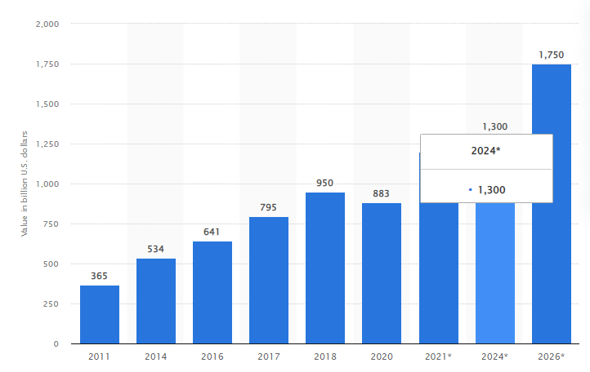
Figure 1: Retail market size across India from 2011 to 2020
(Retail market size across India from 2011 to 2020, 2022).
The above table explains the current retail market of India. The table depicts that it is being augmenting with each passing year. Addition to this, the retail market of India is accounted for ten percent of the overall gross domestic product of the country and around eight percent of the employment. The country is holding a fourth largest position in the retail space after USA, China and Japan (Singh, 2016). Besides, India is the one of the biggest democracy of the globe and is an attractive place to make investment. Being the second populated nation of the globe, it is a country with a strong workforce.

APPLICATION OF THEORIES OF INTERNATIONAL COMMUNICATION

International and Inter-cultural communication
Because of the progress in the field of communication, technologies and transformation there has been evolution of the economy of the world. People from varied countries, languages, backgrounds and cultures are now performing business, communicating and meeting with each other more than ever before. Since, there has been augmentation in the activities of the business amid people from varied diverse cultural backgrounds, firms who are operating at the global level or which are about to expand in the international markets, are required to pay attention on assortment of factors in order to be effective and successful in the global markets. In the current case, Oak, Cash and Carry limited is moving their production in India and the most important element that must be considered by them is culture. For attaining growth and success in this developing nation, the firm is need to have comprehension of the manners of cultural differences throughout and within the country that might impact the functioning of the business (Mead, 2015). Furthermore, they are required to understand the cultural determinants for international business success. This can be done by application of Hofstede’s cultural dimension theory on the selected nation, which is done below.

Hofstede’s cultural dimension theory
A Dutch social psychologist known as Geert Hofstede have founded this cultural dimension theory which is an important framework for inter-cultural communication. This model makes use of six crucial elements such as power-distance, individuality, masculinity, uncertainty avoidance, long term orientation and indulgence. Explanation of these dimensions in the context of the selected developing nation “India” is being done underneath:
- Power Distance index – This dimension means the degree of inequality that takes place in the specified nation or community. It also means the level at which the society is in a position to accept the distribution of power. Talking in relation with India, the nation scores quite high in this dimension which indicates that there is an appreciation of hierarchy along with this, a top down structure is being followed in the communities and business firms. The employees are mostly dependent on boss for the direction. In addition to this, there is a recognition of unequal right amid the power-privileged and those with lesser power. The main power is centralized and even the attitude plus security towards the managers are formal in nature. The top-down communication system is being followed by the organizations in India (Hofstede, 1994).
- Individualism versus Collectivism – This element of the model indicates the extent of interdependence being maintained by the community between its members. The score of this dimension of India is intermediate which clearly indicates that it is a community which involves both the traits of collectivist as well as individualist. The collectivism signifies that high level of priority is being given to large social framework wherein people are supposed to perform as per the higher good for the others. In this condition, the activities of people are impacted by different ideas like family, their opinions, viewpoints etc. In addition to this, the individualism can be seen in the Indian community from their dominant religion that is Hinduism.
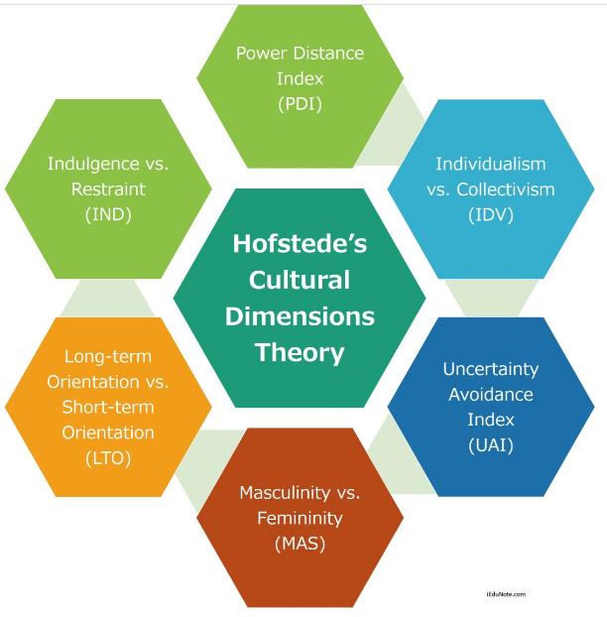
Figure 2: Hofstede’s cultural dimension theory
(Hofstede’s Cultural Dimensions Theory, 2021).
- Masculinity versus Femininity – It is being referred as the flow of employment between the males and females. Since, the score of India on this dimension is quite high which signifies that it is a masculine community where there is displaying of visual power and success. The major emphasis is being given on achievements and women are not given equal opportunities in business (Nicolaidis, 2016).
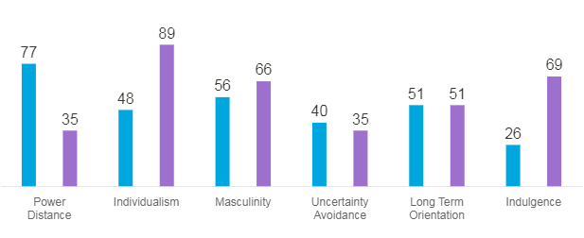
Figure 3: COUNTRY COMPARISON
(COUNTRY COMPARISON, 2022).
- Uncertainty Avoidance Index – This dimension is related with the degree to which the members of the society feel threatened by any uncertain condition or event. The core of India is quite low on this element which means that low preference is being given on avoiding uncertainty. In this nation, people accept imperfection and have tolerance for the unexpected situations. Generally, people are not driven by other for undertaking any actions.
- Long versus short Term Orientation – This element explains the manners in which the community maintains some connection with their past for dealing with future. This score of India is intermediate which means that India follows the idea of Karma and time is not linear. The nation also have a great level of tolerance for religion opinions from across the globe (Farmer, 2015).
- Indulgence versus restraint – This describes the level to which people make efforts to control their desires. The score of India is dimension is quite low which means that India is a culture of restraint and they do not put major emphasis on leisure, control and time.

CRITICAL EVALUATION OF CULTURAL SESITIVITY
Since, India is a multicultural as well as multi-religious nation, the western along with eastern management models will not going to work here in this developing country successfully without adapting as per the local market. The functioning language in corporations in India is English nonetheless it is does not assumed to be an effective communicating. Furthermore, there is a vast differentiation in the communication styles between India and UK and thus, this might act as a hurdle and leads in failure of the business. Speaking in relation with the cultural sensitivity, it simply implies understanding and be aware of the differentiation and similarities existing amid the nations and the manners in which it will influence the behaviour, learning and values (WHAT ABOUT INDIA? 2022). Each and every culture in India has varied sub-cultures like racial group, religion and regions. People with same kind of values, preferences and habits develops the sub-culture. For example, the ways of greeting is majorly dependent on the social status and age of that person in India like, if a son is meeting his parents, he greets them by touching their feet. Nevertheless, while in meetings shaking hands is used for greeting each other. On contrary to this, Indian people always incline to make their business decisions on the basis of their gut feeling and trust. High emphasis is being on cultivation of association with the people they carry out business. Additionally, rushing straight to the business might considered as rude in India. Other than this, Indians also holds a reputation amongst the international business man that they always stick to their roles and does not reflect imitative at times when it is required. This is a stereotype on the basis of cross-cultural comprehension (Bird and Mendenhall, 2016).

ANALYZING DIFFERENT COMMUNICATION BARRIERS
Communication barrier is the hurdle or blockage that comes in between understanding a particular message (Odin, 2021). Communication barriers lead to misunderstanding or miscommunication which leads to wrong feedback. Oak Cash and Carry limited is a retail and wholesale company of United Kingdom. It’s now shifting its business to India which is a developing country for earning more profits. Due to various cultural diversity and communication barriers it becomes difficult for the Oak Cash Carry to survive in India.
Types of communication barriers
- Environmental barriers: These barriers are in the surroundings of a included businesses (Maljich, 2019). The oak cash and carry limited will have to adopt India’s environment and it has to face all the environmental barriers like climate changes, choice of medium, poor lighting etc.
For example: Oak Cash and carry has to use all the technological systems, interiors of workspace that India is using. They have to face all the communication barriers that India is facing.
- Semantic barriers: Due to cultural differences in UK and India the Oak Cash and Carry has to face semantic barriers. Miscommunication will arise due to different languages (Clarke, 2019).
For example: By selling products in India the company has to convert its language according to the customer needs for better understanding.
- Cultural barriers: Diversities of cultures made the communication more difficult. India is a diverse country with diverse cultures. Oak Cash and Carry has to understand all the cultures of India before producing any products.
For example: Different cultural people have different taste and choices. The Oak Cash and Carry has to plan and produce products according to the needs of the customers to earn more profits.
- Psychological barriers: Various psychological barriers like customer’s bad mood, attitudes, and perceptions are changing every time (KRÖGER, 2020). It becomes difficult for a company to coordinate with people and cannot pass meaningful message.
For example: In India the people choices and mood is ever-changing. The Oak Cash and Carry has to advertise its product in a way that every one pay attention to that products. It has to communicate its message in a different way for proper communication.
- Physical barriers: This includes all the barriers like time, place, noise etc. Some are easy to cope up some are difficult. For Oak Cash and Carry has to face these barriers like loud noises in India, poor network connection, poor technological mediums etc.
For example: India has many communication barriers and it is difficult for the employees of Oak Cash and Carry to manage their work efficiently. Due to poor mediums of exchange of communications it may lead to different barriers.
The Oak Cash and Carry has to face all the communication barriers that may arise by moving its business in India. India has various cultural diversity people. Understanding there taste and preferences is a tough task. Due to language and climatic differences the Oak Cash and Carry has to produce the products accordingly. Through better advertisements and promotion schemes customers of India can understand the products of this company easily. There will be no miscommunication.

PROVIDING COMMUNICATION STRATEGIES AND OTHER SUITABLE RECOMMENDATIONS
Communication strategy is the act or plan that is developed by the business to achieve communication goals ( Ali ,2021). For proper communication and between the customers and the organisation the company uses various techniques to achieve this goal.
Various communication strategies are as follows:
- Deciding the target market: The Oak Cash and Carry is dealing in grocery products it has to identify its selected market in India. The company has to make segments for different products and for different markets. The Oak Cash Carry has to decide its communication method to communicate with the target market in India properly.
- Communication objectives: Another strategy of Oak Cash and Carry is to decide its communication objectives. The objective must be clear and specific, it should be measurable and realistic (Raible, 2019). The aim of the objective is to convince the target customers of India to buy the products.
- Formulating the message: The Oak Cash and Carry has to design the message relating to particular product to sell in India. It has to adopt best communication method that Indian customer will understand with more ease. The Oak Cash and Carry has to create a message in which all the details related to product should contain. It should involve in the message the company values to the target audience of India.
- Communication tool: The Oak Cash and Carry should adopt that tool that is acceptable by the Indian market. It should use communication mix methods for its product message to the target market. The Oak Cash and Carry company will use various methods of communication like advertising, sales promotions or sponsorships. India is big country and with huge amount of population. So the Oak Cash and Carry will use advertising method through which it can communicate the message to mass population.
- Setting a budget: Before deciding communication strategy the Oak Cash and Carry has to plan its budget. In what activity they involve how much budget. Oak Cash and Carry should plan its budget in a way that it should involve low cost with high profits.
- Deciding the medium: The Oak Cash and Carry has to decide the communication channels through which it achieves its objectives. In India due to large population and cultural diversities Oak Cash and Carry should use both the pull and push strategy. Attracting the customers and passing on the message to buy the products.
- Measuring the results: After doing all the stages Oak Cash and Carry has to measure its results. All the results should be measured by the company to know whether its making any success in new market or not.
Oak Cash and Carry has to plan various strategies for moving in India due to entirely different market and culture. With good communication method and strategy this company can survive in the market. For successful operation of Oak Cash and Carry it has to defeat all the barriers in India. Need to plan strategy for effective communication to attract more buyers.

CONCLUSION
Thus, from the above evaluation, it can be concluded that international business is very efficacious and can bring numerous benefits to the company expanding in the foreign nations. However, it is quite necessary to evaluate the cultural differences and sensitivity of that particular country for effective functioning and operations of the business activities. It has been found out from the analysis that each and every nation have their own values, belief system and perspectives and this needs to be adopted while planning to move business in other countries or regions. This is due to the fact that consumers and people will behave in the same manner depending upon their religion, language, culture and education.

REFERENCES
Books and journals
Bird, A. and Mendenhall, M.E.( 2016). From cross-cultural management to global leadership: Evolution and adaptation. Journal of World Business, 51(1).
Farmer, RT.(2015). Corporate culture defines a company and its future. American Journal of Business, 20(2), pp.7-3.
Hofstede, G.(1994). Culture’s Consequences. Beverly Hills. Sage Publications. California.
Lauring, J.( 2015). Intercultural Organizational Communication: The Social Organizing of Interaction in International Encounters. Journal of Business and Communication, 48(3), pp.231–55.
Mead, R.(2015). International Management: Cross Cultural Dimensions. 3rded. Cambridge MA. Blackwell Publishers.
Nicolaidis, C.S.( 2016). Cultural Determinants of Corporate Excellence in an Integrated World Economy: The Impact of National Cultures on Organisational Performance. Reading.
Singh, Y.(2016). Culture Change in India. Jaipur: Rawat Publication.
Odin, R.(2021). Spaces of Communication. Amsterdam University Press.
Maljichi, D.(2019). BARRIERS OF INTERCULTURAL COMMUNICATION. Vizione, (32).
Clarke, S.K., Jaffe, J. and Mutch, R.(2019). Overcoming communication barriers in refugee health care. Pediatric Clinics, 66(3), pp.669-686.
KRÖGER, J.(2020). Communication Barriers and Cultural Participation: A Visit to a Wildlife Park as a Multicodal Accessible Text. Easy Language Research: Text and User Perspectives. Berlin: Frank & Timme. pp.179-193.
Ali, B.J and et .al.(2021). Business communication strategies: analysis of internal communication processes. Business Communication Strategies: Analysis of Internal Communication Processes. Journal of Humanities and Education Development, 3(3), pp.16-38.
Raible, W.(2019). Variation in Language: How to characterise types of texts and communication strategies between orality and scripturality. Answers given by Koch Oesterreicher and by Biber. International Journal of Language and Linguistics. 6(2). pp.157-174.

Online references
Hofstede’s Cultural Dimensions Theory. 2021. [Online]. Available through: <https://www.iedunote.com/hofstedes-cultural-dimensions-theory>. [Accessed on 1st April 2022].
WHAT ABOUT INDIA? 2022. [Online]. Available through: <https://www.hofstede-insights.com/country/india/>. [Accessed on 1st April 2022].
Retail market size across India from 2011 to 2020. 2022. [Online]. Available through: <https://www.statista.com/statistics/935872/india-retail-market-size/>. [Accessed on 1st April 2022].
COUNTRY COMPARISON. 2022. [Online]. Available through: <https://www.hofstede-insights.com/country-comparison/india,the-uk/>. [Accessed on 1st April 2022].

