

REPORT

Name: Roxana Pesu

Student number: 2243649

Module Title: Sustainable Hospitality & Tourism Management

Module Code: BMIH5006

Lecturer Name: Kathryn Roberts

AI Declaration
To check the grammatical errors and proofreading of my report I have taken help of ChatGPT on 15th February 2025 with following prompt.
- Please proofread the writing below and find all the mistakes regarding grammar if any.
However, I do acknowledge that, there is no AI generated content being used in the report and I have not used any AI tool to prepare this report. The whole report has been done by me.

Executive Summary
Hospitality is an industry dependent on aviation, and it is important to it as it is an essential part of supporting business travel and global tourism. Nevertheless, it is quite environmentally harmful. The amount of CO₂ emissions released by the aviation sector equals 2.5% of the world’s CO₂ emissions, causes air and noise pollution, consumes a lot of fossil fuel, and disrupts ecosystems. By midcentury, emissions can increase by ‘as similarly as triple’ without intervention. There are several ways in which aviation’s environmental impact could be reduced. SAF can cut emissions by up to 80%, but the fuels are expensive and in low supply. Although carbon offset programs aid in offsetting the number of emissions, they are not effective for some critics. Improvements in aircraft design, better air traffic management and sustainable airport operation have also made it efficient. To get to a greener future, governments, airlines and the hospitality industry must invest in sustainable aviation technology, support emission pressure from stricter and create coria international agreements. These efforts will lower the aviation footprint while their actions will continue to promote the growth of global travel and tourism.
Contents
Executive Summary
Introduction 1
The Environmental Damage Caused by Aviation 2
Carbon Emissions and Climate Change 2
Air and Noise Pollution 3
Fuel Consumption and Resource Depletion 4
Impact on Biodiversity and Ecosystems 5
Solutions to Mitigate Aviation’s Environmental Impact 5
Sustainable Aviation Fuels (SAF) 6
Carbon Offsetting and Green Initiatives 6
Technological Advancements in Aircraft Design 7
Improved Air Traffic Management (ATM) and Operational Efficiency 8
Sustainable Airport Operations 8
Conclusion 9
References 10

Introduction
A major part of the hospitality industry, transportation facilitates the movement of tourists, business travellers and industry professionals around the world at a given time. Transportation in either aviation, rail, maritime, or roadways is very vital to gain access to destinations for tourism growth and economic development. Among these, aviation is highly important as it operates at remote points very fast and conveniently. That is why flight has opened the whole hospitality world, made a strong advancement to global Gross Domestic Product and enabled the international tourism industry. However, there has come a rapid expansion that has also raised questions about its environmental footprint. In this report, we focus on aviation, primarily, as it is the by far preeminent industry in the tourism and hospitality sectors of the world. Though aviation improves connectivity and the chance to generate income, it is one of the major contributors to greenhouse gas emissions, noise pollution, and resource depletion. The focus will be laid on the damages inflicted by aviation on the environment and the methods the industry is applying to reduce its impact.

The Environmental Damage Caused by Aviation
Aviation helps global tourism and business, but it is a major source of pollution. It compounds with climate change, air and noise pollution, high fuel consumption and biodiversity loss. The implication of these issues is on the health of human beings and ecosystems. This section presents data and industry examples of challenges of this sort.

Carbon Emissions and Climate Change
Greenhouse gas emissions from aviation are growing very fast. Despite having a small influence on CO₂ emissions, such as 2.5% for aviation and 12% for transport altogether, aviation is one of the main contributors to transport-related emissions (Kim and Teter, 2023). This means that in 2019, commercial aviation emitted 915 million tonnes of CO₂, which is projected to triple by 2050 without major changes (ATAG, 2023)
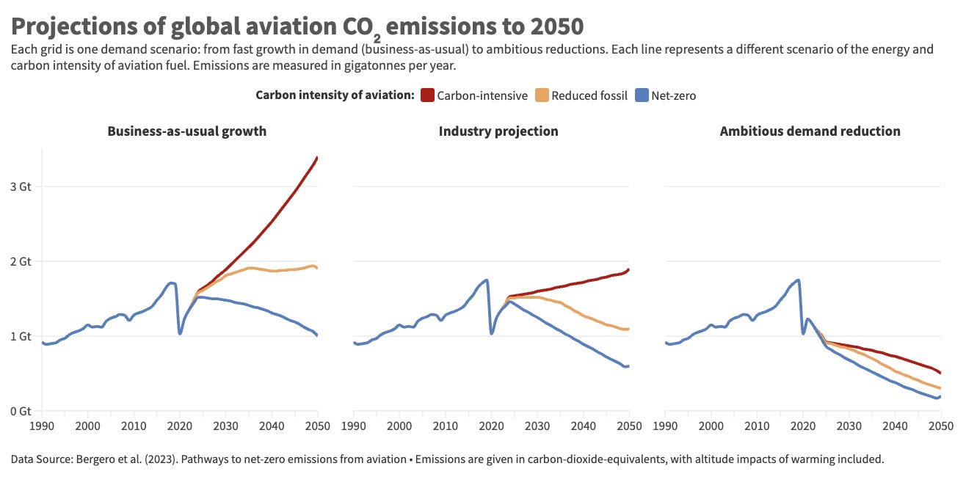
Figure: Global CO₂ emission by aviation to 2050 (Bergeron et al., 2023)
CO₂ is not the only air pollutant produced by aeroplanes; they also emit contrails—thin clouds created when water vapour is afloat at high altitudes. Thus, the Intergovernmental Panel on Climate Change (IPCC) research shows that contrails and non-CO₂ effects could imply a contribution that is up to twice the warming effect of CO₂ emissions alone (IPCC, 2023). It accentuates aviation’s contribution to climate change.
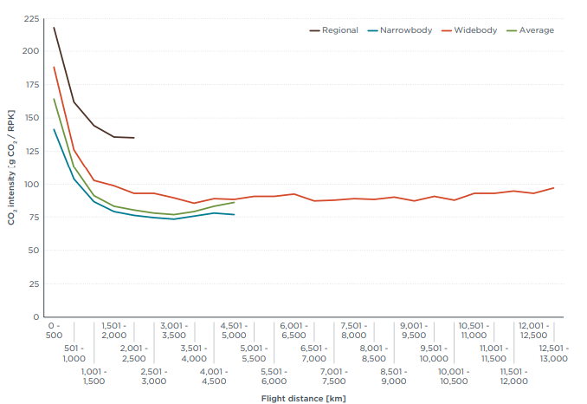
Figure: Passenger CO2 intensity in 2019 by stage length and aircraft class (Graver, Rutherford and Zheng, 2020)
Between 2013 and 2018, aviation emissions grew by 32 per cent, and earlier predictions were met but exceeded by a considerable measure (Graver, Rutherford and Zheng, 2020). Emissions are expected to continue rising unabated unless intervention is made, which will not make it easy to reach the goals of the Paris Agreement, such as the temperature rise should not be more than 1.5 °C.

Air and Noise Pollution
Aviation is a major source of air pollution, and one of great concern is close to busy airports. Harming pollutants to exit the aircraft engines are nitrogen oxides (NOₓ), sulfur oxides (SOₓ) and particulate matter (PM2.5). These pollutants also cause smog, acid rain, and respiratory diseases. According to the European Union Aviation Safety Agency (EASA), aviation-related air pollution is responsible for 16,000 deaths a year prematurely around the world (EASA, 2022)
This is also a problem for communities close to airports due to noise pollution. The aircraft can be up to 140 decibels (dB) in their levels of noise while they take off, exceeding safe levels for human exposure (World Health Organization, 2021). The World Health Organization (WHO) explains that prolonged exposure to aircraft noise higher than 55 dB is stressful, disturbs sleep and raises the risk of heart disease.
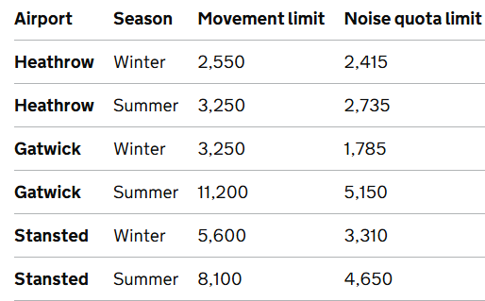
Figure: The structure of the night flight regime (GOV.UK, 2024)
To combat noise pollution, Heathrow Airport has introduced policies such as night flight restrictions, soundproofing homes, and a £700 million investment in quieter aircraft technology (GOV.UK, 2024). Despite these measures, noise complaints continue to rise as air traffic increases.

Fuel Consumption and Resource Depletion
Aviation is heavily dependent on fossil fuels. In 2022, global airlines consumed 359 billion litres of jet fuel, producing around 900 million tonnes of CO₂ (IATA, 2023). Unlike road transport, which is transitioning to electric and hydrogen-powered vehicles, aviation has limited alternatives.
Fuel efficiency improvements have helped reduce per-flight emissions. Modern aircraft like the Boeing 787 Dreamliner and Airbus A350 use composite materials and advanced aerodynamics, cutting fuel consumption by 25% compared to older models (Boeing, 2023). However, these improvements are not enough to offset the overall increase in air travel demand.
Another issue is the depletion of crude oil reserves. At the current rate of consumption, experts predict that global oil reserves could be exhausted within 50-60 years (BP, 2023). This highlights the urgent need for alternative fuels and energy sources in aviation.

Impact on Biodiversity and Ecosystems
The expansion of airports and flight routes affects biodiversity. Large-scale airport projects require deforestation, land reclamation, and habitat destruction. Studies show that over 5,000 km² of natural land has been lost due to airport expansions worldwide (UNEP - UN Environment Programme, 2023).
Bird strikes are also a growing problem. It is reported that there were 17,000 bird strikes in the U.K. alone in 2022, causing $1.2 billion in aircraft damage and threatening bird populations (British Aviation Group, 2023). Many airports, including Singapore Changi Airport, use bird radar systems and habitat management to reduce these risks.
In marine environments, land reclamation for airport expansion disrupts ecosystems. The construction of Hong Kong International Airport’s third runway led to the loss of 650 hectares of marine habitat, affecting species such as the Chinese white dolphin (Yuen et al., 2025).
Aviation significantly impacts the environment through carbon emissions, air and noise pollution, fuel consumption, and biodiversity loss. The data shows that emissions are rising, pollution affects human health, and natural habitats are being destroyed. Despite some improvements in aircraft efficiency and noise control, aviation remains a major environmental challenge. The next section will explore potential solutions to mitigate these impacts.

Solutions to Mitigate Aviation’s Environmental Impact
Aviation has a large environmental footprint, but several solutions can help reduce its impact. Airlines, aircraft manufacturers, and airports are working on sustainable alternatives. This section discusses five key solutions: sustainable aviation fuels, carbon offsetting, new aircraft technologies, better air traffic management, and sustainable airport operations.

Sustainable Aviation Fuels (SAF)
Sustainable Aviation Fuels (SAF) are an alternative to traditional jet fuel. SAF is made from renewable sources such as algae, waste oils, and agricultural residues. It can reduce CO₂ emissions by up to 80% over its lifecycle compared to fossil-based jet fuel (IATA, 2024)
Several airlines are already using SAF. KLM, British Airways, and United Airlines have all invested in SAF production. In 2022, KLM used 39,000 tonnes of SAF, reducing CO₂ emissions by about 100,000 tonnes (KLM, 2023). However, SAF currently makes up less than 1% of global aviation fuel due to high costs and limited production (Madugu and Lea-Langton, 2024).
The cost of SAF is three to five times higher than regular jet fuel (IATA, 2021). Scaling up production and improving infrastructure are necessary to make SAF a mainstream solution. Governments are supporting this transition with incentives and funding.

Carbon Offsetting and Green Initiatives
Many airlines offer carbon offset programs where passengers can pay extra to fund environmental projects. These projects include reforestation, renewable energy, and carbon capture technologies. Lufthansa’s "Compensation" program allows passengers to calculate and offset their flight emissions by investing in SAF and forest conservation (Lufthansa, 2020).
In 2021, the Carbon Offsetting and Reduction Scheme for International Aviation (CORSIA) was launched to help airlines neutralise emissions. More than 80 countries have joined the program, covering 77% of international flights (ICAO, 2024).
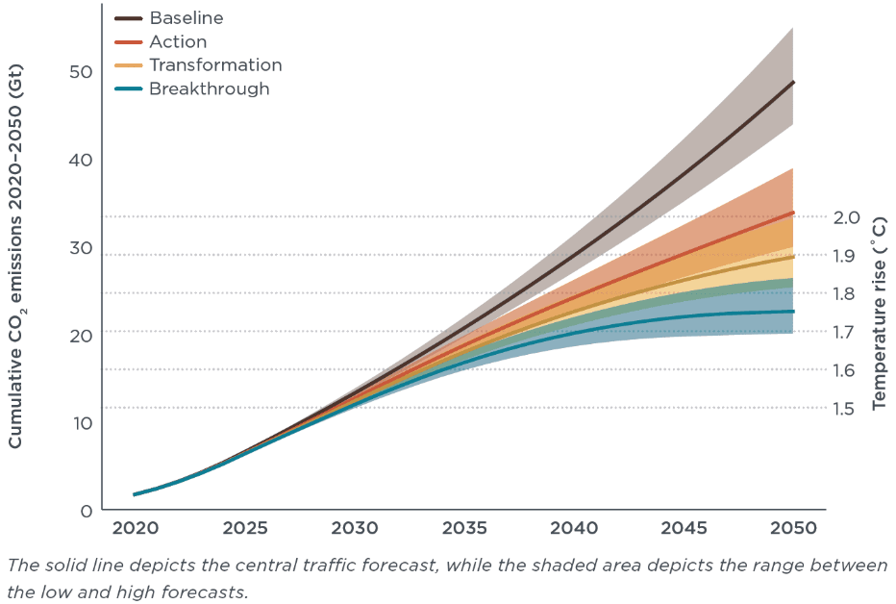
Figure: WTW cumulative global aviation CO2 emissions (Doerrer, 2022)
However, some experts argue that carbon offsetting is “greenwashing.” Studies show that only 2% of offset programs fully remove CO₂ as promised (Doerrer, 2022). Critics say airlines should focus more on reducing emissions rather than compensating for them.

Technological Advancements in Aircraft Design
New aircraft technologies can make flying more fuel-efficient. Modern aircraft use lighter materials, improved aerodynamics, and advanced engines to cut fuel consumption. The Boeing 787 Dreamliner and Airbus A350 are up to 25% more fuel-efficient than older planes (Boeing Company, 2023).
Hybrid and electric aircraft are also in development. Airbus is working on "ZEROe," a hydrogen-powered aircraft set to launch by 2035. Hydrogen planes could reduce CO₂ emissions by up to 50% compared to traditional jet fuel (Airbus, 2021).
Electric aircraft, such as Rolls-Royce’s "Spirit of Innovation", have already completed test flights. However, battery technology is not yet advanced enough for long-haul flights. Most electric aircraft today are limited to short flights of under 500 km (Rolls-Royce, 2023).

Improved Air Traffic Management (ATM) and Operational Efficiency
Better air traffic management can reduce fuel use and emissions. Many flight paths are not optimised, leading to unnecessary fuel consumption. The Single European Sky (SES) initiative aims to create shorter and more direct flight routes, which could reduce aviation emissions by 10% (Interoperable Europe Portal, 2024).
Airlines are also improving operational efficiency. Delta Airlines has optimised its flight routes and ground operations, cutting CO₂ emissions by 5 million tonnes annually (Delta Air Lines, 2023). Modern aircraft also use "continuous descent approaches" (CDA), which reduce fuel burn by 30% during landing (FAA, 2022).

Sustainable Airport Operations
Airports also play a role in reducing aviation’s environmental impact. Many airports are investing in renewable energy, waste management, and energy-efficient infrastructure.
Oslo Airport is the world’s first carbon-neutral airport. It runs on 100% renewable energy and has a 90% recycling rate for airport waste (Airport Carbon Accreditation, 2023). Other airports, like San Francisco International Airport, have installed solar panels and use low-energy LED lighting to cut emissions.
Many airports are also switching to electric ground vehicles. Heathrow Airport has replaced 90% of its diesel-powered baggage vehicles with electric alternatives, reducing CO₂ emissions by 3,000 tonnes per year (Chu, 2025).
Reducing aviation’s environmental impact requires multiple strategies. Sustainable aviation fuels, carbon offset programs, advanced aircraft design, better air traffic management, and sustainable airport operations all contribute to a greener future. While progress is being made, large-scale adoption of these solutions will require more investment, government support, and technological innovation.

Conclusion / Recommendations
Aviation plays an important role in the hospitality industry but has a significant environmental impact. The industry contributes to 2.5% of global CO₂ emissions, worsens air and noise pollution, consumes large amounts of fossil fuels, and disrupts ecosystems. However, several solutions can help reduce aviation’s impact. These include sustainable aviation fuels (SAF), carbon offset programs, fuel-efficient aircraft, improved air traffic management, and sustainable airport operations. Although progress is being made, challenges such as high costs, technological limitations, and slow policy adoption remain obstacles. To support a greener future, the hospitality industry should promote airlines with strong sustainability commitments, such as those investing in SAF and fuel-efficient aircraft. Businesses in the tourism sector should collaborate with airlines to fund sustainable initiatives. Governments and industry leaders must enforce stricter emission regulations, improve infrastructure for SAF production, and support international efforts like CORSIA to reduce aviation’s carbon footprint. By implementing these strategies, the hospitality industry can help reduce aviation’s environmental damage while maintaining global travel and tourism.

References
Airbus (2021) ZEROe - low carbon aviation - Airbus. Available at: https://www.airbus.com/en/innovation/energy-transition/hydrogen/zeroe
Airport Carbon Accreditation (2023) Oslo and Kristiansand airports have successfully renewed their accreditations - Airport Carbon Accreditation. Available at: https://www.airportcarbonaccreditation.org/oslo-and-kristiansand-airports-have-successfully-renewed-their-accreditations/
ATAG (2023) Climate action | ATAG. Available at: https://www.atag.org/industry-topics/climate-action/
Bergero, C., Gosnell, G., Gielen, D., Kang, S., Bazilian, M. and Davis, S.J. (2023) ‘Pathways to net-zero emissions from aviation’, Nature Sustainability, 6(6), pp. 404–414. Available at: https://www.nature.com/articles/s41893-022-01046-9.pdf
Boeing (2023) 2023 Sustainability Report. Available at: https://www.boeing.com/content/dam/boeing/boeingdotcom/principles/sustainability/sustainability-report/2023/assets/2023-Boeing-Sustainability-Report.pdf
Boeing Company (2023) Boeing Company - Climate Change 2023. Available at: https://www.boeing.com/content/dam/boeing/boeingdotcom/principles/environment/pdf/Boeing_CDP_Climate_Response_Final.pdf
BP (2023) bp Energy Outlook 2023 edition. Available at: https://www.bp.com/content/dam/bp/business-sites/en/global/corporate/pdfs/energy-economics/energy-outlook/bp-energy-outlook-2023.pdf
British Aviation Group (2023) Wildlife Strikes to Civil Aircraft in the United States 1990 - 2023. Available at: https://www.britishaviationgroup.co.uk/knowledge/wildlife-strikes-to-civil-aircraft-in-the-united-states-1990-2023/
Chu, B. (2025) Electric planes, new fuel: Can Heathrow’s third runway be green? BBC, 28 January. Available at: https://www.bbc.com/news/articles/cdjdz92v84do
Delta Air Lines (2023) Delta 2023 ESG | Eliminating Our Climate Impact From Flying. Available at: https://esghub.delta.com/content/esg/en/2023/climate-impact.html
Doerrer, M. (2022) The tortoise and the hare? The race to decarbonize aviation - International Council on Clean Transportation. International Council on Clean Transportation. Available at: https://theicct.org/global-aviation-race-jun22/
EASA (2022) European Aviation Environmental Report 2022 - A look into historic and future scenarios of air traffic, noise and emissions. Available at: https://www.easa.europa.eu/en/light/topics/european-aviation-environmental-report-2022
FAA (2022) FAA Implements More Efficient Descent Procedures to Reduce Fuel Burn, Emissions | Federal Aviation Administration. Available at: https://www.faa.gov/newsroom/faa-implements-more-efficient-descent-procedures-reduce-fuel-burn-emissions
GOV.UK (2024) Night flight restrictions: Heathrow, Gatwick and Stansted airports from October 2025. Available at: https://www.gov.uk/government/consultations/night-flight-restrictions-heathrow-gatwick-and-stansted-airports-from-october-2025/night-flight-restrictions-heathrow-gatwick-and-stansted-airports-from-october-2025
Graver, B., Rutherford, D. and Zheng, S. (2020) CO2 Emissions from Commercial Aviation: 2013, 2018, and 2019. International Council on Clean Transportation. Available at: https://theicct.org/publication/co2-emissions-from-commercial-aviation-2013-2018-and-2019/
IATA (2021) Our Commitment to Fly Net Zero by 2050. Available at: https://www.iata.org/en/programs/sustainability/flynetzero/
IATA (2023) Global Outlook for Air Transport Highly Resilient, Less Robust. Available at: https://www.iata.org/en/iata-repository/publications/economic-reports/global-outlook-for-air-transport----june-2023/
IATA (2024) Developing Sustainable Aviation Fuel (SAF). Available at: https://www.iata.org/en/programs/sustainability/sustainable-aviation-fuels/
ICAO (2024) CORSIA 2023 - Year in Review. Available at: https://www.icao.int/environmental-protection/CORSIA/Documents/CORSIA%20Newsletter%20-%20December%202023_for%20web.pdf
Interoperable Europe Portal (2024) SINGLE EUROPEAN SKY. Available at: https://interoperable-europe.ec.europa.eu/collection/rolling-plan-ict-standardisation/single-european-sky-0
IPCC (2023) Sixth Assessment Report — IPCC. Available at: https://www.ipcc.ch/assessment-report/ar6/
Kim, H. and Teter, J. (2023) Aviation. International Energy Agency. Available at: https://www.iea.org/energy-system/transport/aviation
KLM (2023) Annual Report 2023. Available at: https://www.klmannualreport.com/wp-content/uploads/2024/04/KLM-Annual-Report_2023.pdf
Lufthansa (2020) Climate protection. Lufthansagroup.com. Available at: https://report.lufthansagroup.com/2023/annual-report/en/combined-management-report/combined-non-financial-declaration/environmental-concerns/climate-protection/
Madugu, F.U. and Lea-Langton, A.R. (2024) ‘Resource options and challenges for sustainable aviation fuels’, in Lecture notes in energy, pp. 159–179. Available at: https://www.researchgate.net/.../Unpacking-Factors-Behind-Green-Wall-Adoption-in-Sustainable-Buildings.pdf#page=182
Rolls-Royce (2023) Rolls-Royce’s all-electric ‘Spirit of Innovation’ takes to the skies for the first time. Available at: https://www.rolls-royce.com/media/press-releases/2021/15-09-2021-rr-all-electric-spirit-of-innovation-takes-to-the-skies-for-the-first-time.aspx
UNEP - UN Environment Programme (2023) UNEP and Biodiversity. Available at: https://www.unep.org/unep-and-biodiversity
World Health Organization (2021) How much does environmental noise affect our health? WHO updates methods to assess health risks. Who.int. Available at: https://www.who.int/europe/news-room/04-08-2024-how-much-does-environmental-noise-affect-our-health--who-updates-methods-to-assess-health-risks
Yuen, N.L., Leung, F., Chau, K.T., Hung, S.K., Lee, S.Y. and Tai, A.P.K. (2025) ‘Examining environmental factors behind the declining occurrence of dolphins in Hong Kong waters using multivariate statistical methods’, Marine Pollution Bulletin, 213, p. 117655. Available at: https://www.sciencedirect.com/science/article/pii/S0025326X25001304/pdfft?md5=2c5db67341c5465db8e33cad934a00a7&pid=1-s2.0-S0025326X25001304-main.pdf

