Student name: | Kieran Brown | Student ID number: | 1800163
Programme: | Primary
Module: | Principles of Pedagogy
Module code: | M6X01438/C | Contribution to Overall Module Assessment (%): | 100%
Lecturer: | Siân Brooks | Internal Verifier: | Siân Brooks
Assignment Title: | ‘Describe a learning event which has happened during your recent school experience. Reflect upon what took place, connecting events to theories of learning and teaching. Make recommendations about how you could improve your own practice in the light of this. Produce a poster to illustrate how you would develop the elements of an effective learning environment.’ | Word count (or equivalent): | 5,000 or equivalent.
Submission deadline: | 17/10/18 (23.59) | Return date of provisional marks & written feedback: | 14/11/18
Submission method: | All written assessments, where practical and possible, must be submitted via Turnitin unless otherwise instructed by the Lecturer. (Please DO NOT put this assessment specification into Turnitin or it will match many similarities with other students’ submissions.)  Alternative submission method (if applicable):  Late submission of the assessment will result in a late penalty mark. Penalties for late submission: Up to one week late, maximum mark of 40%. Over one week late, 0%. Only the Extenuating Circumstances Panel may approve a change to submission dates.
Academic honesty / referencing: | Academic honesty is required. In the main body of your submission you must give credit to authors on whose research and ideas your work is based. Append to your submission a reference list that indicates the books, articles, etc. that you have used, cited or quoted in order to complete this assessment.

To gain an insight into the working structure and concepts of a primary classroom I observed a Key stage 2 year 4 class in Swansea. The purpose of the observation was also to witness a learning event or a sequence of events and processes that displayed how a variety of well researched and documented teaching theories, strategies and aspects of the national curriculum are implemented in the primary setting. The observation was permitted by the University of Wales Trinity Saint David and the partnership school. The information about the school, it’s pupils and staff will remain anonymous and confidential as per accordance of the revised ‘British Educational Research Association Guidelines’ document (fourth edition, 2018).
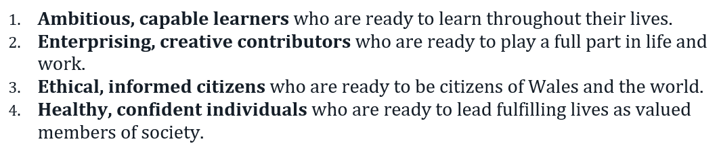
The school itself is a pioneer school in Health and Wellbeing that has arisen from the new curriculum based off the research findings and recommendations of the ‘Successful Futures’ report from Professor Graham Donaldson (2015). It also seeks to fully promote and encompass the four purposes from the aforementioned report within the learning environment and to the pupils of the school. These purposes are displayed in the following figure.
Figure 1. The four purposes of the Donaldson report (2015) for the Welsh national curriculum.
Learning Event
Within a year 3, KS2 classroom of 30, I observed a Literacy session taking place. The bases of the lesson was ‘story planning and writing’ which is a fundamental part of the ‘National Literacy and Numeracy Framework (2014). A question was immediately proposed to the classroom which was as follows.
“What does a good story need and how do you write a good story?” The class was then told to think about the question individually for 1 minute before discussing the idea in their groups of 5 for 5 minutes. Once a collection of ideas had been shared the group provided feedback with the teacher and expressed their views on the best characteristics and format. These ideas were reviewed, discussed and recorded before the teacher offered her own feedback and viewpoints on the structure of a good story and modelled what a she felt a good story needed. After an exchange of dialogue between educator and class, a task was set.
Pupils were given the theme ‘another world’ to build a story from. The children were to interact freely around the classroom with each other, suggesting and recording ideas for their peers’ stories and plans openly. This activity continued for roughly 20 minutes before everyone felt they had a strong bases for a story plan. Nobody was to proceed to the formal layout of their plan until the whole class achieved a foundation for planning.

So what does make a good teacher and an influential education? What is the purpose of education at the primary level? Is there a significance of contribution from the aspects of the learner?
The McKinsey report (2007) sought to examine these commonly asked questions in order to discover the most influential factors of education on a global scale. They found that the most important factors were, getting the correct people to become teachers (academically sound and motivated to teach), developing effective instructors (teachers professionally developed to the standard that would achieve the highest and most effective pedagogical and academic results) and making sure every student performs well and consistently (through a consistently high standard of practice with effective strategies to counteract underperformance).
Grigg (2010) states the importance of teachers becoming Master’s level researchers with a high level of subject knowledge and the ability to make school based decisions based upon evidence of good practice. He also states how various governments endorse this ideology and support the notion of developing high level, well researched educators.
It’s key to understand the importance of education, pedagogy and the impact it has on learners for future development and society. Throughout the last centuries education has developed around various core beliefs that encompass numerous aspects of learning and teaching styles. These ideologies are Behaviourism, constructivism, social constructivism and the humanistic approach.

The main focus of this piece will be both constructivism and social constructivism for their concepts of cognition and social interaction. These theories are embedded with the ethos of learning through environmental experiences, scaffolding and metacognition to promote cognitive development, social understanding, critical thinking skills and reconstructive ability.
One of the main and original founders of this school of psychology was Piaget (1896-1980, seen in Ackermann, 2001). Piaget believed that a child’s knowledge and understanding of the world was a construct of their environment and perception of experiences; these experiences contribute to cognitive development through the development of schemas (a combination of categories of knowledge and the processes of obtaining knowledge). He also believed that a child’s mind constantly constructs and reconstructs from external context, adapting and making sense of new information. His idea of the learning was process categorised into four stages;
The sensorimotor stage (birth to 2 years old)– infant acquires their knowledge through interaction and manipulation of their environment uses their senses.
The preoperational stage (2-7) – Children show an emergence of language and representation of cognition although view the world egotistically and narrowly.
The concrete stage (7-11) – Children alternate between concrete ideas and an attitude of acceptance of alternative ideas. Logical reasoning is far more adept but can be prohibited by the potential for egocentrism, all be it, less likely at this stage.
The formal stage (11/12 +)– child develops ability to make deductions about hypotheses, think critically and develop a sense of reasoning for abstract ideas.
It is important to remember that Piaget considered this learning process as non-quantitative and that the information children receive and possess when they grow older becomes different, allowing them to make cognitive developments. Additions and alterations can be made to preconceptions and schemas regarding external experiences and information (assimilation). Schemas can also be changed and replaced in light of new information (accommodation). Piaget stated that children should seek to find a balance between assimilation and accommodation and labelled this notion, ‘Equilibration.’
When considering the learning environment that I witnessed, there are relatable connections that can be made to the characteristics of the theory regarding the children and their dialogue Taking into account previous knowledge that has been partially explored in early Key Stage 2 provides a base of experience with developing stories and fictitious characters. These ideas would have been developed in the preoperational and early concrete stages of cognitive development, according to Piaget. The age constraints of the theory are open to challenge, however, as certain participants of the exchange possessed the ability to critically think about the implications of particular story characteristics in great detail. For instance, ideas of chronological patterns, how one character’s actions would impact the plot (as well as the additional people in the narrative) and reasons for unorthodox, complex plot twists were all displayed by several participants. If one was to base the understanding of cognitive development in children off Piaget’s four stages, this higher level of critique would indicate a level of cognitive development superior to the expected age bracket in the research. Perhaps one possibility, that would coincide with features of Piaget’s constructivism, would be an early exposure to information about stories that would initiate a reconstruction of perceived ideas regarding narrative quality and features. Additionally, this theory doesn’t take into account the role of peers in the environment It leaves room for the possibility of additional research into the idea of cognitive development through constructions created from increased possible variables within the experiences of younger learners.
A result of Piaget’s cognitive development theory was the birth and evolution of a challenge to the traditional concept of constructivism and the relationship between development and learning. A challenge was put forward by Lev Vygotsky (1896-1934) who was said to be an admirer of Piaget but also possessed a desire to extend his research into the possibility of a new realm. He proposed the idea that development does not precede learning and that instead challenging learning situations are the foundation of development (Walqui, 2006). He also put forward the notion that language is an essential fragment of this process and that viewing both written and spoken language as a constant possible dialogue rather than monologue or basic transcript displayed how individuals learn from social contexts (language is the main facilitator of thought). This was displayed in an observation of a child within her external monologue debating stages of a process. In relation to the my observation, this could be linked with the process of a child asking themselves out loud, “what does a good story need/require?” and forwarding the notion to peers.
In addition to this idea, personal dialogue and dialogue between peers are not the only facilitators of thought and learning. In the case of the classroom observation, the exchange of feedback between learners and teacher about story characteristics provided an opportunity to explore a key concept of Vygotsky’s constructivism known as ‘the Zone of Proximal Development’ (1978, Walqui, 2006). The theory prescribes the concept of understanding the relationship between what a learner can do, can’t do and what they can do with the aid or help of an educator/adult (refer to figure 4 of appendices). Exchanging thought provoking concepts with a child in order to understand previous knowledge is paramount to the model because it provides more clarity regarding where in the process a child may be. If previous knowledge doesn’t suffice and modelling of a principle is necessary, for example, the educator has used the ZPD to understand where a child may need assistance in order to develop and learn.
Referring back to the aforementioned observation again, this was explored during a process of feedback provided by the teacher when she provided additional ideas about stories that the children had not considered. For instance, plot twists, betrayal, more than once main location, different uses of codes and languages, physical imagery and even breaking the fourth wall. The concepts were advanced but the additional information not only gave the teacher and understanding of where here learners were but gave them an opportunity to consider new ideas and reconstruct their notion of what should be included in their narratives.
This theory does not only provide relevant progress from Piaget’s work but also lends itself to future development. The process of providing assistance in a collaborative manor has been labelled as scaffolding and explored by several researchers, one of the most prevalent being Bruner (1983: 60). He defines scaffolding as “a process of ‘setting up’ the situation to make the child’s entry easy and successful and then gradually pulling back and handing the role to the child as he becomes skilled enough to manage it.” (seen in Walqui, 2006). Within the context of the observation in the learning environment, this notion belief could possibly be considered to be relevant regarding the children’s previous knowledge of stories, their development of the knowledge and what their knowledge was as the time. As this was a singular observation, it would be difficult to interpret how much (if any) previous knowledge had been aided by an educator and gradually reduced. However, within the current schooling systems and the LNF of the Welsh curriculum, it would possibly be safe to assume that children, even if through the constructivist approach, had been provided with knowledge of what stories generally consist of at a base level. As a result, it may been the case that the teacher was continuing with a process with a combination of the aforementioned constructivist approaches until eventually, she felt the children has enough knowledge to produce a piece of work that was deemed to be to the appropriate standard.
The combination of these processes could considered to be useful in a developmental model that encompasses the purpose and processes required to implement the predominant principles. The question “ What does a good story need and how do you write a good story” is open to interpretation by the learners. The question is stimulating and thought provoking which is an important feature of classroom dynamics but also draws upon the previous knowledge of story writing that the learners possess. This was no accident and implemented a technique from a firmly conceptualised model of questioning and teaching known as ‘Bloom’s revised taxonomy’ (2001, Armstrong, 2016).
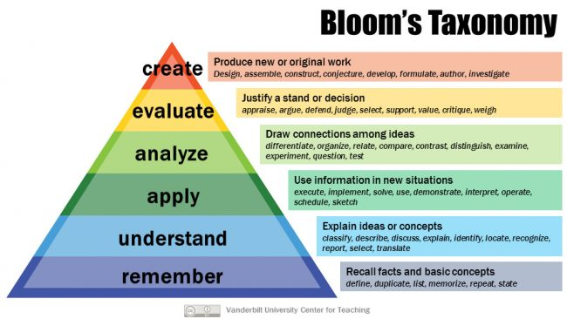

Figure 2. A visual representation/model of Bloom’s revised Taxonomy taken from Armstrong 2016.
The model displays how thought provoking, instructional questioning stimulates six cognitive processes employed by learners when interpreting and using information (1-Remember/Recalling, 2- Understand/Interpreting, 3- Apply/Implementing. 4 – Analyze/Differentiating. 5 – Evaluate/Critiquing & 6 – Create/Producing).
In essence, if an educator is to stimulate a learner is a way that can promote this principle, the likelihood is that metacognition will occur and a greater sense of learning and creativity will develop as learners require a higher order of thinking (Ferguson, 2002, seen in Forehand, 2010). This is vital in terms of what I witnessed in the observation as the task, by nature, was creative and thought provoking yet required a level of understanding and analytical ability to provide an individual and group idea (stemming from the openly proposed question) . Once the understanding is achieved through questioning, the learners can work their way to the top of the taxonomy to produce creative work.
In the setting I observed, the level of thinking was stimulated by the question before peers were encouraged to explore each other’s ideas through exploratory talk. Mercer’s notion of exploratory talk (2000) identifies how peers and groups discuss relevant information to consider and compare ideas. The process requires reasoning, listening to peers, a proposition of relevant ideas and a justification for them. This is displayed very well when the children in the classroom are given the freedom to explore different ideas about each other’s stories and the aspects contributing to their end product. Having the whole class of 30 interact and communicate with each other provides a wider scope of insight and perspective (Brown & Renshaw, 2000, in Van der Linden & Renshaw, 2004, p9). There are possible constraints to the theory in an educational setting. Often, there tends to be a dominant member of a group discussion, a person with multiple ideas and a forceful influence as well as more agreeable and less influential members. This can provide a skewed view on a groups understanding and knowledge about a subject without careful and mindful observation to gain an understanding of the individual knowledge as well as collective.
In addition to this, Mercer & Howe (2012, in Van der Linden & Renshaw, 2004, p9) state that “if a teacher decides to try asking more open questions or waiting for extended answers with a class that has had only a very traditional experience of classroom talk, they will probably only hear (at best) a suspicious silence. This could be a solid justification for the use of the ‘think, pair, share’ strategy as it offered children the opportunity to make their own assumptions about what a story required, apply their own use of metacognition and draw on previous constructs before discussing it with peers (The think, pair, share approach was adapted for groups of 5 for the classroom with the exact same principle and idea).
It's important to understand where activities such as this have developed from. Think, pair, share is a form of sustained-shared thinking (S-ST). The idea of S-ST stems from the principle of dialogic learning and teaching. Wells (1999, in Van der Linden & Renshaw, 2004, p9) believed that education should be orchestrated around the idea of dialogue between educators and learners so that a classroom can be collaborative for the purpose of constant inquiry (this prescribes to the ideas of the aforementioned social constructivist attitude to the learning environment). Different types of dialogue occur in a classroom environment such as pupil to pupil, pupils as a group, pupil to teacher and the teacher to the collective. One strand of this belief is exploratory talk. Siraj-Blatchford (2002, in Tina Bruce, 2004, p92-100). states that “the best help adults can give to children is to help them to begin to ask their own questions and to share their investigations and thinking through shared- sustained conversations.”
This implies that the utilization of activities such as ‘Think, pair, share’ and ‘sustained shared thinking’ allow for opportunities for children to develop their critical thinking skills, analysis skills and metacognition to promote learning and development.
This notion is supported by McGregor (2007) who states that developing thinking involves “interaction with the learning opportunities and frequent invitations for students to reflect on progress in tasks or challenges that entice them to cogitate.” Fisher (2008) also advocates the theory by stating that “thinking needs a stimulus such as a story, problem or question.”
Various possibilities regarding, locations, time periods, character personalities, problems, solutions and twists were all discussed in depth with the aim of aiding peers to gain the best opportunity for creating a captivating story. When conversation is planned for, well-structured and speciﬁcally taught to students, inter-cognitive conversations may evolve thus enhancing learning (Fox-Turnbull, W. 2016).
Mercer and Littleton (2007) developed a guideline/model for educational practitioners to follow and promote for the purpose of learning through collaborative activity.
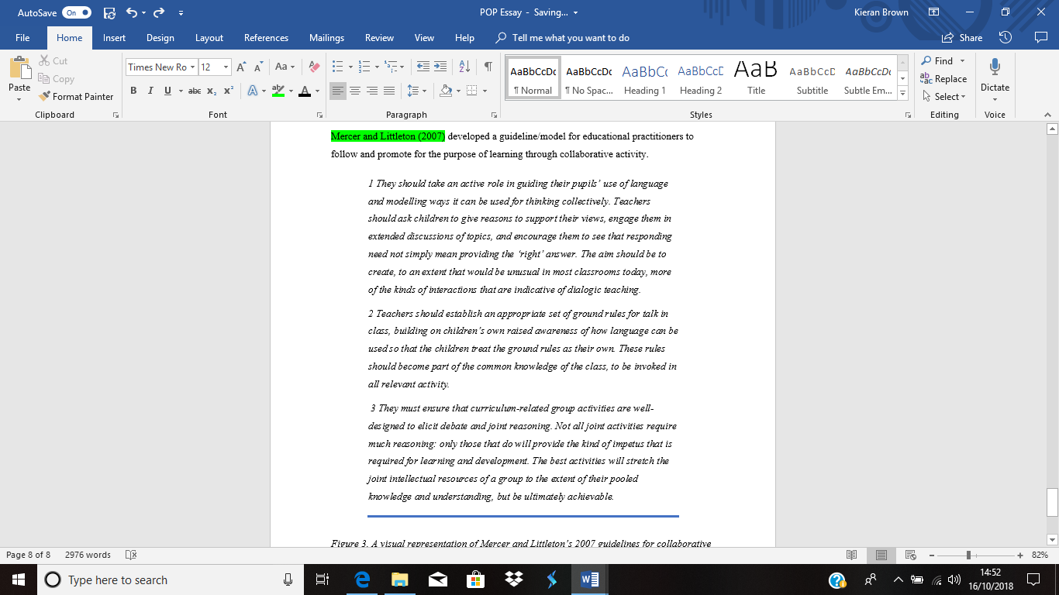

Figure 3. A visual representation of Mercer and Littleton’s 2007 guidelines for collaborative teaching and dialogic learning.
Something to consider is that the constructivist approach to education appears to draw on some immeasurably valuable ideas to aid the learning of children. The concept of allowing children to make constructs of their own environment and develop new understanding seems crucial. Utilizing this and finding a way to develop both cognitive development and social understanding will play a vital part in the teaching of new ideas and the assessment of knowledge that has already been gained. The use of peers, group work and the social setting will provide greater perspective to leaners and myself as an educator regarding different constructs of knowledge and view points as well as promote metacognition amongst pupils and collaboration through tasks.
It is paramount to understand that this is not the only approach and that other theoretical strands of teaching will feature heavily in different aspects of school life. For example, it may be increasingly difficult to adopt a solely constructivist approach to challenging behaviour which is where an approach like the behaviourist may be useful (learning through association, operant conditioning and reward and punishment all from external stimuli (Pavlov – 18-49-1936, Thorndike – 1874-1949, Skinner – 1904-1990, seen in Mergel 1998, p, 4-7). A child may struggle to be able to reconstruct their idea of good/appropriate behaviour and would therefor require action in the form of negative reinforcement to be able to cognitively associate the behaviour with a negative response. Desirable behaviour can still be modelled however, to attempt to offer a reconstruction of their notions of behaviour.
Humanistic approaches are also incredibly useful to the classroom and learning environment and heavily linked to the health and well-being section of the four purposes as it student/learner centred. Emotional needs, a sense of self-value/worth and understanding one’s own learning is an integral part of the belief. The humanistic approach also focuses on the learner being actively engaged with their education, putting their faith in their learning environment and feeling fully supported in the process to pursue self-directed and self-regulated learning (the ability to use and develop knowledge, skills and attitudes acquired in one context or another, (Boekaerts, 1999, p 446, Amer, 2006).
Holt (1964) highlighted how schools, at the time, were failing to meet the emotional and educational demands of children. He stated that children don’t progress due to fear of failure, confusion around subject content and a lack of engagement. This notion reinforces the importance of engaging, supporting and motivating every child in a classroom setting and to be mindful that certain learners can fall short or lack an ability to learn and become successful if the educational systems of a teacher don’t meet the learning requirements and needs of a child. It is also important to remember that children still require a sense of self-motivation and achievement in this approach and schools should work to facilitate this as best they can. In relation to the learning environment, asking a child openly about what they deem to be the best factors for a story may aid this as long as the feedback isn’t overly correctional as it would start to lean towards different styles of teaching and learning.
With all of the observations of techniques and environmental tools and stimuli on my visit to the aforementioned primary setting, it is clear teaching truly is complex and requires a well-researched and highly considerate view from a wide range of scopes. This, according to theory would provide the best chance of creating a learning environment that would benefit a multitude of children from different cultural, ethnic and academic backgrounds in order to create the best space and environment for learners who meet with the needs of the successful futures report and the Welsh curriculum. With that being said, the following figure displays my desired/ideal learning environment to facilitate successful learning and growth.

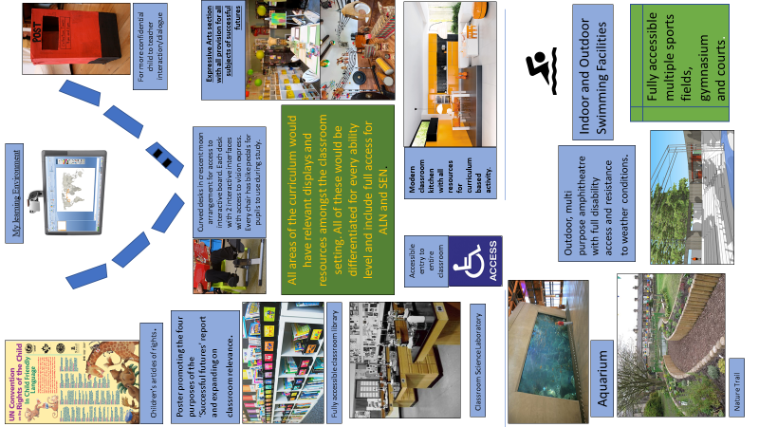
.
The poster contains a variety of traditional and unconventional ideas but all of which can be explained with relevance to experience and research.
One of the main themes in the theoretical section of this report and during the observation was collaboration. This classroom provides an array of opportunity for pupils to collaborate on ideas, themes, activities and pieces of work. For instance, the seating arrangements have been designed to be curved and crescent moon shaped with a full view of the interactive screen at the front of the class as well as the entire cohort of the classroom. Marx, et al (1999) express that children who are sat in a semi-circle shape are more likely to engage in face-to-face experiences with peers and teachers and as a result are increasingly likely to feel comfortable enough to ask more open questions and formulate ideas with peers (teaching style and personality also contribute to this). Alexander (2010) states that although the core principles of the curriculum are essential to life skills, cross-curricular activities and all areas of learning in the school environment, the art of talk from teachers and learners in the fundamental process by which people learn and is imperative to a rich and successful education.
In addition to this, each table is equipped with 2 interactive screens/faces that have access to programmes such as vision exchange, Padlet, Kahoot and ,any others. The use of technology will allow groups of children to make use of digital competency in the classroom setting as well as interactively share ideas and present data amongst their tables, the rest of the class, the teacher and even the wider scope of the internet. Beauchamp & Kennewell (2010) support this notion and exclaim that moving toward a more collaborative environment in the classroom with the use of technology could have the potential to enhance dialogic learning opportunities, collaborative activities and influence other areas of the curriculum
Regarding the poster, these collaborative opportunities and attitudes could extend into all areas of indoor and outdoor activities with dialogue being created and constructed in a variety of settings. For example, sharing ideas about recipes in cooking or exchanging ideas about artistic pieces in the expressive arts section,. Collaborative tasks such as the creation of music and drama could also be implemented with the inclusion of a musical area with full provision in the classroom as well as a full dramatics amphitheatre in the outdoor environment.
The use of such a wide array of provision and resources in the learning environment would provide an increased opportunity for children to interact with all areas of the curriculum. The successful futures report categorises the curriculum into 6 key areas of learning:-
- Expressive Arts – Drama, Art and design & Music
- Health and Well-being – physical and mental
- Humanities- Geography, History, Politics, R.E etc
- Languages, Literacy and Communication – Rapidly growing increase on the emergence of Welsh
- Mathematics and Numeracy
- Science and Technology
Not only do these areas of learning (AOLEs) need to be completely accessible to every child across the schooling system, they need to intertwine, in a cross-curricular manner, in order for further development and a more applied approach to achieving the four purposes of the report, previously stated.
Jonathan Barnes (2015) has highlighted that the idea of a cross curricular education is not a new philosophy and actually stems back to cultures like ancient China and Greece. Language, Numeracy and performing arts have always been imperative and transferable across a variety of school setting and real life situations. However in the 21st century it’s become more prevalent that this idea now needs to be focused on engagement in schooling and learning, challenge, motivation, achievement and future success.
Regarding that notion, engagement in children is something educators have struggled with for centuries with a lot of learners feeling not only like they don’t want to come to school but they don’t need to. In a meta-analysis, completed by Roorda et al (2010), it was evident that a poor relationship between teachers and students lead to disinterest and a lack of trust with the educator. This was caused by the teachers who were not meeting the social and educational needs of the child through mentally stimulating work. Ultimately, disengagement from school life occurred and as a result, poor quality of educational quality lead to a disconnected child, in many cases.
The implications of research like this are enormous as it reiterates the previously mentioned theories in this document. A child needs to be stimulated by the educator and the environment in order to cogitate and develop metacognition as well as reconstructions from the environment as a result of critical analysis of previous vs. new knowledge. Bearing regards to the learning environment design, every area of the curriculum and more would be available to the children who were learning in it with an open policy to equipment and resources (all provision relating to the curriculum) as well as exciting observational opportunities like studying the marine life in the aquarium or making use of the nature trail.
Csikszentmihalyi’s theory of flow (seen in Shernoff & Csikszentmihalyi 2009, p131-145) states that when there is an increased level of engagement and intrinsic motivation in a task/activity, there is a positively correlated level of absorption, fulfilment and skill. It also puts forward the idea that when the challenge of an activity is well matched to an individual’s skills it promotes better engagement and less possibility for distraction. In an outdoor learning environment, this has huge significance as the better engaged a child is with an activity, the higher the level of intrinsic motivation to succeed in it will be. The outdoors provides these opportunities to learn at every turn in the learning environment across the entire curriculum. It is important to know however, that learning outdoors is making use of the outdoors and not just taking a lesson outside.
In my classroom design I feel like I have provided enough opportunity to explore various aspects of the curriculum through outdoor resources to stimulate learners and motivate them to extend their knowledge.
One area of the classroom which may have the potential to keep learners active in the physical sense is the use of exercise pedals underneath seats and desks. In an article published by ‘The Daily Mail’ (Williams, 03/10/2018) there has been a spotlight pointed at schools in the United Kingdom adopting this technique. According to teachers of the school, based on their own observations, the children’s behaviour became more desirable and engagement in tasks increased. Initially the bike pedals were bought to promote the combination of learning in a classroom environment and keeping physically active to stay healthy and burn calories but, the pedals seem to be having a positive influence on the learning environment which may have huge future implications.
This leads on to one incredibly important aspect of the successful futures report and what has been recently a hugely investigated part of school life, Health and Well Being. It is increasingly important that during the school experience, children are given the opportunity both physically and mentally to become, healthy, confident individuals. By having exercise bikes under the tables in the indoor setting and a variety of sporting/performing opportunities in the learning environment design, children will have increased access to the type of activity that will promote a healthy lifestyle as well as a chance to develop in the best manner.
It is also imperative to ensure that children’s mental well-being is cared for and looked after with the utmost diligence and respect as mental health is becoming an increasingly large issue on a global scale. According to a report produced by The Mental Health Foundation (2016), between the years of 2002-2014 there was a 72% increase in the amount of children who were subject to child protection plans and child protection registers in Wales. This highlights the importance to develop a learning environment where children feel safe, secure, supported and trusting of the people are in charge of their wellbeing and that they have their best interests regarding suture success and develop in mind.
Costa discusses the importance of habits of mind in children and reiterates the prevalence of the need to focus on children’s motivation, self-esteem and resilience (refer to appendices, figure).

Maslow also stresses the importance of meeting children’s needs in the learning environment and categorises them as the hierarchy of needs (seen in McLeod, 2018). His model is as follows:

Figure 4. Maslow’s Hierarchy of needs accessed from https://www.simplypsychology.org/maslow.html
He states that these needs need to be met by educators in order to ensure a sound mind and that there are no differences with this notion across different cultures. There are limitations with this model. For instance the order of the needs can be debated by certain individuals depending on their situation. However, it does highlight key areas to be aware of when considering a learner’s frame of mind and how to make sure as an educator you promote a strong sense of self achievement and well-being.
To conclude, from what has been observed and discussed in this report there a some very clear and distinct things that are vital in a classroom setting. Allowing children the opportunity to develop into their best selves through outstanding teaching practices is a must in the modern world of teaching. Children need to be stimulated, motivated and supported in order develop, cognitively and semantically. Educators have a professional responsibility to carry this out in order to create the best learning environment to develop successful contributors to society foe the future.

References
Ackermann, E. (2001). Piaget’s constructivism, Papert’s constructionism: What’s the difference. Future of learning group publication, 5(3), 438.
Alexander, R (2010). Children, their World, their education. Final report and recommendations of the Cambridge Primary Review. Abingdon, Oxon: Routledge. p84
Amer, A. (2006). Reflections on Bloom's Revised Taxonomy. College of Education, Sultan Qaboos University, Muscat. 1. P446
Armstrong, P. (2016). Bloom’s taxonomy. Vanderbilt University Center for Teaching. 3&4. P1-3
Barber, M & Mourshed, M. (2007). How the world's best-performing school systems come out on top. The McKinsey Report. 1 (.), 1-56
Barnes, J (2015). Cross-Curricular Learning. 3-14.. 3rd ed. Lomdon: SAGE Publications. p49-84
Beauchamp, G., & Kennewell, S. (2010). Interactivity in the classroom and its impact on learning. Computers & education, 54(3), 759-766.
British Educational Research Association [BERA] (2018) Ethical Guidelines for Educational Research, fourth edition, London. https://www.bera.ac.uk/researchers-resources/publications/ethicalguidelines-for-educational-research-2018
Bruce, T (2004). Developing Learning in Early Childhood. London: SAGE Publications Company. p92-100.
Costa, A.L. and Kallick, B., 2009. Habits of mind across the curriculum: Practical and creative strategies for teachers. ASCD.
Donaldson, G. (2015). Successful Futures. Independent review of Curriculum and Assessment Arrangements in Wales. . 1 (3), 21-33
Donaldson, G. (2015). Successful Futures. Independent review of Curriculum and Assessment Arrangements in Wales. . 1 (8), 105-120
Fisher, R (2008). Teaching Thinking. Philosophical Enquiry in the Classroom. 3rd ed. London: Continuum International Publishing Group. p106
Forehand, M. (2005 & 2010). Bloom's Taxonomy: Original and Revised . In M. Orey (E.D.), Emerging Perspectives on Learning, Teaching and Technology. 1 (1), p1-10. Retrieved <16/10/2018> “http://projects.coe.uga.edu/epltt/index.php?title+Bloom%27s_Taxonomy”
Fox-Turnbull, W. (2016). The nature of primary students' conversation in technology education. International Journal of Technology and Design Education, 26(1), 21-41
Grigg, R (2010). Becoming an Outstanding Primary School Teacher. Abingdon-On-Thames: Routledge Ltd. p425.
Holt, J.C. and Fromme, A., 1964. How children fail (Vol. 5). New York: Pitman.
Marx, A., Fuhrer, U., & Hartig, T. (1999). Effects of classroom seating arrangements on children's question-asking. Learning Environments Research, 2(3), 249-263.
Mercer, N. and Littleton, K., 2007. Dialogue and the development of children's thinking: A sociocultural approach. Routledge.
Mental Health.Org. (2016). Mental Health in Wales: Fundamental Facts 2016. Mental Health Foundation. 1 (1), 1-20. Accessed on 17/10/2018 from https://www.mentalhealth.org.uk/sites/default/files/FF16%20Wales.pdf
McGregor, D (2007). Developing Thinking; Developing Learning. A Guide to Thinking Skills in Education. Maidenhead, Berkshire: Open university Press, McGraw-Hill. p22
Mercer, N. (2000) Words and Minds: How we use language to think together, London: Routledge.
Mergel, B. (1998). Instructional Design & Learning Theory. . 1 (1), p4-7.
Roorda, D.L., Koomen, H.M., Spilt, J.L. and Oort, F.J., 2011. The influence of affective teacher–student relationships on students’ school engagement and achievement: A meta-analytic approach. Review of educational research, 81(4), pp.493-529.
Shernoff, D.J. and Csikszentmihalyi, M., 2009. Cultivating engaged learners and optimal learning environments. Handbook of positive psychology in schools, pp.131-145.
Van der Linden, J & Renshaw, P (2004). Dialogic Learning. Shifting Perspectives to Learning Instructing and Teaching. London: Kluwer Academic Publishers. p9.
Walqui, A (2006) Scaffolding Instruction for English Language Learners: A Conceptual Framework, International Journal of Bilingual Education and Bilingualism, 9:2, 159-180, DOI: 10.1080/13670050608668639
Williams, T-A. Primary School Introduces Pedal Devices to Students’ desks so they can burn calories as they study in bid to crack down on child-obesity. Mail Online. 03/10/2018. Accessed from https://www.dailymail.co.uk/news/article-6234775/Primary-school-introduces-pedal-devices-students-desks-burn-calories-study.html
Further Internet links
(Art Therapy Room Picture), Bethan. saved to | A R T | T H E R A P Y |293. ART THERAPY REFLECTIONS: Designing an Art Therapy Studio, Accessed on 17/10/2018 from < https://www.pinterest.co.uk/pin/360217670167002566/
(Aquarium). Accessed on 17/10/2018 from http://www.rptchina.cn/投资组合/西雅图水族馆
www.innovativelearning.com/educational_psychology/development/zone-of-proximal-development.html
(Classroom Laboratory) Accessed on 17/10/2018 from http://www.willsens.com/classroom-lab/
(Classroom Library). Accessed on 17/10/2018 from https://schoolgirl-style.myshopify.com/products/just-teach-classroom-library-labels
(Interactive Whiteboard). Promethean. Accessed on 17/10/2018 from http://www.almoedigitalsolutions.com/product/promethean-activboard-500-pro
Kahoot. Accessed on 17/10/18 from https://kahoot.com/
(Music room picture). Accessed on 17/10/2018 from https://www.pinterest.co.uk/pin/63402307227652269/
(Nature Trail). Acessed on 17/10/2018 from https://www.google.co.uk/search?biw=1366&bih=651&tbm=isch&sa=1&ei=6XzHW8SlO4qWkwWgyquoAg&q=Primary+school+wildlife+area&oq=Primary+school+wildlife+area&gs_l=img.3...8004.12897.0.13338.28.24.0.4.4.0.127.1806.19j4.23.0....0...1c.1.64.img..1.18.1281...0j0i67k1j0i5i30k1j0i8i30k1.0.O3Jvq53T8_0#imgrc=I_t_cQy0M59ioM:
(Orange kitchen for classroom). Accessed on 17/10/2018 from http://www.stylehomes.net/french-kitchen-designs-from-perene/orange-kitchen-design/
https://www.simplypsychology.org/maslow.html
Padlet. Accessed on 17/10/18 from https://padlet.com/dashboard
(Post box). Accessed on 17/10/2018 from https://theimaginationtree.com/post-box-play/
Unicef. Convention on the rights of the child in child friendly language. Accessed on 17/10/2018 from file:///C:/Users/kiera/OneDrive/Pictures/uncrcchilldfriendlylanguage.pdf
Vision Exchange. Accessed on 17/10/18 from https://www.sonycreativesoftware.com/download/visionexchange_app
Appendices
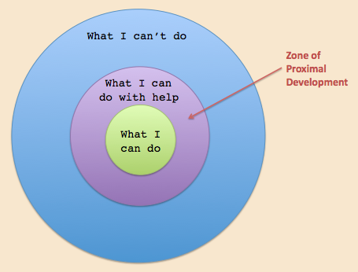

Figure 5. A visual representation of Vygotsky’s Zone of Proximal Development.
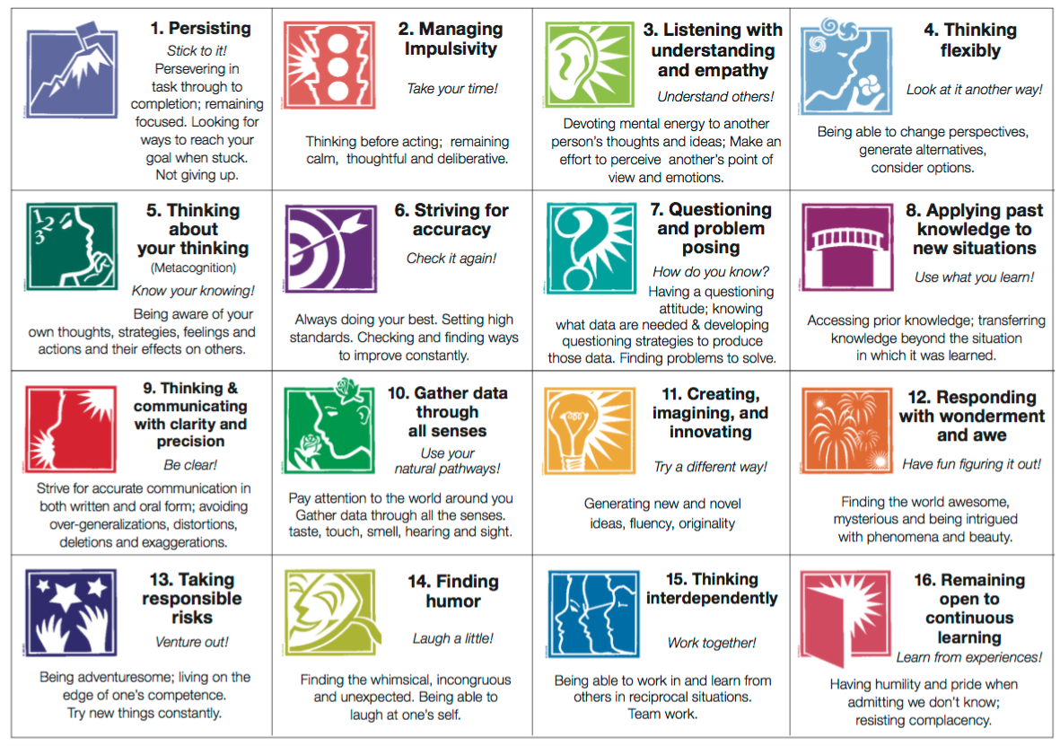

Figure 6. Costa’s 16 Habits of mind

